 | TeleNav, Inc. Ph: 408.245.3800  2975 San Ysidro Way Fax: 408.245.0238  Santa Clara, CA 95051
MRD – Movie Info Demo Requirements

Product: | Movie Info Demo Requirements
Version: | 1.0
Platforms: | TN 5.x
Author: | Manohar Ellanti
Email: | manohare@telenav.com
Telephone: | 408-207-4063

Revision: mrd1b

Contents

Contents 2
Revision History 3
Approval History 3
1 Purpose 4
2 Competitive Analysis 5
3 Product Requirements 6
3.1 Functional Requirements List 6
3.2 Detailed Feature List 6
3.2.1 Provide Movie as second level menu item under Share&More 6
3.2.2 Allow User to Search Movies 7
3.2.3 Movie Search Results 7
3.2.4 Sort b Box Office 8
3.2.5 Sort b Rating 8
3.2.6 More Info 9
3.2.7 Buy Ticket 11
4 Appendix 12

Revision History
Version
# | Date released | Description of changes | Author
Mrd1a | 10/01 | Created initial version | Manohar Ellanti
 | 10/06 | Updated with screen shots
Mrd1b | 10/16 | Updated with new screen shots  Added updated related to clarifications provided to Eng team’s questions | Manohar

Blue font in the MRD means areas that need to be updated in the future.

Approval History
Reviewer | Approval required? | By (Date)?
 | <yes/no>

Section | 
1

Purpose
Purpose of this MRD is to describe requirements for Movie Info 1.0 demo

Client UI flows can be found on the share point

http://sharepoint.telenav.com/pm/Shared%20Documents/TeleNav/MRDs%20+%20UI%20Flow/Movie%20Info%20Demo/Movie%20Info%20Client%20UI%20Flow%201a.vsd

TMS Data Feed Information Can be found here:
\\192.168.118.211\Pub\movie

Section
2

Competitive Analysis

Garmin and other devices with MSN Direct provide movie listings.

Section
3

Product Requirements

Functional Requirements List

Number | Requirement | Priority (P1=Highest)
RE-1 | Movies as second level menu item under Share&More | P1
RE-2 | Allow User to Search for Movies or theaters | P1
RE-3 | Show Movie/Theater Search Results | P1
RE-4 | Show Movie Details | P1
RE-5 | Allow user to Buy Ticket @ Fandango | P1
RE-6 | Sort movie listings by ratings | P1

Detailed Feature List

Provide Movie as second level menu item under Share&More

Number | RE-1
Title | Show Movies as second level menu item under Share&More
Priority | P1
Use Case-1

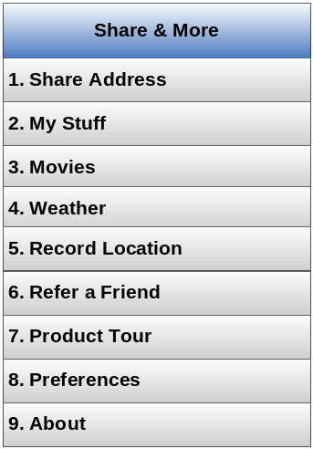
Figure 1 Share&More Menu

Details:

- Shall use browser based mechanism to show the menu
- Request from the device to server shall include current GPS location as known at the application at the time of request.
- Showing ‘Movies’ menu option shall be server controlled based on
  - User Profile
    - Based on user’s email id or demographic information user can see or not see the menu option. This is for future.
  - Web configured user’s preference
    - In future we may enable users to customize features they want to see or not want to see in Share&More. So before Movie is shown, user’s preferences must be checked to see if the user has enabled showing/not showing the option.
  - PTN WhiteList (list of PTNs)
    - If user’s PTN is in the whitelist then the user shall see the Movie menu item
  - Geofence whitelist (list of geofence IDs)
    - If a user is with in allowed geofenced areas then the user shall see the Movie menu item. User’s current lat/long shall be used on server side to determine if the user is within any of the allowed geofenced areas
  - Geofence Blacklist (list of geofence IDs)
    - Opposite behavior to the above
  - PTN area code whitelist
    - If users PTN area code matches with any of the area codes in the whitelist then the user shall see the menu option

Though the above options are called out to allow Eng to architect future proof solution, for now we need Eng to implement in a way that Share&More contains Movie option for any user accessing the server from San Francisco and Seattle areas. Eng shall create geofence whitelist to cover San Francisco bay area and Seattle metro areas. Movie feature access shall be flagged as controlled by Geofence whitelist.

Allow User to Search Movies or Theaters

Number | RE-2
Title | Allow User to Search for Movies or theaters
Priority | P1
Use Case-1 | - User elects to view movie listings from Share&More  - User sees search screen with two fields – where and when and two buttons – one to search for movies and one to search for theaters

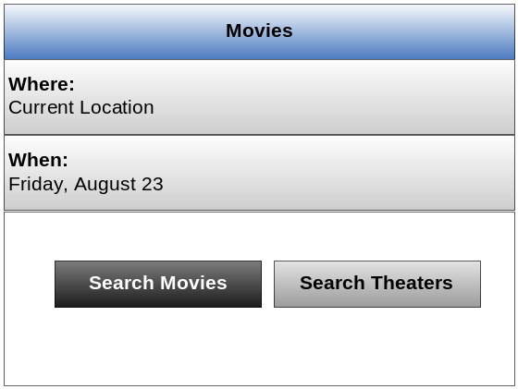
Figure 2 Search Input screen
Details:

- Where field shall be by default current location
- When field shall be automatically filled with today’s name, month and date

Movie/Theater Search Results

Number | RE-3
Title | Show Movie/Theater search results
Priority | P1
Use Case-1 | - user elects to view movie listings from Share&More  - User enters where and when information  - user select movie search option  - user sees movies search results
Use Case-2 | - user elects to view movie listings from Share&More  - User enters where and when information  - user selects theater search option  - user sees theater search results

Use Case -1: Movie Search results

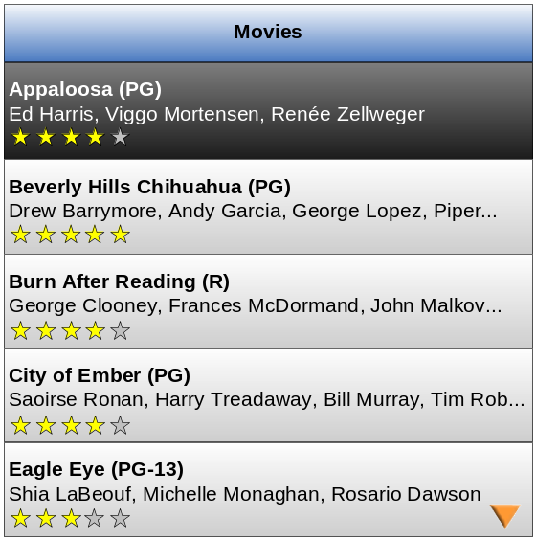
Figure 3 Movie search results

Details:
- Below the title, available cast information shall be displayed
- Next to the movie name, display movie rating
- Show cast members up to 1 line. Add “...” at the end if the space is not enough.
- Sort by movie name by default
- Search shall be limited to movies shown in theaters around user’s current location/inputted address and search shall limit to 20 mile radius.
  - In case the feed doesn’t allow realization of the above then listing all movies currently playing in theaters is OK

Clicking a movie shall show movie details as shown below:
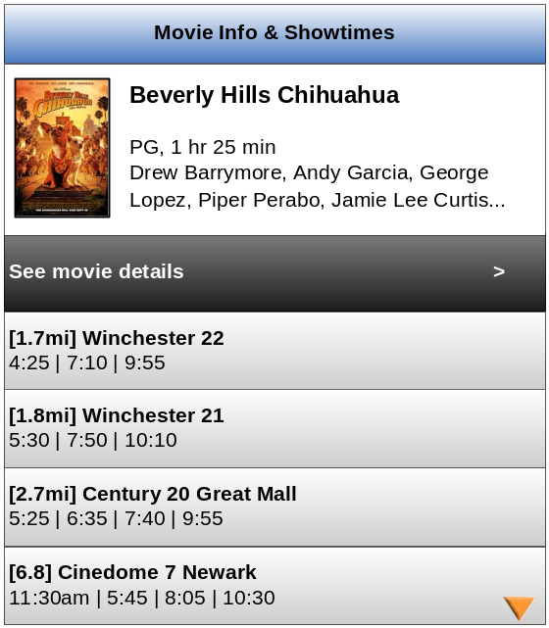
Figure 4 Theater Listings for a selected movie
Details:
- Distance shall be shown in [] before the theater name
- Display showtimes up to 1 line. Add “...” at the end if the space is not enough
- Show cast members up to 2 lines. Add “...” at the end if the space is not enough.

Use Case -2: Theater Search Results

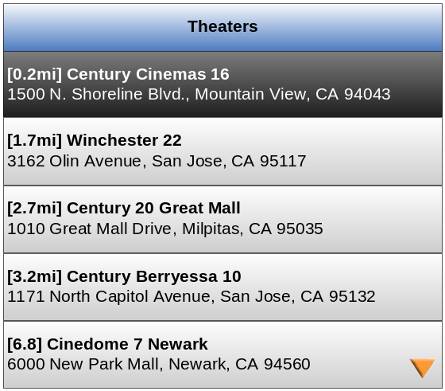
Figure 5 Theater Search results
- Distance shall be shown in [] before the theater name
- Below the theater title, address shall be shown
- Clicking a theater shall show movie listings specific to that theater.

Sort by Rating

Number | RE-4
Title | Sort by Ratings
Priority | P1
Use Case-1 | - user elects to view movie listings from Share&More  - User enters where and when information  - user selects movies search results  - User selects sort by ratings  - User sees movies sorted by ratings

Listing same as in Figure 3 except for the sort order.

Movie Details

Number | RE-5
Title | More Info
Priority | P1
Use Case-1 | - user elects to view movie listings from Share&More  - User enters where and when information  - user selects movies search option  - user sees movie results  - user clicks a particular movie  - user sees Movie Info & Showtimes screen  - user selects see movie details
Use Case -2 | - user elects to view movie listings from Share&More  - User enters where and when information  - user select theater search option  - user sees theater search results  - user clicks a particular theater  - user sees list of movies  - user selects a particular movie  - user sees Movie Info & Tickets screen  - user selects see movie details  - user sees movie details

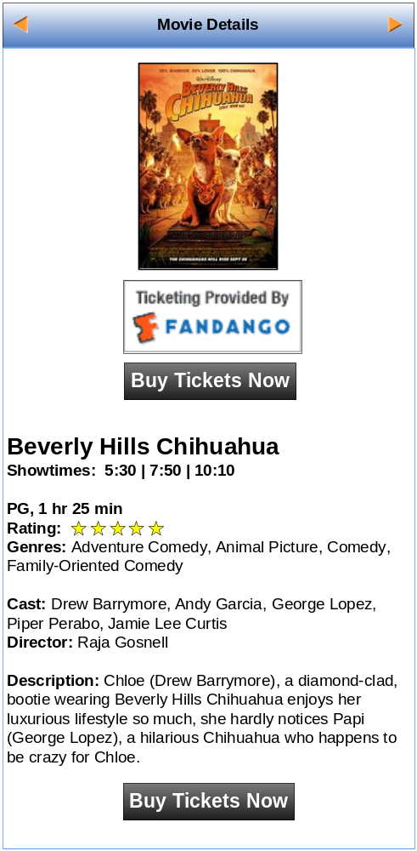

Details:
- The context menu options shall be
  - The show time info is only shown when the user comes from the search theaters from, in which the theater is known before reaching this screen.
- clicking on the fandango icon shall take user to mobile.fandango.com and this URL shall be server controlled

Buy Ticket

Number | RE-6
Title | Buy Ticket
Priority | P1
Use Case-1 | - user selects movie option from Share&More  - User enters where and when information or uses default values  - user selects movie search option  - user sees movie search results  - user selects a particular movie  - user sees Movie Info & Show Times screen with a list of theaters and show times  - User selects theater  - user sees Buy Movie Tickets screen  - user selects a particular show time  - user sees redirect popup  - user redirected to fandango WAP site for the movie/theater page
Use case-2 | - user selects movie option from Share&More  - User enters where and when information or uses default values  - user selects theater search option  - user sees theater search results  - user selects a particular theater  - user sees list of movies for that theater  - user selects a particular movie  - user sees Movie Info & Show Times screen  - user selects a particular show time  - user sees redirect popup  - user redirected to fandango WAP site for the movie/theater page

Use Case -1
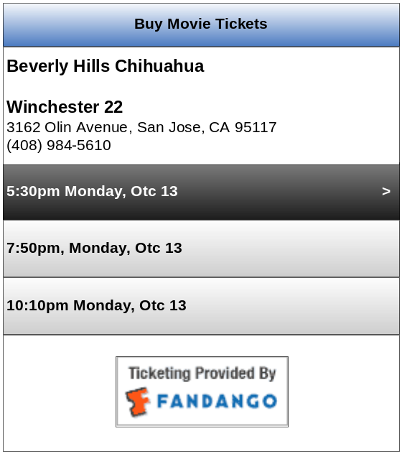
Figure 6 Buy Movie Ticket - Movie Search Flow

Details
- clicking on the fandango icon shall take user to mobile.fandango.com and this URL shall be server controlled

Use Case-2

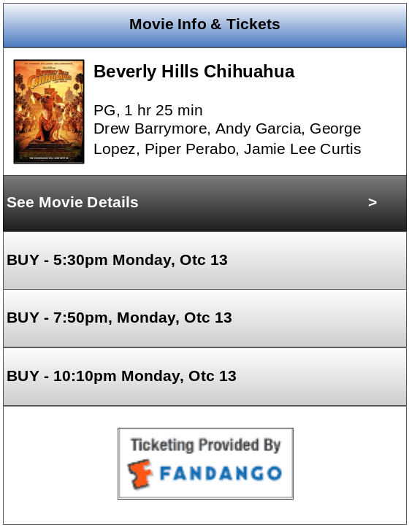
Figure 7 Movie Buy Tickets screen – Theater Search Flow

Details:
- clicking on the fandango icon shall take user to mobile.fandango.com and this URL shall be server controlled

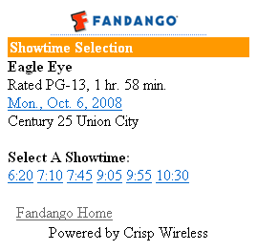
Figure 8 Fandango WAP Site

Appendix
See requirements for affiliates to integrating Fandango WAP site

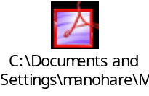

TMS Specs and Sample feeds
\\192.168.118.211\Pub\movie

