[http://sharepoint.telenav.com/Logos and TeleNav Art/_w/TN_logo_177x46_gif.jpg](http://sharepoint.telenav.com/Logos%20and%20TeleNav%20Art/TN_logo_177x46.gif)

**Revision: 1.0**

TN 6X POI Browser Server

Component Functional Specification Document

**Date of Release: See cBL**

###### **Component Owner: See cBL**

###### **Date Completed: See cBL**

Revision History

|  |  |  |  |
| --- | --- | --- | --- |
| **Date** | **Version** | **Description** | **Author** |
| See cBL | 1.0 | Initial Release | See cBL |
| See cBL | 1.1 | Updated with Address Template and General Feedback | See cBL |
|  |  |  |  |
|  |  |  |  |
|  |  |  |  |

Table of Contents

[1. Introduction 4](#_Toc290978892)

[1.1 Component Description 4](#_Toc290978893)

[1.2 Changes in This Release 4](#_Toc290978894)

[2. Specific FSD Changes 6](#_Toc290978895)

[3. Requirements 6](#_Toc290978896)

[3.1 Use Cases 6](#_Toc290978897)

[3.2 Service Level Requirements (as needed) 7](#_Toc290978898)

[4. Design 7](#_Toc290978899)

[4.1 Technologies 7](#_Toc290978900)

[4.1.1 Technologies Utilized 7](#_Toc290978901)

[4.1.2 Alternative Technologies Considered (as needed) 7](#_Toc290978902)

[4.2 External Interface(s) 7](#_Toc290978903)

[4.2.1 Communication Protocol(s) Used 7](#_Toc290978904)

[4.2.2 Interface Operations 8](#_Toc290978905)

[4.3 Implementation 9](#_Toc290978906)

[4.3.1 Structural Diagrams 9](#_Toc290978907)

[4.3.2 Behavior Diagrams 24](#_Toc290978908)

[4.3.3 Data Models/Database Schema (as needed) 29](#_Toc290978909)

[5. Service Level Impacts (as needed) 29](#_Toc290978910)

Component

# Introduction

## Component Description

The TN 6.x POI C-Server is responsible for providing functionality to POI Search, Address Capture, Home Page and Weather, both in business logic and user interface, for all TN 6.x clients. POI Search allows user to perform search of restaurants, gas stations, or any other points of interests. Address Capture allows user to look up the location of a place, an address, an airport. Home Page is the home page of the client, where it displays the four main functions of the client, and Weather is a local app in the client where user can look up weather of a given location.

## Changes in This Release

|  |  |
| --- | --- |
| **Project Name/Bug Number** | **Description** |
| Please see attached cBLTN6xPOICServer.html | |

# Specific FSD Changes

*Describe specific sections in this document changed for this release (highlight in yellow):*

| **Section** | **Description** |
| --- | --- |
| N/A |  |

# Requirements

## Use Cases

*This section should list the specific use cases that would cause this component to be invoked.*

| **Use Case #** | **Description** | **Note** |
| --- | --- | --- |
| 1 | Input Address using one-box |  |
| 2 | Input POI using one-box |  |
| 3 | Drive To Recents |  |
| 4 | Clear Recents |  |
| 5 | Drive To Contact |  |
| 6 | Drive To Airport |  |
| 7 | Drive To Favorite |  |
| 8 | Drive To Places |  |
| 9 | Create New Folder |  |
| 10 | Edit Folder Name |  |
| 11 | Delete Existing Folder |  |
| 12 | Edit Favorite |  |
| 13 | New Favorite |  |
| 14 | Move Favorite/Folder |  |
| 15 | Merge Folders |  |
| 16 | Auto-sync Favorites |  |
| 17 | Received Favorite (Badge + Received Address) |  |
| 18 | Manual Favorites sync |  |
| 19 | Home Page Adjuggler banner |  |
| 20 | Mileage Production Launch |  |
| 21 | General/POI/Search Structured Feedback Implementation |  |
| 22 | Input Address using address template |  |

## Service Level Requirements (as needed)

*This section should list the service level requirements that this component needs to satisfy.*

| **Requirement #** | **Description** |
| --- | --- |
| N/A |  |

# Design

## Technologies

### Technologies Utilized

* Java SE 6: The primary implementation language for all server-side implementations.
* Apache Tomcat 6: The primary application container platform for application services and business services.
* Apache Axis2 1.5: The primary web services container for business services
* SOAP/HTTP: The primary communication protocol used for communication to business services.
* Spring Framework 2.5.6
* Apache Commons
* Log4J 1.2.8

TeleNav proprietary technologies:

* INode: The interface abstraction for TXNode for client to server communication

### Alternative Technologies Considered (as needed)

None

## External Interface(s)

### Communication Protocol(s) Used

INode: The interface abstraction for TXNode for client to server communication

TXNode/INode: The proprietary TN protocol used for client-server communication. It has been optimized for transfer size. INode represents the generalized interface for TXNode to abstract away the concrete implementation and isolate changes

### Interface Operations

Various operations below are handled by the Common CServer over HTTP using TxNode protocol.

#### Validate Airport

This request sends a short code for Airport. The system validates and sends back location information for the airport if it is valid.

#### Search POI

Point of interest search uses this interface.

#### Validate address

All addresses entered by users are validated using this interface.

#### One box search

One box search uses this interface to get results from the backend.

#### 

#### Share address

Share address with other users in done through this interface.

#### Banner Ads

Users receive banner ads using this interface.

## Implementation

### Structural Diagrams



#### Layer Diagrams

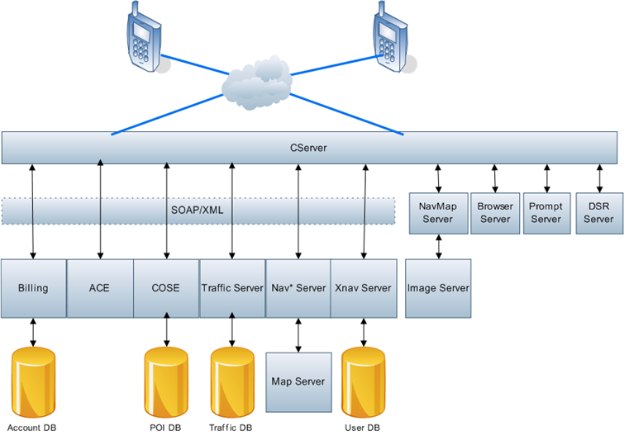

#### Class Diagram

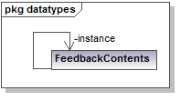

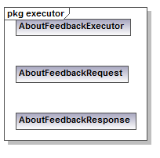

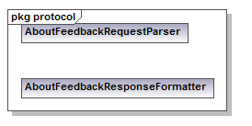

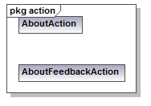

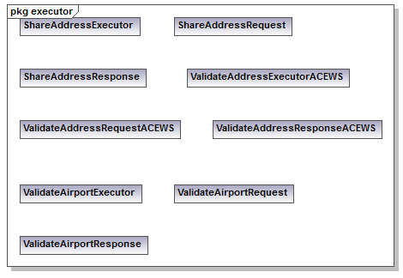

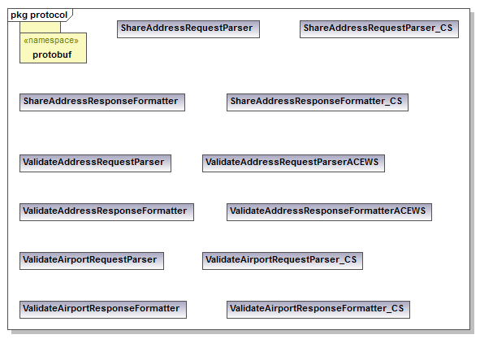

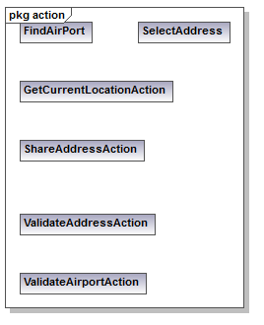

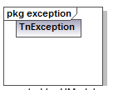

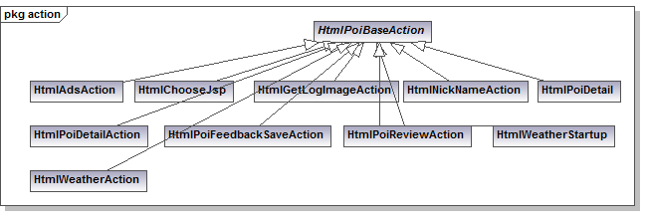

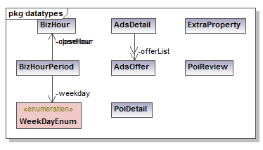

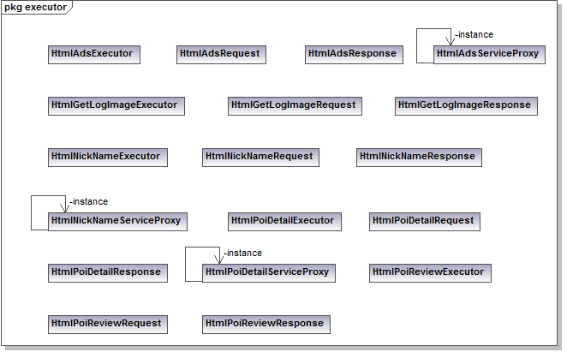

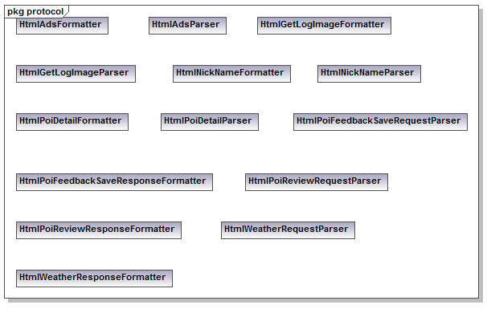

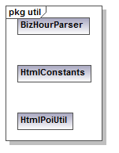

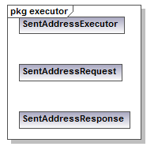

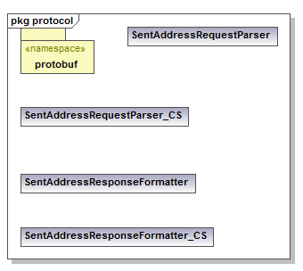

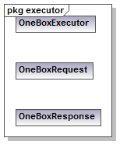

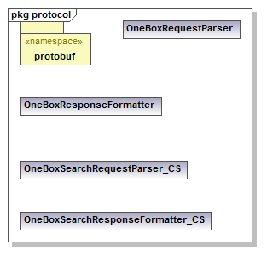

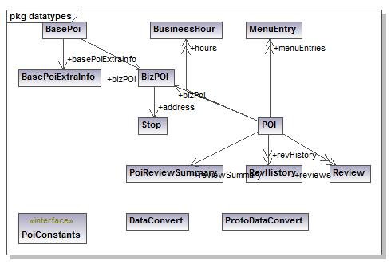

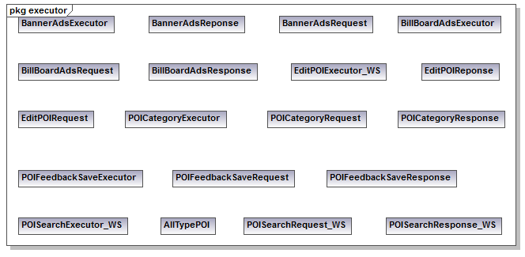

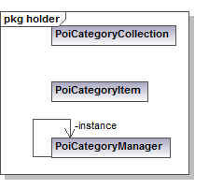

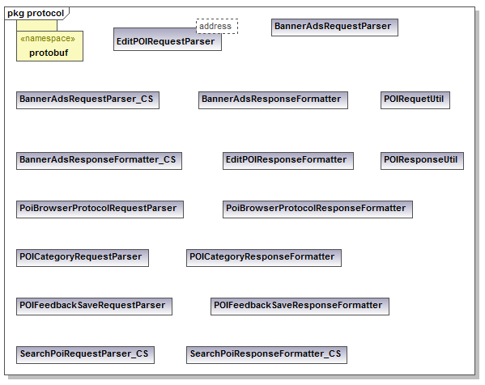

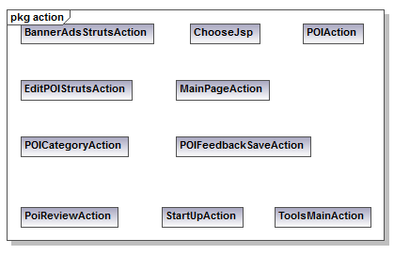

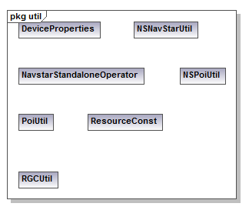

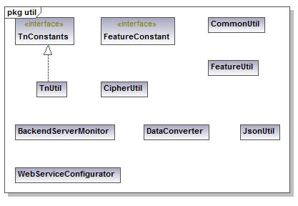

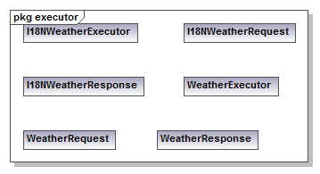

#### Package Diagram

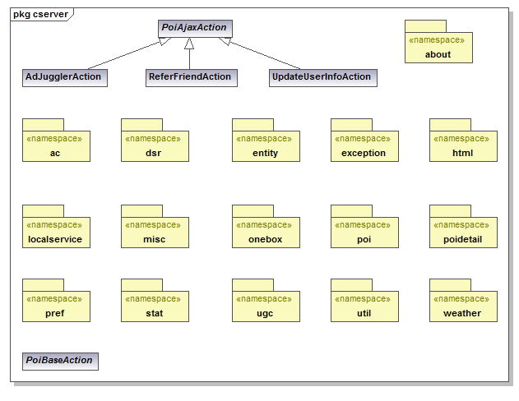

*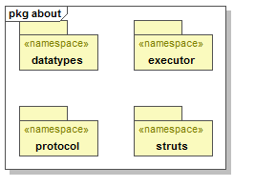*

*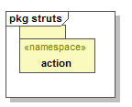*

*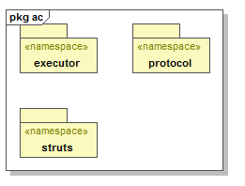*

*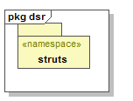*

*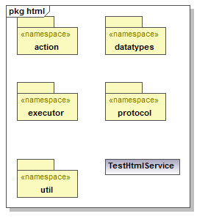*

*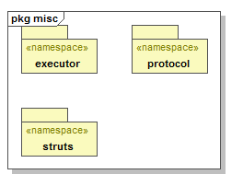*

*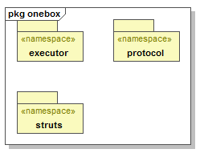*

*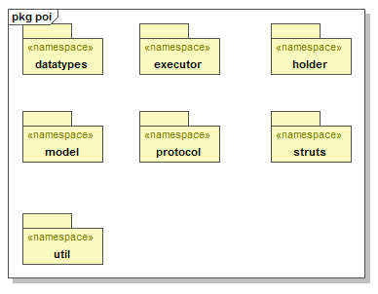*

*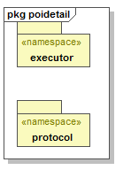*

*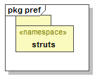*

*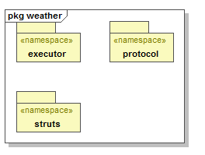*

### Behavior Diagrams

#### UC01 Input Address using one-box

* Run app.
* Click on “Drive To”.
* Click on one-box entry field.
* Enter an address.
* User should be taken to the Route Planning screen directly with the destination set as the inputted address.

#### UC02 Input POI using one-box

* Run app.
* Click on “Drive To”.
* Enter a POI name or keyword into the one-box field.
* User should see search results page.
* Click on an appropriate POI result.
* Click on Drive To from the POI Details page.
* User should be taken to the Route Planning screen with the destination set as the POI address.

#### UC03 Drive To Recents

* Run app.
* Click on “Drive To”.
* Click on “Recents”.
* Make sure that the list includes all Recent addresses/POIs that have been driven to, but ensure that it does not contain a list of addresses/POIs that have only been searched or mapped.
* Click on an address/POI.
* The Route Planning screen should be displayed

#### UC04 Clear Recents

* Run app.
* Click on “Drive To”.
* Click on “Recents”.
* Make sure there are some Recents displayed.
* Click on the softkey and select “Clear Recents”.
* Click “Yes” on the dialogue popup to clear recents.
* Make sure that all Recent entries are deleted.

#### UC05 Drive To Contact

* Run app.
* Click on “Drive To”.
* Select “Contacts”.
* You should now see the native phone contact list appear. Select a contact which has an address entered into it.
* The Route Planning screen should be displayed.

#### UC06 Drive To Airport

* Run app.
* Click on “Drive To”.
* In the search field, enter the airport code LAX and make sure it maps to the Los Angeles International Airport.
  + Suggest trying several major/minor airports at random to test the data.
* Delete data and enter “Los Angeles International Airport”. Make sure auto-complete works properly.
* Click to continue.
* The Route Planning Screen should be displayed.

#### UC07 Drive To Favorite

* Run app.
* Click on “Drive To”.
* Click on Favorite. Make sure you have at least one favorite populated.
* Select the favorite you wish to drive to.
* Click on “Drive To”.
* The Route Planning screen should be displayed.

#### UC08 Drive To Places

* Run app.
* Click on “Drive To”.
* Click on “Places”.
* The Places page should be displayed as normal.

#### UC09 Create New Folder

* Run app.
* Click on “Favorites”.
* Select the “New Folder” icon.
* Name the folder and click create.
* Verify that the folder is created.
* Recommend doing a reboot to check that the change is properly synced.

#### UC10 Edit Folder Name

* Run app.
* Click on “Drive To”.
* Click on “Favorites”.
* Click to edit the folder that you wish to change.
* Change the name of the folder and click confirm.
* Ensure that the folder name is changed properly.
* Recommend doing a reboot to check that the change is properly synced.

#### UC11 Delete Existing Folder

* Run app.
* Click on “Drive To”.
* Click on “Favorites”.
* Click to delete a folder.
* Make sure that the proper confirmation message is displayed (one of two, see the user messaging of this section of this document).
* Confirm the delete.
* Ensure that the folder is deleted.
* Recommend doing a reboot to check that the change is properly synced.

#### UC12 Edit Favorite

* Run app.
* Click on “Drive To”.
* Click on “Favorites”.
* Select a Favorite and choose to edit it.
* Change some details and click to save.
* Ensure that the favorite is changed.
* Recommend doing a reboot to check that the change is properly synced.

#### UC13 New Favorite

* Run app.
* Click on “Drive To”.
* Click on “Favorites”.
* Click on the new favorite icon.
* Enter information to create a favorite and click save.
* Ensure that the favorite is created.
* Recommend doing a reboot to check that the change is properly synced.

#### UC14 Move Favorite/Folder

* Run app.
* Click on “Drive To”.
* Click on “Favorites”.
* Click on a folder/favorite and select “Move”.
* Move the folder/favorite into a new folder or to the root directory if already in a folder.
* Ensure that the favorite/folder is moved successfully.
* Recommend doing a reboot to check that the change is properly synced.

#### UC15 Merge Folders

* Run app.
* Click on “Drive To”.
* Click on “Favorites”.
* Select “Merge” on a folder.
* Choose the folder to merge it with.
* Confirm the merge.
* Ensure that the folder is merged successfully.
* Recommend doing a reboot to check that the change is properly synced.

#### UC16 Auto-sync Favorites

* Make a change to a favorite using manual tool or other method while app is running.
* Click on “Drive To”.
* Click on “Favorites”.
* Wait while sync occurs.
* Make sure change is reflected.

#### UC17 Received Favorite (Badge + Received Address)

* Make sure app is not running.
* Send an address to the phone.
* Receive the notification of the address.
* Run app.
* Make sure there is a badge on the “Drive To” tab.
* Click on “Drive To”.
* Make sure there is a badge on the “Favorites” button.
* Click on “Favorites”.
* Make sure there is a badge on the “Received Addresses” folder.
* Click on “Received Addresses”.
* Make sure that the address you sent is present.

#### UC18 Manual Favorites sync

* Run app.
* Click on “Drive To”.
* Click on “Favorites”.
* Make a change to a favorite using manual tool or other method while still on the Favorites page.
* Click the manual sync button.
* Make sure the change is reflected.

#### Home Page Adjuggler banner

* Run app.
* Get to the home page.
* At the bottom of the home page, locate Adjuggler banner. There will be various types of banner ad displayed. The current ads supported are:
  + Simple text
  + Gas Price
  + New Movies
  + Popular Movies
  + Weather (not on all devices)
  + Image ads (not on Touch devices)
  + Traffic Teaser
  + Survey
* Go through each types of banner ad for various devices to make sure that the click action is accurate, and the display text or image is displayed correctly.
* On Touch device, also test that the home page is displayed correctly in both landscape and portrait orientations
* For Survey banner ad, make sure the submission is successful and answer has been correctly stored on Feed back service Database.
* For Movie related banner ads, make sure the movie listing is displayed when clicked.
* For Traffic Teaser ad, make sure a full screen traffic information page is showed.

#### UC20 Mileage Production Launch

* Run latest SN 3.0 client that includes mileage tracking module in the client.
* Launch the app. Goto Local Apps page. Click on Mileage app.
* Click Start to begin mileage tracking.
* Go for a drive.
* Click Stop to stop mileage tracking.
* Check report to see how many miles you have driven.

#### UC21 General/POI/Search Structured Feedback Implementation

**POI Feedback**

1. On POI detail page, if user clicks at “Feedback” button, POI Feedback survey will popup;
2. If user clicks “Back” , will go to POI detail page;
3. If user clicks “Save” without any input, will get error prompt;
4. If user selects one choice, and then click “Save”, the following will happen:
5. All the required contextual information and user selection will be stored into Database and there will no email sent to CSR;
6. A success message will be prompted;
7. After the transient timeout, the app redirects to POI Detail page;
8. User selects more multiple choices and then click “Save”, the same following process as UC021\_4;

Please see below completed UI Flow:



**Search Feedback**

1. On Search Result page (SERP), if user clicks at system menu key and then “Feedback” button, Search Feedback survey will popup;
2. If user clicks “Back” , will go back to SERP;
3. If user clicks “Save” without any input, will get error prompt;
4. If user selects one choice, and then click “Save”, the following will happen:
5. All the required contextual information and user selection will be stored into Database and there will no email sent to CSR;
6. A success message will be prompted;
7. After the transient timeout, the app redirects to SERP;
8. User selects more multiple choices and then click “Save”, the same following process as UC021\_9;

Please see below completed UI Flow:



**General Feedback**

1. On Home or Dashboard page, if user clicks at “Feedback” button or menu, General Feedback survey will popup;
2. If user clicks “Back” , will go to back to previous page;
3. If user clicks “Save” without any input, will get error prompt;
4. If user selects one choice, and then click “Save”, the following will happen:
5. All the required contextual information and user selection will be stored into Database and there will no email sent to CSR;
6. A success message will be prompted;
7. After the transient timeout, the app redirects back to previous page;
8. User selects more multiple choices and then click “Save”, the same following process as mentioned above;

#### UC22 Input Address using one-box

* Run app.
* Click on “Drive To”.
* Click on Address and go to Address Entry page.
* Enter an address.
* User should be taken to the Route Planning screen directly with the destination set as the inputted address.

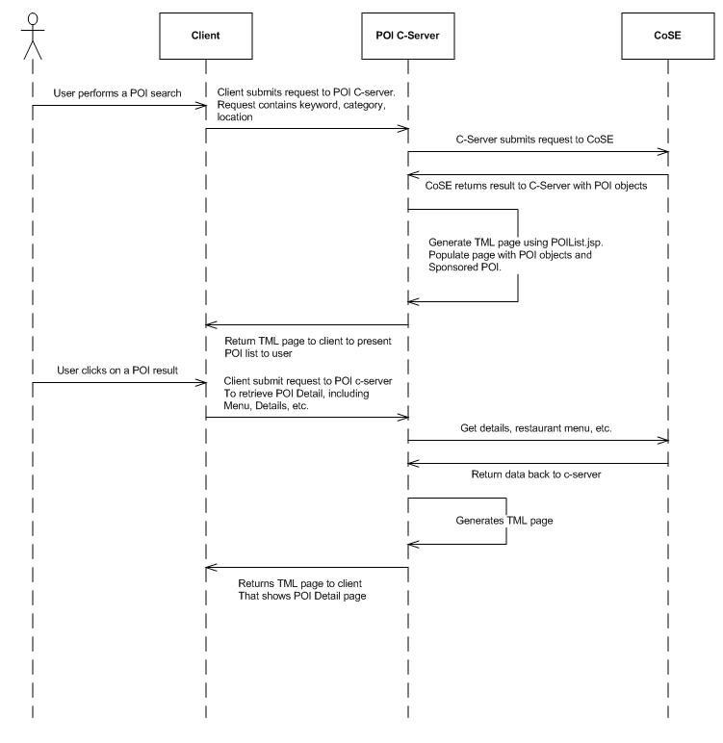

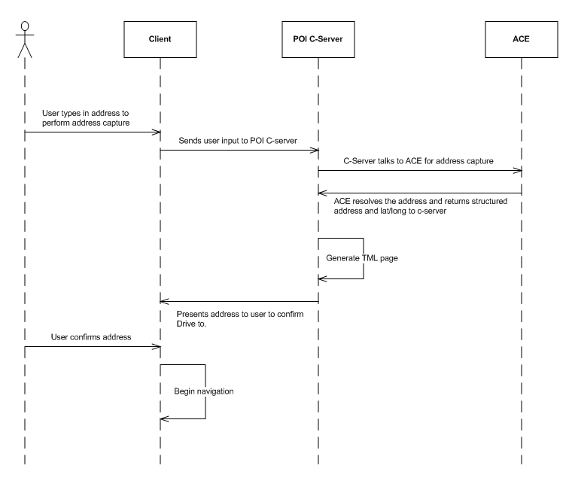

### Data Models/Database Schema (as needed)

*N/A*

# Service Level Impacts (as needed)

*N/A*