Snapshot report on the 5Ws

First quarter 2022

Myanmar Food Security Cluster

2022-06-05

## Summary of achievements

Beneficiaries of humanitarian action formed 98.78% of the 2,230,628 beneficiaries in the first quarter of 2022. The remainder were reached through development interventions.

To recall, the Food Security Cluster’s strategic objectives for 2022 are:

* SO1: IDPs have equitable access to sufficient, safe and nutritious food (either in-kind or through food assistance)
* SO2: Vulnerable persons (excl. IDPs) have equitable access to sufficient, safe and nutritious food (either in-kind or through food assistance)
* SO3: Restore, protect and improve livelihoods and resilience

summarise() has grouped output by ‘strat_obj’. You can override using the .groups argument.

2022 beneficiaries by strategic objective

| strat_obj | Humanitarian | Development | Total |
| --- | --- | --- | --- |
| so_1 | 324,919 | 0 | 324,919 |
| so_2 | 1,839,902 | 0 | 1,839,902 |
| so_3 | 38,589 | 27,218 | 65,807 |
| Total | 2,203,410 | 27,218 | 2,230,628 |

In terms of activities, the number of beneficiaries reached is heavily skewed towards food distributions. More than 95% of beneficiaries in 2022 have been reached by this activity.

summarise() has grouped output by ‘strat_obj’. You can override using the .groups argument.

Breakdown of beneficiaries by activity

| activity | ben_so_1 | ben_so_2 | ben_so_3 | Total | %_ben |
| --- | --- | --- | --- | --- | --- |
| food distribution | 290,150 | 1,839,534 | 0 | 2,129,684 | 95.47 |
| crop, vegetable and seed kits | 0 | 0 | 52,878 | 52,878 | 2.37 |
| multi-purpose cash transfer | 34,769 | 368 | 0 | 35,137 | 1.58 |
| food_cash for work_assets | 0 | 0 | 9,365 | 9,365 | 0.42 |
| IGA and small grants | 0 | 0 | 2,111 | 2,111 | 0.09 |
| vocational training | 0 | 0 | 1,253 | 1,253 | 0.06 |
| FFS and farmer training | 0 | 0 | 150 | 150 | 0.01 |
| livestock kits | 0 | 0 | 50 | 50 | 0 |

57% of beneficiaries were reached by activities where nutrition was mainstreamed. This is highly encouraging. As the year progresses, it will be important to collect more details about how exactly nutrition has been mainstreamed so that coordination with the Nutrition Cluster may be improved.

summarise() has grouped output by ‘strat_obj’. You can override using the .groups argument.

Breakdown of bneficiaries by status of nutrition mainstreaming

| was_nutrition_mainstreamed_in_activity | so_1 | so_2 | so_3 | total_beneficiaries | %_beneficiaries |
| --- | --- | --- | --- | --- | --- |
| Yes | 210,643 | 1,018,696 | 40,782 | 1,270,121 | 56.94 |
| No | 114,276 | 821,206 | 25,025 | 960,507 | 43.06 |

## 1. Geographies

### 1.1 Statewise breakdowns

As in 2021, the number of beneficiaries reached has been heavily biased towards relatively few areas, which is not appropriate for a unionwide response. A total of 73 townships have been reached across 13 states/regions.

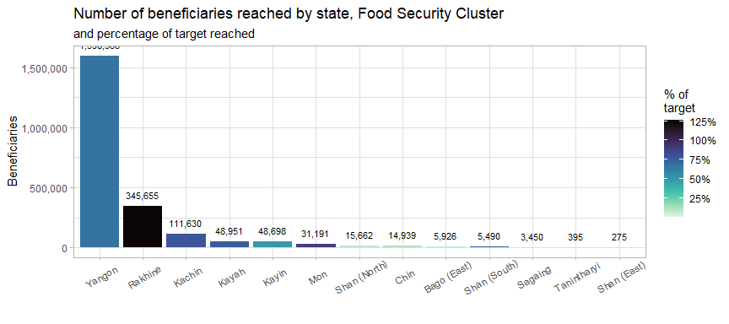

The table below outlines the number of beneficiaries reached by state/region in both 2021 and 2022. In 2021, the response was heavily skewed towards Yangon and Rakhine. The bias is even more pronounced in 2022. As will be discussed in the next section, this is a misallocation of resources as many of the areas reached in Yangon and Rakhine are already heavily oversubscribed and the reach is multiple times the target.

87.15% of beneficiaries reached in the first quarter of 2022 originated from Yangon or Rakhine.

Skew in Q1 2022 geographic reach, comparison with 2021 data

| State | Beneficiaries_2021 | %_ben_2021 | Beneficiaries_2022 | %_ben_2022 |
| --- | --- | --- | --- | --- |
| Yangon | 2,011,575 | 61.69 | 1,598,366 | 71.66 |
| Rakhine | 530,202 | 16.26 | 345,655 | 15.5 |
| Kachin | 89,818 | 2.75 | 111,630 | 5 |
| Kayah | 17,746 | 0.54 | 48,951 | 2.19 |
| Kayin | 68,108 | 2.09 | 48,698 | 2.18 |
| Mon | 48,181 | 1.48 | 31,191 | 1.4 |
| Shan (North) | 73,103 | 2.24 | 15,662 | 0.7 |
| Chin | 17,005 | 0.52 | 14,939 | 0.67 |
| Bago (East) | 12,974 | 0.4 | 5,926 | 0.27 |
| Shan (South) | 15,511 | 0.48 | 5,490 | 0.25 |
| Sagaing | 31,985 | 0.98 | 3,450 | 0.15 |
| Tanintharyi | 4,476 | 0.14 | 395 | 0.02 |
| Shan (East) | 510 | 0.02 | 275 | 0.01 |
| Ayeyarwady | 99,481 | 3.05 | NA | NA |
| Magway | 96,767 | 2.97 | NA | NA |
| Mandalay | 143,526 | 4.4 | NA | NA |

### 1.2 Township-level breakdowns

Just 8 townships (listed in the table below) contained 83.07% of all beneficiaries. In contrast, in 2021, the top 10 townships contained 76% of all beneficiaries. Hlaingthayra East and West by themselves contained 36% of all beneficiaries reached.

Top 7 townships by beneficiaries reached (desc)

| State | Township | Humanitarian | Development | Beneficiaries | %_Total |
| --- | --- | --- | --- | --- | --- |
| Yangon | Hlaingtharya (West) | 461,878 | 0 | 461,878 | 20.71 |
| Yangon | Shwepyithar | 382,031 | 0 | 382,031 | 17.13 |
| NA | 55 other townships | 350,681 | 27,034 | 377,715 | 16.93 |
| Yangon | Hlaingtharya (East) | 339,882 | 0 | 339,882 | 15.24 |
| Yangon | North Okkalapa | 269,720 | 0 | 269,720 | 12.09 |
| Yangon | Dala | 144,855 | 0 | 144,855 | 6.49 |
| Rakhine | Buthidaung | 132,642 | 0 | 132,642 | 5.95 |
| Rakhine | Sittwe | 121,721 | 184 | 121,905 | 5.47 |

### 1.3 Locations

A location refers to either an village, ward, IDP site or industrial zone.

This first plot below is a histogram of location, by number of beneficiaries. The vast majority of locations have only one activity occurring within them. This is something to be monitored over the course of the year, as it is assumed that a range of activities are required to comprehensively meet the food security and livelihoods needs of targeted communities. As it currently stands, the response is very broad, with little depth.

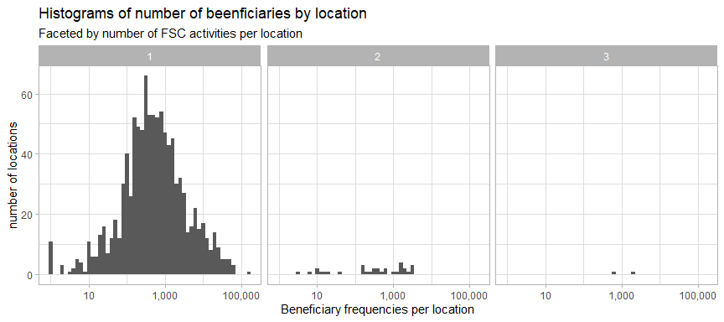

This second plot of locations is faceted by the number of partners – this helps us check for potential overlaps. There are quite a large number of locations with 2 partners in them. Locations with multiple partners were from Rakhine, Kachin and Shan (North).

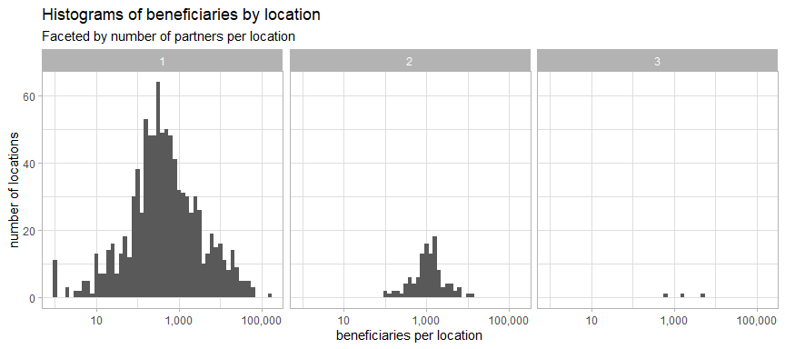

The greatest number of beneficiaries came from urban/peri-urban wards and villages. This runs counter to vulnerability patterns identified by in both the IFPRI Household Welfare Survey and the FAO-WFP Food Security Survey. Both surveys found that rural households were less food secure and less resilient than urban ones.

Breakdown of locations and beneficiaries by context

| rural_or_urban | location_type | locations | beneficiaries | %_of_ben | ben_per_location |
| --- | --- | --- | --- | --- | --- |
| Rural | Camp/IDP site | 536 | 185,798 | 8.33 | 347 |
| Rural | Industrial zone | 3 | 606 | 0.03 | 202 |
| Rural | Village | 1,030 | 354,539 | 15.9 | 344 |
| Urban/Peri-Urban | Camp/IDP site | 403 | 83,120 | 3.73 | 206 |
| Urban/Peri-Urban | Village | 32 | 496,550 | 22.27 | 15,517 |
| Urban/Peri-Urban | Ward | 111 | 1,109,393 | 49.75 | 9,995 |

## 2. Activities

### 2.1 Progress by activity

The first red line below shows the the approval of the IERP in June 2021 and the second red line shows the start of 2022.

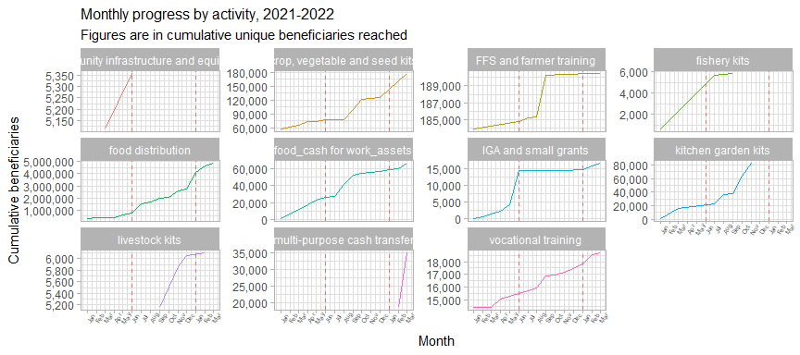

Community infrastructure and equipment, fishery kits and kitchen garden kits have not been implemented in 2022. Income-generating activities, which were largely stagnant since the approval of the IERP, started to increase again in 2022; this might be due to the seasonality of the interventions under this category.

Food distributions (in-kind and CBT/CVA) continued to be the largest activity from 2021 into 2022. Multi-purpose cash transfers was new activity that was not present in 2021.

### 2.2 Delivery modalities

The plots below, faceted by delivery modality, show the breakdown of activities by delivery modality. All activities besides food distribution correpsonded to only one type of delivery modality.

summarise() has grouped output by ‘activity_red’. You can override using the .groups argument.

Percentage of beneficiaries reached by activity and delivery modality

| Activity | In-kind | Service delivery | CBT/CVA | Hybrid | Beneficiaries |
| --- | --- | --- | --- | --- | --- |
| food distribution | 86.4% | - | 11.4% | 2.1% | 2,129,684 |
| crop, vegetable and seed kits | 100.0% | - |  |  | 52,878 |
| multi-purpose cash transfer |  | - | 100.0% |  | 35,137 |
| food_cash for work_assets |  | - | 100.0% |  | 9,365 |
| IGA and small grants |  | - | 100.0% |  | 1,849 |
| vocational training |  | 100.0% |  |  | 1,253 |
| FFS and farmer training |  | 100.0% |  |  | 150 |
| livestock kits |  | - |  | 100.0% | 50 |

There are also clear differences between the different location types and the delivery modalities employed with them. Rural vilalges were predominated by in-kind distributions whilst camps and IDP sites were mostly targeted with cash-based interventions.

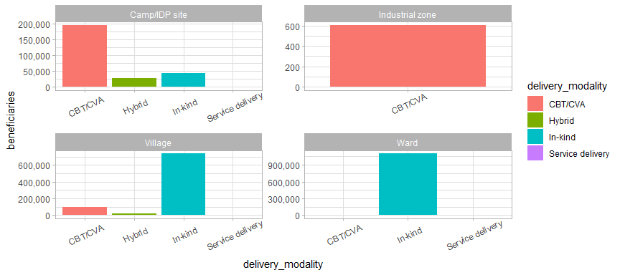

This would perhaps imply that partners believe that markets were more accessible from camps and IDP sites than rural areas; this is certainly a possibility for the longer-standing and more developed camps. Other alternative assumptions include donor preferences and logistical challenges in bringing in-kind goods to camps and IDP sites. This remains a question to be explored by the broader Food Security Cluster.

Below is a breakdown of percentage of beneficiaries reached by the different delivery modalities, by state.

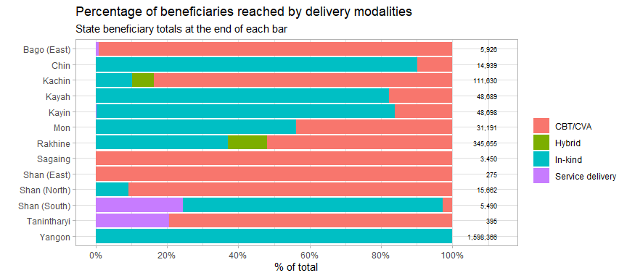

## 3. Cash-based programming

### 3.1 Cash transfer values per household

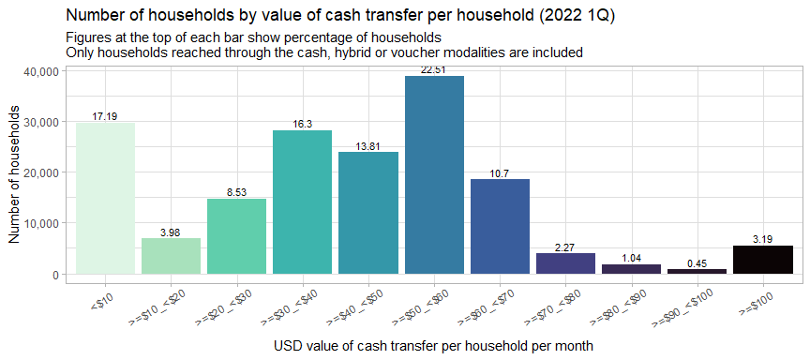

46% of households received less than USD 40/month per transfer. However, the most common transfer values were between USD 40/month and USD 70/month, with 47% of households receiving transfers in this range. This aligns well with the standard of USD 10???/person set by the Food Security Cluster.

The table below shows the average USD values per transfer per household by and total transfer values per activity in the first quarter of 2022.

Average value (USD) of household package values per activity

| activity | hhd_frequencies | total_value_usd | avg_transfer_value |
| --- | --- | --- | --- |
| livestock kits | 50 | 5,631 | 112.6 |
| IGA and small grants | 363 | 30,152 | 83.06 |
| multi-purpose cash transfer | 7,712 | 583,031 | 75.6 |
| food_cash for work_assets | 3,500 | 207,092 | 59.17 |
| food distribution | 162,193 | 6,598,313 | 40.68 |

### 3.2 Cash transfer values by implementing partner

The plots below show average cash transfer values by activity of the partners who reached the most beneficiaries.

The x-axis shows the average value per person or per household, depending on the activity and the colour indicates the number of beneficiaries reached.

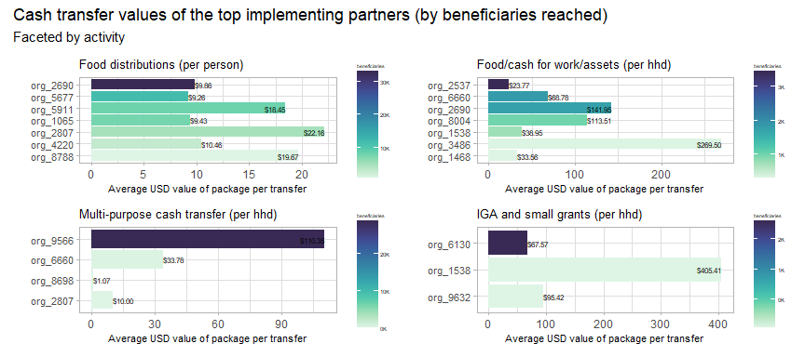

### 3.3 Cash transfer values per person

The boxplots above shows the range of cash transfer values (all values are per person, to facilitate comparability) by activity. The average for reach activity is marked by the thick line in the middle of each box. The leftmost and rightmost side of each box indicate the 25th and 75th percentile of transfer values, respectively. The length of each box is a gauge for how much variation there is in the transfer values of each activity.

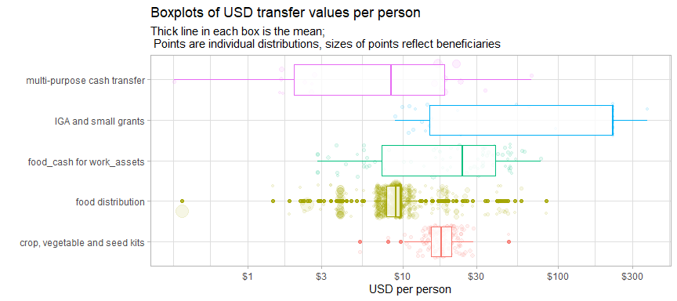

Additionally, each of the bubbles indicate an individual distribution, with their position along the x-axis showing the USD per person value of the distribution and the size of each bubble indicates the number of beneficiaries reached.

Despite being the activity which reached the most beneficiaries, food distributions have one of the tightest ranges of transfer values, though, as will be explored further in the plot below and in the next section, there are substantial outliers.

In the interactive scatterplot below, the x-axis indicates the number of beneficiaries reached and the y-axis indicates the per person value of each transfer. Each point is a distribution and the size of each point indicates the number of beneficiaries reached. More details about each distribution can be seen by hovering your cursor over each point.

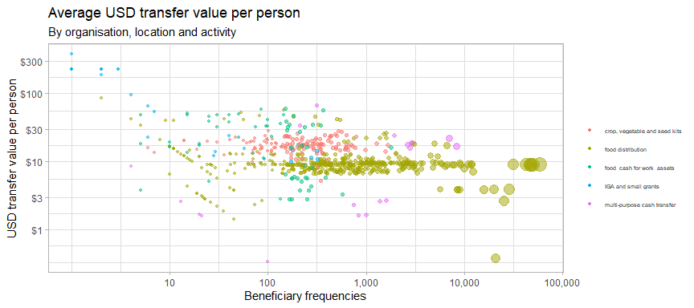

Food for work/cash for assets and multi-purpose cash transfers had the largest dispersions in the values of their transfers. For food for work/cash for assets, there is one cluster largely below USD 5/person in Sagaing and another of between USD 30 and USD 60 per person in Kachin and Shan North.

As mentioned, food distributions had the tightest range of transfer values, with the vast majority of distributions falling just below USD 10/person. However, it has outlying values that reached very large groups of beneficiaries. This will be explored in the next section.

### 3.4 A closer look at food distributions

The interactive plot below breaks down the range of USD per person cash transfer values by state. Similar to the plot above, each point is a distribution and more details about each distribution can be seen by hovering your mouse over each point.

The red line indicates 50% of the monthly expenditure basket (MEB) for food. The vast majority of transfers fall below this value.

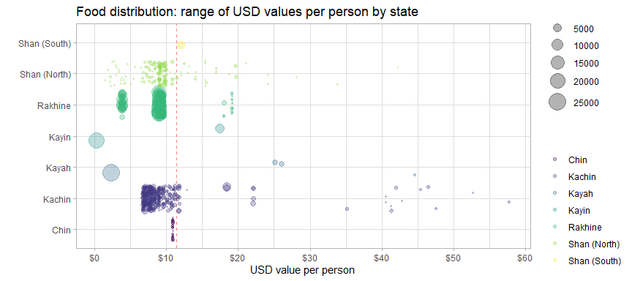

Kachin and Shan notably have several extreme outliers much higher than the average for that state. Kayin, however, has a very large number of beneficiaries who received less the USD 1/person. Distributions in Chin had veyr consistent values as they were all implemented by the same implementing partner.

The table below compares the different bins for cash transfer values of food distributions with the minimum expenditure basket for food established by the Cash Working Group. They have established a floor of MMK 190,555 (or USD 114.55).

Overall, 1.44% of food distribution beneficiaries have received at least 100% of the MEB and 10.05% have received at least 50% of the MEB.

USD values of food distributions by percentage of MEB received

| usd_person_bin | avg_pc_of_meb | avg_usd_month | beneficiaries | pc_of_hhd |
| --- | --- | --- | --- | --- |
| <$2 | 5.39 | 1.23 | 20,923 | 5.99 |
| =$2_<$4 | 15.45 | 3.54 | 57,619 | 16.49 |
| =$4_<$6 | 20.58 | 4.72 | 156 | 0.04 |
| =$6_<$8 | 32 | 7.33 | 35,494 | 10.16 |
| =$8_<$10 | 40.19 | 9.21 | 191,024 | 54.68 |
| =$10_<$12 | 47.59 | 10.9 | 13,775 | 3.94 |
| =$12_<$14 | 54.74 | 12.54 | 4,882 | 1.4 |
| =$14_<$16 | 65.04 | 14.9 | 353 | 0.1 |
| =$16_<$18 | 74.24 | 17.01 | 6,705 | 1.92 |
| =$18_<$20 | 82.73 | 18.95 | 8,692 | 2.49 |
| >=$20 | 163.8 | 37.53 | 9,757 | 2.79 |

However, a very large proportion of the beneficiaries reached were between USD 8 and 10 per person, fairly close to 50% of the MEB. The 50% threshold is of interest because humanitarian assistance does not aim to cover the full MEB and is intended to meet acute needs.

## 4. Beneficiaries

### 4.1 Beneficiary types

74.71% of beneficiaries were from the host or local community. 14.58% beneficiaries were IDPs.

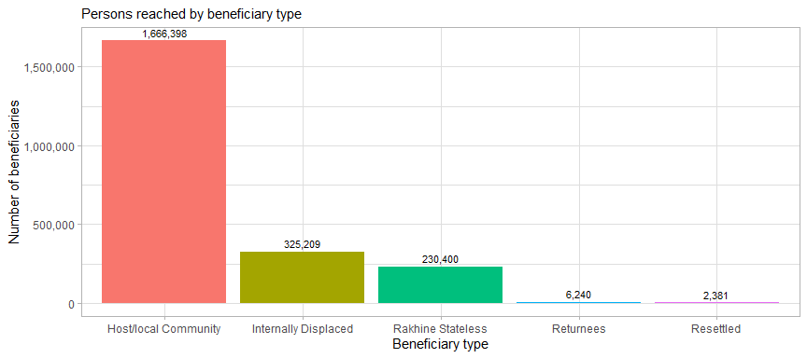

### 4.2 Evidence of food insecurity status

Very few of the beneficiaries reached had evidence of their food insecurity status. This makes it difficult to determine whether or not food security interventions are truly reaching those most in need.

Food insecurity status and evidence provided

| food_insecurity_status | beneficiaries | %_benficiaries |
| --- | --- | --- |
| Food secure | 13,759 | 0.62 |
| Moderately food insecure | 38,081 | 1.71 |
| Severely food insecure | 116,513 | 5.22 |
| No status provided | 2,062,275 | 92.45 |

Though evidence of food insecurity was not provided by for the vast majority of beneficiaries reached, the reasons that were provided were fairly reasonable justifications for targeting beneficiaries. Though more information should be sought on the monthly distribution reports that were used as evidence of food insecurity status to determine the exact tool used.

Breakdown of evidence of food insecurity status

| evidence | beneficiaries | %_beneficiaries |
| --- | --- | --- |
| Armed conflict | 97,999 | 4.39 |
| community-based beneficiary selection | 21,315 | 0.96 |
| Food consumption score | 8,034 | 0.36 |
| Food distribution certificate | 1,040 | 0.05 |
| Monthly distribution report | 16,484 | 0.74 |
| Village Profile | 754 | 0.03 |
| No evidence | 2,085,002 | 93.47 |

The general lack of evidence of evidence of beneficiaries’ food insecurity status makes it difficult to justify to affected communities and donors that the Food Security Cluster is reaching the most in need.

## 5. Partners

There are 36 partners that were involved in direct implementation that have reported achievements in first quarter of 2022. These implementing partners corresponded to a total of 15 reporting organisations. The largest reporting organisation, org_2690, had 21 implementing partners. All other reporting organisations had 1 or 2 implementing partners.

The interactive plot below shows the number of beneficiaries and townships reached by implementing partner.

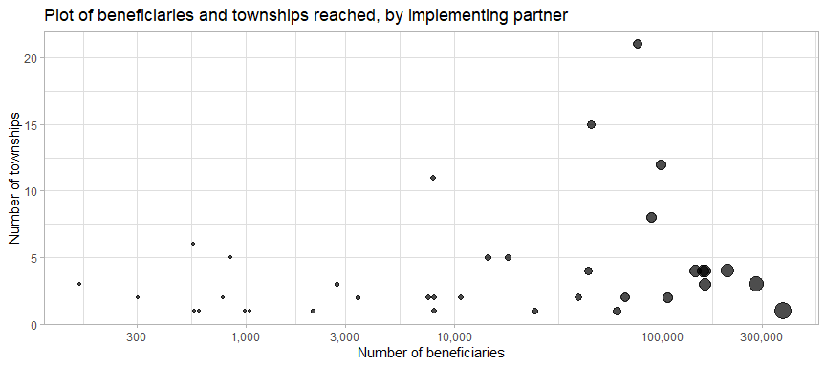

In 2021, it was noted that whilst there was much variation in the numbers of beneficiaries reached by each implementing partner, their geographic footprints were quite limited. This pattern has continued into 2022. Only 6 partners (17% of the total) have a presence in more than 5 townships. The distribution of partners remains an impediment to the implmentation of a countrywide response. And the following steps mentioned in the 2021 report are still very necessary:

* Incentivise partners to expand their footprints
* Identify new partners to reach vulnerable persons in areas recently affected by conflict
* Encourage donors to support expansion of Food Security activities in areas recently affected by conflict (with sufficient support costs)

### 5.1 Monthly progress by partner

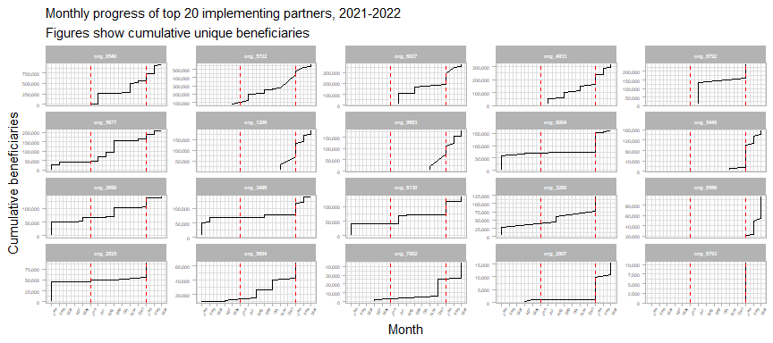

Overall, 13 implementing partners increased the number of beneficiaries reached over their 2021 totals by more than 50%; 29 partners who reported in 2021 also reported in 2022. 7 new implementing partners reported in 2022. And 28 partners who reported in 2021 but have not yet any achievements in 2022.

summarise() has grouped output by ‘org_code’. You can override using the .groups argument.

Top implementing partners by beneficiaries reached in 2022

| org_code | ben_2021 | rank_2021 | ben_2022 | rank_2022 | total_ben |
| --- | --- | --- | --- | --- | --- |
| org_8540 | 565,398 | 1 | 380,478 | 1 | 945,876 |
| org_5722 | 270,216 | 2 | 283,348 | 2 | 553,564 |
| org_6827 | 165,538 | 5 | 206,710 | 3 | 372,248 |
| org_4933 | 151,389 | 6 | 160,480 | 4 | 311,869 |
| org_9693 | 12,094 | 24 | 160,449 | 5 | 172,543 |
| org_1206 | 33,442 | 20 | 156,433 | 6 | 189,875 |
| org_5440 | 11,567 | 25 | 143,505 | 7 | 155,072 |
| org_6792 | 132,464 | 7 | 105,410 | 8 | 237,874 |
| org_9566 | NA | NA | 95,999 | 9 | 95,999 |
| org_8004 | 73,116 | 10 | 86,740 | 10 | 159,856 |
| org_3486 | 77,301 | 9 | 61,257 | 11 | 138,558 |
| org_3280 | 60,057 | 12 | 60,599 | 12 | 120,656 |
| org_6130 | 71,467 | 11 | 59,547 | 13 | 131,014 |
| org_5677 | 165,794 | 4 | 40,377 | 14 | 206,171 |
| org_2825 | 49,692 | 15 | 39,572 | 15 | 89,264 |
| org_2690 | 103,611 | 8 | 38,411 | 16 | 142,022 |
| org_5604 | 40,279 | 17 | 24,298 | 17 | 64,577 |
| org_7002 | 25,954 | 21 | 18,021 | 18 | 43,975 |
| org_2807 | 1,001 | 48 | 14,463 | 19 | 15,464 |
| org_6793 | NA | NA | 10,494 | 20 | 10,494 |

### 5.2 Donors

As shown by the table below, the majority of beneficiaries reported in the first quarter of 2022 were reported without any corresponding donor, as in 2021. The data in this column continues of limited utility in anaylsis.

Top donors by beneficiaries reached

| donor | beneficiaries | %_beneficiaries |
| --- | --- | --- |
| No donor specified | 2,022,049 | 90.65 |
| FCDO | 76,391 | 3.42 |
| CERF | 33,157 | 1.49 |
| WVI | 20,843 | 0.93 |
| Organizational own funds | 19,721 | 0.88 |
| BPRM | 16,362 | 0.73 |
| USAID | 14,386 | 0.64 |
| FCDO+BPRM | 7,059 | 0.32 |
| NZMFAT | 4,854 | 0.22 |
| LIFT | 2,986 | 0.13 |
| Other donors | 2,945 | 0.13 |
| MoFA Luxemburg | 2,730 | 0.12 |
| UN Women | 2,238 | 0.1 |
| Norad | 2,070 | 0.09 |
| ECHO | 1,797 | 0.08 |
| SIDA | 1,040 | 0.05 |

## 6. Comparison with targets

### 6.2 Township-level reach scatterplot

The specifics of each township can be reviewed with the interactive plot below. Each point is a township, with the size indicating the number of beneficiaries. The x-axis indicates the target population by township and the y-axis shows the number of beneficiaries reached in 2022.

The red line down the middle represents reaching 100% of the target. Townships above this line have reached more beneficiaries than their target and townships below the line have not met their target yet. The further away a township is from the red line, the further above or below its target it is. Mouse over each of the townships to see more details.

The 12 townships along the extreme left side of the plot have beneficiaries but do not have targets (their targets have just been coded as $1$ so that they show up on the plot). 230 townships with targets have not been reached.

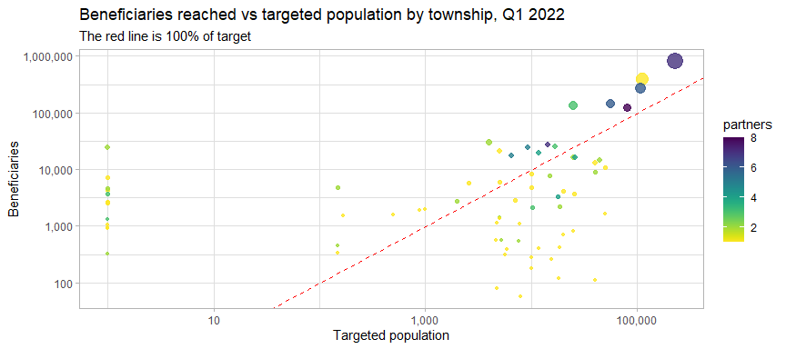

### 6.2 Map of beneficiaries reached vs 2022 target

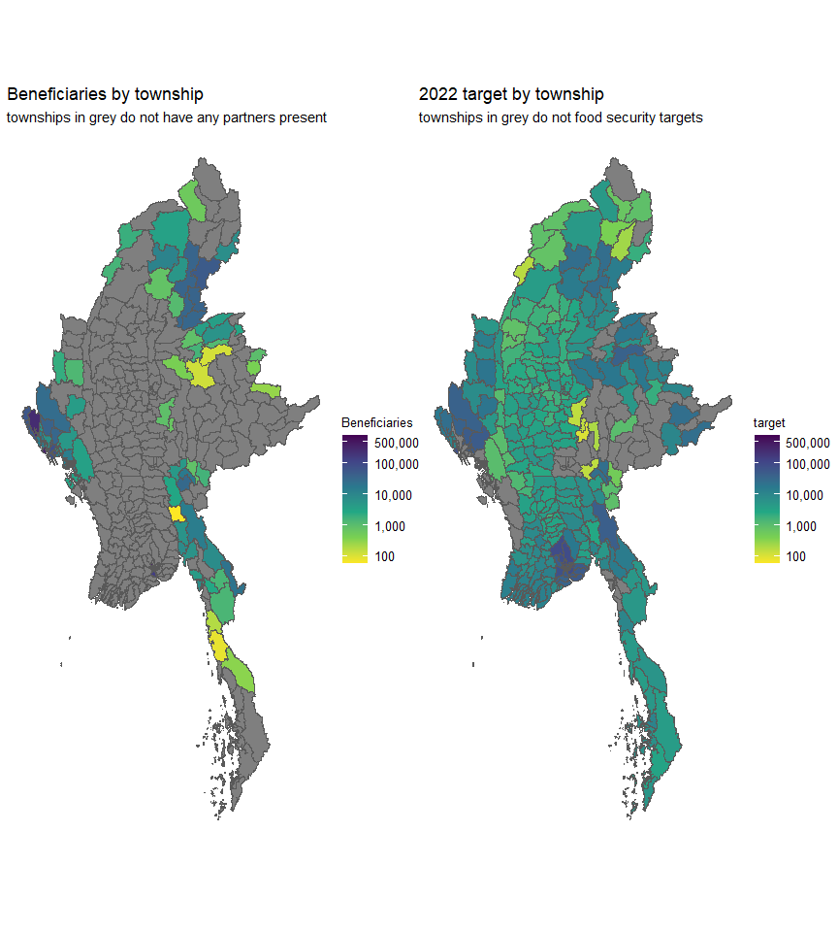

With the important exceptions of Yangon and the Southeast, beneficiaries are concentrated in the peripheral and border regions of the union, where humanitarian actors have traditionally been present. As mentioned in previous reports, this is not consistent with the current patterns of needs and vulnerability.

There was an overallocation of resources in these relatively few areas in 2021 and this has continued in 2022. Below is a list of townships that have already exceeded their targets, though it should be mentioned that some of the townships with very small targets should be re-examined.

23 townships where the target has already been exceeded

| state | township | beneficiaries | target | gap (desc.) | %_reached |
| --- | --- | --- | --- | --- | --- |
| Yangon | Hlaingtharya | 801,760 | 227,976 | -573,784 | 252.7 |
| Yangon | Shwepyithar | 382,031 | 111,938 | -270,093 | 242.3 |
| Yangon | North Okkalapa | 269,720 | 108,603 | -161,117 | 149.3 |
| Rakhine | Buthidaung | 132,642 | 25,001 | -107,641 | 431.6 |
| Yangon | Dala | 144,855 | 56,325 | -88,530 | 158.2 |
| Rakhine | Sittwe | 121,905 | 79,999 | -41,906 | 53.38 |
| Kayah | Hpruso | 30,215 | 4,000 | -26,215 | 656.4 |
| Kayin | Myawaddy | 20,843 | 5,000 | -15,843 | 317.9 |
| Kachin | Momauk | 24,272 | 9,311 | -14,961 | 161.7 |
| Kachin | Waingmaw | 27,446 | 14,284 | -13,162 | 93.14 |
| Kachin | Mansi | 17,484 | 6,567 | -10,917 | 167.2 |
| Rakhine | Maungdaw | 24,983 | 16,889 | -8,094 | 48.92 |
| Kachin | Bhamo | 19,662 | 11,876 | -7,786 | 66.56 |
| Shan (South) | Pekon | 4,710 | 150 | -4,560 | 3,041 |
| Bago (East) | Shwegyin | 5,869 | 2,561 | -3,308 | 130.2 |
| Sagaing | Lay Shi | 1,525 | 168 | -1,357 | 811 |
| Kayah | Shadaw | 1,606 | 500 | -1,106 | 222.2 |
| Sagaing | Lahe | 1,925 | 873 | -1,052 | 121.5 |
| Mon | Bilin | 6,031 | 5,000 | -1,031 | 21.62 |
| Rakhine | Ann | 2,004 | 1,000 | -1,004 | 101.4 |
| Kachin | Chipwi | 2,708 | 1,992 | -716 | 36.95 |
| Shan (South) | Ywangan | 444 | 150 | -294 | 197 |
| Shan (South) | Pindaya | 336 | 150 | -186 | 125 |