Report on 5Ws

July 2022

Myanmar Food Security Cluster

2022-09-01

Table of Contents

[Food Security Cluster Myanmar homepage](https://food-security-cluster-myanmar.github.io/)

## Summary of new achievements

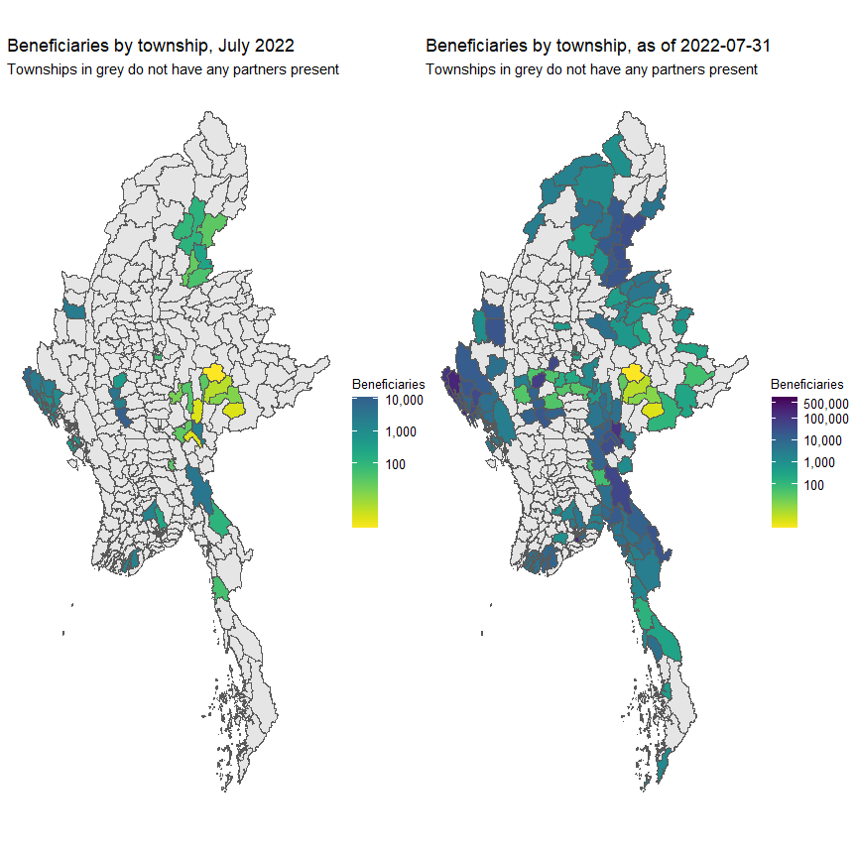

Beneficiaries of humanitarian action in July 2022 formed 0.78% of the 3,267,194 beneficiaries in the first quarter of 2022. The remainder were reached through development interventions.

In this report, when beneficiaries are mentioned, the Food Security Cluster is referring to unique beneficiaries or individuals. This is different from a beneficiary frequency which is an instance of a person receiving aid i.e. a person who receives food distributions, a crop, vegetable and seed kit and farmer training would be counted as three beneficiary frequencies, but as only one beneficiary.

As monthly reporting has just started, the volume of reporting is still lower than the pro-rated quarterly submissions. This means that several partners will hold off on reporting their achievements until the end of the quarter.

**Table** : Beneficiaries reached per month

| **date** | **beneficiaries** | **new_beneficiaries** | **%_increase** |
| --- | --- | --- | --- |
| Jan 2022 | 1,315,218 | 1,315,218 |  |
| Feb 2022 | 1,810,622 | 495,404 | 37.67 |
| Mar 2022 | 2,134,763 | 324,141 | 17.90 |
| Apr 2022 | 2,340,458 | 205,695 | 9.64 |
| May 2022 | 2,763,136 | 422,678 | 18.06 |
| Jun 2022 | 3,217,244 | 454,108 | 16.43 |
| Jul 2022 | 3,267,194 | 49,950 | 1.55 |

In terms of activities, farmer training and food distributions formed the bulk of the activities implemented in July. However, as mentioned earlier, these figure will be revised when new data comes in.

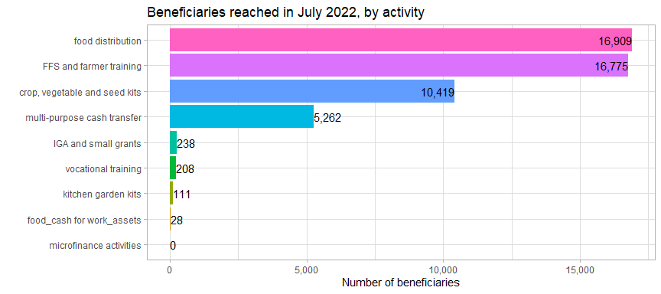

Overall, however, food distribution remains far and away the largest activity.

**Table** : Beneficiaries by acitivity, as of 31 July 2022

| **activity** | **jan_to_jun** | **july** | **%_of_july** | **total** | **%_of_total** |
| --- | --- | --- | --- | --- | --- |
| food distribution | 2,665,934 | 16,909 | 33.85 | 2,682,843 | 82.11 |
| FFS and farmer training | 230,378 | 16,775 | 33.58 | 247,153 | 7.56 |
| crop, vegetable and seed kits | 158,542 | 10,419 | 20.86 | 168,961 | 5.17 |
| multi-purpose cash transfer | 111,489 | 5,262 | 10.53 | 116,751 | 3.57 |
| food_cash for work_assets | 36,199 | 28 | 0.06 | 36,227 | 1.11 |
| IGA and small grants | 5,870 | 238 | 0.48 | 6,108 | 0.19 |
| community infrastructure and equipment | 4,761 | 0 | 0.00 | 4,761 | 0.15 |
| HEB and fortfied rice | 1,876 | 0 | 0.00 | 1,876 | 0.06 |
| vocational training | 1,627 | 208 | 0.42 | 1,835 | 0.06 |
| kitchen garden kits | 475 | 111 | 0.22 | 586 | 0.02 |
| livestock kits | 93 | 0 | 0.00 | 93 | 0.00 |
| Total | 3,217,244 | 49,950 | 100.00 | 3,267,194 | 100.00 |

Food security interventions in July 2022 overwhelmingly targeted persons in host and local communities, this group forms 87.21% of all food distribution support, or 43,562 beneficiary frequencies (this includes if a person had been reached previously and are currently receiving their second or third round of assistance).

## 1. Geographies

### 1.1 States

A total of 3,267,194 beneficiaries were reached in July 2022.

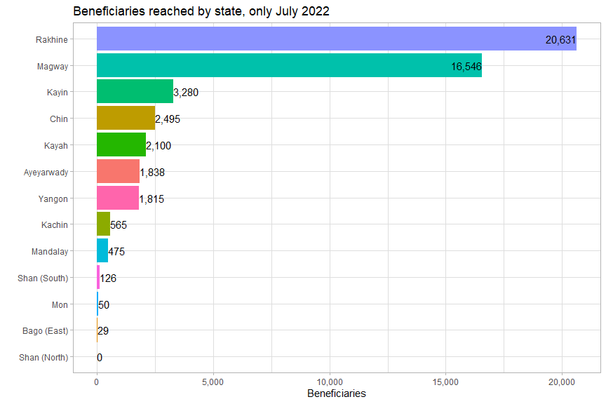

Overall, these are year-to-date state-level breakdowns of beneficiaries reached:

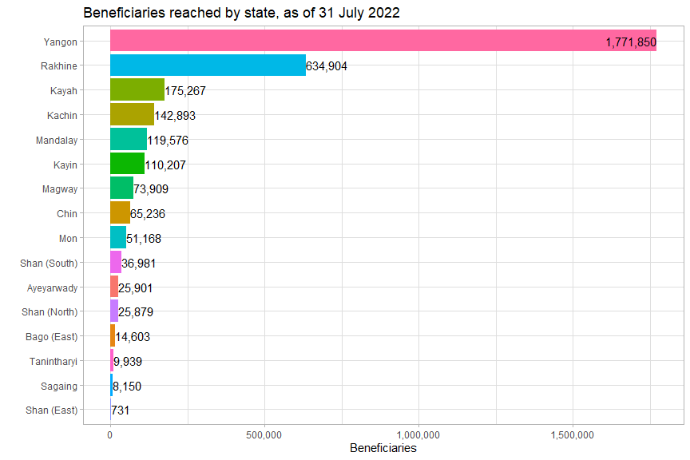

July saw much fewer persons reached in Yangon than in previous months. It is hoped that the reallocation of resources out of the affluent urban core has been accelerated. It is also encouraging to see Magway receive the second-most support, after Rakhine.

### 1.2 Townships

A total of 132 townships have been reached across 16 states/regions as of 31st July 2022.

The top 7 townships – Hlaingtharya East and West, Shwepyithar, North Okkalapa, Buthidaung, Dala and Sittwe – by total number of beneficiaries reached are all from Yangon or Rakhine and contained 65% of all beneficiaries. There is, overall, still quite a significant skew in where the food security cluster is reaching its beneficiaries.

**Table** : Top townships by beneficiaries reached, as of July 2022

| **state** | **township** | **jan_to_jun** | **july1** | **%_of_july** | **total** | **%_of_total** |
| --- | --- | --- | --- | --- | --- | --- |
| Magway | Magway | 10,335 | 11,182 | 22.39 | 21,517 | 0.66 |
| Rakhine | Maungdaw | 108,160 | 7,247 | 14.51 | 115,407 | 3.53 |
| Magway | Chauk | 8,110 | 3,479 | 6.96 | 11,589 | 0.35 |
| Rakhine | Sittwe | 152,770 | 3,269 | 6.54 | 156,039 | 4.78 |
| Kayin | Hpapun | 44,904 | 3,169 | 6.34 | 48,073 | 1.47 |
| Rakhine | Buthidaung | 201,354 | 2,513 | 5.03 | 203,867 | 6.24 |
| Chin | Falam | 13,670 | 2,495 | 4.99 | 16,165 | 0.49 |
| Rakhine | Kyauktaw | 20,198 | 2,129 | 4.26 | 22,327 | 0.68 |
| Kayah | Loikaw | 110,091 | 2,098 | 4.20 | 112,189 | 3.43 |
| Magway | Yenangyaung | 11,168 | 1,885 | 3.77 | 13,053 | 0.40 |
| Ayeyarwady | Bogale | 9,061 | 1,838 | 3.68 | 10,899 | 0.33 |
| Rakhine | Pauktaw | 31,680 | 1,582 | 3.17 | 33,262 | 1.02 |
| 1These top 12 townships are where 86% of beneficiaries were reached in July | | | | | | |

When comparing the current footprint to that of the first quarter, the most significant new activity was observed in Mandalay, Magway, Kayah and Kayin.

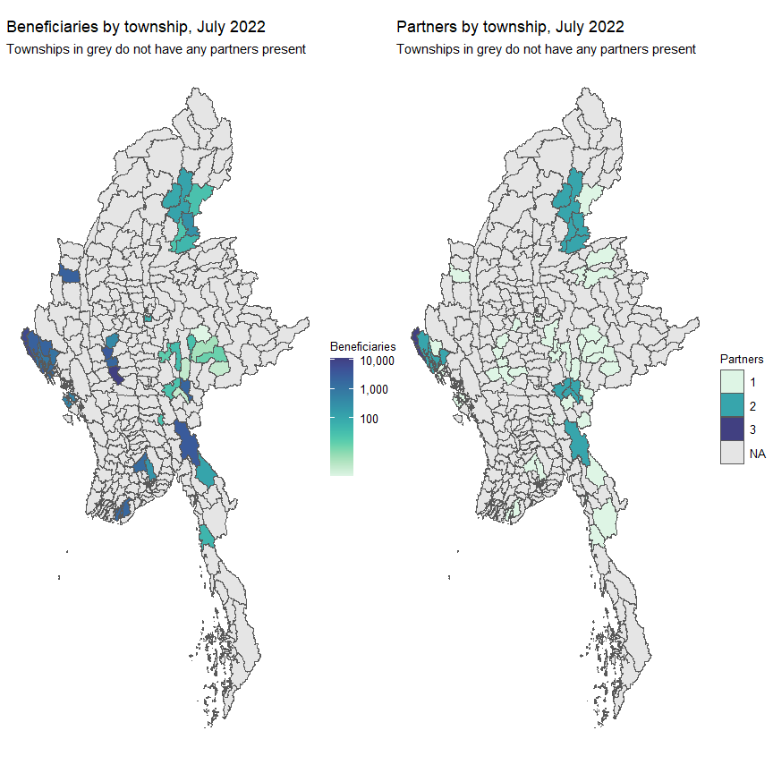

5 new townships were reached in July 2022. They all in Shan South are are Laikha, Loilen, Mongnai, Mongpan and Nansang. All very traditionally remote and underserved areas.

Of the 2,544` sites reached, 421 had more than one partner present.

**Table** : Number of partners by location, as of 31 July 2022

| **partners** | **location** |
| --- | --- |
| 1_partner | 1,986 |
| 2_partners | 384 |
| 3_partners | 34 |
| 4_partners | 3 |

The food security cluster’s partners can mostly be found in Yangon, Rakhine and Kachin.

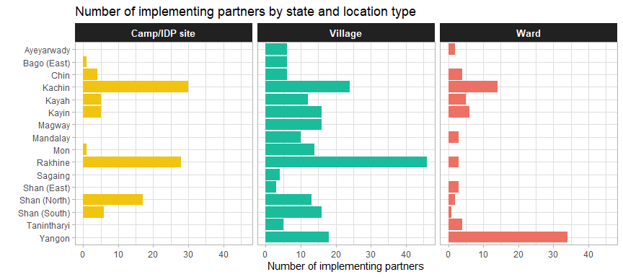

## 2. Activities

### 2.1 Progress by activity

The dotted red line shows the end of Q2 2022. The thick line in grey shows the progress in 2021 for the same activity. It should be noted that the 2021 progress lines are just a reference and not meant to be a direct comparison. The scope of the HRP was much different at the start of 2021 and the response only became nationwide in June; the FSC was also much smaller than it is now in 2022. Indeed, with the post-coup crisis affecting both humanitarian and development programming, the need for stronger coordination to adapt food food security programming has pushed many partners to enter the FSC. This type of comparison will be more useful next year.

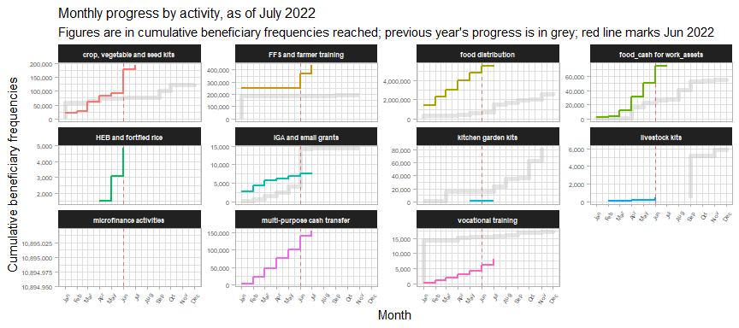

In July 2022, progress primarily came from multi-purpose cash transfers, farmer training, food distributions and vocational training.

### 2.2 Agricultural and livelihoods activities

422,315 persons were reached through a combination of crop, vegetable and seed kits, FFS and farmer training, IGA and small grants and livestock kits.

**Table** : Beneficiaries reached by agricultural and livelihood activities

| **activity** | **jan_to_jun** | **july** | **total1** | **%_total** |
| --- | --- | --- | --- | --- |
| FFS and farmer training | 230,378 | 16,775 | 247,153 | 58.52 |
| crop, vegetable and seed kits | 158,542 | 10,419 | 168,961 | 40.01 |
| IGA and small grants | 5,870 | 238 | 6,108 | 1.45 |
| livestock kits | 93 | 0 | 93 | 0.02 |
| Total | 394,883 | 27,432 | 422,315 | 100.00 |
| 1as of 31 July 2022 | | | | |

### 2.3 Delivery modalities

Only HEB and fortified rice, community infrastructure and equipment and kitchen garden kits were delivered entirely through in-kind modalities.

**Table** : Percentage of benficiaries reached by activity and delivery modality

| **Activity** | **In-kind** | **CBT/CVA** | **Hybrid** | **Service delivery** | **Beneficiaries1** |
| --- | --- | --- | --- | --- | --- |
| Food distribution | 86.5% | 11.9% | 1.6% | 0.0% | 2,682,843 |
| FFS and farmer training | 11.5% | 16.2% |  | 72.3% | 247,153 |
| Crop, vegetable and seed kits | 87.5% | 0.3% | 12.0% | 0.2% | 168,961 |
| Multi-purpose cash transfer | 0.0% | 90.2% | 9.8% |  | 116,751 |
| Food_cash for work_assets | 16.1% | 83.9% |  |  | 36,227 |
| IGA and small grants | 4.3% | 94.4% | 0.5% | 0.9% | 6,108 |
| Community infrastructure and equipment | 100.0% |  |  |  | 4,761 |
| Heb and fortfied rice | 100.0% |  |  |  | 1,876 |
| Vocational training | 0.0% | 20.5% |  | 79.5% | 1,835 |
| Kitchen garden kits | 100.0% |  |  |  | 586 |
| Livestock kits | 97.8% | 0.0% | 0.0% | 2.2% | 93 |
| 1as of 31 July 2022 | | | | | |

There are also clear differences between the different beneficiary types and the delivery modalities employed with them. Beneficiaries from host/local communities largely received in-kind distributions whilst those from camps and IDP sites mostly received cash-based interventions, indicating that partners mostly worked in the same areas in Q1 and Q2.

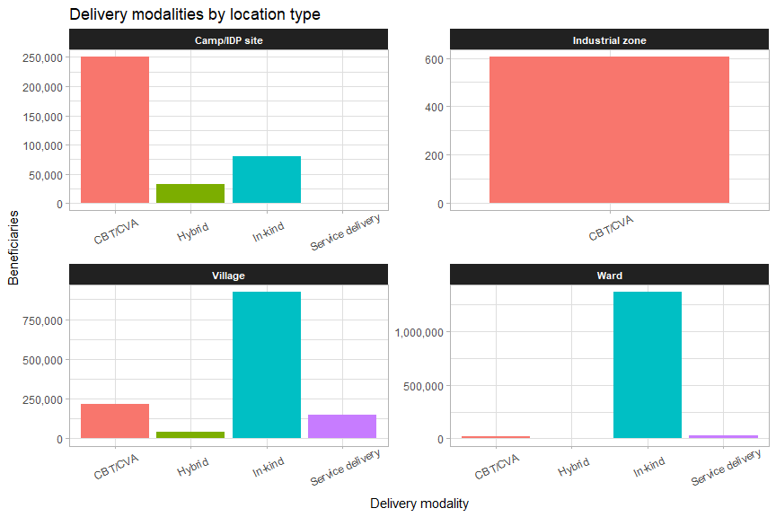

Areas with the highest number of IDPs, such as Sagaing, Rakhine and Kachin, reach most of their beneficiaries through cash-based programming.

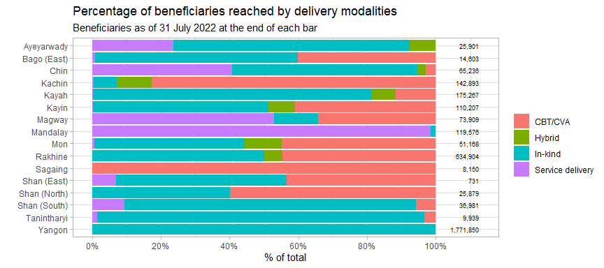

## 3. Cash-based programming

### 3.1 MMK per household

Compared to Q1, beneficiaries in Q2 are much less likely to have received cash transfers of less than USD 10 per household. The most common transfer values were between USD 60 and 70, an increase from the previous quarter.

In July 2022, the most common transfers values were between MMK 100,000 and MMK 200,000,

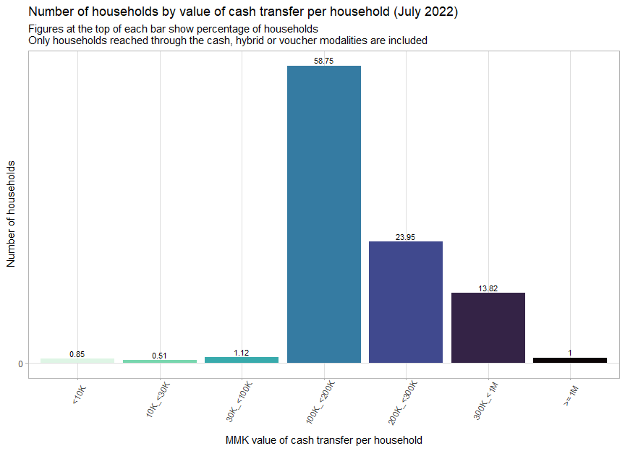

About 40% of beneficiaries of multi-purpose cash transfers in July 2022 were of quite high value.

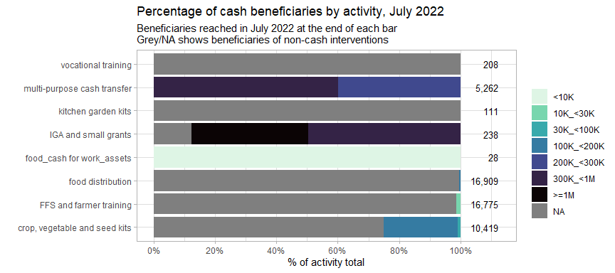

### 3.2 MMK per person

The boxplots below shows the range of cash transfer values (all values are per person, to facilitate comparability) by activity. The average for reach activity is marked by the thick line in the middle of each box. The leftmost and rightmost side of each box indicate the 25th and 75th percentile of transfer values, respectively. The length of each box is a gauge for how much variation there is in the transfer values of each activity.

These plots use data for the entire year, instead of just July.

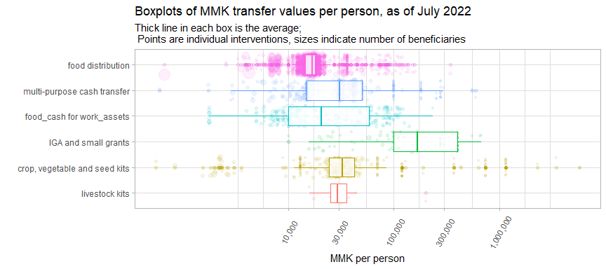

Each of the bubbles represents an individual intervention, with their position along the x-axis showing the USD per person value of the intervention and the size of each bubble indicating the number of beneficiaries reached.

Food distributions tended to have the tightest range of values, which proves that food assistance is quite standardised amongst partners.

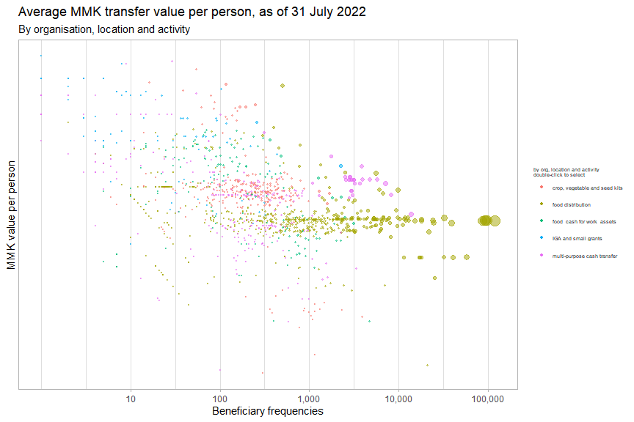

### 3.3 Food distributions

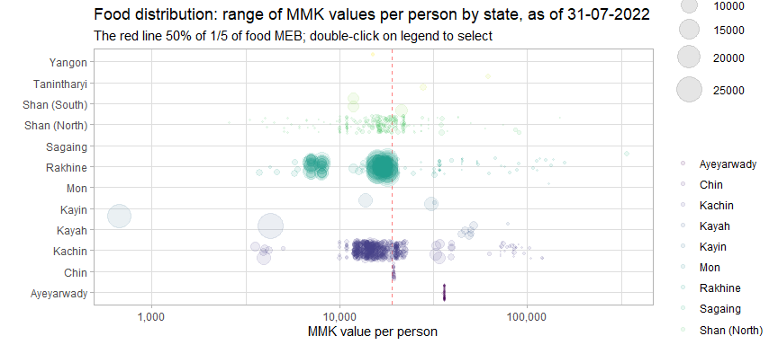

Beneficiaries in Rakhine are split into two groups, one at around MMK 7,000 and another at MMK 17,000. Kayin has a very large number of persons who received less than MMK 1,000 each.

Distributions in Chin and Ayeyarwady had very consistent values as they were all implemented by the same implementing partner.

The table below compares the different bins for cash transfer values of food distributions with the minimum expenditure basket for food established by the Cash Working Group. They have established a floor of MMK 190,555 (or USD 114.55) for the food security component per household per month.

Overall, 1.86% of food distribution beneficiaries have received at least 100% of the food security MEB and 8.99% have received at least 50% of the food security MEB (MMK 19,056 or USD 11.45 per person).

**Table** : MMK values of food disributions by percentage of MEB received

| **mmk_person_bin** | **avg_pc_of_meb** | **avg_mmk_month** | **beneficiaries1** | **pc_of_hhd** |
| --- | --- | --- | --- | --- |
| <10K | 17.11 | 6,519 | 100,964 | 22.85 |
| 10K_<30K | 43.03 | 16,398 | 313,022 | 70.84 |
| 30K_<60K | 98.54 | 37,553 | 24,495 | 5.54 |
| 60K_<100K | 207.72 | 79,164 | 2,242 | 0.51 |
| 100K_<200K | 324.66 | 123,731 | 663 | 0.15 |
| 300K_<1M | 894.43 | 340,876 | 500 | 0.11 |
| 1Only persons reached through CBT/CVA modalities are included | | | | |

### 3.4 Implementing partners

The plots below show the the average cash transfer values by activity for the top 7 partners implementing that activity. The x-axis shows the number of beneficiaries reached and the depth of the colour indicates the value of the cash transfer.

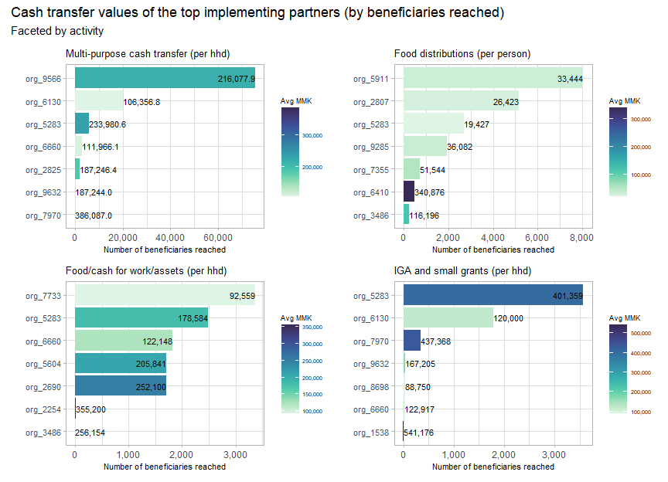

## 4. Partners

A total of 75 partners have reported into the Food Security Cluster as of July 2022 – there are 66 implementing partners and 28 reporting partners. This first instance of monthly reporting has seen a significant dip in submissions, but response has overall been better than expected.

All this means is that several partners are waiting until the end of the quarter to report in.

This section will mostly only look at year-to-date achievements.

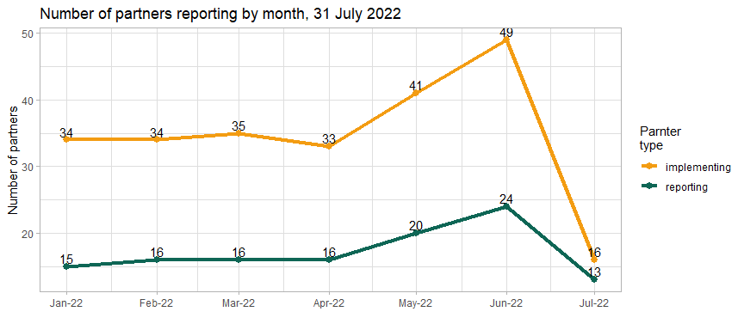

### 4.1 Implementing partners

There are 16 partners that were involved in direct implementation that have reported achievements in July 2022, in comparison with 66 in the first quarter. These implementing partners corresponded to a total of 28 reporting organisations. The largest reporting organisation, 2690, had 24 implementing partners.

The interactive plot below shows the number of beneficiaries and townships reached by implementing partner.

14 partners (21% of the total) have a presence in more than 5 townships. 11 partners (16% of the total) are present in more than 10 townships.

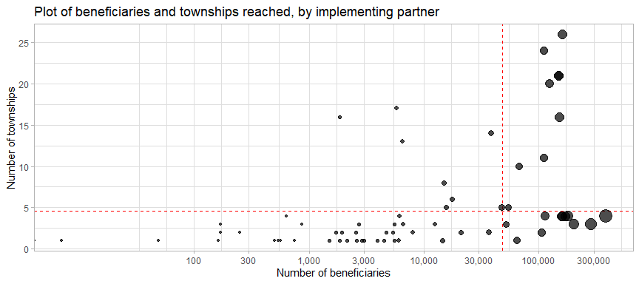

### 4.2 Monthly progress by partner

The thick grey line shows an organisation’s progress from last year, which, as mentioned, cannot exactly be used for a straight comparison as the scope of the HRP in 2021 was different until the approval of the IERP, additionally, many partners only joined the cluster late in 2021 or even in 2022. Still, it serves as a reference.



The table below lists the top 15 partners by number of beneficiaries reached in 2022.

**Table** : Top implementing partners by beneficiaries reached, as of 31-07-2022

| **implementing_partner** | **beneficiaries** | **states** | **townships** |
| --- | --- | --- | --- |
| org_8540 | 384,980 | 2 | 4 |
| org_5722 | 285,255 | 1 | 3 |
| org_9693 | 200,966 | 1 | 3 |
| org_4933 | 181,102 | 1 | 4 |
| org_5440 | 169,086 | 1 | 4 |
| org_6827 | 159,724 | 1 | 4 |
| org_1206 | 156,433 | 1 | 4 |
| org_9566 | 150,307 | 6 | 16 |
| org_3315 | 149,258 | 5 | 21 |
| org_2690 | 148,895 | 6 | 21 |
| org_5677 | 122,788 | 9 | 20 |
| org_5283 | 122,358 | 9 | 26 |
| org_6197 | 113,704 | 1 | 3 |
| org_8004 | 110,408 | 3 | 11 |
| org_6792 | 105,410 | 1 | 2 |

### 4.3 Donors

The table below summarises the reach and scope (in terms of geographic extent and number of organisations supported) of donors who support at least two reporting organisations.

**Table** : Organisations supported and geographic reach by donor

| **donor1** | **report_orgs** | **implementing_orgs** | **states** | **townships** |
| --- | --- | --- | --- | --- |
| LIFT | 7 | 11 | 6 | 15 |
| FCDO | 6 | 8 | 6 | 21 |
| Organizational own funds | 6 | 7 | 14 | 49 |
| MHF | 5 | 6 | 4 | 7 |
| ECHO | 3 | 4 | 3 | 5 |
| GIZ | 3 | 3 | 3 | 8 |
| BHA | 2 | 5 | 4 | 11 |
| CIAA | 2 | 2 | 2 | 5 |
| UN Women | 2 | 3 | 2 | 7 |
| 1Only showing donors supporting more than one reporting partner | | | | |

Sagaing, Shan (East), Tanintharyi and Magway have the fewest number of donors present.

**Table** : Number of donors by state

| **state** | **donors** | **implementing_partners** |
| --- | --- | --- |
| Kayin | 15 | 14 |
| Kayah | 14 | 7 |
| Kachin | 13 | 15 |
| Rakhine | 10 | 19 |
| Shan (South) | 9 | 9 |
| Mon | 8 | 7 |
| Chin | 6 | 7 |
| Shan (North) | 6 | 9 |
| Mandalay | 5 | 4 |
| Bago (East) | 4 | 3 |
| Yangon | 4 | 15 |
| Ayeyarwady | 3 | 6 |
| Magway | 3 | 3 |
| Shan (East) | 3 | 3 |
| Tanintharyi | 3 | 3 |
| Sagaing | 2 | 3 |

However, as shown by the table below, even though the majority of partners reported their donors, the omission of data from three key partners has resulted in the vast majority of reported beneficiaries not being associated with any donor.

**Table** : Top donors by beneficiaries reached

| **donor1** | **beneficiaries** | **%_beneficiaries** |
| --- | --- | --- |
| No donor specified | 2,397,314 | 73.38 |
| Organizational own funds | 249,180 | 7.63 |
| UNDP | 117,634 | 3.60 |
| FCDO | 97,942 | 3.00 |
| CERF | 73,458 | 2.25 |
| AICS | 70,984 | 2.17 |
| LIFT | 43,968 | 1.35 |
| BPRM | 31,640 | 0.97 |
| WVI | 20,843 | 0.64 |
| UN Women | 20,124 | 0.62 |
| DFAT | 17,329 | 0.53 |
| BHA | 16,356 | 0.50 |
| HELVETAS | 13,851 | 0.42 |
| AAP | 12,392 | 0.38 |
| MHF | 12,331 | 0.38 |
| 1Donors starting with 'org_xxxx' are partners using their own organisational funds | | |

## 5. Beneficiaries

87.21% of all beneficiaries in July 2022 were from host or local communities.

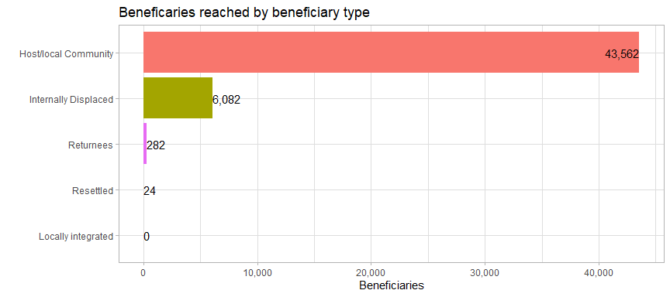

### 5.1 Beneficiary types

In July 2022, 87.21% of beneficiaries were from host or local communities, in comparison to 75.12% for the whole year. 12.18% of beneficiaries in July 2022 were IDPs, compared to 18.51% for the whole year.

**Table** : Persons reached by beneficiary type, as of 31 July 2022

| **beneficiary_type** | **jan_to_jun** | **july** | **%_of_july** | **total** | **%_of_total** |
| --- | --- | --- | --- | --- | --- |
| Host/local Community | 2,410,702 | 43,562 | 87.21 | 2,454,264 | 75.12 |
| Internally Displaced | 598,577 | 6,082 | 12.18 | 604,659 | 18.51 |
| Rakhine Stateless | 194,263 | 0 | 0.00 | 194,263 | 5.95 |
| Returnees | 8,507 | 282 | 0.56 | 8,789 | 0.27 |
| Resettled | 5,034 | 24 | 0.05 | 5,058 | 0.15 |
| Locally integrated | 161 | 0 | 0.00 | 161 | 0.00 |
| Total | 3,217,244 | 49,950 | 100.00 | 3,267,194 | 100.00 |

## 6. Comparison with targets

### 6.1 Reached vs target by township

The specifics of each township can be reviewed with the interactive plot below. Each point is a township, with the size indicating the number of beneficiaries. The x-axis indicates the target population by township and the y-axis shows the number of beneficiaries reached, as of 31 July 2022.

The red line down the middle represents reaching 100% of the target. Townships above this line have reached more beneficiaries than their target and townships below the line have not met their target yet. The further away a township is from the red line, the further above or below its target it is. Mouse over each of the townships to see more details.

The 13 townships along the extreme left side of the plot have beneficiaries but do not have targets (their targets have just been coded as 1 so that they show up on the plot). 198 townships with targets have not been reached.

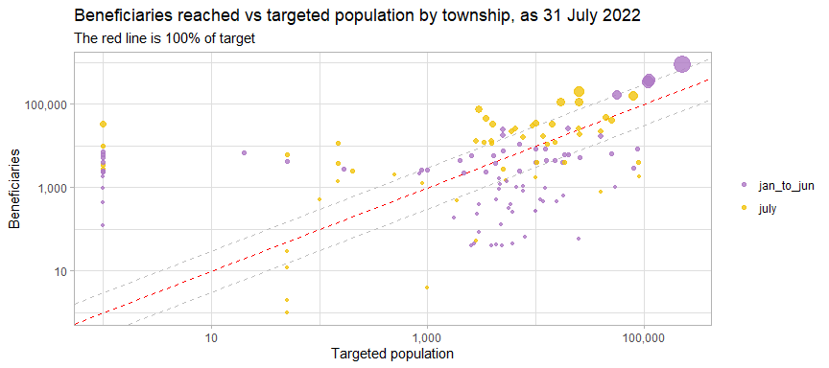

In most of the townships where the food security cluster is present, the number of beneficiaries reached is under the cluster target. Townships which have been heavily oversubscribed have been listed in the [second quarter 5Ws report](https://food-security-cluster-myanmar.github.io/fsc_5ws_second_quarter_2022/).

### 6.2 Map of beneficiaries reached in Q1 & Q2 2022 vs target

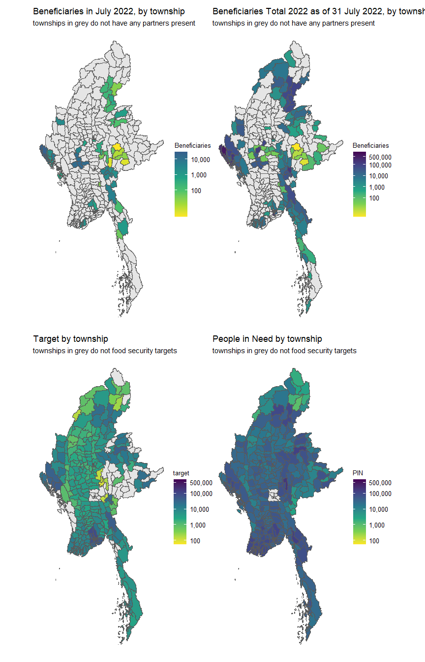

### 6.3 Interactive reference table

In the interactive table below, is a list of townships sorted by the gap between the targeted population and beneficiaries reached in 2022. Any of the columns can be sort; the search bars above each column can also assist in filtering.

This is not available in the word version of this report. Please use the [online version](https://food-security-cluster-myanmar.github.io/fsc_5ws_jul_2022/) to access this table.