Report on the 5Ws

Second quarter 2022

Myanmar Food Security Cluster

2022-07-21

Table of Contents

Summary of achievements 2

1. Geographies 4

1.1 States 4

1.2 Townships 5

1.3 Locations 7

2. Activities 9

2.1 Progress by activity 9

2.2 Agricultural and livelihoods activities 10

2.3 Delivery modalities 11

3. Cash-based programming 13

3.1 USD per household 13

3.3 USD per person 14

3.3 Food distributions 15

3.4 Implementing partners 17

4. Beneficiaries 17

4.1 Beneficiary types 17

4.2 Evidence of food insecurity status 18

4.3 Beneficiary disaggregation 20

5. Partners 21

5.1 Implementing partner 21

5.2 Monthly progress by partner 22

5.3 Donors 23

6. Comparison with targets 26

6.2 Reached vs target by township 26

6.2 Map of beneficiaries reached in Q1 & Q2 2022 vs target 27

6.3 Interactive reference table 27

## Summary of achievements

Beneficiaries of humanitarian action formed 90.57% of the 3,033,156 beneficiaries in the first quarter of 2022. The remainder were reached through development interventions.

To recall, the Food Security Cluster’s strategic objectives for 2022 are:

* SO1: IDPs have equitable access to sufficient, safe and nutritious food (either in-kind or through food assistance)
* SO2: Vulnerable persons (excl. IDPs) have equitable access to sufficient, safe and nutritious food (either in-kind or through food assistance)
* SO3: Restore, protect and improve livelihoods and resilience

Overall, 45.28% of the food security cluster’s beneficiaries were from humanitarian activities.

2022 beneficiaries by strategic objective

| SO | Q1 | Q2 | Total | total% |
| --- | --- | --- | --- | --- |
| SO1 | 193,154 | 341,050 | 534,204 | 19.45 |
| SO2 | 1,547,717 | 584,278 | 2,131,995 | 77.61 |
| SO3 | 33,116 | 47,686 | 80,802 | 2.94 |
| Total | 1,773,987 | 973,014 | 2,747,001 | 100 |

A total of 4.72% beneficiaries were from development activities and actors.

2022 Q1 & Q2 development beneficiaries

| SO | Q1 | Q2 | Total | total% |
| --- | --- | --- | --- | --- |
| SO2 | 13,736 | 4,226 | 17,962 | 6.28 |
| SO3 | 220,587 | 47,606 | 268,193 | 93.72 |
| Total | 234,323 | 51,832 | 286,155 | 100 |

Activities with significant increases in beneficiaries reached compared to Q1 include food/cash for work/assets, multi-purpose cash transfers and vocational training. New persons reached by farmer field school and farmer training dipped, likely due to the seasonality of the intervention. Encouragingly, the number of new persons reached by food distributions in Q2 was 83.08% as opposed to 85.81% in Q1, showing increasing investment in more durable solutions. Myanmar will likely face a prolonged food security crisis.

Beneficiaries by activity, Q1 & Q2 2022

| Activity | Q1 | Q2 | %_change | Total |
| --- | --- | --- | --- | --- |
| Food distribution | 1,723,250 | 851,483 | -50.59 | 2,574,733 |
| Multi-purpose cash transfer | 31,357 | 76,365 | 143.5 | 107,722 |
| Crop, vegetable and seed kits | 48,046 | 60,912 | 26.78 | 108,958 |
| Food_cash for work_assets | 7,352 | 26,362 | 258.6 | 33,714 |
| Community infrastructure and equipment | 0 | 4,770 | 0 | 4,770 |
| HEB and fortified rice for acute emergencies | 0 | 1,706 | 0 | 1,706 |
| Vocational training | 327 | 1,306 | 299.4 | 1,633 |
| FFS and farmer training | 195,839 | 1,003 | -99.49 | 196,842 |
| Kitchen garden kits | 0 | 475 | 0 | 475 |
| IGA and small grants | 2,048 | 462 | -77.44 | 2,510 |
| Livestock kits | 91 | 2 | -97.8 | 93 |

Food distributions overwhelmingly target moderately-food-insecure persons in host and local communities, this group forms 75.04% of all beneficiaries of food distributions.

Food distributions by type food insecurity status and beneficiary type

| beneficiary_type | .group | Moderate | Severe | Total |
| --- | --- | --- | --- | --- |
| Host/local Community | drop | 1,913,480 | 18,655 | 1,932,135 |
| Internally Displaced | drop | 260,257 | 182,793 | 443,050 |
| Rakhine Stateless | drop | 3,618 | 189,405 | 193,023 |
| Resettled | drop | 2,977 | 0 | 2,977 |
| Returnees | drop | 2,413 | 1,135 | 3,548 |
| Total |  | 2,182,745 | 391,988 | 2,574,733 |

55% of beneficiaries were reached by activities where nutrition had been mainstreamed.

Beneficiaries by status of nutrition mainstreaming

| was_nutrition_mainstreamed_in_activity | SO1 | SO2 | SO3 | total_beneficiaries | %_beneficiaries |
| --- | --- | --- | --- | --- | --- |
| Yes | 327,046 | 957,282 | 90,490 | 1,374,818 | 45.33 |
| No | 207,158 | 1,192,675 | 258,505 | 1,658,338 | 54.67 |

## 1. Geographies

### 1.1 States

Though new beneficiaries reached remained biased towards Yangon and Rakhine in Q2, figures were less skewed than they were in Q1. Overall 66.24% of beneficiaries in Q2 came from Yangon or Rakhine, whereas it was 78.83% in Q1. Kayah saw the largest quarter-to-quarter increase in number of beneficiaries.

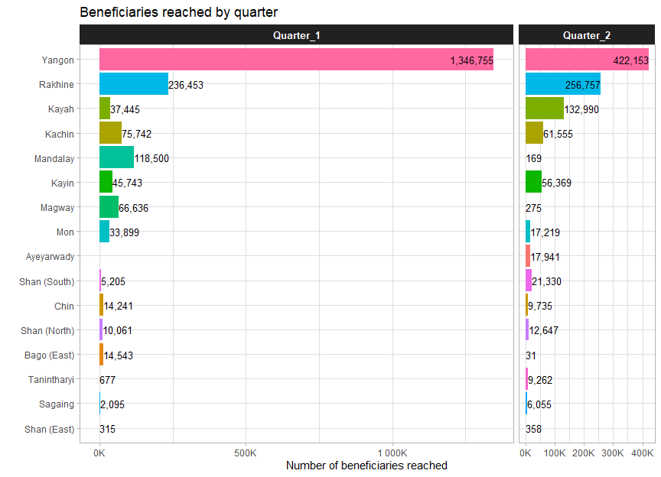

A total of 123 townships have been reached across 16 states/regions.

### 1.2 Townships

The top 7 townships, each from Yangon or Rakhine contained 68% of all beneficiaries.

Top townships by beneficiaries reached

| state | township | Q1 | Q2 | Total | %total |
| --- | --- | --- | --- | --- | --- |
| Yangon | Hlaingtharya (West) | 433,074 | 36,195 | 469,269 | 15.47 |
| Yangon | Hlaingtharya (East) | 270,646 | 128,461 | 399,107 | 13.16 |
| Yangon | Shwepyithar | 380,512 | 0 | 380,512 | 12.55 |
| Yangon | North Okkalapa | 168,400 | 172,559 | 340,959 | 11.24 |
| Rakhine | Buthidaung | 147,534 | 18,314 | 165,848 | 5.47 |
| Yangon | Dala | 81,125 | 81,390 | 162,515 | 5.36 |
| Rakhine | Sittwe | 22,484 | 130,281 | 152,765 | 5.04 |
| Kayah | Loikaw | 815 | 107,473 | 108,288 | 3.57 |
| Mandalay | Nyaung-U | 71,547 | 0 | 71,547 | 2.36 |
| Rakhine | Maungdaw | 44,625 | 22,757 | 67,382 | 2.22 |
| Mandalay | Myingyan | 46,087 | 3 | 46,090 | 1.52 |
| Kayin | Hpapun | 12,477 | 29,561 | 42,038 | 1.39 |
| Kayah | Hpruso | 26,507 | 7,557 | 34,064 | 1.12 |
| Kachin | Waingmaw | 19,249 | 14,292 | 33,541 | 1.11 |
| Rakhine | Pauktaw | 76 | 31,597 | 31,673 | 1.04 |

Comparing the food security cluster’s footprint in the first quarter, with that from the second quarter, new activity can be noted in Mandalay, Magway, Kayah and Kayin.

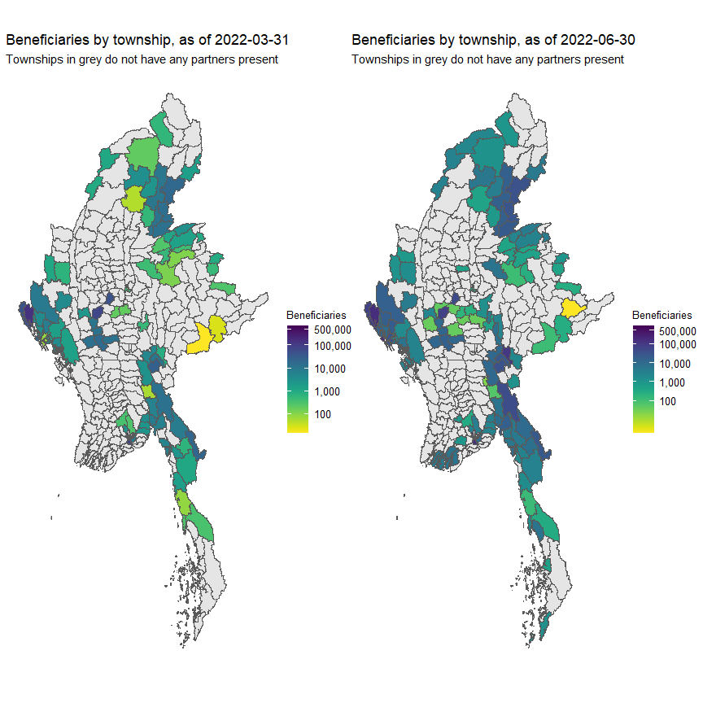

26 new townships were added in the second quarter of 2022, including 5 from Ayeyarwady and 3 each from Mandalay, Magway and Tanintharyi.

### 1.3 Locations

A location refers to either a village, ward, IDP site or industrial zone.

The vast amount of project locations have only one food security activity.

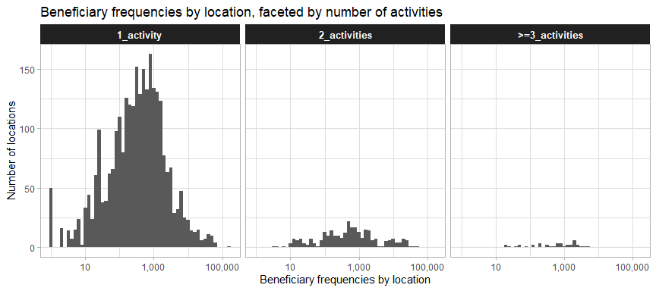

With some exceptions, the vast majority of project locations have only one partner present.

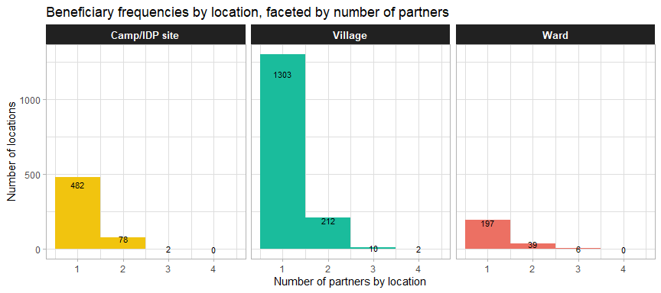

224 villages have more than one partner present. The table below breaks down the beneficiaries from these locations by activity and state.

Activities conducted in villages with more than one partner

| state | activity_red | beneficiaries |
| --- | --- | --- |
| Rakhine | food distribution | 287,278 |
| Yangon | food distribution | 65,721 |
| Magway | FFS and farmer training | 2,735 |
| Rakhine | crop, vegetable and seed kits | 1,525 |
| Kachin | crop, vegetable and seed kits | 698 |
| Rakhine | food_cash for work_assets | 653 |
| Shan (South) | vocational training | 504 |
| Mon | crop, vegetable and seed kits | 365 |
| Rakhine | vocational training | 66 |

The food security cluster’s partners can mostly be found in Yangon, Rakhine and Kachin.

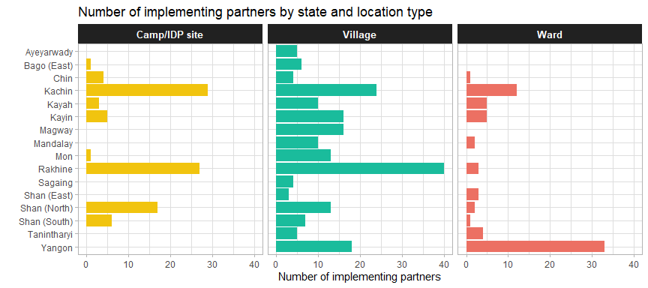

## 2. Activities

### 2.1 Progress by activity

The dotted red line shows the end of Q1 and the dotted blue line shows the end of Q2. The thick line in grey shows the progress in 2021 for the same activity. It is observed that food distributions in 2022 greatly outpaced those in 2021. The same is also true for cash/work for food/assets and crop, vegetable and seed kits.

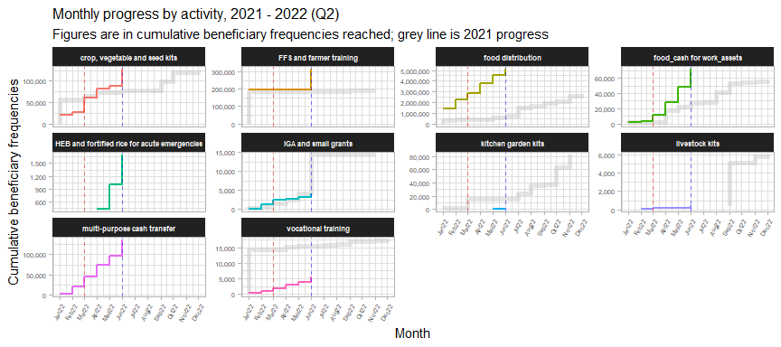

Newly implemented in Q2 of 2022 was the provision of HEB and fortified rice, largely in Chin state. Food distributions continued to be the largest activity, followed by the provision of crop, vegetable and seed kits.

### 2.2 Agricultural and livelihoods activities

The percentage of beneficiaries reached by agriculture and livelihoods activities (crops, vegetable and seed kits; FFS and farmer training; IGA and small grants; livestock kits) declined in Q2 2022, compared to Q1.

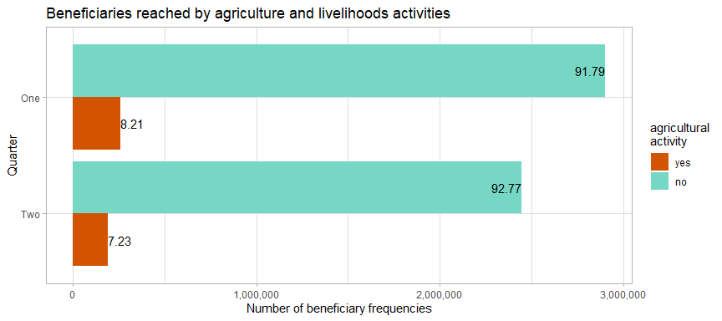

The vast majority of beneficiaries of agricultural and livelihoods activities are recipients of farmer training and crop, vegetable and seed kits. It is possible that not all of Q2 was available for farmer training.

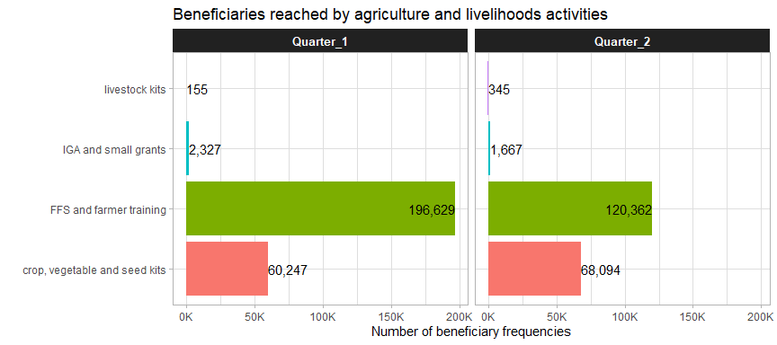

### 2.3 Delivery modalities

Only community infrastructure and equipment, HEB and fortified rice and kitchen garden kits were delivered entirely through in-kind modalities.

Percentage of beneficiaries reahced by activity and delivery modality

| Activity | In-kind | CBT/CVA | Hybrid | Service delivery | Beneficiaries |
| --- | --- | --- | --- | --- | --- |
| food distribution | 86.1% | 12.3% | 1.6% | NA | 2,574,733 |
| FFS and farmer training | 15.0% | 24.7% | NA | 60.3% | 196,842 |
| crop, vegetable and seed kits | 83.3% | 0.5% | 16.2% | 0.0% | 108,958 |
| multi-purpose cash transfer | NA | 89.3% | 10.7% | NA | 107,722 |
| food_cash for work_assets | 17.3% | 82.7% | NA | NA | 33,714 |
| community infrastructure and equipment | 100.0% | NA | NA | NA | 4,770 |
| IGA and small grants | 10.4% | 87.4% | 1.2% | 1.0% | 2,510 |
| HEB and fortified rice for acute emergencies | 100.0% | NA | NA | NA | 1,706 |
| vocational training | 0.0% | 23.1% | NA | 76.9% | 1,633 |
| kitchen garden kits | 100.0% | NA | NA | NA | 475 |
| livestock kits | 97.8% | 0.0% | 0.0% | 2.2% | 93 |

There are also clear differences between the different location types and the delivery modalities employed with them. Rural areas were predominated by in-kind distributions whilst camps and IDP sites were mostly targeted with cash-based interventions.

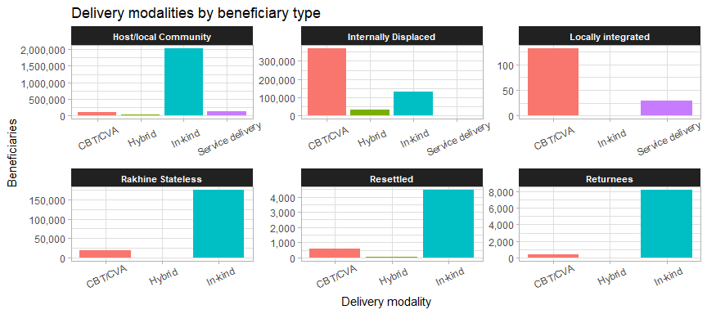

Areas with more IDPs, such as Sagaing, Rakhine and Kachin, reach most of their beneficiaries through cash-based programming.

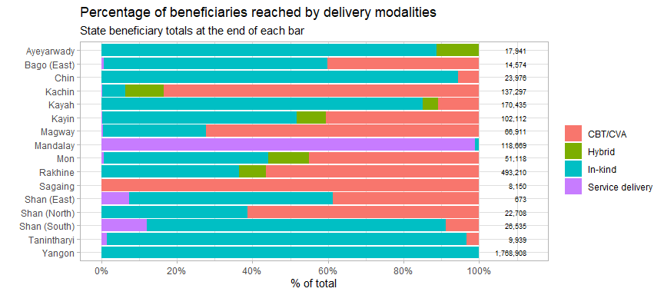

## 3. Cash-based programming

### 3.1 USD per household

Compared to Q1, beneficiaries in Q2 are much less likely to have received cash transfers of less than USD 10 per household. The most common transfer values were between USD 60 and 70, an increase from the previous quarter.

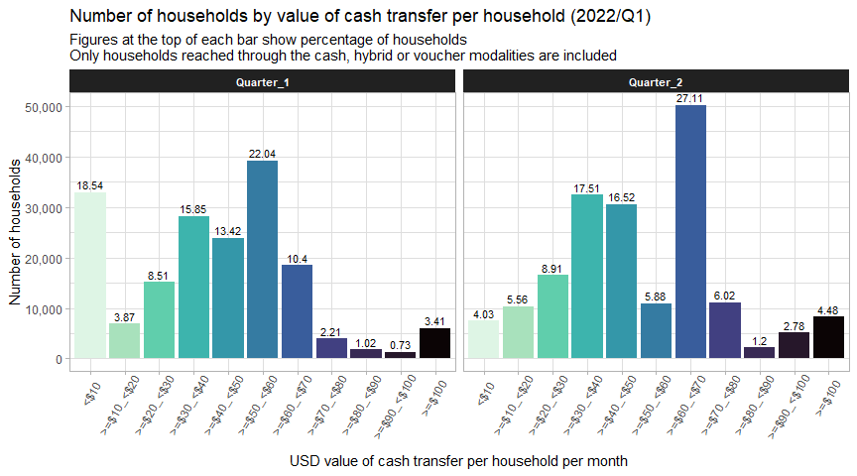

### 3.3 USD per person

The boxplots above shows the range of cash transfer values (all values are per person, to facilitate comparability) by activity. The average for reach activity is marked by the thick line in the middle of each box. The leftmost and rightmost side of each box indicate the 25th and 75th percentile of transfer values, respectively. The length of each box is a gauge for how much variation there is in the transfer values of each activity.

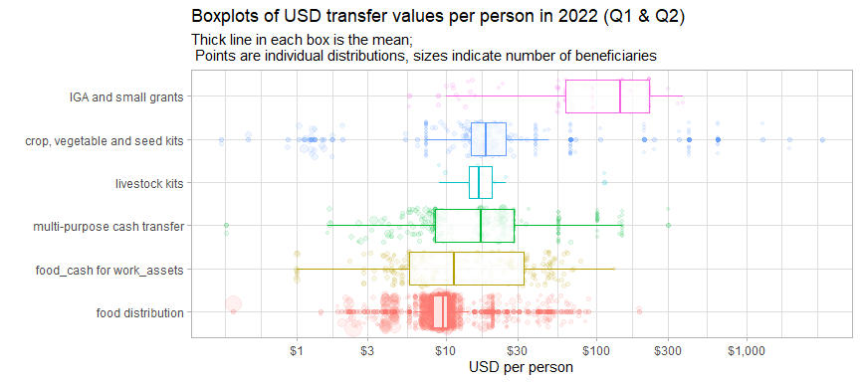

Each of the bubbles represents an individual distribution, with their position along the x-axis showing the USD per person value of the distribution and the size of each bubble indicating the number of beneficiaries reached.

Food distributions tended to have the tightest range of values.

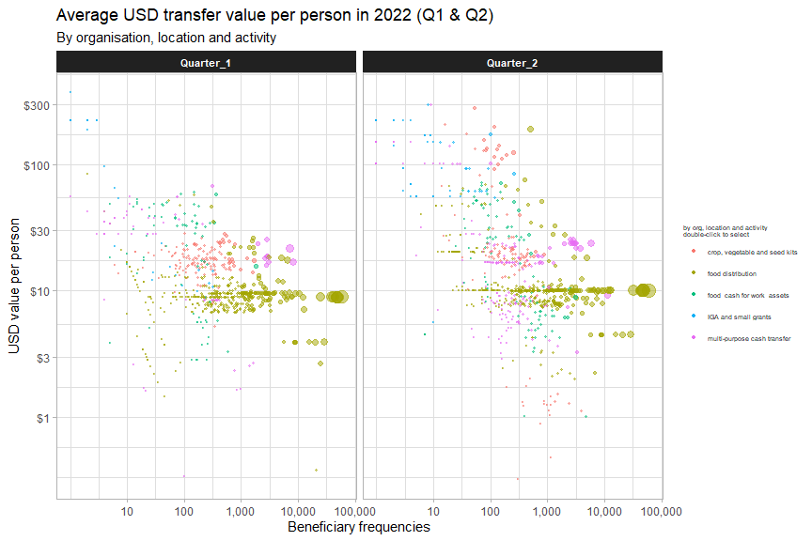

Cash transfer values tended to be higher in Q2 as compared to Q1 largely due to increases in the per-household package of multi-purpose cash transfers.

### 3.3 Food distributions

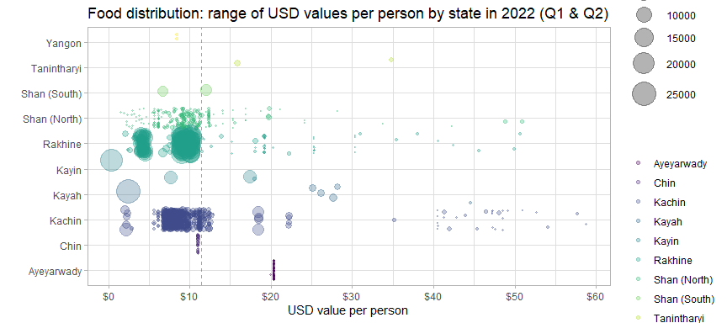

Kachin, Rakhine and Shan notably have several extreme outliers much higher than the average for that state. Kayin, however, has a very large number of beneficiaries who received less the USD 1/person. Distributions in Chin and Ayeyarwady had very consistent values as they were all implemented by the same implementing partner.

The table below compares the different bins for cash transfer values of food distributions with the minimum expenditure basket for food established by the Cash Working Group. They have established a floor of MMK 190,555 (or USD 114.55).

Overall, 1.86% of food distribution beneficiaries have received at least 100% of the MEB and 9.35% have received at least 50% of the MEB.

USD values of food distributions by percentage of MEB received

| usd_person_bin | avg_pc_of_meb | avg_usd_month | beneficiaries | pc_of_hhd |
| --- | --- | --- | --- | --- |
| <$2 | 5.39 | 1.23 | 20,923 | 4.76 |
| =$2_<$4 | 14.44 | 3.31 | 49,617 | 11.3 |
| =$4_<$6 | 21.38 | 4.9 | 30,454 | 6.93 |
| =$6_<$8 | 31.76 | 7.28 | 55,843 | 12.72 |
| =$8_<$10 | 39.62 | 9.08 | 82,235 | 18.73 |
| =$10_<$12 | 45.59 | 10.44 | 164,264 | 37.41 |
| =$12_<$14 | 54.39 | 12.46 | 6,219 | 1.42 |
| =$14_<$16 | 65.65 | 15.04 | 1,741 | 0.4 |
| =$16_<$18 | 74.95 | 17.17 | 6,941 | 1.58 |
| =$18_<$20 | 82.86 | 18.98 | 10,843 | 2.47 |
| >=$20 | 143.5 | 32.89 | 10,066 | 2.29 |

### 3.4 Implementing partners

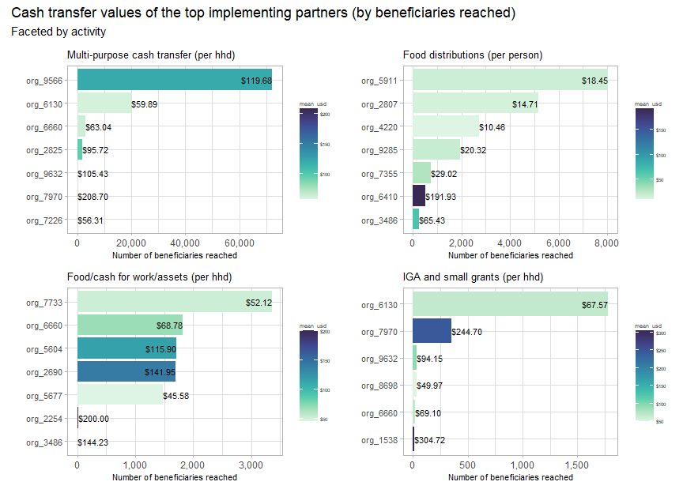

## 4. Beneficiaries

### 4.1 Beneficiary types

In Q2 2022, 22.19% of beneficiaries were from host or local communities, in comparison to 53.31% for round 1. 11.27% of beneficiaries in Q2 were IDPs, compared to 6.38% for Q1.

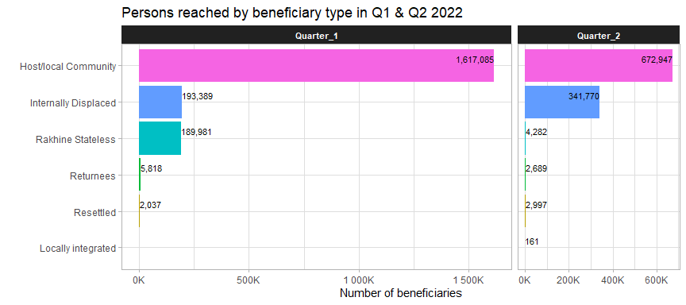

### 4.2 Evidence of food insecurity status

Of the food security activities reported, very few provided details about the food insecurity status of beneficiaries. This makes it difficult ot determine whether interventions are truly reaching those most in need.

In general, the food insecurity status of the beneficiaries of multi-purpose cash transfers were much better documented than the statuses of those who received food distributions.

Mismatch between food insecurity status and activity (Q1 & Q2 2022)

| activity | food_insecurity_status | beneficiaries | %of_group |
| --- | --- | --- | --- |
| food distributions, moderate | Food secure | 31,713 | 1.45 |
| food distributions, moderate | Moderately food insecure | 48,545 | 2.22 |
| food distributions, moderate | Severely food insecure | 206,922 | 9.48 |
| food distributions, moderate | NA | 1,895,565 | 86.84 |
| food distributions, severe | Food secure | 13,601 | 3.47 |
| food distributions, severe | Moderately food insecure | 13,644 | 3.48 |
| food distributions, severe | Severely food insecure | 67,956 | 17.34 |
| food distributions, severe | NA | 296,787 | 75.71 |
| multi-purpose cash transfer, moderate | Food secure | 16,183 | 45.67 |
| multi-purpose cash transfer, moderate | Moderately food insecure | 14,557 | 41.08 |
| multi-purpose cash transfer, moderate | NA | 4,695 | 13.25 |
| multi-purpose cash transfer, severe | Food secure | 41 | 0.06 |
| multi-purpose cash transfer, severe | Severely food insecure | 72,230 | 99.92 |
| multi-purpose cash transfer, severe | NA | 16 | 0.02 |

Evidence of beneficiaries’ food insecurity status provided to the cluster include:

Evidence of food insecurity status in Q1 & Q2 2022

| evidence | beneficiaries | %_beneficiaries |
| --- | --- | --- |
| No evidence | 2,757,212 | 90.9 |
| Armed conflict | 147,088 | 4.85 |
| community-based beneficiary selection | 34,407 | 1.13 |
| Post-distribution monitoring | 31,347 | 1.03 |
| Acceptable FCS | 29,071 | 0.96 |
| Beneficiary list and  distribution list | 19,279 | 0.64 |
| Regular reporting | 8,984 | 0.3 |
| assessment, meeting minutes, payment | 3,020 | 0.1 |
| Village Profile | 1,683 | 0.06 |
| Based on Vulnerable Score (Vulnerable Criteria) | 608 | 0.02 |
| Food distribution certificate | 308 | 0.01 |
| Food Security and Livelihood Baseline Survey | 119 | 0 |
| Provision grants of women led micro business activities | 30 | 0 |

The general lack of evidence of evidence of beneficiaries’ food insecurity status makes it difficult to justify to affected communities and donors that the Food Security Cluster is reaching the most in need. This highlights the need to promote a shared understanding of the response through the development of a common prioritisation tool for food security partners.

### 4.3 Beneficiary disaggregation

In this section, a test is applied to determine if the disaggregated numbers of beneficiaries reach have been copied and pasted – a somewhat common practice that sullies the quality of the data. To do this, the proportions of each disaggregation group by partner have been compared to how close they were to the mean for the entire group. To explain: if partner A reported that 40% of beneficiaries in an activity were adult females, this percentage was then compared to the average percentage of adult females for all other activities reported by that partner. This measure whether or not the same proportions were copied and pasted throughout the 5W form.

It is extremely unlikely that these percentages would be similar across activities as implementing partners worked in an average of 42 locations.

In the plot below, the closer a value is to 0% on the x-axis, the more likely it is that it was copied and pasted. It is estimated that 73% of beneficiary disaggregation values were copied and pasted.

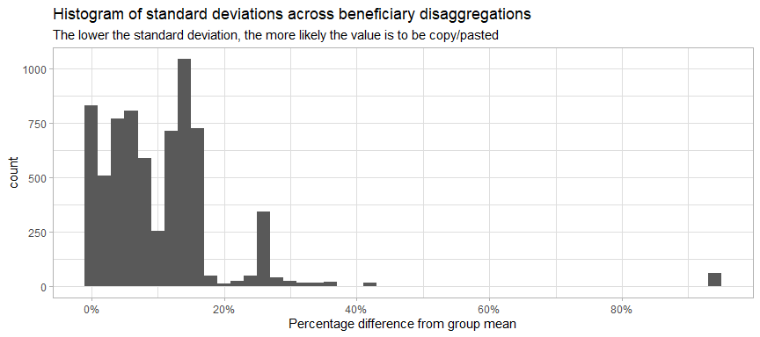

Once the copy-pasted values are removed, this is the breakdown of beneficiaries by disaggregation group:

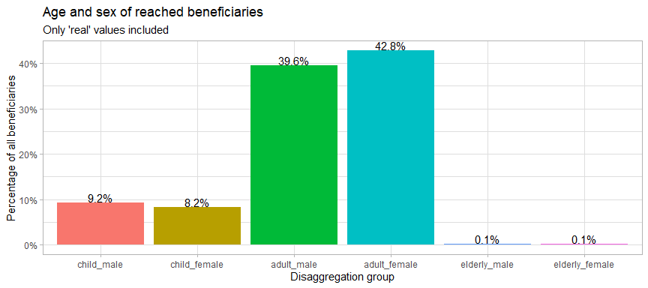

## 5. Partners

### 5.1 Implementing partner

There are 55 partners that were involved in direct implementation that have reported achievements in second quarter of 2022, in comparison with 44in the first quarter. These implementing partners corresponded to a total of 26 reporting organisations. The largest reporting organisation, 2690, had 24 implementing partners.

Reporting organisations with the most implementing partners

| report_org_code | implementing_partners |
| --- | --- |
| org_2690 | 24 |
| org_3536 | 7 |
| org_8415 | 7 |
| org_2625 | 4 |
| org_3422 | 4 |
| org_2214 | 3 |
| org_5369 | 3 |

The interactive plot below shows the number of beneficiaries and townships reached by implementing partner.

13 partners (21% of the total) have a presence in more than 5 townships. 8 partners are present in more than 10 townships.

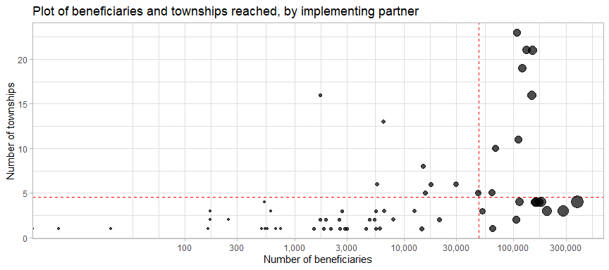

### 5.2 Monthly progress by partner

Organisations 6197, 2690 and 5722 have implemented the majority of their activities in the second quarter of 2022. The thick grey line shows an organisation’s progress from last year.

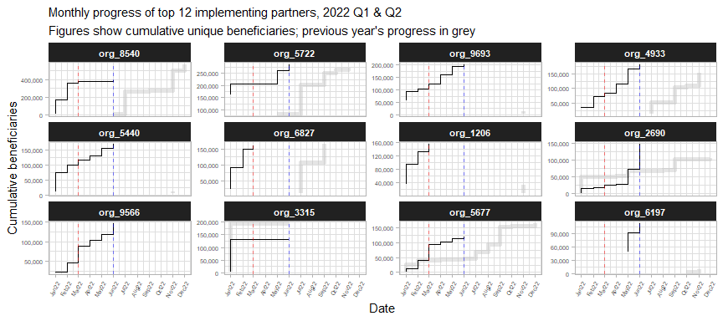

The table below lists the top 15 partners by number of beneficiaries reached in 2022.

Top implementing partners by beneficiaries reached in 2022 (Q1 & Q2)

| org_code | ben_q1 | rank_q1 | ben_q2 | rank_q2 | total_ben |
| --- | --- | --- | --- | --- | --- |
| org_8540 | 380,478 | 1 | 4,502 | 25 | 384,980 |
| org_5722 | 207,512 | 2 | 77,743 | 5 | 285,255 |
| org_9693 | 122,397 | 6 | 78,569 | 4 | 200,966 |
| org_4933 | 85,627 | 11 | 95,475 | 3 | 181,102 |
| org_5440 | 116,142 | 7 | 52,944 | 10 | 169,086 |
| org_6827 | 159,724 | 3 | NA | NA | 159,724 |
| org_1206 | 156,433 | 4 | NA | NA | 156,433 |
| org_2690 | 24,753 | 16 | 124,142 | 1 | 148,895 |
| org_9566 | 89,365 | 10 | 57,723 | 9 | 147,088 |
| org_3315 | 131,861 | 5 | 441 | 43 | 132,302 |
| org_5677 | 95,835 | 9 | 23,473 | 13 | 119,308 |
| org_6197 | NA | NA | 113,704 | 2 | 113,704 |
| org_8004 | 69,918 | 12 | 40,490 | 11 | 110,408 |
| org_6792 | 105,410 | 8 | NA | NA | 105,410 |
| org_6130 | 35,385 | 15 | 61,280 | 8 | 96,665 |

### 5.3 Donors

The table below summarises the reach and scope (in terms of geographic extent and number of organisations supported) of donors who support at least two reporting organisations. FCDO and LIFT support the most expansive programmes.

Organisations supported and geographic reach by donor

| donor | report_orgs | implementing_orgs | states | townships |
| --- | --- | --- | --- | --- |
| FCDO | 6 | 8 | 6 | 19 |
| LIFT | 6 | 10 | 6 | 15 |
| MHF | 5 | 6 | 4 | 7 |
| ECHO | 3 | 4 | 3 | 5 |
| BHA | 2 | 5 | 4 | 11 |
| GIZ | 2 | 2 | 2 | 7 |
| org_5677 | 2 | 2 | 6 | 15 |
| org_6793 | 2 | 3 | 3 | 9 |
| org_7904 | 2 | 3 | 2 | 7 |
| org_8415 | 2 | 2 | 3 | 15 |

Sagaing, Shan (East) and Ayeyarwady have the fewest number of donors present.

Number of donors by state

| state | donors | implementing_partners |
| --- | --- | --- |
| Kayin | 14 | 13 |
| Kachin | 13 | 14 |
| Rakhine | 11 | 18 |
| Kayah | 10 | 5 |
| Mon | 7 | 6 |
| Shan (South) | 7 | 8 |
| Mandalay | 5 | 3 |
| Shan (North) | 5 | 8 |
| Bago (East) | 4 | 3 |
| Chin | 4 | 4 |
| Yangon | 4 | 14 |
| Magway | 3 | 3 |
| Tanintharyi | 3 | 3 |
| Ayeyarwady | 2 | 4 |
| Sagaing | 2 | 3 |
| Shan (East) | 2 | 2 |

However, as shown by the table below, even if the majority of partners reported their donors, the omission of data from three key partners has resulted in the vast majority of reported beneficiaries not being associated with any donor.

Top donors by beneficiaries reached

| donor | beneficiaries | %_beneficiaries |
| --- | --- | --- |
| No donor specified | 2,397,314 | 79.04 |
| org_6793 | 156,303 | 5.15 |
| FCDO | 94,653 | 3.12 |
| CERF | 71,253 | 2.35 |
| AICS | 63,986 | 2.11 |
| org_5677 | 49,279 | 1.62 |
| BPRM | 31,640 | 1.04 |
| org_7904 | 20,213 | 0.67 |
| DFAT | 17,329 | 0.57 |
| BHA | 16,356 | 0.54 |
| org_7002 | 13,851 | 0.46 |
| AAP | 12,392 | 0.41 |
| MHF | 12,303 | 0.41 |
| NZMFAT | 10,791 | 0.36 |
| ECHO | 7,854 | 0.26 |

Below is a table of beneficiaries who are missing donors grouped by state.

Reported beneficiaries with missing donor data

| state | beneficiaries | partners |
| --- | --- | --- |
| Yangon | 1,752,158 | 9 |
| Rakhine | 421,076 | 9 |
| Kayah | 98,394 | 1 |
| Kachin | 69,031 | 3 |
| Shan (North) | 18,420 | 5 |
| Chin | 16,389 | 2 |
| Shan (South) | 9,416 | 2 |
| Sagaing | 7,650 | 2 |
| Kayin | 4,505 | 2 |
| Shan (East) | 275 | 1 |

## 6. Comparison with targets

### 6.2 Reached vs target by township

The specifics of each township can be reviewed with the interactive plot below. Each point is a township, with the size indicating the number of beneficiaries. The x-axis indicates the target population by township and the y-axis shows the number of beneficiaries reached in Q1 and Q2 2022.

The red line down the middle represents reaching 100% of the target. Townships above this line have reached more beneficiaries than their target and townships below the line have not met their target yet. The further away a township is from the red line, the further above or below its target it is. Mouse over each of the townships to see more details.

The 13 townships along the extreme left side of the plot have beneficiaries but do not have targets (their targets have just been coded as 1 so that they show up on the plot). 209 townships with targets have not been reached.

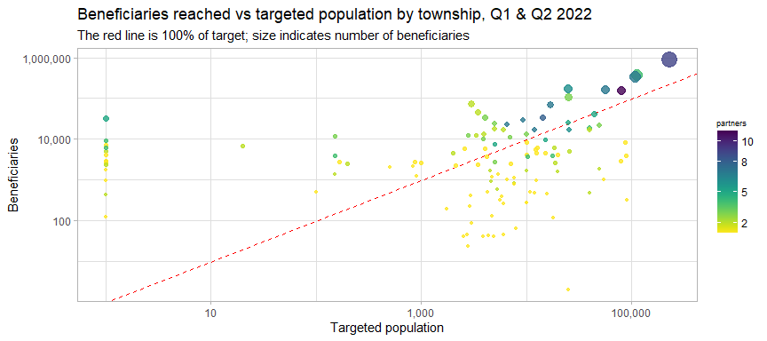

### 6.2 Map of beneficiaries reached in Q1 & Q2 2022 vs target

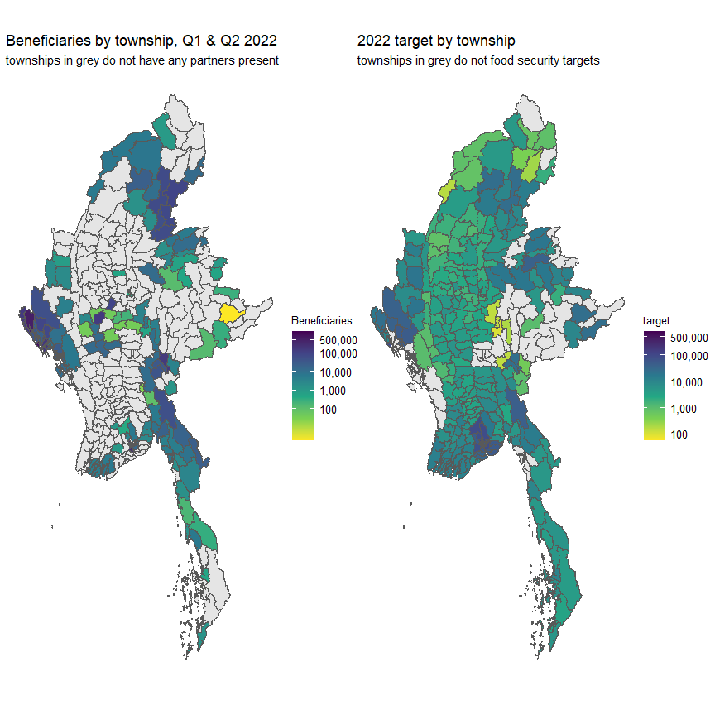

### 6.3 Interactive reference table

There was an overallocation of resources in these relatively few areas in 2021 and this has continued in the first quarter of 2022. In the interactive table below, is a list of townships sorted by the gap between the targeted population and beneficiaries reached in 2022. Any of the columns can be sort; the search bars above each column can also assist in filtering.

