Snapshot report on the 5Ws

First quarter 2022

Myanmar Food Security Cluster

2022-05-06

## Summary of achievements

Beneficiaries of humanitarian action formed 99.84% of the 129,235 beneficiaries in the first quarter of 2022. The remainder were reached through development interventions.

To recall, the Food Security Cluster’s strategic objectives for 2022 are:

* SO1: IDPs have equitable access to sufficient, safe and nutritious food (either in-kind or through food assistance)
* SO2: Vulnerable persons (excl. IDPs) have equitable access to sufficient, safe and nutritious food (either in-kind or through food assistance)
* SO3: Restore, protect and improve livelihoods and resilience

2022/Q1 beneficiaries by strategic objective

| strat_obj | Humanitarian | Development | Total |
| --- | --- | --- | --- |
| SO_1 | 98,106 | 0 | 98,106 |
| SO_3 | 30,926 | 203 | 31,129 |
| Total | 129,032 | 203 | 129,235 |

In terms of activities, the number of beneficiaries reached is heavily skewed towards food distributions. More than 53% of beneficiaries in 2022/Q1 have been reached by this activity.

Breakdown of beneficiaries by activity in 2022/Q1

| activity | ben_SO_1 | ben_SO_3 | ben_SO_2 | Total | %_ben |
| --- | --- | --- | --- | --- | --- |
| food distribution | 69,206 | 0 | 0 | 69,206 | 53.55 |
| crop, vegetable and seed kits | 0 | 29,026 | 0 | 29,026 | 22.46 |
| multi-purpose cash transfer | 28,900 | 0 | 0 | 28,900 | 22.36 |
| IGA and small grants | 0 | 1,900 | 0 | 1,900 | 1.47 |
| vocational training | 0 | 203 | 0 | 203 | 0.16 |

31% of beneficiaries were reached by activities where nutrition was mainstreamed. This is highly encouraging. As the year progresses, it will be important to collect more details about how exactly nutrition has been mainstreamed so that coordination with the Nutrition Cluster may be improved.

Breakdown of beneficiaries by status of nutrition mainstreaming

| was_nutrition_mainstreamed_in_activity | SO_1 | SO_3 | total_beneficiaries | %_beneficiaries |
| --- | --- | --- | --- | --- |
| Yes | 10,516 | 29,229 | 39,745 | 30.75 |
| No | 87,590 | 1,900 | 89,490 | 69.25 |

### Implementation of Information Sharing Protocols

The newly approved ICCG Information Sharing Protocols have been implemented in this report to support the safe, ethical and effective management of data within Myanmar. This implementation is most evident in the use of partner pseudonymisation in this report. Partner names have been replaced by tokens in this report. These tokens are stored in a secure translation table on OCHA servers outside of Myanmar, where they may not be requisitioned by authorities. For more information, please read the full text of the protocols in either [English](https://www.dropbox.com/s/11kv6cvnbvx9hbe/information_sharing_protocol_220323.pdf?dl=0) or [Myanmar](https://www.dropbox.com/s/lqwvo7k80s1xnjj/SE%20partner%20data%20protection_final_220323%20translation.pdf?dl=0).

## 1. Geographies

### 1.1 Statewise breakdowns

As in 2021, the number of beneficiaries reached has been heavily biased towards relatively few areas, which is not appropriate for a unionwide response. A total of 19 townships have been reached across 4 states/regions.

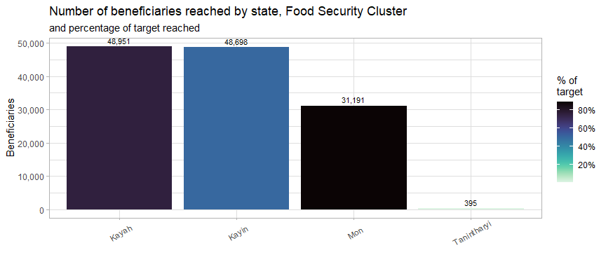

The table below outlines the number of beneficiaries reached by state/region in both 2021 and 2022/Q1. In 2021, the number of beneficiaries reached was lowest in Tanintharyi region, similarly more pronounced in 2022/Q1.

Skew in Q1 2022 geographic reach, comparison with 2021 data

| State | Beneficiaries_2021 | %_ben_2021 | Beneficiaries_2022 | %_ben_2022 | Target | %_target_2022 |
| --- | --- | --- | --- | --- | --- | --- |
| Kayah | 17,746 | 12.81 | 48,951 | 37.88 | 64,400 | 76.01 |
| Kayin | 68,108 | 49.17 | 48,698 | 37.68 | 96,320 | 50.56 |
| Mon | 48,181 | 34.78 | 31,191 | 24.14 | 35,000 | 89.12 |
| Tanintharyi | 4,476 | 3.23 | 395 | 0.31 | 54,410 | 0.73 |

### 1.2 Township-level breakdowns

Just 4 townships (listed in the table below) contained 63% of all beneficiaries. Reached 4 townships in Mon State which were not targeted in HRP 2022. Only few number of beneficiaries were reached in Loikaw and Ye townships which had a large number of target.

Townships reached by number of beneficiaries

| state | township | target | beneficiaries | %_beneficiaries | %_reached |
| --- | --- | --- | --- | --- | --- |
| Kayah | Hpruso | 4,000 | 30,215 | 23.38 | 755.4 |
| Kayin | Myawaddy | 5,000 | 20,843 | 16.13 | 416.9 |
| Kayah | Demoso | 25,000 | 16,315 | 12.62 | 65.26 |
| Kayin | Hpapun | 44,320 | 14,444 | 11.18 | 32.59 |
| Mon | Kyaikto | 10,000 | 8,284 | 6.41 | 82.84 |
| Kayin | Hlaingbwe | 15,000 | 7,778 | 6.02 | 51.85 |
| Mon | Chaungzon | 0 | 7,181 | 5.56 | 100 |
| Mon | Bilin | 5,000 | 6,031 | 4.67 | 120.6 |
| Mon | Paung | 0 | 4,254 | 3.29 | 100 |
| Kayin | Thandaunggyi | 7,000 | 2,811 | 2.18 | 40.16 |
| Mon | Mawlamyine | 0 | 2,691 | 2.08 | 100 |
| Mon | Kyaikmaraw | 0 | 2,570 | 1.99 | 100 |
| Kayah | Shadaw | 500 | 1,606 | 1.24 | 321.2 |
| Kayin | Kawkareik | 5,000 | 1,432 | 1.11 | 28.64 |
| Kayin | Kyainseikgyi | 5,000 | 1,390 | 1.08 | 27.8 |
| Kayah | Loikaw | 25,000 | 815 | 0.63 | 3.26 |
| Tanintharyi | Dawei | 5,667 | 314 | 0.24 | 5.54 |
| Mon | Ye | 10,000 | 180 | 0.14 | 1.8 |
| Tanintharyi | Yebyu | 4,751 | 81 | 0.06 | 1.7 |

### 1.3 Locations

A location refers to either an village, ward, IDP site or industrial zone.

This first plot below is a histogram of location, by number of beneficiaries. The vast majority of locations have only one activity occurring within them. This is something to be monitored over the course of the year, as it is assumed that a range of activities are required to comprehensively meet the food security and livelihoods needs of targeted communities. As it currently stands, the response is very broad, with little depth.

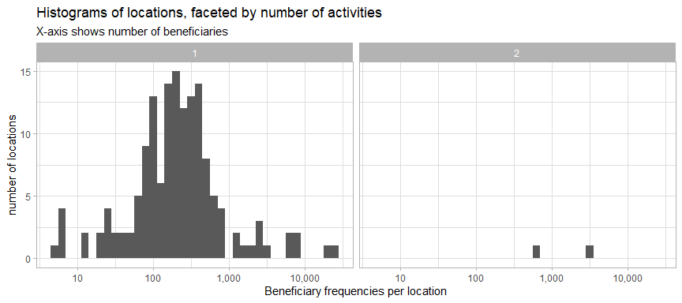

This second plot of locations is faceted by the number of partners – this helps us check for potential overlaps. There are quite a large number of locations with 2 partners in them. Locations with multiple partners were from Rakhine, Kachin and Shan (North).

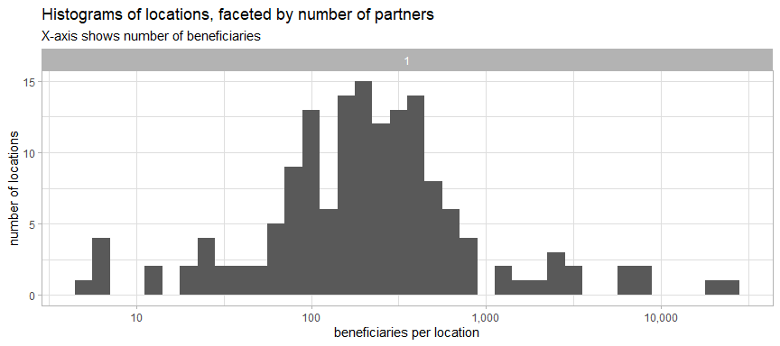

The greatest number of beneficiaries came from rural villages and camp/IDP Sites. This runs counter to vulnerability patterns identified by in both the IFPRI Household Welfare Survey and the FAO-WFP Food Security Survey. Both surveys found that rural households were less food secure and less resilient than urban ones.

Breakdown of locations and beneficiaries

| rural_or_urban | location_type | locations | beneficiaries | %_of_ben | ben_per_location |
| --- | --- | --- | --- | --- | --- |
| Rural | Camp/IDP site | 52 | 28,603 | 22.24 | 550 |
| Rural | Village | 155 | 99,825 | 77.62 | 644 |
| Urban/Peri-Urban | Camp/IDP site | 1 | 104 | 0.08 | 104 |
| Urban/Peri-Urban | Village | 1 | 81 | 0.06 | 81 |

## 2. Activities

### 2.1 Progress by activity

The first grey line below shows the the approval of the IERP in June 2021 and the second red line shows the start of 2022.

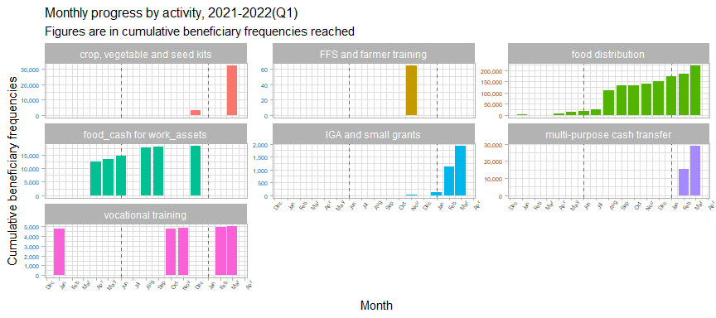

FFS and farmer training, and food cash for work/assets activities have not been implemented in 2022/Q1. Income-generating activities, which were very few in 2021, started to increase in 2022/Q1. Food distributions (in-kind and CBT/CVA) continued to be the largest activity from 2021 into 2022/Q1. Multi-purpose cash transfers was new activity that was not present in 2021.

### 2.2 Agricultural and livelihoods activities

24% of all beneficiary frequencies pertained to agricultural activities. As mentioned earlier, the vast majority of beneficiaries in Q1 2022 were related to food distributions.

Beneficiary frequencies reached by agricultural and non-agricultrural activities

| agricultural_activity | beneficiaries | %_beneficiaries | state | townships | partners |
| --- | --- | --- | --- | --- | --- |
| no | 98,309 | 76.07 | 4 | 13 | 3 |
| yes | 30,926 | 23.93 | 3 | 9 | 2 |

Crop, vegetable and seed kits formed the largest group of agricultural activities and reached 5,729 households (for a full breakdown by agricultural activity, please refer to the plot below).

It will be important to review the results from the second quarter in order to see if this pattern changes and agricultural household receive sufficient assistance prior to the main rice planting season which begins in May 2022. Still, the results are not encouraging and agricultural activities have had a very limited reach.

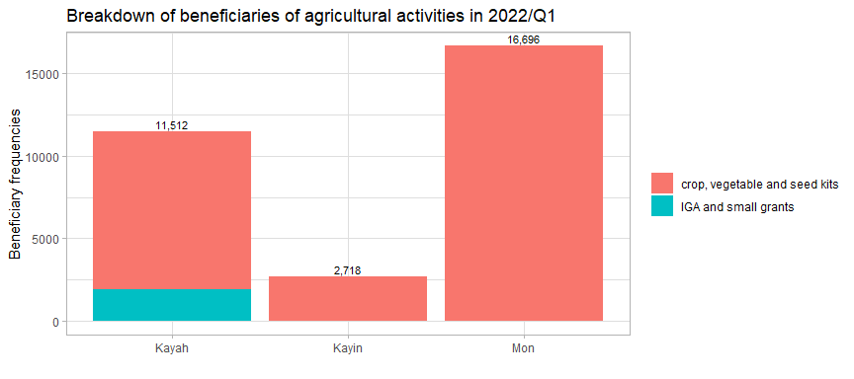

### 2.3 Delivery modalities

The plots below, faceted by delivery modality, show the breakdown of activities by delivery modality. All activities corresponded to only one type of delivery modality.

Percentage of beneficiaries reached by activity and delivery modality

| Activity | In-kind | CBT/CVA | Service delivery | Beneficiaries |
| --- | --- | --- | --- | --- |
| food distribution | 100.0% | NA | NA | 69,206 |
| crop, vegetable and seed kits | 100.0% | NA | NA | 29,026 |
| multi-purpose cash transfer | NA | 100.0% | NA | 28,900 |
| IGA and small grants | NA | 100.0% | NA | 1,638 |
| vocational training | NA | NA | 100.0% | 203 |

Both villages and IDP/Camp sites were predominated by in-kind distributions whilst only villages were targeted with cash-based interventions.

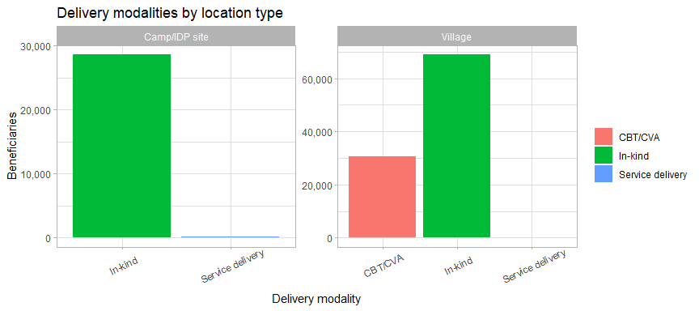

This would perhaps imply that partners believe that markets were more accessible from villages than camp/IDP sites. Other alternative assumptions include donor preferences and logistical challenges in bringing in-kind goods to villages. This remains a question to be explored by the broader Food Security Cluster.

Below is a breakdown of percentage of beneficiaries reached by the different delivery modalities, by state.

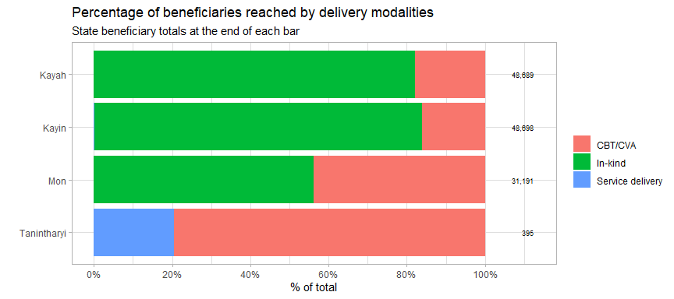

## 3. Cash-based programming

### 3.1 Cash transfer values per household

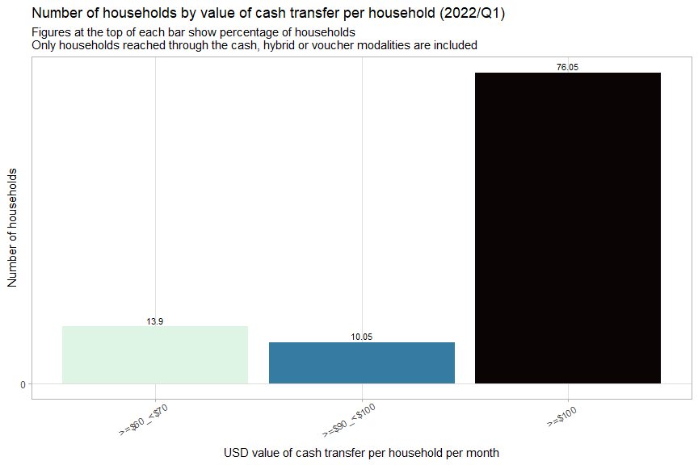

86% of households received greater than USD 90/month per transfer. This aligns fairly well with 100% of the Minimum Expenditure Basket for food expenditures (USD 104.56/household/month). It should be noted, however that the value of the Minimum Expenditure Basket (calculated for 2021) needs to be revised as the Food Security Cluster anticipates 40% inflation in 2022.

The table below shows the average USD values per transfer per household by and total transfer values per activity in the first quarter of 2022.

Only households which were reached by cash, hybrid or voucher modalities are included

| activity | hhd_frequencies | total_value_usd | avg_transfer_value |
| --- | --- | --- | --- |
| multi-purpose cash transfer | 5,110 | 454,046 | 88.85 |
| IGA and small grants | 303 | 20,473 | 67.57 |

### 3.2 Cash transfer values by implementing partner

The plots below show average cash transfer values by activity of the partners who reached the most beneficiaries.

The x-axis shows the average value per person or per household, depending on the activity and the colour indicates the number of beneficiaries reached.

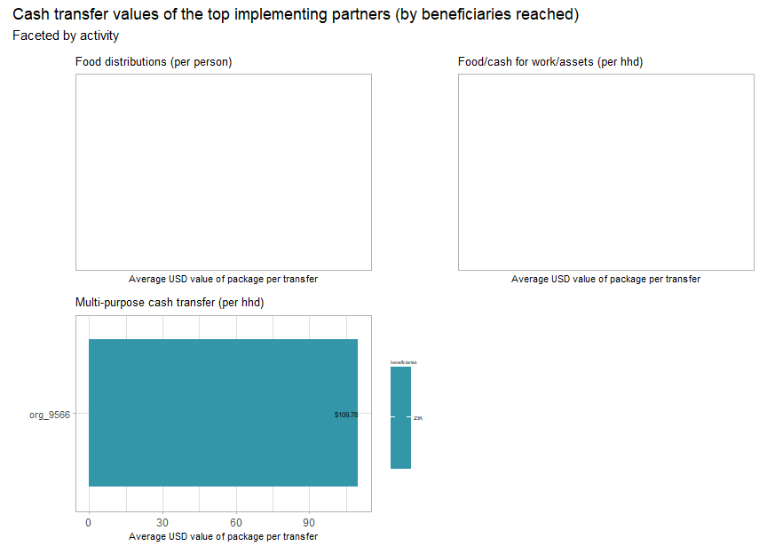

### 3.3 Cash transfer values per person

The boxplots above shows the range of cash transfer values (all values are per person, to facilitate comparability) by activity. The average for reach activity is marked by the thick line in the middle of each box. The leftmost and rightmost side of each box indicate the 25th and 75th percentile of transfer values, respectively. The length of each box is a gauge for how much variation there is in the transfer values of each activity.

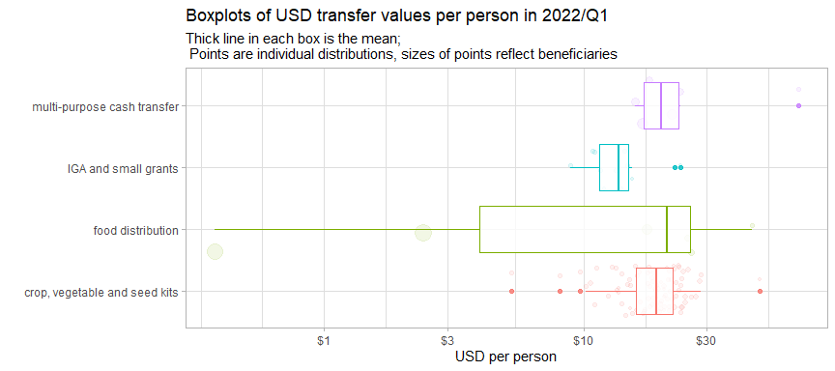

Additionally, each of the bubbles indicate an individual distribution, with their position along the x-axis showing the USD per person value of the distribution and the size of each bubble indicates the number of beneficiaries reached.

Despite being the activity which reached the most beneficiaries, crop and vegetable kit distributions and IGA small grants have the tightest ranges of transfer values, though, as will be explored further in the plot below and in the next section, there are substantial outliers.

In the interactive scatterplot below, the x-axis indicates the number of beneficiaries reached and the y-axis indicates the per person value of each transfer. Each point is a distribution and the size of each point indicates the number of beneficiaries reached. More details about each distribution can be seen by hovering your cursor over each point.

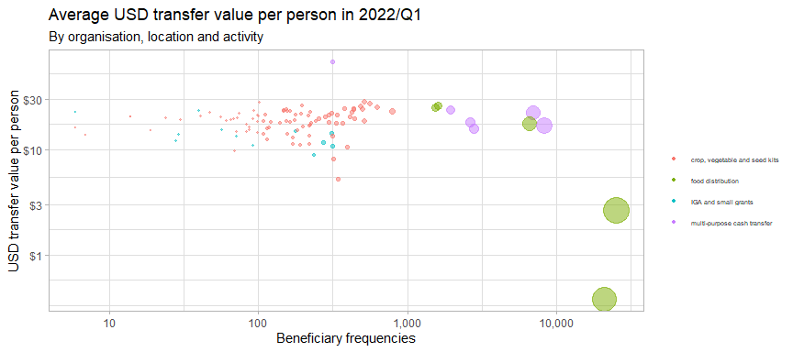

Food distributions and multi-purpose cash transfers had the largest dispersions in the values of their transfers. For food distributions, there are two clusters largely below USD 5/person in Myawaddy in Kayin and Hpruso in Kayah and for multi-purpose cash transfer, above USD 60 per person distributed in Tanintharyi Region.

As mentioned, food distributions had the vast majority of distributions falling just below USD 10/person. However, it has outlying values that reached very large groups of beneficiaries. This will be explored in the next section.

### 3.4 A closer look at food distributions

The interactive plot below breaks down the range of USD per person cash transfer values by state. Similar to the plot above, each point is a distribution and more details about each distribution can be seen by hovering your mouse over each point.

The red line indicates 50% of the monthly expenditure basket (MEB) for food (divided by 5 to get the figure per person). The vast majority of transfers fall below this value.

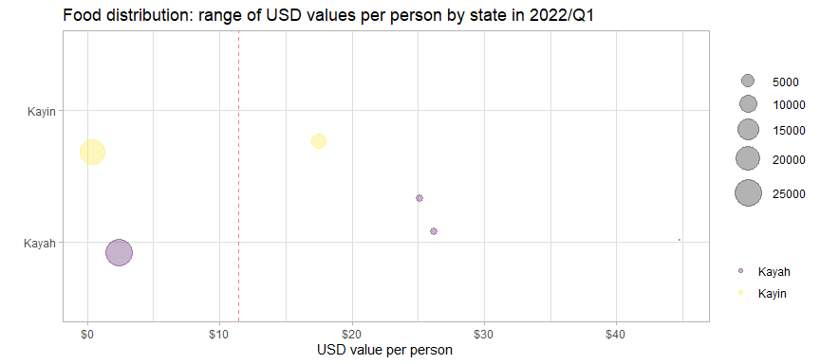

Kayah notably have several extreme outliers much higher than the average for that state. However, Kayin has a very large number of beneficiaries who received less the USD 1/person. There were no food distributions in Mon state.

The table below compares the different bins for cash transfer values of food distributions with the minimum expenditure basket for food established by the Cash Working Group. They have established a floor of MMK 190,555 (or USD 114.55).

Overall, 5.89% of food distribution beneficiaries have received at least 100% of the MEB and 17.83% have received at least 50% of the MEB.

Monthly cash-based transfer values by percentage of MEB received

| usd_person_bin | avg_pc_of_meb | avg_usd_month | beneficiaries | pc_of_ben |
| --- | --- | --- | --- | --- |
| <$2 | 1.65 | 0.38 | 20,843 | 37.36 |
| >=$2_<$4 | 10.56 | 2.42 | 25,000 | 44.81 |
| >=$16_<$18 | 76.28 | 17.48 | 6,665 | 11.95 |
| >=$20 | 139.4 | 31.95 | 3,284 | 5.89 |

However, a very large proportion of the beneficiaries reached were between USD 2 and 4 per person, very low in compare with 50% of the MEB. The 50% threshold is of interest because humanitarian assistance does not aim to cover the full MEB and is intended to meet acute needs.

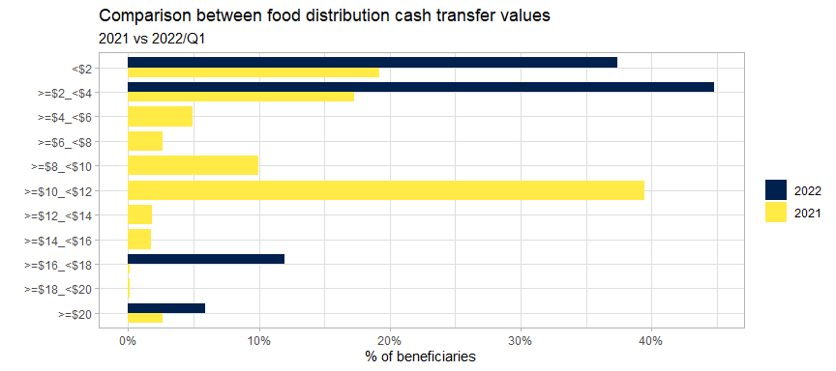

With reference to the plot above, the per person USD values in 2022 are more consistent than in 2021, with more than 40% of beneficiary frequencies receiving between USD 2 and 4 per transfer. The average transfer value for food distributions in 2021 was USD 7.36; in 2022/Q1, it was USD 8.59.

## 4. Beneficiaries

### 4.1 Beneficiary types

74.71% of beneficiaries were from the host or local community. 14.58% beneficiaries were IDPs.

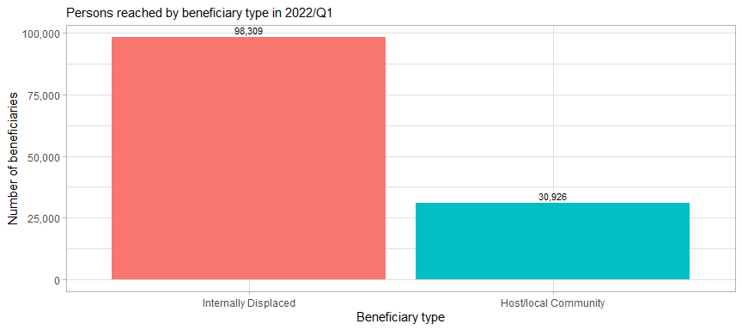

### 4.2 Evidence of food insecurity status

Exploring the food insecurity status is very important to determine whether or not food security interventions are truly reaching those most in need. Most of the beneficiaries reached had evidence of their food insecurity status. 17% of beneficairies didn’t have the evidence.

Food insecurity status and evidence provided in 2022/Q1

| food_insecurity_status | beneficiaries | %_benficiaries |
| --- | --- | --- |
| Moderately food insecure | 19,705 | 15.25 |
| Severely food insecure | 87,590 | 67.78 |
| No status provided | 21,940 | 16.98 |

As evidence of food insecurity was provided by for the vast majority of beneficiaries reached, much of the evidence that was provided were reasonable justifications for targeting beneficiaries. Only one good reason with armed conflict included while 32.22% didn’t have any reason.

Breakdown of evidence of food insecurity status in 2022/Q1

| evidence | beneficiaries | %_beneficiaries |
| --- | --- | --- |
| Armed conflict | 87,590 | 67.78 |
| No evidence | 41,645 | 32.22 |

The general lack of evidence of evidence of beneficiaries’ food insecurity status makes it difficult to justify to affected communities and donors that the Food Security Cluster is reaching the most in need. This highlights the need to promote a shared understanding of the response through the development of a common prioritisation tool for food security partners.

### 4.3 Beneficiary disaggregation

Due to the problems in reporting disaggregated beneficiary data, two tests have been applied to the submitted 5W data. The first involves a comparison to the proportions of disaggregation groups in the census to determine if values have been backfilled from the census.

The plots below show the breakdowns between the “real” values and those that have been backfilled from the census. Approximately 59% of beneficiaries reported had values that were not backfilled from the census; this is an improvement from 2021, where only 44% of beneficiaries had “real” disaggregations.

In the “real” values, it can be seen that the proportion of adult females reached is much higher than adult males – this is in line with the Cluster’s understanding of several activities that specifically target women. The percentages of elderly persons actually reached is also much lower than what has been reported.

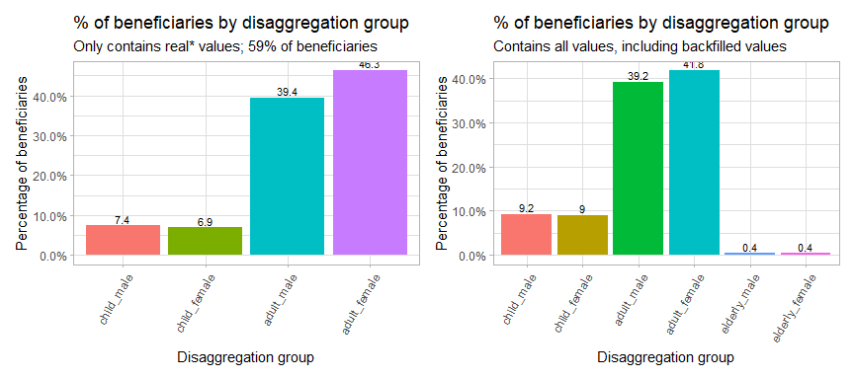

The second test applied is if the disaggregated numbers of beneficiaries reached have been copied and pasted. To do this, the proportions of each disaggregation group by partner have been compared to how close they were to the mean for the entire group. To explain: if partner A reported that 40% of beneficiaries in an activity were adult females, this percentage was then compared to the average percentage of adult females for all other activities reported by that partner. This measure whether or not the same proportions were copied and pasted throughout the 5W form.

It is extremely unlikely that these percentages would be similar across activities as implementing partners worked in an average of 32.39 locations.

In the plot below, the closer a value is to 0% on the x-axis, the more likely it is that it was copied and pasted. It is estimated that 89% of beneficiary disaggregation values were copied and pasted.

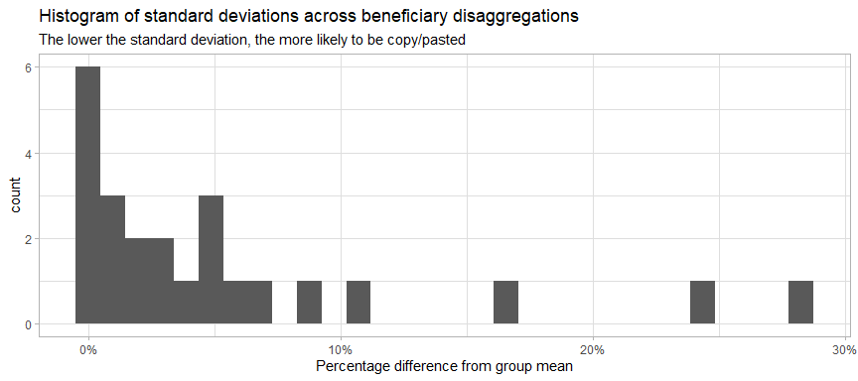

## 5. Partners

### 5.1 Reach by implementing partner

There are 5 partners that were involved in direct implementation that have reported achievements in first quarter of 2022. These implementing partners corresponded to a total of 5 reporting organisations. The largest reporting organisation, org_9566, had reached vast majority of beneficiaries in 10 townships in 4 states.

The interactive plot below shows the number of beneficiaries and townships reached by implementing partner.

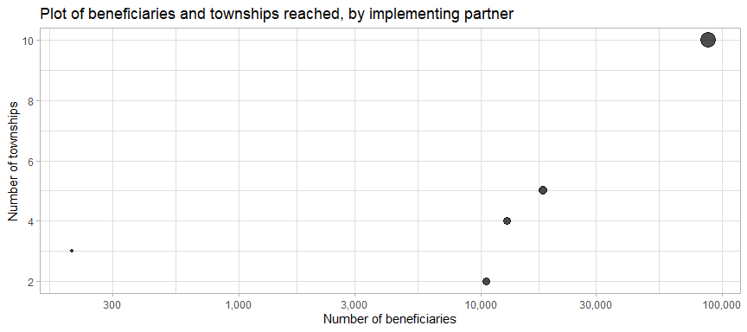

In 2021, it was noted that whilst there was much variation in the numbers of beneficiaries reached by each implementing partner, their geographic footprints were quite limited. This pattern has continued into 2022/Q1. Only 6 partners (17% of the total) have a presence in more than 5 townships. The distribution of partners remains an impediment to the implementation of a countrywide response. And the following steps mentioned in the 2021 report are still very necessary:

* Incentivise partners to expand their footprints
* Identify new partners to reach vulnerable persons in areas recently affected by conflict
* Encourage donors to support expansion of Food Security activities in areas recently affected by conflict (with sufficient support costs)

### 5.2 Monthly progress by partner

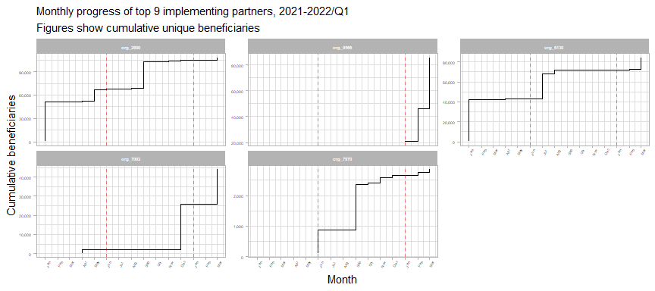

Overall, 13 implementing partners increased the number of beneficiaries reached over their 2021 totals by more than 50%; 29 partners who reported in 2021 also reported in 2022/Q1. 7 new implementing partners reported in 2022. And 28 partners who reported in 2021 but have not yet any achievements in 2022.

summarise() has grouped output by ‘org_code’. You can override using the .groups argument.

Top implementing partners by beneficiaries reached in 2022/Q1

| org_code | ben_2021 | rank_2021 | ben_2022 | rank_2022 | total_ben |
| --- | --- | --- | --- | --- | --- |
| org_9566 | NA | NA | 85,590 | 1 | 85,590 |
| org_7002 | 25,954 | 21 | 18,021 | 2 | 43,975 |
| org_6130 | 71,467 | 11 | 12,396 | 3 | 83,863 |
| org_2690 | 103,611 | 8 | 3,590 | 4 | 107,201 |
| org_7970 | 2,580 | 40 | 203 | 5 | 2,783 |
| org_1206 | 33,442 | 20 | NA | NA | 33,442 |
| org_1233 | 5,162 | 30 | NA | NA | 5,162 |
| org_1538 | 4,208 | 32 | NA | NA | 4,208 |
| org_2157 | 2,612 | 38 | NA | NA | 2,612 |
| org_2254 | 41,231 | 16 | NA | NA | 41,231 |
| org_2441 | 3,697 | 33 | NA | NA | 3,697 |
| org_2461 | 4,433 | 31 | NA | NA | 4,433 |
| org_2537 | 6,052 | 29 | NA | NA | 6,052 |
| org_2807 | 1,001 | 48 | NA | NA | 1,001 |
| org_2825 | 49,692 | 15 | NA | NA | 49,692 |

### 5.3 Donors

As shown by the table below, the majority of beneficiaries reported in the first quarter of 2022/Q1 were reported without any corresponding donor, as in 2021. The data in this column continues of limited utility in analysis.

Top donors by benficiaries reached

| donor | beneficiaries | %_beneficiaries |
| --- | --- | --- |
| FCDO | 43,019 | 33.29 |
| CERF | 29,026 | 22.46 |
| WVI | 20,843 | 16.13 |
| BPRM | 13,457 | 10.41 |
| No donor specified | 10,516 | 8.14 |
| FCDO+BPRM | 7,059 | 5.46 |
| LIFT | 2,898 | 2.24 |
| Norad | 1,900 | 1.47 |
| Other donors | 517 | 0.4 |

## 6. Comparison with targets

### 6.2 Reached vs target by township

The specifics of each township can be reviewed with the interactive plot below. Each point is a township, with the size indicating the number of beneficiaries. The x-axis indicates the target population by township and the y-axis shows the number of beneficiaries reached in 2022/Q1.

The red line down the middle represents reaching 100% of the target. Townships above this line have reached more beneficiaries than their target and townships below the line have not met their target yet. The further away a township is from the red line, the further above or below its target it is. Mouse over each of the townships to see more details.

The 12 townships along the extreme left side of the plot have beneficiaries but do not have targets (their targets have just been coded as $1$ so that they show up on the plot). 230 townships with targets have not been reached.

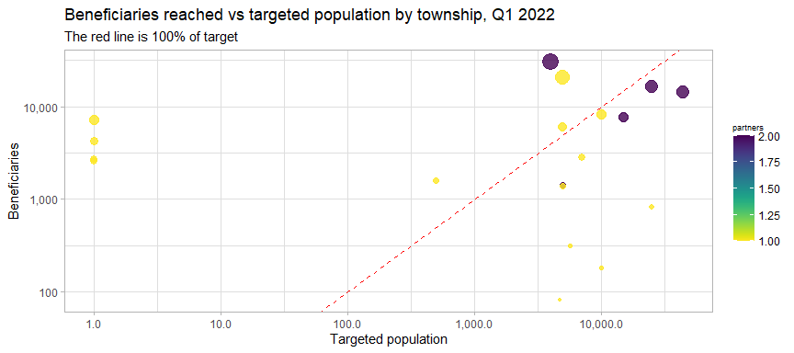

### 6.2 Map of beneficiaries reached in 2022/Q1 vs target

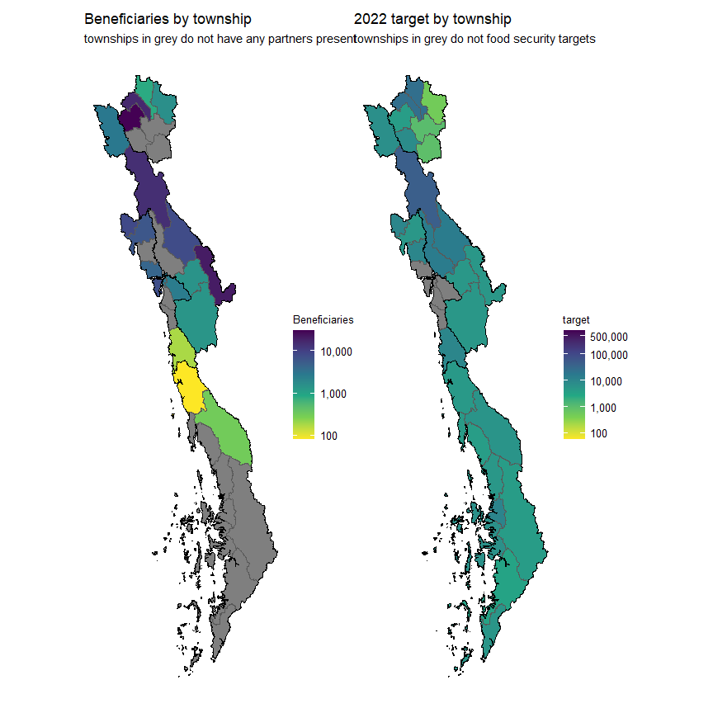

With the important exceptions of Yangon and the Southeast, beneficiaries are concentrated in the peripheral and border regions of the union, where humanitarian actors have traditionally been present. As mentioned in previous reports, this is not consistent with the current patterns of needs and vulnerability.

### 6.3 Interactive reference table

There was an overallocation of resources in these relatively few areas in 2021 and this has continued in the first quarter of 2022. In the interactive table below, is a list of townships sorted by the gap between the targeted population and beneficiaries reached in 2022. Any of the columns can be sort; the search bars above each column can also assist in filtering.

