foodsoft
open source software voor foodcoops

manual for foodcoops
using pre-ordering
version EN 20140710

Order cycle
In a foodcoop, members order food together from suppliers of their own choice. The process of ordering consists of the following steps:
- Prepare
  - Update information about suppliers and articles.
  - Choose which articles can be ordered or not (when needed).
- Order
  - Orders open.
  - Members do their orders (during a number of days, usually).
  - Orders are closed, and are sent to the suppliers (possibly automatically).
- Receive & distribute
  - Orders are delivered at a central location. There they're counted, and any changes are entered.
  - Distribute articles over members
- Finalize
  - After a final check, the administration of this order cycle is closed, and members are charged their final amounts according to what they received.

Please note that the current images are in Dutch. Please feel free to make new screenshots and send them to the developers at foodsoft-dev or foodsoft@foodcoop.nl.


foodsoft
order cycle – prepare

Update assortment
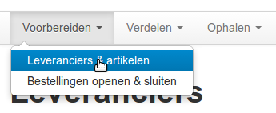
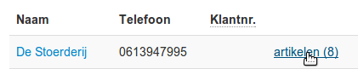
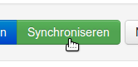 or 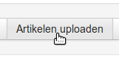 or 

Make selection from assortment
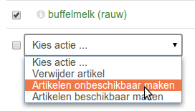

foodsoft
order cycle – order

Open

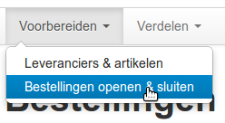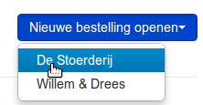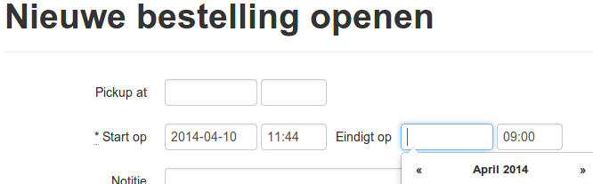
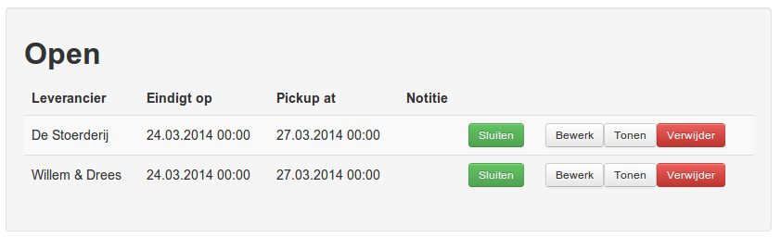 ✔

Members order 

Close

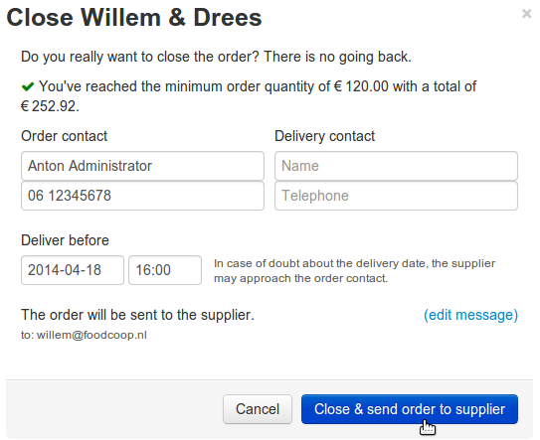
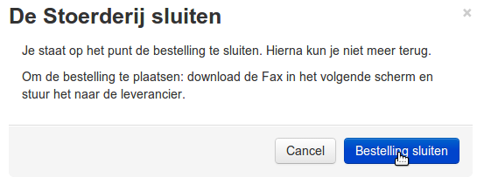
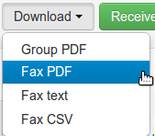 & 

foodsoft
order cycle – receive

Print order lists (when using paper during receive)
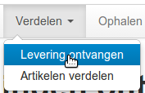
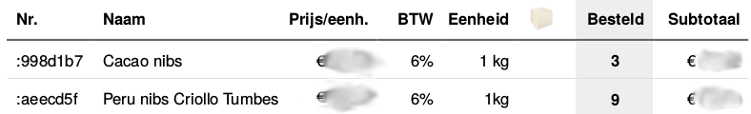

Enter received amounts

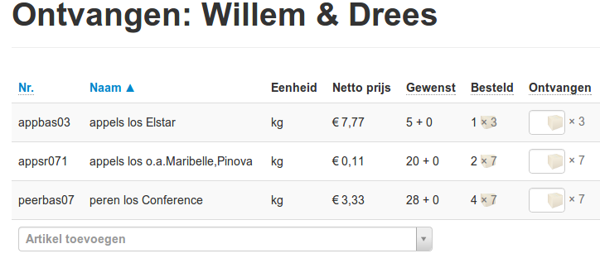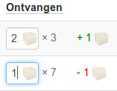

foodsoft
order cycle – distribute

Print distribution lists (when using paper)
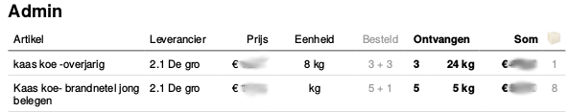
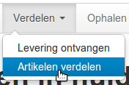
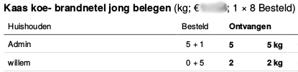
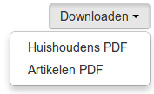

Update and view member amounts
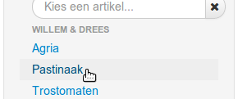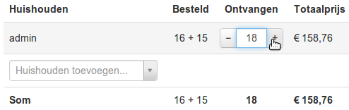

foodsoft
order cycle – finalize

Finalize / Settle
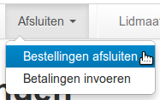
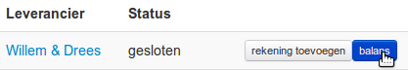

Check and update totals
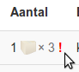 → 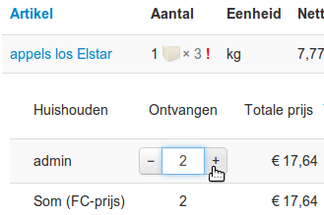 → 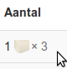

Charge member accounts
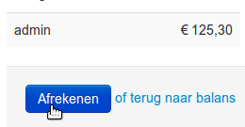
Enter invoice (optional)
( )

Done!


