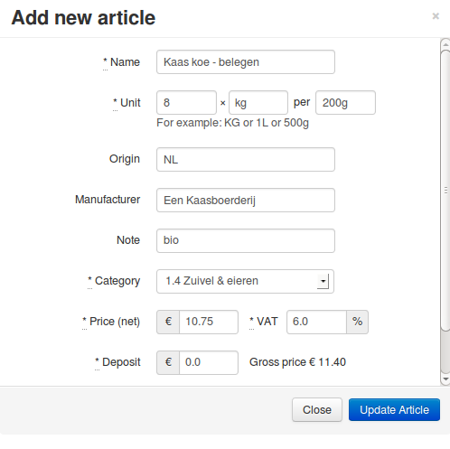
foodsoft user-interface proposal for fresh products
(proposed screen)
28 Feb 2014, wvengen

At this moment, foodsoft can pretty well handle dry goods and packaged products. We'd also like to handle fresh products, that are handled in terms of kilograms. How would foodsoft look to support this? And for those who are new to foodsoft, there are screenshots of existing screens as well.

Articles
In the Admin section, go to “Suppliers & articles” and select the articles of the supplier.
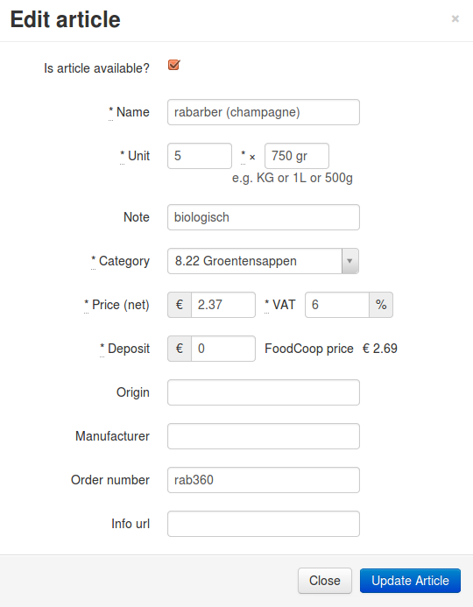
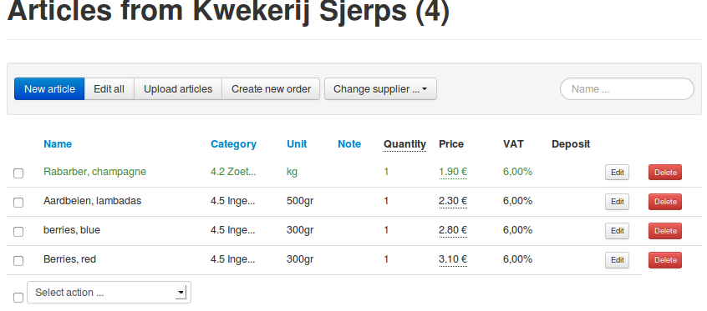
There is a list of articles, where existing ones can be changed or deleted, and new ones can be added. At the moment, there is only a column “Quantity”, which means here: number of articles per pack (only full packs can be ordered from the supplier).

Proposal F.2:
Add a new field “subdivide in”. When entered, members will be able to order multiples of its value. In the example here, Rabarber is ordered from the supplier per kg, and we may want the members to be able to order per 200g.
It would be useful to take “kg” as unit, and enter the weight of a crate (in kg) as unit quantity (supposing the supplier delivers per full crate). The price is then the price per kilograms. The subdivision unit is 200g.

Question (answered):
Do we need a minimum order quantity per product? When a supplier expects any weight above a certain minimum (vs. per full crate), this would be useful. → Not needed

Orders
When the articles are up-to-date, the order is opened (e.g . the “Create new order” button). One can select which articles will be available for ordering.
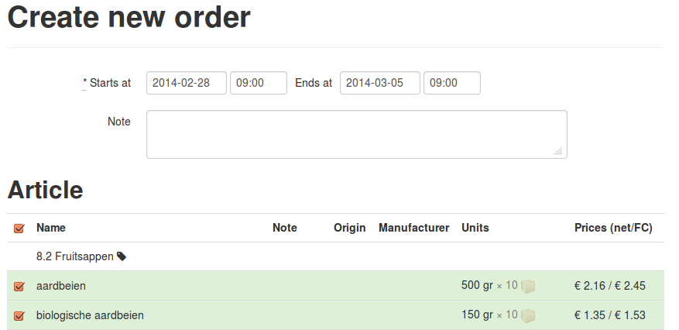

Dashboard
When the order opens, it becomes visible on the dashboard where members can order.
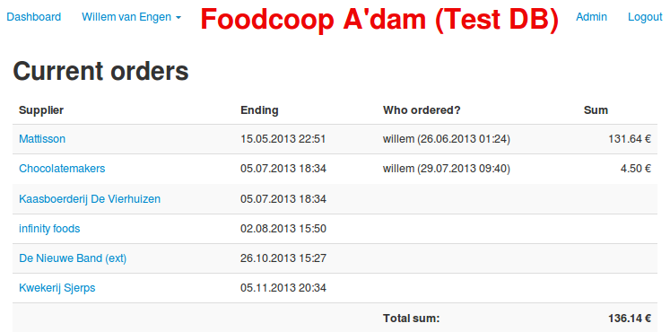

Member order
Clicking on the supplier brings a member to its ordering screen:
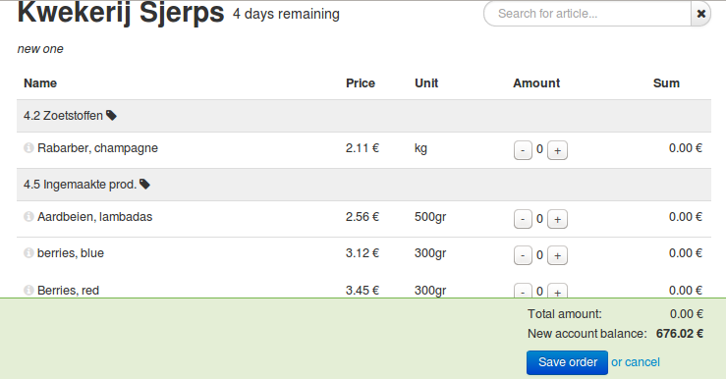
In this case, there are no packs to fill; if there are, a tolerance is shown, which allows members to order more units when that is needed to fill a pack. The “All members” column shows how much of the article has been ordered by all members of the foodcoop, as well as the progress of the last pack to fill.
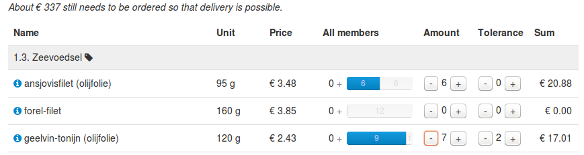
Proposal F.2: in case of fresh products, not much needs to change.

Name Price Unit All orders Amount Sum
Rabarber 1.90 € kg 0 kg 0.2 kg 0.38 €

Perhaps there is a minimum order quantity for a product. In that case, it may be useful to have a column indicating how much still needs to be ordered (when below that amount). Do we need a tolerance in that case? → No minimum order quantity required

When the farmer only delivers in multiples of x kg:

Name Price Unit All orders Your amount tolerance Sum
Rabarber 1.90 € kg 0 + kg 0.2 kg 0.0 kg 0.38 €
0.2
1.8

Ok, the column names could be much clearer, but I hope the idea is clear. The above means that the member has ordered 200g of rabarber, other members have ordered nothing yet, and that still 1.8kg needs to be ordered to fill the last pack.
Members can order in steps of “per ...” (from the article screen), the price shown is per kg or g (the software could do a good guess). TODO
Question: do we want to use tolerance, or instead fill a package for vrije verkoop?
→ ? configurable per article, with supplier default?

Closing orders
When going to (Admin →) Orders, it is possible to close the order.
Upon closing the order, the number of full packs is computed, as well as how much each member receives (first come, first serve). The screen then shows how much full units (packs) there are and a fax PDF or text file with the number of packs can be downloaded. The person doing the ordering sends this information to the supplier.
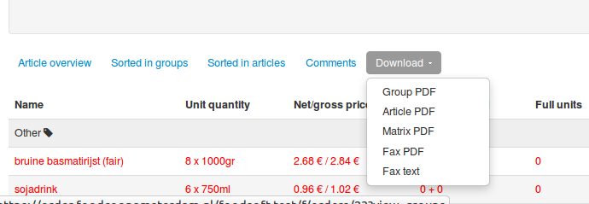

Proposal O:
Before ordering, prices may need to be updated. And maybe the foodcoop wants to order slightly more than just the member orders. At the moment, this cannot be done in the system. It would be nice to be able to enter that before making the Fax PDF – so that the fax is complete, and someone looking in the order system later can see what was ordered. → propose to do that later, not yet

Delivery day
Lists of articles per member (Group PDF) and members per article (Article PDF) can be downloaded from the orders screen beforehand, when desired.
On delivery day, when the orders are received, the products are weighed and entered into the system. When the amount is less than requested, the actual amount is divided over the members. When the amount is more, member orders remain unchanged, the remainder to be sold separately.

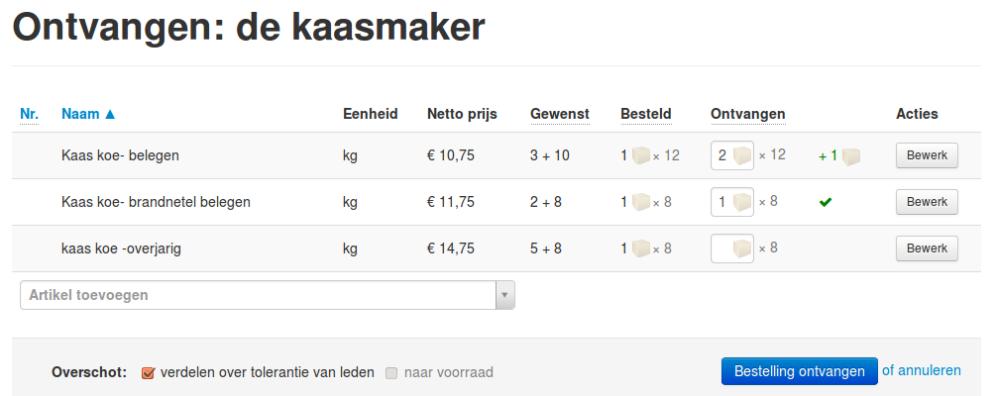

Proposal P:
This receive screen is now present for packaged goods, but needs adaptation to be able to enter a weight (instead of multiples of the ordering unit).
Then the products are distributed in the “distribute articles” screen. Here you can download a PDF with lists per member and per article to help with distribution, covering all current orders. It is also possible to update the amounts members received for each article.
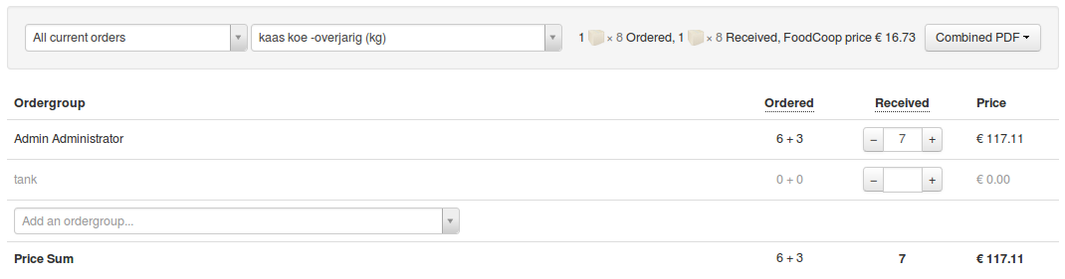
When, during sales, a member's order needs to be updated, that can be done in the “check member orders” screen. Here the articles and amounts can be adjusted. Note that this can only be done before the order is finalized.
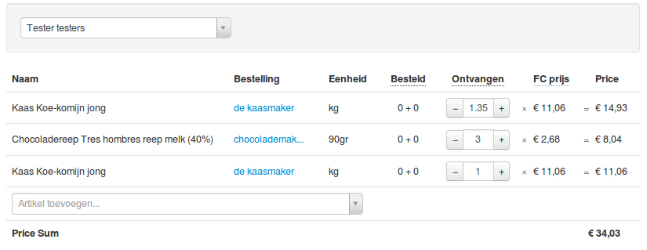

Checkout
Somehow the data needs to go from foodsoft to the existing ordering system. The easiest option is to use the current “vers upload” form, and let foodsoft generate something suitable for that to copy.
One question is: do we want members to wait with checkout until fresh has entered everything? Or is it ok to checkout with what was expected before the ordering day, and correct that later when needed?
An issue here is that within foodsoft member amounts can only be changed when the order is not yet finalized. And only after post-admin is finished, the order can be finalized, which is after the pickup day. → Need to upload intermediate amounts to the vokomokum ordering system, and final amounts after pickup day. Discuss with Nic.

Post administration
What happens here?
* Adding an invoice * Financial check * Paying the supplier * Finalizing the order when all is done.
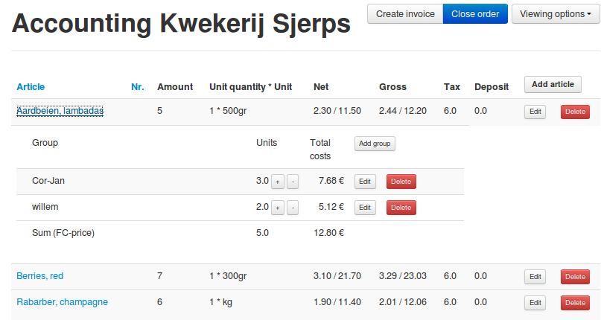
It is possible to add and remove products from the order, and to change the amounts of members. This is mixed with a financial overview of the products and the complete order.

What is needed to achieve this? (technical stuff)
Proposal F.2
- Add subdivision field to order_article model OR add multiple price relations
- Update different views to include this change
Member order screen improvements
- Add “units to fill pack” progress bar (done)
- Allow to enter a number in addition to using the +/- buttons (mostly done)
- Allow to show price / kg even when ordering in fractions.

Proposal P
- Add screen to enter amount received (done)
- Add amount received field to order_article model (done)
- Allow to enter partial weights in receive screen → Q really needed?
- Think about which quantity fields need to be displayed where in the user-interface; do so.
- Redistribute articles among members when amount received differs from ordered (done)
- Allow to redistribute total proportionally over members when it's less in receive → Q needed?

Proposal Q (done)
- Add screen to change member orders for a certain article (done)
- Perhaps also add a screen to review and update a member's ordergroup (done)

Proposal U
- Upload vers amounts to vokomokum dry order system
  - after an order is closed (for all members who ordered)
  - when a member order is changed
  - after an order is finalized (for all members who ordered) (may not be necessary if amounts are also updated when a member order is changed, but it's a good idea to check if the dry and vers system are in sync at that moment)
- Handle upload errors gracefully
  - including when a member is already checked out

Other
- Allow login with account from existing system. (done)
- I think we could ignore member (ordergroup/household) accounts and let that happen in the existing system.
  - Hide everything related to financial transactions
  - Do not debit ordergroups when finalizing/settling an order (but do check vers upload)

