**Project Report FoodCoop**

**Klik-je-(k)eten**

27-06-2014

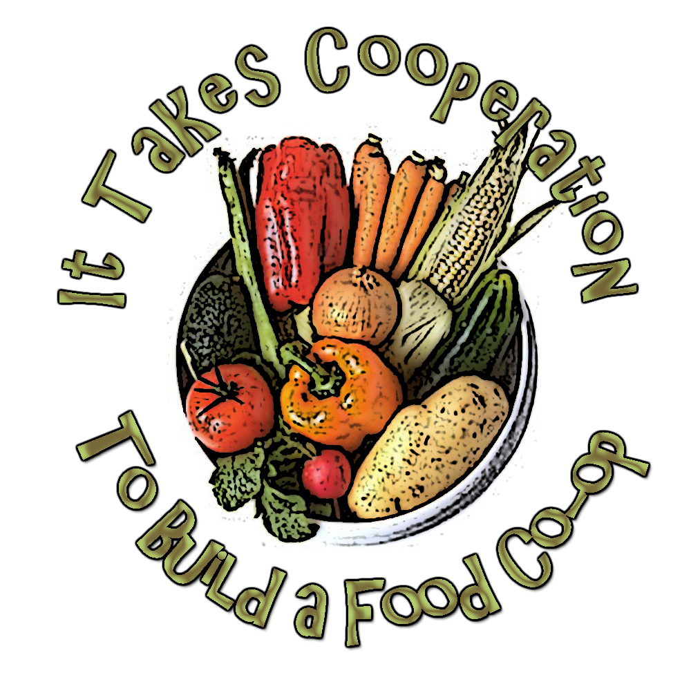

**Created by:**

Martien Bonfrer, Roy Hoeymans, Bart Sunter, Dex Bakker

Bachelor students Information, Multimedia, and Management (2013-2014)

VU University, Amsterdam

**Content**1. Introduction 1.1 What’s in this report? *p.3*  
1.2 Terminology *p.3*  
2. Project description  2.1 Context *p.4*  
 2.2 Scope of the project *p.4*  
 2.3 Project objectives *p.5*  
 2.4 Delivarables *p.5*

3. Advice 3.1 Implementation phases *p.6*

**Executive summary**This project report was commissioned by the foundation FoodCoop NL. It mainly focuses on the problem of creating and providing insight into food chains by means of the provision of information and software. This way foodcoops are enabled to live up to their values, control where the food they buy is coming from and support the suppliers, processors and transporters they think deserve the attention.

The project goals are to give insight in the main problems FoodCoop NL has at this moment and will encounter in the future regarding the IT infrastructure, to create a data model that can be implemented in the system and provide a user interface mockup to visualize how the information and creation of chains can be displayed.

In the first deliverable we first zoom in on the current IT infrastructure with a complete analysis of Foodsoft and the data structure. The problems are divided into four sections in which we separate the issues. These consist of the manual entrance of supplier data, the manual synchronization of the databases, the dispersion of the location of data and the separation of supplying information and Foodsoft as services. For the previous problems we provide two main solutions: a central database and an API to access it.

The second deliverable focuses on the creation of a new data model for Foodsoft that makes it possible to link food chains together. Its objective is to provide a way to store all the information that is generated with the creation of a food chain. In addition, several real life use cases are elaborated to demonstrate how the data model could be used when implemented.

Finally the third deliverable provides a visual interpretation on how the process of linking chains can be practically modelled. We display this with a complete use case of a typical user that would create a chain via Foodsoft. The mock-ups that show this interpretation are meant as an inspiration of what the system could look like and does not focus on how information is retrieved. We end this final document with our final remarks and advice, which is split into several phases of implementation. This is an explanation on how we think FoodCoop NL should continue the development of their system in separate detailed steps.   
  
The first phase would be setting up a central database and API to access the data. The second phase starts with creating a basic foodchain-system where organisations can create their own chains and visualize their own process. The third phase focuses on the extension of the system set up in the second phase where it will be possible to change existing chains and proposals will be send to organisations for approval. The final completion phase encompasses the addition of the ability to create a full chain by linking organisations together by foodcoop users.

**1 Introduction**

* 1. **What’s in this report?**

This report serves as an accompaniment for the three deliverables that we (the project group) have provided. Section 2 of this report starts with a project description in which we define the objectives of our project. These objectives are reflected in the deliverables that we have created. Each deliverable can be treated as a separate report but together they relate to the goals and the questions that we’ve asked in the project description. This report closes with an advice section, which is serves as a guide for FoodCoop that explains how the deliverables can be used to realize and implement this project.

**1.2 Terminology**

We’d like to briefly clarify some of the terms we will be using during this report and in the deliverables.

**What is a foodcoop?**A foodcoop is an abbreviation of the word food cooperation. A food cooperation is a group of people that collectively orders food directly from the suppliers. This way they make sure that they receive a good product and that the supplier gets a fair price.

**Difference between foodcoop and FoodCoop**

A foodcoop refers to a food cooperation, while FoodCoop refers to the organisation that this report is intended for.

**What is Foodsoft?**Foodsoft is the software that is currently used by FoodCoop. Right now it is used as an order system for foodcoops to order directly from suppliers.

**What is a "food chain"?**This question is one of the main subjects we focus on during this project. A food chain encaptures all the processes that a food product goes through from start to finish. The project description in this report and the data model specification (deliverable 2) give a much more in-depth explanation.

**2 Project description**

**2.1 Description of Foodsoft**FoodCoop is an organisation that supplies software and information about suppliers to foodcoops, to support them with the process of selecting suppliers, composing a product assortment, and ordering products. They support secure payment with iDeal via their software or pin. This way, they aim to unburden foodcoops with tedious administration tasks, making it easier for them to focus on selecting products that match their values and ideals.

FoodCoop wants to expand their software with new functionality. They want to give foodcoops the ability to compose their own 'food chains' that matches their values and ideals. These values should be expressed by the choices that the foodcoops make when creating their food chain. These choices include selecting certain suppliers, transportation firms, food processors, and suppliers. This way, foodcoops can purchase food that matches the values and worldviews that they find important. This project focuses on this new functionality of creating food chains.

The following group of people will be using the new system:

* Suppliers - suppliers can make their processes visible to the foodcoops and offer their products via the software.
* Consumers - consumers can be part of a foodcoop. This allows them to collectively indicate from which suppliers they want to order and which values are important to them.
* Foodcoops - a foodcoop has a collective idea about their values, which influences which suppliers they choose to order from. Their is often one person or a group of person that represents the members of the foodcoop.

**2.2 Scope of the project**

The process of creating food chains is very complex and ambitious from not only an organizational, but also a logistic and technological perspective. In this project we will focus purely on how the concept of the food chain can be applied to the IT aspects of the organization FoodCoop, while also recognizing that there other important aspects that are important, like transportation, terms of delivery, rating systems for products or suppliers, and trading marks. We have kept this in mind while working on the project so that the system can be expanded to include these things.

**2.3 Project objectives**

* Giving an overview of IT problems that FoodCoop encounters or will encounter in the future.
* Designing a data model that can handle the food chain concept.
* Finding out how the large amount of information that comes with creating a food chain can be made visible to the possible users of the software.

By creating insight into the IT problems that FoodCoop copes with or will cope with, it can focus on other aspects of their organization. The goal of this report and the deliverables is to create a base for possible expansions and eventually as a reference for the implementation of this project.

**2.4 Deliverables**

Based on the three project objectives and questions we have asked ourselves, we have decided to divide this project into three deliverables. Below is a description of each deliverable along with related questions that we aim to answer in the deliverable.

* **Deliverable 1 - Analysis**

The analysis of the IT aspects of FoodCoop will be presented in this document. This document consists of two parts: an objective analysis of the current system and a proposal for solving the problems that we've discovered in the analysis. This first part can be seen as a separate document that can be used as a reference for IT projects that FoodCoop might want to do in the future. The second part is focused on how solving the IT problems paves a way for the implementation of the food chain concept.

Questions

* What is the current infrastructure of the IT systems of FoodCoop?
* Can this handle the 'food chain' concept that FoodCoop wants to implement?
* If not, how does the infrastructure need to be changed so that it can?  
  Which challenges related to IT does/will FoodCoop face when implementing the food chain functionality?
* **Deliverable 2 - Data model**

Constructing a solid data model that can be applied to the food chain concept is perhaps one of the biggest challenges of this project. The data model is delivered in the form of a UML schema, accompanied by a document that explains the food chain concept in great detail, along with a few use cases that show how to apply the data model, and a documentation that describes each table.

Questions

* How can the many types of data that is available about products, suppliers, foodcoops etc. be generalized to a solid data structure?
* How can the food chain concept be represented in the data model?
* Which elements are part of a chain? How can these parts be linked?
* **Deliverable 3 - User interface**

The last document presents a visual interpretation of how food chains can be composed with the use of  the software. We have created a mock-up, along with a simple clickable model that can be accessed in a browser. Link: [www.klik-je-keten.nl/mockup](http://www.klik-je-keten.nl/mockup)

Questions

* How can the food chain concept be represented visually?
* How can we display the large amount of information concerning a food chain while not losing sight of the overall picture?
* How can we show the consequences of the choices that the user makes while creating a chain on the world and environment?

**3 Advice**

In this section we would like to explain which steps FoodCoopNL can make toward a fully functional system in which the foodcoop’s can create their own foodchains.

We think the project is too big to implement in one step, thats why we came up with a four step process. Each phase is a (small) step towards the end goal. It is very important that this end goal is kept in mind while developing the different phases, this way each new phase can be implemented with the least amount of issues.

**3.1 Implementation phases**

**First phase**

In the analysis (first deliverable) we talk about setting up a central information database and an API to access this data. This would be a great first step. This way you will have all the data at one location which makes the whole system much easier to maintain.

This step will take some time and effort because the Foodsoft system has to be reconfigured to work with the new database and API. But it is a vital first step in creating customizable foodchains.

The first deliverable explains how this phase can be accomplished.

**Second phase**

After laying the foundation it is time to start with the foodchain-system. The second step is implementing a very basic foodchain-system. We don’t want to make things to complicated in this step. So we start with a system in which organisations can create a chain just to visualize their own process.

This will give the user insight in how a product is manufactured and choose a product accordingly. The other two deliverables (Data model and Mock-up) can be used as guidelines when developing this phase, as well as in the next phases. The Data-model provides information about which data is needed and how it is connected to each other. This model is based on a complete system this means that you do have to implement all it parts in the first phases yet. But it can be beneficial to implement as much of the structure as possible so you won’t have to restructure your data between phases.

The Mock-up deliverable is also a great guide to use while developing this phase (and the next phases as well), the developers can use it to visualize the system which they are building. And its design can be used as inspiration for the real design.

**Third phase**

The third phase is enhancing the functionalities of the basic system. Now it will no longer be a system just to visualize the foodchain, it will also be possible to change an existing chain. This new chain will not work right out of the box, it is just an proposal to  the organisations to collaborate. If the involved organisations approve the request they will start working together and then can create a new working chain.

**The final phase**

After implementing this final phase you will have a complete foodchain-system, where a user (foodcoop) can create a completely functional chain. The system takes care of all unnecessary complicating processes. Another functionality of this final system is that it can advise a user to use a specific chain based on user’s values and standards.

This last phase will probably be the hardest phase to implement. There are a lot of functions, stakeholders and organisational issues that have be overcome. We don’t think it is impossible to implement this last phase but it will be very challenging.

**Organisation**

Implementing these phases while maintaining the current system will take a lot of time and effort. So much time that we don’t think it is possible to accomplish with just one developer. Thats why we advise to incorporate other people in the process, this can be done by hiring new people or collaborating with other organisations.