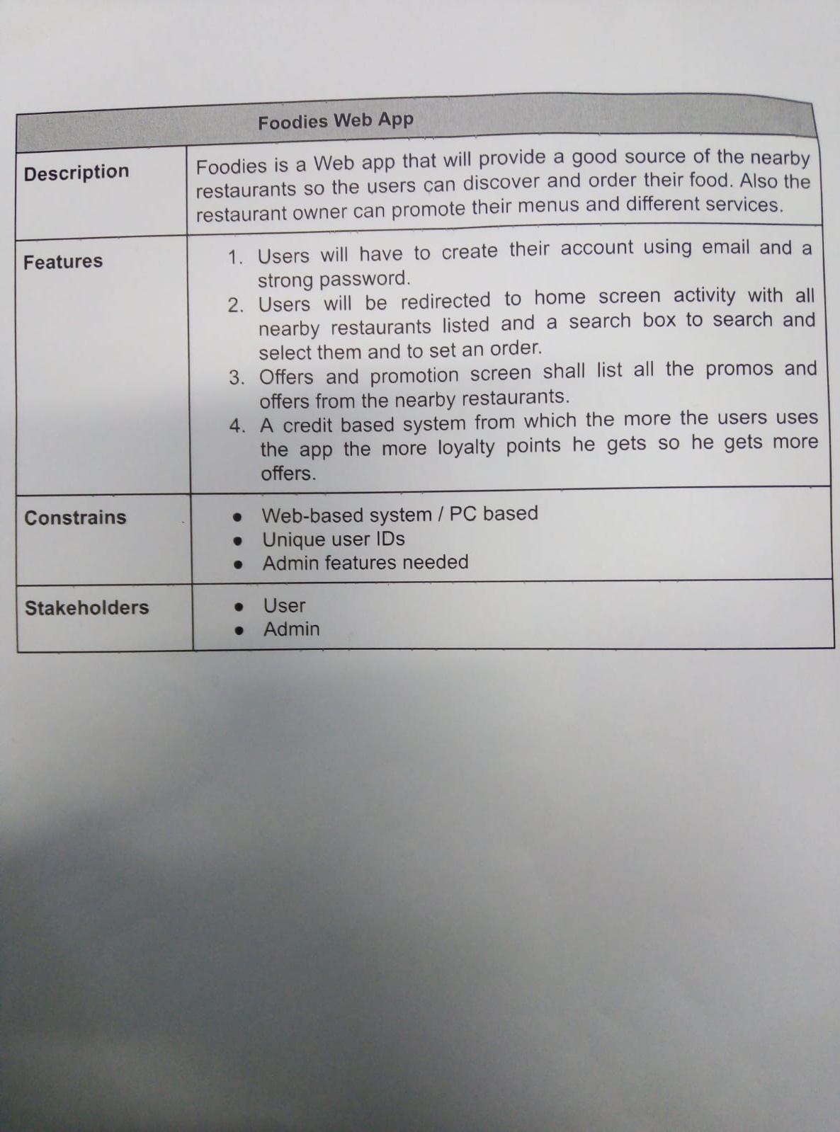

CustomerRequirmen _01

CustomerRequirmen _02

CustomerRequirmen _03

CustomerRequirmen _04