AD PROJECT PROPOSAL
FoodMind APP
A Meal Decision and Food Insight Platform
Team 5 | Date: 24 July 2026

1. Project Team
Team Member | Matric Number | Email
Chen Yaqi | A0335050U | terrence.yaqi.chen@u.nus.edu
Wu Aomo | A0335088X | e1671989@u.nus.edu
Huang Qijun | A0335061N | e1671962@u.nus.edu
Luo Yuxiang | A0335071M | luo.yuxiang@u.nus.edu
Lei Tianyou | A0335067A | tianyou.lei@u.nus.edu
Chen Chen | A0335082J | e1671983@u.nus.edu
Deng Yunke | A0335081L | e1671982@u.nus.edu

2. Executive Summary
FoodMind converts an existing manual behaviour - friends recording what they eat and drink in a shared document - into a cohesive meal-decision and food-insight product. Users can record and share food or drink posts, generate explainable meal recommendations, request a cooking plan, provide feedback, and view personal analytics. An independent FoodMind Chatbot helps users explore authorised platform content by searching, summarising and comparing Meal Notes, Food Products and Places. Native Android and React Web clients expose the same business functions through one Spring Boot Common Backend. A five-agent LangGraph service, an explainable Logistic Regression model, cloud deployment and CI/CD form one integrated end-to-end solution.
Originality statement: This proposal presents FoodMind as an original integrated project and not as a reuse of a previous CA Project.

3. Business Requirements
The business objective is to reduce everyday food-decision effort while preserving useful personal and trusted group knowledge. The MVP will meet the following requirements:
BR-01 - Identity and preferences: Users shall register, sign in with JWT and manage budget, liked or disliked cuisines, spice tolerance, dietary restrictions, preferred meal types, drinks, location area, food goals and hygiene or cleanliness priorities.
BR-02 - Food and drink posts: Users shall create, edit, delete and review food or drink posts. Food fields include meal time, food, restaurant, cuisine, price, rating, comment, optional photo and Would Eat Again. Drink fields additionally include shop, sweetness, ice and Would Buy Again.
BR-03 - History, privacy and trusted groups: Users shall filter daily, weekly or monthly history; create or join a group; publish each post as Private or Group-visible; browse the group feed; and save a shared item as Want to Try.
BR-04 - Direct meal recommendation: Selecting Generate Food Recommendation shall directly invoke the Recommendation Agent, which applies hard constraints, calls Logistic Regression and returns safe, exploratory and group-inspired choices while avoiding recent repetition.
BR-05 - Feedback loop: The system shall store recommendation acceptance, rejection reason, re-recommendation and post-meal rating as separate events, then use them in subsequent decisions and offline retraining.
BR-06 - Cooking plan: Selecting Generate Cooking Plan shall invoke the Cooking Planner Agent to produce a structured recipe from manually entered ingredients, budget, available time and dietary rules.
BR-07 - Independent platform chatbot: Users shall use the FoodMind Chatbot to explore authorised content across the platform. It shall search, organise, summarise and compare Meal Notes, Food Products and Places shared into the conversation. It is not the entry point for recommendation or cooking.
BR-08 - Data visualisation and recap: Users shall view meal and drink frequency, cuisine mix, spending, ratings, repetition, recommendation acceptance and Would Eat or Buy Again metrics, plus a concise weekly recap.
BR-09 - Cross-client parity: Android and Web shall provide the same business capabilities and use the same REST contracts, permission rules and metric definitions; only their UI layout may differ.
BR-10 - Integrated secure delivery: All client features shall use one secured Spring Boot Common Backend, and one or more complete features shall be available through a public HTTPS cloud deployment with automated testing.

Target Users and Business Value
Primary users are university students and young working adults who repeatedly decide what to eat, often with friends, roommates or colleagues. FoodMind reduces repeated searching, preserves dining memory, surfaces trusted group evidence and turns accumulated records into clear personal spending and eating insights.

4. Reference to the Problem
This is a real post from Xiaohongshu, a Chinese social media platform. Its title roughly means, “My friends are serious foodies, so I created a shared document.”
The blogger used to order whatever looked appealing. After seeing a widely discussed story about a food vendor, however, they became more conscious of food safety. They began checking whether a restaurant had a dine-in shop, what its kitchen looked like, and what delivery customers said.
Every meal decision became a research task. It took a lot of time and mental energy, but the blogger still sometimes ordered disappointing food. They even joked that they wished humans could evolve beyond the need to eat.
One day, a friend who knew a lot about food recommended a restaurant in their group chat. The blogger tried it and found the food excellent. Then, they suggested that everyone share their lunch and dinner, so the group could learn from each other.
However, chat messages were easy to forget and difficult to retrieve. The blogger joked that everyone had a goldfish-like memory. Therefore, they created a shared food document and put it in the group chat. Their friends recorded good meals, restaurants, and drinks. It worked well and became a reusable source of meal inspiration.
This is one concrete real-life example, which clearly shows the manual behaviour that inspired our project.
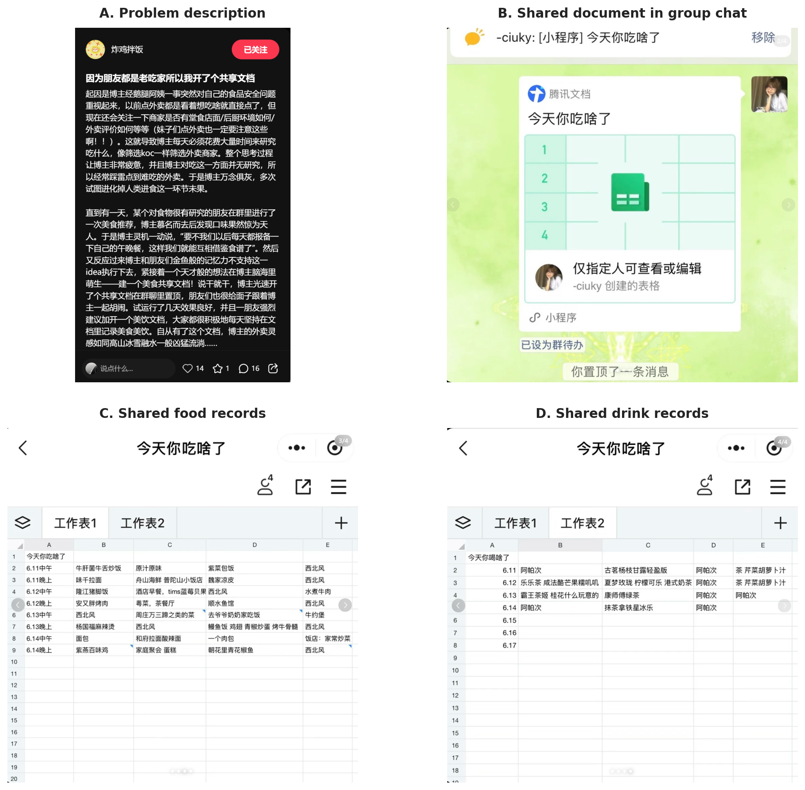
Figure 1. User-generated evidence supplied by the project team. The screenshots show both the stated meal-choice problem and an existing manual group workflow for recording food and drinks.

5. Proposed Integrated Solution
FoodMind centres on one product loop: Record and share -> Generate -> Filter and rank -> Explain -> Choose or reject -> Rate -> Analyse. Candidate meals come from the user's own history, authorised group records and a curated seed catalogue.

Independent AI Workflows
Generate Food Recommendation. The user taps the dedicated button and may add budget, meal type, mood, location or time constraints. Spring Boot authenticates the request and invokes the Recommendation Agent. The agent retrieves authorised context, filters dietary, budget, spice, hygiene and repetition constraints, calls the Logistic Regression ranking tool and returns three grounded choices.
Generate Cooking Plan. The user enters available ingredients, budget and time through a dedicated feature. The Cooking Planner Agent retrieves a seed recipe, checks constraints and produces ordered ingredients and cooking steps. It does not depend on the Chatbot.
Explore with FoodMind Chatbot. The independent Chatbot accepts questions or shared content. Its Orchestrator routes to a Platform Search Agent or Content Summary Agent, which searches, organises, summarises or compares authorised Meal Notes, Food Products and Places. It does not call the recommendation model.

Feature Coverage and MVP Boundaries
- Core records: profile and preferences, food posts, drink posts, personal history, optional photos, Private or Group visibility, group creation or joining, group feed and Want to Try.
- Decision and feedback: hard-constraint filtering, repeat avoidance, three recommendation types, acceptance, rejection reason, re-recommendation, later rating and offline model retraining.
- Insights: identical Android and Web dashboards, live charts and a separate weekly recap report.
- Controlled MVP data: platform records, group data and curated seed content only. Public internet or map search, delivery ordering, payment, public or follower feeds, automatic inventory and purchasing, photo recognition, push notifications, Redis caching and advanced collaborative filtering remain future work.

6. High-Level Use Case Diagram
The user can perform every use case through either client. Recommendation, cooking, and platform exploration are separate feature entry points.
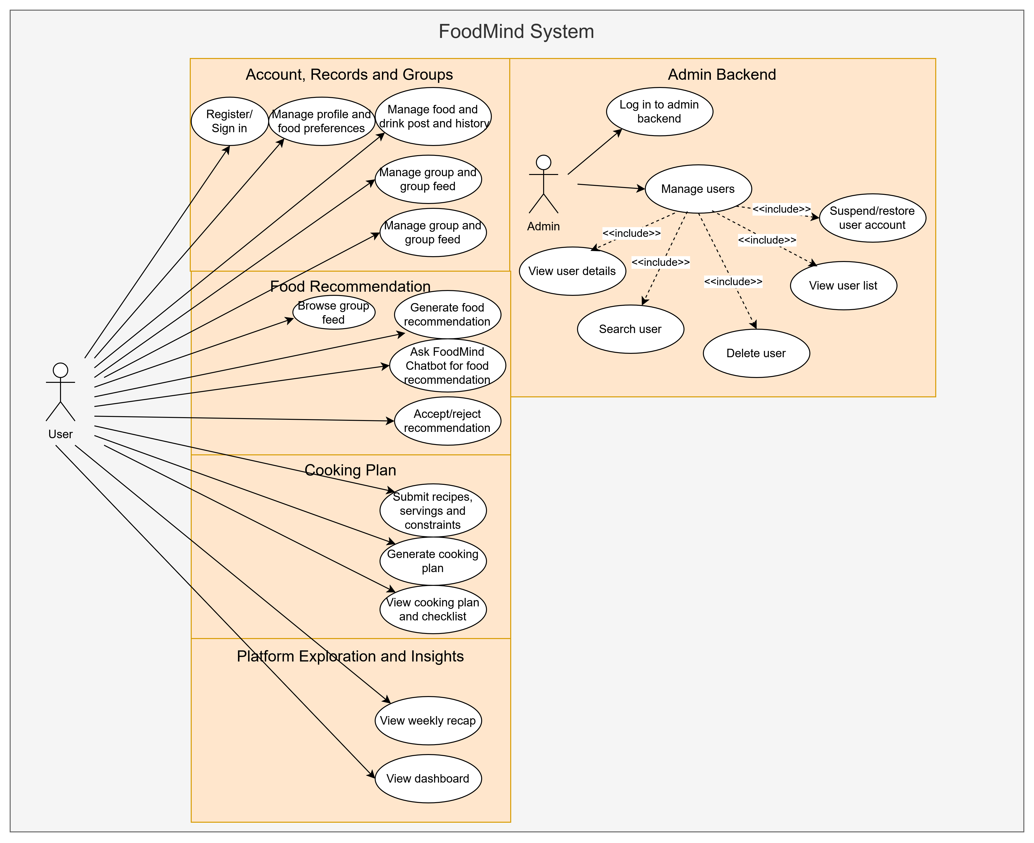
Figure 2. FoodMind high-level use case diagram.

Core Domain Data
The shared data model includes User, Preference, MealNote, FoodRecord, DrinkRecord, Group, GroupMembership, FoodProduct, Place, RecommendationSession, RecommendationCandidate, RecommendationFeedback, CookingPlan, ChatSession, ChatMessage, SharedContentReference and DashboardMetric. Visibility is limited to Private or Group. Spring Boot is the system of record and enforces ownership, group membership and content visibility on every request.

7. Agentic AI and Machine Learning Design

Three Feature Triggers
Feature Trigger | Agent Path | Uses ML?
Generate Food Recommendation button | Recommendation Agent -> controlled context/filter tools -> ML model | Yes
Generate Cooking Plan button | Cooking Planner Agent -> recipe and constraint tools | No
Independent Platform Chatbot | Chatbot Orchestrator -> Platform Search Agent or Content Summary Agent | No

Five-Agent Responsibilities
Recommendation Agent: Directly invoked by Generate Food Recommendation. It calls authorised context, candidate retrieval, hard-filter and ML-ranking tools; applies diversity rules; and explains only evidence supplied by those tools.
Cooking Planner Agent: Directly invoked by Generate Cooking Plan. It uses entered ingredients, time, budget and dietary rules to retrieve a seed recipe and produce a feasible cooking sequence.
Chatbot Orchestrator Agent: Understands platform search, summary, comparison and general navigation intents, maintains chat state and routes the request to one chatbot specialist.
Platform Search Agent: Uses Spring Boot's authorised search tool to retrieve relevant Meal Notes, Food Products and Places that the user is permitted to view.
Content Summary Agent: Summarises or compares user-shared platform items and returns a grounded answer with the source content references used.
LangGraph provides explicit state transitions, tool invocation and traceability. Agents use allow-listed tools, cannot read arbitrary user data and cannot write directly to PostgreSQL. Spring Boot authorises context, validates Pydantic output and owns all persistence.

Recommendation Model
FoodMind uses a hybrid recommendation model that combines Collaborative Filtering with Logistic Regression. First, the system applies rule-based filtering to remove meals that violate hard constraints, such as dietary restrictions, allergies, budget limits, or location requirements. Collaborative Filtering then analyses the user–meal interaction matrix using cosine similarity. User-based Collaborative Filtering produces a similar-user score (2) by examining whether users with comparable eating preferences liked a candidate meal, while item-based Collaborative Filtering produces a meal-similarity score (4) by comparing the candidate with meals the user previously liked.
$$Similarity\left(u,v\right)= \frac{\sum_{i}{R_{u,i}R_{v,i}}}{\sqrt{\sum_{i}{R_{u,i}^{2}}}\sqrt{\sum_{i}{R_{v,i}^{2}}}}$$ | (1)
$$UserCF\left(u,v\right)= \frac{\sum_{v∈N_{u}}{Similarity}(u, v)R_{v,i}}{\sum_{v∈N_{u}}{\left|Similarity(u, v)\right|}}$$ | (2)
$$Similarity\left(i,j\right)= \frac{\sum_{i}{R_{u,i}R_{u,j}}}{\sqrt{\sum_{i}{R_{u,i}^{2}}}\sqrt{\sum_{i}{R_{u,j}^{2}}}}$$ | (3)
$$ItemCF\left(u,i\right)= \frac{1}{K}\sum_{j∈TopK(I_{u})}{Similarity\left(i,j\right)}$$ | (4)
These two collaborative signals are combined with explicit features, including cuisine preference, spice tolerance, price suitability, location convenience, previous ratings, and recent meal history. Logistic Regression uses all these features to estimate the probability (5) that the user will accept each candidate's meal. The candidates are ranked according to this probability, and the highest-ranked meals are returned as recommendations. When collaborative data is insufficient for a new user or meal, the system falls back to preference- and context-based features, allowing it to handle the cold-start problem.

$$P(y=1)=σ(β_{0}​+β_{1}​UserCF+β_{2}​ItemCF+β_{3}​CuisineMatch+⋯)$$ | (5)

This hybrid design allows FoodMind to use both explainable user preferences and hidden behavioural similarities. Logistic Regression provides clear probability and interpretable feature contributions, while Collaborative Filtering discovers relationships between users and meals that would be difficult to capture through manually defined features alone. Finally, the strongest verified signals are converted into structured reason codes, which the Recommendation Agent uses to generate a clear natural-language explanation.
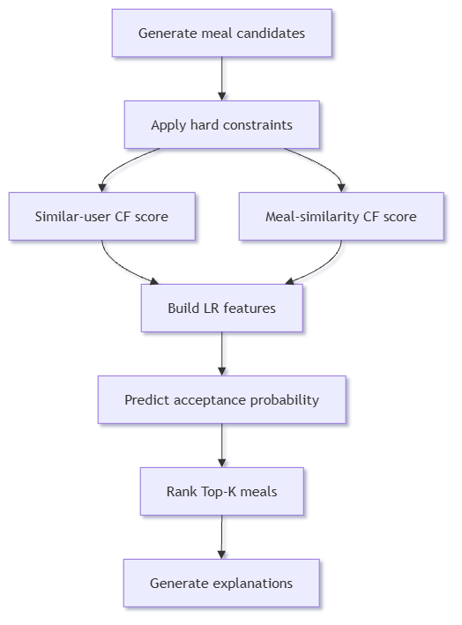

Feedback Semantics
Accepted: the user selected a recommendation.
Rejected: the user declined it and may give a reason such as too expensive, repeated recently, wrong cuisine, unsuitable location or cleanliness concern; the reason becomes a temporary constraint.
Consumed and rated: the user later confirms the meal and submits a rating plus Would Eat Again feedback.

8. Android and Web
Android and Web expose the same business capabilities: account and preferences, food and drink posts, history, groups and feed, direct recommendations, feedback and re-recommendation, cooking plans, independent chatbot search and summaries, dashboard and weekly recap. Android uses mobile navigation and Compose components; Web uses responsive React layouts. Both clients consume the same version of REST contracts and permission rules.

9. Data Visualisation
Data Visualisation converts meal and drink records, spending, cuisine preferences, average ratings, repetition, recommendation acceptance and Would Eat or Buy Again results into clear charts and dashboards. Bar, pie and line charts show weekly or monthly frequency, cuisine distribution, spending trends and recommendation outcomes. Android uses Vico and Web uses Recharts, but both rely on the same backend metric definitions. A weekly recap is a separate periodic report rather than a live dashboard.

10. Technical Requirements and Architecture
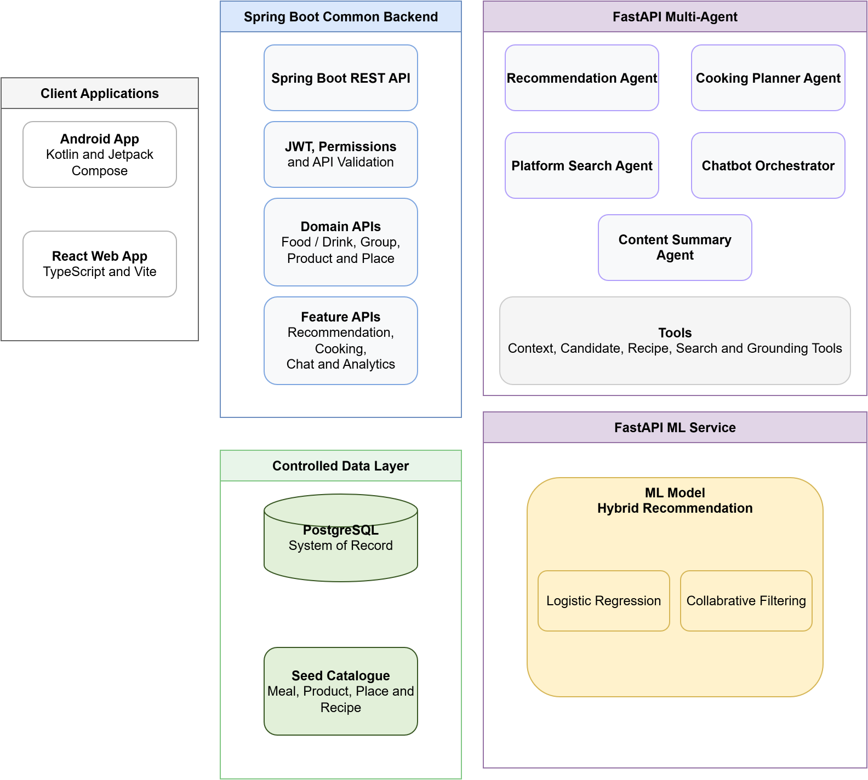
Figure 3. Integrated architecture and separate AI feature paths.

Layer | Selected Technologies | Role in the Integrated Solution
Mobile client | Kotlin, Jetpack Compose, Navigation, ViewModel, StateFlow, Retrofit/OkHttp, Vico | Native Android implementation of every user-facing feature, including chatbot and dashboard.
Web client | React, TypeScript, Vite, Tailwind CSS, TanStack Query, Recharts | Responsive Web implementation of the same business features with a web-appropriate UI.
Common backend | Java 17, Spring Boot, Spring Security, JWT, Spring Data JPA, Bean Validation, Flyway, OpenAPI | Only public business API; owns authentication, permissions, domain rules, search gateway, writes and analytics.
Agent and ML service | Python, FastAPI, LangGraph, Pydantic, scikit-learn, joblib | Runs five controlled agents and the Logistic Regression acceptance-probability model.
Data and search | PostgreSQL, SQL aggregation, PostgreSQL full-text/trigram search | Stores all domain and chat data and supports authorised search over Meal Notes, Food Products and Places.
Data visualisation | Vico (Android), Recharts (Web) | Renders identical metric definitions as mobile charts, responsive dashboards and a weekly recap.
Cloud and DevSecOps | Docker, AWS ECS Fargate, ALB, RDS, Secrets Manager, Vercel, GitHub Actions, Trivy, OWASP ZAP | Provides HTTPS deployment, repeatable builds, CI/CD and auditable security evidence.

Integration and Quality Requirements
Common API boundary. Spring Boot is the only public business API. FastAPI is an internal Agent and ML service.
Versioned contracts. Recommendation, cooking and chatbot responses use separate Pydantic schemas with IDs, grounding evidence, model or fallback status and validation errors.
Privacy and security. JWT, resource ownership, group-membership checks, content visibility, input validation and audit logs protect private and group data.
Shared acceptance tests. JUnit/MockMvc, pytest, React Testing Library and Android tests run the same UAT scenarios against both clients, including chatbot permission and grounding tests.

11. Use Case to Technology Mapping
The matrix below specifies the technologies involved in each high-level use case. Android and Web are listed together because their business scope is identical.
ID | Use Case | Client Technologies | Backend / AI / Data Technologies
UC-01 | Register, sign in, manage profile and food preferences | Compose / React forms | Spring Security, JWT, Bean Validation, JPA, PostgreSQL
UC-02 | Create, edit, delete and filter food or drink posts and history | Compose / React editors, photo picker, history filters | Spring Boot REST, ownership and visibility rules, JPA, PostgreSQL
UC-03 | Create or join a group, browse its feed and save an item to try | Compose / React group and feed screens | Spring Boot group APIs, invite codes, permission filters, PostgreSQL
UC-04 | Generate three explainable food recommendations | Compose / React context form and recommendation cards | Spring Boot orchestration; Recommendation Agent; rule tools; Logistic Regression
UC-05 | Accept, reject, re-recommend and submit post-meal feedback | Compose / React feedback controls | Feedback API, temporary rejection constraints, PostgreSQL, offline retraining pipeline
UC-06 | Generate a cooking plan from ingredients, budget, time and dietary rules | Compose / React cooking-plan form and view | Cooking Planner Agent, recipe catalogue tool, Pydantic output schema
UC-07 | Explore authorised FoodMind content through the independent chatbot | Compose / React chat UI and shared-content cards | Chatbot Orchestrator and Platform Search Agent; Spring Boot authorised search tools
UC-08 | Summarise or compare shared Meal Notes, Food Products and Places | Compose / React share-to-chat and comparison view | Content Summary Agent, content-reference resolver, grounded Pydantic response
UC-09 | View personal dashboard and weekly food recap | Android: Vico; Web: Recharts | Spring Boot aggregation APIs, PostgreSQL queries and shared metric definitions

12. Cloud Deployment, DevSecOps and Delivery Plan

Cloud Deployment
React Web client: Vercel with HTTPS.
Spring Boot and FastAPI: Docker containers on AWS ECS Fargate behind an Application Load Balancer (FastAPI services are private).
PostgreSQL: Amazon RDS in a private network, with credentials and keys in AWS Secrets Manager.
Android client: an installed application connected to the same HTTPS Common Backend.

CI/CD and Security Evidence
GitHub Actions will build, lint and test all components, run dependency and secret checks, scan container images with Trivy and deploy approved builds. OWASP ZAP baseline testing, authorisation tests, agent schema and timeout tests, model fallback tests, platform-search permission tests and grounded-summary tests will be retained as submission evidence.

Four-Week Delivery Plan
Week 1 - Confirm use cases, UI storyboards, product backlog, architecture, database design and API contracts; prepare seed records for meals, drinks, products, places and ML.
Week 2 - Complete authentication, preferences, food and drink CRUD, history, groups, feed, authorised search and rule-based recommendation on both clients through the Common Backend; demonstrate an end-to-end baseline MVP.
Week 3 - Integrate Logistic Regression, all five agents, cooking plans, chatbot search, shared-content summaries, both dashboards and the weekly recap; complete UAT and CI/CD.
Week 4 - Deploy to cloud, complete security, permission, grounding and fallback tests, refine UI, and prepare README, diagrams, code walkthrough, slides and demonstration video.

Principal Risks and Controls
Insufficient data: Use disclosed seed or anonymised interactions and a deterministic fallback; do not claim production-level model accuracy.
Agent unpredictability: Use explicit graphs, allow-listed tools, timeouts, structured output, backend validation and trace logs.
Chatbot privacy or hallucination: Search only authorised platform content, retain content references and reject unsupported claims or inaccessible shared items.
Scope growth: Freeze the future-work boundary stated in Section 5 and use PostgreSQL search rather than adding external search infrastructure during the MVP.
Client divergence: Maintain one acceptance checklist for UC-01 to UC-09 and demonstrate every use case on both clients.

