**Panda Framework**

**～Java Web Application Development Framework～**

**2017/5**

**Table of Contents**

**1** **About Panda Framework** 3

**1.1** **Outline** 3

**1.2** **Features** 3

**1.3** **Panda Framework Applying Effect** 5

**1.4** **System Architecture** 6

**1.5** **Panda Framework Modules** 7

**2** **Code Generator** 8

**2.1** **About code generator** 8

**2.2** **The effect of code generator** 9

**2.3** **Generated features by code generator** 10

**2.4** **Generated web screen/page transition diagram** 11

**2.5** **Screenshot of generated source** 12

# **About Panda Framework**

## **Outline**

Panda Framework is an elegant, extensible framework for creating enterprise-ready Java web applications. The framework is designed to streamline the full development cycle, from designing, to building, to deploying, to maintaining applications over time.

## **Features**

1. **Automatic generation of the source code**  
   The Panda Framework Code Generator can automatically generate the source of Action / Dao / Bean / View. The cost of development can be significantly reduced.
2. **Writing SQL is not needed**   
   Use the API provided by Panda Framework, a programmer does not need to write SQL statements, can easily execute query / insert/ update / delete function based on a database table. It is easy to extend the Panda Framework’s base class to achieve some special purpose. So, it can improve the quality of source code and reduce the bugs.
3. **HTML Page ⇒ PDF Convert Feature**
4. **Business Logic Development is Easy**  
   Using template class to develop Search/List/View/Add/Update/Delete function is very easy and fast.
5. **Improve productivity and source quality**  
   Base on the generated source, the source quality and program productivity can be significantly improved.
6. **Easy to use**  
   We provide a rich set of documents and samples to reduce initial cost from introduction to development.

## **Panda Framework Applying Effect**

By applying Panda Framework, effective development and operation maintenance can be achieved.

**JAVA WEB Development Cost & Panda Framework****Applying Effect**

Development cost reduction

・Source code automatic generation

・Patterned business logic class

・HTML⇒PDF Conversion

Development risk reduction

・Proven processing method

・Existing modules and components

・Rapid prototype development is possible

**Maintenance**

**Test**

**Program**

**Design**

**Requirement**

**Cost**

## **System Architecture**

**SQL**

**Web Browser**

**User Interface**

**（ＨＴＭＬ/AJAX）**

**HTTP(S)**

**Data Store**

**Data**

**Tomcat / WebSphere**

**or Google App Engine**

**View**

**Action**

**Control & Interceptor**

**Business Logic**

**Generated Module**

**Panda Framework**

**IOC / AOP / MVC / DAO**

## **Panda Framework Modules**

Panda Framework has the following modules.

|  |  |
| --- | --- |
| Module | Description |
| panda-core | Utility classes. |
| panda-gear | Ioc/Mvc/TagLib module. |
| panda-glue | ASM/AOP module. |
| panda-html | CSS/JavaScript module. |
| panda-lane | CRUD action base class, authentication module, some tool action. |
| panda-tube | The client module of Web Service API. (ex: WordPress XML-RPC) |
| panda-tool | Code generator. |

# **Code Generator**

## **About code generator**

Use the Code Generator of Panda Framework, programmers do not need to write source code & SQL statements. Just define the database table structure and the user interface layout, and let Code Generator automatically generate source code to achieve the data search / list(sort, paging) & record view / insert / update / delete functions based on a database table. Greatly reduce the amount of manually coded source, improve the quality of source code and reduce the development costs.

Browser

(Chrome, Firefox, IE, Safari)

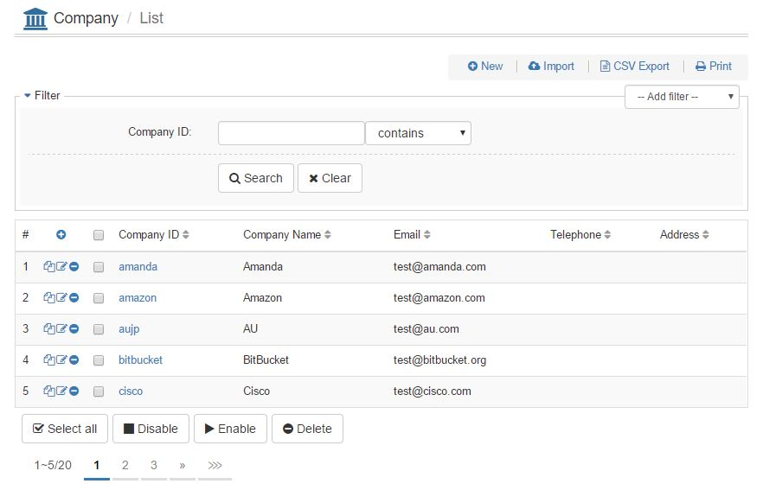

Generated Source

JAVA

* Bean class
* DAO class
* Action class

View & Resource File

* *.ftl
* *.txt

DB

* DDL SQL

Xml Definition

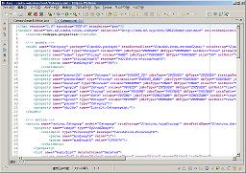

## **The effect of code generator**

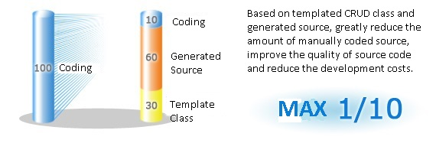

## **Generated features by code generator**

Code generator can generate the following features. And it is easy to customize.

|  |  |  |
| --- | --- | --- |
| No. | Feature | Description |
| 1 | Search | Search/Query form. |
| 2 | List View | Search result list view. |
| 3 | List Print View | Search result list view for print. |
| 4 | List Data CSV Export | Export the list data to CSV file. |
| 5 | Data Detail View | Data detail view page. |
| 6 | Data Detail Print View | Data detail view page for print. |
| 7 | Data Add | Data add feature. |
| 8 | Data Copy | Data duplicate feature |
| 9 | Data Edit | Data edit feature. |
| 10 | Data Delete | Data delete feature. |
| 11 | Csv Data Import | Import data from CSV/XLS file. |
| 12 | Bulk Data Process | Process multiple data. |

## **Generated web screen/page transition diagram**

Other Confirm Page

Other

Complete Page

Data Delete Complete Page

Data Edit Complete Page

Data Copy Complete Page

Data Add Complete Page

Data Delete Confirm Page

Data Copy Confirm Page

Data Edit Confirm Page

Other

Input Page

Optional

Search

List Page

Data Edit Input Page

Data Copy Input Page

Detail View Page

Bulk Process Confirm Page Confirm page

Bulk Process Complete Page

Data Edit

Data Delete

Other

Data Copy

Data Add Input Page

Data Add Confirm Page

Data Add

Bulk Process

## **Screenshot of generated source**

1. **List/Search Page**



1. **Detail View Page**

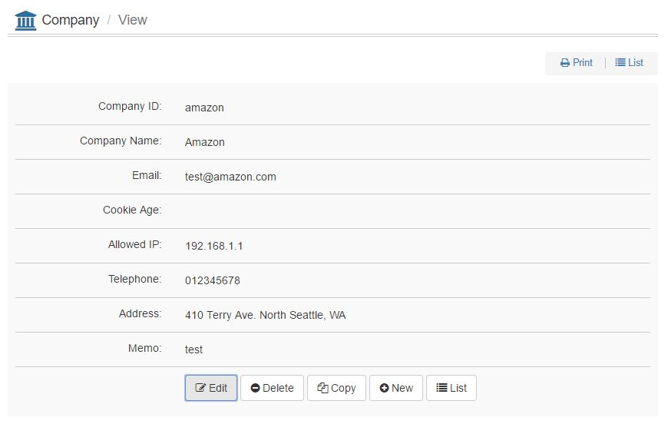

1. **Data Add Page**

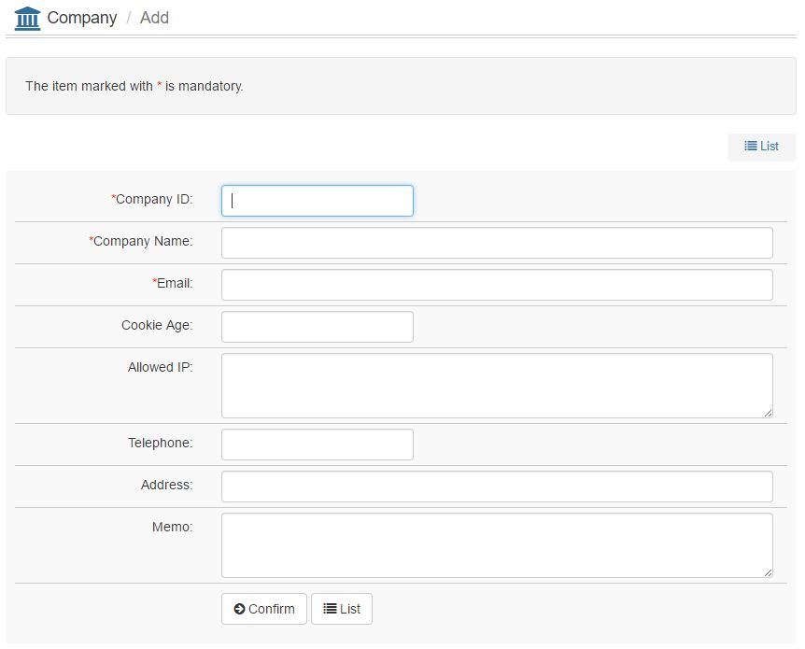

1. **Data Add Confirm Page**

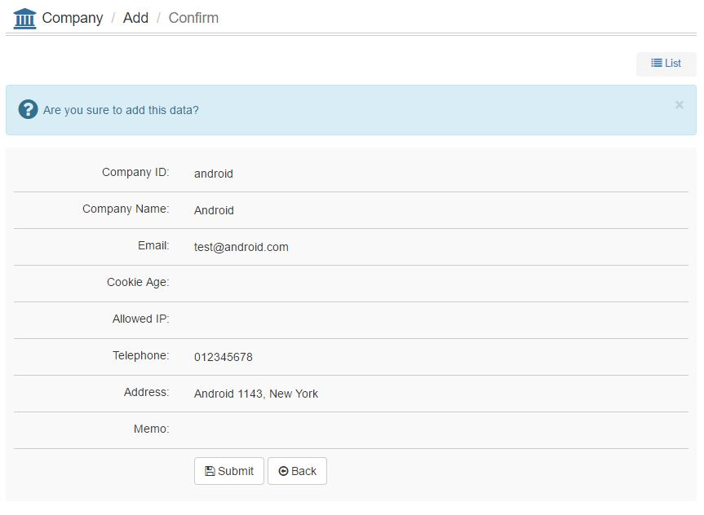

1. **Data Add Complete Page**

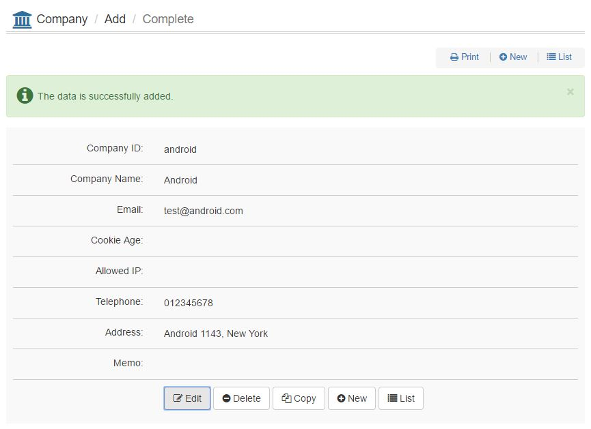

1. **Edit Page**

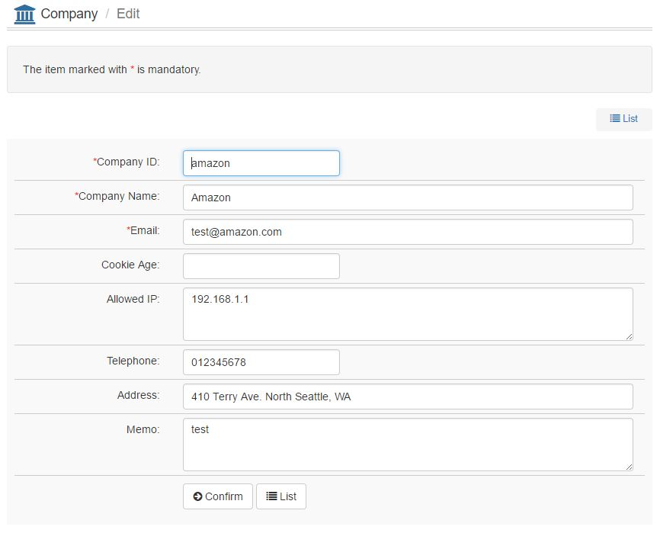

1. **Edit Confirm Page**

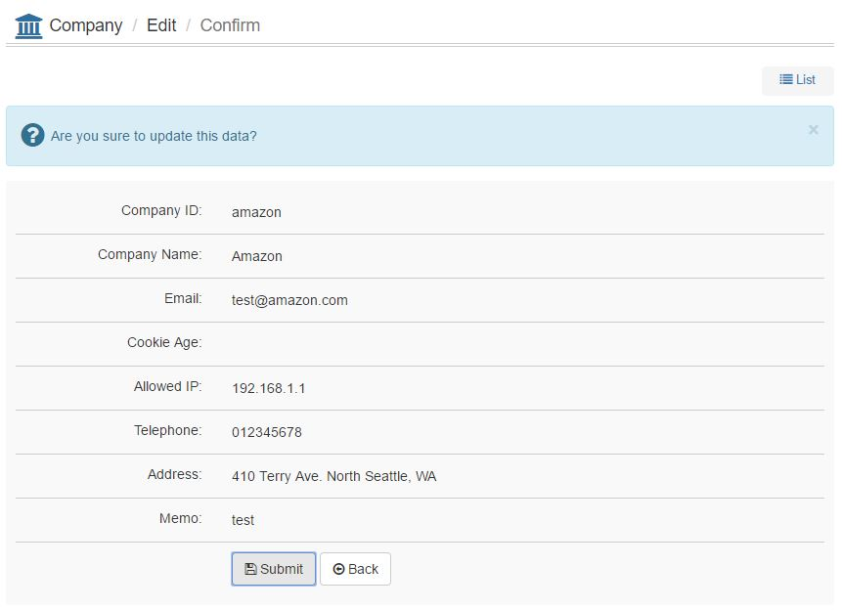

1. **Edit Complete Page**

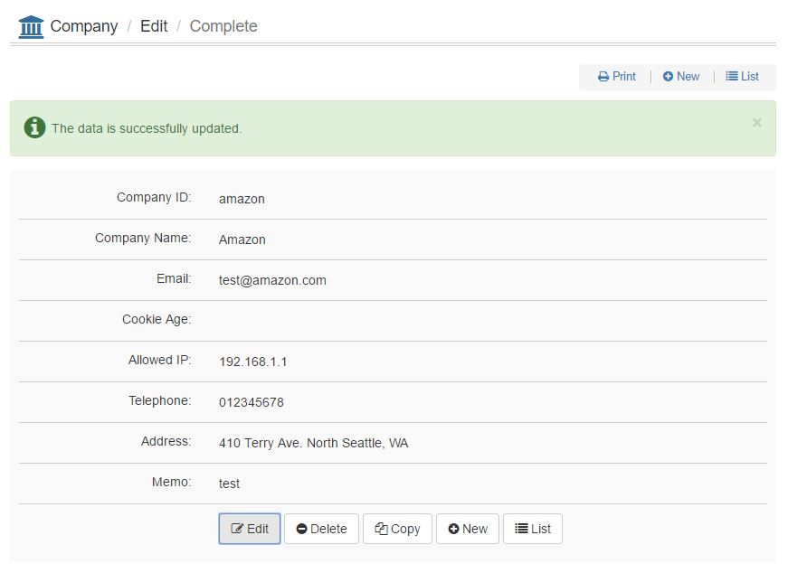

1. **Delete Confirm Page**

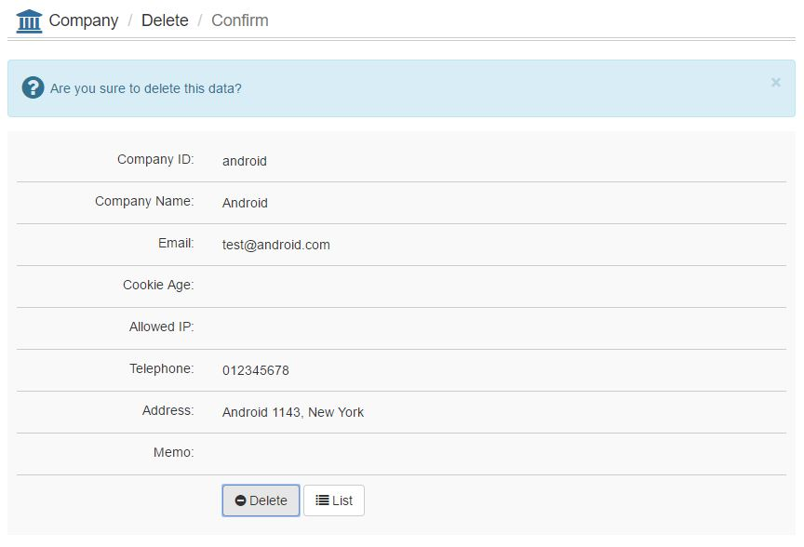

1. **Delete Complete Page**

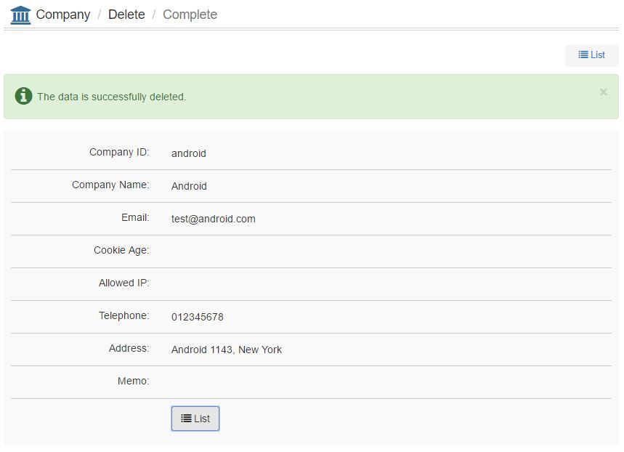

1. **Bulk Delete Confirm Page**

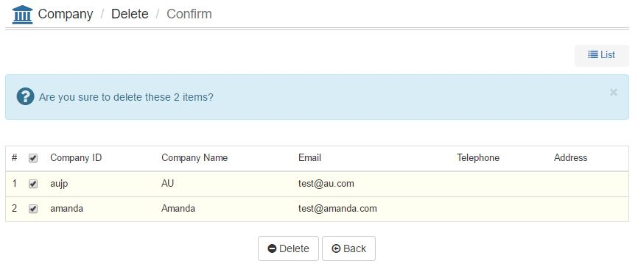

1. **Bulk Delete Complete Page**

