项目名称：基于本体的集群区域资源组织模型的构建方法的研究
项目编号：201410408037
项目版本：MyProV2..0

学 院：[ 信息工程学院 ]
专 业：[ 12计 科1班 ]
学 号：[ 201210510118 ]
拟 制：[ 付 栖 凤 ]
角 色：[ 软件工程师 ]
拟制日期：[2016.05.04 ]
景德镇陶瓷大学

系统开发及运行平台 3
Webapp代码 3
① index.jsp 4
② my.jsp 4
③ my-list.jsp 4
④ my-edit.jsp 6
⑤ Web.xml 7
⑥ Struts.xml 8
⑦ log4j.properties 8
⑧ applicationContext.xml 9
Src资源包 11
① AbstractMyable.java 12
② MyAction.java 13
③ MyService.java 17
④ IMyService.java 18
⑤ MytableDAO.java 19
⑥ Mytable.java 26
初始运行结果： 27
新增测试： 28
删除测试： 29
修改测试： 30
基于元数据的关键词查询测试： 32

系统开发及运行平台
开发环境：myeclipse2015+jdk7+Tomcat7+mysql5.1
软件系统支持包：Struts2.1+Spring4+Hibernate4
使用电脑的操作系统：win8

Webapp代码

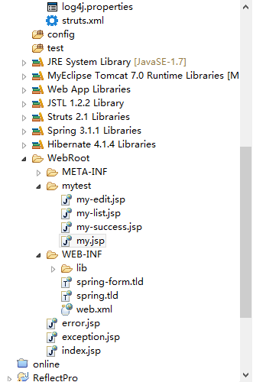

index.jsp
<body>
<jsp:forward page="/mytest/my.jsp"/>
</body>

my.jsp

<body>
<s:form name="findForm" action="my" method="post">
<s:textfield name="keyword" label="输入查询关键词" value="Nacy" />
<tr>
<td><s:submit name="submit" value="查询" method="findByField"
theme="simple" /></td>
<td><s:reset name="reset" value="取消" theme="simple" /></td>
</tr>
</s:form>
<s:label>my!list执行结果：</s:label>
<s:action name="my!list" executeResult="true" />
</body>

my-list.jsp

<body>

<body>

<s:div>
<a href="mytest/my!loading.action">新增信息</a>
<hr>
<table>
<tr>
<td>MID</td>
<td>Name</td>
<td>Age</td>
<td>详细信息</td>
<td>修改信息</td>
<td>删除信息</td>
</tr>
<s:iterator value="list">
<tr>
<td><s:property value="mid" /></td>
<td><s:property value="name" /></td>
<td><s:property value="age" /></td>
<td><a
href="mytest/my!loading.action?flag=<s:property value="mid"/>">详细信息</a></td>
<td><a
href="mytest/my!loading.action?flag=<s:property value="mid"/>">修改信息</a></td>
<td><a
href="mytest/my!delete.action?flag=<s:property value="mid"/>">删除信息</a>
</td>
</tr>
</s:iterator>
</table>

<table>
<tr>
<td>MID</td>
<td>Name</td>
<td>Age</td>
<td>详细信息</td>
<td>修改信息</td>
<td>删除信息</td>
</tr>
<c:forEach items="${list}" var="m">
<tr>
<td>${ m.mid}</td>
<td>${ m.name}</td>
<td>${ m.age}</td>
<td><a href="mytest/my!loading.action?flag=${ m.mid}">详细信息</a></td>
<td><a href="mytest/my!loading.action?flag=${ m.mid}">修改信息</a></td>
<td><a href="mytest/my!delete.action?flag=${ m.mid}">删除信息</a></td>
</tr>
</c:forEach>
</table>
</s:div>
</body>

my-edit.jsp
<%@page import="dashow.model.Mytable"%>
<%@ taglib prefix="s" uri="/struts-tags"%>
<%@ page language="java" import="java.util.*" pageEncoding="UTF-8"%>
<%
String path = request.getContextPath();
String basePath = request.getScheme() + "://"
+ request.getServerName() + ":" + request.getServerPort()
+ path + "/";
%>
<s:if test="flag ==null ">
<s:text name="创建对象" id="title" />
</s:if>
<s:else>
<s:text name="编辑对象" id="title" />
</s:else>

<!DOCTYPE HTML PUBLIC "-//W3C//DTD HTML 4.01 Transitional//EN">
<html>
<head>
<base href="<%=basePath%>">

<title><s:property value="#title" /></title>

<meta http-equiv="pragma" content="no-cache">
<meta http-equiv="cache-control" content="no-cache">
<meta http-equiv="expires" content="0">
<meta http-equiv="keywords" content="keyword1,keyword2,keyword3">
<meta http-equiv="description" content="This is my page">
</head>
<body>
<s:property value="#title" />
<s:actionmessage />
<s:form name="myForm" action="my" method="post">
<s:token />
<!-- 防重复提交 -->
<s:hidden name="mytable.mid" value="%{flag}" />
<s:textfield name="mytable.name" label="姓名" value="%{mytable.name}" />
<s:textfield name="mytable.age" label="年龄" value="%{mytable.age}" />
<tr>
<td><s:submit name="submit" value="保存" method="update"
theme="simple" /></td>
<td><s:reset name="reset" value="取消" theme="simple" /></td>
</tr>
</s:form>
<s:if test="mytable==null">mytable==null</s:if>
<s:else>mytable!=null</s:else>
</body>
</html>

Web.xml
<?xml version="1.0" encoding="UTF-8"?>
<web-app xmlns:xsi="http://www.w3.org/2001/XMLSchema-instance" xmlns="http://java.sun.com/xml/ns/javaee" xsi:schemaLocation="http://java.sun.com/xml/ns/javaee http://java.sun.com/xml/ns/javaee/web-app_3_0.xsd" id="WebApp_ID" version="3.0">
<display-name>MyPro02</display-name>
<welcome-file-list>
<welcome-file>index.html</welcome-file>
<welcome-file>index.htm</welcome-file>
<welcome-file>index.jsp</welcome-file>
<welcome-file>default.html</welcome-file>
<welcome-file>default.htm</welcome-file>
<welcome-file>default.jsp</welcome-file>
</welcome-file-list>
<filter>
<filter-name>struts2</filter-name>
<filter-class>org.apache.struts2.dispatcher.ng.filter.StrutsPrepareAndExecuteFilter</filter-class>
</filter>
<filter-mapping>
<filter-name>struts2</filter-name>
<url-pattern>/*</url-pattern>
</filter-mapping>
<listener>
<listener-class>org.springframework.web.context.ContextLoaderListener</listener-class>
</listener>
<context-param>
<param-name>contextConfigLocation</param-name>
<param-value>classpath:applicationContext.xml</param-value>
</context-param>
</web-app>

Struts.xml
<?xml version="1.0" encoding="UTF-8" ?>
<!DOCTYPE struts PUBLIC "-//Apache Software Foundation//DTD Struts Configuration 2.1//EN" "http://struts.apache.org/dtds/struts-2.1.dtd">
<struts>
</struts>

log4j.properties
### direct log messages to stdout ###
log4j.appender.Console=org.apache.log4j.ConsoleAppender
log4j.appender.stdout.Target=System.out
log4j.appender.Console.layout=org.apache.log4j.PatternLayout
log4j.appender.stdout.layout.ConversionPattern=%d{ABSOLUTE} %5p %c{1}:%L - %m%n

### direct messages to file hibernate.log ###
#log4j.appender.file=org.apache.log4j.FileAppender
#log4j.appender.file.File=hibernate.log
#log4j.appender.file.layout=org.apache.log4j.PatternLayout
#log4j.appender.file.layout.ConversionPattern=%d{ABSOLUTE} %5p %c{1}:%L - %m%n

### set log levels - for more verbose logging change 'info' to 'debug' ###

log4j.rootLogger=INFO, Console, File

#log4j.logger.org.hibernate=info
#log4j.logger.org.hibernate=debug

### log HQL query parser activity
#log4j.logger.org.hibernate.hql.ast.AST=debug

### log just the SQL
#log4j.logger.org.hibernate.SQL=debug

### log JDBC bind parameters ###
#log4j.logger.org.hibernate.type=info
#log4j.logger.org.hibernate.type=debug

### log schema export/update ###
#log4j.logger.org.hibernate.tool.hbm2ddl=debug

### log HQL parse trees
#log4j.logger.org.hibernate.hql=debug

### log cache activity ###
#log4j.logger.org.hibernate.cache=debug

### log transaction activity
#log4j.logger.org.hibernate.transaction=debug

### log JDBC resource acquisition
#log4j.logger.org.hibernate.jdbc=debug

### enable the following line if you want to track down connection ###
### leakages when using DriverManagerConnectionProvider ###
#log4j.logger.org.hibernate.connection.DriverManagerConnectionProvider=trace
###### File appender definition #######
log4j.appender.File=org.apache.log4j.DailyRollingFileAppender
log4j.appender.File.File=spring.log
log4j.appender.File.Append=false
log4j.appender.File.layout=org.apache.log4j.PatternLayout
log4j.appender.File.layout.ConversionPattern=%d{ABSOLUTE} %-5p [%c] %m%n\t
##\u89E3\u9664\u7C7Borg.apache.jasper.compiler.TldLocationsCache\u7684log
org.apache.jasper.compiler.TldLocationsCache.level =FINE

applicationContext.xml
<?xml version="1.0" encoding="UTF-8"?>
<beans xmlns="http://www.springframework.org/schema/beans"
xmlns:xsi="http://www.w3.org/2001/XMLSchema-instance" xmlns:p="http://www.springframework.org/schema/p"
xmlns:context="http://www.springframework.org/schema/context" xmlns:tx="http://www.springframework.org/schema/tx"
xsi:schemaLocation="
http://www.springframework.org/schema/beans http://www.springframework.org/schema/beans/spring-beans-3.1.xsd
http://www.springframework.org/schema/context http://www.springframework.org/schema/context/spring-context.xsd
http://www.springframework.org/schema/tx http://www.springframework.org/schema/tx/spring-tx.xsd">
<!--使用注解，开启相应的处理器 -->
<context:annotation-config />
<!--注册代理过滤器开启扫描 -->
<context:component-scan base-package="dashow" />
<bean id="dataSource" class="org.apache.commons.dbcp.BasicDataSource">
<property name="driverClassName" value="com.mysql.jdbc.Driver" />
<property name="url" value="jdbc:mysql://localhost:3306/ecommerce" />
<property name="username" value="root" />
<property name="password" value="xiao25QIU" />
</bean>
<bean id="sessionFactory"
class="org.springframework.orm.hibernate4.LocalSessionFactoryBean">
<property name="dataSource" ref="dataSource" />
<property name="hibernateProperties">
<props>
<prop key="hibernate.show_sql">true</prop>
<prop key="hibernate.format_sql">true</prop>
<prop key="hibernate.dialect">
org.hibernate.dialect.MySQLDialect
</prop>
<prop key="hibernate.query.factory_class">
org.hibernate.hql.internal.classic.ClassicQueryTranslatorFactory
</prop>
<prop key="current_session_context_class">thread</prop>
<prop key="hibernate.autoReconnect">true</prop>
</props>
</property>
<property name="annotatedClasses">
<list>
<value>dashow.model.Mytable</value>
</list>
</property>
</bean>
<bean id="transactionManager"
class="org.springframework.orm.hibernate4.HibernateTransactionManager">
<property name="sessionFactory" ref="sessionFactory" />
</bean>
<tx:annotation-driven transaction-manager="transactionManager" />
<bean id="mytableDAO" class="dashow.operation.dao.MytableDAO" scope="singleton"/>
<!-- Cache配置 略 -->
<!--定义Autowired自动注入bean -->
<bean name="processor"
class="org.springframework.beans.factory.annotation.AutowiredAnnotationBeanPostProcessor" />
</beans>

Src资源包
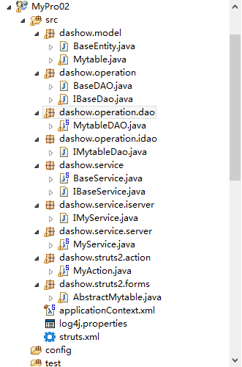

AbstractMyable.java
package dashow.struts2.forms;

import javax.persistence.Column;
import javax.persistence.GeneratedValue;
import javax.persistence.Id;
import javax.persistence.MappedSuperclass;

import com.opensymphony.xwork2.validator.annotations.RequiredStringValidator;

import dashow.model.BaseEntity;

/**
* AbstractMytable entity provides the base persistence definition of the
* Mytable entity. @author MyEclipse Persistence Tools
*/
@MappedSuperclass
public abstract class AbstractMytable extends BaseEntity implements
java.io.Serializable {

// Fields

private Integer mid;
private String name;
private Integer age;

// Constructors

/** default constructor */
public AbstractMytable() {
}

/** full constructor */
public AbstractMytable(String name, Integer age) {
this.name = name;
this.age = age;
}

// Property accessors
@Id
@GeneratedValue
@Column(name = "MID", unique = true, nullable = false)
public Integer getMid() {
return this.mid;
}

public void setMid(Integer mid) {
this.mid = mid;
}

@Column(name = "name", nullable = false, length = 20)
public String getName() {
return this.name;
}
@RequiredStringValidator(message = "请输入用户名!")
public void setName(String name) {
this.name = name;
}

@Column(name = "age", nullable = false)
public Integer getAge() {
return this.age;
}
@RequiredStringValidator(message = "请输入密�?")
public void setAge(Integer age) {
this.age = age;
}

}

MyAction.java
package dashow.struts2.action;

import java.util.List;

import org.apache.struts2.convention.annotation.InterceptorRef;
import org.apache.struts2.convention.annotation.InterceptorRefs;
import org.apache.struts2.convention.annotation.Namespace;
import org.apache.struts2.convention.annotation.Result;
import org.apache.struts2.convention.annotation.Results;
import org.springframework.beans.factory.annotation.Autowired;
import org.springframework.context.annotation.Scope;
import org.springframework.stereotype.Controller;
import com.opensymphony.xwork2.ActionSupport;
import dashow.model.Mytable;
import dashow.service.server.MyService;

/**
* Created by fooxe on 2015/12/20.
*/
@Namespace("/mytest")
@Controller
@Scope("prototype")
@Results({

@Result(name = "error", location = "/error.jsp"),
@Result(name = "loading", location = "/mytest/my-edit.jsp"),
@Result(name = "update", location = "/mytest/my.jsp"),
@Result(name = "delete", type = "redirect", location = "my!list.action"),
@Result(name = "list", location = "/mytest/my-list.jsp"),
@Result(name = "invalid.token", location = "/error.jsp")

})
@InterceptorRefs({
@InterceptorRef(value = "tokenSession", params = { "includeMethods",
"update" }),
@InterceptorRef(value = "defaultStack", params = { "includeMethods",
"update" }) })
public class MyAction extends ActionSupport {// implements Preparable
@Autowired
private MyService myService=null;
private List<Mytable> list=null;
private Mytable mytable=null;
private Integer flag=null;
private String keyword = null;// 搜索词

// 单击新增或修改时，跳转到edit界面
public String loading() throws Exception {
mytable=new Mytable();
if (flag == null) {
System.out.println("loading方法执行,新增一条信息");
mytable = null;
} else {
System.out.println("保存 mid=" + flag + " 的信息");
mytable = myService.findById(flag);
System.out.println("mytable="+mytable+",(mytable==null)=" + mytable == null);// 输出为faluse

/**
* Field[] fields = mytable.getClass().getFields(); for (Field field
* : fields) { Object ob = field.get(mytable); //
* mem.setAccessible(true); System.out.println(field.get(mytable));
* }
*/
// System.out.println("Name="+mytable.getName());

}
return "loading";
}

public String update() throws Exception {
System.out.println("enter update method,flag=" + flag);
if (flag == null) {
addActionMessage("新增信息");
System.out.println("新增信息");
} else {
addActionMessage("修改 mid=" + flag + " 的信息");
System.out.println("保存 mid=" + flag + " 的信息");
}
myService.update(mytable);
System.out.println("save end");
return "update";
}

public String delete() throws Exception {
System.out.println("execute delete method flag=" + flag);
myService.delete(flag);
return "delete";
}

public String list() throws Exception {
System.out.println("findAll start ");
list = myService.findAll();
System.out.println("find all query end");
return "list";
}

public String findByField() throws Exception {
System.out.println("findByField start ");
list = myService.findByField(keyword);
if (list.size() < 1)
System.out.println("没有你需要的元数据查询结果");
else
addActionMessage("查询结果如下：******************");
// Map request = (Map) ActionContext.getContext().get("request");
// request.put("list", list);
System.out.println("find all query end");
return "list";
}

/*************** getter and setter ************************/

public List<Mytable> getList() {
return list;
}

public void setList(List<Mytable> list) {
this.list = list;
}

public Mytable getMytable() {
return mytable;
}

public void setMytable(Mytable mytable) {
this.mytable = mytable;
}

public Integer getFlag() {
return flag;
}

public void setFlag(Integer flag) {
this.flag = flag;
}

public String getKeyword() {
return keyword;
}

public void setKeyword(String keyword) {
this.keyword = keyword;
}

}

MyService.java
package dashow.service.server;

import java.util.List;

import org.springframework.beans.factory.annotation.Autowired;
import org.springframework.stereotype.Service;

import dashow.model.Mytable;
import dashow.operation.dao.MytableDAO;
import dashow.service.iserver.IMyService;

/**
*
* MyService.java create by fooxe on 2016年4月24日 下午7:08:45
*
*/
@Service("myService")
public class MyService implements IMyService {
@Autowired
private MytableDAO mytableDAO = null;

@Override
public List<Mytable> findAll() {
return mytableDAO.findAll();
}

@Override
public void delete(Integer id) {
// TODO Auto-generated method
System.out.println("execute savice delete method" + id);
mytableDAO.delete(mytableDAO.findById(id));
}

@Override
public Mytable findById(Integer flag) {
return mytableDAO.findById(flag);
}

private void getMetadate(Integer flag) {
mytableDAO.getMetaDate(flag);
}

@Override
public void update(Mytable mytable) {
// TODO Auto-generated method stub
mytableDAO.save(mytable);
}

@Override
public List<Mytable> findByField(String keyword) throws Exception {
// TODO Auto-generated method stub
System.out.println("myService �Ĺؼ�ʲ�ѯ��ʼ");
List<Mytable> list = mytableDAO.findByFields(keyword);
return list;
}

}

IMyService.java
package dashow.service.iserver;

import java.util.List;

import dashow.model.Mytable;
import dashow.service.IBaseService;
/**
* 可以通过抽取类的接口进行生成
*IMyService.java create by fooxe on 2016年4月24日 下午7:14:00
*
*/
public interface IMyService {//extends IBaseService<T>{
public abstract List<Mytable> findAll();
public abstract void delete(Integer id);
public abstract Mytable findById(Integer flag);
public abstract void update(Mytable mytable);
public abstract List<Mytable> findByField(String keyword) throws Exception;

}

MytableDAO.java
package dashow.operation.dao;

import java.util.ArrayList;
import java.util.Collection;
import java.util.List;

import org.hibernate.Criteria;
import org.hibernate.LockOptions;
import org.hibernate.Query;
import org.hibernate.ScrollMode;
import org.hibernate.ScrollableResults;
import org.hibernate.Session;
import org.hibernate.SessionFactory;
import org.hibernate.metadata.ClassMetadata;
import org.hibernate.metadata.CollectionMetadata;
import org.hibernate.type.Type;

import static org.hibernate.criterion.Example.create;

import org.slf4j.Logger;
import org.slf4j.LoggerFactory;
import org.springframework.beans.factory.annotation.Autowired;
import org.springframework.context.ApplicationContext;
import org.springframework.transaction.annotation.Transactional;

import dashow.model.Mytable;

/**
*
* MytableDAO.java create by fooxe on 2016年4月24日 下午7:18:16
*
*/
@Transactional
public class MytableDAO {
private static final Logger log = LoggerFactory.getLogger(MytableDAO.class);
// property constants
public static final String NAME = "name";
public static final String AGE = "age";
@Autowired
private SessionFactory sessionFactory;

private Session getCurrentSession() {
return sessionFactory.getCurrentSession();
}

protected void initDao() {
// do nothing
}

/**
* 新增
*
* @param transientInstance
*/
@Transactional(rollbackFor = { Exception.class })
public void save(Mytable transientInstance) {
log.debug("saving Mytable instance");
try {
System.out.println("MytableDAO save start");
getCurrentSession().save(transientInstance);
System.out.println("MytableDAO save successful");
log.debug("save successful");
} catch (RuntimeException re) {
log.error("save failed", re);
throw re;
}
}

/**
* 删除
*
* @param persistentInstance
*/
public void delete(Mytable persistentInstance) {
log.debug("deleting Mytable instance");
try {
getCurrentSession().delete(persistentInstance);
log.debug("delete successful");
} catch (RuntimeException re) {
log.error("delete failed", re);
throw re;
}
}

/**
* 修改
*
* @param persistentInstance
*/

public void update(Mytable persistentInstance) {
log.debug("update Mytable instance");
try {
getCurrentSession().update(persistentInstance);
System.out.println("更新成功");
log.debug("update successful");
} catch (RuntimeException re) {
log.error("update failed", re);
throw re;
}
}

/**
* 以id为关键词进行 对象查询
*
* @param id
* @return
*/
public Mytable findById(Integer id) {
log.debug("getting Mytable instance with id: " + id);
try {
System.out.println("start find object mid=" + id);
Mytable instance = (Mytable) getCurrentSession().get(
"dashow.model.Mytable", id);
System.out.println("end find find object " + instance.getName());
return instance;
} catch (RuntimeException re) {
log.error("get failed", re);
throw re;
}
}

/**
* key word search
*
* @param keyword
* @return
*/
public List<Mytable> findByField(String keyword) {
List<Mytable> result = new ArrayList<Mytable>();
List<Mytable> list = findAll();
System.out.println("MyDAO 层 findByField进行基于元数据的关键词查询,rows="
+ list.size() + ";keyword=" + keyword);
for (Mytable my : list) {
ClassMetadata myMetadate = sessionFactory
.getClassMetadata(Mytable.class);
String[] propertiesNames = myMetadate.getPropertyNames();
Object[] propertiesValues = myMetadate.getPropertyValues(my);
Type[] propertyTypes = myMetadate.getPropertyTypes();

for (int i = 0; i < propertiesValues.length; i++) {
System.out.println("propertiesValues[" + i + "]="
+ propertiesValues[i]);
if (propertiesValues[i] instanceof Integer) {
if (propertiesValues[i].toString().equals(keyword)) {
result.add(my);
System.out.print("A=instanceof Integer==result.size()="
+ result.size());
}
}
if (propertiesValues[i] instanceof String) {
if (propertiesValues[i].equals(keyword)) {
result.add(my);
System.out.print("B=instanceof String===result.size()="
+ result.size());
}
}

}
}
return result;
}

public List<Mytable> findAll() {
log.debug("finding all Mytable instances");
try {
String queryString = "from Mytable";
Query queryObject = getCurrentSession().createQuery(queryString);
return queryObject.list();
} catch (RuntimeException re) {
log.error("find all failed", re);
throw re;
}
}

/******************************************************************/

public List<Mytable> findByExample(Mytable instance) {
log.debug("finding Mytable instance by example");
try {

List<Mytable> results = (List<Mytable>) getCurrentSession()
.createCriteria("dashow.model.Mytable")
.add(create(instance)).list();
log.debug("find by example successful, result size: "
+ results.size());
return results;
} catch (RuntimeException re) {
log.error("find by example failed", re);
throw re;
}
}

@Transactional(readOnly = true)
public List findByProperty(String propertyName, Object value) {
log.debug("finding Mytable instance with property: " + propertyName
+ ", value: " + value);
try {
String queryString = "from Mytable as model where model."
+ propertyName + "= ?";
Query queryObject = getCurrentSession().createQuery(queryString);
queryObject.setParameter(0, value);
System.out.println("queryObject.list().size()="
+ queryObject.list().size());
return queryObject.list();
} catch (RuntimeException re) {
log.error("find by property name failed", re);
throw re;
}
}

public List<Mytable> findByName(Object name) {
System.out.println("按名查找�?��…�?");
return findByProperty(NAME, name);
}

public void attachDirty(Mytable instance) {
log.debug("attaching dirty Mytable instance");
try {
getCurrentSession().saveOrUpdate(instance);
log.debug("attach successful");
} catch (RuntimeException re) {
log.error("attach failed", re);
throw re;
}
}

public void attachClean(Mytable instance) {
log.debug("attaching clean Mytable instance");
try {
getCurrentSession().buildLockRequest(LockOptions.NONE).lock(
instance);
log.debug("attach successful");
} catch (RuntimeException re) {
log.error("attach failed", re);
throw re;
}
}

/**
* 查询 主键为mid,持久化类的元数据".
*
* @param mid
*/
public void getMetaDate(Integer mid) {
Mytable my = (Mytable) getCurrentSession().get(Mytable.class,
new Integer(mid));
ClassMetadata myMetadate = sessionFactory
.getClassMetadata(Mytable.class);
String[] propertiesNames = myMetadate.getPropertyNames();
Object[] propertiesValues = myMetadate.getPropertyValues(my);
for (int i = 0; i < propertiesNames.length; i++) {
System.out.println("属�?:" + propertiesNames[i] + "="
+ propertiesValues[i]);
}
}

/***
* 获取"集合的元数据"
*
* @param mid
*/
public void getCollectionDate(Integer mid) {
Mytable my = (Mytable) getCurrentSession().get(Mytable.class,
new Integer(mid));
sessionFactory.getCollectionMetadata("com.");

CollectionMetadata cMeta = sessionFactory
.getCollectionMetadata("dashow.model");// 集合属�?的角色名�?由持久化类的名称加上集合属�?的名称组�?
System.out.println(cMeta.getRole());
System.out.println(cMeta.getKeyType());
System.out.println(cMeta.getElementType());
}

/**
* 流动结果�?
*
* @param list
* @return
*/
public List<Mytable> scrollView(List<Mytable> list) {
Query q = getCurrentSession().createQuery("from mytable");
ScrollableResults sr = q.scroll(ScrollMode.SCROLL_INSENSITIVE);
while (sr.next()) {
Mytable mytabel = (Mytable) sr.get(0);
}

return null;
}

public static MytableDAO getFromApplicationContext(ApplicationContext ctx) {
return (MytableDAO) ctx.getBean("mytableDAO");
}
}

Mytable.java

package dashow.model;

import javax.persistence.Entity;
import javax.persistence.Table;

import dashow.struts2.forms.AbstractMytable;

/**
* Mytable entity. @author MyEclipse Persistence Tools
*/
@Entity
@Table(name = "mytable", catalog = "ecommerce")
public class Mytable extends AbstractMytable implements java.io.Serializable {

// Constructors

/** default constructor */
public Mytable() {
}

/** full constructor */
public Mytable(String name, Integer age) {
super(name, age);
}

@Override
public Mytable clone() {
// TODO Auto-generated method stub
Mytable mytable=null;
try {
mytable=(Mytable)super.clone();
} catch (CloneNotSupportedException e) {
// TODO Auto-generated catch block
e.printStackTrace();
}

return mytable;
}

}

初始运行结果：

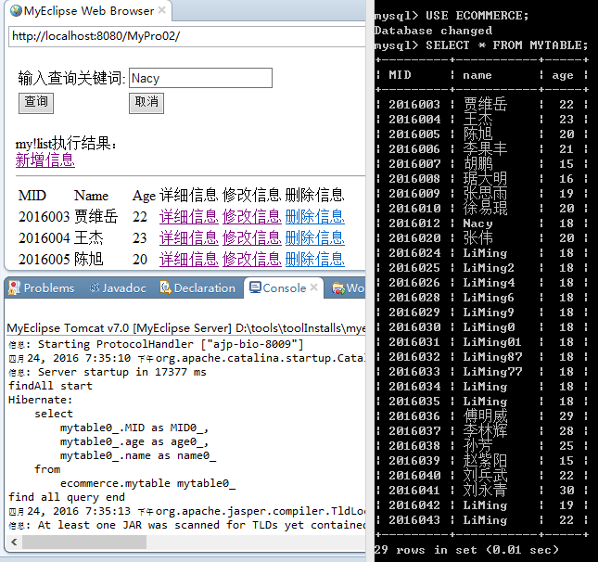

新增测试：
单击新增信息，并手工填写。结果如下：

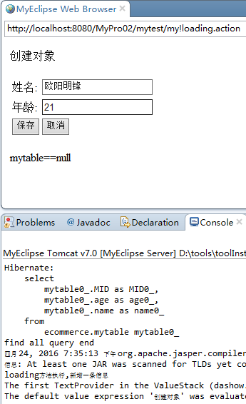
单击保存，跳转到my.jsp页面
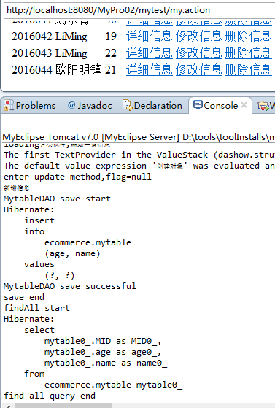

删除测试：
在上图中单击“删除信息”，删除主键为2016043的信息。运行结果如下：

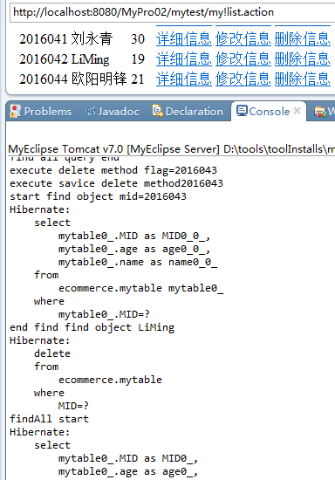

修改测试：
选择主键为2016041的刘永青，单击上图的“修改信息”，运行结果如下：

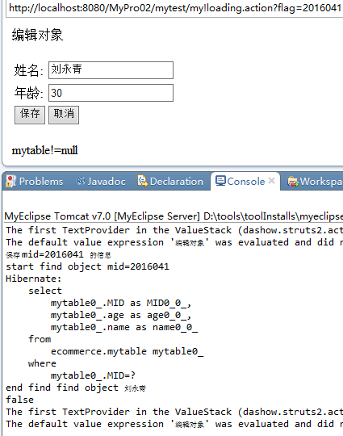

将“刘永青”改为“刘永轻”，“30”改为“31”，运行结果如下：

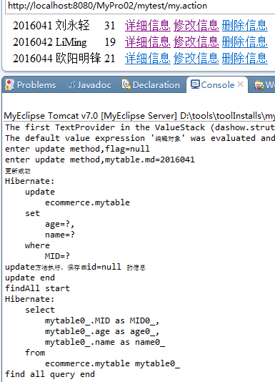

基于元数据的关键词查询测试：
在主界面输出LiMing，单击查询，查询前界面如下：
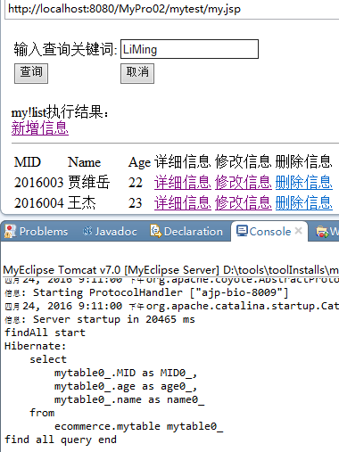

查询结果如下：
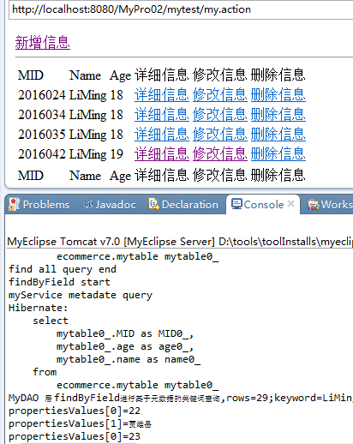
查询Age为20的

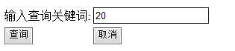
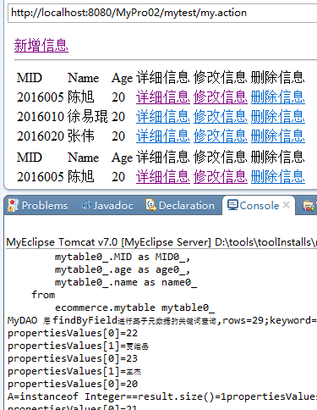

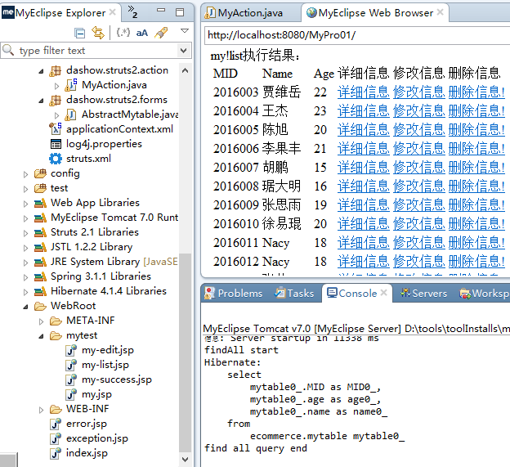

my.jsp运行结果

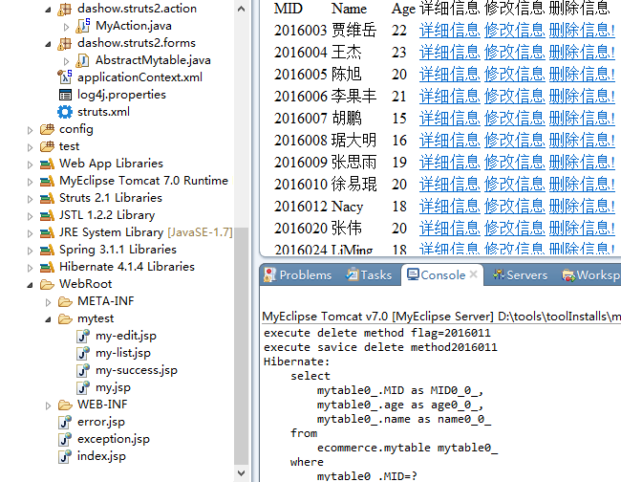

删除mid为2016011，名字为Nacy后的结果

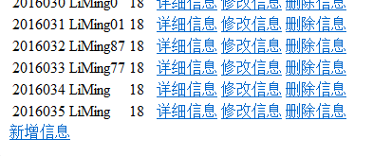
My.jsp运行结果下方显示新增
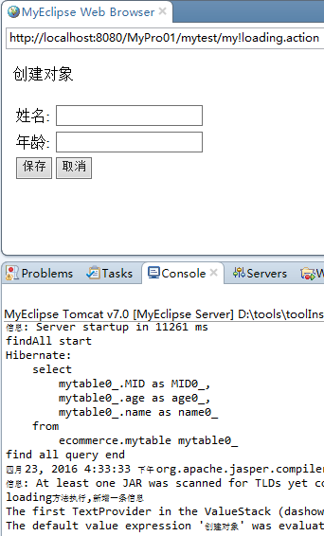
单击新增
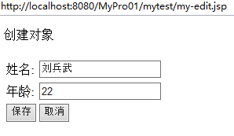

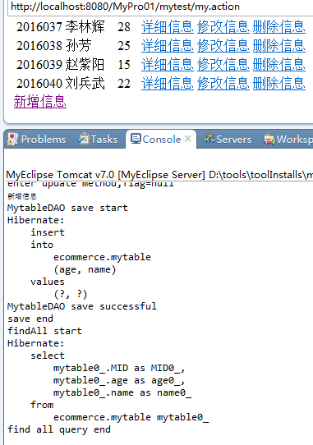
运行结果

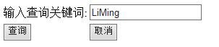

查询测试：
