

About Torryn Capital
Torryn Capital & Holding Poland Sp. z o.o. is a privately held investment, corporate finance and strategic capital platform headquartered in Poland and operating with an international perspective.
The firm supports selected companies, entrepreneurs, asset owners, investors, family offices, project sponsors and professional counterparties in situations where capital, market access, transaction structuring and trusted execution are essential to value creation.
Torryn Capital is active across corporate finance, private capital, commodities, infrastructure, energy-related investment themes and selected strategic ventures. Its role is to help clarify opportunities, structure credible transaction paths, connect relevant counterparties and support execution in a controlled, discreet and commercially realistic manner.
The firm does not position itself as a volume-driven financial intermediary. Its work is selective, relationship-led and focused on transactions where the commercial rationale is clear, the counterparties are identifiable and the execution framework can be reviewed with appropriate legal, financial, operational and reputational discipline.

Positioning
Torryn Capital is a senior-led private capital and corporate finance platform connecting strategic opportunities with credible capital, trusted counterparties and disciplined execution across Poland, Europe and selected international markets.
The firm is best suited to clients and partners who require more than introduction or capital placement alone. Torryn Capital brings commercial judgement, transaction preparation, structuring support, access to selected relationships and a clear focus on controlled execution.

Investment Philosophy
Torryn Capital’s philosophy is based on prudence, selectivity and alignment of interests.
The firm favours opportunities with tangible economic substance, credible counterparties and a clear path towards structured engagement. It places particular emphasis on authority, transparency, documentation discipline and realistic execution.
Torryn Capital seeks to build long-term relationships with counterparties whose interests are aligned across the transaction lifecycle. The firm’s approach is discreet, commercially grounded and focused on quality rather than volume.

Core Principles

Discretion
Transactions are handled on a confidential basis, with appropriate sensitivity to commercial, financial and reputational considerations.
Integrity
The firm seeks to engage only with counterparties that demonstrate authority, substance and a credible ability to perform.
Governance
Transactions are expected to follow structured
documentation, appropriate review standards and clear decision-making processes.
Execution Discipline
Torryn Capital places emphasis on realistic timelines, defined responsibilities and commercially achievable transaction structures.
Long-Term Alignment
The firm seeks enduring relationships rather than one-off engagements, with a preference for partners whose interests are aligned across the transaction lifecycle.

Core Capabilities
Torryn Capital operates through selected areas of activity where private capital, transaction preparation, market access and execution discipline are central to the opportunity.
 Strategic & Corporate Finance Advisory Torryn Capital provides corporate finance support for selected companies, investors, asset owners and transaction sponsors. The firm assists with transaction positioning, capital structuring, investor narrative, strategic partner identification, project finance preparation, restructuring considerations and selected M&A-related advisory work. Its role is typically to help clients clarify the commercial proposition, prepare a credible transaction case, identify suitable capital or strategic partners and support the structuring of opportunities that can be reviewed by professional counterparties. |  Private Capital & Investor Access Torryn Capital supports selected opportunities requiring access to private investors, family offices, strategic capital partners and institutional or professional counterparties. The firm focuses on situations where the capital requirement, risk profile, commercial logic and transaction structure can be clearly articulated. It assists in preparing opportunities for serious investor dialogue and in coordinating introductions where there is a credible basis for engagement.
 Commodities & Trade Finance Coordination Torryn Capital, together with selected affiliated and partner entities, is active in the origination, structuring and facilitation of physical commodity transactions, with particular relevance to energy products and petroleum-related commodities. The firm’s commodity-related activities focus on credible supply channels, qualified buyers, established logistics routes, appropriate financial documentation and transaction-specific execution frameworks. Typical transaction elements may include sourcing coordination, buyer and seller alignment, logistics interfaces, storage considerations, structured payment mechanisms and documentation support. Torryn Capital generally favours structured transactions over speculative spot activity. Where appropriate, an initial trial transaction may form the basis for a longer-term contractual relationship. |  Infrastructure, Energy & Strategic Assets Torryn Capital is active in selected infrastructure and energy-related investment opportunities, particularly where long-term capital requirements intersect with strategic economic transformation. The firm’s areas of interest include energy infrastructure, transition infrastructure, storage solutions, grid-related investment themes and selected industrial or strategic assets. Torryn Capital seeks to support projects and counterparties that require disciplined financing structures, credible investor access and commercially robust execution frameworks. The firm is particularly interested in opportunities where the asset base, project economics, counterparties and regulatory context can be assessed with sufficient clarity.
 Investment Structuring & Strategic Ventures Torryn Capital also considers selected early-stage and growth-oriented investment opportunities, particularly where technology, applied innovation, energy transition and industrial transformation converge. The firm’s preferred approach is to support ventures that demonstrate credible management, defensible technology, clear market relevance and a path towards institutional funding, strategic partnership or commercial scale. Torryn Capital is particularly attentive to opportunities linked to engineering excellence, European research capability, energy transition, advanced technology and practical industrial application. |  Market Access & Cross-Border Partnerships Torryn Capital supports companies, investors and asset owners seeking relevant relationships, transaction partners and market access across Poland, CEE, Europe and selected international markets. The firm’s network includes experienced principals, financial partners, sector specialists and transaction counterparties with backgrounds in banking, asset management, corporate finance, commodities, infrastructure, international business development and government-related advisory. This allows Torryn Capital to assess opportunities from multiple perspectives: financial, commercial, legal, operational and reputational.
 | Governance, Documentation & Execution Control  Torryn Capital places emphasis on structured documentation, appropriate review, counterparty verification, realistic timelines and clear responsibilities.  The firm expects transactions to be developed with suitable legal, financial, operational and commercial discipline. Where legal, tax, regulatory or specialised professional advice is required, Torryn Capital works alongside qualified external advisers.  The objective is to support engagement in a manner that protects credibility, reduces unnecessary execution risk and creates a clear basis for decision-making.

Our Value Proposition
Torryn Capital’s value is strongest where opportunities require more than capital alone.
The firm brings together commercial judgement, strategic positioning, private-market access, transaction preparation, partner coordination and execution discipline. It helps clients and partners transform selected opportunities into credible transaction propositions that can be assessed by serious counterparties.
Torryn Capital is particularly relevant in situations where trust, discretion, market knowledge and structured engagement are critical to progress. Its work is intended to create clarity, improve readiness, connect relevant relationships and support measurable movement from initial discussion to executable transaction framework.
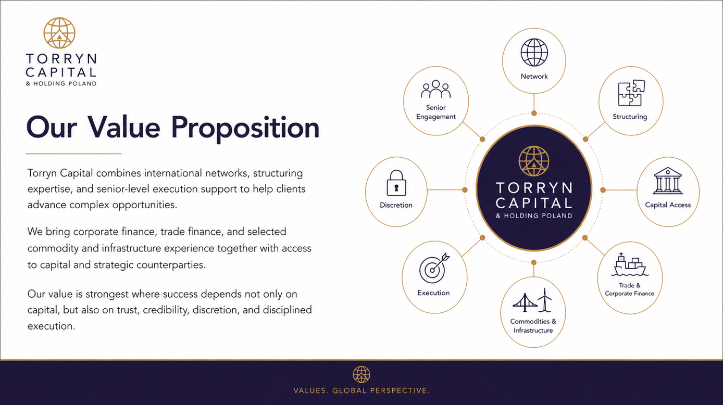

Clients and Partners
Torryn Capital welcomes dialogue with selected corporate clients, entrepreneurs, asset owners, family offices, qualified investors, commodity counterparties, project sponsors and institutional partners.
The firm is best suited to counterparties seeking a discreet, professional and commercially grounded partner for transactions involving corporate finance, strategic capital, commodities, infrastructure, energy-related investment themes or selected private-market opportunities.
Engagements are considered on a case-by-case basis and are subject to appropriate review, documentation, counterparty verification and commercial alignment.

Differentiators
Torryn Capital’s differentiators are based on senior involvement, selectivity, international perspective and practical transaction experience.
The firm combines relationship access with disciplined screening and commercial judgement. It is not structured around broad distribution, generic advisory language or speculative transaction flow. Instead, Torryn Capital focuses on selected opportunities where substance, authority, timing and execution capability can be properly assessed.
Its culture is discreet, senior-led and relationship-driven. The firm aims to engage with counterparties who value trust, clarity, aligned interests and measurable progress.

Engagement Approach
Torryn Capital works discreetly, selectively and at senior level.
The firm begins with a careful understanding of the opportunity, the counterparties, the commercial rationale and the intended outcome. It then considers whether the transaction can be structured, documented and introduced in a manner that is credible to professional counterparties.
Where there is alignment, Torryn Capital supports the development of a clear engagement path. This may include transaction positioning, investor or partner identification, documentation preparation, coordination with advisers, phased execution planning and support through key decision points.
The firm favours realistic timelines, defined responsibilities and commercially achievable structures. Its objective is to support transactions that can move from conversation to credible execution without compromising discretion, governance or reputational standards.

Confidentiality and Professional Standards
Torryn Capital operates with a high regard for confidentiality, commercial sensitivity and reputational discipline.
Transactions are handled with appropriate discretion and subject to suitable review. The firm expects counterparties to demonstrate authority, substance and a credible ability to perform.
Torryn Capital does not provide legal, tax, regulatory or investment advice unless expressly agreed within the limits of applicable authorisation and supported by the appropriate professional advisers. Recipients and counterparties are expected to conduct their own independent legal, financial, tax, regulatory, commercial and operational due diligence before entering into any transaction.

CONTACT | Harald Mueller  President of the Board  Torryn Capital & Holding Poland Sp. z o.o.  Direct: +48 451 295 270

Disclaimer
This document has been prepared by Torryn Capital & Holding Poland Sp. z o.o. for private information purposes only.
The information contained herein does not constitute legal, tax, financial, investment, accounting, regulatory, or other professional advice. Nothing in this document should be construed as an offer, solicitation, recommendation, or invitation to buy, sell, subscribe for, or otherwise participate in any investment, security, financial instrument, commodity transaction, trading programme, or other product or service.
This document is intended only for qualified, professional, institutional, or otherwise eligible recipients. It is not intended for retail distribution. Any recipient should conduct independent legal, financial, tax, regulatory, commercial, and operational due diligence before entering into any transaction or relying on any information contained herein.
All information has been prepared in good faith and from sources considered reliable; however, no representation or warranty, express or implied, is made as to the accuracy, completeness, or continued validity of the information. The information may be subject to change without notice.
Any forward-looking statements, projections, estimates, market views, or strategic expectations are inherently uncertain and may differ materially from actual outcomes. Past performance, prior transaction experience, or market access does not guarantee future results.
Torryn Capital accepts no liability for any loss, damage, cost, or expense arising directly or indirectly from the use of, reliance upon, or interpretation of this document.
This document is private and confidential. It may not be reproduced, distributed, published, or disclosed to any third party without the prior written consent of Torryn Capital & Holding Poland Sp. z o.o.
TC/CP/2026/EVOLVED

