**Module 2 - HTML**

**Ans (1):-**

**What is HTML.Purpose of HTML in web development:-**

HTML is standard Markup Language.HTML is used to create Structures of web page.

**Purpose:-**

* Designing of web page.
* Creating link and paragraphs.
* Include multimedia such as images, videos and audio.

**Ans (2):-**

**Structure of an HTML:-**

<! DOCTYPE html>

<html>

<head>

<title> web page title </title>

</head>

<body>

..show in browser..

</body>

</html>

**<! DOCTYPE html>:-**

It is Specifies this is an HTML-5 code.

**<html>:-**

This is root element of html page.

**<head>:-**

Important information about the webpage.

**<title>:-**

the title of the webpage, which is run on browser.

**<body>:-**

This is main part of webpage. Show in browser.

**Ans (3):-**

**Difference between Block-level and Inline element:-**

**Block-level:-**

Block-level element is start on new line and Taking up space the full width available.

Example:-<p>, <div>, <hr>.

**Inline:-**

Inline Means Flow with nearby text on the same line. Only take up the space needed for their content.

Example:-<b>, <a>, <u>, <mark>.

**Ans (4):-**

**The role of semantic HTML, Why it is important Semantic:-**

**Role of semantic:-**

Semantic HTML that means understand user and machine it is called semantic elements.

**Why Important:-**

Because it helps structure web content in a meaningful way.

Example, <header>,<footer>,<main>.

|  |
| --- |
| **Lab Assignment** |

**OUTPUT:-** 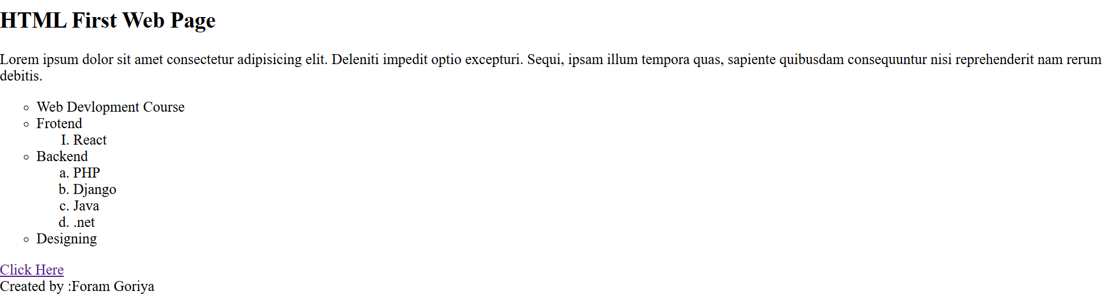

**HTML Forms:-**

**Theory:-**

**Ans(1):-**

**HTML Form :-**

HTML form on web page allow a user to enter data that is sent to a server for processing.

**Ans(2):-**

**Difference between GET and POST Method:-**

|  |  |
| --- | --- |
| **GET** | **POST** |
| Data is visible in the URL. | Data is not visible in the URL. |
| Data is store in browser history. | Data is not store in browser history. |
| Limited data length restrictions. | No Limited data length restrictions. |

**Ans(3):-**

**Purpose of the label element:-**

The <label> element in HTML associates text labels with form controls, making forms more accessible and usable. This helps users understand what data to enter .

**Screen readers**

Screen readers read the label when the user focuses on the form input. This helps users understand what data to enter.

**Clicking**

Clicking the label focuses the input, This helps users who have difficulty clicking on small regions, like checkboxes or radio buttons.

**Fine motor control**

The clickable label helps users with hand tremors or other challenges related to fine motor control.

**Search engine optimization**

The label tag helps search engines understand the context of form elements, which can improve SEO.

|  |
| --- |
| **Lab Assignment** |

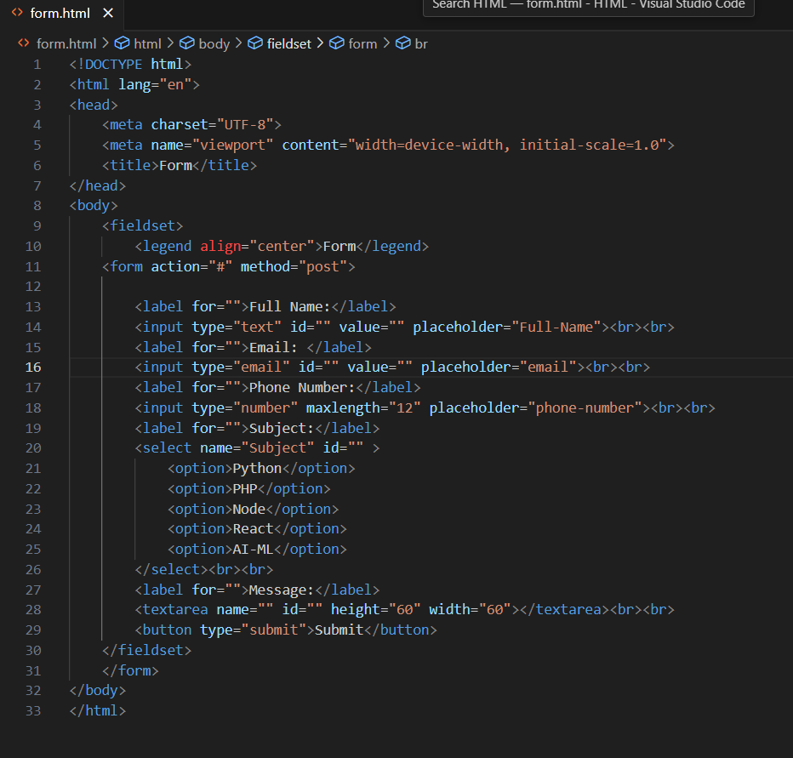

**OUTPUT:-**

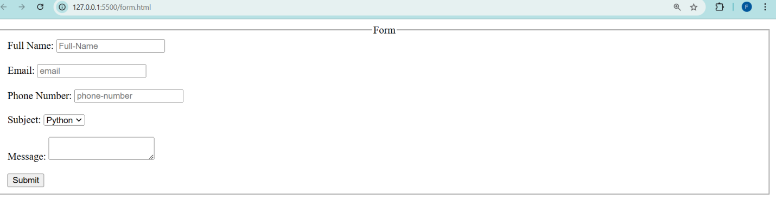

**HTML Tables:-**

**Ans(1):-**

HTML table is a structure that organizes data in rows and columns.

**<table>**: The main container for the entire table

**<tr>**: Defines a row in table the

**<th>**: Defines a header cell in the table

**<td>**: Defines a standard data cell in the table

**<thread>**: Groups rows together to create a table head

**Ans(2):-**

**Diffrence between rowspan and colspan:-**

🡪HTML tables, cols pan is merge cell horizontally.

🡪 row span is merge cells vertically.

Example:-

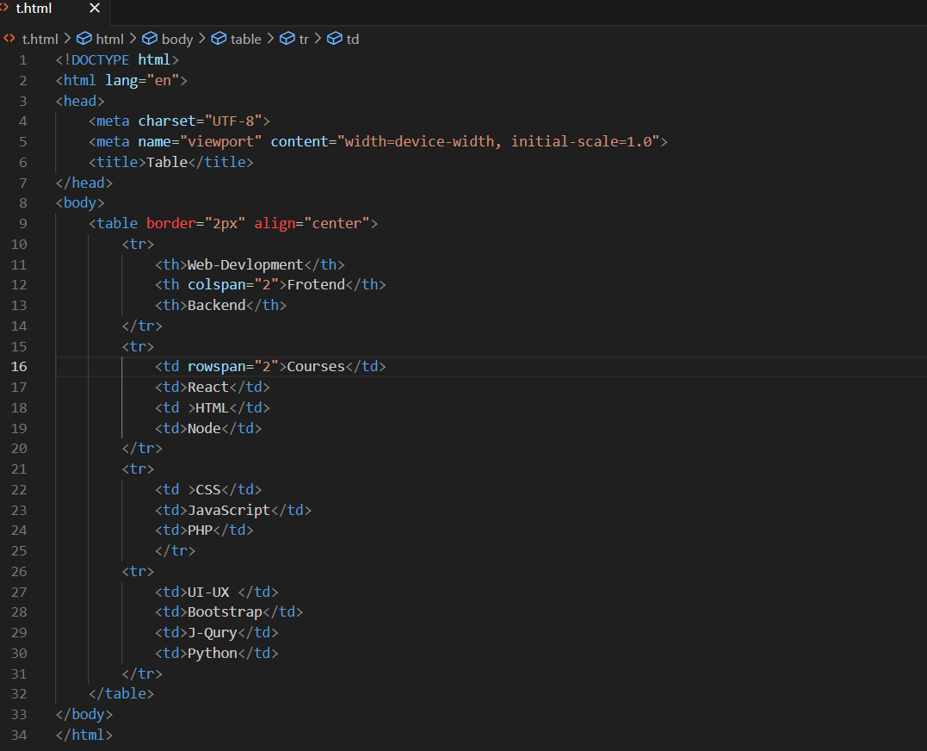

OUTPUT:-

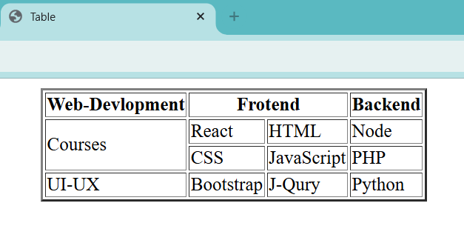

**Ans(3):-**

Because content and structure are completely separate from presentation.

**CSS (Cascading Style Sheets)**: CSS allows for the separation of content and presentation, making it easier to create flexible and responsive layouts.

**Responsive Design**: Techniques like media queries and flexible grid systems e.g., Bootstrap, Tailwind CSS

**Semantic HTML**: Use proper semantic elements like <header>, <nav>, <main>, <article>, and <footer> to structure your content.

|  |
| --- |
| **Lab Assignment** |

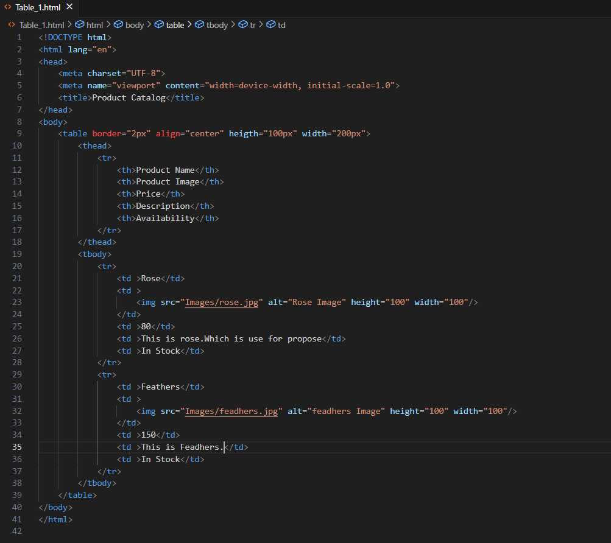

**OUTPUT:-**

