**Q-1 What is SDLC ?**

**Ans :-**  SDLC is stands for **Software Development Life Cycle** is structured process that is used to design, develop nd test good quality software.

**Q-2 what is software testing?**

**Ans :-**  Testing is process to indentify the correctness, completeness and quality of developed computer software.

**Q-3 what is agile methodology**

**Ans :-**  Agile is combination of interactive and increment model with a focus on adaptability and customer satisfaction

**Q-4 What is SRS**

**Ans :-**  SRS stands for software requirement specification is complete description of the behavior of the system to be developed

**Q-5 What is oops**

**Ans :-**  OOPS is object oriented programming system

**Q-6 write basics concepts of oops**

**Ans :-**  Concepts :-

1. Object
2. Class
3. Encapsulation
4. Polymorphism
5. Abstraction

**Q-7 What is object**

**Ans :-**  object is an instance of an class

**Q-8 What is class**

**Ans :-**  class is a collection of data member and member function with its behavior

**Q-9 What is encapsulation**

**Ans :-**  warring a data in to single unit

**Q-10 What is inheritance**

**Ans :-**  properties of parent extends into child class. Mainly use of

reusability and extedsibility

**Q-11 What is polymorphism**

**Ans :-**  ability to take one name having many forms

**Q-12 Draw usecase on online book shooping**

**Ans :-**

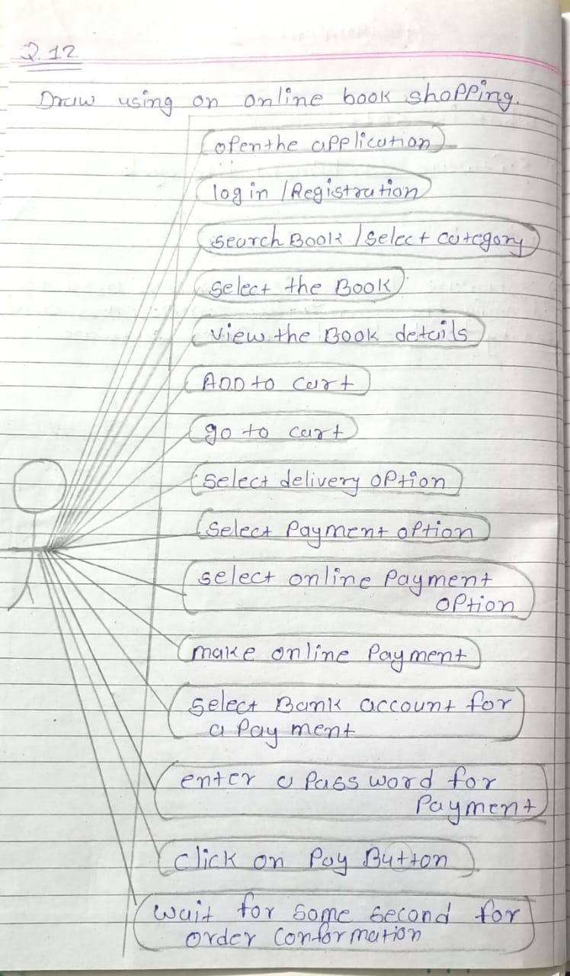

**Q-13 Draw usecase on online bill payment system**

**Ans :-**

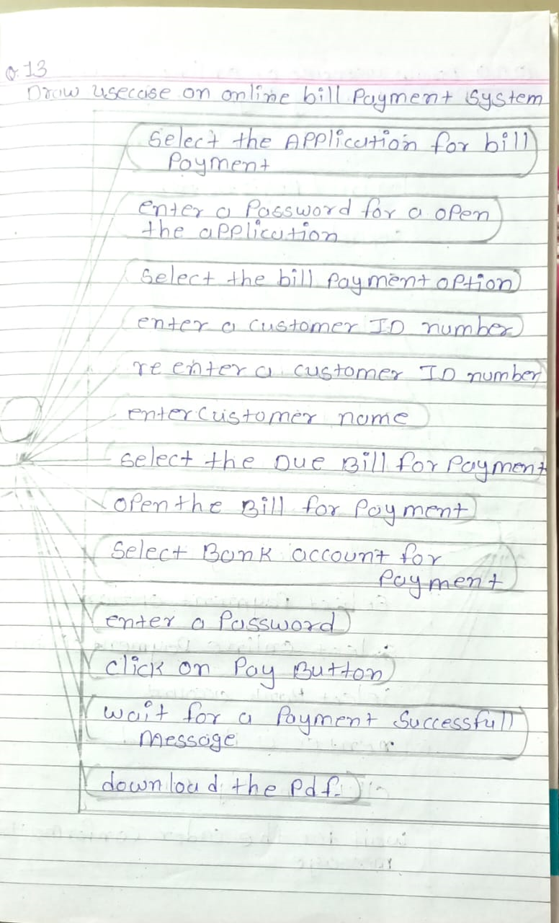

**Q-14 Write a SDLC phases with basic introduction**

**Ans :-**  SDLC phases :-

1. Requirement gathering :-

* Features
* Usage scenario
* Requirements will be changed
* Threes types :-
  + Lack of clarity
  + Requirements confusion
  + Requirements amalgamation

1. Analysis phases

* The deliverable result at the end of the phases is requirement document
* This analysis represent the “what” phase

1. Design phase

* Design architecture document
* Design team can now open information established in document

1. Implementation phase

* The team should build exactly what has been requested
* Deals with issues of quality, performance libraries and debugging

1. Testing

* Quality is very important but some company has not learn quality is important
* Its easier to explain to customer there is missing features

1. Maintenance

* Types:-
* Corrective
* Adaptive
* Perfective

**Q-15 explain phases of waterfall model**

**Ans :-**  waterfall model phases :-

1. Business requirement analysis

* This is the first phase in the development cycle
* The product requirement are understood from the customer perspective

1. System design

* You have the clear and detailed product requirement and its time to complete system
* System test plan is developed based on the system design

1. Architectural design

* This design are to understand and design in this phase
* This is also referred to as high level

1. Module design

* The detailed internal esign for all system is specified and referrd to low level design
* Unit tests can be designed at this stage based on the internal module design

1. Code phase

* Actual coding of the system module designed in the design phase is taken up in the phase

**Validation phase :-**

1. Unit testing

* unit testing designed in the module design phase re executed on the code during this phase

1. integration testing

* integration testing is associated with the architectural design phase

1. system testing

* this testing is directly associated with system design phase

1. acceptance testing

* this testing is associated with business requirement analysis and involves testing the product in user environment

**Q-16 write a phases of spiral model**

**Ans :-**  spiral model phases :-

* planning
* risk analysis
* engineering
* customer evaluation

**Q-17 write agile manifesto**

**Ans :-**  agile manifesto

* individual interation
* customer collaboration
* working software
* responding to change

**Q-18 Working methodology of agile model and also write pros and cons**

**Ans :-**  Agile is combination of interactive and increment model with a focus on adaptability and customer satisfaction

* these builds are provided in iterations
* each iteration involves last one at three weeks
* at the end of the iteration on a work product is displayed to the customer and important stakeholders

**Pros:-**

* realistic approach to software development
* resource requirement are minimum
* good model for environment change steaily
* suitable for fix and changing requirement

**Cons:-**

* not suitable for handling complex dependencies
* more risk of maintainability and extensibility
* there is high individual dependency and there is a minimum documentation genearated

**Q-19 draw usecase of on online shopping cod**

**Ans :-**

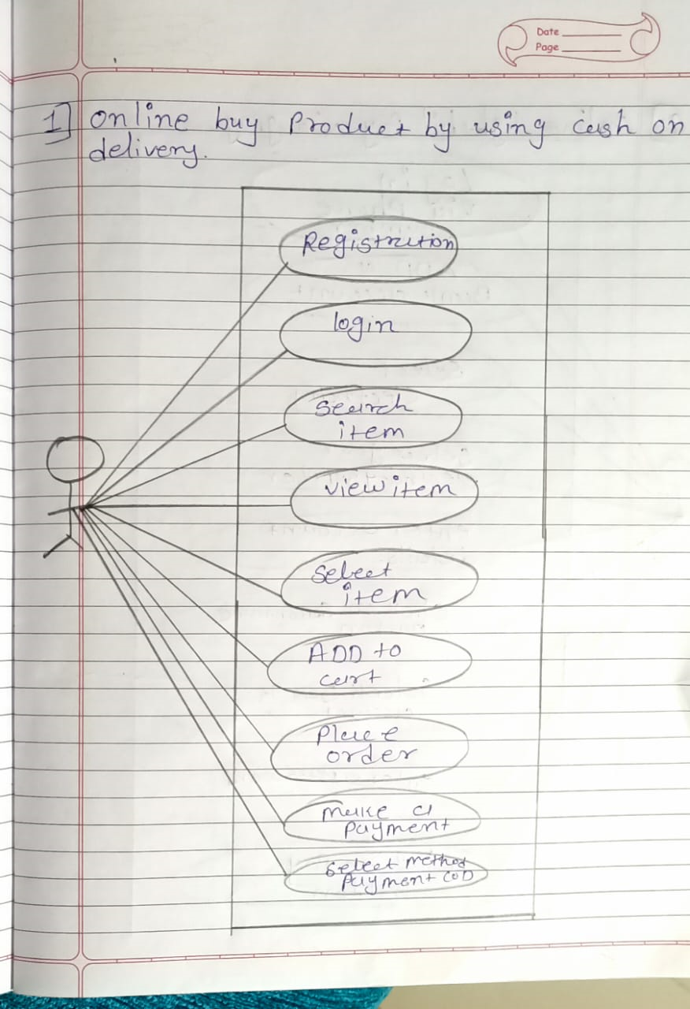

**Q-20 draw usecase of online shopping product using payment gatway**

**Ans :-**

