Software Requirements Specification
for
HealthHub
Version 1.0 approved
Prepared by Ayush Zalavadiya, Neel Dalsania &
Foram Dholakiya
RKU
Date :- 23-02-2024
Table of Contents
Table of Contents ii
Revision History ii
1. Introduction 1
1.1 Purpose 1
1.2 Document Conventions 1
1.3 Intended Audience and Reading Suggestions 1
1.4 Project Scope 1
1.5 References 1
2. Overall Description 2
2.1 Product Perspective 2
2.2 Product Features 2
2.3 User Classes and Characteristics 2
2.4 Operating Environment 2
2.5 Design and Implementation Constraints 2
2.6 User Documentation 2
2.7 Assumptions and Dependencies 3
3. System Features 3
3.1 System Feature 1 3
3.2 System Feature 2 (and so on) 4
4. External Interface Requirements 4
4.1 User Interfaces 4
4.2 Hardware Interfaces 4
4.3 Software Interfaces 4
4.4 Communications Interfaces 4
5. Other Nonfunctional Requirements 5
5.1 Performance Requirements 5
5.2 Safety Requirements 5
5.3 Security Requirements 5
5.4 Software Quality Attributes 5
6. Other Requirements 5
Appendix A: Glossary 5
Appendix B: Analysis Models 6
Appendix C: Issues List 6

Revision History
Name | Date | Reason For Changes | Version

Introduction

Purpose

The purpose of this document is to provide a comprehensive overview of the requirements for the development of a Hospital Management System (HMS). The HMS aims to streamline hospital operations, improve patient care, and enhance administrative efficiency.

1.2 Document Conventions

Font: Use a consistent font throughout the document, such as Arial or Times New Roman.

Heading Styles: Use distinct styles for different sections, e.g., bold for section titles, italics for subsections.

Numbering: Hierarchical numbering system.

- Bullet Points: Use bullet points for lists and enumerations.

1.3 Intended Audience and Reading Suggestions
1.3.1. Intended Audience :-

- Hospital Administrators: Individuals responsible for overseeing the overall operation and management of the hospital, including strategic planning, financial management, and resource allocation.

- Medical Staff (Doctors, Nurses, Technicians): Healthcare professionals involved in direct patient care, including physicians, nurses, laboratory technicians, radiology technicians, and other allied health professionals.

- Information Technology (IT) Staff: IT professionals responsible for the implementation, maintenance, and support of the hospital management system, including system administrators, network engineers, and technical support staff.

- Non-Medical Staff (Administrative, Finance, Human Resources): Personnel responsible for administrative, financial, and human resource management within the hospital, including administrative assistants, finance managers, and HR personnel.

1.3.2. Reading Suggestions :-

- Project Stakeholders: Begin by reviewing the "Introduction" and "General Description" sections to gain an understanding of the project's objectives, scope, and key functionalities. Proceed to the "Specific Requirements" section for detailed insights into both functional and non-functional requirements.

- End Users (Hospital Staff): While this document may not be directly applicable to end users, rest assured that their input and needs have been taken into account during the requirements definition process. End users can expect a hospital management system that is designed to streamline workflows, enhance efficiency, and improve patient care delivery.

1.4 Project Scope

The HMS aims to streamline hospital operations, improve patient care, and enhance administrative efficiency. It includes modules for patient management, appointment scheduling, medical records, billing, and inventory management.

Overall Description

Product Perspective

The HMS is a standalone system designed to operate within a hospital environment. It interfaces with external systems such as laboratory information systems (LIS) and picture archiving and communication systems (PACS).

Product Features
- Patient Management: Create, update, and manage patient records including demographics, medical history, and insurance information.

- Appointment Scheduling: Schedule patient appointments with doctors, manage appointment slots, and send appointment reminders.

- Medical Records: Maintain electronic health records (EHR) including diagnoses, prescriptions, lab results, and imaging reports.

- Billing and Invoicing: Generate bills, process payments, and manage invoicing for services rendered.

- Inventory Management: Track and manage hospital inventory including medical supplies, medications, and equipment.

User Classes and Characteristics
- Hospital Administrators: Manage overall hospital operations and system configuration.

- Medical Staff: Access patient information, update medical records, and schedule appointments.

- Receptionists: Manage appointment scheduling, patient check-ins, and inquiries.
- Billing Department: Generate bills, process payments, and manage financial transactions.

Operating Environment
- Web Browser Compatibility: The HMS should be compatible with major web browsers (e.g., Chrome, Firefox, Safari).

- Database Management System: Integration with a relational database management system (RDBMS) such as MySQL or PostgreSQL.

- External System Integration: Integration with external systems requires compatibility with relevant protocols and APIs.

Design and Implementation Constraints
- Web-Based Application: The HMS is designed as a web-based application accessible via standard web browsers.

- Security Standards: Compliance with healthcare industry security standards (e.g., HIPAA) for handling sensitive patient data.

- User Authentication: Implement secure authentication mechanisms (e.g., username/password, multi-factor authentication) for user access control.

User Documentation
The user documentation will include:
- Introduction
- User Registration
- List Of Departments
- List Of Announcements
- List Of Medicines
- List Of Ambulances
- Appointment Scheduling Instructions

Assumptions and Dependencies
Assumptions:

- Internet Connectivity: Users have access to a stable internet connection for accessing the HMS.

- User Training: Hospital staff receive training on using the HMS effectively.

- Data Accuracy: Patient data entered into the system is accurate and up-to-date.

Dependencies:

- Database System: Dependence on the availability and reliability of the chosen database management system.

- External System Integration: Dependence on the availability and reliability of external systems such as React DOM, etc.

System Features
3.1. Patient Registration and Authentication:

3.1.1. Description: Patients can create accounts using their personal information, and they can securely log in to access their medical records and appointments.

3.1.2. Response Sequence:

- Patient provides registration details.

- System verifies and validates patient information.

- Patient receives a confirmation email or SMS for account activation.

3.1.3. Functional Requirements:

- Implement secure authentication mechanisms.

- Validate patient information during registration.

- Send confirmation notifications.

3.2. Appointment Management:

3.2.1. Description: Patients can schedule appointments with doctors, view appointment details, and receive reminders.

3.2.2. Response Sequence:

- Patient selects preferred date and time for an appointment.

- System checks doctor's availability.

- Appointment confirmation is sent to patient and doctor.

3.2.3. Functional Requirements:
- Implement appointment scheduling functionality.

- Check doctor's availability in real-time.

- Send appointment reminders to patients.

External Interface Requirements

User Interfaces

Login and Registration Interface:
- Allow users (patients, doctors, staff) to log in to existing accounts or create new ones.
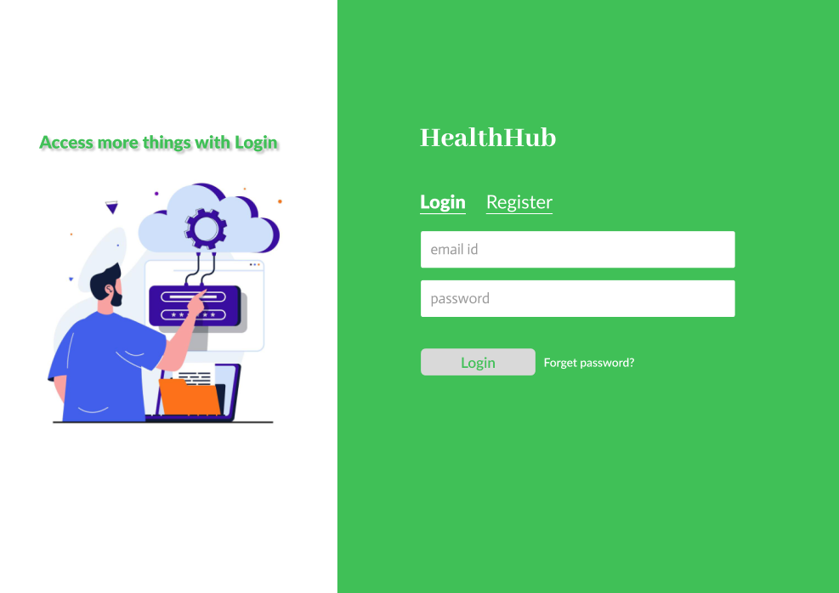
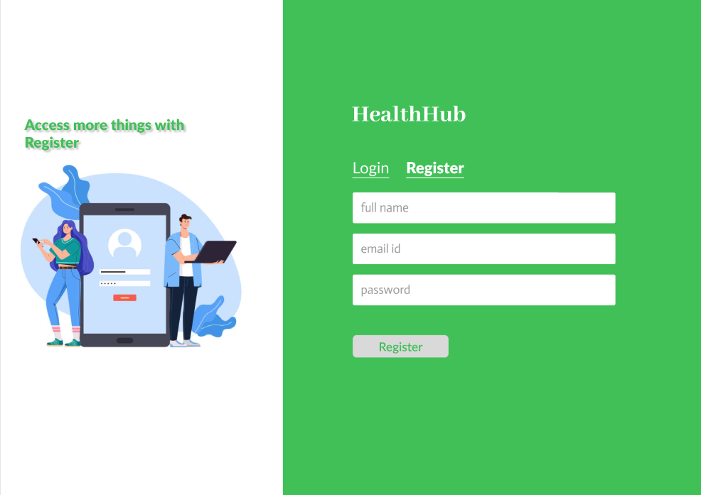

Patient Dashboard:
- Display patient appointments, medical records, and other relevant information.

List Of Departments
This interface allows users to view a list of departments available within the hospital, along with their respective specialties and contact information.
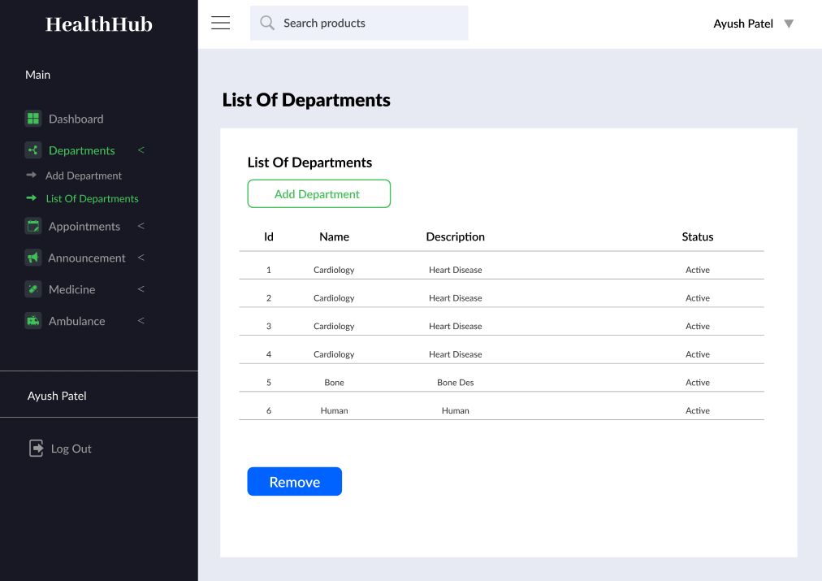
4.1.4 List Of Announcements
Users can access announcements regarding hospital events, policy updates, and other relevant information through this interface.
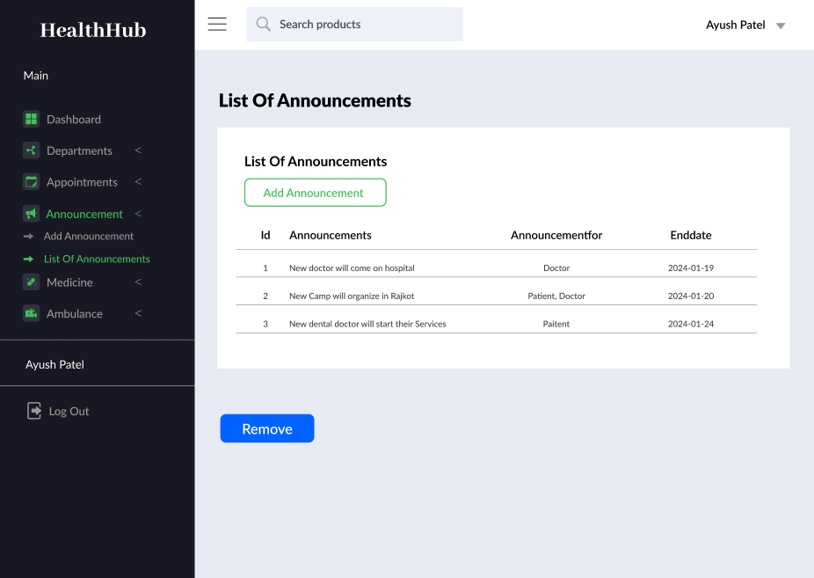

List Of Medicines
Provides a catalog of available medicines within the hospital, including details such as name, dosage, and stock availability.
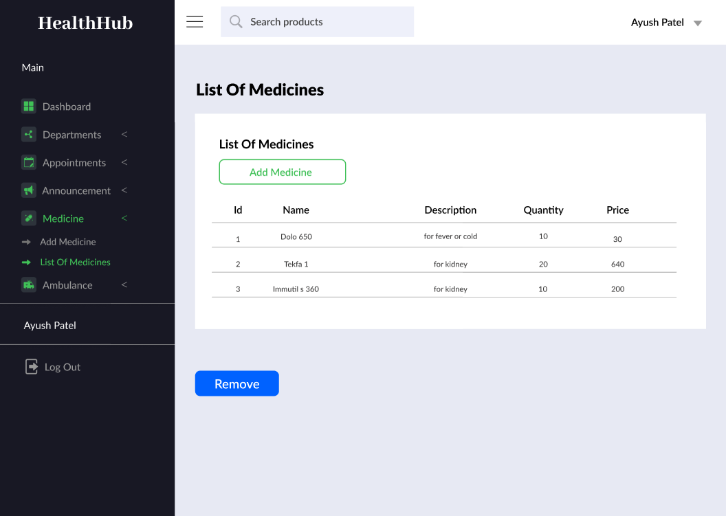

List Of Ambulances
Displays information about the hospital's ambulance services, including availability, contact details, and tracking options for emergency requests.
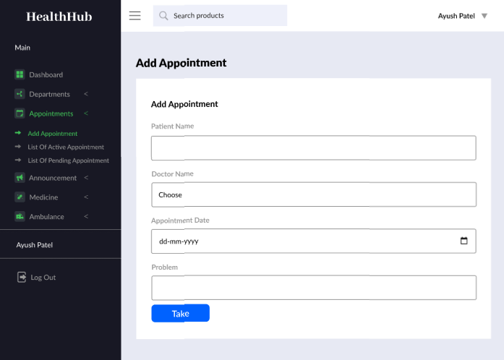
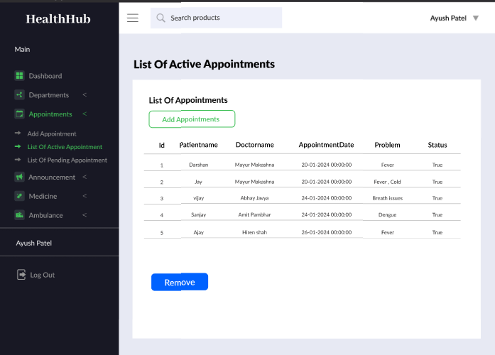

Appointment Scheduling Instructions
Guidelines and instructions for scheduling appointments with healthcare providers, including steps to book appointments online or through other communication channels.

Hardware Interfaces
No specific hardware interfaces required for the software.

Other Nonfunctional Requirements

Performance Requirements

Response Time:
- Ensure that the system responds to user requests within 2 seconds.

Data Retrieval:
- Retrieve patient records and appointment details quickly, even under heavy load conditions.

Safety Requirements

Data Privacy:
- Ensure compliance with HIPAA regulations and protect patient data from unauthorized access.

Secure Authentication:
- Implement secure authentication mechanisms to prevent unauthorized access to patient records.

Security Requirements

User Authentication:
- Implement strong password policies and secure login procedures for all users.

Data Encryption:
- Encrypt sensitive patient data to ensure confidentiality during transmission and storage.

Software Quality Attributes

Usability:
- Design an intuitive user interface that is easy to navigate for patients, doctors, and staff.

Reliability:
- Ensure that the system is stable and reliable, with minimal downtime for maintenance.

Appendix A: Glossary
- Appointments: Scheduled meetings between patients and healthcare providers for medical consultations, examinations, treatments, or procedures.

- Announcements: Official notifications or messages disseminated within the hospital system to inform staff, patients, or visitors about events, policy updates, or other relevant information.

- List Of Departments: A feature within the HMS that provides users with a comprehensive list of all departments available within the hospital, along with their respective specialties, services offered, and contact information.

- List Of Announcements: An interface in the HMS where users can access and view announcements regarding hospital events, policy updates, and other important information.

- List Of Medicines: A catalog within the HMS that displays information about the medicines available within the hospital, including details such as name, dosage, stock availability, and usage instructions.

- List Of Ambulances: Information about the hospital's ambulance services, including availability, contact details, and tracking options for emergency requests.

- Appointment Scheduling Instructions: Guidelines and instructions provided to users for scheduling appointments with healthcare providers through the HMS, including steps to
- book appointments online or through other communication channels.

Appendix B: Analysis Models
Class Diagram:
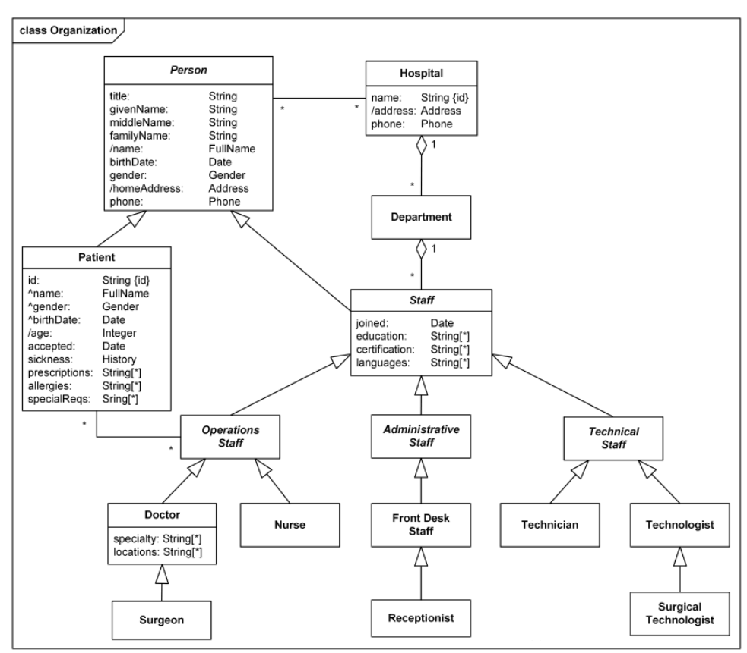
Use Case Diagram:
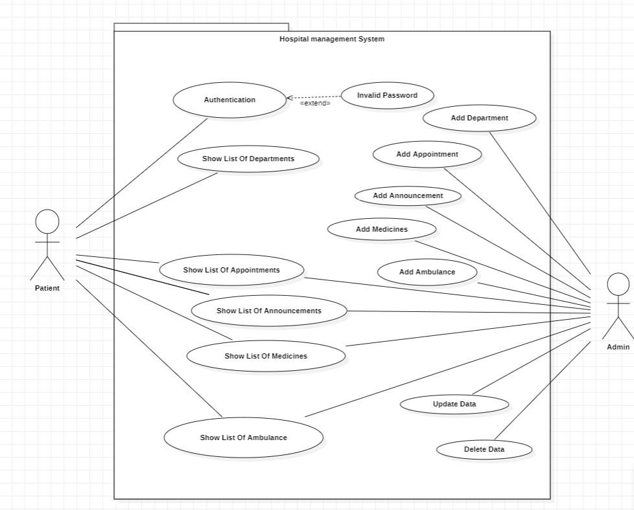
DFD Diagram Level 1:
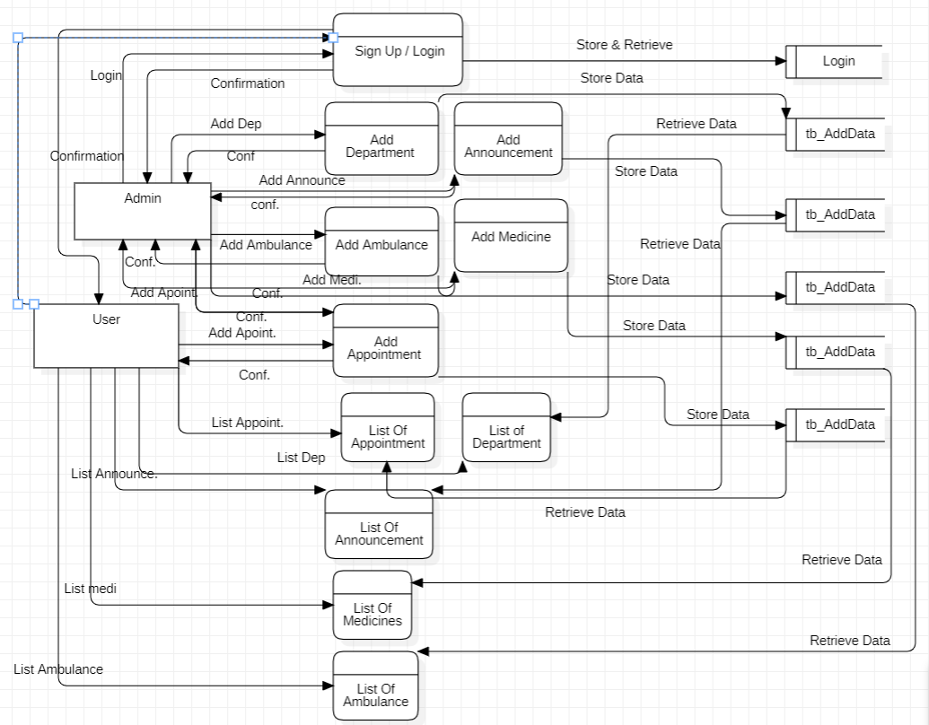
Appendix C: Issues List
- Network and Offline Functionality: Providing a seamless experience for users with limited or no internet connectivity requires careful planning and offline functionality development.
- User Data Privacy: Ensuring compliance with data privacy regulations (e.g., GDPR) and securing user data.
- User Feedback and Reviews: Managing user reviews and addressing negative feedback.

