

**ASSIGNMENT-1**

**Subject:** SOFTWARE ENGINEERING

**SUBMITTED TO:**

MR. DARSHAN SONECHA

Assistant professor

**SUBMITED BY:**

Foram Mehta

CE-TC1(SEM.-6)

Enrollment no.-140970107016

**SUBMITED ON:**

22nd December 2016

**Question 1**

* Implement in C++ a program that will instantiate two automobile objects, allowing them to change it’s speed and direction. Both automobile objects, their class declarations to say, auto1 and auto2, should have different characteristics. For example, auto1 could have air conditioner and auto2 could have no air conditioner, auto1 could be red color and auto2 could be blue. Please limit common features to minimum required, 6 at max, such as number of wheels, steering wheel and headlights. Differentiating characteristics should be, 2 or 3 at the max.

#include<iostream>

#include<conio.h>

using namespace std;

class auto1

{

public:

int speed;

char direction[];

char colour[];

int no_of_wheels;

int cc;

void getdata()

{

cout<<"Enter speed";

cin>>speed;

cout<<"Enter direction";

cin>>direction;

cout<<"Enter colour";

cin>>colour;

cout<<"Enter wheels count";

cin>>no_of_wheels;

cout<<"Enter cc";

cin>>cc;

}

void putdata()

{

cout<<speed<<endl<<direction<<endl<<colour<<endl<<no_of_wheels<<endl<<cc<<endl;

}

};

class auto2

{

public:

int speed;

char direction[];

char colour[];

int no_of_wheels;

int cc;

void getdata()

{

cout<<"Enter speed";

cin>>speed;

cout<<"Enter direction";

cin>>direction;

cout<<"Enter colour";

cin>>colour;

cout<<"Enter wheels count";

cin>>no_of_wheels;

cout<<"Enter cc";

cin>>cc;

}

void putdata()

{

cout<<speed<<endl<<direction<<endl<<colour<<endl<<no_of_wheels<<endl<<cc<<endl;

}

};

int main()

{

auto1 obj1;

auto1 obj2;

obj1.getdata();

obj2.getdata();

obj1.putdata();

obj2.putdata();

}

**Question 2**

* Describe what is UML?
* **UML** (**Unified Modeling Language**) is a standard notation for the modeling of real-world objects as a first step in developing an object-oriented design methodology.
* Unified modeling language diagram is designed to let developers and customers view a software system from different perspective and in varying degree of abstraction.
* One reason UML has become a standard modeling language is that it is programming language independent.
* Types of UML:

1. Structural Diagram:

* Structure diagrams emphasize on the things that must be present in the system being modeled.
* Since structure diagrams represent the structure,they are used extensively in documenting the software architecture of software system.

1. Behavioral Diagram:

* Behavior diagrams emphasize on what must happen in the system being modeled.
* Since behavior diagrams illustrate the behavior of a system, they are used extensively to describe the functionality of system software.

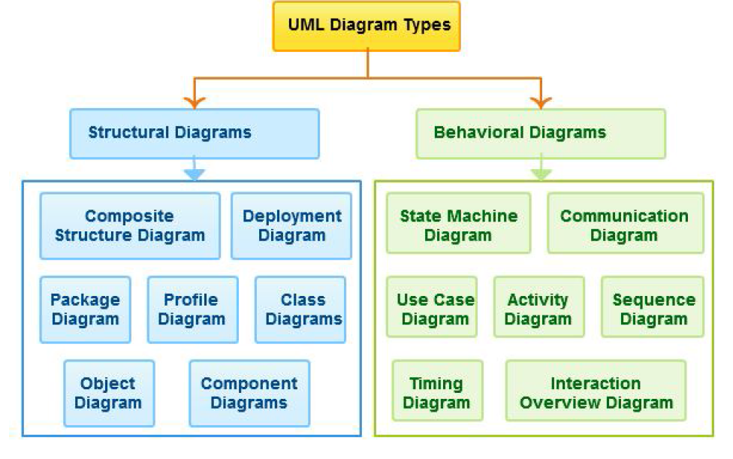

**Question 3**

* Describe what is Software Engineering?
* Software engineering is a field of engineering for designing and writing programs for computers or other electronic devices.
* A software engineer or programmer writes software and compiles software using methods that make it better quality.
* Software engineering is the application of a systematic, disciplined, quantifiable approach to the development, operation and maintenance of software that is the application of engineering to software.