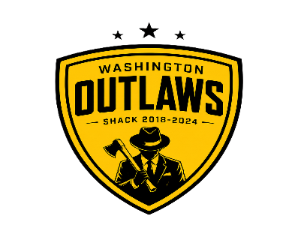
WASHINGTON OUTLAWS
2018-2024

Declared by;
MAURICE KATEREGGA
CHAIRPERSON ELECTORAL COMMISSION
WASHINGTON OUTLAWS

