**\*NOTE\*** Words within the text in **bold** are vocab words you might need to look up

**Basics of the Carbon Cycle**

The carbon cycle is the **biogeochemical** cycle by which carbon is exchanged among the biosphere (system living organisms on earth), pedosphere (outermost layer of the Earth, soil), geosphere (deeper solid regions of the earth), hydrosphere (waters of the Earth’s surface), and atmosphere of the Earth. Carbon is the main component of biological compounds as well as a major component of many minerals such as limestone. Along with the nitrogen cycle and the water cycle, the carbon cycle comprises a sequence of events that are key to make Earth capable of sustaining life. It describes the movement of carbon as it is recycled and reused throughout the biosphere, as well as long-term processes of carbon sequestration to and release from carbon sinks.

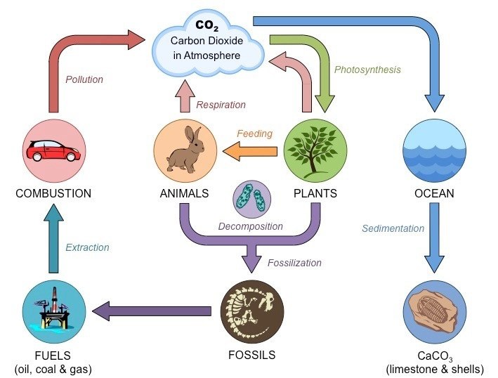

**Figure 1** | The basic carbon cycle (diagram provided by Wikipedia)

**Forest Carbon Cycle**

Forest ecosystems globally influence climate through their critical in the global carbon (C) cycle. Their annual gross CO2 sequestration (gross primary **productivity**, GPP) is estimated at 59 Gigatons (Gt) C yr, or 6.3 times average annual fossil fuel emissions from 2007-2016 (9.4 ± 0.5 Gt C yr-1). A small portion of global GPP is retained in ecosystems (mainly forests), resulting in a terrestrial C sink (an area that absorbs carbon) that averaged 3.0 ± 0.8 Gt C yr-1 from 2007-2016, offsetting 32% of anthropogenic fossil fuel emissions (emissions caused by humans). The remaining ~98% of global GPP is counterbalanced by **ecosystem** respiration (*Reco*) or wildfire. Perturbation to the global GPP- *Reco* balance can substantially influence the growth rate of atmospheric CO2; for example, the 2015-2016 *El Niño,* which brought historically high temperatures and low precipitation to the tropics, released an extra 2.5 ± 0.3 Gt C to the atmosphere, resulting in the largest recorded atmospheric CO2 growth rate. In addition, forests contain substantial C stocks that, when disturbed, release significant amounts of CO2 to the atmosphere. Although they cover only ~30% of the land surface, forests contain an estimated 92% of terrestrial biomass and 45% of terrestrial C (biomass and soils). Globally, gross tropical deforestation averaged 2.8 Gt C yr-1 from 2000-2007, but ~40% of this was offset by forest regrowth, resulting in a net source of ~1.1 Gt C yr-1 from tropical land use change. This, coupled with minimal net deforestation in the **extratropics** and net uptake by intact forests, resulted in a total gain in forest C of ~1.2-1.7 Gt C yr-1 thereby substantially slowing the rate of increase of atmospheric CO2.



**Figure 2 |** The role of forests in the global carbon cycle**.** Values apply to the period 2000-2018.

Given their vital role in regulating atmospheric CO2, the future of Earth’s forests will strongly influence the course of climate change. If forests globally respond to the suite of contemporary and future global change drivers—including elevated CO2, climate change, and atmospheric deposition—with increased productivity and net biomass increases, they could continue to act as a significant buffer against anthropogenic emissions. In contrast, if factors such as higher temperatures and drought stress lead to net C losses, the C sink of forests could be lost and even reversed. Global coupled climate models vary substantially in predictions regarding the future of the global forest C sink, with uncertainty exceeding current annual anthropogenic CO2 emissions. Anthropogenic land use decisions will also strongly influence the future course of atmospheric CO2. In the absence of measures to reduce deforestation, this will continue to be a significant component of anthropogenic CO2 emissions. On the other hand, forest conservation and reforestation hold strong potential to help stabilize and eventually reduce total anthropogenic CO2 emissions and thereby contribute towards the goals of the **Paris Climate Agreement**. Indeed, forest-based climate mitigation was a key component of Paris Climate Agreement commitments, totaling approximately one-fourth of nations’ planned emissions reductions. Thus, forest will strongly influence the future course of climate change both through their responses to global change and through forest-related anthropogenic land use decisions.

While forests will play a critical role in the future course of climate change, there remain significant uncertainties as to current and future C cycling the world’s forests. Recent studies attempting to quantify the role of forests in the global C cycle have been hampered by insufficient data on regrowth rates of tropical forests worldwide, C in non-living pools (i.e., dead wood, litter, soil), and source/sink status of forests in some regions. A relative dearth of data on C cycling in secondary forests, particularly in the tropics is problematic in that almost 2/3 of the world’s forests were secondary as of 2010 (FAO 2010), implying an under-filled need to characterize age-related trends in forest C cycling. Moreover, as discussed above, model representation of forest responses to global change remain highly uncertain, with efforts to reduce model uncertainty in part limited by availability of appropriate benchmark data. Tens of thousands of published forest C measurements provide a wealth of data that could contribute to large-scale analyses and syntheses, as well as model evaluation, and there has been much recent progress in compiling these data into intermediate- sized databases, typically focused on one or a few variables. However, global scale analyses covering multiple components of forest C cycles—particularly those focused on regrowth forests or requiring data on stand history—have remained limited by the distribution of data across a myriad original publications or data compilations, with variation in data formats, units, measurement methods, etc.

To facilitate global-scale analyses of forest C cycling, we have developed an open-access Global Forest Carbon database, ForC(<https://github.com/forc-db/ForC>)**.** ForC contains data on forest ecosystem C stocks and annual fluxes (>50 variables) and associated data required for interpretation (e.g., stand history, measurement methods) amalgamated from numerous previous data compilations and directly from original publications. ForC currently contains records from plots and distinct geographic areas representing all forested biogeographic and climate zones.

**ForC Introduction: (**[**https://forc-db.github.io/**](https://forc-db.github.io/) **)**

Forests play an influential role in the global carbon (C) cycle, storing roughly half of terrestrial C and annually exchanging with the atmosphere more than ten times the carbon dioxide (CO2) emitted by anthropogenic activities. Yet, scaling up from ground-based measurements of forest C stocks and fluxes to understand global scale C cycling and its climate sensitivity remains an important challenge. Tens of thousands of forest C measurements have been made, but these data have yet to be integrated into a single database that makes them accessible for integrated analyses. Here we present an open-access global Forest Carbon database (ForC) containing records of ground-based measurements of ecosystem-level C stocks and annual fluxes, along with disturbance history and methodological information. ForC expands upon the previously published tropical portion of this database, TropForC (DOI: 10.5061/dryad.t516f), now including 17,505 records (previously 3,568) representing 2,731 plots (previously 845) in 827 geographically distinct areas. The database covers all forested biogeographic and climate zones, represents forest stands of all ages, and currently includes data collected between 1934 and 2015. We expect that ForC will prove useful for **macroecological** analyses of forest C cycling, for evaluation of model predictions or remote sensing products, for quantifying the contribution of forests to the global C cycle, and for supporting international efforts to inventory forest carbon and greenhouse gas exchange. A dynamic version of ForC is maintained at on Github (<https://github.com/forc-db> ), and we encourage the research community to collaborate in updating, correcting, expanding, and utilizing this database.

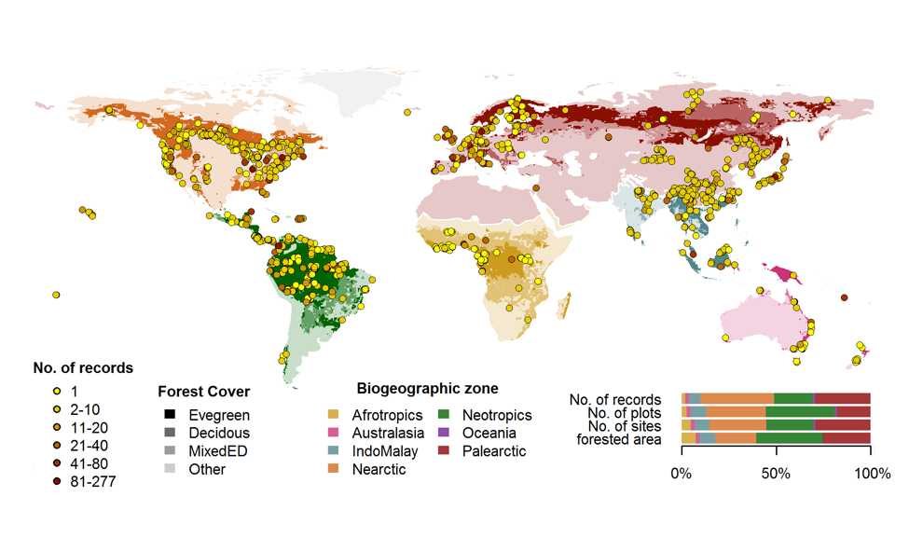

**Figure 3** | Geographical distributions of sites included in ForC. Symbols are colored according to the number of records from each site. Underlying map shows coverage of evergreen, deciduous, and mixed forests and biogeographic zones. Distribution of sites, plots, and records among biogeographic zones is shown in the inset.