

**Breathing In**

Featured scientists: Krista J. Anderson-Teixeira, Smithsonian Conservation Biology Institute and Susan C. Cook-Patton, The Nature Conservancy. Written by Ryan Helcoski

*Research Background:*

Plants use the process of **photosynthesis** to trap the energy of the sun within the molecular bonds of **glucose** (C6H12O6, a type of sugar).

$$6{CO}_{2}+{6H}_{2}O+Energy→ C_{6}H_{12}O_{6}+6O_{2}$$

All living things require oxygen for **cellular respiration** to free the energy stored within those glucose molecules for all cellular processes.

$$C_{6}H_{12}O_{6}+6O_{2}→{6H}_{2}O+6{CO}_{2}+Energy$$

We get our glucose from the food we eat and our oxygen from the air we breathe. Since trees and other photosynthetic organisms, like algae, provide us with oxygen as a byproduct of photosynthesis they’re often portrayed as the lungs of the planet “breathing out” oxygen. But there’s another aspect of photosynthesis that’s just as important. Look at the photo of the massive tree below (to the right/left?). How did that tree get so big? The answer is in the equation for photosynthesis where carbon dioxide and water provide the carbon, hydrogen, and oxygen necessary to build glucose. Trees use glucose as both an energy source and construction material. They arrange glucose in long winding structures as they grow and some of it becomes part of them for as long as they live. This process of pulling carbon out of the atmosphere and holding on to it like that for long periods of time is known as **carbon sequestration**, it’s what the trees do when they “breathe in.” And that’s what Krista and Susan were interested in.

They knew that the Earth’s climate was heating up due to human activities like burning fossil fuels which release **greenhouse gases** like carbon dioxide into the atmosphere. They also knew that many forests around the world had been cut down and regrowing them was a natural climate solution, since more trees means more carbon sequestration and more carbon sequestration means less carbon dioxide in the atmosphere. However, they wanted to know how carbon sequestration rates differ between forest types as they regrow. They also wanted a more accurate assessment of the full potential of forest regrowth since they believed that current estimates were limited by uncertainty and variability.

To answer these questions they needed to do a lot more than a few studies in a single area, they needed to analyze thousands of studies in locations from all over the world. So that’s exactly what Krista did when she and other researchers from around the world began their work on creating **ForC,** the Forest Carbon Database.

ForC is an open-access database containing over 29,713 records from 4,971 plots in 3,325 geographically distinct areas. All of the data comes from published research by accredited scientists and includes studies from every forested biogeographic and climate zone. It is a living database that is continually updated as scientists publish their work, making it the most complete source of forest carbon data in the world.

Together with many other researchers Krista and Susan used the ForC database to investigate global carbon capture. They predicted that tropical forests would have the highest rate of carbon accumulation and that the default forest regrowth rates from the Intergovernmental Panel on Climate Change (IPCC) were inaccurate.

In order to measure carbon sequestration they chose the unit **MgC/ha/yr** which is a measure of the **megagrams** (a little less than a ton)of **carbon** (from carbon dioxide) sequestered by a **hectare** (100 acers, about 75 football fields)of forest per year. Using ForC they selected a total of 13,112 georeferenced measurements of carbon accumulation from around the world. Then they grouped the measurements by forest type, averaged them, and compared that to the IPCC values. With these values they could help to better inform policy decisions and prioritize forest regrowth in different parts of the world.

*Scientific Question*: How does forest carbon sequestration differ by forest type? How do the estimates of ForC compare to those predicted by the IPCC?

*What is the hypothesis?* Find the hypothesis in the Research Background and underline it. A hypothesis is a proposed explanation for an observation, which can then be tested with experimentation or other types of studies.

*Scientific Data:*

**Use the data below to answer the scientific question:**

(NEEDED! Data used to make Fig 4, see below). We will not be able to use each set of data, but the goal is a simple data table in the following format:

|  |  |  |  |
| --- | --- | --- | --- |
| Location | Habitat Type | Above ground rate  MgC/ha/yr: ForC | Above ground rate  MgC/ha/yr: IPCC |
|  |  |  |  |

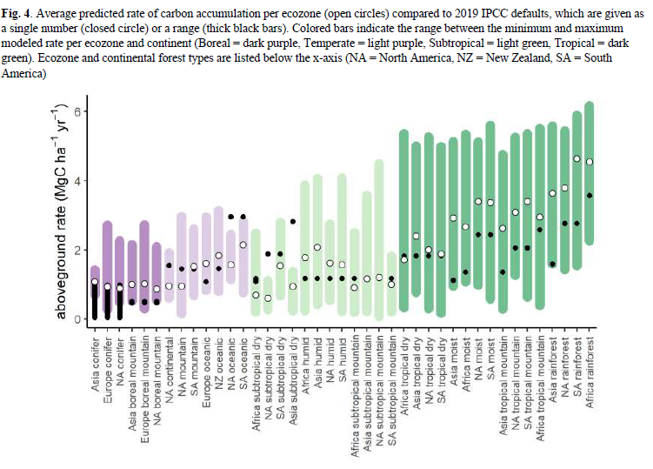

What data will you graph to answer the question?

Independent variable: location or habitat type

Dependent variable: Aboveground rate (MgC/ha/yr), ForC vs IPCC

*Draw your graph below*: Identify any changes, trends, or differences you see in your graph. Draw arrows pointing out what you see, and write one sentence describing what you see next to each arrow.

(Data Nuggets ask that we do NOT do this part, just provide the data in Excel and instructions on how to make the graph and what kind of graph)

*Interpret the data:*

Make a claim that answers the scientific question.

The data show that Forest carbon accumulation is, on average highest in the tropical forests. Forest carbon accumulation calculated as estimated by the IPCC is on, average, lower than these more precise measurements. The predicted regrowth rate in tropics were an average of 53% higher than the IPCC defaults.

What evidence was used to write your claim? Reference specific parts of the table or graph.

Students should discuss how the average annual carbon accumulation rate in the tropical forests is higher than that of other forests. While there are some locations outside of the topics with higher rates of accumulation, more than half of the tropical rates are higher than every other forest. They may choose to discuss specific forests or just compare averages. They can also compare the tropical average of forest accumulation to the overall average. In addition, the IPCC underestimated carbon sequestration in most ecozones, students may discuss the topics where the difference is very obvious or discuss differences per zone. Overall the IPCC underestimated carbon sequestration by 33%

Make a recommendation on where in the world reforestation efforts should be intensified if your goal was to have the biggest possible impact on fighting global warming. Connect the data back to what you learned about photosynthesis.

Students should discuss how regrowth in the tropics would be best due to the high rates of sequestration. They should explain how photosynthesis is necessary for carbon accumulation and may choose to write the formula.

Did the data support Krista and Susan’s hypotheses?  Use evidence to explain why or why not.  If you feel the data was inconclusive, explain why.

(Yes, need specific data first though)

*Your next steps as a scientist:* Science is an ongoing process. What new question do you think should be investigated? What future data should be collected to answer your question? What do you think should come next?

Natural forest regrowth is a very real strategy to help in climate mitigation that not only captures carbon but also provides additional benefits such as stabilizing biodiversity. The biggest finding here is that the IPCC underestimated the rates of carbon accumulation meaning this strategy is even more beneficial than previously thought. Students can suggest using the data to carry out regrowth efforts and then measuring those efforts over time to carry out even larger scale regrowth.

It is undeniable that the current goal of stabilizing carbon emissions is challenging. It will require not only a reduction in emissions but also an increase in sequestration. Students may suggest further research on other forms of sequestration or studies that delve into different types of regrowth. There are some species of trees that sequester carbon more rapidly than others, students may suggest trying to figure out the ideal combination of tropical plants to achieve the highest rate of carbon accumulation. It is possible students will also suggest studies of soil carb accumulation, which is another major aspect of the published study.