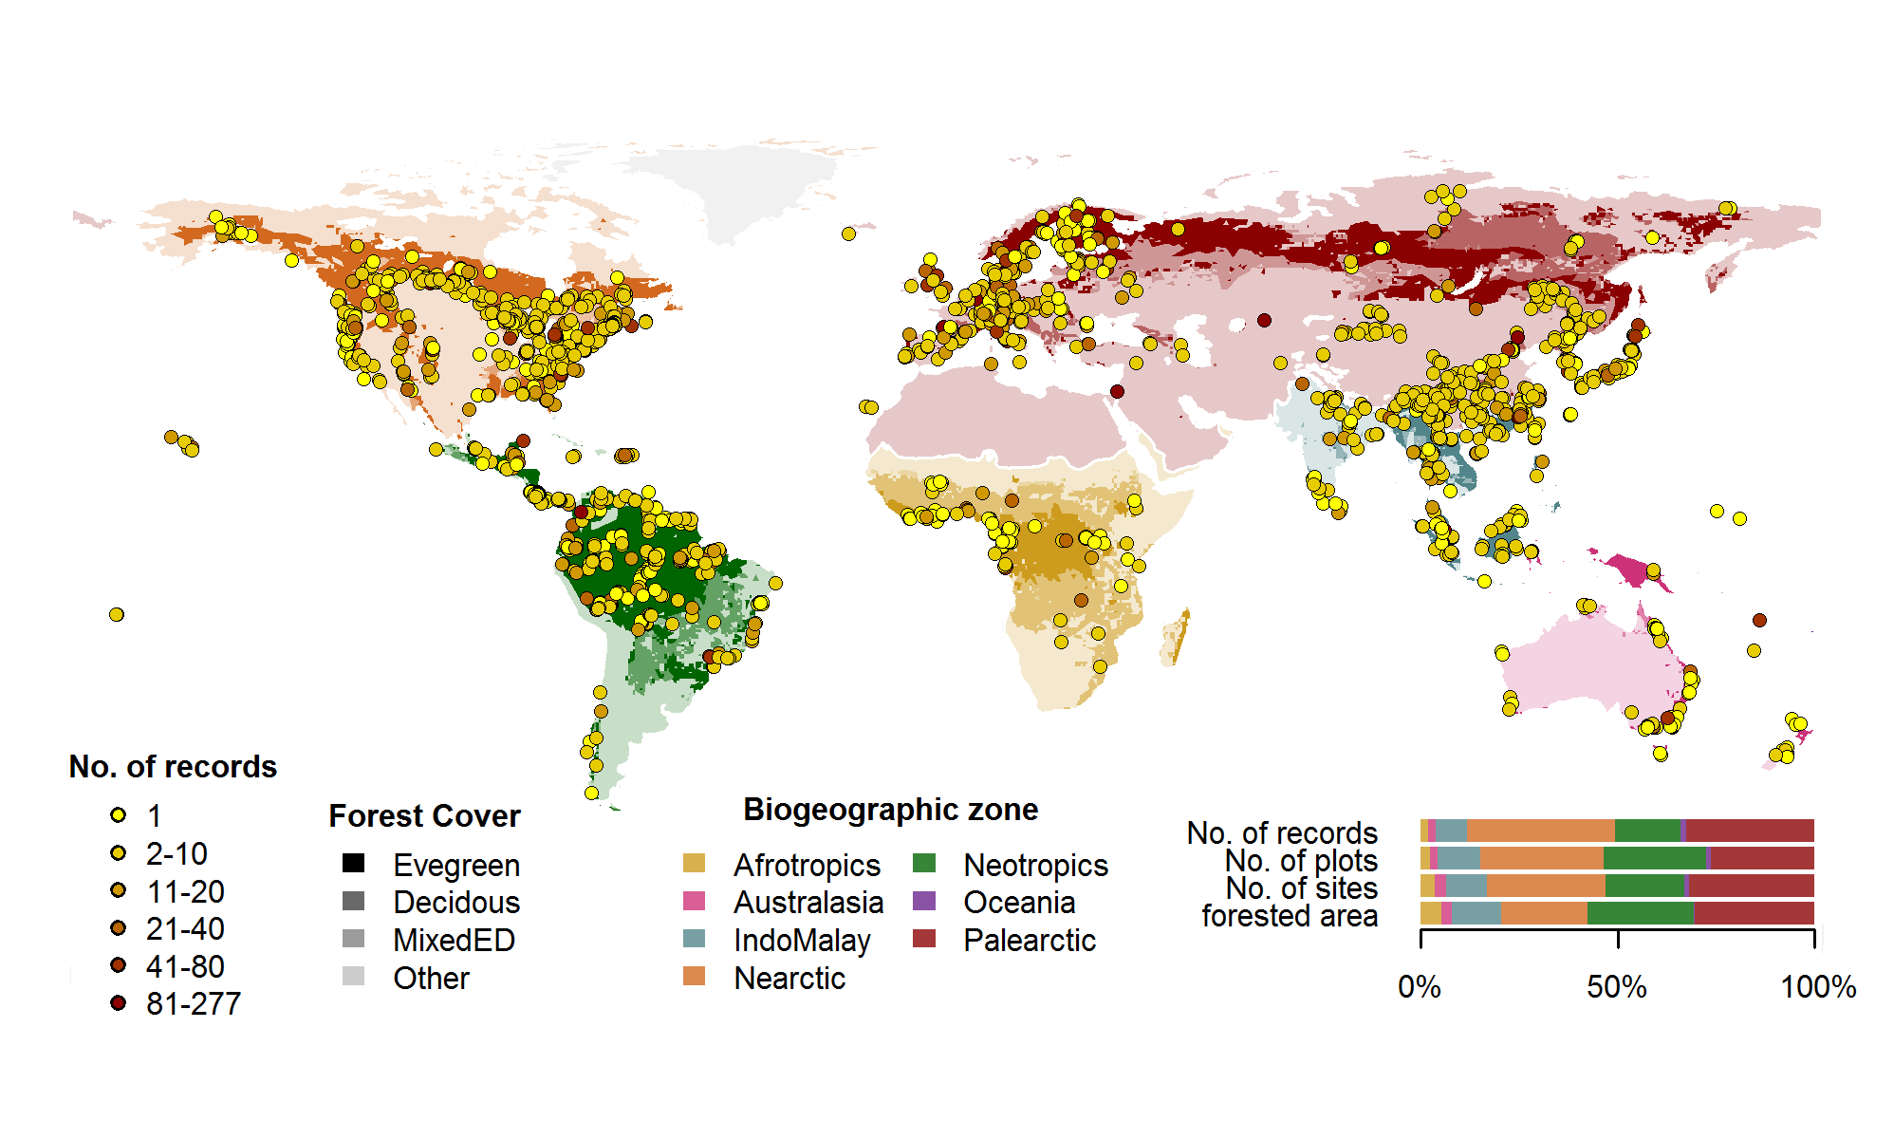

**Figure 1:** Geographical distributions of sites included in ForC. Symbols are colored according to the number of records from each site. Underlying map shows coverage of evergreen, deciduous, and mixed forests and biogeographic zones. Distribution of sites, plots, and records among biogeographic zones is shown in the inset.

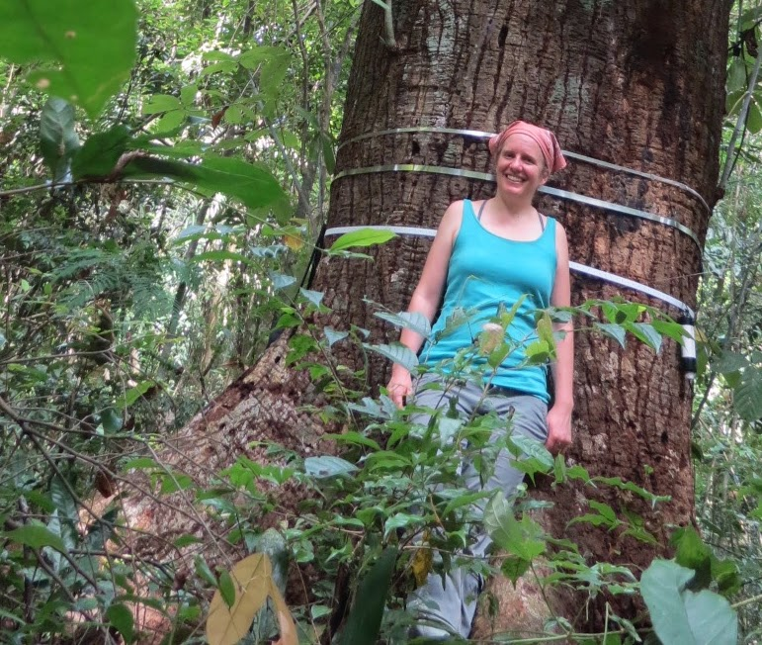

**Figure 2: Dr. Kristina Anderson-Teixeira stands in front of a *Pseudobombax septenatum* tree on Barro Colorado Island, Panama. She equipped this tree with an automated dendrometer band to measure its growth.**

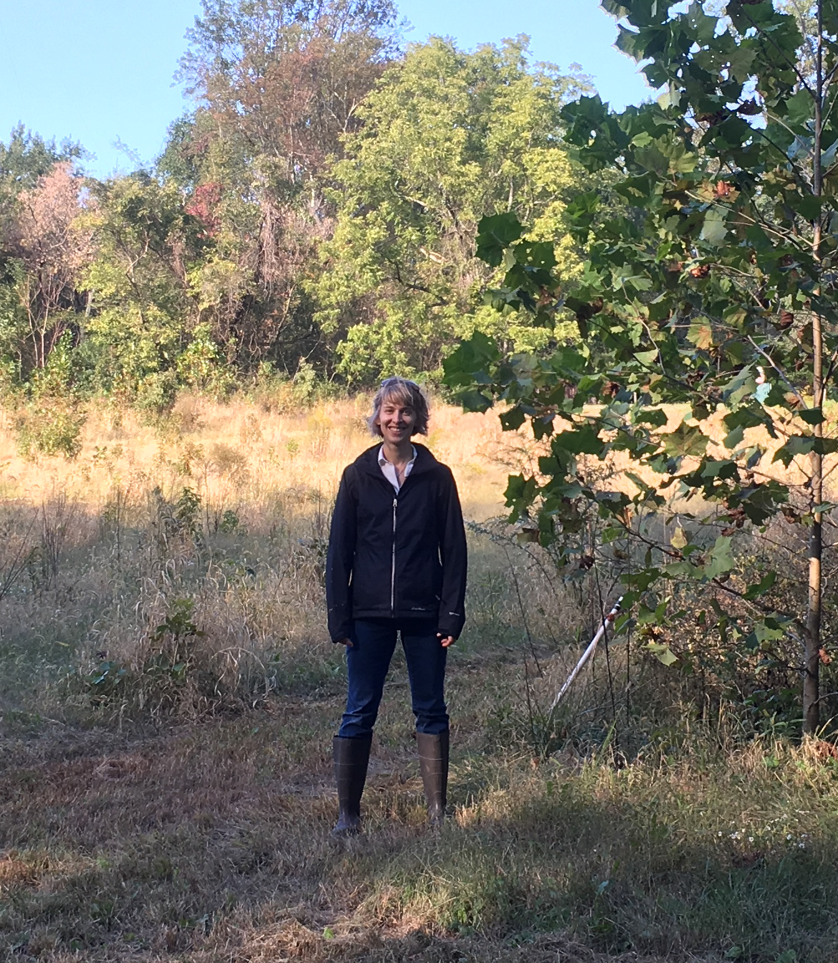

**Figure 3: Dr. Susan Cook-Patton stands in the *Biodiversitree* reforestation experiment in the Chesapeake Bay watershed. The sycamore trees (*Platanus occidentalis*) are growing much faster than the other trees species peeking above the grass in the background.**

**Relevant links:**

**A Year in the Life of Earth’s Carbon Dioxide**

[**https://svs.gsfc.nasa.gov/cgi-bin/details.cgi?aid=11719**](https://svs.gsfc.nasa.gov/cgi-bin/details.cgi?aid=11719)

**ForC**

[**https://forc-db.github.io/**](https://forc-db.github.io/)

**students can view the shiny app (**[**https://forc.shinyapps.io/global_data_visualization/**](https://forc.shinyapps.io/global_data_visualization/)**) to explore where the data comes from and anyone feeling really ambitious can view the raw data (**[**https://github.com/forc-db/ForC**](https://github.com/forc-db/ForC)**)**

**ForC_education**

[**https://github.com/forc-db/ForC_education**](https://github.com/forc-db/ForC_education)

**This is a private link with additional lesson plans for anyone interested in further exploring the database and asking original questions.**