**Name**:

**Essential Question**: How does temperature impact Gross Primary Productivity?

**Part I: Background**

Sketch and/or explain the basics of the carbon cycle**:**

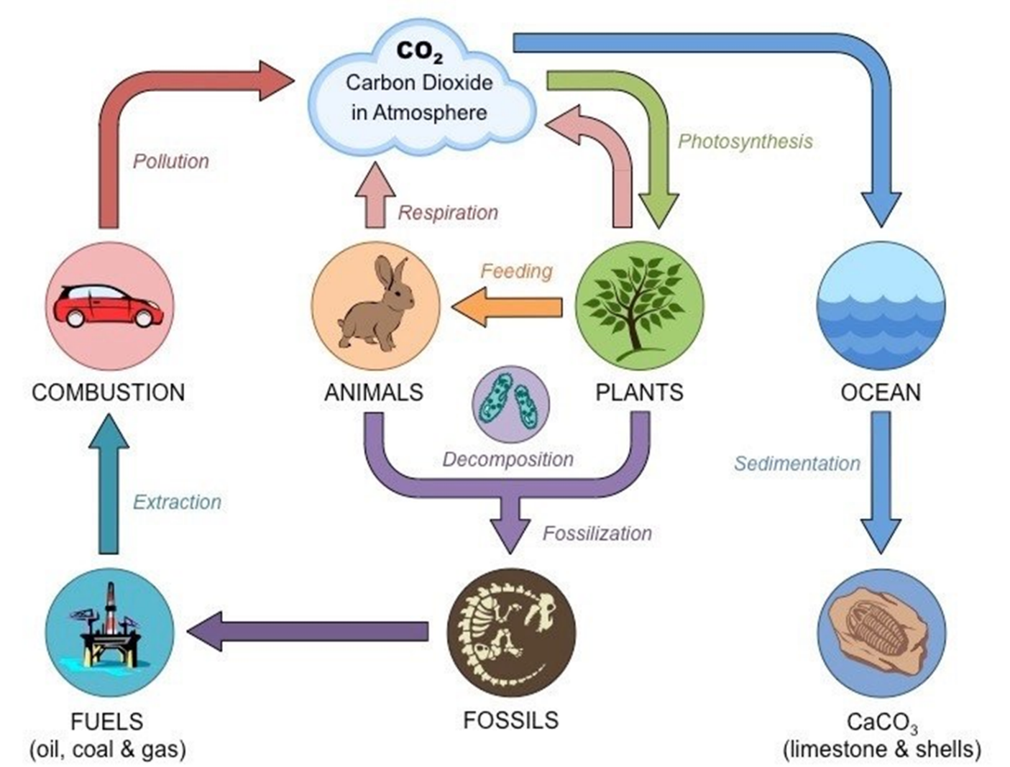

Students can have a variety of answers, but the basic concept should be…

1) That there is a great deal of carbon that is in flux between plants and animals (respiration and photosynthesis) and this cycle is mostly sustainable.

2) That atmospheric CO2 is increasing due to combustion caused by humans burning fossil fuels. Some of this is stored in the ocean, but far less than necessary to offset the current rate of greenhouse gas emissions.

**Define** the following and explain their role in the carbon cycle:

**Carbon Stock –** The amount of carbon pulled out of the atmosphere and now stored within the forest ecosystem

**Carbon Flux –** Carbon that is exchanged between the earth’s carbon pools

**GPP –** annual gross CO2 sequestration (gross primary productivity). This is the carbon the trees hold inside themselves and pull out of the atmosphere

**Atmospheric Carbon –** Carbon Dioxide, this is the carbon in the atmosphere as opposed to that held in the bodies of living things or otherwise within the Earth

**Part II: Structured Inquiry**

Write down the **essential question** you will be answering today:

How does temperature impact Gross Primary Productivity?

The **Protocols** for this study are already input into ForC. You do not need to do anything. The protocols were developed by researchers using a standardized approach to monitor GPP, and collect mean annual temperature.

**Data Collection** was also done by researchers in the field for individual studies. The ForC database (<https://forc-db.github.io/>) collected data from multiple studies other questions can be asked. Your specific question deals with GPP and temperature. Define the following terms and determine which temperature and GPP should be placed.

**Independent variable**: Mean temperature

**Dependent variable**: GPP

Write your **hypothesis** about how you think temperature might impact Gross Primary Productivity:

(various possible answers, but they should predict it will either go up, down, or have no impact)

**Data Processing**: Follow the instructions on the PPT or follow along with your instructor to get the data into a scatter plot in Excel. Use the following link to access the data: ( <https://github.com/forc-db/ForC/blob/master/educational%20resources/ForC_GPP_and_temperature.csv>)

Write down some initial observations once you have the chart complete. What seems to be happening?

As temperature rises GPP rises, there seems to be a correlation between the two values

**Data Analysis**: Answer the following

What is a linear regression line? A linear regression line has an equation of the form Y = a + bX, where X is the independent variable and Y is the dependent variable. The slope of the line is b, and a is the intercept (the value of y when x = 0).

Write down your liner regression equation: y= 0.5295x -9.4

What is an R squared value and how do you interpret it? value is a statistical measure of how close the data are to the fitted regression line, measured from 0 to 1.

Write down your R squared value: .89

**Import your data from Excel**. Make sure that you have your x and y axis labeled, the graph is titled, and includes a short description

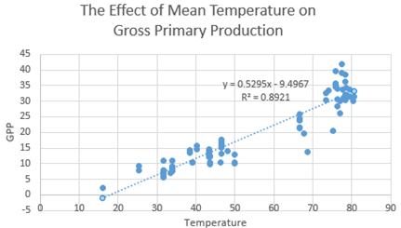

As temperature rises as a function of different habitats the forest primary productivity increases.

**Think/Pair/Share**: You have now spent some time processing real data provided by the ForC database through ForestGEO (of the Smithsonian Institution). But what does it actually mean? Write down what you THINK it means (don’t worry if you’re wrong, you just need to have something in the blank here).

I **THINK** the data is showing that:

Careful of what students might share! It seems very clear that an increase in temperature means and increase in GPP and that IS true, but remember that these values came from all over the world. This doesn’t mean if we just started to cook plants up to higher temperatures they would be more productive. This means that plants that evolved in areas of higher temperature also have higher GPP. This is a good chance to discuss what linear regressions do and do not reveal.

Students might have a wide range of statements here, though likely centering on “temp up means GPP up” and that IS true as far as the data indicate, but make sure that they fully understand what’s going on.

In this first section, students write a simple sentence.

Because:

Here students justify their first statement backing it up with data from the graph.

Now talk to a partner/group member about what the data shows. What is the effect of mean temperature on gross primary production?

(Variety of answers, be careful with what students might take away from this. Though the data seems fairly simple, it is far from it.)

8) **Conclusion**: Write a concluding paragraph on the impacts of mean temperature on gross primary production. Be sure to structure include an introduction sentence (on the forest carbon cycle), clearly state your hypothesis, background on ForC, the methods we used as a class, and a reference to your graph and R squared value. Avoid words like “prove” and make sure to explain what the data “suggests.”

(Make sure students restate everything that is significant. This should be similar to an abstract section)

* Our results suggest that as mean temperature rises so does GPP
* GPP is defined as the annual CO2 sequestered
* CO2 cycles between plants and animals through photosynthesis and cellular respiration
* We hypothesized that as temperature increased (hypothesis)
* Our experiment backs up/refutes our hypothesis
* It is important to emphasize that the data used in the exerpiment is from different latitudes with plants adapted to specific temperature. We do not know what would happen if we were to slowly increase the temperature of a specific area nor do we suggest this would lead to an increase in GPP

**Extension**: Using what you have learned what you can say about the GPP of forests at the equator vs forests growing far north or south of the equator?

At the equator have a higher rate of GPP than those further away

Using your graph what is the GPP approximate in the following cities?

Miami, FL, USA: Average Annual Temperature 77°F:

Iqaluit, Canada: Average Annual Temperature 15.3°F:

Washington, DC, USA: Average Annual Temperature 64.8°F :

In the coming years as carbon dioxide continues to accumulate in our atmosphere it is likely the temperature is going to rise. Based on your graph this rise in temperature could be associated with increased plant productivity. Does this mean global warming will **always** be good for plant growth? Why or why not? Explain (you may want to watch <https://svs.gsfc.nasa.gov/vis/a010000/a010600/a010630/index.html> for some background information)

The very purpose of this section is for students to think about the limits of the data. Just because there is a clear and strong correlation it doesn’t mean that global warming will cause plants everywhere to be more productive. The data show clearly a correlation between temperature and GPP of plants in completely different locations