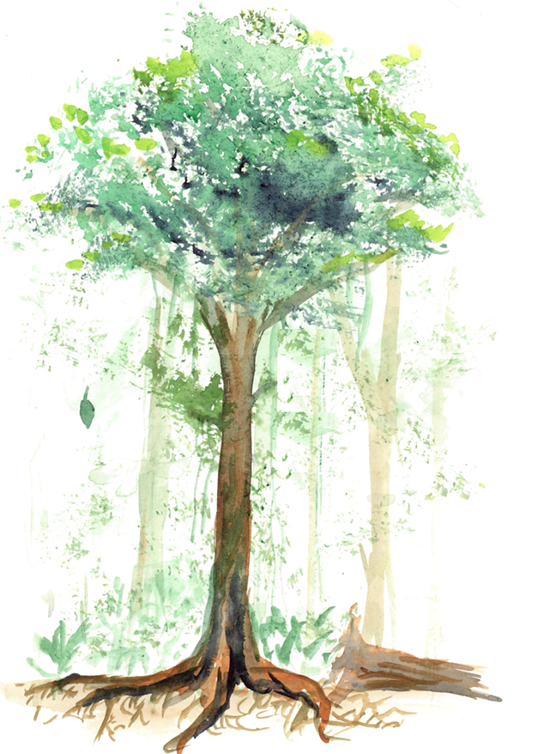

Forest Carbon Cycle Structured Inquiry Lesson Plan

Introduction to ForC database

**Using the ForC Database to Explore Carbon Cycling and Climate Change**

|  |  |  |  |
| --- | --- | --- | --- |
| **Title of Unit** | Using structured inquiry to explore a large scientific database on forest carbon cycling | **Grade Level** | 9th, 10th |
| **Curriculum Area** | Climate change, photosynthesis, carbon sequestration, process of science | **Time Frame** | One 90 minute lesson or more |
| **Next Generation Science Standards** | | | |
| HS. Matter and Energy in Organisms and Ecosystems   * **HS-LS2-4:** Use mathematical representations to support claims for the cycling of matter and flow of energy among organisms in an ecosystem   HS. Earth’s Systems   * **HS-ESS2-6:** Develop a quantities model to describe the cycling of carbon among the hydrosphere, atmosphere, geosphere, and biosphere.   HS. Weather and Climate   * **HS**-**ESS3-5:** Analyze geoscience data and the results from global climate models to make an evidence-based forecast of the current rate of global or regional climate change   HS. Human Sustainability   * **HS-ESS3-6**: Use a computational representation to illustrate the relationships among Earth systems and how those relationships are modified due to human activity   HS. Living Systems   * **HS-LS1-5**: Use a model to illustrate how photosynthesis transforms light energy into stored chemical energy. | | | |
| **Students will be able to…** | | **Essential Questions** | |
| * Review the process of science * Explain the structure of the forest carbon cycle and the process of carbon cycling * Explain the impacts of temperature on gross primary production | | * What is the carbon cycle? * How do forests factor into the global carbon cycle? * What is the impact of temperature gross primary production? | |
| **Materials** | |
| * ForC_SI_PPT * ForC_SI_lesson * ForC_SI_Handout (digital or print) * Students will also need access to the internet and computers with Excel | |

Introduction:

Welcome to the Forest Carbon Database (ForC)’s structured inquiry lesson, created by researchers at the Smithsonian Conservation Biology Institute (SCBI) and Forest Global Earth Observatory (ForestGEO). ForC is an open-access global database; a real scientific resource that is continually updated by scientists at SCBI and ForestGEO as new research is made available. Our goal in this lesson is to introduce students to the process of science by using a real scientific database to answer a straightforward question that involves carbon sequestration and climate change.

Forests strongly influence Earth’s climate through their role in the global carbon cycle. They sequester nearly 30% of anthropogenic carbon dioxide (CO2) emissions, and clearing just 100m2 (about a half of a school bus) of mature forest has the same climate change impact as driving most of the way around Earth’s circumference. Developing a better understanding of global forest carbon cycling and its climate sensitivity is critically important to projecting the future role of forests in Earth’s changing climate. Tens of thousands of pre-existing forest carbon measurements provide a wealth of data that could contribute to basic ecological research, ecosystem model benchmarking, and improved quantification of the climate impacts of alternative policy pathways. We want your students to be a part of this movement.

The lesson outlined here is a small part of the ForC curriculum, but includes an introduction, short investigation, and summary questions.

## **Lesson Plan**

**Engagement: A Year in the Life of Earth’s CO2** (5 - 10 minutes)

Preparation: Load PPT and have students copy down questions or write them on the board/ white board for them to see during the video. (<https://svs.gsfc.nasa.gov/cgi-bin/details.cgi?aid=11719>)

Make sure students watch the dates progressing and concentration of CO2.

**Questions** (also available on the PPT):

1. Before the video begins predict what will happen to Earth’s carbon dioxide concentrations over the course of a year. (wide range of answers)
2. What happens to the carbon dioxide emitted from fossil fuel combustion (roughly half remains in atmosphere, half is absorbed)
3. Watch the video carefully and write down quick notes on what you’re seeing as the year progresses. Note months with high and low concentrations. Write down as many observations as you can. Be sure to write down any major changes or anything you hear that is surprising.
4. What is happening to the concentrations of carbon dioxide in the air?

**Explain: Forest Carbon Cycling** (10 - 20 minutes)

2 minutes: Photosynthesis and cellular respiration review. Use slide 4 to remind students of the two processes, ask for input about how the processes are connected.

6 – 16 minutes: Carbon cycle review

* Option 1: Lecture – Explain the carbon cycle using slides 5 – 10, go as fast or slow as necessary. Students have some questions to answer in their handouts
* Option 2: Reading – instead of a lecture you may pass out the ForC_SI_Background handout and have students answer questions in their handouts

2 minutes: Review the process of science (slide 11)

**Explore**: **Structured Inquiry** (30 - 50 minutes)

5 minutes: Investigating the data, allow students some time to explore the raw data and apps created by ForC. A more advanced class may choose to download their own data instead of following the protocol. It’s up to you how much time students should have to explore. <https://forc-db.github.io/>

10 - 20 minutes: **Data Processing**, students continue the handout following along with the step-by step PPT (or you can just have them follow along with you as you complete it). Students follow directions and answer questions together or alone. We suggest having students work in small groups or pairs if they have little experience in data analysis or Excel.

(<https://github.com/forc-db/ForC/blob/master/educational%20resources/ForC_GPP_and_temperature.csv>)

20 minutes (or more): **Data Analysis**, students complete the data analysis and conclusion sections. Circulate around the classroom. As students complete the data analysis section they can continue to the extension sections (or it can be assigned as homework). Make sure the “Data Analysis” slide is left up as reference while students work and that students have access to text books or other references.

**Extension**: (5 – 20 minutes)

5 – 15 minutes: Written section: The written section of the handout can be completed for homework or the following class period.

5 minutes – **Discussion**: When class is drawing to a close to be sure to go over the essential question to ensure students understand their analysis and the importance of GPP.

**Acknowledgements**:

**Co-authors**: Ryan Helcoski, Kristin Black, Kristina Anderson-Teixeira

We would like to thank the following organizations for providing funding to make this endeavor possible

