**Title:** Informing forest carbon inventories under the Paris Agreement using ground-based forest monitoring data

**Authors:**

Kristina J. Anderson-Teixeira1,2*

Valentine Herrmann1

Madison Williams1

Teagan Tinuviel3 (ORCID: 0000-0002-8828-9640)

Rebecca Banbury Morgan1,4,5

Ben Bond-Lamberty6

Susan Cook-Patton7

**Affiliations:**

1. Center for Conservation Ecology, Smithsonian’s National Zoo & Conservation Biology Institute, Front Royal, VA, United States
2. Forest Global Earth Observatory, Smithsonian Tropical Research Institute, Panama, Republic of Panama
3. Smithsonian-Mason School of Conservation, Front Royal, VA, United States
4. School of Geography, University of Leeds, Leeds, United Kingdom
5. School of Biological Sciences, University of Bristol, Bristol, United Kingdom
6. Joint Global Change Research Institute, Pacific Northwest National Laboratory, College Park, MD, United States
7. The Nature Conservancy; Arlington VA 22203, United States

*corresponding author: [teixeirak@si.edu](mailto:teixeirak@si.edu)

# Summary

* Humans have been influencing Earth’s climate via transformative impacts on forests for millenia, and forests are now recognized as critical to climate change mitigation under the Paris Agreement. The efficacy of climate change mitigation planning and reporting depends on quality data on forest carbon (C) stocks and changes. The Emission Factor Database (EFDB) of the International Panel on Climate Change (IPCC) is intended to be a definitive source for such data, but needs comprehensive and well-documented data to be so.
* To facilitate submission of forest C estimates from scientific studies to EFDB, we develop and document a process for semi-automated data submission from the Global Forest C database (ForC v4.0), which is the largest compilation of ground-based forest C estimates. We then assess the data currently available through ForC and provide recommendations for improving forest data collection, analysis, and reporting.
* As of August 2024, ForC contained ~19286 independent records relevant to EFDB, 1068 of which had been submitted and posted to EFDB. These represented 19% of the total EFDB records for forest land. Records were unevenly distributed across variables and geographic regions. 37% of ForC records reviewed could not be submitted because the original publication lacked required information.
* In the future, ground-based forest C estimates should target gaps in the record, and studies should ensure that they report all information necessary for inclusion in EFDB. Given that climate change is rapidly impacting the world’s forests, timely reporting of recent estimates will be critical to accurate forest C inventories.

**Keywords:**

climate change, database, forest carbon, greenhouse gas inventory, International Panel on Climate Change (IPCC), natural climate solutions, nature based climate solutions

# Societal Impact Statement

Human interactions with forests have shaped Earth’s climate for millennia and will continue to do so as we target net-zero emission goals. Accurately characterizing these climate impacts requires making accurate forest carbon data available for forest monitoring and planning. Here we develop a semi-automated process for submitting forest carbon measurements from the largest relevant scientific database to the International Panel on Climate Change’s Emission Factor Database, which currently has sparse forest carbon data. Building this bridge from scientific research to international policy is an important step towards managing forests in a net-zero motivated future.

# Introduction

Humans have been influencing Earth’s climate via ecologically transformative impacts on ecosystems for >12,000 years (Bonan, 2016; Sanderman *et al.*, 2017; Ellis *et al.*, 2021). In recent decades, as both anthropogenic land transformation and climate change have accelerated, this relationship has come into increasing focus (IPCC, 2019a). Deforestation and forest degradation are substantial sources of the greenhouse gas carbon dioxide (CO2), currently accounting for >10% of anthropogenic emissions (Friedlingstein *et al.*, 2022). At the same time, CO2 uptake by remaining and regrowing forests, woodlands, and savannas has exceeded releases from deforestation and other severe disturbances, resulting in a net carbon CO2 sink of ~0.88 - 1.6 Gt C yr-1 (Xu *et al.*, 2021; Harris *et al.*, 2021), that offsets an estimated 10 - 18% of anthropogenic CO2 emissions from fossil fuels and cement (Xu *et al.*, 2021; Harris *et al.*, 2021). The future of this important CO2 sink depends primarily upon future trajectories of direct human impacts on forests (i.e., deforestation/ degradation vs. conservation/ restoration, IPCC, 2019a, 2022a), and also upon forest responses to climate change, which are likely to reduce the sink strength (McDowell *et al.*, 2020).

Accordingly, forests play a substantial role in international plans for climate change mitigation under the Paris Agreement (UNFCCC, 2015; Grassi *et al.*, 2017). Forest conservation, reforestation, and improved sustainable management all have significant – and relatively cost-effective – potential as climate change mitigation options (Roe *et al.*, 2021). Conservation and reforestation have the fourth and fifth largest net emission reduction potentials or all mitigation options (IPCC, 2022b). However, envisioned forest-based climate change mitigation initiatives do not always correspond to actual emission reductions implemented on the ground (e.g., Badgley *et al.*, 2022). Realistic planning and reporting is critically needed to ensure that forest-based climate change mitigation initiatives are effective, and this requires solid scientific data and accounting frameworks (Deng *et al.*, 2021; Anderson-Teixeira & Belair, 2022).

To this end, the International Panel on Climate Change (IPCC) provides guidance for national greenhouse gas inventories for reporting to the United Nations Framework Convention on Climate Change (UNFCCC) (IPCC, 2006a; IPCC, 2019b). Under this guidance, greenhouse gas emissions to, or withdrawals from, the atmosphere are quantified on an annual basis for all managed land, which includes most of the world’s forest land (Ellis *et al.*, 2010; Ogle *et al.*, 2018). The IPCC inventory guidelines include specific instructions for inventories for greenhouse gas (mainly CO2) exchanges between forest land and the atmosphere (Notes S1, IPCC, 2006b, 2019b). A tiered approach is employed, where the lowest tier (Tier 1) represents the simplest approach and relies on default parameter values – for example, forest carbon (C) stocks values by ecozone and forest age class derived as the average of published estimates (IPCC, 2019b; Rozendaal *et al.*, 2022). Tier 1 values have improved over the years as more data and methods have become available (Requena Suarez *et al.*, 2019; Rozendaal *et al.*, 2022), but there remains room for improvement. For example, following the 2019 release of the latest IPCC guidelines, it was revealed that IPCC’s Tier 1 default failed to capture eight-fold variation of C accumulation in regrowth forests within ecozones (Cook-Patton *et al.*, 2020) and that C stocks in mature African tropical montane forests were two-thirds higher than the IPCC Tier 1 values for these forests (Cuni-Sanchez *et al.*, 2021). High variability of forest C cycling within ecozones (e.g., Cook-Patton *et al.*, 2020; Cuni-Sanchez *et al.*, 2021) means that it is crucial for practitioners to have access to locally-specific information, when available. This rapid evolution of scientific information on C cycling in forests is valuable for informing climate change mitigation efforts but requires improved mechanisms for communicating the latest information from scientific researchers to the practitioners who need reliable estimates for greenhouse gas mitigation planning.

To improve data accessibility for preparing greenhouse gas estimates, the IPCC created the Emission Factor Database (EFDB; <https://www.ipcc-nggip.iges.or.jp/EFDB/main.php>), which is intended as a recognized library of emission factors and other parameters that can be used for estimating greenhouse gas emissions and removals. The EFDB can be used both for efforts to tally a nation’s intended or accomplished greenhouse gas reductions, or as a basis of comparison for external parties to evaluate these inventories. The EFDB encourages researchers to submit estimates of emission factors or other related parameters (e.g., C stocks, net annual increments, and annual fluxes for various pools, IPCC, 2006a; IPCC, 2019b) from peer-reviewed journal articles or other accepted sources for inclusion in the database. Tens of thousands of relevant forest carbon estimates have been published – and continue to be published at an accelerating rate – but are not readily accessible to the practitioners assembling national greenhouse gas inventories. To contribute to the goal of making forest C parameters available for accounting under IPCC guidelines, forest scientists need an accessible summary of EFDB’s requirements and an efficient system for submission of data to the EFDB.

Our goal is to facilitate submission of forest C estimates from scientific studies to EFDB. We document the process of submitting data to EFDB from the Global Forest Carbon Database, ForC (<https://forc-db.github.io/>), which is the largest collection of published estimates of forest C stocks, increments, and annual fluxes (Anderson-Teixeira *et al.*, 2018, 2021; Anderson-Teixeira *et al.*, 2023), including data ingested from individual publications and relevant databases, including the Global Reforestation Opportunity Assessment (GROA) database (Cook-Patton *et al.*, 2020, database doi: 10.5281/zenodo.3983644), and the Global Soil Respiration Database (SRDB-V5, Bond-Lamberty & Thomson, 2010; Jian *et al.*, 2021). We (1) map common scientific forest C estimation methods and definitions to those used by the IPCC; (2) develop a semi-automated process for preparing ForC data for submission to EFDB; and (3) assess the data in ForC relevant to EFDB and records that have been submitted to date. We conclude with recommendations as to how the scientific community can better provide useful data for forest C inventories under the Paris Agreement.

# Materials and Methods

Major steps for submission of data from ForC to EFDB included (1) mapping ForC into EFDB, including aligning ForC terms and concepts with those defined by IPCC guidelines (summarized in Notes S1), (2) revising ForC v3.0 to support semi-automated submissions to EFDB, yielding ForC v4.0 (detailed in Methods S1), and (3) submitting data to EFDB.

## 1. Mapping ForC to EFDB

With input from the EFDB Technical Support Unit and referencing IPCC guidance (IPCC, 2003, 2019b; IPCC, 2006a), we determined how EFDB fields should be populated using ForC fields (summarized in Table S2). Fields in EFDB included several fields describing how the record fits within IPCC’s framework (source/sink category, greenhouse gas type, C pool, relevant equations), several describing the C estimate itself (variable, value, units, 95% confidence limits), a few composite fields describing biotic and abiotic conditions (e.g., vegetation type, minimum diameter included, site location, climate, edaphic properties, notable disturbances, stand age, plot information), and a few describing the source (e.g., type, citation, data provider). Most relevant ForC fields mapped directly into an EFDB field, either as the only contents of that field or as part of a composite record. For some fields, simple conditional logic was used to populate EFDB fields based on ForC records. For example, in cases where original studies did not present 95% confidence intervals (required by IPCC when available) but did present standard error or n and standard deviation, we calculated the 95% confidence intervals. There were two cases in which more complex mapping was required: (1) mapping of C cycle variables and (2) land classification.

### Carbon cycle variables

Working in consultation with the EFDB Technical Support Unit and referencing IPCC guidance (IPCC, 2003, 2019b; IPCC, 2006a), we identified ForC variables that were relevant to the IPCC methodology and EFDB (Fig. 1, Notes S1). These included organic matter or C stocks, net annual increments, influxes (a.k.a. “gross annual increments” by IPCC), and outfluxes for each IPCC-defied C pool (Table 1, Fig. 1). It is important to note that the correspondence of ForC variables to IPCC criteria often depends upon measurement protocols (“important sources of estimate variation” in Table 1). For example, ForC records of biomass and dead wood vary in the minimum stem diameter censused, such that some records would match the IPCC criteria whereas others would not. Information on minimum diameters censused and other important sources of methodological variation were mapped into EFDB (Table S2). Details on the mapping of ForC variables to EFDB are documented in the GitHub repository associated with this publication (<https://github.com/forc-db/IPCC-EFDB-integration>).

**Table 1. IPCC-defined forest carbon pools with definitions and measurement methods.**

| **pool** | **definition** | **important sources of estimate variation** | **IPCC guidance** |
| --- | --- | --- | --- |
| aboveground biomass | all biomass of living vegetation | minimum size censused | may exclude understory if minor component |
|  |  | include non-dicot trees? | yes |
|  |  | include dead standing? | no |
|  |  | biomass allometry | Tier 1 defaults draw on a variety of allometric models |
| belowground biomass | all biomass of live roots | all factors relevant to aboveground biomass | see above |
|  |  | allometry or assumed ratio of below- to above-ground biomass (R) | can estimate based on R |
|  |  | minimum root diameter | may exclude fine roots; suggested diameter cutoff of 2 mm for fine roots |
| dead wood | all non-living woody biomass above a specified diameter, aboveground or belowground | minimum diameter | 10 cm default, but may be chosen by country |
|  |  | include belowground? | yes |
| litter | all non-living biomass smaller than dead wood but larger than soil organic matter, in various states of decomposition both above or within the mineral or organic soil | maximum diameter (= minimum diameter for deadwood) | 10 cm default, but may be chosen by country |
|  |  | minimum size (= size limit for soil organic matter) | suggested 2 mm |
|  |  | layers included | entire O horizon: litter (OL), fumic (OF), and humic (OH) layers |
|  |  | include belowground? | yes |
| soil organic matter | organic carbon in mineral soils to a specified depth | sampling depth | 30 cm default, but may be chosen by country |

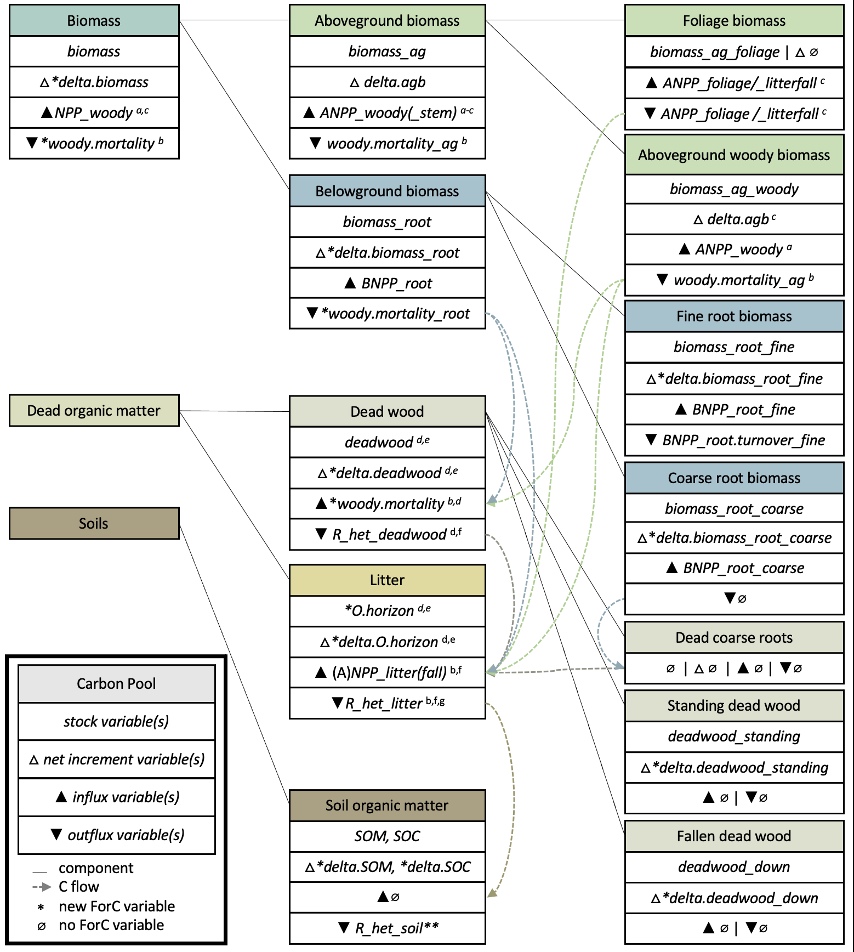

**Figure 1. Schematic illustrating the carbon pools defined under IPCC Guidelines for national greenhouse gas inventories; corresponding ForC variables, and relationships among them.** For each C pool, we show ForC variables corresponding to the stock, net annual increment, influx, and outflux. Most, but not all, EFDB-relevant ForC variables are shown here. Correspondence of ForC variables to IPCC criteria often depends upon measurement protocols (e.g., minimum stem diameter censused). Additional caveats are as follows: (a,b) branch fall and mortality of stems below the minimum stem diameter censused, which are necessary for a full accounting of dead organic matter production but typically assumed negligible for calculations of biomass change, are excluded by common measurement practice (a) or ForC variable definition (b); (c) assumes that leaf production equals leaf fall, or that changes in foliage biomass are negligble; (d,e) belowground components excluded by common measurement practice (d) or ForC variable definition (e); (f) excludes movement of dead wood into litter through breakage or size reduction; (g) measurements often limited to litter layer (OL) and may exclude larger branches and stems classified as litter and/or the more decomposed layers of the O horizon. **This variable is techically EFDB-relevant but not selected for submission because their is no corresponding influx variable.

### Land classification

Determination of the IPCC land-use category (i.e., Forest Land, Grassland, Wetlands, Cropland, Settlements, or Other Land; Notes S1) was made based on the dominant life form recorded in ForC. Woody vegetation – including early seral vegetation – was classified as forest, consistent with the IPCC definition that Forest Land includes land expected to succeed to forest. Mixtures of woody vegetation and grasses (i.e., anything from a shrub-encroached grassland to a tree-dominated savanna) were given dual classification of Forest Land and Grassland, indicating that records may be relevant to either category depending on the definition of forest applied (varies by country). Grass- or crop-dominated ecosystems (included in ForC as controls for studies of forest regrowth following agricultural abandonment) were classified as Grassland and Cropland, respectively.

Classification into EFDB sub-categories was dependent upon stand age and site history. For Forest Land ≥ 20 years old or of unknown (relatively mature) age, or Forest Land < 20 years old that was forest prior to a stand-clearing disturbance, the past land-use category was Forest Land, making the sub-category “Forest Land Remaining Forest land”. For forests <20 years old with history including cultivation/ tillage or grazing, past land-use categories were Cropland and Grassland, respectively, making land-use subcategories were “Cropland converted to Forest Land” and “Grassland converted to Forest Land”, respectively. For forests <20 years old with unspecified previous agricultural use, we assigned the sub-category “Land Converted to Forest land”. Forests <20 years old with unknown land use prior to the study date were simply classified as “Forest Land”. The same logic was applied for savannas, but including both Forest Land and Grassland as potentially relevant categories.

Given the lack of public information needed to determine whether lands are classified as managed (Ogle *et al.*, 2018; Deng *et al.*, 2021), and because the IPCC’s definition of managed land is more expansive than is commonly applied in the scientific literature and hence in ForC, we did not include any classification of land management status from ForC in the records submitted to EFDB. However, we did provide auxiliary information that should be useful in making this determination, including geographical location and notable disturbance events.

## 2. Updating ForC

Previous versions of ForC (Anderson-Teixeira *et al.*, 2016, 2018, 2021) contained most of the information required by EFDB, and, more broadly, to inform C stock change calculations under the Paris Agreement. However, modest changes to the structure and contents of ForC were needed in order to provide all information required by EFDB and to improve ForC’s capacity to serve as a repository of valuable information for forest C inventories under IPCC guidelines. To support export of data to EFDB, and to improve the overall quality of the ForC database, we added or modified 18 fields (Table S1), defined 15 new variables, implemented enhanced quality control, manually reviewed >1968 records to obtain additional required information, and added 329 new records. Having implemented these changes, which are described in detail in Methods S1, to ForC v3.0 (Anderson-Teixeira *et al.*, 2021), we released a new major version: ForC v4.0.

## 3. Submission of ForC data to EFDB

To submit complete, reviewed ForC records into EFDB, we created R scripts to restructure ForC records and populate EFDB’s bulk import form (publicly available; see **Data Availability Statement**). Criteria for data submission were that (1) records had been checked against the original study and determined to be complete and correct, and as originally presented, (2) all relevant records within the publication were included in ForC, (3) the original study presented values in tables or text, as opposed to the values having been digitized from graphs or calculated based on related variables, and (4) the records had not previously been submitted to EFDB. Once converted into EFDB format, the records were reviewed and then sent to the IPCC’s Technical Support Unit for submission to EFDB.

# Results

As of August 05, 2024, ForC (v4.0) contained 32686 independent records (39848 total), 19286 of which were for the 40 variables relevant to EFDB (Fig. 1). We had reviewed or added 2297 records for submission to EFDB, 1443 of which had been submitted, and 1068 of which had been reviewed by EFDB’s review panel, accepted, and posted (Table S3). The 37% discrepancy between records we reviewed and those submitted to EFDB was due to the presence of digitized records and records where a variable’s value had been calculated as the sum or difference of related variables rather than presented directly in the text. The discrepancy between the number of records submitted and that posted to EFDB is because some records (26%) were deemed not applicable to EFDB by the review panel. Reasons included – but were not limited to – non-applicability to the IPCC methodology of the variable submitted (e.g., net ecosystem CO2 exchange, litter - OL layer; subsequently excluded from lists of relevant variables and counts of relevant records), inadequate information on the quality of data and thus on its replicability (e.g., confidence interval/uncertainty), and vaguely described disturbance histories (e.g., “moderately”/ “severely” burned). As of August 05, 2024, the 1443 ForC records posted in EFDB represented ~7% of the EFDB-relevant data in ForC and 19% of the total EFDB records for forest land.

ForC v4.0 contained records for 28 of the 40 variables (or closely-related variable groups) relevant to EFDB (Fig. 1, Table S3). Records were submitted for 18 variables (or closely-related variable groups), including variables from each C pool (Table S3). The records available in ForC v4.0 – and the subset submitted to EFDB – were very unevenly distributed across variables (Table S3). The majority (81%) of records submitted were for C stocks, including 3% for total biomass, 53% for aboveground biomass, 4% for components of aboveground biomass (wood or foliage), 4% for root biomass, 2% for components of root biomass (coarse or fine roots), 5% for dead wood, 3% for components of dead wood (standing or fallen), 3% for litter (entire O horizon), and 4% for SOM/ SOC. Increment records totaled 9% of records submitted, all but four of which described aboveground biomass. The remaining 9% of records submitted described fluxes, all of which were either inputs or outputs to the aboveground biomass pool, a subset of which also described inputs to the dead wood or litter pool (Fig. 1,Table S3).

ForC v4.0 records and the subset submitted to EFDB were distributed across all forested continents, biomes, and forest types, albeit unevenly (Figs. 2-4). Relative to forested area, submitted data under-represented the tropics and over-represented temperate regions, mirroring the composition of ForC (Figs. 2, 4b). Submitted data covered all forested climates with substantial land area except the colder boreal regions (boreal tundra woodland; Figs. 2, 3) and were concentrated in climates that are relatively common over Earth’s land area (Fig. 3). Among the records submitted to EFDB, the largest number came from North America, followed by Asia, South America, and Africa, with strongly disproportionate representation of North America and under-representation of South America, Africa, Europe, Australia, and Oceania (Fig. 4c). In terms of FAO ecozones, boreal coniferous forest, temperate continental forest, and temperate mountain systems had the most records and were the best represented relative to their global area, whereas other ecozones were poorly represented relative to their global area (Fig. 4b). By far the most records and best representation relative to global area were for needleleaf evergreen forests, followed by broadleaf deciduous and broadleaf evergreen (Fig. 4b). The largest number of records came from mature forests (>100 years), followed by young and intermediate-aged stands, but young (<20 year) stands were best represented relative to their global area (Fig. 4d).

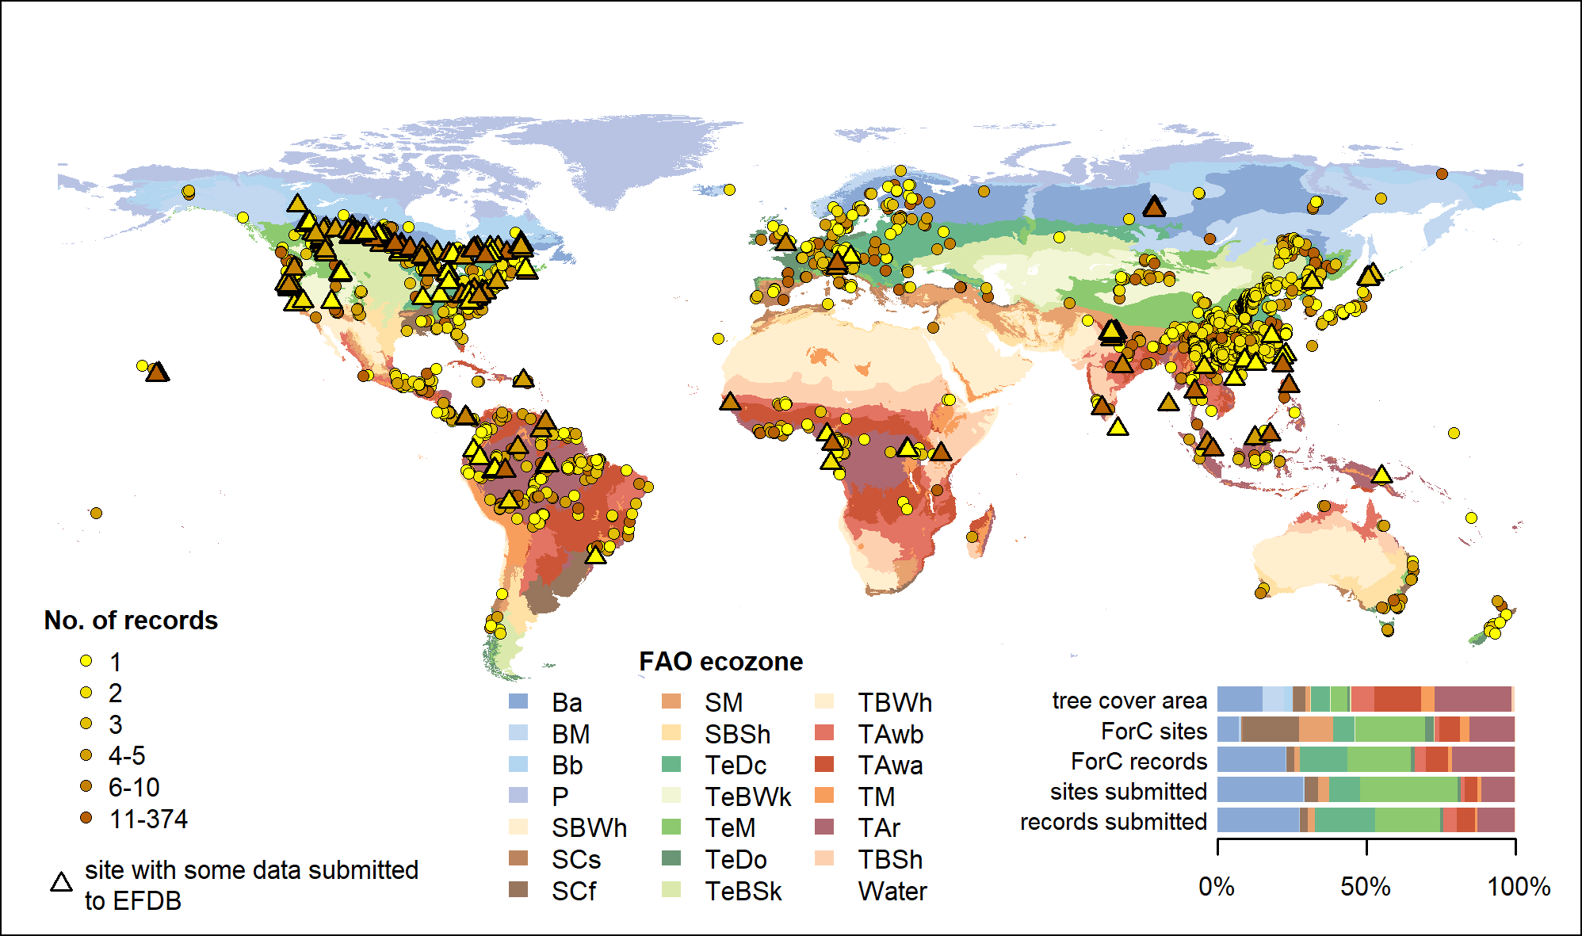

**Figure 2. Map of sites in ForC shaded by number of independent records relevant (circles) and submitted (triangles) to EFDB.** Underlying map shows FAO ecozones, and symbols are colored according to the number of records at each site. Inset stacked bar chart shows proportional representation by FAO ecozone for tree cover area (from SYNMAP, Jung *et al*, 2006), relevant ForC records, and submitted records. FAO ecozones (obtained from FAO’s GEOnetwork: <http://www.fao.org:80/geonetwork>) are coded as follows: Ba-Boreal coniferous forest, Bb-Boreal tundra woodland, BM-Boreal mountain systems, P-Polar, SBSh-Subtropical steppe, SBWh-Subtropical desert, SCf-Subtropical humid forest, SCs-Subtropical dry forest, SM-Subtropical mountain systems, TAr-Tropical rain forest, TAwa-Tropical moist deciduous forest, TAwb-Tropical dry forest, TBSh-Tropical shrubland, TBWh-Tropical desert, TeBSk-Temperate steppe, TeBWk-Temperate desert, TeDc-Temperate continental forest, TeDo-Temperate oceanic forest, TeM-Temperate mountain systems, TM-Tropical mountain systems.

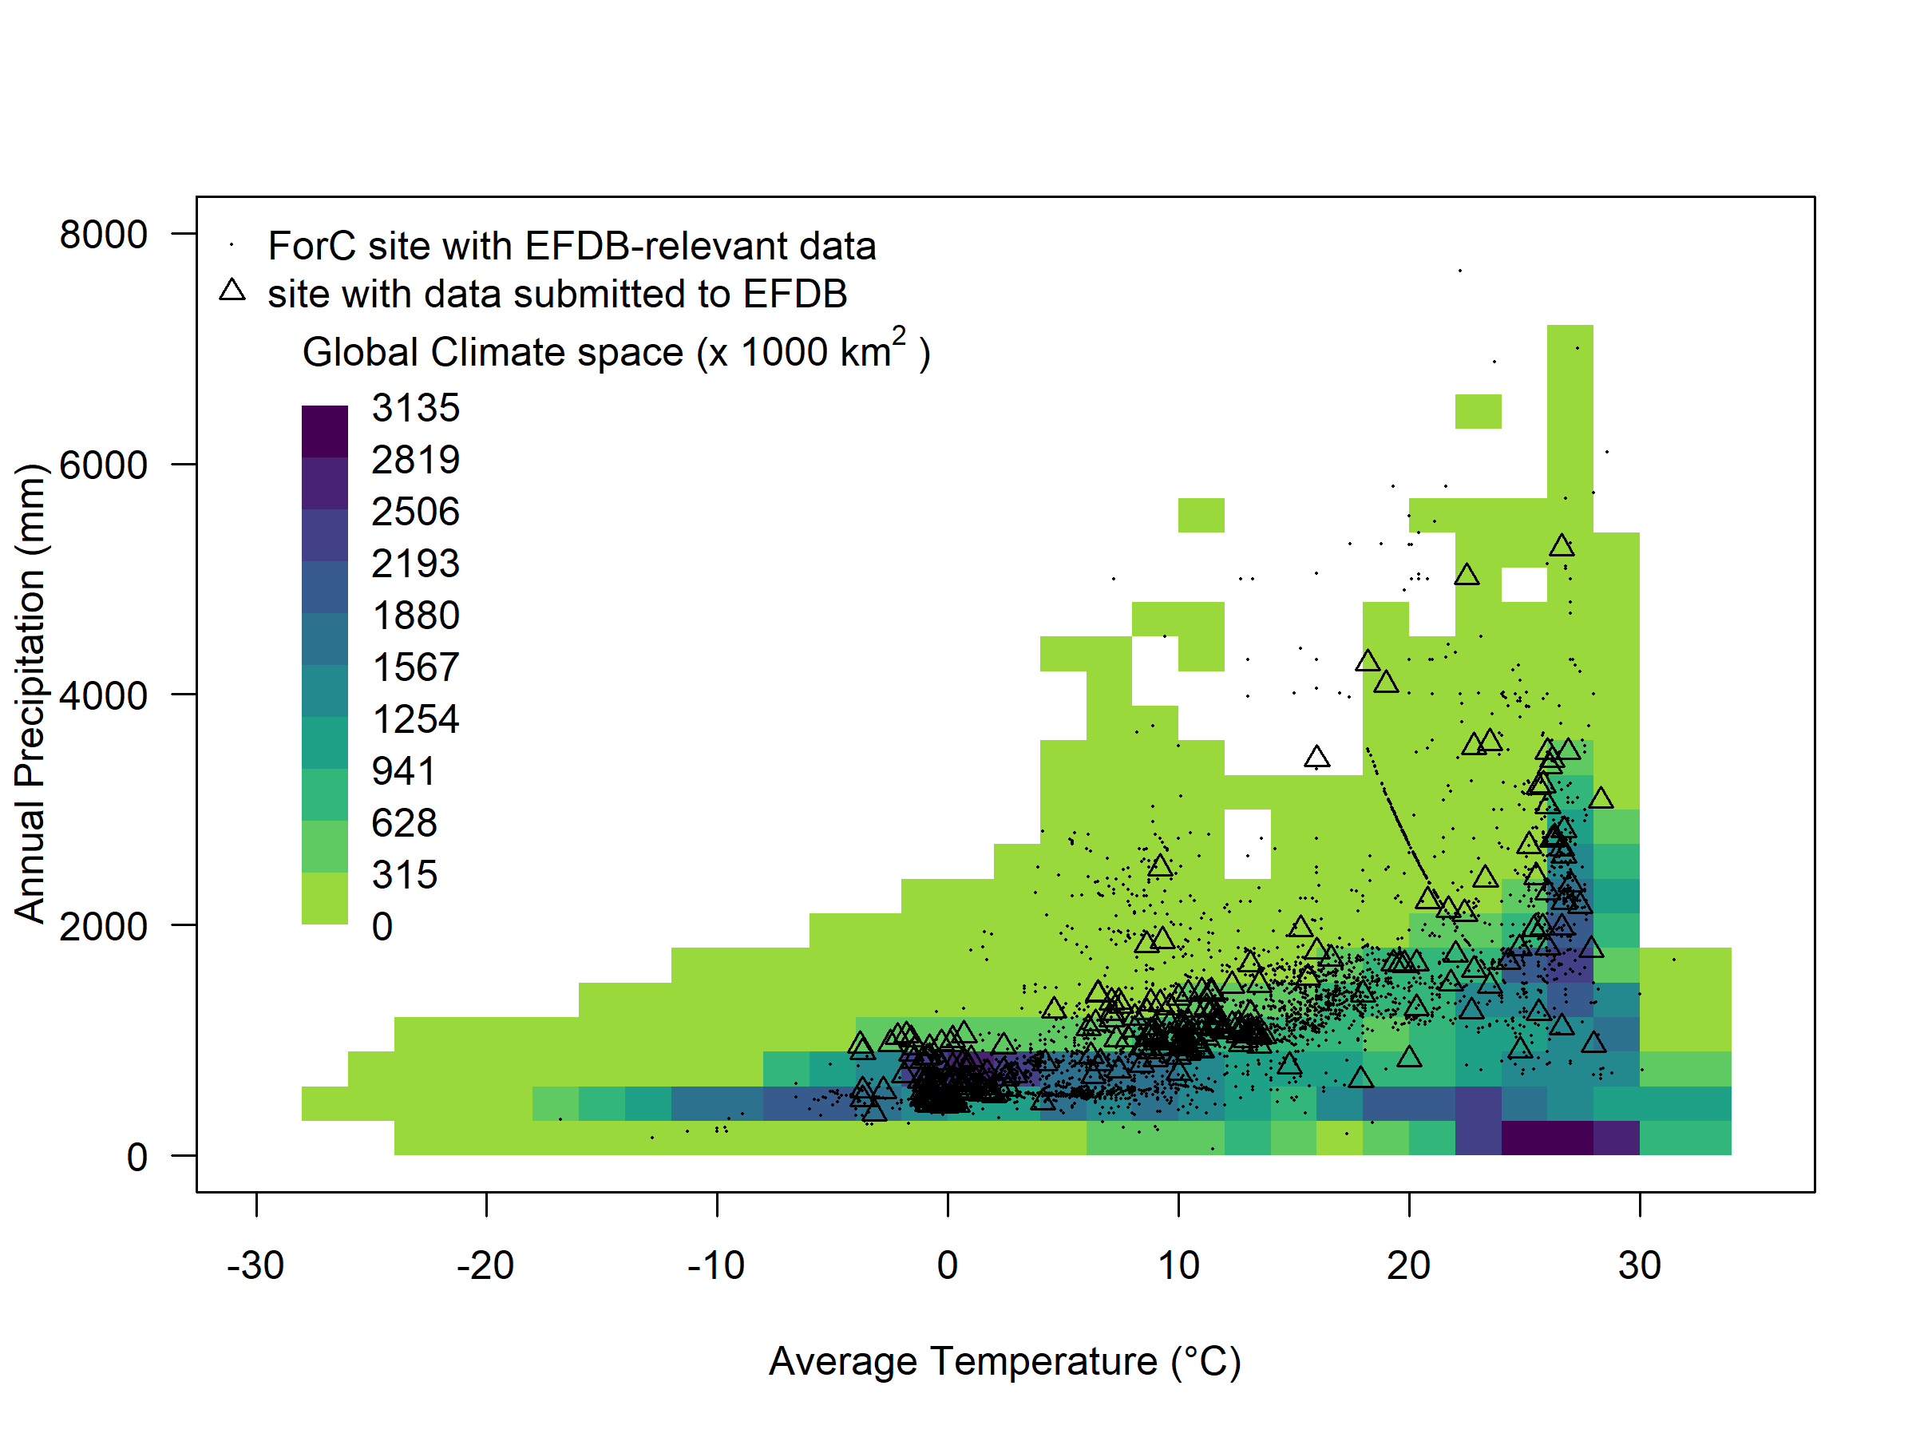

**Figure 3. Distribution of ForC records relevant (dots) and submitted (triangles) to EFDB within the global climate space of mean annual temperature (MAT) and mean annual precipitation (MAP).** Climate data are from the CRU TS3.10 dataset (0.5° resolution, 1990-2014, Harris *et al*, 2014). Background colors indicate the global land area with each MAT-MAP combination.

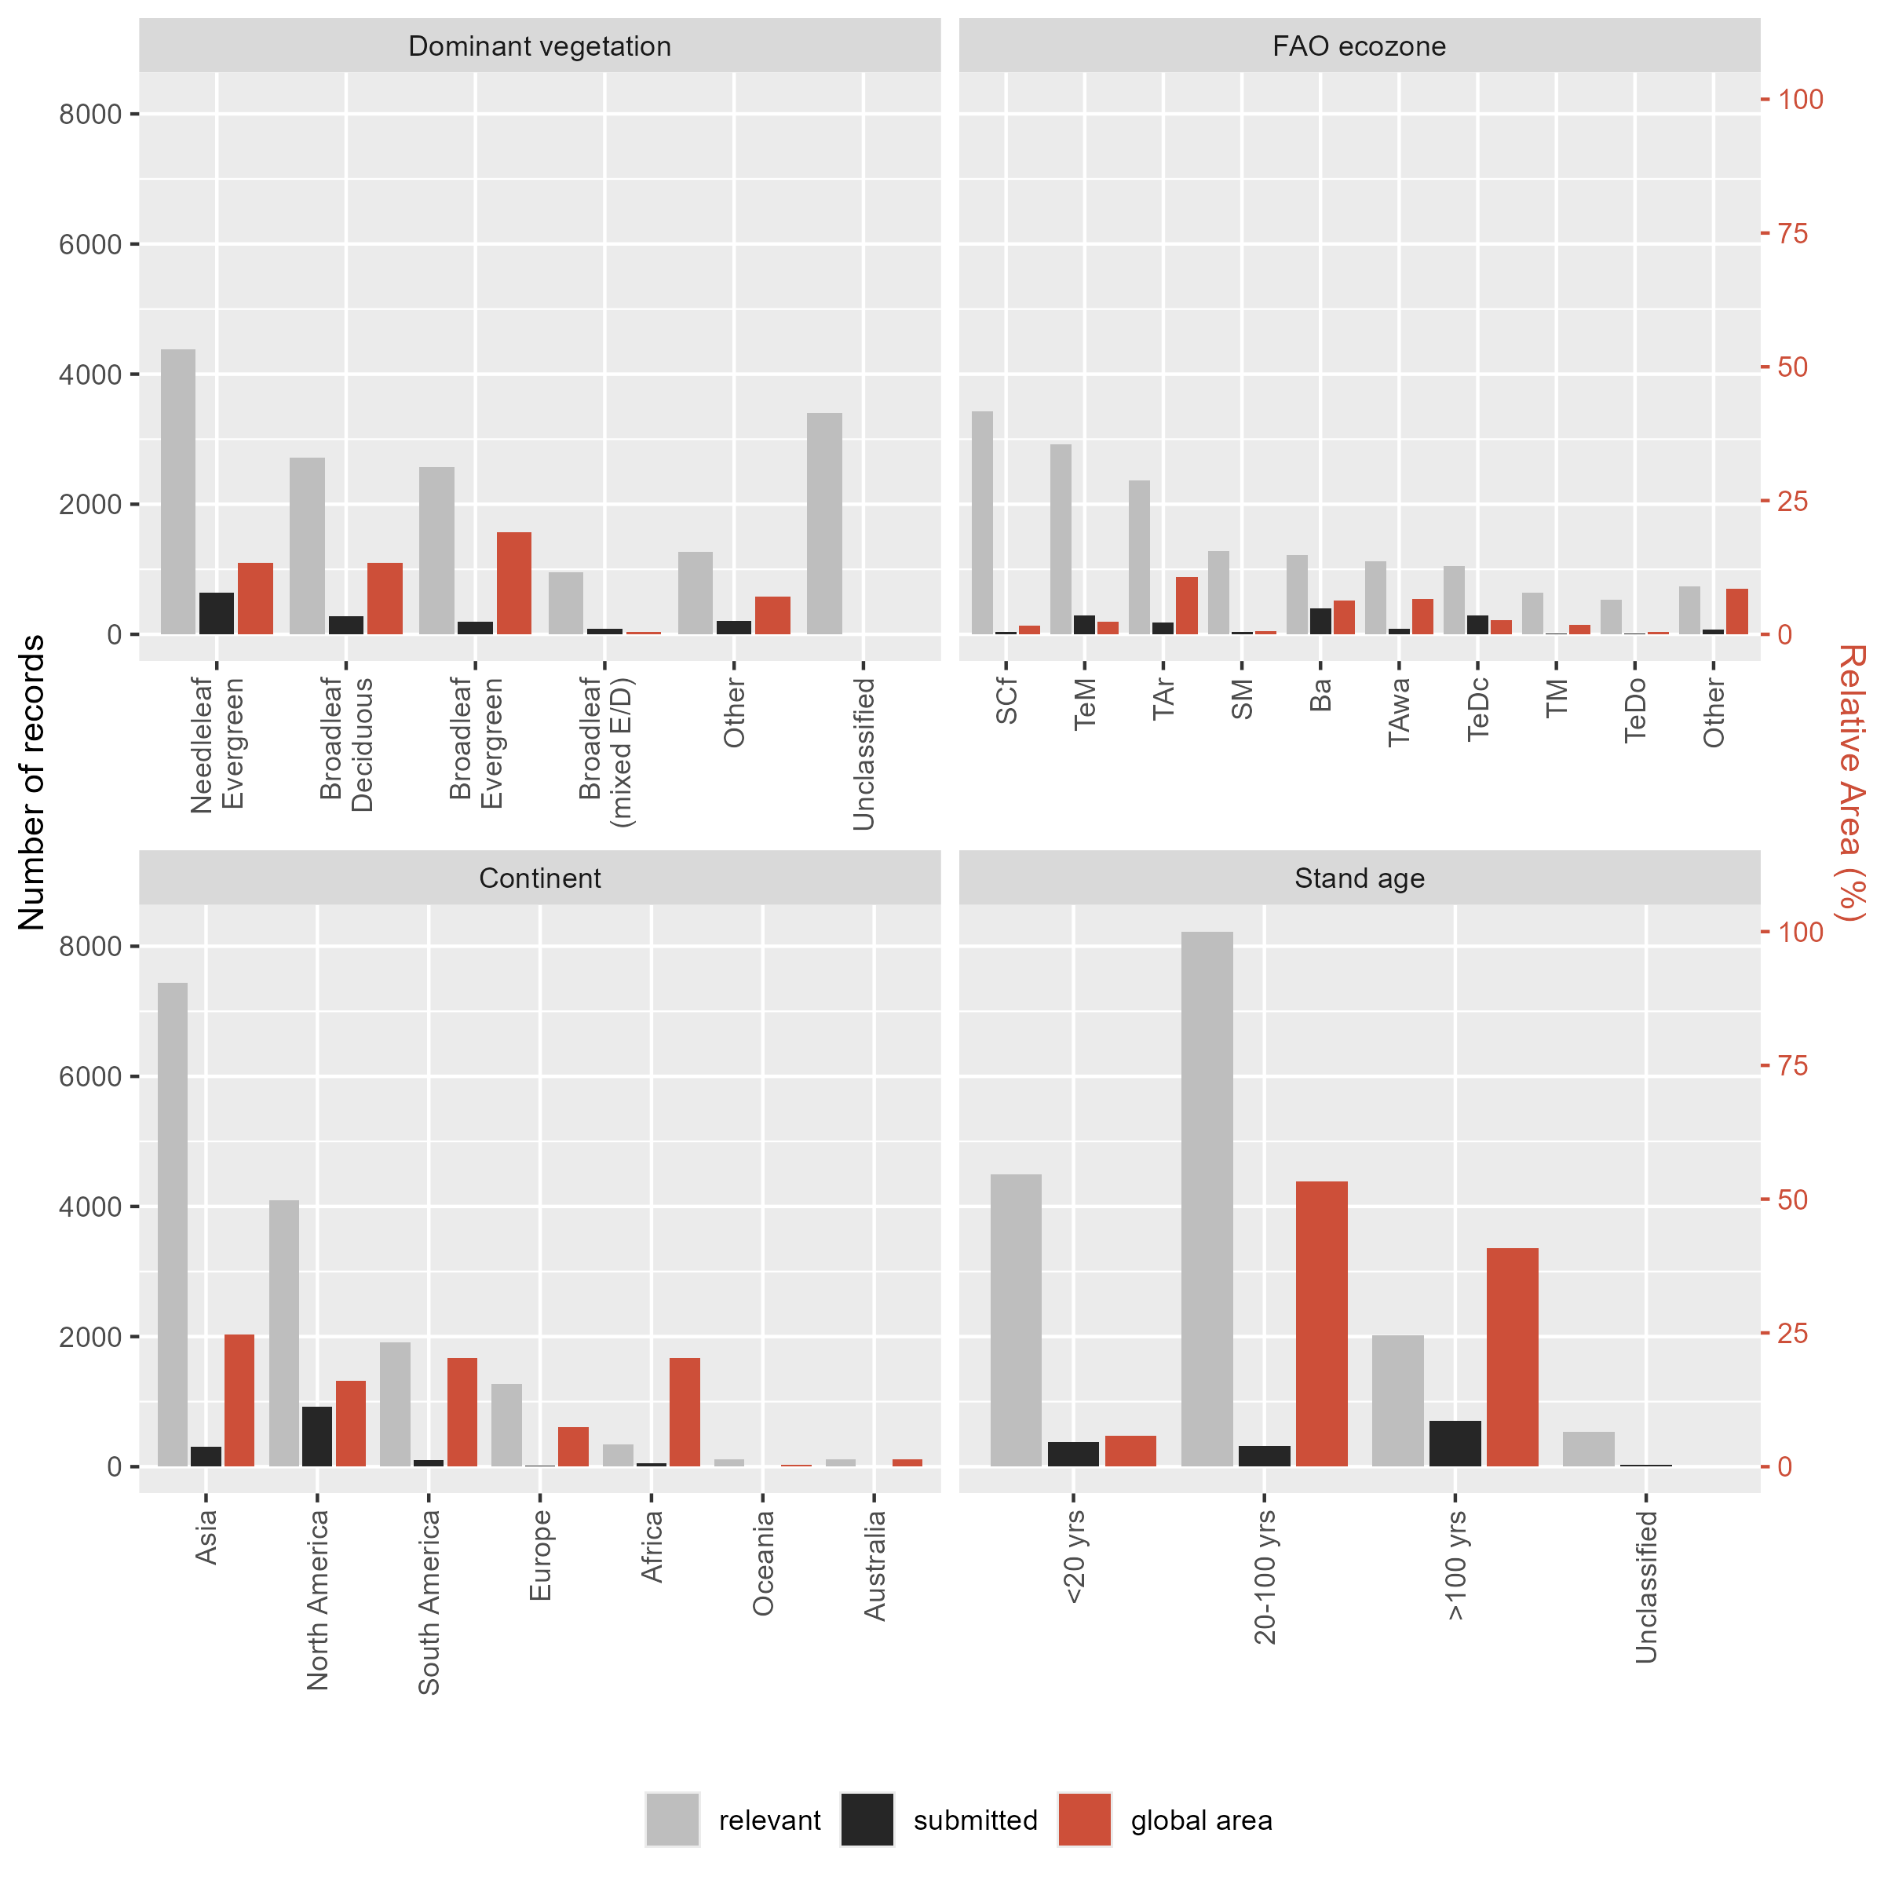

**Figure 4. Histograms of number of independent records in ForC relevant (grey) and submitted (black) to EFDB (both left axis), along with the relative global area of each type (red, right axis), organized by (a) dominant vegetation type, (b) FAO ecozone, (c) continent, and (d) stand age.** For dominant vegetation (a), ‘Other’ includes deciduous needleleaf, mixed broadleaf- needleleaf, non-woody vegetation (e.g., early successional), and incompletely classified or mixed forest types. Global coverage of each was obtained from SYNMAP (Jung *et al*, 2006). For FAO ecozones (b), codes are as listed in the caption of Figure 2. The relative area of forests by age class was obtained from the global forest age database of Besnard *et al.* (2021, 2024).

# Discussion

Here we have developed a framework for submitting records from ForC v4.0, the largest compilation of ground-based forest C estimates, to the EFDB, thus making those data more accessible for reporting CO2 emissions and removals from forest land consistent with good practice in the IPCC guidelines (IPCC, 2006a; IPCC, 2019b). As of August 05, 2024, 1068 ForC records have been posted to EFDB, which represents just 6% of potentially relevant records in ForC v4.0, but currently comprises 19% of the total EFDB records for forest land. The records present in ForC and submitted to EFDB are very unevenly distributed across variables, regions, and forest types (Figs. 2-4, Table S3), reflecting broader patterns in allocation of research effort and pointing to scientific research and reporting needs.

Based on our experience contributing forest C data to EFDB via ForC, we make several recommendations as to how scientists can improve forest C records in EFDB through database work, new data collection and analysis, and reporting.

### Database needs

There is vast potential to expand forest C data in EFDB by completing the process of reviewing and submitting data that are already in ForC (Figs. 2-4). So far, only ~7% of the EFDB-relevant data in ForC have been submitted to EFDB. Although this process requires manual review of records, the submission of new records to EFDB is greatly facilitated by the fact that most pertinent information for each record is already entered in ForC and can be easily prepared for submission to EFDB using the system developed here. Future efforts to review studies for submission should optimize for representation across geographic regions, forest types, and variables, giving priority to those from currently under-represented regions and forest types (Figs. 2-4, Table S3). Other categories of records to prioritize include those from countries relying on existing data for their greenhouse gas inventories (Tier 1 or 2 methodology), the variables most needed by EFDB users, and the most up-to-date records.

In addition to the large potential to expand EFDB using records already in ForC, there are extensive EFDB-relevant forest C data that are not currently included in ForC, with more being published on a nearly daily basis. Coverage of particular variables or regions could be vastly improved through systematic review of the literature, although this requires focused and extensive manual effort. Recent efforts have compiled large databases of relevant data from monoculture plantation forests (Bukoski *et al.*, 2022) and mixed species plantation forests (Warner *et al.*, 2022; Feng *et al.*, 2022), and such a compilation is in works for agroforestry (Susan Cook-Patton, unpublished data). Beyond expanding collections of relevant forest C records, such reviews are valuable for assessing the availability of published records and identifying variables and regions that require additional data collection and analysis.

### Data collection and analysis needs

New data collection and analyses are needed to fill notable knowledge gaps. While aboveground biomass stocks in particular have received – and continue to receive – by far the most research attention (Table S3, NISAR, 2018; Quegan *et al.*, 2019; Dubayah *et al.*, 2020; Anderson-Teixeira *et al.*, 2021), production of an accurate global map of forest C stocks remains an ongoing challenge (Araza *et al.*, 2023). Other pools and variables remain poorly quantified and highly uncertain for many parts of the world (Table S3, Tifafi *et al.*, 2018; Anderson-Teixeira *et al.*, 2021), introducing substantive uncertainties into global forest C budgets (Pan *et al.*, 2011; Harris *et al.*, 2021). Furthermore, data distribution is very uneven across forest types and geographical regions (Figs. 2-4). For instance, data on C cycling of tropical forests – particularly in Africa – remains relatively sparse, in large part due to substantial barriers to data collection and distribution (de Lima *et al.*, 2022). More generally, belowground C measurements remain sparse globally. Significant investment in research and researchers focused on ground-based measurement of forest C in such regions will be important to filling knowledge gaps in forest C cycling (de Lima *et al.*, 2022; Labrière *et al.*, 2023; Araza *et al.*, 2023).

Several EFDB-relevant variables have not been calculated and presented as frequently as would be possible given existing forest census data and minimal extra research effort. For example, aboveground woody mortality and aboveground biomass increment can be calculated from the same census data as aboveground woody productivity, yet the latter has received far more research attention (Table S3, Anderson-Teixeira *et al.*, 2021). Similarly, live coarse root biomass, total biomass, and changes therein could in theory be estimated in parallel with aboveground biomass, with the greatest barrier being that allometric models for estimating root biomass are not as reliable or easily available as are those for aboveground biomass (Chave *et al.*, 2014; Réjou-Méchain *et al.*, 2017; Gonzalez-Akre *et al.*, 2022). However, while equations for estimating root (and thereby total) biomass require improvement, they do exist for many forest types (Mokany *et al.*, 2006; e.g., Brassard *et al.*, 2011; Chojnacky *et al.*, 2014; Waring & Powers, 2017). We recommend that, when possible, researchers calculate and report all EFDB-relevant variables.

### Data reporting needs

We recommend that, in order to make research most useful for estimating C stock changes following IPCC guidelines, researchers calculate and report results according to IPCC good practice (Table 2). Importantly, simple decisions on the presentation of results will determine whether the records meet the current criteria for inclusion in EFDB. For example: (1) presenting data only in a figure makes them ineligible for inclusion in EFDB, whereas presentation in a table or supplementary data file allows inclusion while supporting FAIR goals (Stall *et al.*, 2019); (2) direct presentation of all relevant variables allows inclusion, whereas presenting only components of variables of interest (e.g., parsing litter into fine woody debris, OL, OF, and OH layers) or requiring simple mathematical operations to obtain a variable of interest (e.g., *delta.agb* = *ANPP_woody* - *woody.mortality.agb*) disqualifies records from inclusion; (3) matching IPCC-defined thresholds for defining C pools (Table 1), which may vary by country, can make the data far more relevant estimating forest C stock changes according to IPCC guidelines (e.g., using a 10 cm cutoff between dead wood and litter, presenting soil C to a depth of 30 cm). It should also be emphasized that reporting of 95% confidence intervals (or other metrics of error), when applicable, is highly desirable and makes the data more relevant to IPCC.

**Table 2. Recommended best practices for reporting forest C estimates of value to national greenhouse gas inventories under IPCC guidance.**

| **criteria** | **recommendation** | **rationale** |
| --- | --- | --- |
| variables to include | When possible, calculate and present all relevant variables that can be readily estimated based on available data. | Estimates of relevant variables are not always calcualted. |
| forest census methods | Adopt IPCC guidelines (country-specific) for minimum stem size in censues in census and reporting. Ideally, census stem down to the smallest diameter feasible. | IPCC biomass pool definition includes all living vegetation, but understory may be excluded when contribution is minor. |
|  | Census all taxa crontributing signficantly to biomass | IPCC biomass pool definition includes all living vegetation. |
| dead organic matter sampling | Adopt IPCC recommendations for minimum diameter of deadwood (country-specific, default 10 cm). | Diameter cutoff must be applied consistently by each country. |
| belowground sampling | Select and report soil sampling increments to include a cutoff at 30 cm depth (or country-specific depth). | Diameter cutoff must be applied consistently by each country. |
| reporting variables | Present each EFDB- relevant variable individually, as opposed to requiring summation of related variables. | EFDB requires that values in the database be presented in the original article, and cannot accept subsequent calculations. |
| reporting estimates | Report all relevant values in tables, text, or supplementary tables/ data files, as opposed to in figures only. | EFDB does not accept values digitized from figures. |
| reporting confidence intervals | Report 95% confidence intervals, standard error, or standard deviation and sample size. | EFDB requires confidence invervals whenever possible. |

For those compiling published records (e.g., for meta-analyses), the data set can have added value if all information required by EFDB is extracted from original publications. This includes – but is not limited to – retaining original values as presented without modification or rounding, noting whether data were digitized, recording confidence intervals, and recording all required fields (as indicated in the EFDB’s bulk import template). The significant effort required to map a database into EFDB has been accomplished here (Table S2), and we hope that it will prove useful as a model for other efforts.

# Conclusions

As human society strives to achieve net-zero greenhouse gas emissions, forest researchers can make their research more useful for forest C inventories under IPCC guidelines by calculating and reporting results in ways that are consistent with methodologies provided in the IPCC guidelines (Tables 1, 2). In addition, substantial investments in research and researchers focused on ground-based measurement of forest C will be required to fill knowledge gaps and thereby increase the accuracy of forest CO2 inventories for forest lands under the Paris Agreement. This challenge is heightened by the fact that forests are changing rapidly (e.g., McDowell *et al.*, 2020), and data collected a decade or more in the past may be increasingly less accurate. This heightens the need for an efficient system of making forest C data accessible for national greenhouse gas inventories. We view the system developed here for submitting ForC data to the IPCC EFDB as one important step towards that goal.

# Acknowledgements

We gratefully acknowledge the substantial contributions of Valentyna Slivinska and Sandro Federici for collaboration on the conception, design, and technical review of this project. Thank you to all researchers who collected and published the data contained in ForC, and to all research assistants and collaborators who have contributed to building the database. Thank you to Avni Malhotra for helpful comments on an earlier draft of this manuscript. Funding for this study was provided by the Smithsonian (Forest Global Earth Observatory, Smithsonian Working Land and Seascapes) and a Bezos Earth Fund grant to the Nature Conservancy with a sub-grant to NZCBI.

# Author Contribution

KAT and VH conceived and designed the project; VH wrote the scripts for database management, data submission to EFDB, and the analyses presented here; MW, TR, and RBM added and reviewed ForC data, BBL and SCP contributed large databases to ForC (EFDB and GROA, respectively); CP provided methodological expertise; KAT, VH, and MW prepared the first draft of the manuscript; all authors reviewed the results and approved the final version of the manuscript.

# Data Availability Statement

All code and data are openly available. The ForC database and associated code are available via the ForC repository within the ForC-db organization on GitHub (<https://github.com/forc-db/ForC>), and the version used here (ForC v4.0) is archived in Zenodo (Anderson-Teixeira *et al.*, 2023, DOI: 10.5281/zenodo.8020861). The data and code associated with data submission to EFDB and preparation of this manuscript are available via the the IPCC-EFDB-integration repository within the ForC-db organization on GitHub (<https://github.com/forc-db/IPCC-EFDB-integration>) and archived in Zenodo (DOI: 10.5281/zenodo.8021474).

# Supplementary Information

Table S1. Updates to ForC field implemented between releases of v3.0 and v4.0

Table S2. Mapping of ForC fields to EFDB

Table S3. Numbers of ForC records and EFDB submissions by variable

Notes S1. Primer on forest land classification and carbon pools under IPCC guidelines

Methods S1. Updates to ForC (ForC v4.0)

# References

**Anderson-Teixeira KJ, Belair EP**. **2022**. [Effective forest-based climate change mitigation requires our best science](https://doi.org/10.1111/gcb.16008). *Global Change Biology* **28**: 1200–1203.

**Anderson-Teixeira K, Herrmann V, Morgan BB, Actions-User, Williams M, Rogers T, McGregor I, Hua MWM, Ferson A, Bond-Lamberty B, *et al.*** **2023**. [Forc-db/ForC: First version with EFDB integration](https://doi.org/10.5281/ZENODO.8020861).

**Anderson-Teixeira KJ, Herrmann V, Morgan RB, Bond-Lamberty B, Cook-Patton SC, Ferson AE, Muller-Landau HC, Wang MMH**. **2021**. [Carbon cycling in mature and regrowth forests globally](https://doi.org/10.1088/1748-9326/abed01). *Environmental Research Letters* **16**: 053009.

**Anderson-Teixeira KJ, Wang MMH, McGarvey JC, Herrmann V, Tepley AJ, Bond-Lamberty B, LeBauer DS**. **2018**. [ForC: A global database of forest carbon stocks and fluxes](https://doi.org/10.1002/ecy.2229). *Ecology* **99**: 1507–1507.

**Anderson-Teixeira KJ, Wang MMH, McGarvey JC, LeBauer DS**. **2016**. [Carbon dynamics of mature and regrowth tropical forests derived from a pantropical database (TropForC-db)](https://doi.org/10.1111/gcb.13226). *Global Change Biology* **22**: 1690–1709.

**Araza A, Herold M, de Bruin S, Ciais P, Gibbs DA, Harris N, Santoro M, Wigneron J-P, Yang H, Málaga N, *et al.*** **2023**. [Past decade above-ground biomass change comparisons from four multi-temporal global maps](https://doi.org/10.1016/j.jag.2023.103274). *International Journal of Applied Earth Observation and Geoinformation* **118**: 103274.

**Badgley G, Freeman J, Hamman JJ, Haya B, Trugman AT, Anderegg WRL, Cullenward D**. **2022**. [Systematic over-crediting in California’s forest carbon offsets program](https://doi.org/10.1111/gcb.15943). *Global Change Biology* **28**: 1433–1445.

**Besnard S, Koirala S, Santoro M, Weber U, Nelson J, Gütter J, Herault B, Kassi J, N’Guessan A, Neigh C, *et al.*** **2021**. [Mapping global forest age from forest inventories, biomass and climate data](https://doi.org/10.5194/essd-13-4881-2021). *Earth System Science Data* **13**: 4881–4896.

**Besnard S, Santoro M, Herold M, Cartus O, Gütter J, Heinrich VHA, Herault B, Kassi J, Koirala S, N’Guessan A, *et al.*** **2024**. [Global Age Mapping Integration (GAMI). V. 2.0. GFZ Data Services.](https://doi.org/10.5880/GFZ.1.4.2023.006)

**Bonan GB**. **2016**. [Forests, Climate, and Public Policy: A 500-Year Interdisciplinary Odyssey](https://doi.org/10.1146/annurev-ecolsys-121415-032359). *Annual Review of Ecology, Evolution, and Systematics* **47**: 97–121.

**Bond-Lamberty B, Thomson A**. **2010**. [A global database of soil respiration data](https://doi.org/10.5194/bg-7-1915-2010). *Biogeosciences* **7**: 1915–1926.

**Brassard BW, Chen HYH, Bergeron Y, Paré D**. **2011**. [Coarse root biomass allometric equations for Abies balsamea, Picea mariana, Pinus banksiana, and Populus tremuloides in the boreal forest of Ontario, Canada](https://doi.org/10.1016/j.biombioe.2011.06.045). *Biomass and Bioenergy* **35**: 4189–4196.

**Bukoski JJ, Cook-Patton SC, Melikov C, Ban H, Chen JL, Goldman ED, Harris NL, Potts MD**. **2022**. [Rates and drivers of aboveground carbon accumulation in global monoculture plantation forests](https://doi.org/10.1038/s41467-022-31380-7). *Nature Communications* **13**: 1–13.

**Chave J, Réjou-Méchain M, Búrquez A, Chidumayo E, Colgan MS, Delitti WBC, Duque A, Eid T, Fearnside PM, Goodman RC, *et al.*** **2014**. [Improved allometric models to estimate the aboveground biomass of tropical trees](https://doi.org/10.1111/gcb.12629). *Global Change Biology* **20**: 3177–3190.

**Chojnacky DC, Heath LS, Jenkins JC**. **2014**. [Updated generalized biomass equations for North American tree species](https://doi.org/10.1093/forestry/cpt053). *Forestry* **87**: 129–151.

**Cook-Patton SC, Leavitt SM, Gibbs D, Harris NL, Lister K, Anderson-Teixeira KJ, Briggs RD, Chazdon RL, Crowther TW, Ellis PW, *et al.*** **2020**. [Mapping carbon accumulation potential from global natural forest regrowth](https://doi.org/10.1038/s41586-020-2686-x). *Nature* **585**: 545–550.

**Cuni-Sanchez A, Sullivan MJP, Platts PJ, Lewis SL, Marchant R, Imani G, Hubau W, Abiem I, Adhikari H, Albrecht T, *et al.*** **2021**. [High aboveground carbon stock of African tropical montane forests](https://doi.org/10.1038/s41586-021-03728-4). *Nature* **596**: 536–542.

**de Lima RAF, Phillips OL, Duque A, Tello JS, Davies SJ, de Oliveira AA, Muller S, Honorio Coronado EN, Vilanova E, Cuni-Sanchez A, *et al.*** **2022**. [Making forest data fair and open](https://doi.org/10.1038/s41559-022-01738-7). *Nature Ecology & Evolution*.

**Deng Z, Ciais P, Tzompa-Sosa ZA, Saunois M, Qiu C, Tan C, Sun T, Ke P, Cui Y, Tanaka K, *et al.*** **2021**. [Comparing national greenhouse gas budgets reported in UNFCCC inventories against atmospheric inversions](https://doi.org/10.5194/essd-2021-235). *Earth System Science Data Discussions*: 1–59.

**Dubayah R, Blair JB, Goetz S, Fatoyinbo L, Hansen M, Healey S, Hofton M, Hurtt G, Kellner J, Luthcke S, *et al.*** **2020**. [The Global Ecosystem Dynamics Investigation: High-resolution laser ranging of the Earth’s forests and topography](https://doi.org/10.1016/j.srs.2020.100002). *Science of Remote Sensing* **1**: 100002.

**Ellis EC, Gauthier N, Klein Goldewijk K, Bliege Bird R, Boivin N, Díaz S, Fuller DQ, Gill JL, Kaplan JO, Kingston N, *et al.*** **2021**. [People have shaped most of terrestrial nature for at least 12,000 years](https://doi.org/10.1073/pnas.2023483118). *Proceedings of the National Academy of Sciences* **118**: e2023483118.

**Ellis EC, Klein Goldewijk K, Siebert S, Lightman D, Ramankutty N**. **2010**. [Anthropogenic transformation of the biomes, 1700 to 2000](https://doi.org/10.1111/j.1466-8238.2010.00540.x). *Global Ecology and Biogeography* **19**: 589–606.

**Feng Y, Schmid B, Loreau M, Forrester DI, Fei S, Zhu J, Tang Z, Zhu J, Hong P, Ji C, *et al.*** **2022**. [Multispecies forest plantations outyield monocultures across a broad range of conditions](https://doi.org/10.1126/science.abm6363). *Science* **376**: 865–868.

**Friedlingstein P, O’Sullivan M, Jones MW, Andrew RM, Gregor L, Hauck J, Le Quéré C, Luijkx IT, Olsen A, Peters GP, *et al.*** **2022**. [Global Carbon Budget 2022](https://doi.org/10.5194/essd-14-4811-2022). *Earth System Science Data* **14**: 4811–4900.

**Gonzalez-Akre E, Piponiot C, Lepore M, Herrmann V, Lutz JA, Baltzer JL, Dick CW, Gilbert GS, He F, Heym M, *et al.*** **2022**. [Allodb: An R package for biomass estimation at globally distributed extratropical forest plots](https://doi.org/10.1111/2041-210X.13756). *Methods in Ecology and Evolution* **13**: 330–338.

**Grassi G, House J, Dentener F, Federici S, den Elzen M, Penman J**. **2017**. [The key role of forests in meeting climate targets requires science for credible mitigation](https://doi.org/10.1038/nclimate3227). *Nature Climate Change* **7**: 220–226.

**Harris NL, Gibbs DA, Baccini A, Birdsey RA, Bruin S de, Farina M, Fatoyinbo L, Hansen MC, Herold M, Houghton RA, *et al.*** **2021**. [Global maps of twenty-first century forest carbon fluxes](https://doi.org/10.1038/s41558-020-00976-6). *Nature Climate Change*: 1–7.

**Harris I, Jones PD, Osborn TJ, Lister DH**. **2014**. [Updated high-resolution grids of monthly climatic observations - the CRU TS3.10 Dataset](https://doi.org/10.1002/joc.3711). *International Journal of Climatology* **34**: 623–642.

**IPCC**. **2003**. *Good Practice Guidance for Land Use, Land-Use Change and Forestry* (J Penman, M Gytarsky, T Hiraishi, T Krug, D Kruger, R Pipatti, L Buendia, K Miwa, T Ngara, K Tanabe, *et al.*, Eds.). Hayama, Japan: Institute for Global Environmental Strategies.

**IPCC**. **2006a**. *2006 IPCC Guidelines for National Greenhouse Gas Inventories, Prepared by the National Greenhouse Gas Inventories Programme, Eggleston H.S., Buendia L., Miwa K., Ngara T. And Tanabe K. (eds).* Japan: IGES.

**IPCC**. **2006b**. Agriculture, Forestry, and Other Land Use. In: Eggleston S, Buendia L, Miwa K, Ngara T, Tanabe K, eds. 2006 IPCC Guidelines for National Greenhouse Gas Inventories. Hayama, Japan: Institute for Global Environmental Strategies.

**IPCC**. **2019b**. 2019 Refinement to the 2006 IPCC Guidelines for National Greenhouse Gas Inventories. In: Calvo Buendia E, Tanabe K, Baasansuren J, Fukuda M, Ngarize S, Osako A, Pyrozhenko Y, Shermanau P, Federici S, eds. Switzerland: IPCC.

**IPCC**. **2019a**. *Climate Change and Land: An IPCC special report on climate change, desertification, land degradation, sustainable land management, food security, and greenhouse gas fluxes in terrestrial ecosystems [P.R. Shukla, J. Skea, E. Calvo Buendia, V. Masson-Delmotte, H.- O. Pörtner, D. C. Roberts, P. Zhai, R. Slade, S. Connors, R. Van Diemen, M. Ferrat, E. Haughey, S. Luz, S. Neogi, M. Pathak, J. Petzold, J. Portugal Pereira, P. Vyas, E. Huntley, K. Kissick, M. Belkacemi, J. Malley, (eds.)]*.

**IPCC**. **2022a**. [Climate Change 2022: Mitigation of Climate Change. Contribution of Working Group III to the Sixth Assessment Report of the Intergovernmental Panel on Climate Change [P.R. Shukla, J. Skea, R. Slade, A. Al Khourdajie, R. Van Diemen, D. McCollum, M. Pathak, S. Some, P. Vyas, R. Fradera, M. Belkacemi, A. Hasija, G. Lisboa, S. Luz, J. Malley, (eds.)]. Cambridge University Press, Cambridge, UK and New York, NY, USA.](https://doi.org/10.1017/9781009157926.001)

**IPCC**. **2022b**. Summary for Policymakers. Policymakers [P.R. Shukla, J. Skea, A. Reisinger, R. Slade, R. Fradera, M. Pathak, A. Al Khourdajie, M. Belkacemi, R. Van Diemen, A. Hasija, G. Lisboa, S. Luz, J. Malley, D. McCollum, S. Some, P. Vyas, (eds.)]. In: Climate Change 2022: Mitigation of Climate Change. Contribution of Working Group III to the Sixth Assessment Report of the Intergovernmental Panel on Climate Change [P.R. Shukla, J. Skea, R. Slade, A. Al Khourdajie, R. Van Diemen, D. McCollum, M. Pathak, S. Some, P. Vyas, R. Fradera, M. Belkacemi, A. Hasija, G. Lisboa, S. Luz, J. Malley, (eds.)]. Cambridge University Press, Cambridge, UK and New York, NY, USA. Doi: 10.1017/9781009157926.001.

**Jian J, Vargas R, Anderson-Teixeira K, Stell E, Herrmann V, Horn M, Kholod N, Manzon J, Marchesi R, Paredes D, *et al.*** **2021**. [A restructured and updated global soil respiration database (SRDB-V5)](https://doi.org/10.5194/essd-13-255-2021). *Earth System Science Data* **13**: 255–267.

**Jung M, Henkel K, Herold M, Churkina G**. **2006**. [Exploiting synergies of global land cover products for carbon cycle modeling](https://doi.org/10.1016/j.rse.2006.01.020). *Remote Sensing of Environment* **101**: 534–553.

**Labrière N, Davies SJ, Disney MI, Duncanson LI, Herold M, Lewis SL, Phillips OL, Quegan S, Saatchi SS, Schepaschenko DG, *et al.*** **2023**. [Toward a forest biomass reference measurement system for remote sensing applications](https://doi.org/10.1111/gcb.16497). *Global Change Biology* **n/a**.

**McDowell NG, Allen CD, Anderson-Teixeira K, Aukema BH, Bond-Lamberty B, Chini L, Clark JS, Dietze M, Grossiord C, Hanbury-Brown A, *et al.*** **2020**. [Pervasive shifts in forest dynamics in a changing world](https://doi.org/10.1126/science.aaz9463). *Science* **368**.

**Mokany K, Raison RJ, Prokushkin AS**. **2006**. [Critical analysis of root : Shoot ratios in terrestrial biomes](https://doi.org/10.1111/j.1365-2486.2005.001043.x). *Global Change Biology* **12**: 84–96.

**NISAR**. **2018**. *NASA-ISRO SAR (NISAR) Mission Science Users’ Handbook*. NASA Jet Propulsion Laboratory.

**Ogle SM, Domke G, Kurz WA, Rocha MT, Huffman T, Swan A, Smith JE, Woodall C, Krug T**. **2018**. [Delineating managed land for reporting national greenhouse gas emissions and removals to the United Nations framework convention on climate change](https://doi.org/10.1186/s13021-018-0095-3). *Carbon Balance and Management* **13**: 9.

**Pan Y, Birdsey RA, Fang J, Houghton R, Kauppi PE, Kurz WA, Phillips OL, Shvidenko A, Lewis SL, Canadell JG, *et al.*** **2011**. A Large and Persistent Carbon Sink in the World’s Forests. *Science* **333**: 988–993.

**Quegan S, Le Toan T, Chave J, Dall J, Exbrayat J-F, Minh DHT, Lomas M, D’Alessandro MM, Paillou P, Papathanassiou K, *et al.*** **2019**. [The European Space Agency BIOMASS mission: Measuring forest above-ground biomass from space](https://doi.org/10.1016/j.rse.2019.03.032). *Remote Sensing of Environment* **227**: 44–60.

**Réjou-Méchain M, Tanguy A, Piponiot C, Chave J, Hérault B**. **2017**. [Biomass: An r package for estimating above-ground biomass and its uncertainty in tropical forests](https://doi.org/10.1111/2041-210X.12753). *Methods in Ecology and Evolution* **8**: 1163–1167.

**Requena Suarez D, Rozendaal DMA, Sy VD, Phillips OL, Alvarez-Dávila E, Anderson-Teixeira K, Araujo-Murakami A, Arroyo L, Baker TR, Bongers F, *et al.*** **2019**. [Estimating aboveground net biomass change for tropical and subtropical forests: Refinement of IPCC default rates using forest plot data](https://doi.org/10.1111/gcb.14767). *Global Change Biology* **25**: 3609–3624.

**Roe S, Streck C, Beach R, Busch J, Chapman M, Daioglou V, Deppermann A, Doelman J, Emmet-Booth J, Engelmann J, *et al.*** **2021**. [Land-based measures to mitigate climate change: Potential and feasibility by country](https://doi.org/10.1111/gcb.15873). *Global Change Biology* **27**: 6025–6058.

**Rozendaal DMA, Suarez DR, Sy VD, Avitabile V, Carter S, Yao CYA, Alvarez-Davila E, Anderson-Teixeira K, Araujo-Murakami A, Arroyo L, *et al.*** **2022**. [Aboveground forest biomass varies across continents, ecological zones and successional stages: Refined IPCC default values for tropical and subtropical forests](https://doi.org/10.1088/1748-9326/ac45b3). *Environmental Research Letters* **17**: 014047.

**Sanderman J, Hengl T, Fiske GJ**. **2017**. [Soil carbon debt of 12,000 years of human land use](https://doi.org/10.1073/pnas.1706103114). *Proceedings of the National Academy of Sciences* **114**: 9575–9580.

**Stall S, Yarmey L, Cutcher-Gershenfeld J, Hanson B, Lehnert K, Nosek B, Parsons M, Robinson E, Wyborn L**. **2019**. [Make scientific data FAIR](https://doi.org/10.1038/d41586-019-01720-7). *Nature* **570**: 27–29.

**Tifafi M, Guenet B, Hatté C**. **2018**. [Large Differences in Global and Regional Total Soil Carbon Stock Estimates Based on SoilGrids, HWSD, and NCSCD: Intercomparison and Evaluation Based on Field Data From USA, England, Wales, and France](https://doi.org/10.1002/2017GB005678). *Global Biogeochemical Cycles* **32**: 42–56.

**UNFCCC**. **2015**. Adoption of the Paris Agreement. : 31.

**Waring BG, Powers JS**. **2017**. [Overlooking what is underground: Root:shoot ratios and coarse root allometric equations for tropical forests](https://doi.org/10.1016/j.foreco.2016.11.007). *Forest Ecology and Management* **385**: 10–15.

**Warner E, Cook-Patton SC, Lewis OT, Brown N, Koricheva J, Eisenhauer N, Ferlian O, Gravel D, Hall JS, Jactel H, *et al.*** **2022**. [Higher aboveground carbon stocks in mixed-species planted forests than monocultures – a meta-analysis](https://doi.org/10.1101/2022.01.17.476441). : 2022.01.17.476441.

**Xu L, Saatchi SS, Yang Y, Yu Y, Pongratz J, Bloom AA, Bowman K, Worden J, Liu J, Yin Y, *et al.*** **2021**. [Changes in global terrestrial live biomass over the 21st century](https://doi.org/10.1126/sciadv.abe9829). *Science Advances* **7**: eabe9829.