|  |
| --- |
| Close-up image showing the leaf-sides of two oversized books side-by-side on a bookshelf, with additional books in soft focus background |
| Report on web assignment (csy1018)  Name: Rohit Rajbanshi  UN ID:17425093  Submission Date:03/04/2017  GitHub link: <https://github.com/force-viscous/csy1018-assign1> |
| |  |  |  | | --- | --- | --- | | rohitrazzzbanshi@gmail.com |  | BSc Computing | |

**Contents**

Getting Started 2

Designs 2

Wireframes 2

Wireframe for my home page 2

Wireframe for my bio page 3

Wireframe for my cv page 3

Wireframe for my contact page 4

Sketches 4

Sketch of my homepage 4

Sketch of my bio page 5

Sketch of my cv page 6

Sketch of my contact page 6

Evidence of how I have used Models of Good Practice 7

Page Loading Speed 7

Visual appeal 7

Navigation 7

Development of website over the weeks 8

Week 9 8

Week 10 8

Week 11 9

Week 12 10

References 10

# **Getting Started**

Before starting to create a cv portfolio of mine, I did a bit research about it as I didn’t know how the design should look and what contents it should contain. During my research, I found that most of the websites were beautiful and contained animation but those websites were mainly made by using JavaScript and some front-end framework like Bootstrap. As I loved those websites, I decided to use animations too in my website. So, I figured out a way to use animations in my website without using JavaScript and Bootstrap. I started learning about animation properties from different websites. I found those websites very much useful because this website not only helped me in learning animation using CSS3 but also helped me in making my website look more attractive by adding more new properties. The websites from which I got inspired to start my work and make a good design are as follow:

* + <https://w3schools.com>
  + <https://joel.sh/about>
  + <http://learn.shayhowe.com/advanced-html-css/transitions-animations/>

# **Designs**

## **Wireframes**

### **Wireframe for my home page**

Name Navigation bar

Footer

### **Wireframe for my bio page**

Name Navigation bar

Image

Biography

Footer

### **Wireframe for my cv page**

Name Navigation bar

Heading

CV Details

Footer

### **Wireframe for my contact page**

Name Navigation bar

Contact Form

Footer

# **Sketches**

## **Sketch of my homepage**

The home page of my webpage will be simple. It will not contain many information about me. In the header, it will contain a navigation bar with a name of mine in its left side. The name will be linked to the home page so whenever the name will be clicked, it will direct towards the home page. I will make the navigation of current page to appear in blue color so that user could know on which page they are currently on. Below the navigation bar, I will add a picture of mine and on the side of my image there will be three circles that would be linked to each of my other pages. The circles will be of three different colors and on hovering those circles their color will change. The header and section will have the same gray color. And finally, there will be a footer which will be of dark blue color containing links to my different accounts of social medias. The header and footer will be used in all the other pages and will have the same functionality.

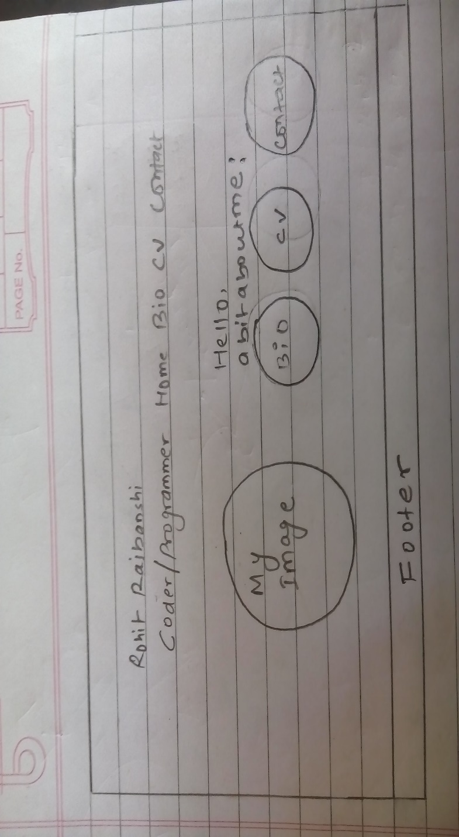

## **Sketch of my bio page**

In this bio page, there will be the same navigation bar and this navigation bar will be used in all the pages. In the section part, I will make two divisions in which the first division will contain my biography while another division will contain a photo of mine. And I will make these two divisions to appear side to side. And below the section part, I will use the same footer as used in the home page containing same features.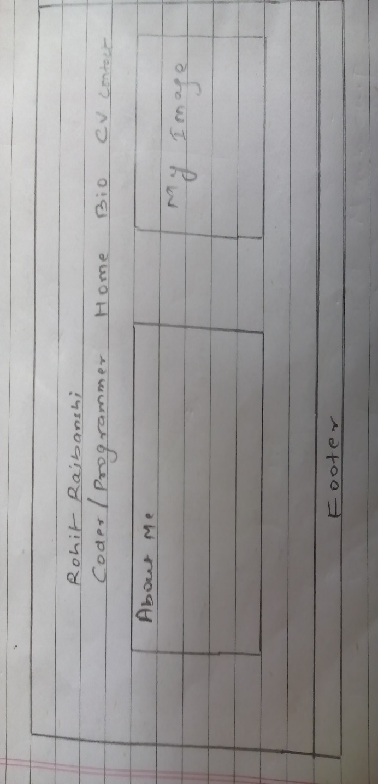

## **Sketch of my cv page**

In this page, there will be a heading and the background color of that heading will be dark gray. I will add one circular image of mine in the middle of the page and the image on hovering will become enlarged. Below the image and heading part, there I will insert all the details related to my CV.

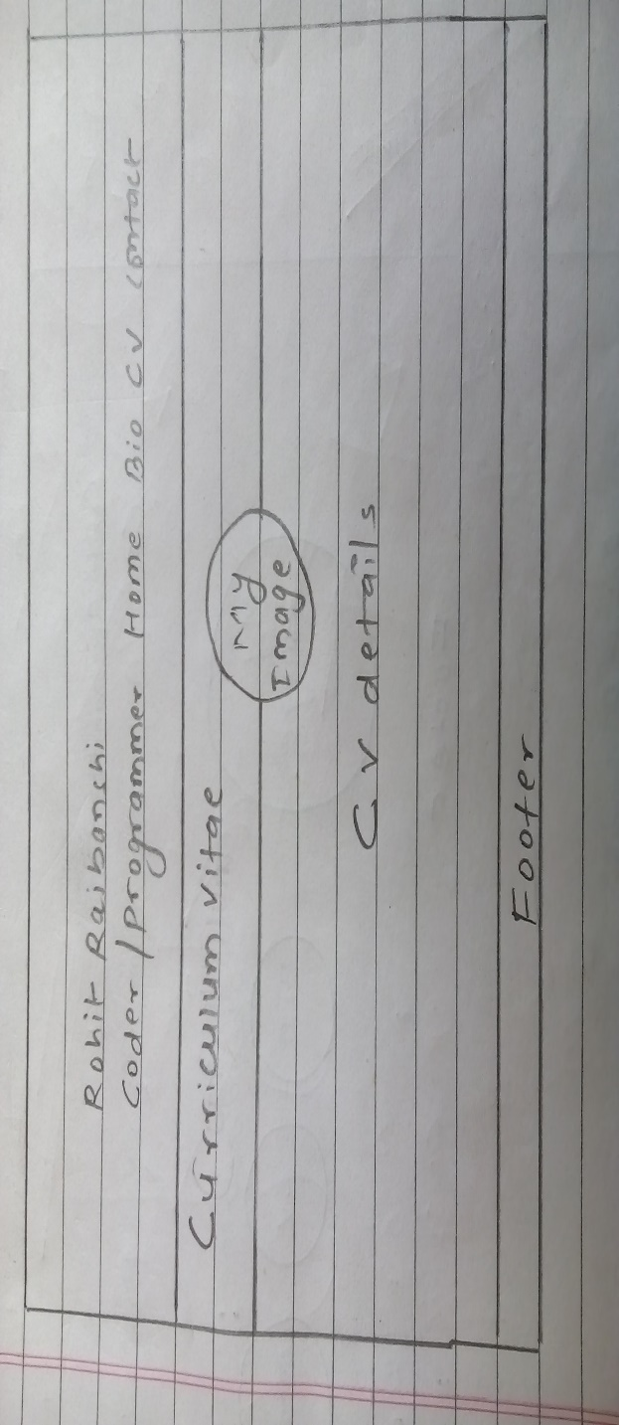

## **Sketch of my contact page**

This contact page will simply contain a contact form so that users can send me feedback via this form. The contact form will be in a bit right side of the page. The field part of the form will be blue in color and on focusing the field, the color will change from blue to green. And also, the submit button will contain some animation effects. On clicking the submit button, the box shadow will increase and the button will also shift few pixels down.

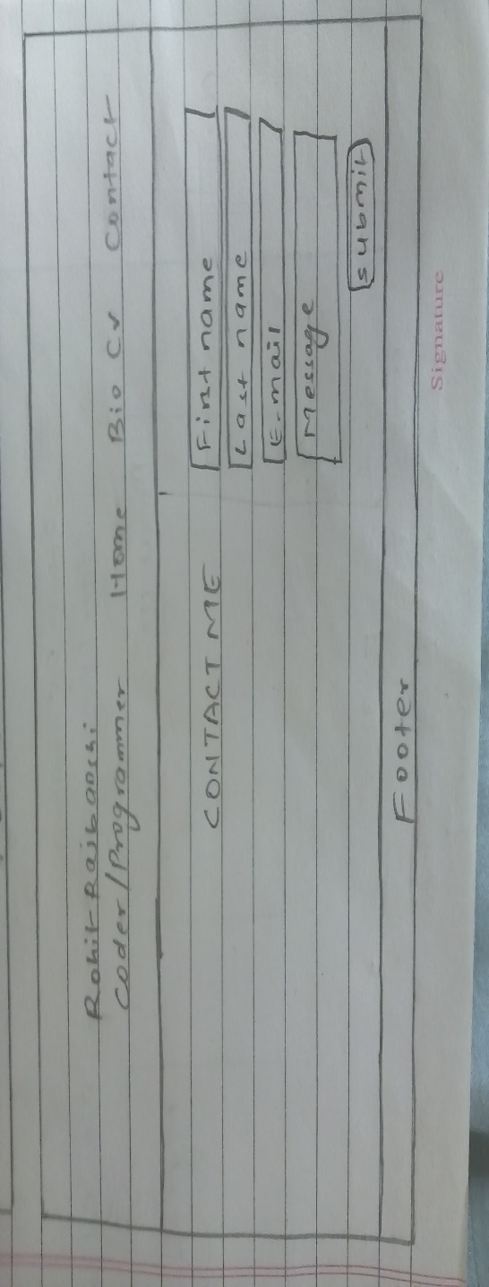

# **Evidence of how I have used Models of Good Practice**

## **Page Loading Speed**

As we all know that speed is one of the important thing while surfing on the internet. So, one of the models of good practice is to make the website load faster. This website has been tested in pingdom.com and the outcomes are given below. The loading speed of my webpage is 643ms which is faster than 95% of other tested websites. By reducing the size of images that I have used can help the website load much faster.

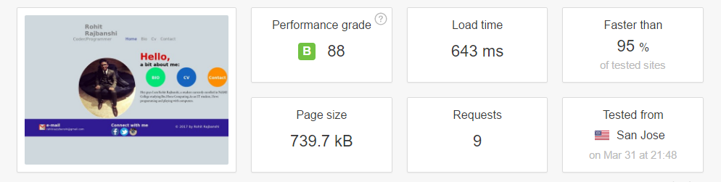

Pingdom.com (2017)

## 

## **Visual appeal**

While creating this webpage, I also looked many of the other portfolio pages and found what contents can make the people to like the webpage. I have used user friendly colors and simple good looking animations in my webpage so that user will like my webpage. While creating this webpage I also asked for the opinions of my friends so that I could make my webpage look beautiful and to be liked by many of the users.

## **Navigation**

Proper use of navigation system is one of the good practice of web design. Making navigation simple and not using much more complex features helps the users to navigate easily through the other pages. Adding complicated features can make users difficult to navigate which could lead the users to dislike the page. And also keeping the navigation bar on the top will help the users to navigate easily. So, I have made my navigation bar simple and have kept it at the top for easy use of the users.

# **Development of website over the weeks**

## **Week 9**

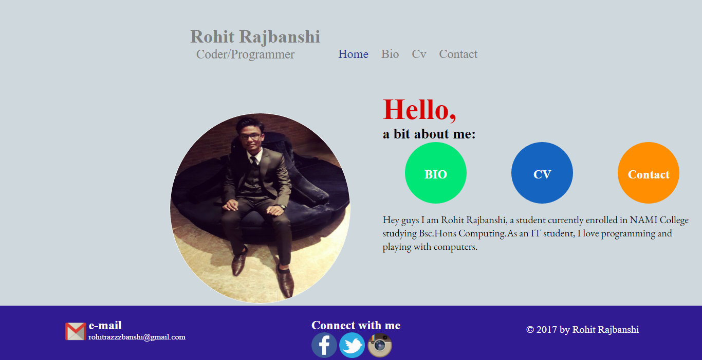

This is the first page that I have made in the 9th week. This is my home page. The three circles i.e. bio, cv and contact are linked to each of my other pages. These circles are initially green, blue and orange in color but on hovering those circles their color will change into the dark form of previous colors. I have also used google fonts.

## **Week 10**

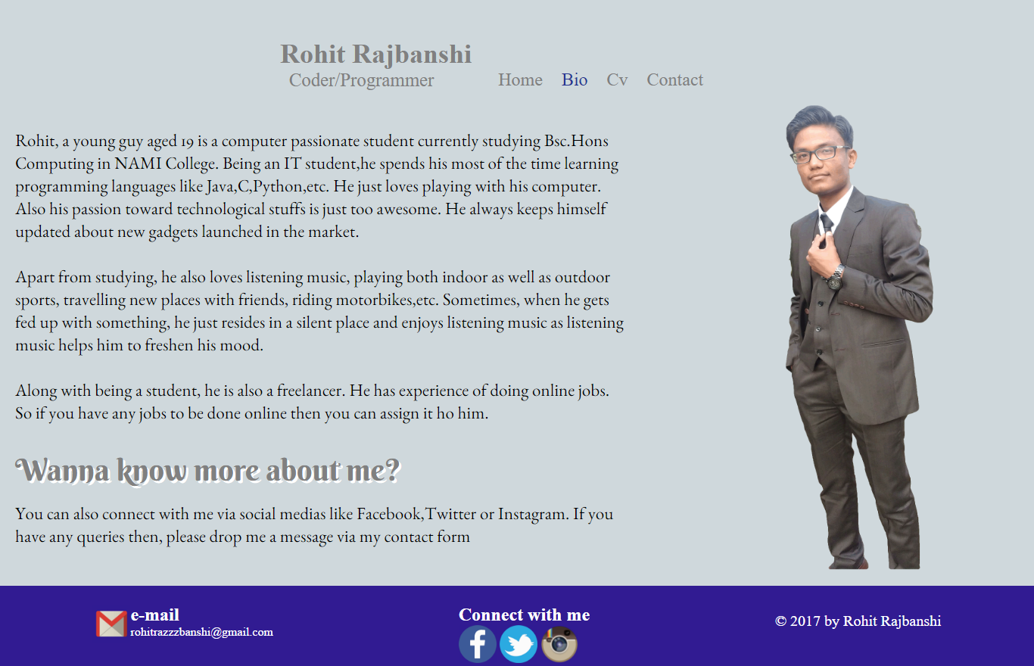

This is the second page that I have created in the 10th week and this is my bio page. As you can see this page contains my biography along with my image in its side. The header and footer is used in all the pages and contains the same functionality. Google font is also used.

## **Week 11**

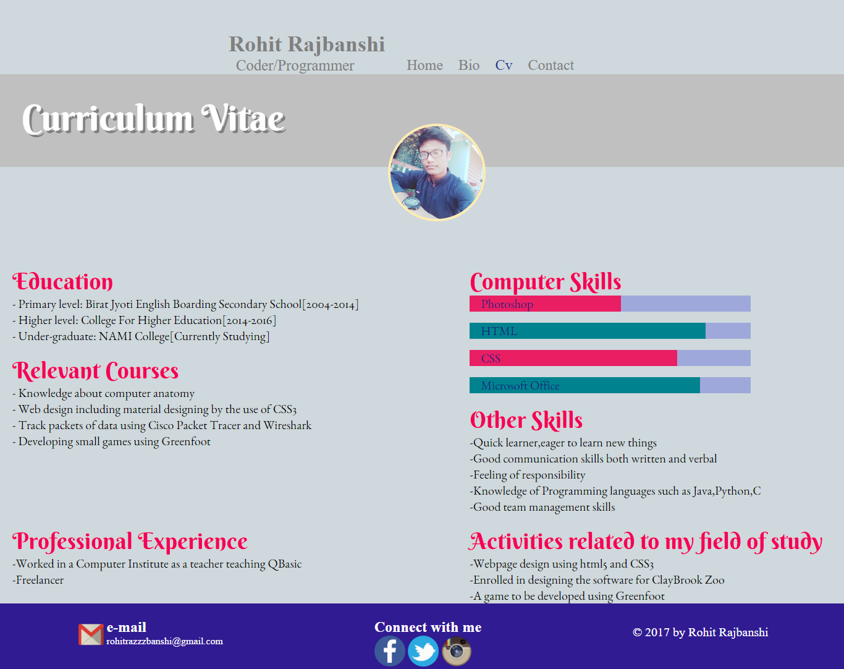

This is the cv page that I have created in the 11th week. There is a heading and I have inserted an image of mine which on hover will be enlarged. Below the heading and image there are the cv details. I have also used google fonts to make the fonts look attractive.

## **Week 12**

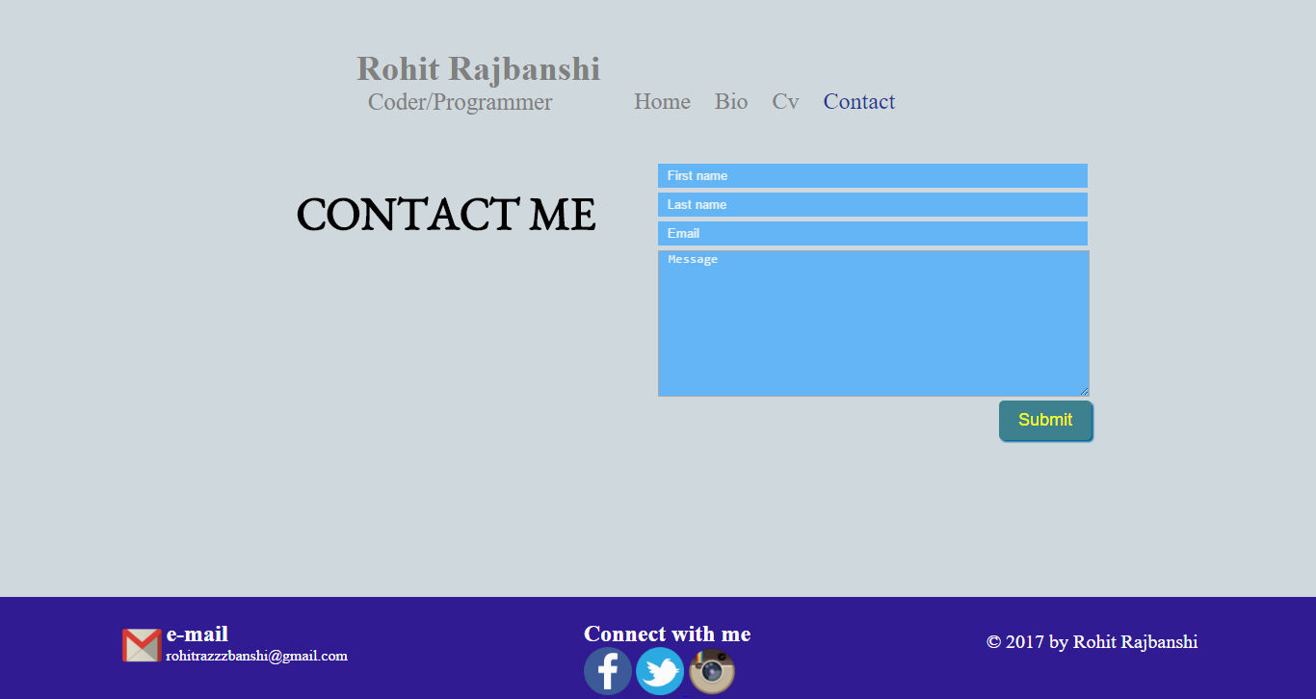

This is the final page i.e. contact page that I have created in the 12th week. This page is simple and it simply contains a contact form via which user can contact me. The fields of the contact form are initially light blue in color but on focusing on specific field the color changes from light blue to green.

# **References**

* Pingdom Website Speed Test. *Website speed test*[online]. Available from: <https://tools.pingdom.com/> [Accessed 03/04/2017].