**Stack Develop**

**• Frontend**

**• Angular & Tailwind CSS**

**• Backend**

**• C# .NET 6 Web API**

**Solution Infrastructure**

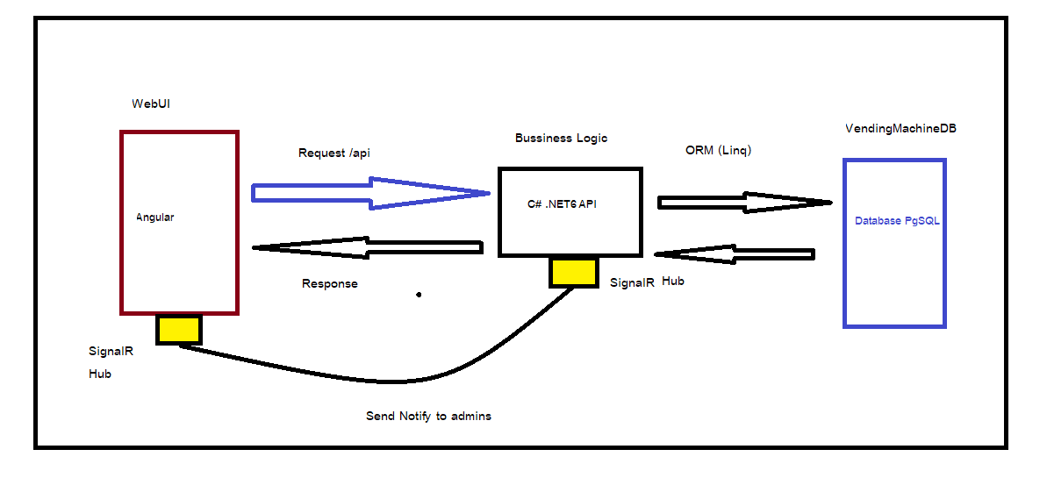

**•** Webui (angular) request to server by rest API for request get all location, machine, Product and Authorization

• C# API connect to Database PgSql by Linq (ORM EF) for manage data provide to webui example query or join

• Database PgSQL is Store data of Users, Admins, Machines or products etc.

• SignalR is read time communication between from server to client by connect Hub when client send update server can send notify to client at client connect on server

**ER-D Diagrams**

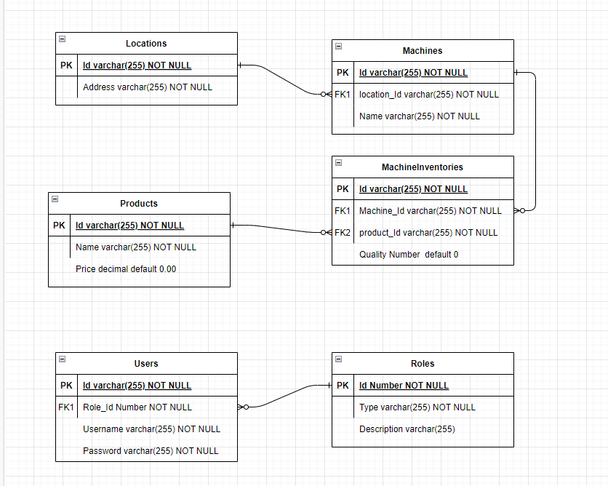 **Application Workflow**

**Use Case 1 : Customer Can buy item on Vending Machine item is decrease**

**• When customer into website display on Categories**

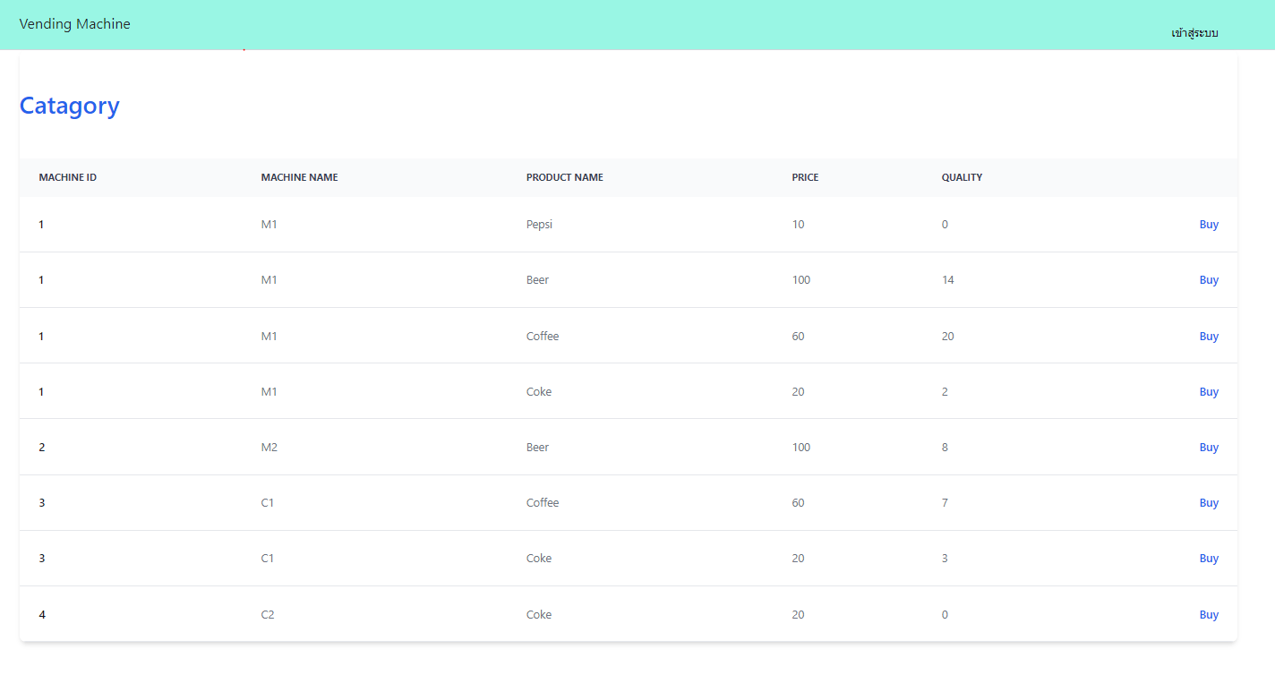

**• Customer click buy, Customer can select quality of item**

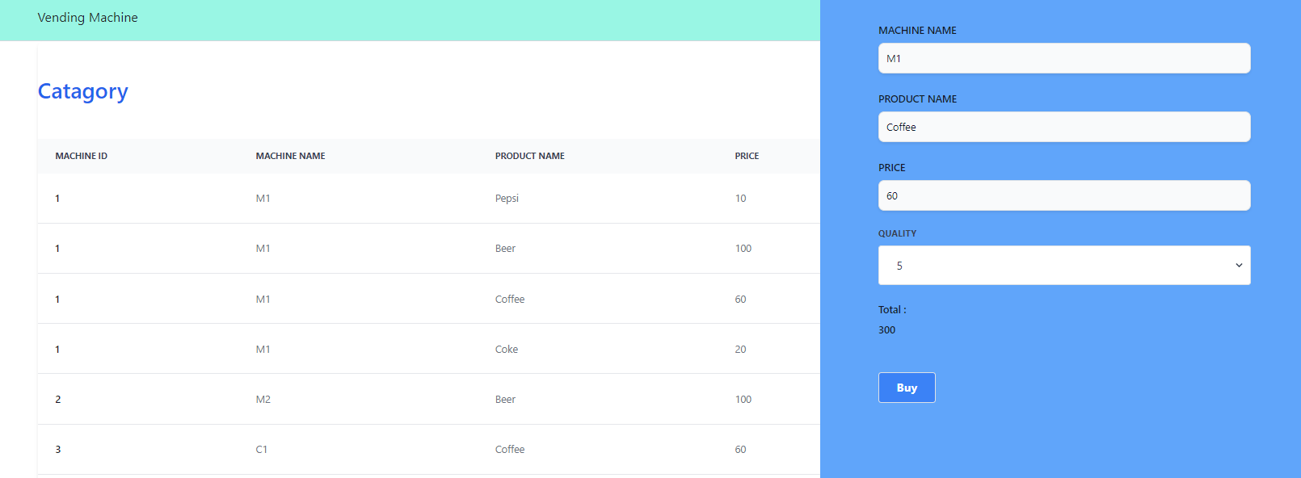

**• Customer click buy if customer isn’t login yet, route to login page**

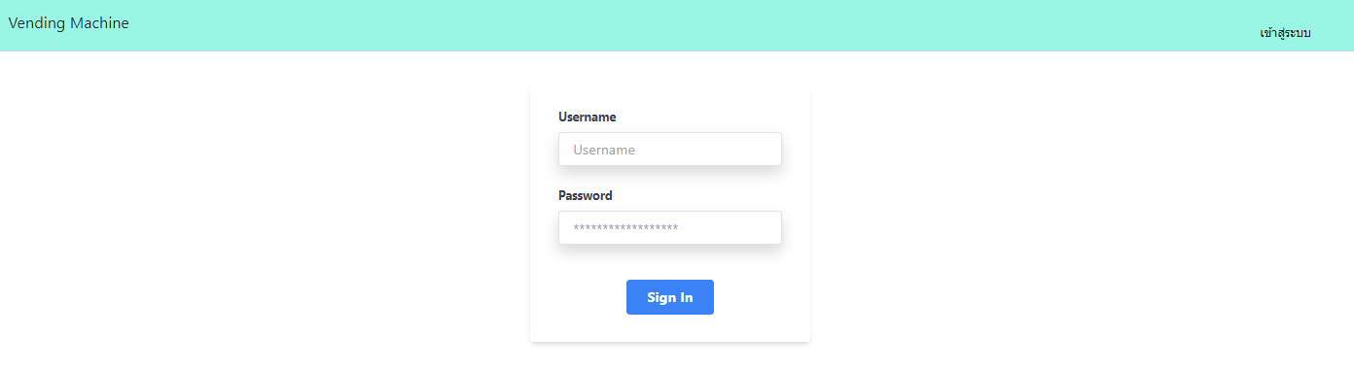

**• When customer Login successful customer can buy item**

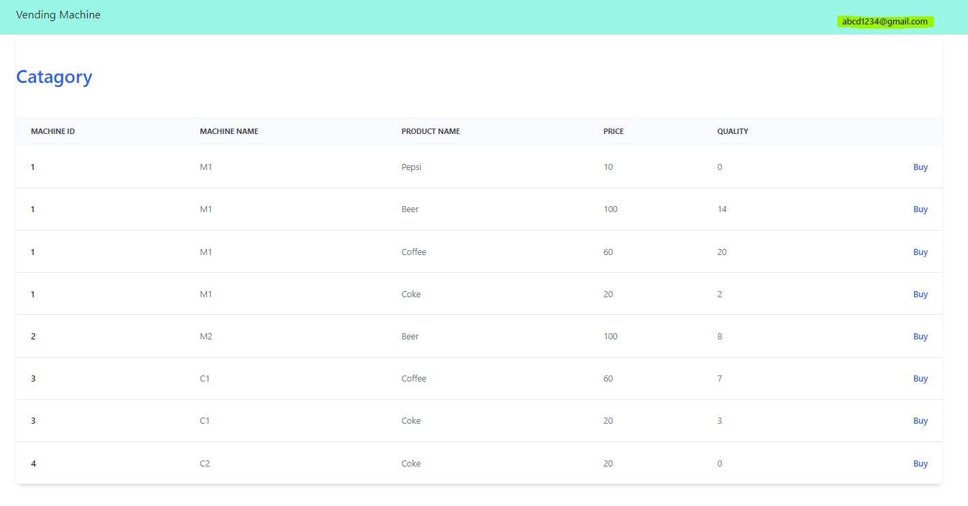 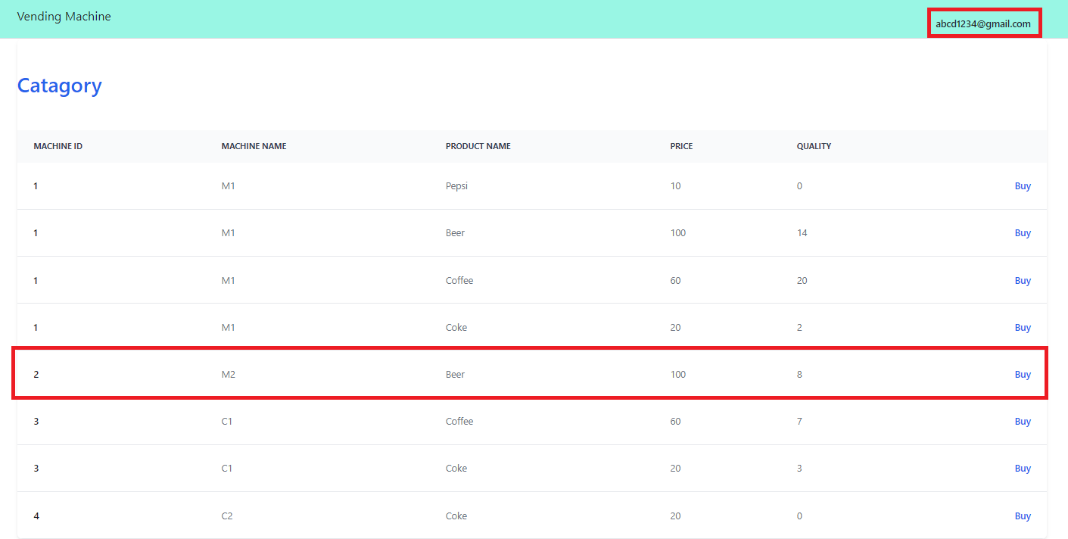

**• Customer buy Beer 4 items, beer is decrease 4**

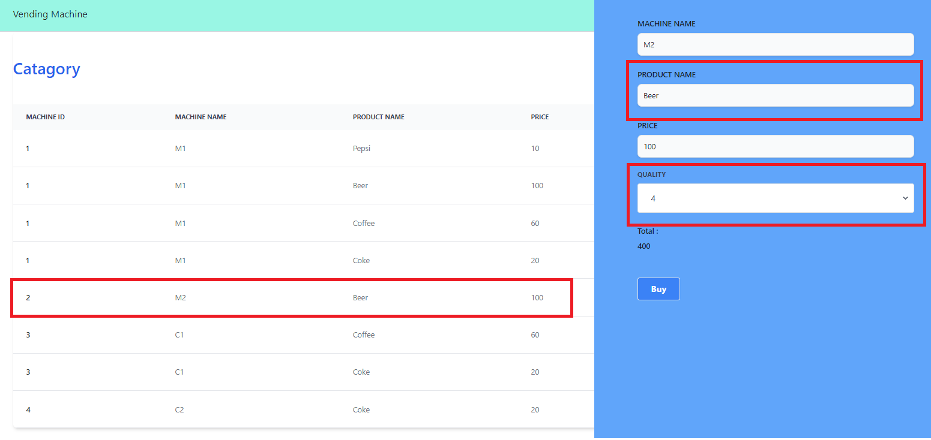

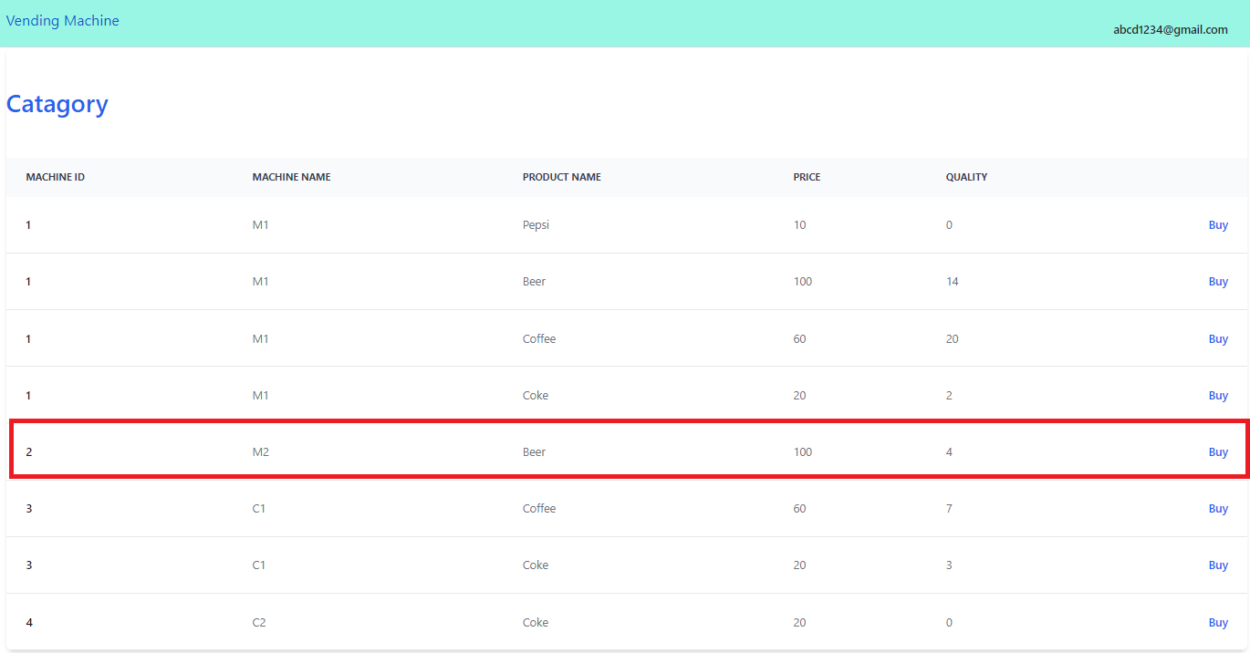

**Use Case 2 : Admin can know all location of machines**

**• When admin login will menu location display machine**

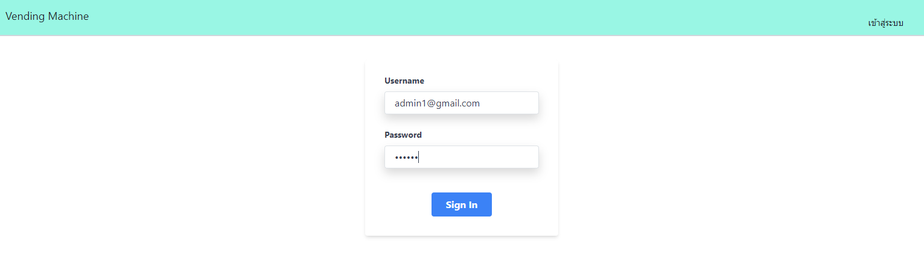

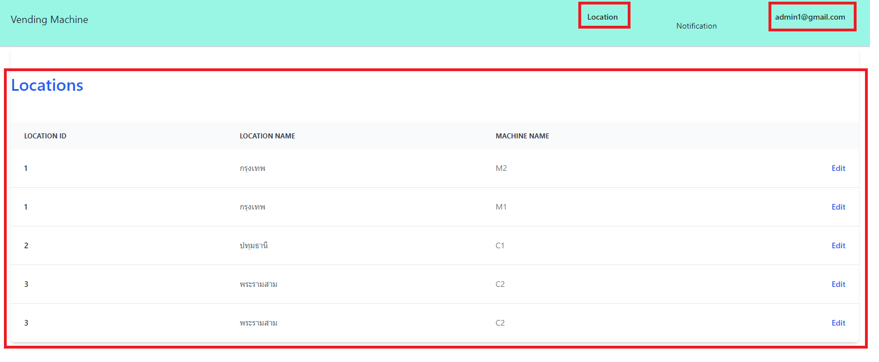

**Use Case 3 : When product decrease then 10 notify to admin**

**• When customer buy item quality than 10 example customer buy coffee 4 items on Machine C1**

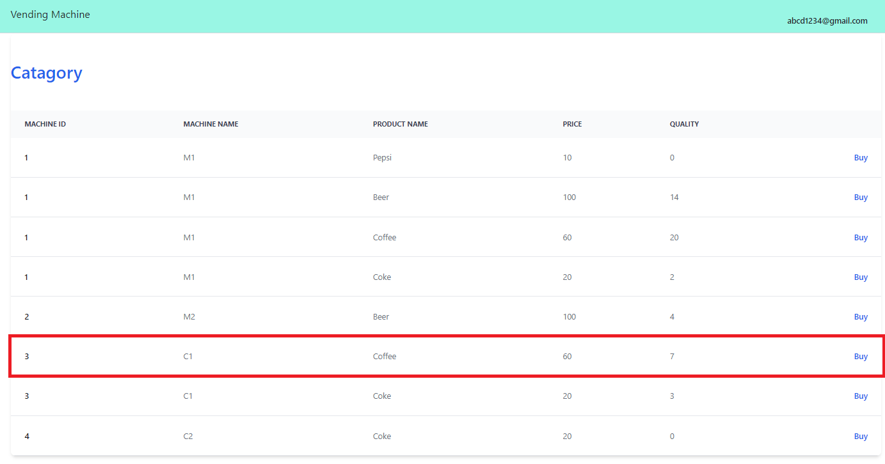

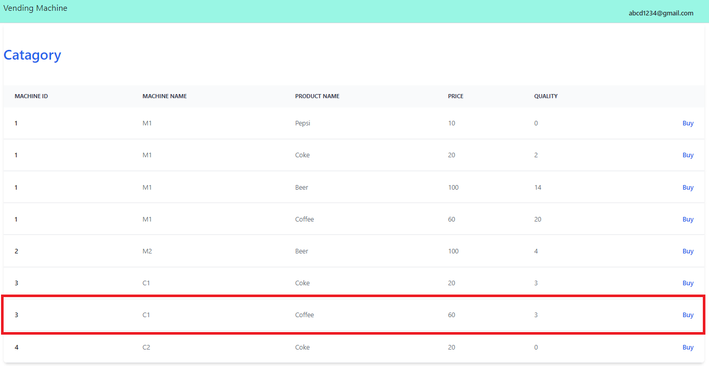

**• Admin pages will notification**

