Technology and Innovation

AI and Coding

Apentomos — Pest Intelligence Platform

Apentomos is an AI-powered agricultural pest surveillance and early warning platform designed for smallholder farmers in India, where over 80% of pre-harvest crop loss is pest-driven and only 5.7% of farmers currently access formal extension services. The platform bridges this critical gap by putting real-time pest diagnostics, outbreak maps, and localized risk forecasts directly into a farmer's mobile browser.
The primary objective is to democratize access to crop protection intelligence — enabling any farmer with a smartphone to photograph a diseased crop and receive an instant diagnosis, severity assessment, and recommended treatment in their own language. The system also aggregates community-submitted reports into a live heatmap, overlays weather data to forecast pest risk, and pushes alerts to keep farming communities ahead of outbreaks.
The working methodology follows a three-layer architecture. On the client side, a Progressive Web App built with Next.js and Tailwind CSS provides a responsive, offline-capable interface across English, Hindi, Marathi, Telugu, and Kannada. The AI layer uses Google Gemini for primary vision-based crop diagnosis, with fallback through Groq's Llama 3.2 90B Vision and a simulated analysis pipeline for resilience. A chatbot named Bob, powered by Groq's Llama 3.3 70B, answers farming queries via text or voice input (browser SpeechRecognition or Groq Whisper transcription). The data layer runs on Supabase (PostgreSQL) for pest reports, user profiles, and notifications, while OpenWeather provides climate data for pest risk modeling that references ICAR-established temperature thresholds for major pests.
Innovation lies in the fusion of multiple AI services into a single coherent pipeline that requires no specialized hardware, no app store installation, and works on low-end devices. The platform shuns cloud lock-in by remaining deployable entirely on free-tier infrastructure — Vercel Hobby for hosting, Supabase free plan for database, and API-based AI services consumed on-demand. Entrepreneurially, the model targets India's 120 million farming households as potential users, with future revenue paths in hyperlocal weather-insurance tie-ups, precision agriculture data licensing, and premium advisory subscriptions.
Expected outcomes include a 2–3 day faster response time to pest outbreaks, 15–25% reduction in crop losses through early detection, and a measurable decrease in indiscriminate pesticide use — the World Bank's Digital Agriculture Study (2022) found that digital pest alerts reduced pesticide application by 34%. Sustainability is embedded in the design: the app runs entirely in the browser (zero device e-waste), uses serverless infrastructure that scales to zero when idle, and promotes Integrated Pest Management principles by recommending targeted treatments only when pest thresholds are crossed.

List of Materials Used
• Next.js 16 — React framework with server-side rendering and static generation
• TypeScript — Type-safe programming language
• Tailwind CSS v4 — Utility-first CSS framework for responsive UI
• Google Gemini API — Primary AI vision analysis for crop pest diagnosis
• Groq API (Llama 3.3 70B, Llama 3.2 90B Vision, Whisper large-v3-turbo) — Chatbot, vision fallback, and voice transcription
• Supabase (PostgreSQL) — Database, authentication, file storage
• Leaflet + react-leaflet — Interactive outbreak heatmap
• OpenWeather API — Real-time temperature data for pest risk modeling
• Resend — Email notification delivery
• SerpAPI — Real-time pest control product pricing lookups
• GSAP — Splash screen and scroll animations
• Recharts — Outbreak trend charts on dashboard
• Lucide React — User interface icon set
• Web Push API — Browser push notifications
• Zod — Form and API input validation
• Zustand — Client-side state management
• Vercel — Serverless deployment and hosting
• PWA (Service Worker + Web App Manifest) — Offline support and installable app

Screenshots

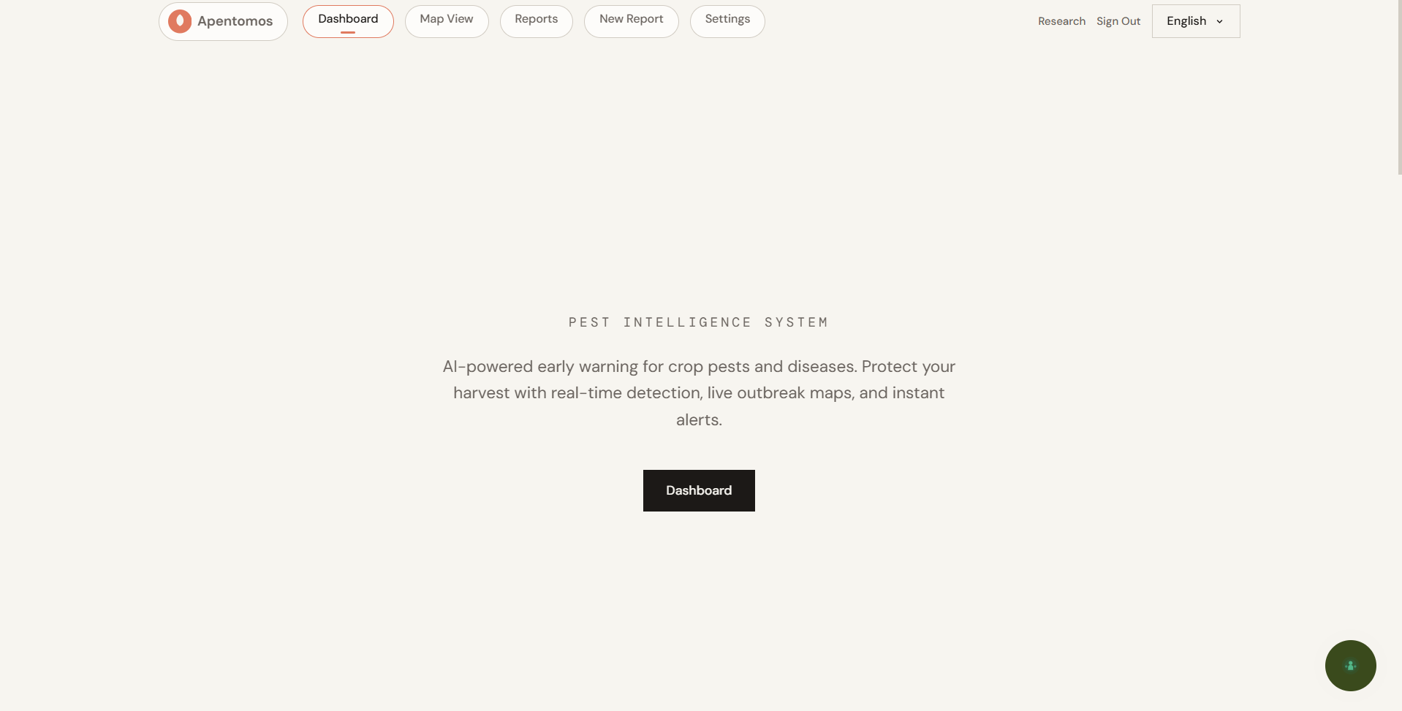
Landing Page
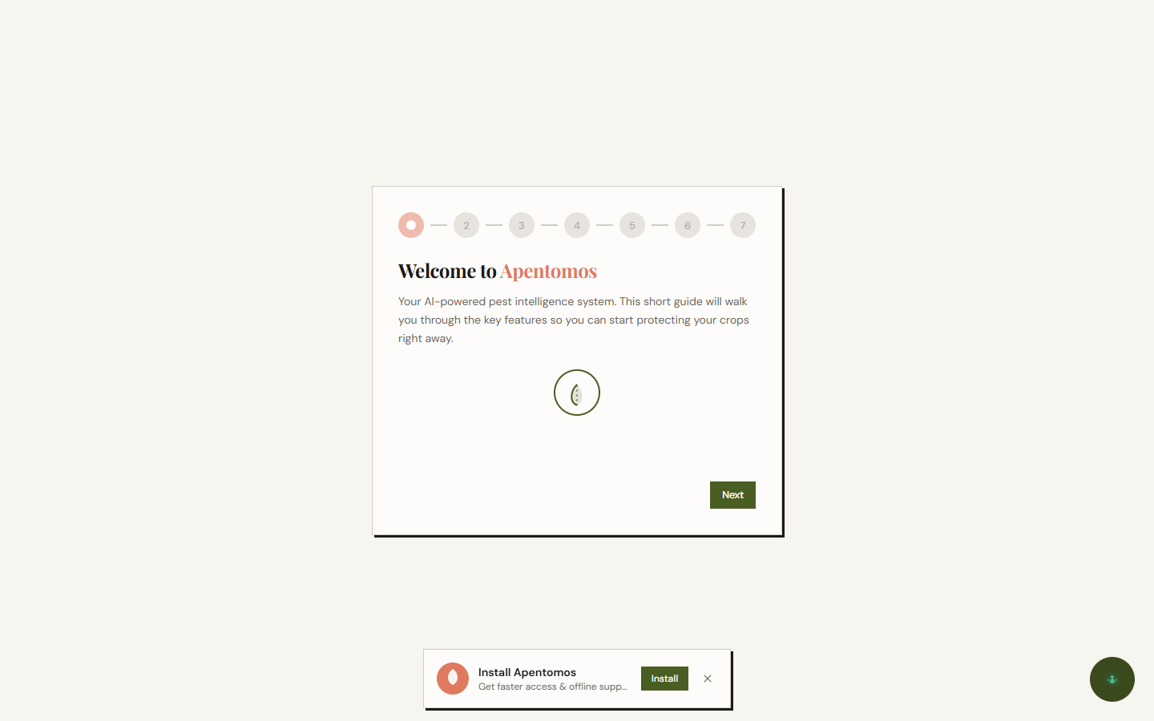
Onboarding
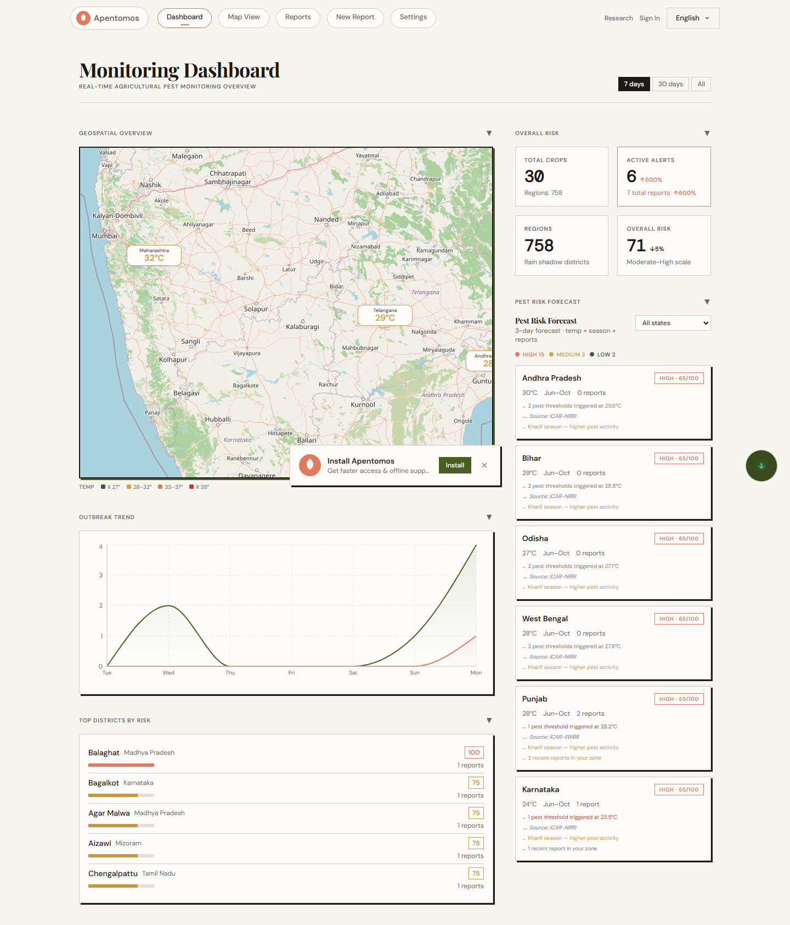
Dashboard
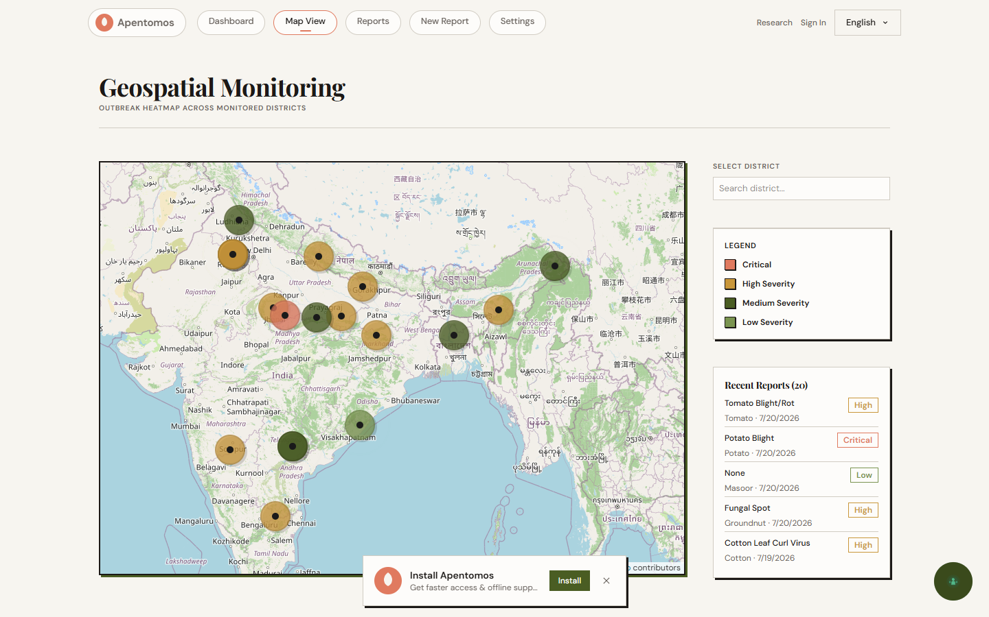
Outbreak Heatmap
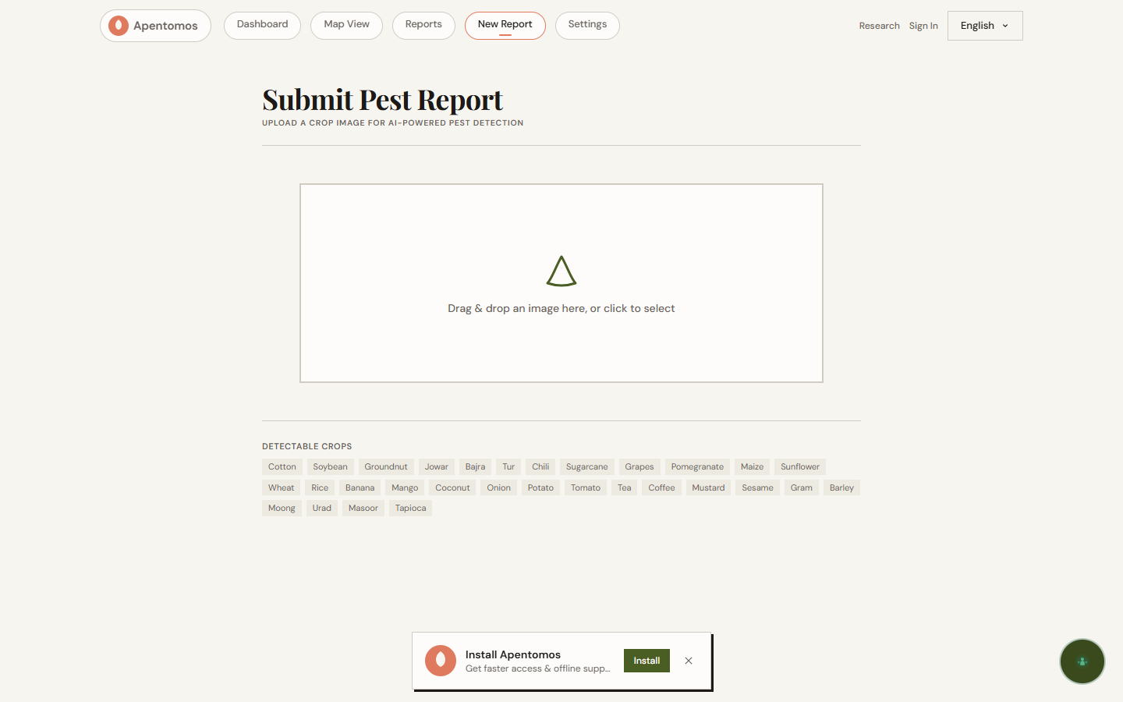
Upload & Analyze
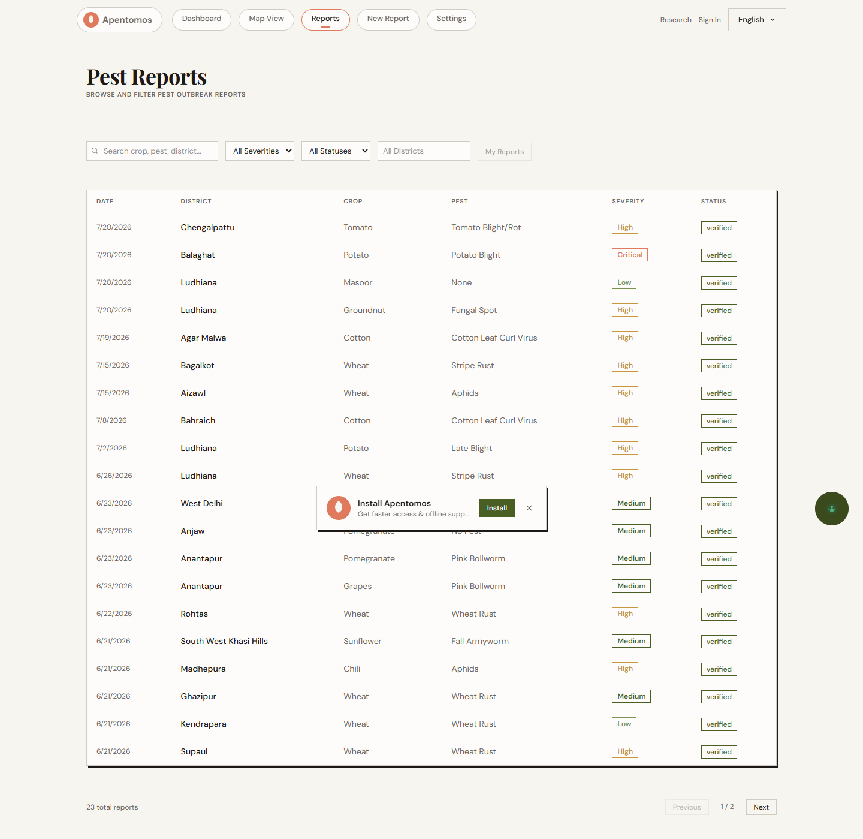
Community Reports
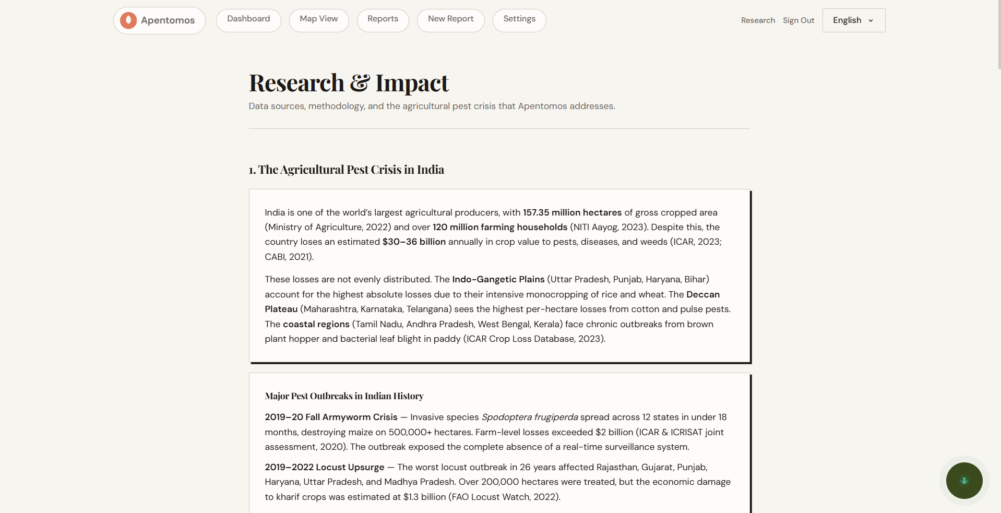
Research & Impact

