  Volume 9, Issue 3 (I) |  | ISSN: 2394 – 7780
July - September 2022

International Journal of
Advance and Innovative Research

Indian Academicians and Researchers Association

www.iaraedu.com
International Journal of Advance and Innovative Research

Volume 9, Issue 3 (I): July - September, 2022

Editor- In-Chief | Dr. Tazyn Rahman
Members of Editorial Advisory Board
Mr. Nakibur Rahman | Dr. Mukesh Saxena
Ex. General Manager ( Project ) | Pro Vice Chancellor,
Bongaigoan Refinery, IOC Ltd, Assam | University of Technology and Management, Shillong
Dr. Alka Agarwal | Dr. Archana A. Ghatule
Director, | Director,
Mewar Institute of Management, Ghaziabad | SKN Sinhgad Business School, Pandharpur
Prof. (Dr.) Sudhansu Ranjan Mohapatra | Prof. (Dr.) Monoj Kumar Chowdhury
Dean, Faculty of Law, | Professor, Department of Business Administration,
Sambalpur University, Sambalpur | Guahati University, Guwahati
Dr. P. Malyadri | Prof. (Dr.) Baljeet Singh Hothi
Principal, | Professor,
Government Degree College, Hyderabad | Gitarattan International Business School, Delhi
Prof. (Dr.) Shareef Hoque | Prof. (Dr.) Badiuddin Ahmed
Professor, | Professor & Head, Department of Commerce,
North South University, Bangladesh | Maulana Azad Nationl Urdu University, Hyderabad
Prof.(Dr.) Michael J. Riordan | Dr. Anindita Sharma
Professor, | Dean & Associate Professor,
Sanda University, Jiashan, China | Jaipuria School of Business, Indirapuram, Ghaziabad
Prof.(Dr.) James Steve | Prof. (Dr.) Jose Vargas Hernandez
Professor, | Research Professor,
Fresno Pacific University, California, USA | University of Guadalajara,Jalisco, México
Prof.(Dr.) Chris Wilson | Prof. (Dr.) P. Madhu Sudana Rao
Professor, | Professor,
Curtin University, Singapore | Mekelle University, Mekelle, Ethiopia
Prof. (Dr.) Amer A. Taqa | Prof. (Dr.) Himanshu Pandey
Professor, DBS Department, | Professor, Department of Mathematics and Statistics
University of Mosul, Iraq | Gorakhpur University, Gorakhpur
Dr. Nurul Fadly Habidin | Prof. (Dr.) Agbo Johnson Madaki
Faculty of Management and Economics, | Faculty, Faculty of Law,
Universiti Pendidikan Sultan Idris, Malaysia | Catholic University of Eastern Africa, Nairobi, Kenya
Dr. Neetu Singh | Prof. (Dr.) D. Durga Bhavani
HOD, Department of Biotechnology, | Professor,
Mewar Institute, Vasundhara, Ghaziabad | CVR College of Engineering, Hyderabad, Telangana

Prof. (Dr.) Shashi Singhal

Professor,
Amity University, Jaipur

Prof. (Dr.) Aradhna Yadav

Professor,
Krupanidhi School of Management, Bengaluru

Prof. (Dr.) Alireza Heidari

Professor, Faculty of Chemistry,
California South University, California, USA

Prof.(Dr.) Robert Allen

Professor
Carnegie Mellon University, Australia

Prof. (Dr.) A. Mahadevan

Professor
S. G. School of Business Management, Salem

Prof. (Dr.) S. Nallusamy

Professor & Dean,
Dr. M.G.R. Educational & Research Institute,Chennai

Prof. (Dr.) Hemant Sharma

Professor,
Amity University, Haryana

Prof. (Dr.) Ravi Kumar Bommisetti

Professor,
Amrita Sai Institute of Science & Technology, Paritala

Dr. C. Shalini Kumar

Principal,
Vidhya Sagar Women’s College, Chengalpet

Dr. Syed Mehartaj Begum

Professor,
Hamdard University, New Delhi

Prof. (Dr.) Badar Alam Iqbal

Adjunct Professor,
Monarch University, Switzerland

Dr. Darshana Narayanan

Head of Research,
Pymetrics, New York, USA

Prof.(Dr.) D. Madan Mohan

Professor,
Indur PG College of MBA, Bodhan, Nizamabad

Dr. Rosemary Ekechukwu

Associate Dean,
University of Port Harcourt, Nigeria

Dr. Sandeep Kumar Sahratia

Professor
Sreyas Institute of Engineering & Technology

Dr. P.V. Praveen Sundar

Director,
Shanmuga Industries Arts and Science College

Dr. S. Balamurugan Director - Research & Development, Mindnotix Technologies, Coimbatore

Dr. Manoj P. K.

Associate Professor,
Cochin University of Science and Technology

Dr. Dhananjay Prabhakar Awasarikar

Associate Professor,
Suryadutta Institute, Pune

Dr. Indu Santosh

Associate Professor,
Dr. C. V.Raman University, Chhattisgath

Dr. Mohammad Younis

Associate Professor,

Dr. Pranjal Sharma

Associate Professor, Department of Management

King Abdullah University, Saudi Arabia
Mile Stone Institute of Higher Management, Ghaziabad

Dr. Kavita Gidwani

Associate Professor,
Chanakya Technical Campus, Jaipur

Dr. Lalata K Pani

Reader,
Bhadrak Autonomous College, Bhadrak, Odisha

Dr. Vijit Chaturvedi

Associate Professor,
Amity University, Noida

Dr. Pradeepta Kishore Sahoo

Associate Professor,
B.S.A, Institute of Law, Faridabad

Dr. Marwan Mustafa Shammot

Associate Professor,
King Saud University, Saudi Arabia

Dr. R. Navaneeth Krishnan

Associate Professor, Bharathiyan College of Engg &
Tech, Puducherry

Dr. Mahendra Daiya | Dr. G. Valarmathi
Associate Professor, | Associate Professor,
JIET Group of Institutions, Jodhpur | Vidhya Sagar Women's College, Chengalpet
Dr. Parbin Sultana | Dr. M. I. Qadir
Associate Professor, | Assistant Professor,
University of Science & Technology Meghalaya | Bahauddin Zakariya University, Pakistan
Dr. Kalpesh T. Patel | Dr. Brijesh H. Joshi
Principal (In-charge) | Principal (In-charge)
Shree G. N. Patel Commerce College, Nanikadi | B. L. Parikh College of BBA, Palanpur
Dr. Juhab Hussain | Dr. Namita Dixit
Assistant Professor, | Assistant Professor,
King Abdulaziz University, Saudi Arabia | ITS Institute of Management, Ghaziabad
Dr. V. Tulasi Das | Dr. Nidhi Agrawal
Assistant Professor, | Associate Professor,
Acharya Nagarjuna University, Guntur, A.P. | Institute of Technology & Science, Ghaziabad
Dr. Urmila Yadav | Dr. Ashutosh Pandey
Assistant Professor, | Assistant Professor,
Sharda University, Greater Noida | Lovely Professional University, Punjab
Dr. M. Kanagarathinam | Dr. Subha Ganguly
Head, Department of Commerce | Scientist (Food Microbiology)
Nehru Arts and Science College, Coimbatore | West Bengal University of A. & F Sciences, Kolkata
Dr. V. Ananthaswamy | Dr. R. Suresh
Assistant Professor | Assistant Professor, Department of Management
The Madura College (Autonomous), Madurai | Mahatma Gandhi University
Dr. S. R. Boselin Prabhu | Dr. V. Subba Reddy
Assistant Professor, | Assistant Professor,
SVS College of Engineering, Coimbatore | RGM Group of Institutions, Kadapa
Dr. A. Anbu | Dr. R. Jayanthi
Assistant Professor, | Assistant Professor,
Achariya College of Education, Puducherry | Vidhya Sagar Women's College, Chengalpattu
Dr. C. Sankar | Dr. Manisha Gupta
Assistant Professor, | Assistant Professor,
VLB Janakiammal College of Arts and Science | Jagannath International Management School

Copyright @ 2022 Indian Academicians and Researchers Association, Guwahati All rights reserved.

No part of this publication may be reproduced or transmitted in any form or by any means, or stored in any retrieval system of any nature without prior written permission. Application for permission for other use of copyright material including permission to reproduce extracts in other published works shall be made to the publishers. Full acknowledgment of author, publishers and source must be given.

The views expressed in the articles are those of the contributors and not necessarily of the Editorial Board or the IARA. Although every care has been taken to avoid errors or omissions, this publication is being published on the condition and understanding that information given in this journal is merely for reference and must not be taken as having authority of or binding in any way on the authors, editors and publishers, who do not owe any responsibility for any damage or loss to any person, for the result of any action taken on the basis of this work. All disputes are subject to Guwahati jurisdiction only.
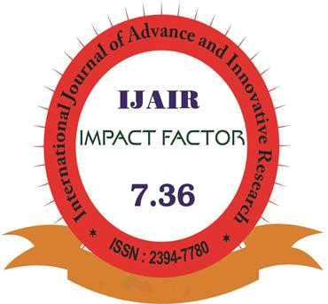

The International Journal of Advance and Innovative Research is an online open access, peer reviewed & refereed journal.
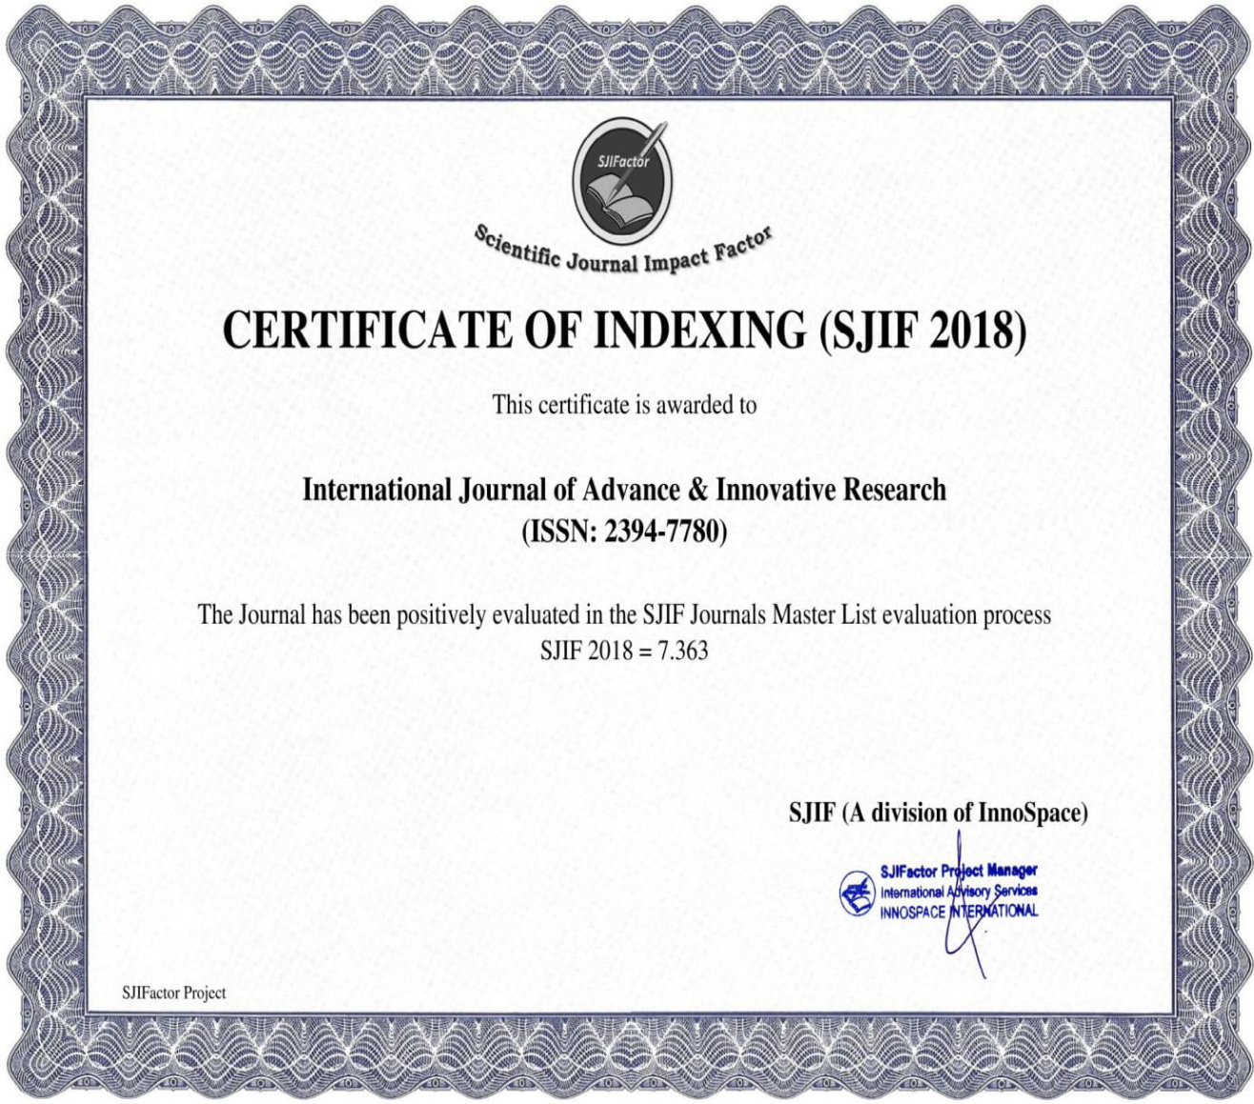
International Journal of Advance and Innovative Research | ISSN 2394 - 7780
Volume 9, Issue 3 (I): July - September, 2022 | ISSN 2394 - 7780


INTEGRATION OF IOT AND BLOCKCHAIN IN AGRICULTURE ECOSYSTEMS: A REVIEW

Oyelowo, Timothy Olaniran, Oduroye, Ayorinde P*
Computer Science Department, Caleb University, Imota, Lagos

ABSTRACT

Internet of Things (IoT) and Blockchain is an area of information and communication technology (ICT) that can impact modern agricultural processes, methods and practices. The integration of IoT and Blockchain is revolutionizing the production, processing, transportation, and delivery of agricultural products and food to end consumers. Internet of Things (IoT) involves interconnection of different heterogeneous devices that are linked together with diverse technologies generating big data which are processed and analyze for timely decision making. A lot of research work has been done on IoT in different domains including agriculture but research work on blockchain in Agriculture had been few until recent time. Blockchain is an emerging field of study that cut across a broad range of domains and applications outside of cryptocurrencies. It’s already making big impact in domains such as finance, healthcare, industries etc. When IoT is combined with Blockchain in Agriculture the transformative power of Blockchain could revolutionize entire agriculture value chain from production to end consumers. This paper reviewed IoT and Blockchain integration on agriculture and suggest how this emerging technology combo can be leveraged to improve agricultural production and build trust and transparency in the entire agriculture value chain. The contribution of this paper is to improve agriculture value chain right from production to end consumers. This paper will also inspire more research work on IoT and Blockchain integration in Agriculture ecosystems for improved production, monitoring, food quality and safety as well as benefits to farmers and consumers.

Keywords: Internet of Things (IoT), Blockchain, Smart Agriculture, Supply chain, Ecosystem, Traceability

INTRODUCTION

IoT is defined as a network of networks, in which, typically, a massive number of objects, things, sensors, devices are connected through the information and communications infrastructure to provide value added services (Perera et al., 2015). IoT is a major technological revolution in information and communication technology with updated infrastructure and networks where all the connected devices are able to identify and communicate with each other (Singh D et al, 2014).

The focus of IoT in agriculture and farming is on automation of all the aspects of farming and agricultural methods to make the process more efficient and effective (Madushanki et al., 2019). IoT enables the vision of smart agriculture through real time data gathering, analyzing, processing, and allowing the improvement of overall farm management while helping the farmers to make more informed decisions (Mohammad et.al, 2022). IoT may aid farmers in gathering information about soil moisture, temperature, received sunshine, and other related parameters. (Gubbi et al., 2013).

Blockchain technology is an online platform which tracks and records transactions chronologically via distributed registers (shared ledgers). Transactions in the network may include such as receiving and sending cash payments for services and products, making reservations, booking hotel rooms or flights, signing contracts, and so on. In addition, blockchain technology allows you to track asset ownership if you lease it to a third party. In short valuable things can be leased, recorded, exchanged and tracked on the blockchain platform and their duplicate transactions records are shared at the same participating agent’s time with in the network (Alphand et al., 2018). Blockchain is the evolutionary next step for smart agriculture. This technology has great potential for smart farming and allows data sharing, more transparent, safe and effective for smart farming (Sabir Hussain et al, 2020).

The integration of blockchain technology with IoT is another important contribution predicted to revolutionize the digital transformation of various domains (Makhdoom et al., 2018). Blockchain as a distributed ledger can be verified and deployed across several heterogeneous IoT networks. Integration of blockchain technology with IoT is another significant contribution to the digital transformation of various domains. By integrating with IoT, blockchain is projected to add $176 billion to the global economy by 2025 and $3 trillion by 2030 (Panarello et al., 2018).

This paper is structured into four sections. Section one is on background, section two is on methodology while section three is on IoT and Blockchain Integration in Agriculture review and section four is on Discussion and conclusion.

336

International Journal of Advance and Innovative Research | ISSN 2394 - 7780
Volume 9, Issue 3 (I): July - September, 2022 | ISSN 2394 - 7780

1. BACKGROUND

The world population projection of 9 billion by 2050 will require raising overall food production by 70% by 2050 and production in the developing countries will need to almost double (FAO, 2009). To meet this expected demand, agricultural products will require concerted effort that will improve efficiency in Agricultural process and methods leading to increase productivity in the entire agricultural chain.

Climate change has negatively impacted the agriculture eco-system causing heavy rains, droughts, floods, and abrupt weather conditions. These changes are creating threats to agriculture-related food security in the developing as well as the developed world. The climates related challenges faced by agriculture can be overcome by adopting smart agriculture using IoT devices, which can increase agriculture productions. (Khalid et al, 2020).

Covid-19 impact on agriculture too cannot be under estimated causing worldwide intermittent shortage of farm products. Agronomic producers also face growing concerns of the high cost of management, limited ability of crop monitoring, pressures to minimize environmental impact. (Wei Zhao et al, 2020). A potential solution to mitigate some of the issues are autonomous agricultural systems. These systems are hoped to reduce labor issues for the most dangerous and tedious agronomic tasks, improve efficiency, and reduce environmental impacts through better utilization of crop inputs. (Wei Zhao et al, 2020)

An estimated 690 million people are undernourished in 2019 which is about 60 million more than 2014. While most of the undernourished people live in Asia, Africa has the highest prevalence of undernourishment. (FAO, 2020). The implication of this is that to reduce undernourishment in Africa there is need to leverage on the capabilities of IoT to improved Agricultural production.

As IoT and Blockchain will continue to play a very big role in the entire agriculture ecosystem and value chain from production to end consumers we need to be asking the following questions:

How is IoT and Blockchain integration impacting agriculture ecosystems

How can we leverage on this impact in our agriculture value chain in Nigeria

How do rural farmers in Nigeria benefit from IoT Blockchain integration

What are the IoT and Blockchain integration challenges in Agriculture

How do we manage IoT and blockchain integration challenges

How do we use IoT and Blockchain integration to build transparency and trust in our Agriculture value chain

2. METHODOLOGY

In order to answer the questions raised in this review, over twenty journals and articles were sourced from different websites. These articles were mainly on Internet of Things (IoT) and Blockchain, IoT and Blockchain in Smart Agriculture, IoT and Block Chain in Agriculture Supply chain, Blockchain and IoT based food Traceability etc. The journals were critically reviewed to understand the concept of IoT and Blockchain, IoT and Blockchain integration in agriculture and supply chain with their various challenges and opportunities.

2.1 Internet of Things (Iot)

The Internet of Things (IoT) is a cutting-edge computing and networking technology that reflects the future. IoT systems are complex system consisting of devices, gateways, mobile technologies, appliances, web services, datastore, data analytics and many more depending on the type of IoT application. (Russell, 2016). IoT is defined as a network of networks, in which, typically, a massive number of objects, things, sensors, devices are connected through the information and communications infrastructure to provide value added services (Perera et al., 2015). The Internet of Things (IoT)has the potential to link billions of devices (smart objects). These smart

objects can gather data and interact with other systems over the internet. IoT has evolved into a next generation technology with several agricultural applications (S. Nižetić et al., 2020).

2.2 Internet of Things (Iot) in Smart Agriculture

IoT is rapidly transforming agricultural ecosystem providing opportunities for precision farming, smart irrigation, livestock management, agriculture environment monitoring, smart Green house, better food quality and safety. Introduction of new innovative IoT solutions and technologies are shaping agricultural production with increase efficiency leading to increase yield, better quality output, cost effectiveness and sustainable environment. IoT application in agriculture depend on the use of sensors to generate big data on the agricultural environment. It discovers, analyses and deals with models built upon big data to make the development of agriculture more sustainable. (Dolci, 2017).

337

International Journal of Advance and Innovative Research | ISSN 2394 - 7780
Volume 9, Issue 3 (I): July - September, 2022 | ISSN 2394 - 7780

IoT applications can support farmers during crop planting, irrigation, crop processing, harvesting and postharvest, crop storage and transportation, and many other benefits in agricultural IoT systems. Soil moisture sensors, humidity sensors, leaf moisture sensors, solar radiation sensors, infrared light sensors, and rainfall predictors are among the field sensors used in IoT-based systems. In IoT scenarios, sensors can be installed in a variety of locations, including greenhouses, seed banks, cold rooms, agricultural machinery, transportation systems, and livestock, and the data collected can be processed in the cloud for monitoring and control (Sabir Awan et al., 2021).

2.3 Blockchain Technology

Blockchain is a distributed database where data can be recorded and shared via a decentralized computing network while also providing security and privacy, when the data is spread, only the owner who has the private key can make transactions. The other machines or computers on the network serve as validators. It safely records transactions between nodes in a public ledger without the need for a trusted third party (Pavithran et al., 2020).

2.3.1 Blockchain Process

Blockchain records transactions in block units, and every block includes the hash of the block history, hash of the current block, date, other details, and transactions for the block. When a sender node makes a transaction, it distributes it to the other nodes on the network. The receiving nodes verify the transaction and have proof of work. The node that succeeds in the proof of work will broadcast it to all the other nodes and connect the block to the chain. The transaction shall contain the public key of the recipient and shall be signed by the sender. Therefore, any other node will verify the validity of the transaction. Each block includes a hash of the previous block, which means that each block is connected to each other (Yadav et al., 2020).

Blockchain Distributed Ledger Technology (DLT) is Distributed, Immutable, Time-stamped, Programmable, Secure, Anonymous and Unanimous. These properties of blockchain may be the game changer in the food supply chain and also add accountability to the supply chain system by exchanging accurate data between supply chain stakeholders. Integration of IoT with blockchain will provide the overall visibility of food products across the supply chain. The major advantages of blockchain and IoT in the food supply chain are real-time monitoring and sensing of original food items from the origin which identify major bottlenecks.

2.4. Blockchain in Agriculture and Food Supply Chain

The Blockchain is playing transformative role in agriculture ecosystems such as crop and food production, controlling weather crisis and managing agricultural finances. This is shown in Fig.1. below.
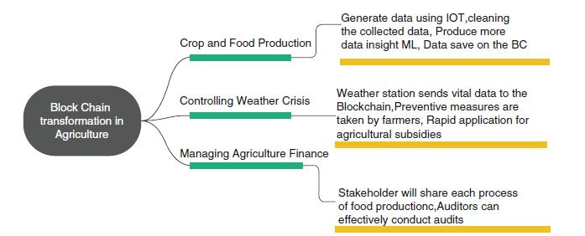

Fig.1. Blockchain Transformation. Source (M. Sandeep Kumar et al., 2021)

In agricultural products and food supply chain, blockchain is providing a digital database that monitors, tracks records, and processes digital and physical resources. Blockchain allows greater traceability and higher quality transactions. Blockchain can manage and integrate all procedures and dealings in real-time across the agricultural supply chain. Every transaction treated in a distributed manner may contain product specific attributes and transactions that will be added by players in the supply chain. The supply chain players can recognize and investigate the association of products along with all stages of the supply chain and zoological technology practices (fertilizers, feed, and veterinary services) (Clauson et al., 2018).

2.5 Iot Integration with the Blockchain

IoT becomes more efficient when it is combined with cloud computing, artificial intelligence, and machine learning (M. Nazari Jahantigh et al. 2020). Integration of blockchain technology with IoT is another significant contribution to the digital transformation of various domains. By integrating with IoT, blockchain it is projected to add $176 billion to the global economy by 2025 and $3 trillion by 2030 (Panarello et al., 2018).

338

International Journal of Advance and Innovative Research | ISSN 2394 - 7780
Volume 9, Issue 3 (I): July - September, 2022 | ISSN 2394 - 7780

The integration of IoT and Blockchain has the capability to fix the problem of food quality and safety by creating a distributed system and eliminating the third party participating in the system at the same time. By building customer confidence, IoT and blockchain technology could eradicate all concerns and fears from customers on food safety and quality. Each product has a digital identity in this framework, which stores information from the point of origin up to the end of the retailer (K. Pal and A.-U.-H. Yasar, 2020).

2.6. Iot and Blockchain Integration Challenges

As IoT and Blockchain integration in Agriculture continue to progress toward stabilization, there are some challenges that needs to be addressed to take full benefit of the combo technology. Some of these challenges according to (Mohamed Torky & Aboul Ella Hassanein, 2020) are:

Privacy And Security Challenges – The P2P design and time stamping-based transactions of blockchain make IoT networks more secure against a lot of attacks but blockchain-based IoT systems and networks still suffer from four major attacks: Denial of Services (DoS) attacks, Sybil Attacks, Eclipse Attacks, and Routing Attacks.

Privacy Preserving - This occurs because all IoT devices and participants are authenticated by their public key or a hash value with the blockchain. The anonymity is not ensured and, since all transactions are shared publicly, there is a likelihood for the attacker to analyze such transactions and infer the real identities of the IoT nodes.

Blockchain Size and Energy Consumption – Blockchain continuous transactions make it to grow rapidly with increase block size leading to larger download times and the need for a larger memory space for mining purposes. A lot of IoT devices storing large volumes of data that are not interesting to them leads to a waste of computational power and resources but this can be addressed by using lightweight blockchain or mini blockchain.

Storage Capacity and Scalability - In the context of IoT-based agricultural applications the scalability limitations are much difficult to address. Blockchain may appear to be not appropriate for IoT models. With IoT communication, IoT nodes can send gigabytes (GBs) of data in real-time. This attribute represents a solid barrier against the blockchain and IoT integration model.

Blockchain Forking - Forking occurs when two peers (i.e. miners) add two right blocks to the chain at the same time. All known blockchain protocols solve the forking problem with a simple rule: The longest chain of blocks is the right one.

Latency and Throughput - Due to developing many topologies of IoT networks, developing blockchain-based IoT networks requires rapid processing for a variety of transaction patterns per time unit. This represents a great challenge in IoT networks regarding throughput.

Multi-chain Management – There may be need for professionals and blockchain engineers to configure more than one blockchain platform for different purposes in an IoT network leading to more security, privacy, scalability, operability, and monitoring problems.

2.7. IOT and Blockchain Integration Opportunities

According to (David, 2019) some of the benefits farmers can derive from mobile blockchain applications include the following:

Cryptocurrency Applications enable farmers to execute payment transactions with crop traders and receive real time remittances.

Electronic Wallet APPs that enable farmer to store and manage their digital assets and money.

Digital crop tracker apps to provide farmers updated information about the trade rates, cryptocurrency-based transactions, crop market dynamics and a portfolio of various agricultural variables.

Retail APPs allowing its Farmer to execute payment transactions through digital currencies

Smart Contracts or self-executable protocols APPs allow the farmer to detect any fraud or illegal operations regarding their digital crops or digital assets

In the area of food safety, according to (Tian, 2006) integrating blockchain with IoT provides the following benefits:

Food tracking and monitoring management.

Reducing the agri-food loses and logistic costs

339

International Journal of Advance and Innovative Research | ISSN 2394 - 7780
Volume 9, Issue 3 (I): July - September, 2022 | ISSN 2394 - 7780

Detecting food fraud and verifying product information.

Protecting agri-food safety information based on integrating RFID technology with blockchain and IoT

Maintaining safety and quality of food products.

3.0. IOT and Blockchain Integration in Agriculture Review

In order to leverage on IoT and Blockchain integration for improved agriculture productivity which is the main focus of this review, five out of the over twenty articles sourced from different websites were selected for review based on the suitability of the topics, quality of the presented work, research contributions, recommendations and excellent writing. The summary of each paper is as follows:

Showkat, Ahmad Bhat et al., (2022). “Agriculture-Food Supply Chain Management Based on Blockchain and IOT: A Narrative on Enterprise Blockchain Interoperability” The study presents Agriculture Supply Chain Management using Blockchain and Internet of things architecture to address the storage and scalability optimization, interoperability, security and privacy issues and also classifying security threats with IoT infrastructure and provide possible available blockchain-based defense mechanisms. For this architecture to be effective it has to be built to use minimum computing power, memory, energy, and bandwidth, resource-efficient, appropriate, simple to implement, provide interoperability, and most importantly, trustworthy without the need for human participation. The limited sensors’ capabilities and security elements which make ensuring Confidentiality, Integrity, and Availability difficult will need to be addressed.

Biswas, Milon et al., (2021). “BIOT: Blockchain based Smart Agriculture with Internet of Thing” The study proposed a model that combines AI, IoT, and Blockchain to develop a smart and futuristic agricultural system that provides farmers with a secure and open transaction approach to rich, new, and effective decision support that can specifically create the scope of greater agricultural process productivity and help farmers maximize their benefits. The model allows farmers to sell their crops to middlemen, agents, or firms in the quickest and most efficient manner possible, with no inconvenience or risk of fraud. This model will need to be subjected to rigorous test with large data set and different scenarios.

Mohamed Torky and Aboul Ella Hassanein (2020). “Integrating blockchain and the internet of things in precision agriculture: Analysis, opportunities, and challenges”. The study proposed a novel blockchain models that can be used as solutions for major challenges in IoT-based precision agricultural systems. With these models, blockchain can be integrated with IoT for mitigating many challenges in internet of farms and crop overseeing, supply chain, food safety, land registration, and financial transaction between farmers with each other or between farmers and agricultural organizations as well as security and performance challenges in IoT based precision agricultural systems. The proposed models will need to be tested and validated before implementation in the agriculture value chain to earn the trust of the farmers.

Sabir, Awan et al., (2021). “IoT with Blockchain: A Futuristic Approach in Agriculture and Food Supply Chain”. This study proposes a futuristic IoT with a blockchain smart model for agriculture and the food supply chain, which offers an innovative way for farmers to acquire information on crops and also address some of the existing issues on IoT-based agriculture systems such as centralized format, data security, manipulation, and single failure points. The study also proposes a novel energy-efficient clustering IoT-based agriculture protocol for lower energy consumption and network stability. Although this model according to the authors provide better result than its counterpart low-energy adoptive clustering hierarchy (LEACH) protocol in terms of network stability, energy consumption and network life, there is need to subject the model to larger dataset and rigorous test and validation.

Lin, Jun et al., (2018). “Blockchain and IoT based Food Traceability for Smart Agriculture.” This study proposed a trusted, self-organized, open and ecological food traceability system based on blockchain and Internet of Things (IoT) technologies, which involves all parties of a smart agriculture ecosystem, even if they may not trust each other. The proposed system uses IoT devices to replace manual recording and verification as many as possible reducing human intervention to the system effectively. The author plan to use the smart contract technology in future to help the law-executor to find problems and process them timely. This need to be tested and validated with large data sets and scenarios.

4.0 DISCUSSION AND CONCLUSION

In this review IoT and Blockchain integration in Agriculture Ecosystem was explore from different authors. The paper was able to examine areas of agriculture ecosystem and food supply chain such as precision farming, crop production, weather monitoring, agricultural finances, agricultural product and food distribution, food quality and safety, agricultural product and food traceability where IoT and Blockchain integration is playing a major

340

International Journal of Advance and Innovative Research | ISSN 2394 - 7780
Volume 9, Issue 3 (I): July - September, 2022 | ISSN 2394 - 7780

role. The review shows that IoT and Blockchain integration in Agriculture ecosystem is still at infancy with some challenges which are being addressed. The opportunities currently offered by IoT and blockchain integration can significantly improve our agriculture if properly applied. IoT and Blockchain integration in Agriculture is still an emerging area and will require continuous attention of researchers in order to address some of the shortcomings of the existing models and fashion out a standard framework that will revolutionize Agriculture ecosystems building trust and transparency from production to final consumers.

In addition to current work in IoT and Blockchain integration, the following suggestion could add to existing body of knowledge in improving Agriculture production with IoT and Block chain integration.

IoT devices are accessible by anyone from anywhere affecting sensitive data, confidentiality and privacy then specific standards or rules must be defined to avoid security and privacy violation.

IoT and Blockchain integration model should use minimum computing power, memory, energy and bandwidth.

IoT and Blockchain integration model should be resource-efficient, appropriate, simple to implement and provide interoperability.

IoT and Block chain model should be transparent, trustworthy without any human intervention.

Specific skills and expertise are critical factors in IoT and Blockchain integration. Lack of skill may slow down the adoption.

Further research will be required in the IoT and Blockchain integration as they continue to be applied to different domains.

REFERENCES

Alphand., Olivier., Michele, Amoretti., Timothy, Claeys., Simone, Dall'Asta., Andrzej, Duda., Gianluigi, Ferrari., Franck, Rousseau., Bernard, Tourancheau., Luca, Veltri., and Francesco, Zanichelli. (2018). "IoTChain: A blockchain security architecture for the Internet of Things." In 2018 IEEE Wireless Communications and Networking Conference (WCNC), pp. 1-6. IEEE, 2018 .

Biswas, Milon., Akhund, Tajim Md. Niamat Ullah., Kar, Susmita., Anis, Adeeba., & Shanto, Sadah Anjum. (2021). BIoT: Blockchain based Smart Agriculture with Internet of Thing

Clauson, K. A., Breeden, E. A., Davidson, C., &. Mackey, T. K. 2018). Leveraging blockchain technology to enhance supply chain management in healthcare: an exploration of challenges and opportunities in the health supply chain,” Blockchain in Healthcare Today, vol. 1, no. 3.

David, R. (2019). New Tool for Mobile App Development in 2019: Blockchain. Available:https:// adtmag.com/articles/2019/01/14/blockchain-mobile.aspx

Dolci, R. (2017). IoT Solutions for Precision Farming and Food Manufacturing: Artificial Intelligence Applications in Digital Food. IEEE 41st Annual Computer Software and Applications Conference (COMPSAC), 2017.

FAO (2009). How to feed the World 2050. Rome, Italy.

FAO (2020). Statistical Yearbook World Food and Agriculture 2020. Rome, Italy.

Gubbi, J., Buyya, R., Marusic, S., & Palaniswami, M. (2013). Internet of things (IoT): A vision, architectural elements, and future directions. Future Generation Computer Systems, vol. 29, no. 7, pp. 1645 – 1660, 2013.

Jahantigh, M. Nazari., Rahmani, A. Masoud., Navimirour, N. Jafari., & Rezaee, A. (2020). Integration of internet of things and cloud computing: a systematic survey. IET Communications, vol. 14, no. 2, pp. 165– 176

Khalid, Haseeb., Ikram, Ud Din., Ahmad, Almogren., & Naveed, Islam. (2020). An Energy E_cient and Secure IoT-Based WSN Framework: An Application to Smart Agriculture. doi:10.3390/s20072081

Lin, Jun., Shen, Zhiqi., Zhang, Anting., & Chai, Yueting. (2018). Blockchain and IoT based food traceability for smart agriculture. Proceedings of the 3rd International Conference on Crowd Science and Engineering (ICCSE 2018), 3-. doi:10.1145/3265689.3265692.

341

International Journal of Advance and Innovative Research | ISSN 2394 - 7780
Volume 9, Issue 3 (I): July - September, 2022 | ISSN 2394 - 7780

Madushanki, A. A. Raneesha., Halgamuge, Malka N., Wirasagoda, W. A. H. Surangi., & Ali Syed. (2019) Adoption of the Internet of Things (IoT) in Agriculture and Smart Farming towards Urban Greening: A Review. (IJACSA) International Journal of Advanced Computer Science and Applications, Vol. 10, No. 4, 2019.

Makhdoom, I., Abolhasan, M., Abbas, H., & Ni, W. (2018). Blockchain’s adoption in IoT: The challenges, and a way forward. J. Network Comput. Appl.

Mohamed, Torky., Aboul, Ella Hassanein. (2020). Integrating blockchain and the internet of things in precision agriculture: Analysis, opportunities, and challenges.

Muhammad Shoaib Farooq, Osama Omar Sohail, Adnan Abid,, & Saim Rasheed (2022). A Survey on the Role of IoT in Agriculture for the Implementation of Smart Livestock Environment. DOI: 10.1109/ ACCESS.2022.3142848.

M. Sandeep, Kumar., Prabhu, Jayagopal., Maheshwari, Venkat., & Prasanna, Mani. (2021). Applying Blockchain in Agriculture. A study on Blockchain Technology, Benefits, and Challenges. DOI: 10.1007/978-3-030-60265-9_11.

Pal, K., & Yasar, A.-U.-H. (2020). Internet of things and blockchain technology in apparel manufacturing supply chain data management,” Procedia Computer Science, vol. 170, pp. 450–457.

Panarello, A., Tapas, N., Merlino, G., Longo, F., & Puliafito, A. (2018). Blockchain and IoT integration: a systematic survey,” Sensors, vol. 18, no. 8, p. 2575.

Pavithran, D., Shaalan, K., Al-Karaki, J.N., & A. Gawanmeh, A. (2020). “Towards building a blockchain framework for IoT,” Cluster Computing, vol. 23, no. 3, pp. 2089–2103, 2020.

Perera, C., Ranjan, R., Wang, L., Khan, S. U., & Zomaya, A. Y. 2015. Big Data Privacy in the Internet of Things Era. IT Professional, 17(3): 32–39. https://doi.org/10.1109/MITP.2015.34

Sabir, Awan., Sheeraz, Ahmed., Fasee, Ullah., Asif, Nawaz., Atif, Khan., M. Irfan, Uddin., Abdullah, Alharbi., Wael, Alosaimi., & Hashem, Alyami. (2021). IoT with Blockchain: A Futuristic Approach in Agriculture and Food Supply Chain. Wireless Communications and Mobile Computing, Volume 2021, Article ID 5580179, 14 pages. https://doi.org/10.1155/2021/5580179.

Showkat, Ahmad Bhat., Nen-Fu, Huang., Ishfaq, Bashir Sofi., & Muhammad, Sultan. (2022). Agriculture-Food Supply Chain Management Based on Blockchain and IoT: A Narrative on Enterprise Blockchain Interoperability. https://doi.org/10.3390/agriculture12010040.

Singh, D., Tripathi, G., & Jara, A.J. (2014). A survey of Internet-of Things: Future Vision, Architecture, Challenges and Services in Internet of Things (WFIoT).

S. Nižetić, P. Šolić., D. López-de-Ipiña., González-de-Artaza., & L. Patrono. (2020). “Internet of Things (IoT): opportunities, issues and challenges towards a smart and sustainable future,” Journal of Cleaner Production, vol. 274, p. 122877, 2020.

Tian, F., 2016. An agri-food supply chain traceability system for China based on RFID &blockchain technology. In: 2016 13th International Conference on Service Systems and Service Management (ICSSSM). IEEE, pp. 1–6.

Wei, Zhao., Xuan, Wang., Bozhao, QI., & Troy, Runge. (2020). Ground-Level Mapping and Navigating for Agriculture Based on IoT and Computer Vision. DOI: 10.1109/ACCESS.2020.3043662

Yadav, J., Misra, M., & Goundar, S. (2020). An overview of food supply chain virtualisation and granular traceability using blockchain technology, International Journal of Blockchains and Cryptocurrencies, vol. 1, no. 2, pp. 154–178, 2020.

342

