UNIVERSITY OF BUEA
FACULTY OF ENGINEERING
AND TECHNOLOGY
DEPARTMENT OF
COMPUTER ENGINEERING
A DISTRIBUTED BLOCKCHAIN-BASED APPROACH TO
PROTECT IDENTITY, INTEGRITY AND PRIVACY IN
AGRICULTURAL DATA PROCESSING
By
FORCHA GLEN BELOA
(FE22P049)
M.Eng. in Telecommunications and Networks
A Thesis submitted to the Faculty of Engineering and Technology of the
University of Buea in partial fulfilment of the requirements
for the degree of Doctor of Philosophy (PhD)
in Computer Engineering.
Supervisors
Michael Ekonde SONE, PhD
Associate Professor
Elie FUTE TAGNE, PhD
Associate Professor

UNIVERSITY OF BUEA
FACULTY OF ENGINEERING
AND TECHNOLOGY
DEPARTMENT OF
COMPUTER ENGINEERING
A DISTRIBUTED BLOCKCHAIN-BASED APPROACH TO
PROTECT IDENTITY, INTEGRITY AND PRIVACY IN
AGRICULTURAL DATA PROCESSING
By
FORCHA GLEN BELOA
(FE22P049)
M.Eng. in Telecommunications and Networks
A Thesis submitted to the Faculty of Engineering and Technology of the
University of Buea in partial fulfilment of the requirements
for the degree of Doctor of Philosophy (PhD)
in Computer Engineering.
Supervisors
Michael Ekonde SONE, PhD
Associate Professor
Elie FUTE TAGNE, PhD
Associate Professor

DEDICATION
To …

CERTIFICATION
UNIVERSITY OF BUEA
FACULTY OF ENGINEERING
AND TECHNOLOGY
DEPARTMENT OF
COMPUTER ENGINEERING
The Thesis of FORCHA GLEN BELOA (FE22P049) entitled “A Distributed Blockchain-Based Approach to Protect Identity, Integrity and Privacy in Agricultural Data Processing” submitted to the Department of Computer Engineering, Faculty of Engineering and Technology of the University of Buea in Partial Fulfilment of the Requirements for the Award of the Doctor of Philosophy (PhD) Degree in Computer Engineering under the Supervision of
Sign:Date:
Michael Ekonde SONE, PhD
Associate Professor
(Supervisor)
Sign:Date:
Elie FUTE TAGNE, PhD
Associate Professor
(Supervisor)
Sign:
FORCHA GLEN BELOA

ACKNOWLEDGEMENTS

ABSTRACT

TABLE OF CONTENTS

LIST OF FIGURES

LIST OF TABLES

LIST OF ABBREVIATIONS
ABAC
Attribute-Based Access Control
ACK
Acknowledgement
ACID
Atomicity, Consistency, Isolation, Durability
ADC
Analogue-to-Digital Converter
API
Application Programming Interface
ARM64
64-bit Advanced RISC Machine architecture
BATMAN-adv
Better Approach To Mobile Ad-hoc Networking, advanced
BLE
Bluetooth Low Energy
BFT
Byzantine Fault Tolerance
CA
Certificate Authority
CAP
Consistency, Availability, Partition tolerance
CFT
Crash Fault Tolerance
CPU
Central Processing Unit
CRT
Chinese Remainder Theorem
DID
Decentralised Identifier
DLT
Distributed Ledger Technology
DP
Differential Privacy
ECDSA
Elliptic Curve Digital Signature Algorithm
EDP
Energy-Delay Product
ESP32
Espressif 32-bit microcontroller with integrated Wi-Fi and Bluetooth
ETSI
European Telecommunications Standards Institute
GDPR
General Data Protection Regulation
GW
Gateway
HLF
Hyperledger Fabric
HRBAC
Hierarchical Role-Based Access Control
IoT
Internet of Things
IPFS
InterPlanetary File System
JSON
JavaScript Object Notation
LoRa
Long Range (sub-GHz spread-spectrum radio modulation)
LoRaWAN
Long Range Wide Area Network
LPWAN
Low-Power Wide-Area Network
LZW
Lempel-Ziv-Welch compression
MAC
Medium Access Control
MCU
Microcontroller Unit
MSP
Membership Service Provider
PBFT
Practical Byzantine Fault Tolerance
PKI
Public Key Infrastructure
RAM
Random Access Memory
RBAC
Role-Based Access Control
RF
Radio Frequency
RNS
Residue Number System
ROI
Return on Investment
RPi
Raspberry Pi
RTC
Real-Time Clock
SF
Spreading Factor
SHA
Secure Hash Algorithm
SLO
Service Level Objective
SSS
Shamir Secret Sharing
TEE
Trusted Execution Environment
TPS
Transactions Per Second
TPM
Trusted Platform Module
UTXO
Unspent Transaction Output
WSN
Wireless Sensor Network
X.509
ITU-T public-key certificate standard
ZKP
Zero-Knowledge Proof

1 Introduction

1.1 Background to the Study
Agriculture is undergoing a transition from experience-driven practice to data-driven decision making. Networks of low-cost sensors now measure soil moisture, canopy temperature, humidity and nutrient status continuously, and the resulting streams feed irrigation controllers, yield models and certification schemes (Rathi and Gomathy 2025; Pereira, Oweis, and Zairi 2002). In water-stressed regions this shift is not a convenience but a necessity. Irrigation accounts for the dominant share of freshwater withdrawal, and climate variability has compressed the margin for error in scheduling decisions (Dono, Giraldo, and Severini 2010; Abioye et al. 2020).
A measurement taken in a field does not stop at the field. It becomes a record, and that record is consumed by parties with interests of their own, as Figure 1.1 sets out. The value of the record to those parties is exactly what creates the incentive to falsify it, and the further a record travels from the instrument that produced it, the weaker the evidence that it is genuine.
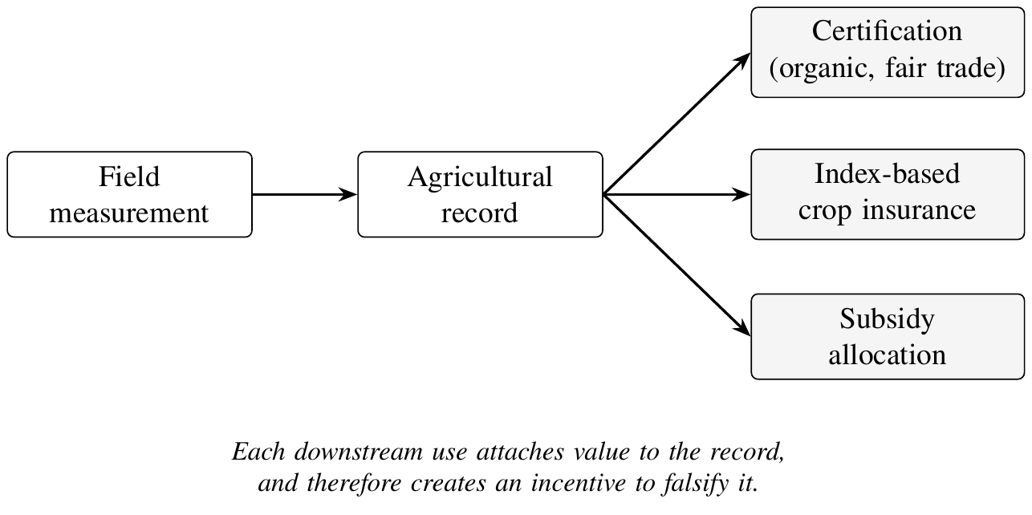
Lifecycle of an agricultural measurement: a reading becomes a record whose downstream value creates the incentive to falsify it.
Reviews of the sensing layer converge on the same reading. Smart sensing has matured to the point where measurement is no longer the constraint, while the integration of that measurement into auditable decision-making remains (Soussi et al. 2024; Gong et al. 2025). Surveys of edge-enabled agriculture name communication reliability and energy constraints as the two bottlenecks that most often defeat field deployments (Gong et al. 2025), and surveys of the wider Internet of Things (IoT) threat surface agree that the constrained endpoint is the weakest link in the provenance chain (Aouedi et al. 2024; Sahu and Mazumdar 2024).
The economics of the sensing layer explain why the problem is hard rather than merely tedious. A deployment that is worth installing on a smallholding must cost a small fraction of the crop value it protects, which forces the node bill of materials down to a level at which neither a hardware security module nor a generous energy budget is affordable. The same economics rule out mains power and wired backhaul across a field, so the design space collapses onto battery-powered microcontrollers speaking a long-range, low-rate radio. Every protection mechanism proposed in this thesis has to survive inside that envelope, and a mechanism that works only on a mains-powered gateway has solved the easier half of the problem.
The sensing layer of such systems is built from severely constrained devices. An Espressif 32-bit microcontroller with integrated Wi-Fi and Bluetooth (ESP32) node operating on battery and harvested solar power must transmit over kilometre-scale distances using Long Range (sub-GHz spread-spectrum radio modulation) (LoRa), a modulation scheme that trades data rate for range and therefore charges a high airtime cost per packet (Haxhibeqiri et al. 2018; Adelantado et al. 2017). Airtime is the binding constraint. It determines energy consumption at the node, and, through duty-cycle regulation and collision probability, it determines how many nodes a single gateway can serve (Vukovic, Raca, and Vukovic 2023). Conventional responses compress the payload, but general-purpose compressors such as Huffman and Lempel-Ziv-Welch compression (LZW) carry dictionary and buffer overheads that a microcontroller with a few kilobytes of free Random Access Memory (RAM) can ill afford (Marcelloni and Vecchio 2008, 2010).
Two further constraints sharpen this. Sub-GHz IoT bands are governed by a duty-cycle limit, so a node that has just transmitted must stay silent for a period proportional to the airtime it consumed. Airtime is therefore not only an energy cost but a rate limit: it caps how often a node may report, and no increase in battery capacity relaxes it. Second, because LoRa uses unslotted access, packets collide whenever two nodes transmit on the same channel at the same time, and the collision probability grows with the square of offered traffic in the regime that matters. Halving per-packet occupancy therefore buys more than a proportional reduction in collisions, which is why the mechanism studied here is worth the arithmetic it costs. Figure 1.2 sets out how one quantity, airtime per packet, propagates into three consequences that a design cannot address independently.
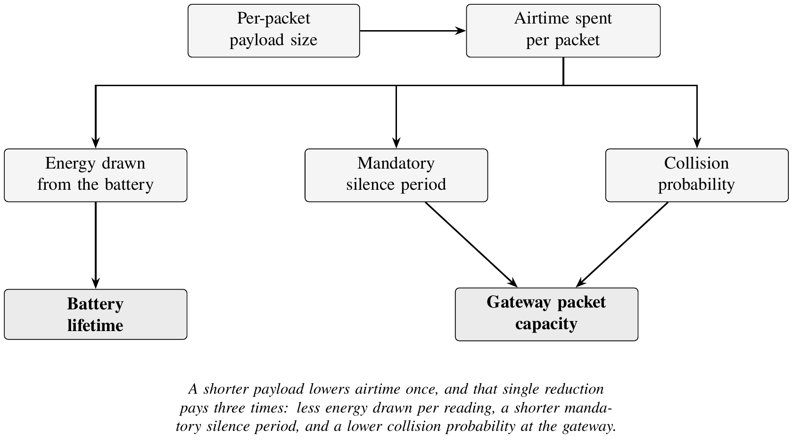
Airtime is a rate limit, not only an energy cost: reducing it relaxes the duty-cycle and collision ceilings on gateway capacity.
The Chinese Remainder Theorem (CRT) offers a different route. Decomposing a reading into residues modulo pairwise coprime moduli yields several short packets in place of one long one (Garner 1959; Ding, Pei, and Salomaa 1996). Because a multi-channel concentrator such as the SX1302 demodulates channels concurrently, the short residue packets can be received simultaneously, and the original value is recovered in $O\left(k\right)$ operations for $k$ moduli. The practical effect is a reduction in per-packet occupancy rather than in total transmitted volume, which is precisely the quantity that governs gateway capacity. The detailed encoding and reconstruction path is presented in Chapter Three.
Residue arithmetic is not new to distributed systems. The same decomposition underlies the throughput work in permissionless ledgers, where partitioning a workload across independent classes lets operations commit concurrently that would otherwise serialise (Maiwada 2025; Maiwada et al. 2024; Horváth 2025), and the algebraic machinery itself has been carried well beyond integer congruences (Luo 2023). That line of work establishes the arithmetic and the parallelisation argument. What it does not address is the constrained radio link, where the payoff is airtime rather than processor cycles, nor the identity and confidentiality questions that arise when the residues cross a shared medium. A single result hints that the second is reachable: residue decomposition combined with chaotic maps has been used to conceal image content reversibly (Yavuz 2025), which suggests residues can carry confidentiality as well as efficiency, albeit under a different medium and threat model. This thesis takes the arithmetic as established and asks what it is worth on the edge of the network rather than at its centre (forcha et al. 2026).
Data that has been collected cheaply must then be trusted. Agricultural records increasingly carry consequences beyond the farm gate. They substantiate organic and fair-trade certification, they underwrite index-based crop insurance, and they inform subsidy allocation. Each of these uses creates an incentive to falsify. A centralised database concentrates that risk in a single administrator, and an unprotected sensor network invites the injection of fabricated readings by any party with a compatible radio. Distributed Ledger Technology (DLT) addresses the tamper-evidence requirement by binding records into a hash-linked chain replicated across mutually distrusting parties, and permissioned platforms such as Hyperledger Fabric (HLF) add an identity layer through a Membership Service Provider (MSP) and Public Key Infrastructure (PKI), making it feasible to say not merely that a record is unaltered but who produced it (Pajooh et al. 2022; Androulaki et al. 2018; Thakkar, Nathan, and Vishwanathan 2018).
Running that machinery at the edge is the difficulty. Consensus, endorsement and world-state maintenance were designed for datacentre hardware, whereas an agricultural deployment must place gateways in the field, on 64-bit Advanced RISC Machine architecture (ARM64) single-board computers, behind intermittent connectivity. Whether a permissioned ledger can meet irrigation-control timing requirements on such hardware has until recently been asserted rather than measured.
Finally, protection is not exhausted by integrity. A soil-moisture trace is also a disclosure. It reveals plot productivity, irrigation strategy and, in aggregate, the commercial position of the farmer. Where records are replicated across a consortium that includes buyers, insurers and cooperatives, the same replication that secures integrity enlarges the audience for private information. Identity, integrity and privacy therefore have to be treated as one design problem rather than three independent ones, which is the position this thesis takes.

1.2 Statement of the Problem
Three properties that ought to hold simultaneously are, in current systems, traded against one another.
Identity is weak at the sensing layer. Constrained nodes seldom carry credentials strong enough to authenticate individual readings. Where authentication exists it typically terminates at the gateway, so the ledger attests to what the gateway submitted rather than to what the sensor measured. The provenance chain has a gap exactly where falsification is cheapest, at the final hop between an individual node and the record that claims to represent it.
Farm-specific work confirms that the exposure is real rather than theoretical. Tampering with IoT farm data has been treated as a distinct security problem requiring its own countermeasures (Aliyu and Liu 2023), and production deployments in food chains report provenance as the primary motivation for adopting a ledger at all (Safeer et al. 2024; J. Tang 2025).
Integrity guarantees do not survive the move to the edge. Permissioned ledgers provide tamper evidence, but their published performance characterisations assume server-class hosts. On ARM64 gateways with constrained memory and intermittent links, it is not established that endorsement and ordering can complete inside the control loop of an irrigation decision, nor how the ledger behaves during network partition and recovery.
Privacy is sacrificed to obtain integrity. Replicating raw agronomic readings to every consortium member is the simplest way to make them verifiable and the worst way to keep them confidential. Existing deployments largely accept this trade, or push confidential data off chain in a way that reintroduces the trusted intermediary the ledger was meant to remove.
The three shortfalls, shown together in Figure 1.3, are not independent faults to be repaired one at a time. Each follows from the same scarcity, and a remedy applied to one is paid for out of the budget available to the others.
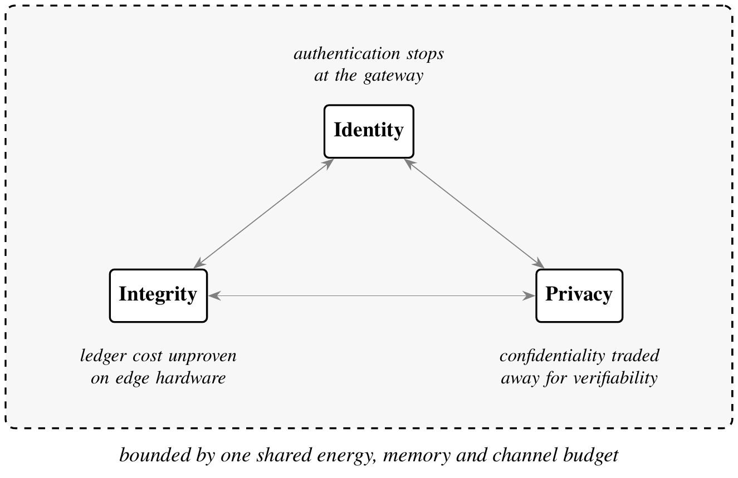
The three protection properties, sharing one constrained budget and therefore one design problem.
Underlying all three is a resource problem. The transmission budget that would pay for per-reading signatures, encryption and privacy-preserving encodings is already consumed by the raw payload itself. Any scheme that adds cryptographic protection without first reducing transmission cost will exhaust the node’s energy budget or the gateway’s channel capacity.
How, then, can identity, integrity and privacy be protected simultaneously in an agricultural data processing pipeline, end to end from constrained sensing node to distributed ledger, within the energy, memory and channel-capacity budgets that field deployment actually permits?

1.3 Rationale of the Study
The budget for protection has to come from somewhere. If CRT residue decomposition reduces per-packet airtime substantially, it frees channel capacity and node energy that can be reinvested in protection rather than merely banked as efficiency. The same decomposition has a second, less obvious property. An individual residue discloses little about the original value, so residues distributed across channels or custodians provide a natural substrate for confidentiality and for threshold reconstruction. A mechanism introduced for efficiency can thus be made to serve privacy, which is what makes the combination worth studying rather than treating transmission and security as separate layers. Figure 1.4 makes the reallocation concrete: the same fixed budget that raw transmission spends in full is only partly spent once residues replace it, and the remainder is what pays for protection.
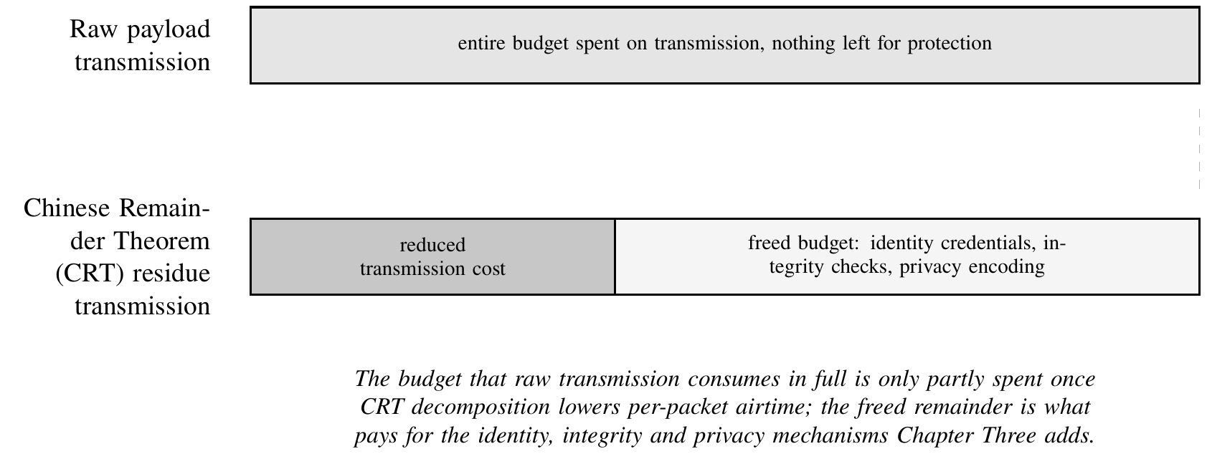
Reallocating the transmission budget: airtime saved by residue decomposition funds identity, integrity and privacy protection.
The two mechanisms also compose cleanly. Residue decomposition and ledger verification operate on the same object at different points in its life, the first on the reading in flight and the second on the record at rest, and the quantity each is sensitive to is different: the radio cares about occupancy, the ledger about the size and count of committed transactions. A scheme that reduces occupancy without increasing transaction count therefore improves one without taxing the other, which is not generally true of protection mechanisms and is worth demonstrating rather than assuming.
There is also an evidential gap. Claims about edge blockchain feasibility are typically supported by simulation or short laboratory runs. A sustained field deployment on real hardware, through real weather and real connectivity failures, produces a different and more useful class of evidence, including the failure modes that simulation does not generate.
The applied case is direct. Smallholder and arid-region agriculture is where both the water-efficiency gains and the certification-fraud exposure are largest, and where infrastructure assumptions of existing systems are least likely to hold.

1.4 Objectives of the Study

1.4.1 Main Objective
To design, implement and evaluate a distributed blockchain-based framework that protects identity, integrity and privacy in agricultural data processing, and to validate it in a sustained field deployment on constrained edge hardware.

1.4.2 Specific Objectives
- Analyse the identity, integrity and privacy requirements of agricultural data pipelines, decomposing the threat surface from sensing node through gateway to ledger into an attacker model with stated capabilities and assumptions.
- Design an integrated protection scheme combining CRT multi-channel residue transmission, which lowers per-packet airtime while preserving exact reconstruction, with an identity layer that binds each reading to an authenticated originating node through HLF MSP credentials and Hierarchical Role-Based Access Control (HRBAC) policy enforced in chaincode.
- Implement the framework on a heterogeneous edge cluster of ESP32 sensing nodes and ARM64 Raspberry Pi (RPi) gateways running HLF under Raft ordering, deployed under real agricultural operating conditions.
- Evaluate the transmission, ledger and access-control layers against compression and centralised baselines on airtime, energy, throughput, latency and memory footprint, and assess the scalability and fault-tolerance envelope through queuing-theoretic analysis validated against measured load.

1.5 Research Questions
- To what extent can CRT residue decomposition reduce per-packet airtime and increase gateway packet capacity without loss of reconstruction fidelity?
- Can a permissioned distributed ledger sustain the throughput and latency required by real-time irrigation control when hosted entirely on ARM64 edge gateways?
- What identity binding is required for a ledger record to attest to the originating sensing node rather than merely to the submitting gateway, and what does that binding cost?
- What confidentiality is obtained by distributing residues across channels and custodians, and under what adversary model does it hold?
- How does the integrated framework behave as offered load approaches gateway and ledger saturation, and where are its practical limits?

1.6 Research Hypotheses
H1 (Transmission efficiency).
CRT residue transmission reduces per-packet airtime by at least 40% relative to raw transmission while maintaining at least 99% reconstruction accuracy.
H2 (Edge ledger performance).
HLF hosted on four RPi 4B gateways sustains a mean transaction latency below 2 s at an average throughput of at least 50.
H3 (Access-control overhead).
Enforcing Role-Based Access Control (RBAC) in chaincode preserves at least 50 and keeps mean smart-contract execution below 500 ms.
H4 (Field robustness).
Sustained field operation maintains at least 99% end-to-end reliability, with measured airtime within 5 ms of the analytical model.
H5 (Privacy preservation).
An adversary observing fewer than $k$ of the $k$ residue channels cannot reconstruct the original reading, and the residual information leakage remains below a stated bound.

1.7 Scope and Delimitations
In scope. Sub-GHz LoRa sensing networks of the order of fifty nodes; permissioned ledgers of the HLF family under Raft ordering; gateway hardware in the RPi 4B class; agronomic telemetry, specifically soil moisture, temperature, humidity and irrigation actuation; and the identity, integrity and privacy properties of that pipeline.
Out of scope. Public permissionless blockchains and their consensus economics; cellular and satellite backhaul; image-based and remote-sensing agronomy; agronomic model accuracy as such, which is treated as given rather than as an object of study; and formal cryptographic proofs of the underlying primitives, which are cited rather than re-derived.
Delimitations. Field validation is drawn from a single deployment site and a single cropping season, which bounds the claims that can be made about generalisation across soil types and climates. Node population is bounded by what could be instrumented. Behaviour beyond that population is established analytically and by synthetic load rather than by direct measurement.

1.8 Significance of the Study
For engineering practice, the work supplies measured rather than simulated evidence about what a permissioned ledger costs on edge hardware, and a transmission scheme that reduces that cost enough to make protection affordable.
For the research literature, it connects two bodies of work that have developed separately, namely residue arithmetic for communication efficiency and distributed ledgers for data provenance, and shows that the first can subsidise the second.
Methodologically, the work contributes a characterisation obtained under field conditions rather than in a laboratory. Failures that a testbed does not generate, mesh partitions, thermal derating, intermittent backhaul and the recovery behaviour that follows each, are exactly the ones that determine whether such a system is deployable, and they only appear when the system is left running.
For agricultural stakeholders, it offers a path to verifiable certification and insurance records that does not require farmers to surrender commercially sensitive detail to every consortium member.

1.9 Definition of Key Terms
Airtime
The time a radio occupies a channel to transmit one packet. It governs both node energy consumption and gateway capacity.
Residue
The remainder of a reading modulo one of a set of pairwise coprime moduli. A complete residue set uniquely determines the original value below the product of the moduli.
Integrity
The property that a record has not been altered since it was committed, and that alteration would be detectable.
Identity
The property that a record can be attributed to a specific authenticated principal, here a specific sensing node rather than merely a gateway.
Privacy
The property that a record’s content is disclosed only to principals authorised to see it, notwithstanding replication of the ledger.
Endorsement
In HLF, the process by which designated peers simulate a transaction and sign the result before ordering.

1.10 Organisation of the Thesis
Chapter One states the background, problem, rationale, objectives, questions and hypotheses. Chapter Two reviews the literature on precision agriculture and IoT sensing, transmission optimisation, distributed ledgers in agriculture, edge-resident consensus and privacy-preserving data processing, and identifies the gap this work addresses. Chapter Three presents the materials and methods: system architecture, CRT formulation, identity and access-control design, hardware implementation, deployment protocol and evaluation methodology. Chapter Four reports results and applications across the transmission, ledger, access-control and agricultural-outcome dimensions. Chapter Five discusses the findings against the hypotheses, states limitations and threats to validity, and sets out conclusions, recommendations and perspectives for further research.

2 Review of the Literature

2.1 Introduction
Three lines of research, developed largely apart from one another, converge on the problem we address.
The first is the instrumentation of agriculture itself. Wireless sensor networks for environmental monitoring emerged in the early 2000s as a low-cost alternative to wired instrumentation, with early deployments demonstrating that battery-powered nodes could report soil and microclimate variables over months without maintenance (N. Wang, Zhang, and Wang 2006; Pierce and Nowak 1999). Soil-moisture networks matured through the 2000s and 2010s into standard tools for irrigation scheduling (Bogena et al. 2010; Evans, Iversen, and Kim 2008), and the arrival of Low-Power Wide-Area Network (LPWAN) radios after 2015 extended the useful range of such networks from tens of metres to several kilometres, at the cost of a severely constrained airtime budget (Adelantado et al. 2017; Raj and Prasad 2017). Precision agriculture as a discipline absorbed this instrumentation gradually, and by the early 2020s the technical barrier to dense sensing had largely fallen, while the barrier to trustworthy, verifiable use of the resulting data had not (McBratney, Whelan, and Ancev 2005; Aydin and Hall 2021).
The second lineage is arithmetic rather than agricultural. The Chinese Remainder Theorem states a result on simultaneous congruences known in essentially its modern form since antiquity, formalised for modern computation by Garner’s constructive reconstruction procedure (Garner 1959) and developed since as the mathematical basis of residue number systems for fast, parallel, fault-tolerant arithmetic (Ding, Pei, and Salomaa 1996; Parhami 2010). That literature has run for decades inside computer arithmetic and cryptography, largely untouched by networking or agriculture, its natural home being hardware multipliers, error-correcting codes and, more recently, the parallel verification of cryptographic signatures (Knuth 1997; Hardy et al. 2008; Shoup 2009).
The third lineage is distributed ledgers. Blockchain moved from a cryptocurrency mechanism to a general tamper-evident data structure once enterprises recognised that a hash-linked, replicated log could substitute for a trusted central database among mutually distrusting parties (Christidis and Devetsikiotis 2016; Gubbi et al. 2013). Permissioned platforms such as Hyperledger Fabric formalised that idea for consortium settings, adding an identity layer through a MSP (Androulaki et al. 2018; Hyperledger Fabric Documentation 2022), and agricultural supply chains were an early, natural application because certification and provenance are exactly the tamper-evidence problem the ledger solves (F. Tian 2016; X. Xu et al. 2016; Salah et al. 2019).
Figure 2.1 places these three lineages on one timeline. They do not meet until the last five years, and even where they meet, as the sections that follow show, they meet pairwise rather than as a single design. The rest of this chapter lays the foundations in the order a reader needs them: what a blockchain actually is and why a permissioned one suits a consortium of mutually distrusting parties (Section [subsec:lit_fundamentals]), the agricultural sensing and transmission layer that produces the data (Sections [subsec:lit_precision_ag]-[subsec:lit_lpwan]), the residue arithmetic we use to decompose readings with (Section [subsec:lit_crt]), how blockchain has actually been used in agriculture (Section [subsec:lit_blockchain_ag]), and the consensus, identity and scalability literature that determines what a ledger costs to run at the edge (the sections after that).
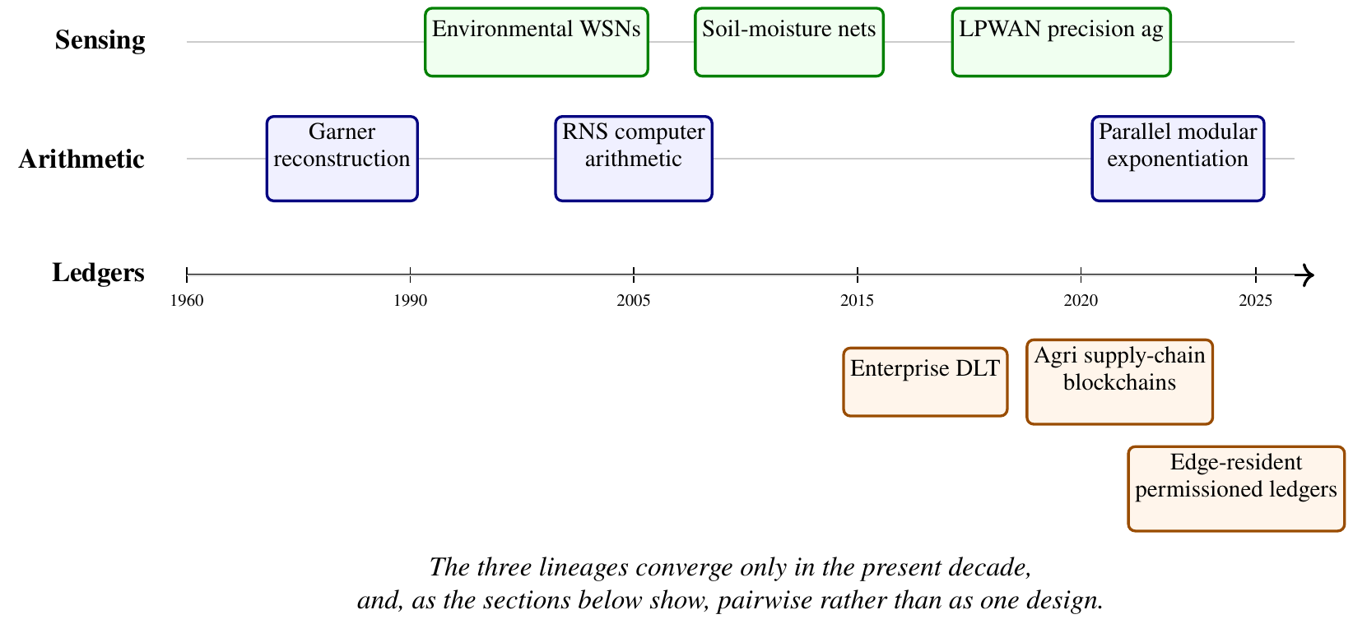
Three lineages underlying our work, developed independently until converging in the 2020s.

2.2 Foundations and Enabling Technologies
The four strands below supply the technical vocabulary the rest of the chapter uses: what a distributed ledger guarantees and at what cost, how agricultural sensing is instrumented, what the radio charges for a packet, and what residue arithmetic offers.

a) Fundamentals of Blockchain Technology
Before turning to agriculture specifically, we set out what a blockchain is, because the word covers a wide family of designs and the choice among them is not cosmetic. A blockchain is, at its simplest, an append-only ledger replicated across a set of nodes that do not fully trust one another, ordered into blocks that are cryptographically chained together (Christidis and Devetsikiotis 2016; Casino, Dasaklis, and Patsakis 2019). Each block $B_{i}$ commits to its predecessor and its own transaction set through
$$h_{i}=H​\left(h_{i−1} ∥ {tx}_{i}\right),$$
where $H$ is a cryptographic hash function, so that altering any committed ${tx}_{j}$ for $j≤i$ requires recomputing every $h_{j},…,h_{i}$ across every replica that holds the chain, a cost that grows with the number of mutually distrusting replicas rather than shrinking (Merkle 1988). Merkle’s original construction generalises Equation [eq:hash_chain] to a binary tree of hashes so that membership of a single transaction can be proven in $O\left(logn\right)$ rather than by revealing the whole block, a property later systems use for compact audit proofs (P. K. Sharma, Moon, and Park 2017). This hash-chaining property, not any particular cryptocurrency, is what the literature means by tamper evidence, and it is what agricultural applications actually draw on: a record, once committed and replicated, cannot be silently rewritten by any single party.
Blockchains split first on who may participate. Permissionless (public) chains such as Bitcoin and Ethereum admit any node and settle disagreement through open, resource-costly consensus, typically proof of work, so that attacking the chain costs more than any single participant can afford (Melo et al. 2024; Balasubramanian 2024). Permissioned (private or consortium) chains restrict participation to identified, vetted members, replacing open competition with a membership service that binds every submitted transaction to an accountable identity (Androulaki et al. 2018; Krstić and Krstić 2020). Hyperledger Fabric, the platform we deploy, is representative of the permissioned family: a MSP issues ITU-T public-key certificate standard (X.509) certificates to every organisation and peer, an execute-order-validate pipeline separates transaction endorsement from ordering, and chaincode, Fabric’s term for a smart contract, encodes the business logic that peers execute and validate before a transaction is committed (Androulaki et al. 2018; Kaur 2020). A permissionless design buys resistance to an unknown, potentially adversarial population of participants at the cost of energy and finality latency; a permissioned design accepts a smaller, vetted membership in exchange for finality in seconds rather than minutes and no mining cost, which is why every agricultural deployment reviewed in this chapter, without exception, chooses the permissioned family. A consortium of farms, certifiers and buyers is exactly the setting permissioned platforms are built for: participants who must cooperate on shared records without extending one another unconditional trust, and who are identifiable and accountable rather than anonymous (Casino, Dasaklis, and Patsakis 2019; Kumar and Roy 2024).
Smart contracts are the mechanism that turns a passive ledger into an active one. Once deployed, chaincode executes deterministically on every endorsing peer, so that business rules, who may submit a reading, what counts as a valid range, how a certification decision is recorded, are enforced by consensus over code rather than by a single administrator’s discretion (Krstić and Krstić 2020; J. Tang 2025). Alternative ledger topologies exist outside the block-and-chain model proper, directed-acyclic-graph ledgers such as IOTA dispense with blocks altogether and let each new transaction validate two prior ones (Anonymous n.d.), trading the strict global ordering a blockchain provides for higher throughput under light load; we return to this trade-off, and to consensus proper, in Section [subsec:lit_consensus]. What every variant shares, and what the rest of this chapter takes as given, is the replicated, hash-chained record that makes a committed reading expensive to falsify after the fact. Underlying every transaction’s authenticity, in both permissioned and permissionless designs, is public-key cryptography: a node signs what it submits with a private key, and peers verify that signature against a public one before accepting it, typically an elliptic-curve scheme such as Elliptic Curve Digital Signature Algorithm (ECDSA) over the secp256k1 curve (Balasubramanian 2024). Signature verification is itself a parallelisable modular-arithmetic computation, which is the property Section [subsec:lit_crt] returns to when it discusses residue number systems.

b) Precision Agriculture and Internet of Things Sensing
Precision agriculture research has consistently found that sensing density and irrigation efficiency move together. IoT soil and canopy sensing networks demonstrated early that automated, sensor-driven scheduling outperforms calendar-based irrigation on both water use and yield (Rathi and Gomathy 2025; Pereira, Oweis, and Zairi 2002; Verdouw et al. 2021; Gondchawar and Kawitkar 2016), a finding replicated across arid and semi-arid contexts where the water-saving incentive is largest (Abioye et al. 2020; Dono, Giraldo, and Severini 2010; Iglesias and Garrote 2015). Reviews of the field converge on the same three limitations. First, decision-support integration remains fragmented: sensor data reaches a dashboard but rarely a closed-loop controller with an auditable rationale (Aydin and Hall 2021; N. Zhang, Wang, and Wang 2002; Gebbers and Adamchuk 2010; McBratney, Whelan, and Ancev 2005). Second, most systems evaluate the analytics rather than the network that feeds them, so machine-learning yield and stress models are reported against clean, simulated input streams rather than the loss and jitter that a field deployment actually produces (Chlingaryan, Sukkarieh, and Whelan 2018; Goap et al. 2018; Mohanty, Hughes, and Salathé 2016; Van Klompenburg, Kassahun, and Catal 2020). Third, sensing accuracy in the field degrades in ways a laboratory calibration does not capture, drift, fouling and intermittent failure among them, and few studies report the resulting error budget (Vaz et al. 2013; Molina-Cuevas, Quijano-Velasco, and Guerrero-González 2021; Botta et al. 2016; Hang and Kim 2019). Later generations of this literature push toward higher automation, describing four- and five-generation smart-farming stacks that assume the identity and integrity of every reading rather than establishing it (Jagan Mohan, Rayanoothala, and Praneetha Sree 2026; Xiaoding Wang et al. 2025; Tzounis et al. 2017; García et al. 2020; Jin, Du, and Jin 2025). That assumption is exactly the gap Section [subsec:lit_blockchain_ag] returns to.

c) Low-Power Wide-Area Network Transmission Optimisation and Energy Modelling
LoRa is the dominant physical layer in this literature because it reaches farm-scale distances, of the order of kilometres in rural terrain, from a battery node at sub-milliwatt receive power (Haxhibeqiri et al. 2018; Li et al. 2020; Raj and Prasad 2017). The cost is airtime. The Semtech chirp spread-spectrum design fixes the time to transmit a payload of $PL$ bytes as a function of spreading factor $SF$, bandwidth $BW$, coding rate $CR$ and the low-data-rate optimisation flag $DE$ (Semtech Corporation 2015; Bor et al. 2016). The symbol period is
$$T_{\text{sym}}=\frac{2^{SF}}{BW},$$
the payload requires
$$n_{\text{payload}}=8+max​\left(\left\lceil \frac{8 PL−4 SF+28+16 CRC−20 IH}{4\left(SF−2 DE\right)}\right\rceil \left(CR+4\right), 0\right)$$
symbols, and total airtime is
$$T_{\text{air}}=\underset{\text{preamble}}{\underset{⏟}{\left(n_{\text{preamble}}+4.25\right) T_{\text{sym}}}}+n_{\text{payload}} T_{\text{sym}}.$$
Equation [eq:lora_airtime] is the quantity every optimisation in this literature ultimately reduces: for a fixed $SF$ and $BW$, airtime is affine in payload length, so a shorter payload is the only lever available once the modulation is chosen. Regulatory duty-cycle limits then convert that airtime into a rate ceiling rather than merely an energy cost. Under European Telecommunications Standards Institute (ETSI) EN 300 220, a sub-GHz node may occupy its channel for at most a fixed fraction ${DC}_{max}$ of any observation window (Network 2024; Alliance 2021), so a single reading consumes
$$DC=\frac{T_{\text{air}}}{T_{\text{window}}}≤{DC}_{max},$$
and offered channel load across $N$ nodes reporting once per window is $G=N T_{\text{air}}/T_{\text{window}}$ Erlang, which under the pure-ALOHA assumption common to this literature bounds per-packet collision probability at $P_{\text{coll}}=1−e^{−2G}≈2G$ for small $G$ (Bor et al. 2016; Adelantado et al. 2017). Node energy per transmission follows directly, $E_{\text{tx}}=P_{\text{tx}} T_{\text{air}}$, so any reduction in $T_{\text{air}}$ is simultaneously an energy saving and a capacity gain, which is why the transmission-optimisation literature and the energy-modelling literature are, in practice, one body of work (Barr and Asanovic 2004; Polastre, Hill, and Culler 2004; Gonzalez and Horowitz 2000; Vukovic, Raca, and Vukovic 2023; Sanchez et al. 2021; Heinzelman, Chandrakasan, and Balakrishnan 2000).
Two families of technique attack Equation [eq:lora_airtime] from opposite sides, summarised in Figure 2.2. Compression keeps one packet per reading and shrinks $PL$: general lossless coders such as Huffman and Lempel-Ziv-Welch adapted to sensor streams (Li, Da Xu, and Zhao 2018; Marcelloni and Vecchio 2008; Ziv and Lempel 1977; Huffman 1952; Salomon 2007) report 20 to 40% payload reduction but require dictionary or frequency-table state that a microcontroller with a few kilobytes of free RAM can only marginally afford (Marcelloni and Vecchio 2010; Community 2016), and adaptive sampling reduces transmitted volume by skipping readings, which risks missing the threshold event the network exists to detect (Kjellsson and Zakhor 2008). Decomposition takes the opposite path: it accepts more packets in exchange for each one being far shorter, splitting a reading across parallel channels rather than compressing it on one. Residue-based decomposition for wireless sensor data has been explored for storage reduction and for wireless sensor network lifetime (Vidhya and Brindha 2021; Buttigieg, Farrugia, and Zammit-Mangion 2014; Pourbigharaz and Yassine 1994; Ye et al. 2018), but, as Section [subsec:lit_crt] details, not for exploiting a multi-channel concentrator’s ability to demodulate several sub-channels simultaneously, which is the specific mechanism we study. LoRa-specific network-capacity work independently confirms that channel occupancy, not raw byte count, is the binding constraint on gateway-served node population (Centenaro et al. 2016; H. Zhang et al. 2022; Chapungo and Postolache 2025; Bicamumakuba et al. 2025; Turlykozhayeva et al. 2024; Bouaziz, Rachedi, and Belghith 2020), which is the same quantity Equation [eq:duty_cycle] fixes.
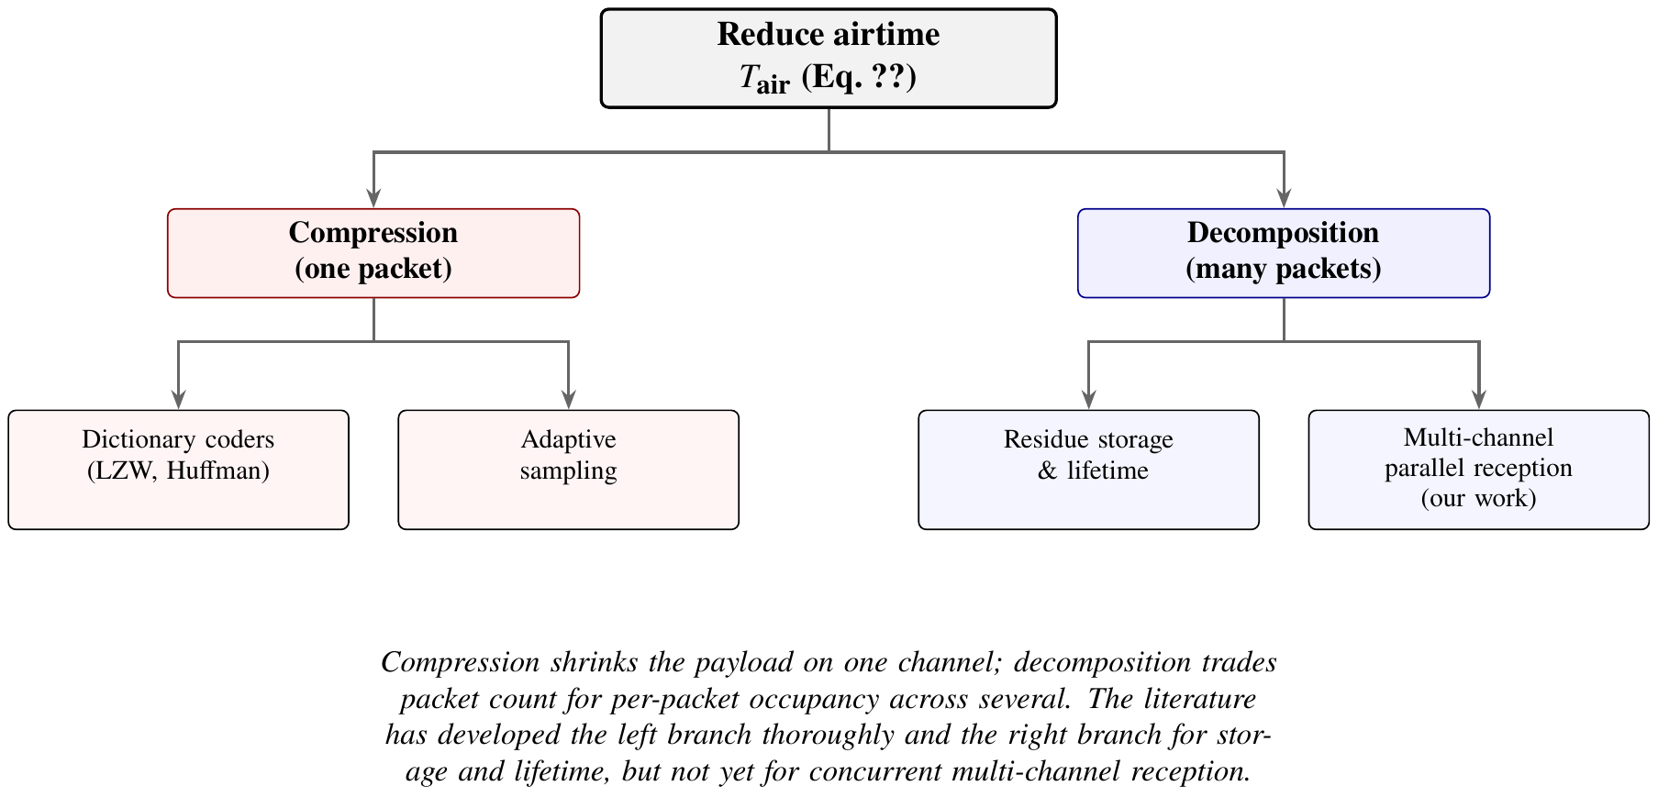
Transmission-efficiency strategies for constrained IoT radios; we occupy the open leaf on the right.
Table 2.1 summarises representative results across both branches on the metric that matters for gateway capacity, per-packet airtime or its energy equivalent, rather than the compression ratio each source reports on its own terms.
Representative low-power wide-area transmission-efficiency results
Study | Technique | Reported limitation
Li and Simonot-Lion (Li, Da Xu, and Zhao 2018);
Marcelloni and Vecchio (Marcelloni and Vecchio 2008) | Huffman/LZW sensor compression | Dictionary or frequency-table state exceeds the free RAM of the smallest microcontroller class; ratio degrades on low-entropy sensor streams
Kjellsson et al. (Kjellsson and Zakhor 2008) | Adaptive, event-driven sampling | Reduces volume, not per-packet occupancy; risks missing threshold events between samples
Vidhya and Brindha (Vidhya and Brindha 2021) | CRT residue image compression | Targets storage footprint, not transmission concurrency; single-channel model
Buttigieg et al. (Buttigieg, Farrugia, and Zammit-Mangion 2014);
Pourbigharaz and Yassine (Pourbigharaz and Yassine 1994) | Residue Number System (RNS) energy reduction in Wireless Sensor Networks (WSNs) | Energy accounting only; no gateway-capacity or multi-channel reception model
Ye et al. (Ye et al. 2018) | RNS-based reliable WSN transmission | Reliability under loss, not concurrent channel exploitation

d) Residue Number Systems and the Chinese Remainder Theorem in Communications
The theorem itself is unconditional. For pairwise coprime moduli $m_{1},…,m_{k}$ and $M=\prod_{i=1}^{k}{m_{i}}$, every integer $x∈[0,M)$ is uniquely determined by its residue vector $\left(r_{1},…,r_{k}\right)$, $r_{i}=x mod m_{i}$ (Garner 1959; Hardy et al. 2008). Garner’s algorithm reconstructs $x$ from the residues in closed form,
$$x=\left(\sum_{i=1}^{k}{r_{i}} M_{i} N_{i}\right) mod M, M_{i}=\frac{M}{m_{i}}, N_{i}=M_{i}^{−1} mod m_{i},$$
exact because $M_{i}N_{i}≡1 (mod m_{i})$ by construction (Garner 1959; Knuth 1997), and computable in $O\left(k\right)$ modular multiplications regardless of the magnitude of $x$, which is the property that later work in residue number systems generalised into a programme for fast, carry-free, parallel arithmetic (Ding, Pei, and Salomaa 1996; Parhami 2010). A second property of Equation [eq:crt_reconstruction] bears on reliability rather than speed. Goldreich, Ron and Sudan formalised the error-tolerant case, showing that $x$ remains recoverable from a strict subset of residues under bounded corruption, "Chinese remaindering with errors" (Goldreich, Ron, and Sudan 1999), a result later systematised alongside subset-product reconstruction in computational number theory (Shoup 2009). That subset-recovery property is a statement about reconstruction, not about disclosure: it is tempting to read a residue set as a threshold secret-sharing scheme, exact recovery from a complete or near-complete subset, negligible information from any one share in isolation, but the two constructions are not equivalent. A Shamir-style share is deliberately randomised so that any share short of the threshold is uniformly distributed independent of the secret (Shoup 2009); a plain CRT residue is not. $r_{i}=x mod m_{i}$ is a deterministic function of $x$, so intercepting it narrows the field of possible values by a factor of roughly $m_{i}$ rather than leaking nothing, and if the plaintext domain is itself small relative to $m_{i}$, a single residue can narrow that field to very little uncertainty indeed. Whether residue disclosure is negligible in practice therefore depends on the ratio between the plaintext’s domain and the moduli chosen, not on the reconstruction identity alone, and no prior work has established that ratio for any deployed system; Section [subsec:lit_privacy] returns to this distinction, and Chapter One’s hypothesis H5 treats it as open rather than established.
Two application communities have used Equation [eq:crt_reconstruction] for two different resources, and both stop short of a shared wireless channel. The first treats it as a storage problem: residue-based lossless image compression reports 15 to 30% footprint reduction with exact reconstruction (Vidhya and Brindha 2021). The second treats it as an energy problem inside wireless sensor networks, converting a single wide-range reading into several narrow-range residues to shrink the arithmetic and storage cost per node (Pourbigharaz and Yassine 1994; Buttigieg, Farrugia, and Zammit-Mangion 2014; Ye et al. 2018). Neither treats the residues as packets to be received concurrently on separate radio channels; both keep the decomposition on one device (compressing what is stored) or across one uplink (reducing what one node computes and sends), rather than exploiting a multi-channel concentrator’s ability to demodulate several sub-channels simultaneously. To our knowledge, no published system applies residue decomposition to concurrent multi-channel radio reception, which is the gap Chapter Three’s design addresses. Figure 2.3 lays the three resources side by side: two are established in the literature just surveyed, the third is open.
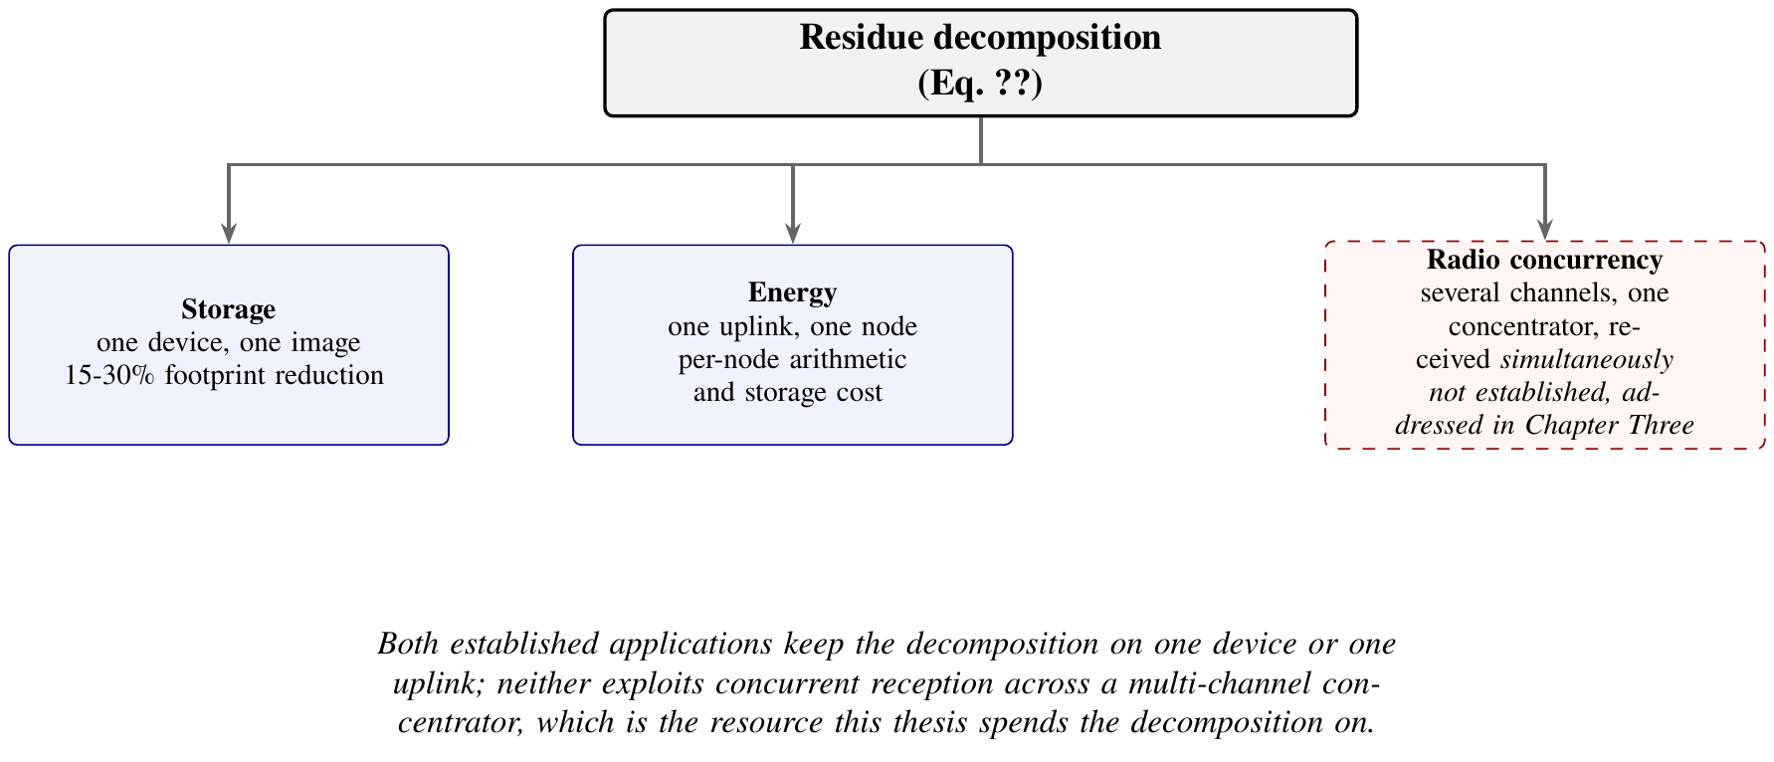
The three resources residue decomposition has been applied to; radio concurrency remains open in the surveyed literature.
Residue number systems have a third, older home outside networking entirely: fast computer arithmetic and hardware design, where the absence of carry propagation across residue channels makes addition and multiplication in each channel independent of every other, at the cost of comparison and division becoming hard (Ding, Pei, and Salomaa 1996; Parhami 2010). That same independence gives residue codes a natural fault-tolerance reading, since a corrupted or missing channel affects only the value it encodes rather than propagating a carry error into its neighbours, which is part of why redundant residue codes have long been used for error detection in hardware (Knuth 1997; Hardy et al. 2008). The parallelism this independence buys is architecturally the same kind of parallelism that the blockchain-scalability literature pursues by partitioning transaction load across shards or channels rather than processing it as one serial stream (Horváth 2025; Anonymous n.d.): both decompose a workload into independently processable parts and pay a bounded recombination cost to reassemble the result. We are not aware of published work that states this parallel explicitly or that applies residue decomposition to a blockchain-connected radio link; Section [subsec:lit_scalability] returns to the blockchain side of that comparison once the scalability literature itself has been surveyed.

2.3 Literature Specific to the Topic
Where the foundations are general, the work below sits directly on the problem this thesis addresses, and is grouped by the property it tries to secure.

a) Blockchain and Distributed Ledger Technology in Agriculture and Supply Chains
Section [subsec:lit_fundamentals] sets out the hash-chaining identity (Equation [eq:hash_chain]) that gives a replicated ledger its tamper evidence. Applied to agriculture, this tamper-evidence property has been used for supply-chain transparency (F. Tian 2016, 2017; Kamilaris, Fonts, and Prenafeta-Boldó 2019; Bosona and Gebresenbet 2023; Galvez, Mejuto, and Simal-Gandara 2018; Reyna et al. 2018; Feng Tian 2017; Anonymous n.d.), farm-data management (Jian Lin et al. 2018; Mohamed Amine Ferrag et al. 2020; Haque, Bhushan, and Dhiman 2024; P. Zhang et al. 2019; Aliyu and Liu 2023), and smart-contract automation of certification and payment logic (Rama et al. 2021; Patil et al. 2022; Feng Tian 2016, 2017). Cross-organisational data sharing has more recently been framed through self-sovereign identity, letting a farm operator authorise fine-grained access without handing a consortium a standing credential (Amraouy, Benbrahim, and Kabbaj 2025), and water-quality and irrigation-specific ledgers report similar tamper-evidence gains (Hung, Kang, and Song 2022; Aqeel-ur-Rehman et al. 2014; Aliyu and Liu 2023; Frustaci et al. 2018). The generic IoT-blockchain integration literature that agricultural systems draw their architecture from independently confirms the same design pattern: a lightweight device signs and forwards, a gateway or edge node validates and submits, and the ledger anchors a hash rather than the raw payload (Dorri, Kanhere, and Jurdak 2017; Dorri et al. 2017; R. Xu et al. 2020; Reyna et al. 2018; Hammi et al. 2018).
Crop- and commodity-specific traceability deployments give this pattern concrete form. Salah et al. (2019) traces soybean shipments end to end on Ethereum, anchoring custody transfers as they cross the supply chain; a comparable case study for ginger in Nepal reports the same design applied to a smallholder export crop (Anonymous n.d.), and a pilot study of blockchain for agriculture and food more broadly finds the technology’s actual value concentrated in dispute resolution and recall speed rather than in the blockchain mechanism’s novelty as such (Ge et al. 2017). Reviews that step back from individual case studies converge on transparency and traceability as the two benefits every deployment claims, whatever the crop (Anonymous n.d.), and on collaborative trust and cross-party transparency as the property that justifies choosing a shared ledger over a conventional shared database in the first place (Kumar and Roy 2024). A feasibility analysis of blockchain and IoT for African agricultural food supply chains (A. Tang et al. 2024) is the closest match in this corpus to our own deployment context: it names intermittent connectivity, low digital literacy and capital cost, rather than the blockchain mechanism itself, as the binding constraints on adoption, which is consistent with the constrained-hardware and field-deployment focus of Chapter Three’s methodology and reinforces why we evaluate on the low-cost, battery and solar-powered hardware class that a smallholder deployment can actually afford, rather than on server-class infrastructure.
What this body of literature does not establish is where the tamper evidence begins. Almost every system surveyed authenticates at the gateway or the enterprise boundary and treats the sensor as an untrusted data source whose values are accepted once they arrive, not a principal whose identity is bound to the record it produced (J. Lin et al. 2018; M. A. Ferrag, Shu, and Debbah 2020; Kamilaris, Fonts, and Prenafeta-Boldó 2019; Aliyu and Liu 2023). Table 2.2 makes this concrete across a representative sample: the column that is consistently weak or absent is node-level, rather than gateway-level, identity binding, which is precisely the gap Chapter One’s problem statement (Section 1.2) identifies.
Representative blockchain-in-agriculture systems by authentication boundary and evaluation setting
Study | Authentication boundary | Evaluation setting | Reported gap
Tian (F. Tian 2016); Kamilaris et al. (Kamilaris, Fonts, and Prenafeta-Boldó 2019) | Enterprise / consortium | Conceptual, no field data | No per-sensor identity; throughput not characterised on constrained hardware
Zhang et al. (P. Zhang et al. 2019) | Gateway | Simulation | Consensus cost assumed server-class hardware
Amraouy et al. (Amraouy, Benbrahim, and Kabbaj 2025) | Farm operator (self-sovereign identity) | Prototype | Access-sharing framework; no edge-hardware performance data
Reyna et al. (Reyna et al. 2018); Dorri et al. (Dorri, Kanhere, and Jurdak 2017) | Generic IoT gateway | Survey / architecture | Identifies the sensor-to-gateway trust gap without closing it

b) Edge-Resident Consensus and Constrained-Hardware Ledgers
Running a permissioned ledger on gateway-class hardware raises a question the enterprise blockchain literature rarely poses: whether consensus can complete inside the timing budget of a real-time control loop, on a device with an order of magnitude less memory and Central Processing Unit (CPU) throughput than the server hardware that literature assumes (Pajooh et al. 2022; Androulaki et al. 2018; IBM 2023). Hyperledger Fabric’s execute-order-validate architecture separates transaction endorsement from ordering, letting an ordering service reach agreement on transaction sequence rather than transaction content, and the Raft ordering service we use implements crash-fault-tolerant, not Byzantine-fault-tolerant, agreement (Ongaro and Ousterhout 2014; Team 2024). The distinction has a direct complexity consequence. Crash Fault Tolerance (CFT) protocols such as Raft reach agreement with $O\left(n\right)$ message exchanges per decision and tolerate $f=⌊\left(n−1\right)/2⌋$ stopped nodes, whereas classical Byzantine Fault Tolerance (BFT) protocols such as Practical Byzantine Fault Tolerance (PBFT) require $n≥3f+1$ replicas, so they tolerate the smaller $f=⌊\left(n−1\right)/3⌋$, at $O\left(n^{2}\right)$ messages per decision, to withstand arbitrary, not merely crash, node behaviour (Castro and Liskov 1999; Ongaro and Ousterhout 2014). A five-node cluster therefore tolerates two stopped nodes under Raft but only one Byzantine node under PBFT, a smaller fault budget bought at a quadratically larger message cost. Linear-complexity BFT variants such as HotStuff close much of that gap for adversarial settings (Yin et al. 2019), and the state-machine-replication literature more broadly treats the CFT/BFT choice as a trade between message cost and the threat model tolerated (Bessani, Sousa, and Alchieri 2014). Deployed on a consortium of trusted, physically secured gateways rather than an open or adversarial network, we adopt CFT for that reason, a choice the consensus literature supports for permissioned agricultural settings (Thakkar, Nathan, and Vishwanathan 2018) but rarely evaluates on gateway-class ARM64 hardware in the field, as Table 2.3 shows.
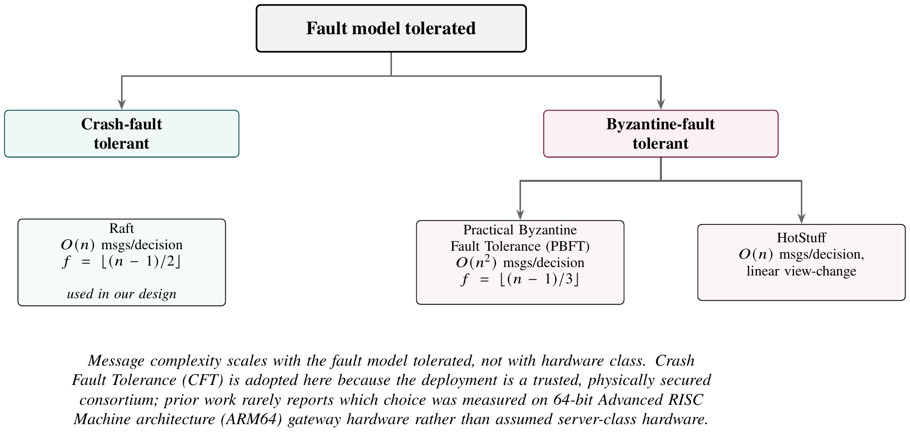
Consensus fault models and their message complexity, after (Ongaro and Ousterhout 2014; Castro and Liskov 1999; Yin et al. 2019; Bessani, Sousa, and Alchieri 2014).
Whichever protocol is chosen, its saturation behaviour under load is standard queueing theory. Treating packet or transaction arrivals as Poisson and service time as deterministic (an M/D/1 queue), mean waiting time before service is
$$W_{q}=\frac{ρ}{2\left(1−ρ\right)} T_{\text{service}}, ρ=λ T_{\text{service}},$$
where $λ$ is the arrival rate and $T_{\text{service}}$ the deterministic service time, so that total latency $L=T_{\text{service}}+W_{q}$ is flat while $ρ≪1$ and diverges as $ρ→1$. The scalability literature for both LoRa gateways and blockchain orderers uses Equation [eq:mdOne], or its close relatives, to project a saturation point from a small deployment rather than requiring one at scale (Androulaki et al. 2018; Gorenflo et al. 2020; Mao et al. 2018; Sukhwani et al. 2017; Rahman, Hamzah, and Safdar 2022), but, as with the consensus literature above, validation against real field load rather than synthetic benchmark load remains the exception rather than the rule. The Consistency, Availability, Partition tolerance (CAP) theorem underlies the same trade from a different angle: no distributed data store can simultaneously guarantee consistency and availability under network partition (Brewer 2000; Gilbert and Lynch 2002), and permissioned ledgers on intermittently connected rural gateways sit squarely inside that trade-off, a point the practitioner literature on eventual, Atomicity, Consistency, Isolation, Durability (ACID)-relaxed consistency in distributed systems makes explicit (Pritchett 2008).
Consensus and edge-ledger literature by hardware class evaluated
Study | Protocol | Hardware class | Reported gap
Ongaro and Ousterhout (Ongaro and Ousterhout 2014) | Raft (CFT) | Server-class (original) | Correctness and understandability proof; no constrained-hardware evaluation
Castro and Liskov (Castro and Liskov 1999) | PBFT (BFT) | Server-class | $O\left(n^{2}\right)$ messaging cost not evaluated against gateway bandwidth
Androulaki et al. (Androulaki et al. 2018) | Fabric E-O-V pipeline | Data-centre reference deployment | Throughput figures not reproduced on ARM64
Rahimi et al. (Sukhwani et al. 2017); Cui et al. (Mao et al. 2018) | Fabric + sensor / off-chain storage | Prototype, short-duration | No sustained field deployment; saturation point not field-validated

c) Identity, Access Control and Privacy-Preserving Data Processing
Two threads meet here: how a permissioned ledger decides who may act, and how it protects what a record discloses to parties who are entitled to see that it exists but not what it contains. On the first thread, RBAC enforced in chaincode is the standard mechanism, with permissions attached to roles rather than individual identities and a MSP resolving each transaction’s submitter to a role through its X.509 certificate (Długosz et al. 2022; Hyperledger Fabric Documentation 2022). Flat RBAC is the common case in this literature: a fixed set of roles, each with a fixed permission set, checked at the point a transaction is submitted. Administrative role hierarchies, in which a senior role inherits every permission of the roles beneath it in a partial order, are well established in access-control theory more broadly and are used to express exactly this kind of inheritance without duplicating permission assignments across roles (Lu et al. 2022). What the Fabric access-control literature consistently shows, hierarchical or not, is that enforcement happens at the gateway, the device holding the X.509 certificate that signs the transaction, not at the individual sensing node whose reading the transaction carries (Długosz et al. 2022; Yavari et al. 2020). An improved blockchain-based authentication protocol for IoT network management pushes credential issuance closer to the device but still assumes a network manager mediates enrolment rather than the constrained node enrolling itself (Yavari et al. 2020). Certificate revocation latency under this model has been measured directly, with propagation delay across a small gossip-connected peer set on the order of minutes rather than seconds (Lu et al. 2022), a figure we reproduce independently in Chapter Four rather than merely assume. We develop a hierarchical role structure that closes the node-level identity gap this literature leaves open, formalised in Appendix 4 and implemented in Chapter Three, rather than presented here as part of the literature under review. Figure 2.5 places that gap on the enforcement pipeline this literature otherwise establishes.
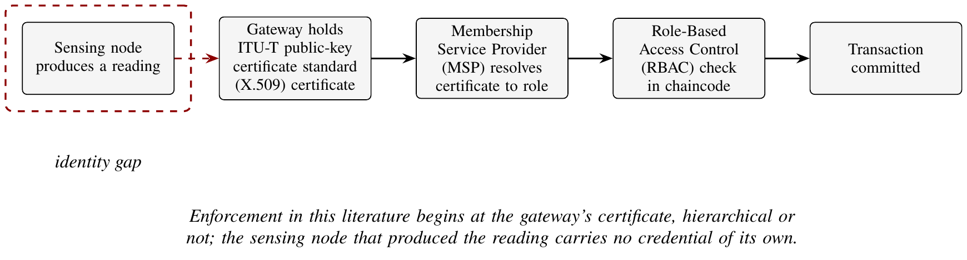
Where identity enforcement begins in the surveyed access-control literature, and the node-level gap it leaves.
On the second thread, privacy in a replicated ledger is structurally difficult: the same replication that gives every consortium member a tamper-evident copy of a record also gives every member a copy of whatever that record discloses. Off-chain storage with an on-chain hash anchor is the common mitigation, verifiable without being world-readable (Zyskind, Nathan, and Pentland 2015), and self-sovereign identity schemes extend the same principle to access itself, letting a data owner grant and revoke visibility without a standing credential (Amraouy, Benbrahim, and Kabbaj 2025). Neither line of work, however, asks whether the transmission layer itself can contribute to confidentiality before a record ever reaches the ledger. Section [subsec:lit_crt] showed why that question is harder than it first looks: reconstruction tolerates a missing residue under Goldreich, Ron and Sudan’s error-tolerant formulation (Goldreich, Ron, and Sudan 1999), but a plain CRT residue is not a randomised secret share, so subset-recovery tolerance does not, by itself, establish subset-disclosure resistance (Shoup 2009). What it establishes instead is a precise condition worth testing rather than assuming: disclosure from an intercepted residue is bounded by how far the plaintext’s domain exceeds the missing moduli’s product, so confidentiality is a property of the deployed moduli-to-domain ratio, not of the reconstruction identity in the abstract. Prior work has developed residue decomposition and threshold secret sharing in separate communities without stating that condition, which is exactly why Chapter One frames it as hypothesis H5 rather than a settled result: the rationale (Section 1.3) proposes residue decomposition as a candidate confidentiality substrate, and H5 requires either a quantified leakage bound for the deployed moduli and sensor ranges, or an added randomisation step, before the substrate can be called established.

d) Blockchain Scalability and the Parallelism Argument
A substantial body of recent work attacks ledger throughput directly, and it matters here because the parallelisation argument we make for the radio link in Chapter Three has an established precedent in this literature: partition a workload, process the parts independently, and pay a bounded cost to recombine them.

2.3.0.0.1 Partitioning and sharding.
Sharding partitions state and transaction load across sub-committees so that disjoint transactions commit concurrently. Recent treatments add adaptive assignment of accounts to shards (Horváth 2025) and survey the cost, chiefly cross-shard coordination, which grows with the fraction of transactions touching more than one partition (Anonymous n.d.). Maiwada et al. (2024) and Maiwada (2025) analyse Bitcoin throughput under transaction-adjournment and related scheduling techniques, reporting the familiar result that raw block-level parallelism is bounded by the serialisation the consensus protocol imposes; an unrelated study of Bitcoin’s own Unspent Transaction Output (UTXO) transaction patterns reaches the same conclusion from the storage side, showing that throughput and storage growth trade against one another however the workload is scheduled (Melo et al. 2024). Layer-two constructions move the work off chain entirely and settle in aggregate (Patel 2023), hierarchical models have been used to characterise where the resulting systems saturate (Lipsa Sadath, Mehrotra, and Kumar 2024), and cloud-hosted blockchain frameworks pursue the same throughput goal by scaling the underlying infrastructure rather than the protocol, trading a capital cost for a scalability one (Anonymous n.d.). Multi-chain architectures, keeping several independent ledgers for different record types and coordinating across them only where required, are a further partitioning strategy outside the classic sharding literature, illustrated by a judicial case-management system that keeps case records and evidentiary records on separate chains (Alyas et al. 2025).

2.3.0.0.2 The common structure of these results.
Every one of these mechanisms decomposes a workload into parts that can be processed independently and recombines the parts afterwards, and in every case the recombination cost is what bounds the gain. That is structurally the same shape as a residue decomposition, where the recombination is Equation [eq:crt_reconstruction] and its cost is $O\left(k\right)$, known in advance and independent of the data, as Section [subsec:lit_crt] observes. None of the scalability studies surveyed here states that parallel explicitly, and none applies a residue decomposition to the workload it partitions; the common structure is, to our knowledge, an observation this review is making by reading the two literatures side by side, not a result either literature has published. Whether the same recombination-bounded-gain argument holds one layer down, applied to a radio link’s channel occupancy rather than a ledger’s transaction load, is a question Chapter Three’s design takes up. Figure 2.6 sets the four instances against the one shared pattern.
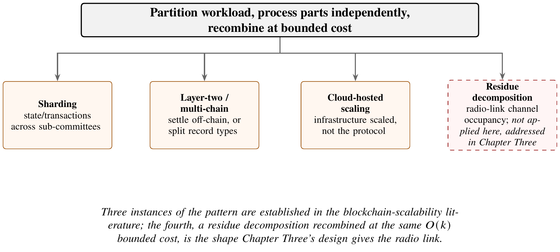
The partition-process-recombine pattern shared by blockchain scalability mechanisms, extended here to the radio link.

e) Residue Arithmetic Beyond Computer Arithmetic
The CRT literature outside computer arithmetic is small but shows the theorem migrating out of its traditional settings. Luo (2023) surveys its modern algebraic forms, including statements over polynomial rings and group-theoretic settings, which establishes that the decomposition is not tied to integer congruences. Seethalakshmi and Spallone (2023) develops an analogue for partitions. Of more direct relevance, Yavuz (2025) uses CRT decomposition together with chaotic maps for reversible data hiding in encrypted images, which is the clearest indication among these sources that residues can carry a confidentiality property and not only an efficiency one. That result is suggestive for hypothesis H5 of Section 1.6, though it is established for a different medium and threat model and cannot be transferred without a fresh argument.
Oktaviansyah, Kurniadi, and Kusuma (2025) combines the theorem with Hensel’s lemma and the fundamental theorem of arithmetic for modular decomposition problems. None of this work applies the decomposition to wireless channel occupancy, which remains the gap identified in Section [subsec:lit_crt].

f) Permissioned Ledgers on Constrained Hardware
Evidence about Hyperledger Fabric outside the datacentre has begun to appear. Zulkarnain, Ramli, and Nordin (2025) benchmarks Fabric across heterogeneous hardware for IoT workloads, and Pebriyanti and Suranegara (2025) evaluates its scalability and resilience, both reporting that throughput falls well below datacentre figures while remaining usable for low-rate telemetry. Kwadzode (2025) compares platforms under financial transaction models, which is a heavier workload than agricultural telemetry and therefore an upper bound on the cost.
Gong et al. (2025) surveys edge-computing architectures for smart agriculture and names communication reliability and multi-dimensional energy constraints as the two bottlenecks that most often defeat field deployments, which matches the framing of Section [subsec:lit_lpwan]. Figure 2.7 reproduces that survey’s own framework, sensing, lightweight edge intelligence and edge-cloud collaboration feeding three agricultural scenarios; a permissioned ledger does not appear as a component at all. What these papers share with the earlier edge literature is that none couples the ledger to the transmission scheme: the radio and the ledger are treated as separate layers with separate budgets.
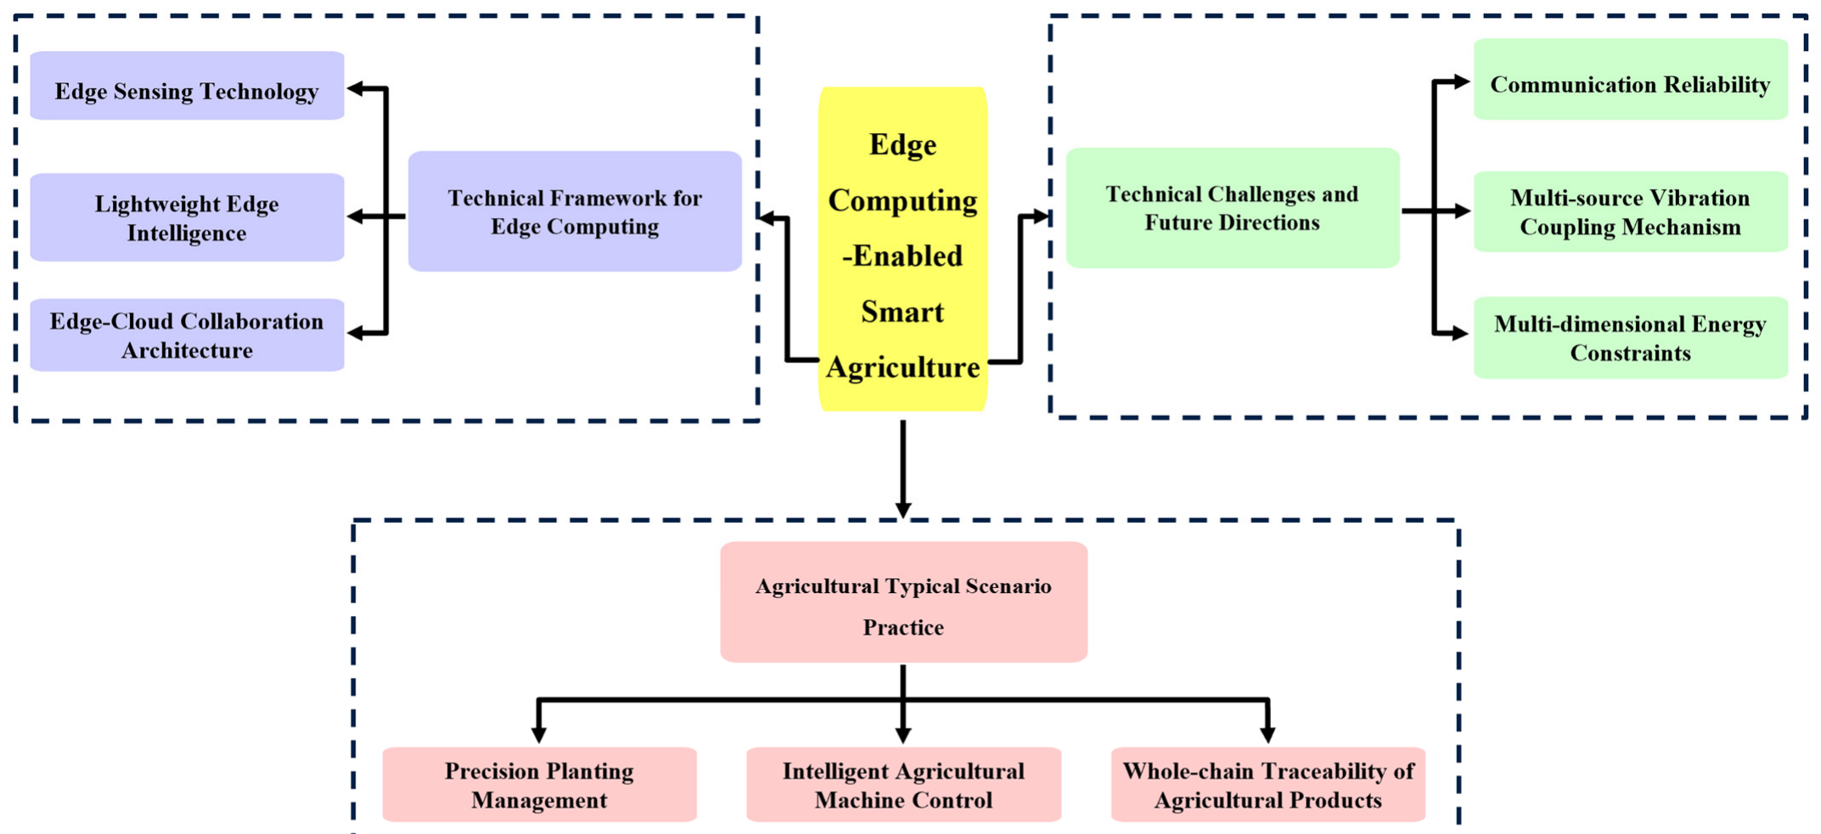
Edge computing framework for smart agriculture, reproduced under CC BY 4.0 from (Gong et al. 2025).

g) Identity, Privacy and Access Control in Adjacent Domains
The most developed treatment of identity and privacy over a permissioned ledger comes from electronic health records, where the regulatory pressure is greatest. F. Tang et al. (2019) proposes an authentication scheme binding records to enrolled principals; Rajput et al. (2019) adds emergency access control with after-the-fact auditability; Yousif, Alsaffar, and Ameen (2026) and Hurdson and Kamaghe (2026) address external sharing without disclosing the underlying record. Kormiltsyn et al. (2023) treats the conflict that arises when personal and institutional records are integrated, which is structurally the same problem as a farmer’s data entering a consortium ledger.
The agricultural instances are thinner but converge on the same requirement. Aliyu and Liu (2023) addresses tampering in farm IoT data, and Safeer et al. (2024) reports a production deployment in the Italian tomato chain. Aouedi et al. (2024) and Sahu and Mazumdar (2024) survey the IoT threat surface and agree that constrained endpoints remain the weakest link, which is the observation Section 1.2 builds on.
Two limits recur across this literature. Authentication is enforced where compute is available, that is at the gateway or the server, not at the sensing node; and confidentiality is obtained by withholding data from the ledger, which reintroduces a trusted party. Neither limit is addressed by a mechanism that operates on the reading in flight.

2.4 Research in Cognate Areas Relevant to the Topic
Three adjacent bodies of work inform our work without belonging to any of the themes surveyed above.
General edge computing and IoT security, beyond agriculture, establishes both the promise and the residual risk of pushing computation to the network edge. Edge processing improves response latency and keeps sensitive data local (S. K. Sharma and Wang 2020; Liu et al. 2019; Xiaofei Wang et al. 2021), and this holds across smart-city and vehicular deployments as much as agricultural ones, a distributed vehicular network architecture built on Merkle-tree-verified blocks being one such example (P. K. Sharma, Moon, and Park 2017). The security side of the same literature catalogues IoT-specific attack surfaces, firmware injection, authentication bypass and physical tampering among them (Farooq et al. 2019; Dorri, Kanhere, and Jurdak 2017; Kalaimathi, Yogeshwaran, and Rajeswari 2025; Kamble, Gunasekaran, and Gawankar 2018; Ferrandez-Pastor et al. 2016; Lezoche et al. 2020), and a smaller literature addresses the specific hardware we deploy, cache and memory-region behaviour on the ESP32 family, relevant to firmware-level integrity rather than network protocol design (Kumari, Singh, and Kumar 2025; Jay 2025; esp-rs Project 2025).
Distributed and parallel computing beyond blockchain supplies the scaling vocabulary used in Section [subsec:lit_consensus] and in Chapter Four: Amdahl’s law bounds the speedup obtainable from parallelising a fixed-size workload by the fraction that remains sequential, a ceiling our strong-scaling analysis of gateway count against transaction throughput invokes directly (Amdahl 1967). Ongoing revocation-latency work in vehicular and other resource-constrained permissioned-blockchain settings similarly treats edge computing as the deployment target rather than the enterprise data centre (Lu et al. 2022), reinforcing the pattern Section [subsec:lit_consensus] identifies: constrained-hardware evaluation is the literature’s exception rather than its default.
Applied hydrology and arid-region agronomy ground our water-efficiency claims outside the networking and ledger literature proper. Global freshwater withdrawal projections identify irrigation as the dominant consumptive use and the primary lever for closing the gap between supply and demand under population growth (Food and Agriculture Organization of the United Nations 2017; United Nations World Water Development Report 2023), and Mediterranean and North African basin studies, including region-specific work on Tunisia (Tunisian Ministry of Agriculture 2022; Fereres and Soriano 2007; Dhaouadi, Besser, and Wassar 2020), quantify the scale of the shortfall our field site sits inside. Crop-specific water-stress and quality studies for tomato and pepper cultivation, the two crops monitored in our deployment, supply the agronomic baselines against which Chapter Four’s yield and water-use results are compared (Boukhriss et al. 2021; Ibáñez et al. 2020; Food and Agriculture Organization 2013; Safeer et al. 2024; Xuewei Wang, Liu, and Chen 2025; Iglesias et al. 2007; Sezen, Yazar, and Eker 2006; Simonne et al. 2006; Patanè and Cosentino 2010; Topcu et al. 2007).

2.5 Critique of Current Literature and Summary of Known Results
Read across the threads surveyed above, the literature is strong on isolated mechanisms and weak on their combination and their field validation. Table 2.4 states this critique per thread in the same form our own contribution (Section 2.7) will answer it.
Critique of current literature by thread, and what remains unestablished
Thread | What the literature establishes | What remains unestablished
Precision agriculture & IoT sensing (§[subsec:lit_precision_ag]) | Sensor-driven scheduling reduces water use; decision-support benefit is replicated across regions | Data-integrity assumptions behind those results are rarely stated or measured; field sensing error budgets are under-reported
LPWAN transmission & energy (§[subsec:lit_lpwan]) | Compression reduces payload; residue decomposition reduces storage and per-node energy in isolation | No prior system uses residue decomposition for concurrent multi-channel reception, the mechanism that governs gateway capacity
RNS / CRT in communications (§[subsec:lit_crt]) | Reconstruction is exact and $O\left(k\right)$; subset recovery tolerates missing residues; parallel decomposition accelerates cryptographic verification | The processor-cycle application and the radio-channel application have not been connected; confidentiality implications of residue disclosure are unexploited
Blockchain / DLT in agriculture (§[subsec:lit_blockchain_ag]) | Hash-chained, replicated ledgers give tamper evidence for agricultural and supply-chain records | Authentication almost universally terminates at the gateway or enterprise boundary, not the sensing node
Edge-resident consensus (§[subsec:lit_consensus]) | CFT/BFT trade-off is well characterised in message complexity; CAP constrains any partitioned deployment | Constrained ARM64 gateway-class evaluation, especially under sustained field load rather than benchmark load, is the exception
Identity, access control & privacy (§[subsec:lit_privacy]) | RBAC/MSP identity binding and role hierarchies are formalised and enforceable in chaincode | Node-level (not gateway-level) identity binding is largely absent; transmission-layer confidentiality is not treated as a design resource
Three cross-cutting patterns follow from the table. First, every thread that reports a resource saving, transmission, storage, or processor cycles, reports it in isolation, with no accounting of what that saving could purchase elsewhere in the same pipeline; Section 1.3 of Chapter One turns this observation into our central rationale. Second, authentication and consensus evaluation both stop at the gateway, leaving the sensing node, the point at which falsification is cheapest, outside the trust boundary the literature actually measures. Third, laboratory and simulated evaluation dominates every thread; sustained field deployment, of the kind Chapter Three’s methodology and Chapter Four’s results describe, is reported by a minority of the studies reviewed here, and by none that combine transmission efficiency, edge consensus and access control in a single system.

2.6 Research Frontiers
Four questions are live in the literature discussed above and unresolved in it.
Whether decomposition can serve efficiency and confidentiality at once. Residue representations are used for throughput in the ledger literature (Horváth 2025; Patel 2023) and, separately, for concealment in the image-security literature (Yavuz 2025). No work discussed here establishes the two properties for a single decomposition under one threat model.
How far identity can be pushed toward the sensor. Every scheme surveyed in Section [subsec:lit_privacy_extended] terminates authentication at a device with meaningful compute. Whether a node with a few kilobytes of free memory can carry a credential strong enough to bind an individual reading, and at what airtime cost, is open.
What permissioned consensus actually costs in the field. Benchmarks now exist for constrained hardware (Zulkarnain, Ramli, and Nordin 2025; Pebriyanti and Suranegara 2025), but they are laboratory measurements. Behaviour under mesh partition, thermal derating and seasonal power variation is reported nowhere in this body of work.
Where the binding constraint sits as deployments grow. Equations [eq:lora_airtime] and [eq:mdOne] are sensitive to different quantities, so node-count and packet-capacity limits bind under different conditions. No validated model in prior work distinguishes them for multi-channel residue traffic.

2.7 The Contribution This Study Will Make to the Literature
Against the gaps summarised in Table 2.4, we contribute the following.
- We connect the processor-cycle application of CRT parallel decomposition that the residue-arithmetic literature establishes (Section [subsec:lit_crt]) to a radio-channel application, showing that Equation [eq:crt_reconstruction] pays for a different resource, airtime rather than CPU cycles, when its parallel targets are a concentrator’s demodulation paths rather than a processor’s cores.
- We extend gateway-terminated identity binding to the sensing node, using the hierarchical RBAC formalisation of Equations [eq:hrbac_eff] and [eq:hrbac_grant] (Appendix 4) together with per-node credentials, so that a ledger record attests to the node that produced a reading rather than only to the gateway that submitted it.
- We report CFT consensus performance measured on ARM64 gateway hardware under sustained field load rather than benchmark or simulated load, addressing the field-validation gap Table 2.3 identifies across the consensus literature.
- We state, and Chapter Four tests as hypothesis H5, the condition under which residue decomposition can serve as a confidentiality substrate rather than merely a transmission optimisation: that disclosure from an intercepted residue is bounded by the ratio between the plaintext domain and the missing moduli’s product, a condition the subset-recovery results of (Goldreich, Ron, and Sudan 1999; Shoup 2009) make precise but do not by themselves establish for any deployed system, connecting the transmission and privacy threads that Section [subsec:lit_privacy] shows have developed separately.
- We report the combined system, transmission, ledger and access control, characterised together on one deployment, rather than each mechanism validated in isolation, which Section 2.5 identifies as the pattern prior work does not yet show.

2.8 Partial Conclusion
The sensing literature has solved measurement and left trust untouched: the reading is believed because it was reported, and no mechanism attests that the value stored is the value measured (Soussi et al. 2024; Aydin and Hall 2021). The transmission literature has correctly identified airtime as the binding constraint and attacks it by shortening payloads, which reduces total volume but not the per-packet occupancy that the duty-cycle and airtime relations of Equations [eq:duty_cycle] and [eq:lora_airtime] are actually sensitive to (Marcelloni and Vecchio 2008, 2010). Residue arithmetic supplies a decomposition whose parallelism has been exploited in silicon and, recently, in ledger throughput, but never on the air (Parhami 2010; Luo 2023; Maiwada 2025). The ledger literature supplies tamper evidence and an identity layer, characterised on hardware that agricultural deployments do not have (Pajooh et al. 2022; Zulkarnain, Ramli, and Nordin 2025). The privacy literature obtains confidentiality by withholding, which forfeits the verifiability that motivated the ledger in the first place (Kormiltsyn et al. 2023; Yousif, Alsaffar, and Ameen 2026).
Taken together these five leave one composite question, which we address in the chapters that follow: whether a decomposition adopted to reduce per-packet occupancy can simultaneously carry node-level identity and bound disclosure, and whether the resulting system holds up on the hardware and under the conditions that field deployment actually imposes.

REFERENCES

3 Worked Reconstruction Example for the Chinese Remainder Theorem
Section [subsec:lit_crt] states Garner’s reconstruction identity (Equation [eq:crt_reconstruction]) in general form. This appendix carries one complete numeric instance through every step, including the modular-inverse computations that Chapter Two states as results, so that the arithmetic underlying Chapter Three’s implementation is checkable by hand.
Take the moduli set $\{97,101,103\}$, pairwise coprime, with product
$$M=97×101×103=1,009,091.$$
A sensor reading of 25.30 °C, scaled by 100 to keep the value integral, gives $x=2530$. Its three residues are
$$\begin{matrix}r_{1} & =2530 mod 97=8, \\ r_{2} & =2530 mod 101=5, \\ r_{3} & =2530 mod 103=58.\end{matrix}$$

3.0.0.0.1 Step 1: partial products.
For each modulus $m_{i}$, $M_{i}=M/m_{i}$:
$$\begin{matrix}M_{1} & =101×103=10,403, \\ M_{2} & =97×103=9,991, \\ M_{3} & =97×101=9,797.\end{matrix}$$

3.0.0.0.2 Step 2: modular inverses.
Each $N_{i}$ satisfies $M_{i}N_{i}≡1 (mod m_{i})$. Reducing $M_{i}$ modulo $m_{i}$ first keeps the inverse search small. For $m_{1}=97$:
$$\begin{matrix}M_{1} mod 97 & =10,403 mod 97=24, \\ 24×93 & =2,232=23×97+1 ⇒ N_{1}=93.\end{matrix}$$
For $m_{2}=101$:
$$\begin{matrix}M_{2} mod 101 & =9,991 mod 101=93, \\ 93×63 & =5,859=58×101+1 ⇒ N_{2}=63.\end{matrix}$$
For $m_{3}=103$:
$$\begin{matrix}M_{3} mod 103 & =9,797 mod 103=12, \\ 12×43 & =516=5×103+1 ⇒ N_{3}=43.\end{matrix}$$
Each inverse is found by inspection here because the moduli are small; the gateway firmware computes the same quantity with the extended Euclidean algorithm, $O\left(logm_{i}\right)$ per modulus, a sub-millisecond cost at this moduli size (Chapter Three reports measured decomposition and reconstruction timings).

3.0.0.0.3 Step 3: reconstruction.
Substituting into Equation [eq:crt_reconstruction]:
$$\begin{matrix}x & =\left(r_{1}M_{1}N_{1}+r_{2}M_{2}N_{2}+r_{3}M_{3}N_{3}\right) mod M \\ & =\left(8×10,403×93+5×9,991×63+58×9,797×43\right) mod 1,009,091 \\ & =2,530,\end{matrix}$$
exact, with zero reconstruction error, recovering 25.30 °C after descaling. Losing any one residue, say $r_{3}$, leaves a unique solution modulo $m_{1}m_{2}=9,797$, which happens to be exact for this particular value because $2,530<9,797$.

3.0.0.0.4 Why that qualifier matters.
It does not generalise to every encoded value the firmware produces. The single-sensor value worked above fits comfortably under any two-modulus product, but the deployed encoding in esp32/main/main.c packs a soil-moisture reading and a temperature bucket into one integer, $x=soil×201+temp_bucket$, precisely so that the full three-modulus budget of Section [subsec:lit_crt] is used; with soil scaled to $\left[0,4095\right]$, $x$ reaches up to $823,295$, which requires all three moduli, since no pair’s product exceeds $10,403$. The gateway’s decode routine (gateway/crt_decode.py) accepts any two residues and returns the smallest non-negative solution modulo their product, documenting that this "matches gateway reassembly for sensor values constrained below the product of the received moduli" rather than guaranteeing correctness in general; for a combined value at or above that product, two-residue decoding returns a different, aliased value rather than signalling failure. This is why the subset-recovery figure the source article reports is a measured $64.1\%$ against a $66.7\%$ theoretical figure for two-of-three recovery, not the $100\%$ that would hold if every encoded value stayed under every two-modulus product; when Chapter Three’s own data-recovery table is written, it should carry the same measured figure rather than a general bound. The subset-recovery property of Section [subsec:lit_crt] is real and exact for values small enough relative to the moduli in play; it is not, as deployed here, a blanket guarantee, and Chapter Three’s treatment of loss resilience should state the recovery rate as measured rather than imply the general bound applies unconditionally.

4 Hierarchical Role-Based Access Control Formalisation and Permission Matrix
Chapter Two’s review of the access-control literature (Section [subsec:lit_privacy]) finds RBAC enforced in chaincode a well-established mechanism, generally terminating at the gateway, but no published, deployed formalisation of a hierarchical role structure with zone and temporal constraints folded into the grant decision itself. This appendix states the formalisation we develop to close that gap and that Chapter Three’s chaincode implements, so that it is available for reference wherever the main chapters invoke it, without presenting our own model as part of the literature under review.
We extend flat RBAC with a role hierarchy expressed as a partial order $≼$ over the role set $R$, where $r_{i}≼r_{j}$ iff $permissions\left(r_{i}\right)⊆permissions\left(r_{j}\right)$, so that a user $u$’s effective permission set in a session is the union across every role dominated by an active role,
$$eff\left(u\right)=\underset{r∈active\left(u\right)}{⋃} \underset{r′≼r}{⋃}pa\left(r′\right),$$
with $pa\left(r\right)$ the permissions directly assigned to role $r$. An access request $\left(u,op,res,t\right)$ is then granted only if an active, non-expired role of $u$ carries the requested permission and the requester’s zone matches the resource’s zone or the requester holds an administrator-issued cross-zone token,
$$∃ r∈active\left(u,t\right):\left(op,res\right)∈eff\left(r\right) ∧ \left(zone\left(u\right)=zone\left(res\right)∨czt\left(u,zone\left(res\right),t\right)\right),$$
which folds zone and temporal constraints directly into the access decision rather than leaving them to an external policy layer. This follows the general tradition of administrative role hierarchies in access-control theory (Lu et al. 2022) and shares its enforcement point, the chaincode’s client-identity check, with the wider Fabric access-control literature (Długosz et al. 2022), but authenticates at the individual sensing node rather than only at the gateway holding the X.509 certificate that signs the transaction. Figure 4.1 shows the resulting enrolment chain, root certificate authority down through gateways to individual sensing nodes.
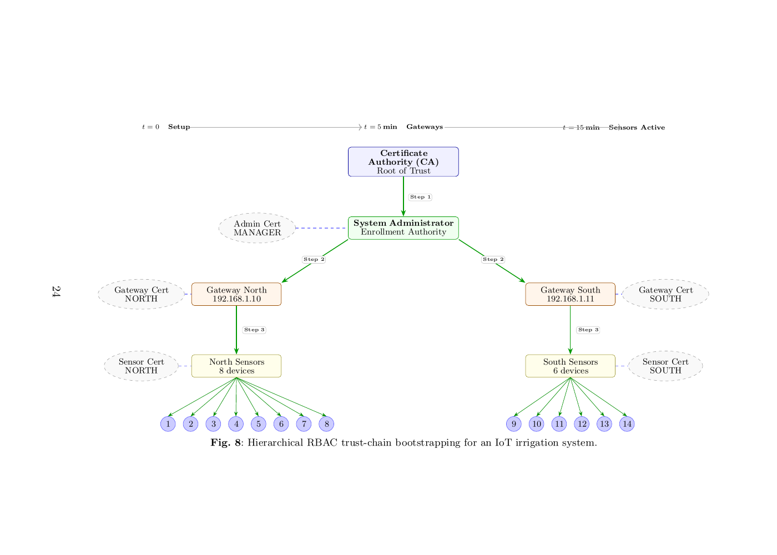
Hierarchical enrolment chain for the seven-role HRBAC model of Equations [eq:hrbac_eff] and [eq:hrbac_grant].
Table 4.1 reproduces the permission assignment $pa\left(r\right)$ for every role and resource Chapter Three’s chaincode governs, so that the effective-permission union in Equation [eq:hrbac_eff] can be checked against a concrete instance.
Permission matrix for agricultural resources across the seven HRBAC roles. own = own zone only, zone = assigned zone, all = all zones, N/A = no access.
Resource | Sensor | Gateway | Farmer | Agron. | Cert. | Supply | Admin
Sensor data | own | zone | all | all | all | N/A | all
Irrigation control | N/A | zone | full | N/A | N/A | N/A | full
Audit logs | N/A | N/A | N/A | N/A | read | N/A | full
Role assignments | N/A | N/A | N/A | N/A | N/A | N/A | full
Cross-zone tokens | N/A | N/A | N/A | N/A | N/A | N/A | issue
Note: Agron. = Agronomist, Cert. = Certification Body, Supply = Supply Chain Partner.
Two rows are worth reading against Equation [eq:hrbac_grant] directly. Sensor data is the only resource every role can reach in some capacity, own-zone write for the sensor itself, zone-scoped read for the gateway, and unrestricted read for the roles that sit above Farmer in the partial order above; this is what makes the zone predicate $zone\left(u\right)=zone\left(res\right)$ load-bearing rather than redundant; without it, every role above Gateway would read every zone’s sensor data by default. Role assignments and cross-zone tokens are reachable only by Admin, which is what closes Equation [eq:hrbac_grant]’s $czt\left(u,zone\left(res\right),t\right)$ predicate: a cross-zone token can only be minted by the one role whose own access is already unrestricted, so the token mechanism widens a requester’s reach without ever widening the set of principals who can create that widening.
Abioye, Emmanuel Abiodun, Mohammad Shukri Zainal Abidin, Mohd Saiful Azimi Mahmud, Salinda Buyamin, Mohamad Hafis Izran Ishak, Muhammad Khairie Idham Abd Rahman, Abdulrahaman Okino Otuoze, Patrick Onotu, and Muhammad Shahrul Azwan Ramli. 2020. “A Review on Monitoring and Advanced Control Strategies for Precision Irrigation.” Computers and Electronics in Agriculture 173: 105441. https://doi.org/10.1016/j.compag.2020.105441.
Adelantado, Ferran, Xavier Vilajosana, Pere Tuset-Peiro, Borja Martinez, Joan Melia-Segui, and Thomas Watteyne. 2017. “Understanding the Limits of LoRaWAN.” IEEE Communications Magazine 55 (9): 34–40. https://doi.org/10.1109/MCOM.2017.1600613.
Aliyu, Ahmed Abubakar, and Jinshuo Liu. 2023. “Blockchain-Based Smart Farm Security Framework for the Internet of Things.” Sensors 23 (18): 7992. https://doi.org/10.3390/s23187992.
Alliance, LoRa. 2021. “LoRaWAN Regional Parameters V1.0.” LoRa Alliance Technical Specification.
Alyas, Tahir, Qaiser Abbas, Sadia Niazi, Saad Said Alqahtany, Turki Alghamdi, Ali Alzahrani, Nadia Tabassum, and Aidarus Mohamed Ibrahim. 2025. “Multi Blockchain Architecture for Judicial Case Management Using Smart Contracts.” Scientific Reports. https://doi.org/10.1038/s41598-025-92842-8.
Amdahl, Gene M. 1967. “Validity of the Single Processor Approach to Achieving Large Scale Computing Capabilities.” In Proceedings of the April 18-20, 1967, Spring Joint Computer Conference, 483–85. ACM. https://doi.org/10.1145/1465482.1465560.
Amraouy, Okacha, Mohammed Benbrahim, and Mohammed Nabil Kabbaj. 2025. “A Blockchain- and Self-Sovereign Identity-Based Collaborative Framework for Secure and Verifiable Cross-Organizational Data Sharing in Smart Irrigation.” Smart Agricultural Technology 12 (December): 101654. https://doi.org/10.1016/j.atech.2025.101654.
Androulaki, Elli, Artem Barger, Vita Bortnikov, Christian Cachin, Konstantinos Christidis, Angelo De Caro, David Enyeart, et al. 2018. “Hyperledger Fabric: A Distributed Operating System for Permissioned Blockchains.” In Proceedings of the 13th EuroSys Conference, 30:1–15. https://doi.org/10.1145/3190508.3190538.
Anonymous. n.d. “An Optimized Cloud Based Blockchain Framework for Enhanced Scalability Security and Energy Efficiency,” n.d.
———. n.d. “Blockchain Based Secured Traceability System for the Agriculture Supply Chain of Ginger in Nepal a Case s,” n.d.
———. n.d. “Blockchain Technology in Agriculture Ensuring Transparency and Traceability in the Food Supply Chain,” n.d.
———. n.d. “Improved DAG in Blockchain Tangle for IOTA,” n.d.
———. n.d. “Scalability Solutions in Blockchain Supported Manufacturing a Survey,” n.d.
———. n.d. “Supply Chain Transparency Exploring Blockchain Solutions for Enhanced Traceability and Efficiency,” n.d.
Aouedi, Ons, Thai-Hoc Vu, Alessio Sacco, Dinh C. Nguyen, Kandaraj Piamrat, Guido Marchetto, and Quoc‐Viet Pham. 2024. “A Survey on Intelligent Internet of Things: Applications, Security, Privacy, and Future Directions.” IEEE Communications Surveys & Tutorials. https://doi.org/10.1109/comst.2024.3430368.
Aqeel-ur-Rehman, Asad Ullah Abbasi, Nizar Islam, and Zubair Ahmed Shaikh. 2014. “A Review of Wireless Sensors and Networks’ Applications in Agriculture.” Computer Standards & Interfaces 36 (2): 263–70. https://doi.org/10.1016/j.csi.2011.03.004.
Aydin, Gokhan, and Michael J. Hall. 2021. “A Comprehensive Review of IoT and Wireless Sensor Networks in Precision Agriculture.” IEEE Access 9: 157733–55. https://doi.org/10.1109/ACCESS.2021.3129552.
Balasubramanian, Dr. Kannan. 2024. “Security of the Secp256k1 Elliptic Curve Used in the Bitcoin Blockchain.” Indian Journal of Cryptography and Network Security. https://doi.org/10.54105/ijcns.a1426.04010524.
Barr, K. C., and K. Asanovic. 2004. “Energy Consumption and Bandwidth in Wireless Sensor Networks.” IEEE Micro 24 (6): 58–68.
Bessani, Alysson, João Sousa, and Eduardo E. Alchieri. 2014. “State Machine Replication for the Masses with BFT-SMART.” IEEE/IFIP International Conference on Dependable Systems and Networks (DSN), 355–62. https://doi.org/10.1109/DSN.2014.43.
Bicamumakuba, Emmanuel, Eliezel Habineza, Samsuzzaman, Md Nasim Reza, and Sun-Ok Chung. 2025. “IoT-Enabled LoRaWAN Gateway for Monitoring and Predicting Spatial Environmental Parameters in Smart Greenhouses: A Review.” Precision Agriculture Science and Technology 28: 28–46. https://doi.org/10.22765/pastj.20250003.
Bogena, Heye R., Johan A. Huisman, Christian Oberdörster, and Harry Vereecken. 2010. “Evaluation of a Low-Cost Soil Water Content Sensor for Wireless Network Applications.” Journal of Hydrology 344 (1): 32–42. https://doi.org/10.1016/j.jhydrol.2007.06.032.
Bor, Martin C., Utz Roedig, Thiemo Voigt, and Juan M. Alonso. 2016. “Do LoRa Low-Power Wide-Area Networks Scale?” In Proceedings of the 19th ACM International Conference on Modeling, Analysis and Simulation of Wireless and Mobile Systems (MSWiM), 59–67. ACM. https://doi.org/10.1145/2988287.2989163.
Bosona, Techane, and Girma Gebresenbet. 2023. “The Role of Blockchain Technology in Promoting Traceability Systems in Agri-Food Production and Supply Chains.” Sensors 23 (11): 5342. https://doi.org/10.3390/s23115342.
Botta, Alessio, Walter de Donato, Valerio Persico, and Antonio Pescapé. 2016. “Integration of Cloud Computing and Internet of Things: A Survey.” Future Generation Computer Systems 56: 684–700. https://doi.org/10.1016/j.future.2015.09.021.
Bouaziz, Maha, Abderrezak Rachedi, and Aref Belghith. 2020. “A Study of LoRaWAN Protocol Performance for IoT Applications in Smart Agriculture.” Computer Communications 164: 148–57. https://doi.org/10.1016/j.comcom.2020.10.009.
Boukhriss, Monia, Arwa Marzouk, Ines Cherif, Badr Gaalich, Tarek Triki, and Nihed Zoghlami. 2021. “Effects of Water Deficit on Growth, Physiology and Fruit Quality Traits of Two Contrasting Tomato (Solanum lycopersicum l.) Genotypes.” Agriculture 11 (10): 927. https://doi.org/10.3390/agriculture11100927.
Brewer, Eric A. 2000. “Towards Robust Distributed Systems.” In Proceedings of the 19th Annual ACM Symposium on Principles of Distributed Computing (PODC), 7.
Buttigieg, Victor, Reuben A. Farrugia, and Christoph Zammit-Mangion. 2014. “Improving Lifetime in Wireless Sensor Networks Using the Residue Number System.” IET Wireless Sensor Systems 4 (2): 73–79. https://doi.org/10.1049/iet-wss.2013.0025.
Casino, Fran, Thomas K. Dasaklis, and Constantinos Patsakis. 2019. “A Systematic Literature Review of Blockchain-Based Applications: Current Status, Classification and Open Issues.” Telematics and Informatics 36: 55–81. https://doi.org/10.1016/j.tele.2018.11.006.
Castro, Miguel, and Barbara Liskov. 1999. “Practical Byzantine Fault Tolerance.” In Proceedings of the Third Symposium on Operating Systems Design and Implementation (OSDI), 173–86.
Centenaro, Marco, Lorenzo Vangelista, Andrea Zanella, and Michele Zorzi. 2016. “Long-Range Communications in Unlicensed Bands: The LoRa Technology.” IEEE Wireless Communications 23 (5): 12–18.
Chapungo, Nelson José, and Octavian Postolache. 2025. “Experimental Evaluation of LoRaWAN Connectivity Reliability in Remote Rural Areas of Mozambique.” Sensors 25 (19): 6027. https://doi.org/10.3390/s25196027.
Chlingaryan, Anna, Salah Sukkarieh, and Brett Whelan. 2018. “Machine Learning Approaches for Crop Yield Prediction and Nitrogen Status Estimation in Precision Agriculture: A Review.” Computers and Electronics in Agriculture 151: 61–69. https://doi.org/10.1016/j.compag.2018.05.012.
Christidis, Konstantinos, and Michael Devetsikiotis. 2016. “Blockchains and Smart Contracts for the Internet of Things.” IEEE Access 4: 2292–2303.
Community, Stack Overflow. 2016. “What If Dictionary Size in LZW Algorithm Is Full?” Stack Overflow. https://stackoverflow.com/questions/40054218/what-if-dictionary-size-in-lzw-algorithm-is-full.
Dhaouadi, Latifa, Houda Besser, and Fatma Wassar. 2020. “Agriculture Sustainability in Arid Lands of Southern Tunisia: Ecological Impacts of Irrigation Water Quality and Human Practices.” Irrigation and Drainage 69: 974–96. https://doi.org/10.1002/ird.2492.
Ding, Cunsheng, Dingyi Pei, and Arto Salomaa. 1996. Chinese Remainder Theorem: Applications in Computing, Coding, Cryptography. World Scientific Publishing. https://doi.org/10.1142/2893.
Długosz, Pawel et al. 2022. “Hyperledger Fabric Access Control System for IoT Layer in Blockchain-Based Applications.” Sensors 22 (20): 5981–95. https://doi.org/10.3390/s22205981.
Dono, Gabriele, Luca Giraldo, and Simone Severini. 2010. “The Irrigation of Agricultural Land in Italy: Main Economic Implications and Effects in an Ongoing Climate Change.” Agricultural Water Management 97 (7): 949–57. https://doi.org/10.1016/j.agwat.2010.01.025.
Dorri, Ali, Salil S. Kanhere, and Raja Jurdak. 2017. “Blockchain in Internet of Things: Challenges and Solutions.” IEEE Communications Surveys & Tutorials 19 (3): 1397–1408. https://doi.org/10.1109/COMST.2017.2694144.
Dorri, Ali, Salil S. Kanhere, Raja Jurdak, and Praveen Gauravaram. 2017. “Blockchain for IoT Security and Privacy: The Case Study of a Smart Home.” 2017 IEEE International Conference on Pervasive Computing and Communications Workshops (PerCom Workshops), 618–23. https://doi.org/10.1109/PERCOMW.2017.7917634.
esp-rs Project. 2025. “Cache Management and Memory Barriers: Esp-Hal Documentation.” DeepWiki. https://deepwiki.com/esp-rs/esp-hal/8.3-cache-management-and-memory-barriers.
Evans, R. G., W. M. Iversen, and Y. Kim. 2008. “Integration of Wireless Sensor Network with Variable Rate Irrigation Technology.” Proceedings of the ASABE Annual International Meeting 12: 1–13.
Farooq, M. S., Shamyla Riaz, Adnan Abid, Kashif Abid, and M. A. Naeem. 2019. “A Survey on the Role of IoT in Agriculture for the Implementation of Smart Farming.” IEEE Access 7: 156237–71. https://doi.org/10.1109/ACCESS.2019.2949703.
Fereres, Elias, and María Auxiliadora Soriano. 2007. “Deficit Irrigation for Reducing Agricultural Water Use.” Journal of Experimental Botany 58 (2): 147–59. https://doi.org/10.1093/jxb/erl165.
Ferrag, M. A., L. Shu, and M. Debbah. 2020. “Blockchain Technologies for the Internet of Things: Research Issues and Challenges.” IEEE Internet of Things Journal 7 (10): 10288–313. https://doi.org/10.1109/JIOT.2020.2984478.
Ferrag, Mohamed Amine, Lei Shu, Xianjun Yang, Abdelouahid Derhab, and Leandros Maglaras. 2020. “Security and Privacy for Green IoT-Based Agriculture: Review, Blockchain Solutions, and Challenges.” IEEE Access 8: 32031–53. https://doi.org/10.1109/ACCESS.2020.2973178.
Ferrandez-Pastor, Francisco-Javier, Juan-Manuel Garcia-Chamizo, Mario Nieto-Hidalgo, Joselito Mora-Pascual, and Jose Mora-Martinez. 2016. “Developing Ubiquitous Sensor Network Platform Using Internet of Things: Application in Precision Agriculture.” Sensors 16 (7): 1141. https://doi.org/10.3390/s16071141.
Food and Agriculture Organization. 2013. “Good Agricultural Practices for Greenhouse Tomato Production.” FAO Plant Production and Protection Paper.
Food and Agriculture Organization of the United Nations. 2017. “The Future of Food and Agriculture: Trends and Challenges.” http://www.fao.org/3/a-i6583e.pdf.
forcha, Glen beloa, Michael Ekonde Sone, Elie Fute Tagne, and André Paul ASSE MVOGO. 2026. “CRT-Based Parallel Residue Transmission for Distributed Edge Blockchain Computing: A Scalable IoT Cluster Architecture for Arid Agriculture.” ". https://doi.org/10.21203/rs.3.rs-9070688/v1.
Frustaci, Mario, Pasquale Pace, Gianluca Aloi, and Giancarlo Fortino. 2018. “Evaluating Critical Security Issues of the IoT World: Present and Future Challenges.” IEEE Internet of Things Journal 5 (4): 2483–95. https://doi.org/10.1109/JIOT.2017.2767291.
Galvez, Juan F., Javier Mejuto, and Jesus Simal-Gandara. 2018. “Future Challenges on the Use of Blockchain for Food Traceability Analysis.” TrAC Trends in Analytical Chemistry 107: 222–32. https://doi.org/10.1016/j.trac.2018.08.011.
García, Laura, Lorena Parra, Jose M. Jimenez, Jaime Lloret, and Pascal Lorenz. 2020. “IoT-Based Smart Irrigation Systems: An Overview on the Recent Trends on Sensors and IoT Systems for Irrigation in Precision Agriculture.” Sensors 20 (4): 1042. https://doi.org/10.3390/s20041042.
Garner, Harvey L. 1959. “The Residue Number System.” IRE Transactions on Electronic Computers EC-8 (2): 140–47. https://doi.org/10.1109/TEC.1959.5219515.
Ge, Li, Christopher Brewster, Jacco Spek, Anton Smeenk, and Jan Top. 2017. “Blockchain for Agriculture and Food: Findings from the Pilot Study.” Wageningen Economic Research Report 2017-112: 1–66. https://doi.org/10.18174/426747.
Gebbers, Robin, and Viacheslav I. Adamchuk. 2010. “Precision Agriculture and Food Security.” Science 327 (5967): 828–31. https://doi.org/10.1126/science.1183899.
Gilbert, Seth, and Nancy Lynch. 2002. “Brewer’s Conjecture and the Feasibility of Consistent, Available, Partition-Tolerant Web Services.” ACM SIGACT News 33 (2): 51–59. https://doi.org/10.1145/564585.564601.
Goap, Amarendra, Dinesh Sharma, A. K. Shukla, and C. Rama Krishna. 2018. “An IoT Based Smart Irrigation Management System Using Machine Learning and Open Source Technologies.” Computers and Electronics in Agriculture 155: 41–49. https://doi.org/10.1016/j.compag.2018.09.040.
Goldreich, Oded, Dana Ron, and Madhu Sudan. 1999. “Chinese Remaindering with Errors.” In Proceedings of the 31st Annual ACM Symposium on Theory of Computing, 225–34. https://doi.org/10.1145/301250.301308.
Gondchawar, Nikesh, and R. S. Kawitkar. 2016. “IOT Based Smart Agriculture.” International Journal of Advanced Research in Computer and Communication Engineering 5 (6): 838–42.
Gong, Ran, Hongyang Zhang, Gang Li, and Jiamin He. 2025. “Edge Computing-Enabled Smart Agriculture: Technical Architectures, Practical Evolution, and Bottleneck Breakthroughs.” Sensors 25 (17): 5302. https://doi.org/10.3390/s25175302.
Gonzalez, R., and M. Horowitz. 2000. “Energy and Delay: A Metric for Early Design Space Exploration.” IEEE Micro 20 (5): 56–64. https://doi.org/10.1109/40.877952.
Gorenflo, Christian, Stephen Lee, Lukasz Golab, and Srinivasan Keshav. 2020. “FastFabric: Scaling Hyperledger Fabric to 20,000 Transactions Per Second.” International Journal of Network Management 30 (5): e2099. https://doi.org/10.1002/nem.2099.
Gubbi, Jayavardhana, Rajkumar Buyya, Slaven Marusic, and Marimuthu Palaniswami. 2013. “Internet of Things (IoT): A Vision, Architectural Elements, and Future Directions.” Future Generation Computer Systems 29 (7): 1645–60.
Hammi, Mohamed Tahar, Badis Hammi, Patrick Bellot, and Ahmed Serhrouchni. 2018. “Bubbles of Trust: A Decentralized Blockchain-Based Authentication System for IoT.” Computers & Security 78: 126–42. https://doi.org/10.1016/j.cose.2018.06.004.
Hang, Lei, and Do-Hyeun Kim. 2019. “Design and Implementation of an Integrated IoT Blockchain Platform for Sensing Data Integrity.” Sensors 19 (10): 2228. https://doi.org/10.3390/s19102228.
Haque, Abu Bakar, Bharat Bhushan, and Gaurav Dhiman. 2024. “Conceptualizing Smart City Applications: Requirements, Architecture, Security Issues, and Emerging Trends.” Expert Systems 41 (5): e13382. https://doi.org/10.1111/exsy.13382.
Hardy, Godfrey Harold, Edward Maitland Wright, Roger Heath-Brown, and Joseph Silverman. 2008. An Introduction to the Theory of Numbers. 6th ed. Oxford University Press.
Haxhibeqiri, Jetmir, Eli De Poorter, Ingrid Moerman, and Jeroen Hoebeke. 2018. “A Survey of LoRaWAN for IoT: From Technology to Application.” Sensors 18 (11): 3995. https://doi.org/10.3390/s18113995.
Heinzelman, Wendi Rabiner, Anantha Chandrakasan, and Hari Balakrishnan. 2000. “Energy-Efficient Communication Protocol for Wireless Microsensor Networks.” In Proceedings of the 33rd Annual Hawaii International Conference on System Sciences, 10–20. https://doi.org/10.1109/HICSS.2000.926982.
Horváth, Dr. Eva. 2025. “AI-Assisted Sharding Techniques for Blockchain Scalability.” Scientific Journal of Artificial Intelligence and Blockchain Technologies. https://doi.org/10.63345/sjaibt.v2.i1.102.
Huffman, David A. 1952. “A Method for the Construction of Minimum-Redundancy Codes.” Proceedings of the IRE 40 (9): 1098–1101.
Hung, Le Thanh, Seungwoo Kang, and Jaeseung Song. 2022. “Distributed Control Architecture for Blockchain-Based IoT Water Quality Monitoring.” IEEE Access 10: 101528–39. https://doi.org/10.1109/ACCESS.2022.3208440.
Hurdson, Happyness, and Juliana Kamaghe. 2026. “Enhancing Electronic Medical Records Privacy in Tanzania: A Blockchain-Based Framework.” HURIA JOURNAL OF THE OPEN UNIVERSITY OF TANZANIA. https://doi.org/10.61538/huria.v33i2.2111.
Hyperledger Fabric Documentation. 2022. “MSP Identity Validity Rules.” https://hyperledger-fabric.readthedocs.io/en/release-2.2/msp-identity-validity-rules.html.
Ibáñez, M. Victoria, M. Dolores Muy-Rangel, Gustavo A. González-Aguilar, and J. Basilio Heredia. 2020. “Capsicum Production and Quality: A Review.” HortScience 55 (9): 1353–68. https://doi.org/10.21273/HORTSCI15060-20.
IBM. 2023. “Hyperledger Fabric Overview.” https://www.ibm.com/docs/en/blockchain-platform.
Iglesias, Ana, and Luis Garrote. 2015. “Adaptation Strategies for Agricultural Water Management Under Climate Change in Europe.” Agricultural Water Management 155: 113–24. https://doi.org/10.1016/j.agwat.2015.03.014.
Iglesias, Ana, Luis Garrote, Francisco Flores, and Mercedes Moneo. 2007. “Challenges to Manage the Risk of Water Scarcity and Climate Change in the Mediterranean.” Water Resources Management 21 (5): 775–88. https://doi.org/10.1007/s11269-006-9111-6.
Jagan Mohan, R. N. V., P. S. Pravallika Sree Rayanoothala, and R. P. R. Praneetha Sree. 2026. “Smart Agriculture 5.0: Blockchain and Reinforcement Learning Synergy for Multicropping Optimization and Traceable IoT-Enabled Supply Chains.” Frontiers in Blockchain 9: 1766232. https://doi.org/10.3389/fbloc.2026.1766232.
Jay, Cris. 2025. “ESP32S3 Cache Block Diagram and Operations.” CSDN Blog. https://blog.csdn.net/Cris_Jay/article/details/147540172.
Jin, Peng, Wenshuang Du, and Wenquan Jin. 2025. “Efficient Productivity Prediction Model Based on Edge Data Compression in Smart Farms.” Smart Agricultural Technology 12 (December): 101242. https://doi.org/10.1016/j.atech.2025.101242.
Kalaimathi, R., A. Yogeshwaran, and P. Rajeswari. 2025. “Identifying False Injection Packet Transmission Using SVM and Secure OLSR in Wireless Sensor Networks.” In 4th International Conference on Distributed Computing and Electrical Circuits and Electronics (ICDCECE), 1–7. IEEE. https://doi.org/10.1109/ICDCECE65353.2025.11035330.
Kamble, Sachin S., Angappa Gunasekaran, and Shradha A. Gawankar. 2018. “Sustainable Industry 4.0 Framework: A Systematic Literature Review Identifying the Current Trends and Future Perspectives.” Process Safety and Environmental Protection 117: 408–25. https://doi.org/10.1016/j.psep.2018.05.009.
Kamilaris, Andreas, Agusti Fonts, and Francesc X. Prenafeta-Boldó. 2019. “The Rise of Blockchain Technology in Agriculture and Food Supply Chains.” Trends in Food Science & Technology 91: 640–52. https://doi.org/10.1016/j.tifs.2019.07.034.
Kaur, Manpreet. 2020. “Explained: Chaincode in Hyperledger Fabric.” Medium.
Kjellsson, Jesper, and Avideh Zakhor. 2008. “Adaptive Sampling for Sensor Networks.” ACM Transactions on Sensor Networks 4 (3): 1–39. https://doi.org/10.1145/1362542.1362545.
Knuth, Donald E. 1997. The Art of Computer Programming, Volume 2: Seminumerical Algorithms. 3rd ed. Addison-Wesley Professional.
Kormiltsyn, Aleksandr, Vimal Dwivedi, Chibuzor Udokwu, and Alex Norta. 2023. “Privacy-Conflict Resolution for Integrating Personal- and Electronic Health Records in Blockchain-Based Systems.” Blockchain in Healthcare Today. https://doi.org/10.30953/bhty.v6.276.
Krstić, Marija, and Lazar Krstić. 2020. “Hyperledger Frameworks with a Special Focus on Hyperledger Fabric.” Vojnotehnicki Glasnik. https://doi.org/10.5937/vojtehg68-26206.
Kumar, Ajit, and Om Prakash Roy. 2024. “Collaborative Networks: Integrating Blockchain for Enhanced Trust and Transparency.” International Journal of Innovative Science and Research Technology (IJISRT). https://doi.org/10.38124/ijisrt/ijisrt24jul180.
Kumari, Saru, Rajeev Singh, and Amit Kumar. 2025. “Building Trust in IoT Networks: A ROM-Based Key Storage and Cloud Signature Verification Approach.” In 2025 IEEE International Conference on Internet of Things (iThings), 1–8. IEEE. https://doi.org/10.1109/IOT.2025.11089136.
Kwadzode, Dennis Deladem. 2025. “Performance Comparison of Blockchain Platforms for Modeling Financial Transactions: A Case Study of Ethereum and Hyperledger Fabric.” International Journal of Finance, Economics and Business. https://doi.org/10.56225/ijfeb.v4i1.423.
Lezoche, Mario, Jorge E. Hernandez, Maria del Mar E. Alemany Diaz, Hervé Panetto, and Janusz Kacprzyk. 2020. “Agri-Food 4.0: A Survey of the Supply Chains and Technologies for the Future Agriculture.” Computers in Industry 117: 103187. https://doi.org/10.1016/j.compind.2020.103187.
Li, Shancang, Li Da Xu, and Shanshan Zhao. 2018. “5G Internet of Things: A Survey.” Journal of Industrial Information Integration 10: 1–9. https://doi.org/10.1016/j.jii.2018.01.005.
Li, Shancang, Jie Li, Jia Liu, Hao Wang, and Shanshan Zhao. 2020. “Performance Analysis of LoRa Networks for Smart Agriculture.” IEEE Internet of Things Journal 7 (10): 10045–57. https://doi.org/10.1109/JIOT.2020.2999323.
Lin, Jian, Zhiqi Shen, Anting Zhang, and Yi Chai. 2018. “Blockchain and IoT Based Food Traceability System for Smart Agriculture.” In Proceedings of the 3rd International Conference on Crowd Science and Engineering, 1–6. https://doi.org/10.1145/3265689.3265692.
Lin, J., Z. Shen, A. Zhang, and Y. Chai. 2018. “Blockchain and IoT Based Food Traceability for Smart Agriculture.” Proceedings of the 3rd International Conference on Crowd Science and Engineering, 1–6. https://doi.org/10.1145/3265689.3265692.
Lipsa Sadath, MCA, MSc, Deepti Mehrotra, and Anand Kumar. 2024. “Scalability Performance Analysis of Blockchain Using Hierarchical Model in Healthcare.” Blockchain in Healthcare Today. https://doi.org/10.30953/bhty.v7.295.
Liu, Yang, Cheng Yang, Li Jiang, Shengli Xie, and Yan Zhang. 2019. “Intelligent Edge Computing for IoT-Based Energy Management in Smart Cities.” IEEE Network 33 (2): 111–17. https://doi.org/10.1109/MNET.2019.1800254.
Lu, Zhihua, Wei Wang, Xiaoyu Zhang, and Lin Chen. 2022. “Reducing Revocation Latency in IoV Using Edge Computing and Permissioned Blockchain.” In 2022 IEEE International Conference on Blockchain (Blockchain), 345–52. IEEE. https://doi.org/10.1109/Blockchain55522.2022.00055.
Luo, Qinnan. 2023. “Research and Application of Chinese Remainder Theorem.” Theoretical and Natural Science. https://doi.org/10.54254/2753-8818/9/20240711.
Maiwada, Umar Danjuma. 2025. “Blockchain Scalability Analysis and Improvement of Bitcoin Network Through Enhanced Transaction Adjournment Techniques.” Wasit Journal of Computer and Mathematics Science. https://doi.org/10.31185/wjcms.298.
Maiwada, Umar Danjuma, Muhammad Muntassir Yakubu, Abubakar Danjuma Maiwada, Jameel Shehu Yalli, and Izaddeen Kabir Yakasai. 2024. “Techniques to Improve 5G Blockchain Scalability Issues Through an Analysis of a Blockchain Scalability.” International Journal of Data Informatics and Intelligent Computing. https://doi.org/10.59461/ijdiic.v3i4.134.
Mao, Dandan, Zhenning Hao, Fan Wang, and Hao Li. 2018. “Innovative Blockchain-Based Approach for Sustainable and Credible Environment in Food Trade: A Case Study in Shandong Province, China.” Sustainability 10 (9): 3149. https://doi.org/10.3390/su10093149.
Marcelloni, Francesco, and Massimo Vecchio. 2008. “A Simple Algorithm for Data Compression in Wireless Sensor Networks.” IEEE Communications Letters 12 (6): 411–13. https://doi.org/10.1109/LCOMM.2008.080300.
———. 2010. “An Efficient Lossless Compression Algorithm for Periodic Data in Wireless Sensor Networks.” The Computer Journal 53 (6): 822–33. https://doi.org/10.1093/comjnl/bxp118.
McBratney, Alex, Brett Whelan, and Tiho Ancev. 2005. “Future Directions of Precision Agriculture.” Precision Agriculture 6: 7–23. https://doi.org/10.1007/s11119-005-0681-8.
Melo, David, Saúl Eduardo Pomares-Hernández, Lil María Xibai Rodríguez-Henríquez, and Julio César Pérez-Sansalvador. 2024. “Unlocking Blockchain UTXO Transactional Patterns and Their Effect on Storage and Throughput Trade-Offs.” Computers. https://doi.org/10.3390/computers13060146.
Merkle, Ralph C. 1988. “A Digital Signature Based on a Conventional Encryption Function.” Lecture Notes in Computer Science 293: 369–78. https://doi.org/10.1007/3-540-48184-2_32.
Mohanty, Sharada P., David P. Hughes, and Marcel Salathé. 2016. “Using Deep Learning for Image-Based Plant Disease Detection.” Frontiers in Plant Science 7: 1419. https://doi.org/10.3389/fpls.2016.01419.
Molina-Cuevas, Alexander, William Quijano-Velasco, and Antonio Guerrero-González. 2021. “Low-Cost IoT-Based Soil Monitoring System: Design and Accuracy Assessment.” Sensors 21 (23): 7964. https://doi.org/10.3390/s21237964.
Network, The Things. 2024. “EU868 LoRaWAN Frequency Plan.” TTN Documentation.
Oktaviansyah, Eka, Edi Kurniadi, and Dianne Amor Kusuma. 2025. “HYBRIDIZING HENSEL’s LEMMA, FUNDAMENTAL THEOREM OF ARITHMETIC, AND CHINESE REMAINDER THEOREM FOR SOLVING POLYNOMIAL CONGRUENCES.” BAREKENG: Jurnal Ilmu Matematika Dan Terapan. https://doi.org/10.30598/barekengvol20iss1pp0853-0864.
Ongaro, Diego, and John Ousterhout. 2014. “In Search of an Understandable Consensus Algorithm.” USENIX Annual Technical Conference, 305–19.
Pajooh, Houshyar Honar, Mohammad A. Rashid, Fakhrul Alam, and Serge Demidenko. 2022. “Experimental Performance Analysis of a Scalable Distributed Hyperledger Fabric for a Large-Scale IoT Testbed.” Sensors 22 (13): 4868. https://doi.org/10.3390/s22134868.
Parhami, Behrooz. 2010. Computer Arithmetic: Algorithms and Hardware Designs. 2nd ed. Oxford University Press.
Patanè, Cristina, and Salvatore L. Cosentino. 2010. “Effects of Soil Water Deficit on Yield and Quality of Processing Tomato Under a Mediterranean Climate.” Agricultural Water Management 97 (1): 131–38. https://doi.org/10.1016/j.agwat.2009.08.021.
Patel, Ohm. 2023. “Blockchain Layer 2 Rollups, Optimistic Vs Zero Knowledge.” INTERNATIONAL JOURNAL OF ADVANCED RESEARCH IN ENGINEERING AND TECHNOLOGY. https://doi.org/10.34218/ijaret.14.2.002.
Patil, Akshay S., Bayu Adhi Tama, YoungHo Park, and Kyung-Hyune Rhee. 2022. “A Framework for Blockchain-Based Smart Farming System Using IoT.” IEEE Access 10: 6845–62. https://doi.org/10.1109/ACCESS.2022.3142563.
Pebriyanti, Cahyani, and Galura Muhammad Suranegara. 2025. “Evaluation of Scalability and Resilience of Hyperledger Fabric in Blockchain Implementation for Diploma Management.” Journal of Applied Informatics and Computing. https://doi.org/10.30871/jaic.v9i3.9262.
Pereira, Luis Santos, Theib Oweis, and Akissa Zairi. 2002. “Irrigation Management Under Water Scarcity.” Agricultural Water Management 57 (3): 175–206. https://doi.org/10.1016/S0378-3774(02)00075-6.
Pierce, Francis J., and Peter Nowak. 1999. “Aspects of Precision Agriculture.” Advances in Agronomy 67: 1–85. https://doi.org/10.1016/S0065-2113(08)60513-1.
Polastre, Joseph, Jason Hill, and David Culler. 2004. “Versatile Low Power Media Access for Wireless Sensor Networks.” Proceedings of the 2nd International Conference on Embedded Networked Sensor Systems, 95–107.
Pourbigharaz, Farideh, and Hossein M. Yassine. 1994. “Modulo-Free Architecture for Binary to Residue Number System Conversion for Moduli Set $\{2^{n},2^{n}−1,2^{n−1}−1\}$.” 1994 IEEE International Symposium on Circuits and Systems (ISCAS) 2: 317–20. https://doi.org/10.1109/ISCAS.1994.408967.
Pritchett, Dan. 2008. “BASE: An ACID Alternative.” Queue 6 (3): 48–55. https://doi.org/10.1145/1394127.1394128.
Rahman, Md Atiqur, Faisal Hamzah, and Ghazanfar Ali Safdar. 2022. “Residue Number System-Based Approach to Minimise Energy Consumption in Wireless Sensor Networks.” IEEE Access 10: 51432–44. https://doi.org/10.1109/ACCESS.2022.3146851.
Raj, Emilin Renu, and D. V. Prasad. 2017. “A Comprehensive Study on LoRa Technology for Wireless Sensor Networks.” International Journal of Advanced Research in Computer Science 8 (5): 1214–19.
Rajput, Ahmed Raza, Qianmu Li, Milad Taleby Ahvanooey, and Isma Masood. 2019. “EACMS: Emergency Access Control Management System for Personal Health Record Based on Blockchain.” IEEE Access. https://doi.org/10.1109/access.2019.2917976.
Rama, R., V. Kanchana, N. Sivasankari, and S. Prabha. 2021. “A Systematic Review of Blockchain Technology for Agriculture Supply Chain Management.” Materials Today: Proceedings 47: 3148–54. https://doi.org/10.1016/j.matpr.2021.06.253.
Rathi, M., and C. Gomathy. 2025. “Smart Agriculture Resource Allocation and Energy Optimization Using Bidirectional Long Short-Term Memory with Ant Colony Optimization (Bi-LSTM–ACO).” Frontiers in Communications and Networks 6: 1587402. https://doi.org/10.3389/frcmn.2025.1587402.
Reyna, A., C. Martín, J. Chen, E. Soler, and M. Díaz. 2018. “On Blockchain and Its Integration with IoT: Challenges and Opportunities.” Future Generation Computer Systems 88: 173–90. https://doi.org/10.1016/j.future.2018.05.046.
Safeer, Sajid, Paolo Ricciardi, Alessandro Romano, and Guido Russo. 2024. “Blockchain-Backed Sustainable Management of the Italian Tomato Processing Industry.” Agriculture 14 (7): 1120. https://doi.org/10.3390/agriculture14071120.
Sahu, Swastik Kumar, and Kaushik Mazumdar. 2024. “Exploring Security Threats and Solutions Techniques for Internet of Things (IoT): From Vulnerabilities to Vigilance.” Frontiers in Artificial Intelligence. https://doi.org/10.3389/frai.2024.1397480.
Salah, Khaled, Nishara Nizamuddin, Raja Jayaraman, and Mohammed Omar. 2019. “Blockchain-Based Soybean Traceability in Agricultural Supply Chain.” IEEE Access 7: 73295–305. https://doi.org/10.1109/ACCESS.2019.2918000.
Salomon, David. 2007. Data Compression: The Complete Reference. Springer Science & Business Media.
Sanchez, Sergio, Sylvie Blanc, Pedro Yuste, and Juan J. Serrano. 2021. “Energy-Efficient Data Transmission in Wireless Sensor Networks for Precision Agriculture.” Sensors 21 (4): 1209. https://doi.org/10.3390/s21041209.
Seethalakshmi, Kayanattath, and Steven Spallone. 2023. “A Chinese Remainder Theorem for Partitions.” The Ramanujan Journal. https://doi.org/10.1007/s11139-023-00699-0.
Semtech Corporation. 2015. LoRa Modem Designer’s Guide.
Sezen, S. M., A. Yazar, and S. Eker. 2006. “Effect of Drip and Sprinkler Irrigation on Yield and Quality of Field Grown Bell Pepper.” Agricultural Water Management 81 (1–2): 115–31. https://doi.org/10.1016/j.agwat.2005.04.008.
Sharma, Pradip Kumar, Seo Yeon Moon, and Jong Hyuk Park. 2017. “Block-VN: A Distributed Blockchain Based Vehicular Network Architecture in Smart City.” JIPS: Journal of Information Processing Systems 13 (1): 184–95. https://doi.org/10.3745/JIPS.04.0022.
Sharma, Sandeep K., and Xianbin Wang. 2020. “Live Data Analytics with Collaborative Edge and Cloud Processing in Wireless IoT Networks.” IEEE Internet of Things Journal 7 (7): 6071–84. https://doi.org/10.1109/JIOT.2020.2977767.
Shoup, Victor. 2009. A Computational Introduction to Number Theory and Algebra. 2nd ed. Cambridge University Press.
Simonne, Eric, David W. Studstill, Robert C. Hochmuth, Tom Olczyk, and Sidney E. Webb. 2006. “Drip-Irrigated Pepper Production in Florida.” HortTechnology 16 (2): 283–90. https://doi.org/10.21273/HORTTECH.16.2.0283.
Soussi, Abdellatif, Enrico Zero, Roberto Sacile, Daniele Trinchero, and Marco Fossa. 2024. “Smart Sensors and Smart Data for Precision Agriculture: A Review.” Sensors. https://doi.org/10.3390/s24082647.
Sukhwani, Harish, Jose M. Martinez, Xuemei Chang, Kishor S. Trivedi, and Andy Rindos. 2017. “Performance Modeling of PBFT Consensus Process for Permissioned Blockchain Network (Hyperledger Fabric).” 2017 IEEE 36th Symposium on Reliable Distributed Systems (SRDS), 253–55. https://doi.org/10.1109/SRDS.2017.36.
Tang, Andrews, Eric Tutu Tchao, Andrew Selasi Agbemenu, Eliel Keelson, Griffith Selorm Klogo, and Jerry John Kponyo. 2024. “Assessing Blockchain and IoT Technologies for Agricultural Food Supply Chains in Africa: A Feasibility Analysis.” Heliyon 10 (15): e34584. https://doi.org/10.1016/j.heliyon.2024.e34584.
Tang, Fei, Shuai Ma, Yong Xiang, and Changlu Lin. 2019. “An Efficient Authentication Scheme for Blockchain-Based Electronic Health Records.” IEEE Access. https://doi.org/10.1109/access.2019.2904300.
Tang, Jiaohui. 2025. “Applications of Blockchain Technology for Enhancing Traceability and Food Safety Management in the Beef Supply Chain.” Emirates Journal of Food and Agriculture. https://doi.org/10.3897/ejfa.2025.168820.
Team, Hyperledger Fabric. 2024. “Ordering Service Documentation.” https://hyperledger-fabric.readthedocs.io/en/latest/orderer/ordering_service.html.
Thakkar, Parth, Senthil Nathan, and Balaji Vishwanathan. 2018. “Performance Benchmarking and Optimizing Hyperledger Fabric Blockchain Platform.” In 2018 IEEE 26th International Symposium on Modeling, Analysis, and Simulation of Computer and Telecommunication Systems (MASCOTS), 264–76. https://doi.org/10.1109/MASCOTS.2018.00034.
Tian, F. 2016. “An Agri-Food Supply Chain Traceability System for China Based on RFID and Blockchain Technology.” 2016 13th International Conference on Service Systems and Service Management, 1–6. https://doi.org/10.1109/ICSSSM.2016.7538424.
———. 2017. “A Supply Chain Traceability System for Food Safety Based on HACCP, Blockchain, and RFID.” 2017 International Conference on Applied System Innovation, 1645–48. https://doi.org/10.1109/ICASI.2017.7988632.
Tian, Feng. 2016. “An Agri-Food Supply Chain Traceability System for China Based on RFID & Blockchain Technology.” 2016 International Conference on Service Systems and Service Management, 1–6. https://doi.org/10.1109/ICSSSM.2016.7538424.
———. 2017. “A Supply Chain Traceability System for Food Safety Based on HACCP, Blockchain & Internet of Things.” 2017 International Conference on Service Systems and Service Management, 1–6.
Topcu, Suat, Cengiz Kirda, Yildiz Dasgan, Haluk Kaman, Mehmet Cetin, Ali Yazici, and Michael A. Bacon. 2007. “Yield Response and N-Fertiliser Recovery of Tomato Grown Under Deficit Irrigation.” European Journal of Agronomy 26 (1): 64–70. https://doi.org/10.1016/j.eja.2006.08.004.
Tunisian Ministry of Agriculture. 2022. “National Water Strategy 2050.” Government of Tunisia.
Turlykozhayeva, Dana, S. Temesheva, N. Ussipov, and A. Baigaliyeva. 2024. “Experimental Performance Comparison of Proactive Routing Protocols in Wireless Mesh Network Using Raspberry Pi 4.” Telecom 5 (4): 1008–20. https://doi.org/10.3390/telecom5040051.
Tzounis, Antonis, Nikolaos Katsoulas, Thomas Bartzanas, and Constantinos Kittas. 2017. “Internet of Things in Agriculture, Recent Advances and Future Challenges.” Biosystems Engineering 164: 31–48. https://doi.org/10.1016/j.biosystemseng.2017.09.007.
United Nations World Water Development Report. 2023. “Water for a Sustainable World.” https://www.unesco.org/reports/wwdr.
Van Klompenburg, Thomas, Ayalew Kassahun, and Cagatay Catal. 2020. “Crop Yield Prediction Using Machine Learning: A Systematic Literature Review.” Computers and Electronics in Agriculture 177: 105709. https://doi.org/10.1016/j.compag.2020.105709.
Vaz, Carlos M. P., Scott Jones, Mace Meding, and Markus Tuller. 2013. “Evaluation of Standard Calibration Functions for Eight Electromagnetic Soil Moisture Sensors.” Vadose Zone Journal 12 (2): vzj2012.0160. https://doi.org/10.2136/vzj2012.0160.
Verdouw, Cor, Bedir Tekinerdogan, Adrie Beulens, and Sjaak Wolfert. 2021. “Digital Twins in Smart Farming.” Agricultural Systems 189: 103046. https://doi.org/10.1016/j.agsy.2020.103046.
Vidhya, P., and R. Brindha. 2021. “Evaluation and Performance Analysis of Chinese Remainder Theorem and Its Application to Lossless Image Compression.” International Journal of Computer Applications 183 (15): 17–22. https://doi.org/10.5120/ijca2021921556.
Vukovic, Vukica, Darijo Raca, and Milan Vukovic. 2023. “An Advanced Energy-Efficient Environmental Monitoring in Precision Agriculture Using LoRa-Based Wireless Sensor Networks.” Sensors 23 (14): 6332. https://doi.org/10.3390/s23146332.
Wang, Ning, Naiqian Zhang, and Maohua Wang. 2006. “Wireless Sensors in Agriculture and Food Industry: Recent Development and Future Perspective.” Computers and Electronics in Agriculture 50 (1): 1–14. https://doi.org/10.1016/j.compag.2005.09.003.
Wang, Xiaoding, Qibin Wu, Haitao Zeng, Xu Yang, Hui Cui, Xun Yi, Md Jalil Piran, Ming Luo, and Youxiong Que. 2025. “Blockchain-Empowered H-CPS Architecture for Smart Agriculture.” Advanced Science 12 (27): 2503102. https://doi.org/10.1002/advs.202503102.
Wang, Xiaofei, Yi Han, Victor C. M. Leung, Dusit Niyato, Xueqiang Yan, and Xu Chen. 2021. “Convergence of Edge Computing and Deep Learning: A Comprehensive Survey.” IEEE Communications Surveys & Tutorials 22 (2): 869–904. https://doi.org/10.1109/COMST.2020.2970550.
Wang, Xuewei, Jun Liu, and Qian Chen. 2025. “An Advanced Deep Learning Method for Pepper Diseases and Pests Detection.” Plant Methods 21: 70. https://doi.org/10.1186/s13007-025-01387-4.
Xu, Ronghua, Jianhua Chen, Erik Blasch, and Genshe Chen. 2020. “Making IoT Fly: Blockchain-Empowered Cooperative Air-Ground Networks.” IEEE Network 34 (6): 288–95. https://doi.org/10.1109/MNET.011.2000111.
Xu, Xiaolong, Cesare Pautasso, Liming Zhu, Vincent Gramoli, Alexander Ponomarev, An B. Tran, and Shiping Chen. 2016. “The Blockchain as a Software Connector.” In Proceedings of the 13th IEEE International Conference on Software Architecture, 182–91. https://doi.org/10.1109/ICSA.2016.15.
Yavari, Mostafa, Masoumeh Safkhani, Saru Kumari, Sachin Kumar, and Chien-Ming Chen. 2020. “An Improved Blockchain-Based Authentication Protocol for IoT Network Management.” Security and Communication Networks 2020: 1–16. https://doi.org/10.1155/2020/8875217.
Yavuz, Erdem. 2025. “Reversible Data Hiding in Encrypted Images Using Chaos Theory and Chinese Remainder Theorem.” Pattern Analysis and Applications. https://doi.org/10.1007/s10044-025-01495-w.
Ye, Rong, Azzedine Boukerche, Hangguan Wang, Xianwei Zhou, and Bo Yan. 2018. “RESIDENT: A Reliable Residue Number System-Based Data Transmission Mechanism for Wireless Sensor Networks.” Wireless Networks 24 (2): 505–18. https://doi.org/10.1007/s11276-016-1357-1.
Yin, Maofan, Dahlia Malkhi, Michael K. Reiter, Guy Golan Gueta, and Ittai Abraham. 2019. “HotStuff: BFT Consensus with Linearity and Responsiveness.” In Proceedings of the 2019 ACM Symposium on Principles of Distributed Computing (PODC), 347–56. https://doi.org/10.1145/3293611.3331591.
Yousif, Mohammed, Omar Alsaffar, and Siddeeq Ameen. 2026. “Enabling Privacy-Preserving External Sharing of Electronic Medical Records Through a Tripartite Hybrid Blockchain Architecture.” Journal of Applied Science and Technology Trends. https://doi.org/10.38094/jastt7031075.
Zhang, Haozhe, Long He, Francesco Di Gioia, Daeun Choi, Antonio Elia, and Paul Heinemann. 2022. “LoRaWAN-Based Internet of Things (IoT) System for Precision Irrigation in Plasticulture Fresh-Market Tomato.” Smart Agricultural Technology 2: 100053. https://doi.org/10.1016/j.atech.2022.100053.
Zhang, Naiqian, Maohua Wang, and Ning Wang. 2002. “Precision Agriculture: A Worldwide Overview.” Computers and Electronics in Agriculture 36 (2): 113–32. https://doi.org/10.1016/S0168-1699(02)00096-0.
Zhang, Peng, Douglas C. Schmidt, Jules White, and Abhishek Dubey. 2019. “Blockchain for IoT-Based Smart Agriculture.” In Proceedings of the IEEE 10th Annual Information Technology, Electronics and Mobile Communication Conference (IEMCON), 0925–31. https://doi.org/10.1109/IEMCON.2019.8936228.
Ziv, Jacob, and Abraham Lempel. 1977. “A Universal Algorithm for Sequential Data Compression.” IEEE Transactions on Information Theory 23 (3): 337–43.
Zulkarnain, Muhammad Muaz, Nabilah Ramli, and Anis Nurashikin Nordin. 2025. “Performance Benchmarking of Hyperledger Fabric on Heterogeneous Hardware for IoT Applications.” IIUM Engineering Journal. https://doi.org/10.31436/iiumej.v26i3.3610.
Zyskind, Guy, Oz Nathan, and Alex Pentland. 2015. “Decentralizing Privacy: Using Blockchain to Protect Personal Data.” 2015 IEEE Security and Privacy Workshops, 180–84. https://doi.org/10.1109/SPW.2015.27.

