### **Parking Spot Locator**

(PSL)

#### **CS 3337 Software Engineering**

#### **Functional Requirements and Design Document**

Prepared by

Bernal, Alejandro

Marlis, Kevin

Stanford, Audrey

West, Justine

May 30, 2018

**Table of Contents**

Page

**1.0 INTRODUCTION** .......................................................................................... 6

**1.1**  Purpose ..…………………………………………...………………………......... 6

**1.2** Scope ………………………………………..……………………………………. 6

1.2.1 Document Organization …………………………………………………………. 7

1.2.2 Relationship to Other Documents ……………………………………………… 7

**1.3** PSL Architecture …………………………………………………………………. 7

1.3.1 Context Diagram (Level 0 Data Flow Diagram) ……………………… 7

1.3.2 Description and Major Functions ……………………………………… 7

1.3.3 Hardware and Software Considerations ……............……………… 7

**1.4** Documentation of the Development Process …………………………. 8

**1.5** References ............................................................................................. 9

1.5.1 Controlling Documents .......................................................................... 9

1.5.2 Applicable Documents ........................................................................... 9

1.5.3 Standards ………………………………………………………………. 9

**2.0** **PSL DETAILED FUNCTIONAL DESCRIPTION**............... 10

**2.1**  Detailed PSL Functional Description ………………………….. 10

2.1.1 Level 1 Data Flow Diagram (DFD) …..………………………………. 10

2.1.2 Detailed Functional Description of PSL Major Sub-Units …….. 11

**3.0 PSL REQUIREMENTS** ……………………….……………. 15

**3.1** PSL Functional Requirements ………………………………… 15

**3.2** PSL Non-Functional Requirements ……………………………. 26

**3.3** PSL Hardware Requirements …………………………………. 26

**4.0 PSL IMPLEMENTATION**……………………………….. 33

**4.1** Introduction …………………………………………………………. 33

**4.2** Descriptions of Java Classes ……………………………………………. 33

**6.0 PSL TEST PLAN** …..…………………………………… .. 36

**6.1** Introduction ……………………………………………………….. 36

**6.2** Functional Requirements Validation Matrix …………………. 36

**Appendix A. ACRONYMS** …................................................................. 43

**Appendix B. DATA DICTIONARY** ........................................................... 45

# **List of Figures**

Figure 1-1 Context Diagram (Level 0 Data Flow Diagram)

Figure 2-1 Level 1 Data Flow Diagram

Figure 4.1.1 Level 2 Data Flow Diagram-Main Control Module

(Figure 4.1.2 Level 2 Data Flow Diagram-Login Omitted)

# **List of Tables**

None.**1.0 INTRODUCTION**

**1.1 Purpose**

The purpose of this document is four-fold:

a) Define a full set of requirements for PSL. These sections correspond to a Software Requirements Document, SRD).

b) Define the design for PSL. These sections correspond to a Software Design Document (SDD).

c) Define the implementation of PSL. These sections correspond to a Software Implementation Document (SID).

d) Define the Test Plan for PSL. These sections correspond to a Software Test Plan (STP).

The complete definition of all PSL requirements provides the requirements to be used in the subsequent software subsystem documents.

**1.2 Scope**

This documentation was developed as part of a Software Design class, CS 3337.

The scope of this document includes the following:

* All functional and non-functional requirements. These requirements are organized by key PSL functional units shown on the Level 1 DFD given in section 2.0.
* A trace matrix, relating all PSL functional requirements to functional subunits as expanded in lower level DFDs.
* Functional descriptions of each of the modules of PSL.
* General descriptions of hardware necessary for implementation of PSL.
* A matrix showing testing methods for each functional requirement.

**1.2.1 Document Organization**

The organization of this document provides a natural 'flow' or allocation of requirements to each succeeding section. Details regarding the overall document structure are discussed in sub-section 1.4.

**1.2.2 Relationship to Other Documents**

The PSL SRD/SDD/STP/SID is a complete self-contained document. However, Java code is included in separate files. Some relationships to other documents in the literature are indicated below in sub-section 1.5.

**1.3 PSL Architecture**

**1.3.1 Context Diagram (DFD Level 0)**

PSL’s architecture is summarized in the Context Diagram (DFD Level 0) given below. A more detailed Functional Description is given in Section 2 of this document.

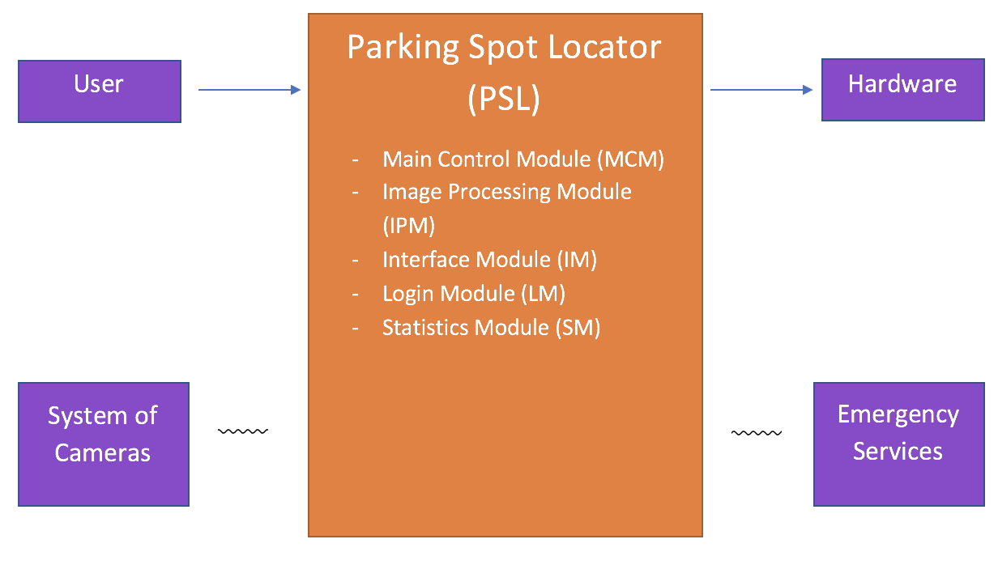

**Figure 1-1:** **Level 0 DFD**

**1.3.2 Description and Major Functions of PSL**

PSL provides real-time parking lot information. The system determines available parking spots and allows the user to reserve a spot in the parking area closest to their destination. A physical system will deploy a Parking Reinforcement Device to secure a reserved spot. PSL will also provide the user with the ability to contact local emergency services to assist with everything from a flat tire or dead battery to more severe issues like a stolen vehicle.

The name PSL is a play on the common acronym for the popular pumpkin spice latte from coffee shops like Starbucks.

**1.3.3 Hardware and Software Considerations**

PSL requires standard computer hardware. Other hardware requirements include parking structure cameras and parking reservation devices.

**1.4 Documentation of the Development Process**

PSL’s detailed functional description is documented in section 2.0. Section 2.0 is a succinct software description document. The overall detailed functional description is based on higher level DFDs (levels 0 and 1). All major functional units are described in detail in this part of the document.

Requirements for PSL are captured in Section 3.0 of this document. This section includes both functional and non-functional software requirements, supplemented with more detailed information when necessary.

Section 4.0 consists of PSL’s elements of implementation. This section details the implementation of the requirements listed in Section 3.0. Only those requirements implemented are described in this section.

Section 6 is PSL’s Software Test Plan (STP).

**1.5 References**

All references used in the creation of this document are listed below.

**1.5.1 Controlling Documents**

There is no other document controlling this document.

**1.5.2 Applicable Documents**

No additional applicable document has been used in the production of this document.

**1.5.3 Standards**

No standard has been used in the creation of this document. However, some Standards described in textbooks have been examined as a reference. In particular, the IEEE standard has been briefly discussed in class.

**2.0 DETAILED FUNCTIONAL DESCRIPTION OF PSL**

**2.1 Detailed PSL Functional Description.**

The major tool used to design PSL is the Data Flow Diagram (DFD). The rationale for the selection of DFDs as the preferred design tool is its simplicity and versatility. In the future additional tools may be used if a stronger correlation from Design to Requirement to Implementation and Testing is required.

**2.1.1 Level 1 DFD**

PSL’s major functional subunits are shown in the DFD Level 1 shown below:

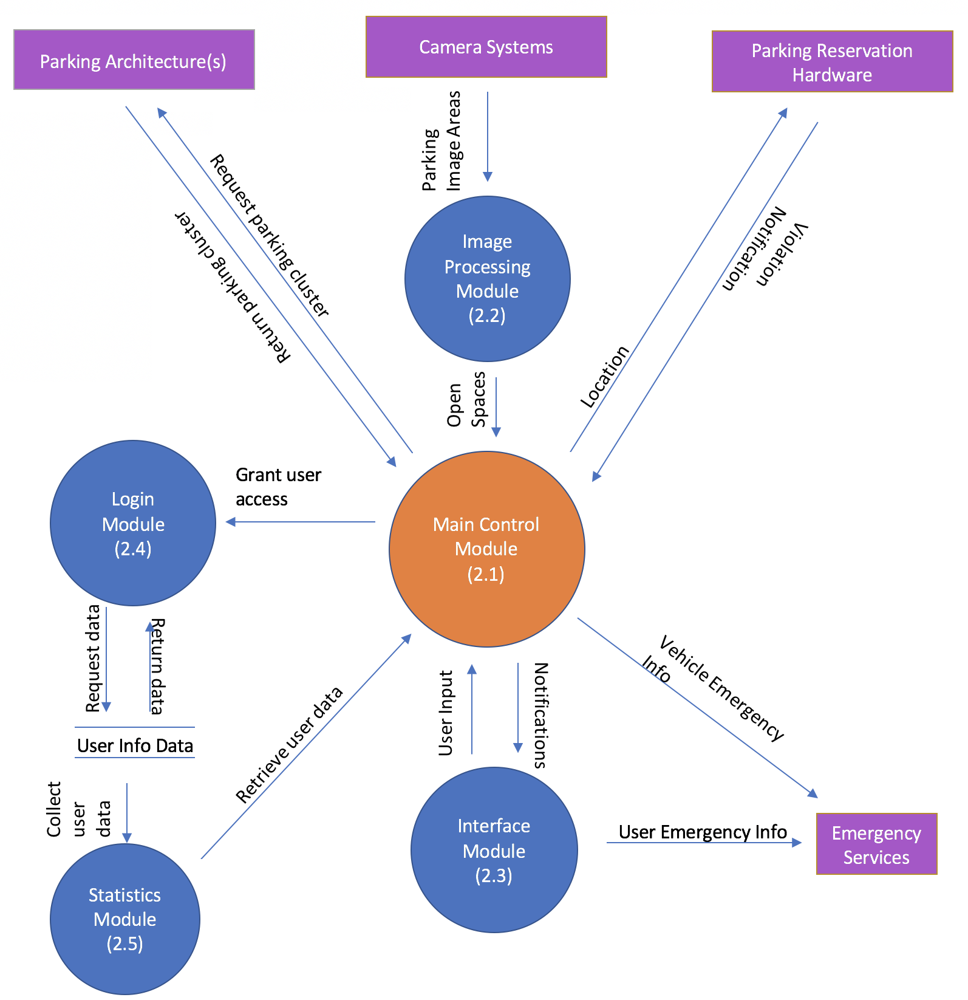

**Figure 2.1: Level 1 DFD**

**2.1.2 Detailed Functional Description of PSL’s Major Units.**

The description of PSL’s major functional units shown in Figure 2.1 follows. Most of PSL’s operations depend on image processing in order to determine what constitutes a parking spot and whether or not each parking spot is available.

Main Control - Module 2.1

The Main Control Module (MCM) communicates with other modules to determine the availability of parking spots. The MCM will receive the GPS location of the user’s destination from the Interface Module. The MCM will determine the closest available parking area by comparing the destination GPS with those in the Parking Architecture database. It will then send that data to the Image Processing Module which will return to the MCM the location of cars in the parking area. The MCM will compare the location of the cars with the location of the parking spots to determine parking spot availability. The MCM will reserve that parking spot in the Parking Architecture database and send the parking spot location back to the Interface Module. In order to ensure a user’s spot is reserved, MCM utilizes parking reinforcement hardware to physically prevent other vehicles from parking in a reserved space. If a reserved parking space is violated, the Parking Reservation hardware will send a violation notice to the MCM and the vehicle violating the reservation policy will receive a parking citation. After the user has parked, the Interface Module will notify the MCM once the reserved parking spot is vacated, and the MCM will update the Parking Architecture database.

Log-in - Module 2.2

The Login Module allows new users to create a PSL account and returning users to log in to their account. It has access to a database that contains detailed information for each registered user of PSL. Upon creation of a new account, the user will input personal data tied to their account. This data includes the user’s name, make and model of car, etc. The data also includes parking pass details for various parking lots where access is restricted to a certain user group.

Image Processing - Module 2.3

The Image Processing Module (IPM) monitors the parking structure. The IPM receives from the Main Control Module a parking area. The IPM then communicates with the Camera Systems database in order to receive a photo of the parking area, which is then processed to determine the location of all objects, such as cars or Parking Reservation hardware, within the photo. This data is then sent back to the Main Control Model.

Interface - Module 2.4

The Interface Module (IM) shall allow a user friendly representation of the parking spots available displayed on the application. The interface will allow the user to input a destination. This GPS location will be sent to the Main Control Module, which will return to the IM the location of a reserved parking spot in the parking area closest to the destination. The IM will notify the Main Control Module to release the spot in the Parking Architecture Database once the user’s GPS departs the parking spot. The IM will also allow the user to contact emergency services in the case of a flat tire, dead battery, or stolen car.

Statistics - Module 2.5

The Statistics Module (SM) will collect user data in order to track large usage trends. Some trends include parking lot usage throughout the day and user-location frequency. The data will be retrieved to provide information to see where there is a greater demand for parking lots and current availability.

**3.0 PSL REQUIREMENTS**

**3.1 PSL Functional Requirements**

This Section lists PSL’s functional requirements. This section includes the complete set of functional requirements. All requirements relate to the design modules described in Section 2. An effort has been made to standardize the correlation between the design modules and the requirements to make access and organization more consistent. For example, requirement number “n” affecting module 2.1 will be labeled 3.1.n

|  |  |
| --- | --- |
| **Requirements Related to Design Module 2.1: Main Control Module (MCM)** | |
| Requirement No. | Requirement Description |
| 3.1.1 | MCM shall determine closest available parking lot to the user’s destination. |
| 3.1.2 | MCM shall determine availability of parking spots. |
| 3.1.3 | MCM shall reserve available spot closest to user’s destination. |
| 3.1.4 | MCM shall notify emergency services of cars violating a reservation. |
| **Design Module 2.1 Requirements Not Implemented Due To Time Constraints** | |
| 3.1.1 | MCM shall determine closest available parking lot to the user’s destination. |
| 3.1.3 | MCM shall reserve available spot closest to user’s destination. |
| 3.1.4 | MCM shall notify emergency services of cars violating a reservation. |
| **Requirements Related to Design Module 2.2: Image Processing Module (IPM)** | |
| Requirement No. | Requirement Description |
| 3.2.1 | IPM shall process parking area images. |
| **Requirements Related to Design Module 2.3: Interface Module (IM)** | |
| Requirement No. | Requirement Description |
| 3.3.1 | IM shall allow the user to input a destination. |
| 3.3.2 | IM shall notify the user of the closest available parking spot. |
| 3.3.3 | IM shall allow the user to contact emergency services. |
| **Design Module 2.3 Requirements Not Implemented Due To Time Constraints** | |
| 3.3.1 | IM shall allow the user to input a destination. |
| 3.3.2 | IM shall notify the user of the closest available parking spot. |
| 3.3.3 | IM shall allow the user to contact emergency services. |
| **Requirements Related to Design Module 2.4: Login Module (LM)** | |
| Requirement No. | Requirement Description |
| 3.4.1 | LM shall allow user to create account |
| 3.4.2 | LM shall allow user to login to existing account |
| **Design Module 2.4 Requirements Not Implemented Due To Time Constraints** | |
| 3.4.1 | LM shall allow user to create account |
| 3.4.2 | LM shall allow user to login to existing account |
| **Requirements Related to 2.5: Statistics Module (SM)** | |
| Requirement No. | Requirement Description |
| 3.5.1 | SM shall store user data. |
| 3.5.2 | SM shall track user data. |
| **Design Module 2.5 Requirements Not Implemented Due To Time Constraints** | |
| 3.5.1 | SM shall store user data. |
| 3.5.2 | SM shall track user data. |

**3.2 PSL Non-Functional Requirements**

This Section collects all the PSL Non-Functional Requirements. All non-functional requirements are numbered “NF – n” where “n” indicates the nth requirement.

NF - 1 PSL requires data storage on the CloudStorage to store parking structure architecture as well as the current state of the parking lot.

**3.3 PSL Hardware Requirements**

This Section collects all PSL’s electronic hardware requirements. All hardware requirements are numbered “H – n” where “n” indicates the nth requirement.

H - 1 PSL will require a system of cameras.

H - 2 PSL will require a system of Parking Reservation Devices (PRD).

H - 3 PSL will run on smartphone and related devices.

**4.0 PSLELEMENTS OF IMPLEMENTATION**

**4.1 Introduction**

This section describes the implementation of the requirements described above. We include brief descriptions of each of the coded classes. Java code files are included separately.

**4.2 Descriptions of Java Classes**

**Main GUI:**

*PSLGUI* is the main GUI and starting point for the program.

**Parking Spot:**

The *ParkingSpot* class is used to represent individual parking spots, each of which consists of x and y coordinates for each edge of a parking spot.

**Parking Spot Locator:**

*ParkingSpotLocator* contains functions for processing empty parking lots and comparing