**Spike:** 06

**Title:** Basic Game Data Structures

**Author:** Ford Killeen, 9731822

**Goals / deliverables:**

*Goals this spike aims to achieve:*

* Research and evaluate four different data structures
* Write a short report detailing the advantages and disadvantages of using each data structure for a game inventory system in the context of our Zorkish game
* Using the chosen data structure, implement an inventory system into your Zorkish game, capable of adding, accessing and removing objects

*Deliverables required:*

* Code for the inventory system
* Short report on four different data structures
* Spike report

**Technologies, Tools, and Resources used:**

The following is required to complete this spike:

* Visual Studio 2015
* Zorkish game specification
* Online C++ data structure references   
  (eg. <http://en.cppreference.com/w/cpp/container>)

**Tasks undertaken:**

The list below details the steps taken to complete this spike.

* Using online references, four C++ data structures were chosen and investigated
* The pros and cons of each data structure were found out and put into a short report, also detailing the chosen data structure for the inventory
* Using the chosen data structure, I started on the Inventory class which uses the vector class to contain all inventory items

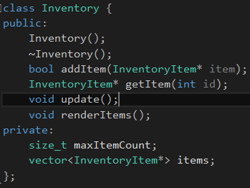

* The InventoryItem was then set up as the base class for the rest of the inventory items

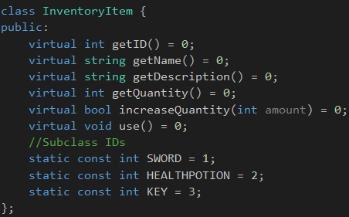

* With the base class ready I set up a Sword, Key and HealthPotion classes which inherit from the base InventoryItem class
* To show off the inventory I used the existing GameplayState. You can see in the image below addition, removal and access of inventory items within the inventory

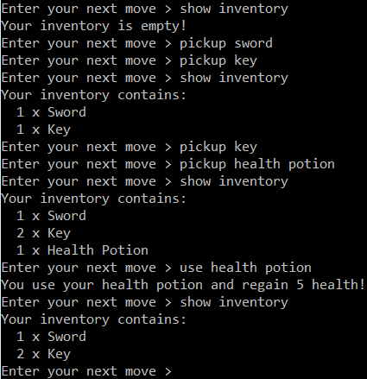

**What we found out:**

By completing this spike we found out the advantages and disadvantages of four main data structures and how they can be used in games. We applied the knowledge we gained about these data structures to make an informed decision on which data structure to use for our Zorkish inventory system and then implemented it. By implementing it I was able to re-enforce my understanding and usage of the vector data structure.