**Spike:** 08

**Title:** Command Pattern

**Author:** Ford Killeen, 9731822

**Goals / deliverables:**

*Goals this spike aims to achieve:*

* Extend upon Zorkish by adding a command processor
* Load adventure files with partial game entities

*Deliverables required:*

* Code showcasing the command processor in use
* Spike report

**Technologies, Tools, and Resources used:**

The following is required to complete this spike:

* Visual Studio 2015
* Zorkish game specification
* Online C++ references
* A text file adventure of your own making
* A thesaurus to aid with choosing aliases

**Tasks undertaken:**

The list below details the steps taken to complete this spike.

* Firstly I designed the classes that would form my command pattern, ie. the Command and CommandManager classes. The command manager would hold a list of string command/aliases mapped against the Command that would handle that command, so that when the manager is given a string of commands it can determine who gets to handle it.

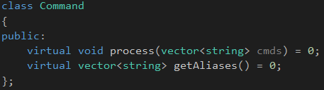

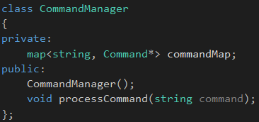

* After setting up these two main classes, I started the implementation with the GoCommand class. This handles all movement aliases and directions within the game world.
* This was tested and refined.
* I then moved on to add the LookCommand, HelpCommand, PickupCommand and UseCommand classes to the game.

**What we found out:**

By completing this spike we found out the usefulness of the Command Pattern, as it enables us to easily add new command modules to take care of very specific and focussed tasks along with the easy addition of any aliases that go with that command.

**Issues:**

This is not so much an issue but more that when completing this spike, I didn’t add any extra functionality to my adventure loading code as I figured this would be better handled in the future spike. Because of this I kept some of the command classes quite simple for now (it just prints the action you intended on completing), as I’m not sure how I will design these future entities yet. See image below.

