**Spike:** 10

**Title:** Component Pattern

**Author:** Ford Killeen, 9731822

**Goals / deliverables:**

*Goals this spike aims to achieve:*

* Extend upon Zorkish by adding entities that are made up entirely of components
* Entities that receive actions as well as attributes

*Deliverables required:*

* Code showcasing the component pattern in use
* Spike report
* Any hand written notes or diagrams

**Technologies, Tools, and Resources used:**

The following is required to complete this spike:

* Visual Studio 2015
* Zorkish game specification
* Online C++ references

**Tasks undertaken:**

The list below details the steps taken to complete this spike.

* Firstly I started by creating the Component class, which is the virtual class to be inherited by all other component subclasses. All it contained was a virtual update() method.

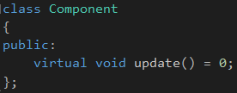

* Next I set up the Entity class, which acts purely as a container of components. It has functionality to add, remove, check and get components within itself.

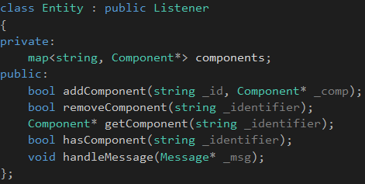

* Once setting up these two classes, I worked on getting some basic component subclasses in, they were HealthComponent, DamageComponent, DamageableComponent and PickupableComponent. The first two agiving an entity some attributes while the latter two allow certain actions to be taken upon the entity.
* I then created a System class, with subclasses HealthSystem and DamageSystem, which would each take care of their respective components and call the update() method on them each cycle. Upon creating a component for an entity, it must also be registered with the system that handles those types of components.

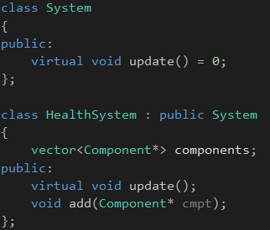

* Now it was testing time, and I had a lot of trouble working out how the individual components within an entity, would instruct the components of another entity to complete an action. Say a sword entity is to inflict damage on the player entity, how would the DamageComponent within the sword know how to tell the HealthComponent within the player to set the health.
* Since the above situation puzzled me and was making the project look super messy and confusing, I decided to continue on with spike 11 (Messaging) and use that messaging system to handle communications between my components for this spike.

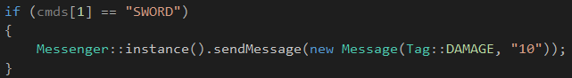

* This was then tested and proven to show that the components within the entities could receive an action and handle the actions in their update() methods.

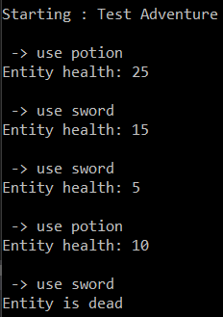

**What we found out:**

By completing this spike we found out how to use the Component Pattern, as it enables us to create game ‘objects’ which are made up entirely of components, instead of multiple inheritance and creating massive classes for each type of entity. We also learnt that this allows us to reuse the code around components for multiple entities, without having to write that specific action into each entity class type.

**Issues:**

My main issue with this spike was the communication between the the components within entities and calling actions on components in different entities. It was due to this issue that I decided to complete spike 11 in this same project so that I could utilise the messaging system to handle communication between entities. This seemed to work much better and caused less issues as I didn’t have to reference or #include every other class into my Component or Entity classes.

