**Spike:** 11

**Title:** Messaging

**Author:** Ford Killeen, 9731822

**Goals / deliverables:**

*Goals this spike aims to achieve:*

* Extend upon Zorkish by adding a messaging system
* To put some thought into how you implement the messages and what a message may consist of

*Deliverables required:*

* Code showing off the messaging system
* Spike report
* Messaging specification

**Technologies, Tools, and Resources used:**

The following is required to complete this spike:

* Visual Studio 2015
* Zorkish game specification
* Online C++ references

**Tasks undertaken:**

The list below details the steps taken to complete this spike.

* Firstly I got a pen and paper and drew a quick plan of how I wanted my messaging system to work. It consisted of a Message class, Listener class and Messenger class.
* **Message**. The message class represents an actual message, each message will have a unique id, a tag representing what type of message it is and the contents of the message in a string.

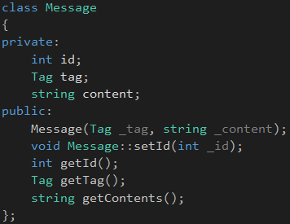

* **Listener**. The listener class is a pure virtual class that will be inherited by any class that is going to receive and handle messages.

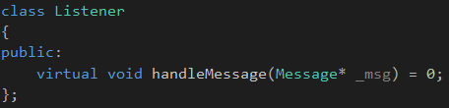

* **Messenger**. The messenger class is what sends out the actual messages, as it contains a list of all of the listeners to send new messages to. This class is also a singleton and as such is static so it can be accessed from anywhere, allowing anything to send messages at any time.

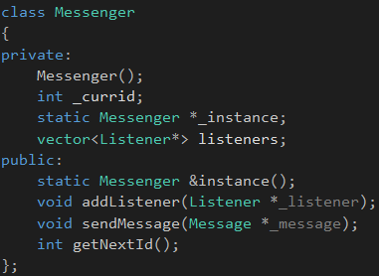

* Then I just implemented the messaging system throughout the game, by making the Entity class a subclass of Listener, and adding messages that are sent on certain commands input by the user. These are then handled by the entity in the handleMessage() method.

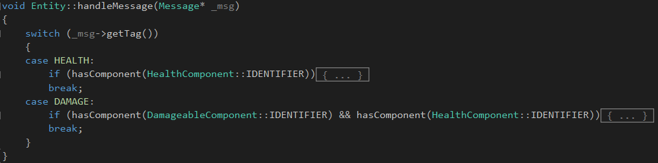

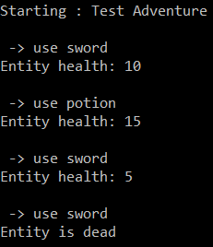

**What we found out:**

By completing this spike we found out how useful a messaging system is within a game environment. No longer do I need to have references and pointers to objects scattered around the place, or pass in more data than required in update calls, now I can just kick off a message from anywhere in the code which will go down and be handled by the entities we care about.