**Spike:** 12

**Title:** Announcements & Blackboards

**Author:** Ford Killeen, 9731822

**Goals / deliverables:**

*Goals this spike aims to achieve:*

* Extend upon Zorkish by adding to the messaging system to allow for announcements and blackboards
* To put some thought into how announcements and blackboards are implemented. Blackboards letting entities read messages at any time and announcements being sent to all entities.

*Deliverables required:*

* Code showing off the updated messaging system
* Spike report
* Messaging specification

**Technologies, Tools, and Resources used:**

The following is required to complete this spike:

* Visual Studio 2015
* Zorkish game specification
* Online C++ references

**Tasks undertaken:**

The list below details the steps taken to complete this spike.

* The first thing I did was add a map<int, Message*> to the Messenger class to act as the blackboard to which messages will be written.



* Next the addBlackboardMessage(Message* msg), removeBlackboardMessage(int msg) and viewBlackboard() methods were added to Messenger class. This allows messages to be written to the blackboard and removed when they are no longer needed, as well as be read by entities at any time.

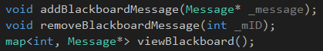

* I then added the sendAnnouncement(Message* msg) method which would send the message to all registered listeners.



* The Listener class had no way for entities to check the blackboard when they needed to, this was fixed by adding a checkBlackboard() method to the Listener class.



* This was then tested by letting the player leave a note within the game, which would be put on the blackboard and allowed to be read back at a later time. The current sendMessage(Message* msg) calls were changed to sendAnnouncement(Message* msg) so that all entities received the messages.



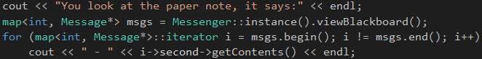

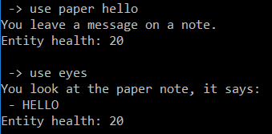

**What we found out:**

By completing this spike we found out how useful different messaging methods are and how they can be used. Now we are able to send announcements that will be received by all registered listeners, for cases where multiple entities need to know about an event, and how a blackboard can be used to leave messages for other entities which may want to check them some time in the future.