**Spike:** 15

**Title:** Unreal Engine Familiarisation

**Author:** Ford Killeen, 9731822

**Goals / deliverables:**

*Goals this spike aims to achieve:*

* A list of 3 games made in Unreal Engine and their pros and cons
* An example of a blueprint that prints a string in the top left hand of the screen every tick
* Two commenting styles possible in UE4 blueprints

*Deliverables required:*

* UE games list with pros/cons
* Blueprint example that prints a string every tick
* Example of two commenting styles in UE4 blueprints
* Spike report

**Technologies, Tools, and Resources used:**

The following is required to complete this spike:

* Unreal Engine 4 (ver. 4.13.2)
* Online UE4 material and guides

**Tasks undertaken:**

The list below details the steps taken to complete this spike.

* The first thing I did was do a little research into three games that were developed with the Unreal Engine and what their pros and cons might be.
* I then created the short list as can be seen at the end of this report.
* I then looked up how to output strings using the blueprint system.
* Adding the string print out to the screen was fairly easy by using the Print String node in the blueprint system. Since I was using the scene I had made for spike 16, I got the rotation of my spinning actor and printed the rotation each tick. This was done by feeding the rotation from GetActorRotation into the BuildString(rotator) function which then sent its return value to the Print String node, where it was set to also print to the screen.

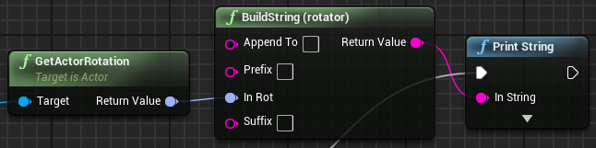

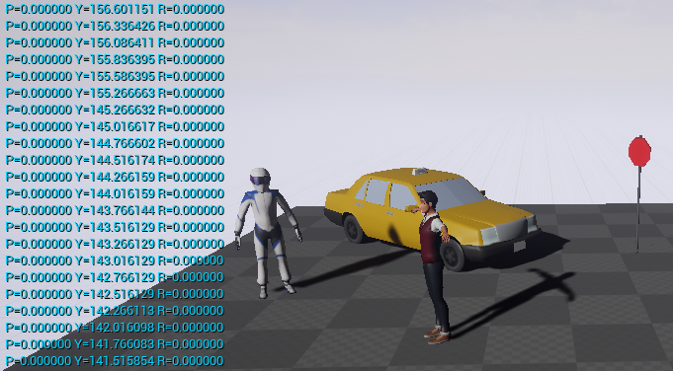

* Next on the list was to learn and figure out both commenting styles for the blueprint system. This was easily done by looking up the Unreal documentation for comments.
* I then added both styles of comments to my existing blueprint. The first is a Node Comment, which is linked directly to a single node within the blueprint while the second is a Comment Box, which is a large box that can encase a selection of nodes that are related to that comment.

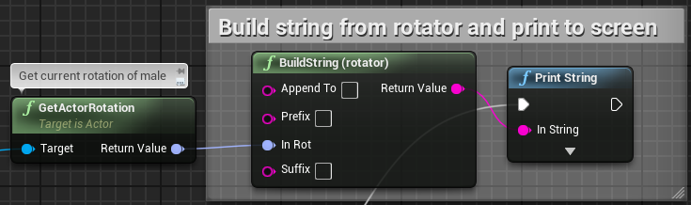

**What we found out:**

By completing this spike we found out how to use the blueprint system and to output text to the screen during simulation. This is a very handy thing to know as sometimes we need to print out and see some debugging text. Comments are also another thing learnt by doing this spike and are handy to know and will become very useful as the blueprints become larger and more complex in future spikes and projects.

**Unreal Engine Games Report**

Below are three games that were developed using Unreal Engine and a little about what might have been the reasons, followed by the pros and cons to using UE.

**Bioshock Infinite**

Was UE the right choice? Yes. For such a visually detailed game they made the right choice I believe by going with the Unreal Engine as opposed to say Unity or some other engine. The visual scripting would have also aided their development and reusability of in game objects immensely.

**Chivalry: Medieval Warfare**

Was UE the right choice? Yes, it must have been since the developers moved from their mod on the Source game engine to using the Unreal Engine for the full game. This was most likely due to the visual scripting, easy to learn design and development techniques and lack of coding knowledge required to pull off most in game tasks and activities. It is also free to use and Unreal only take royalties if sales exceed a certain amount.

**XCOM: Enemy Unkown**

Was UE the right choice? It must have been since the game did so well, but as the Unreal Engine started off as a FPS engine they may have had a bit more trouble making a top down game with such detail. They must have utilised the blueprint system as much as possible before needing to extend functionality using C++ scripts to further their game. Though I have never played this game so I can’t judge the final product.

**Unreal Engine Pros**

* Stunning visuals
* Easy to use blueprinting system
* Reusable blueprint design
* Less coding for simple things that can be done with blueprints
* Easy to learn for non-coders
* Better for PC and console games

**Unreal Engine Cons**

* Blueprint system does have its limitations
* Coding required where blueprint system falls down, which is bad for designers