**Spike:** 16

**Title:** Creating a Simple Scene

**Author:** Ford Killeen, 9731822

**Goals / deliverables:**

*Goals this spike aims to achieve:*

* Create an Unreal Engine 4 scene
* Scene must contain 2 actors as imported 3D models, one dynamic light and one baked light.

*Deliverables required:*

* Proof of UE4 scene and actors
* Spike report

**Technologies, Tools, and Resources used:**

The following is required to complete this spike:

* Unreal Engine 4 (ver. 4.13.2)
* Online UE4 material and guides
* 3D models used from my final year game

**Tasks undertaken:**

The list below details the steps taken to complete this spike.

* The first thing I did was download and install Unreal Engine 4 through the Epic Game launcher
* I then created a new UE4 project using the Blank Blueprint scene option. This allowed me to start clean with nothing pre-existing within the scene except for the lights and a simple plane.
* I then set up a Models folder in the Content Browser within UE4 and added subfolders for each of the 3D models I was going to import
* Upon selecting the desired subfolder within the Content Browser I selected Import and navigated to the .FBX file for that particular 3D model

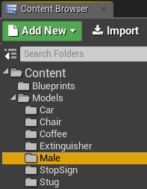

* Unfortunately none of the models my team produced came with the materials so I had to manually find their textures and add them in myself. This was done by again importing the image file and turning it into a material (right click -> create material). The material was then selected for the model in the viewer opened by double clicking a model.
* I continued to import and add more models until I was happy with my scene.

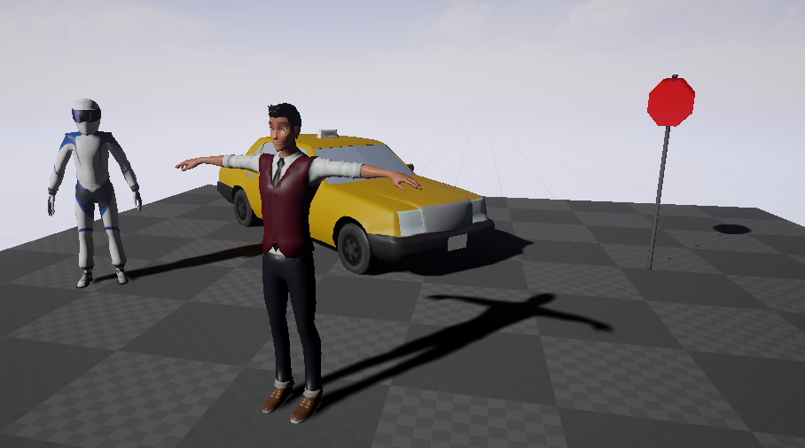

* I then looked up how to make an actor rotate and was able to make the male actor at the front of the scene rotate around the Z axis. This was done by going into the level blueprint editor, adding the mesh as a target and then using the AddActorLocalRotation node.

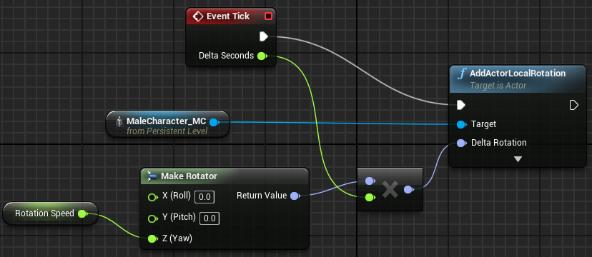

**What we found out:**

By completing this spike we found out how to quickly and easily set up a scene in Unreal Engine 4 (something I had never done before), import models and add them to a scene. This spike was fairly straight forward and easy to complete, with the main areas of trouble being that the materials were not included in the models so I had to manually find and add them and then figuring out how to use the blueprint system to make an actor rotate on the spot. This was a little confusing at first but made sense after watching an online tutorial explaining the steps.