**Spike:** 17

**Title:** Input Handling

**Author:** Ford Killeen, 9731822

**Goals / deliverables:**

*Goals this spike aims to achieve:*

* Use FPS template
* Inverse WASD input mapping
* Print a message when input buttons are pressed

*Deliverables required:*

* Proof of UE4 input changes
* Proof of output messages on button presses
* Spike report

**Technologies, Tools, and Resources used:**

The following is required to complete this spike:

* Unreal Engine 4 (ver. 4.13.2)
* Online UE4 material and guides

**Tasks undertaken:**

The list below details the steps taken to complete this spike.

* The first thing I did was research how to change the input mapping in UE4. I discovered that the way to do this is to go into *Edit -> Project Settings -> Input* and all of the mappings are under the *Bindings* section.
* I then changed the scales of each of the WASD keys to give the opposite value that it initially did. Eg. W had a scale of 1 for MoveForward, so I changed it to -1.

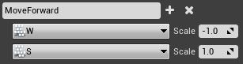

* Once all inputs were changed I then rebuilt my project and ran it to check that it worked.

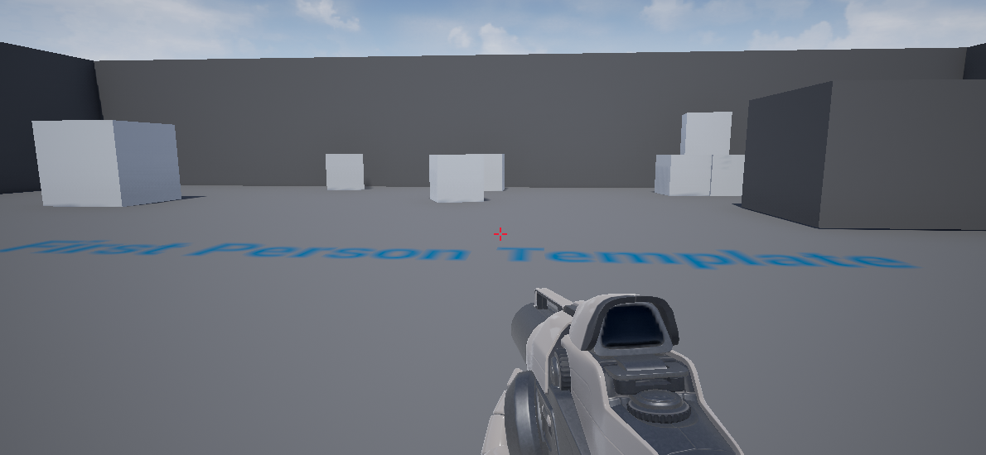

* Next I went into the Player actor blueprint to add in a message on each key press. *FirstPersonCharacter -> Edit Blueprint -> Open blueprint editor*.
* To print out text displaying which key had been pressed, I only needed three nodes. *Any Key*, *Key Get Display Name* and *Print Text*.

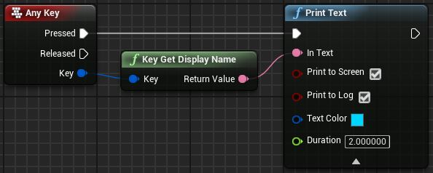

* I then rebuilt the project and ran it to check that it worked and indeed it did.

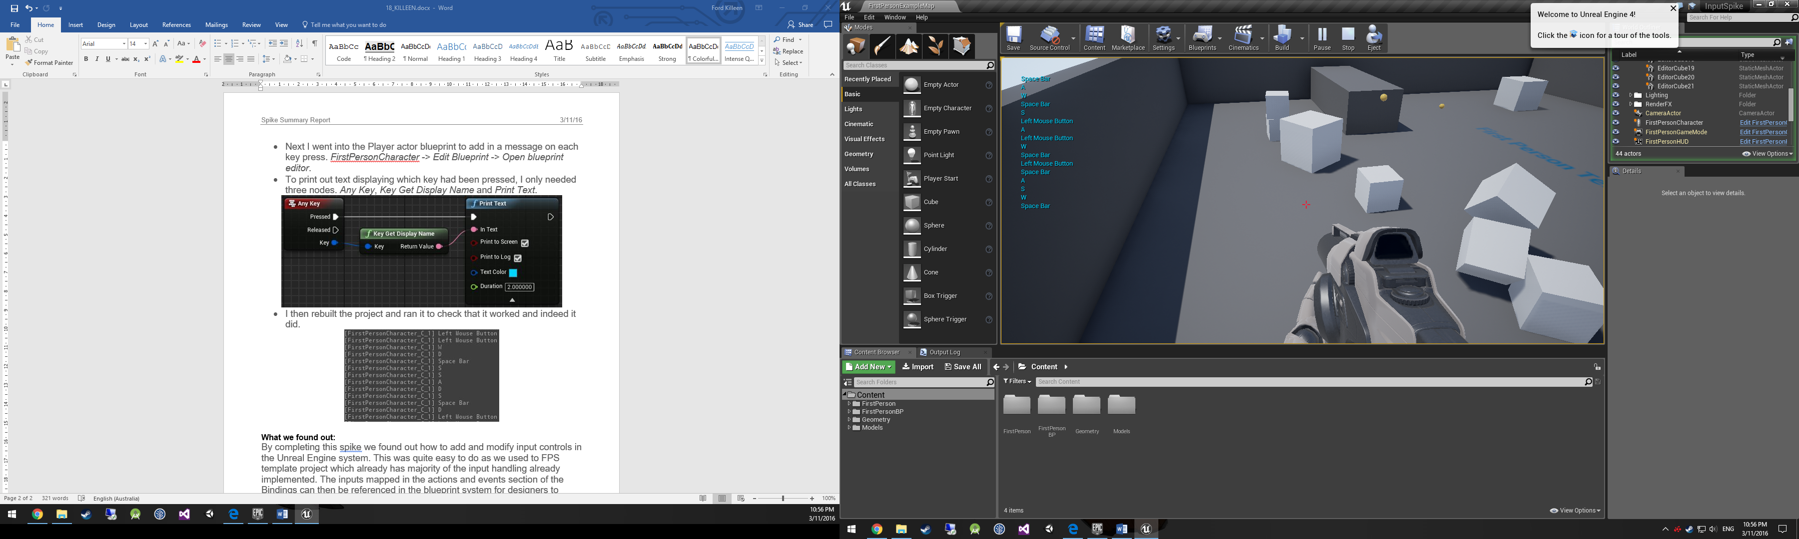

**What we found out:**

By completing this spike we found out how to add and modify input controls in the Unreal Engine system. This was quite easy to do as we used to FPS template project which already has majority of the input handling already implemented. The inputs mapped in the actions and events section of the Bindings can then be referenced in the blueprint system for designers to handle inputs with specific functionality.