**Spike:** 18

**Title:** Sounds

**Author:** Ford Killeen, 9731822

**Goals / deliverables:**

*Goals this spike aims to achieve:*

* Import two sound files
* Play each sound file on a button press
* One sound global and one sound at a location with attenuation

*Deliverables required:*

* Proof of UE4 sounds
* Proof of use with blueprint
* Spike report

**Technologies, Tools, and Resources used:**

The following is required to complete this spike:

* Unreal Engine 4 (ver. 4.13.2)
* Online UE4 material and guides
* Free sound files (.wav)

**Tasks undertaken:**

The list below details the steps taken to complete this spike.

* The first thing I did was research how to add sounds to Unreal Engine.
* I created a new folder in the Content Browser called Audio and imported my two sound files.
* I right clicked on each of the sound files in the browser and chose Create Cue which creates an Audio Cue from the raw sound file.
* I went into my global sound file cue (*fart_cue*), which would be heard at the same level anywhere in the game, and added a Modulator node in between the Wave Player and the Output, this just gives the sound a bit of variation so it isn’t exactly the same each time.

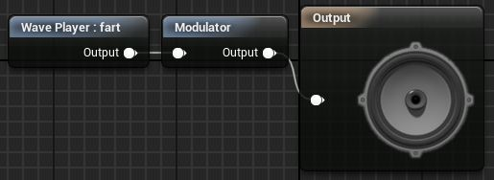

* For my location based sound (*car_cue*) I opened up the cue, ticked Override Attenuation and changed the values to work with my scene.

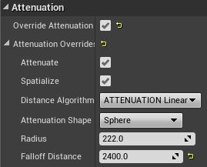

* I then went into my Player actor blueprint, created a keyboard event node for the E and F keys. These are the input buttons used for my two sounds.
* For my global sound I only needed to add the *Play Sound 2D* node and select the required cue.
* For my location based sound I needed to add a *Play Sound at Location* node to play the audio at the required location. I set the location to the location of the car model in the scene.

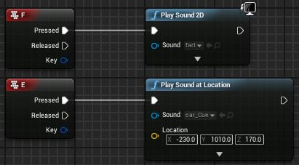

* I then ran and tested the game and the sounds and got it all working fine.
* I then opened up the Session Frontend by going to *Window -> Developer Tools -> Session Frontend*, which can be used to see the statistics real time while the game is running and record them to go over again later.
* I ran the game with this recording the session and started spamming my two keyboard buttons and the left mouse button as it also made sound
* The most audio instances/sources/sounds I could get playing at a time was 21.

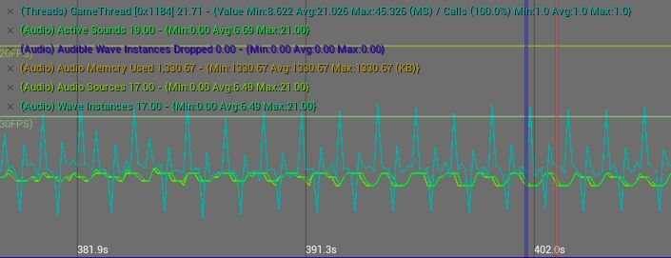

* The amount of memory used by the audio stayed consistent at 1330.67KB the whole time, therefore I would assume the engine is smart enough to reference the one point in memory and does not use up more and more memory when sounds are played multiple times or on top of each other.

**What we found out:**

By completing this spike we found out how to add sound to a scene in Unreal Engine and change sounds to work either globally and be consistently heard anywhere in the level or location based and have the sound lessen the further away from the source the player gets. I also discovered how to use the Session Frontend developer tool to map and record statistics while the game is playing. This would be useful in a real project as developers definitely want their game to be optimised and not leaking memory/wasting resources.

**Issues:**

The biggest issue I had with this spike was to get the location based sound to play on the button press. When the player actor was within the attenuation sound range, the sound would play on the key press and alter depending on the distance from the source. When the player actor was outside the attenuation range (where the sound stops and can no longer be heard) the sound would not play on the key press, but seemed to be queued up and would play when the player entered the range for that sound. I did some research but couldn’t figure out how to get around this and just decided to make the attenuation max range large enough to just cover my entire scene. That way it would play instantly on the key press and be heard (at least even slightly) from anywhere in the level.