1. Introduction 2
2. Certification 2
3. Getting Started 3
4. ‘Bang for the Buck’ Data Models 23
5. Design Patterns 23
6. Master Data Management (MDM) 36
7. Build your Own 57
8. Generic Data Models 79
9. From the Cradle to the Grave 88
10. Commercial Web Sites 108
11. Vertical Applications 109
Appendix A. Business Rules 114
Appendix B. Glossary of Terms 114

1. Introduction

1.1 Our Approach
This book adopts a unique approach which is based on using existing Data Models as the basis for designing new ones to meet specific requirements.

We have almost 800 Data Models on our Database Answers Website and they define our starting point –
- http://www.databaseanswers.org/data_models/index.htm

We have used the Dezign Data Modelling Tool to create most of the Data Models in this book.
I chose it because it is powerful, flexible and affordable.

Members of the Database Answers Community and people who buy this book can purchase Dezign and benefit from a discount of 25%.

In order to gain the benefit of this discount, all you have to do is to send an email to dba_requests@barryw.org with your Database Answers Community ID.

We will then send you the order instructions.

1.2 Tutorials
We have a number of useful Tutorials on our Website.
Here are two of them :-
- Data Modelling with two young people visiting Windsor Castle
  - http://www.databaseanswers.org/tutorial4_data_modelling_dimple_and_toby_visit_windsor_castle/index.htm
- Beginner’s Guide to Data Modelling using Dezign –
  - http://www.databaseanswers.org/tutorial4_data_modelling/index.htm

2. Certification
Certification in Data Modelling is available from Database Answers
Details will be available on our Website :-
- http://www.databaseanswers.org/certification.htm

3. Getting Started
This material is also available as a Tutorial for Amazon and Starbuck on the Database Answers Website –
- http://www.databaseanswers.org/tutorial4_data_modelling/index.htm

We will cover these Basic Concepts :-
  - Creating Entities
  - Primary and Foreign Keys
  - One-to-Many and Many-to-Many Relationships
  - Hierarchies
  - Inheritance
  - Reference Data

At the end of this Tutorial, we will have produced a Data Model, which is commonly referred as an Entity-Relationship Diagram, or 'ERD'

3.1 What is the Scope ?
Photo of Starbucks

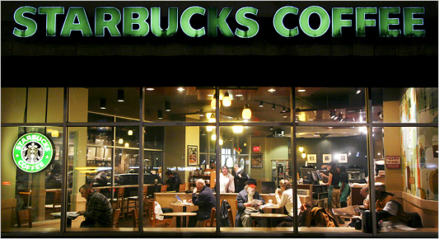

GETTING STARTED :
The area I have chosen for this Tutorial is a Data Model for a simple Order Processing System for Starbucks.
I have done it this way because many people are familiar with Starbucks and it provides an application that is easy to relate to.
• We think about the area we are going to Model.
• We can see Customers ordering Products,(Food and Drinkg and so on).
• My Approach has three Steps :-
- Establish the Scope of the Data Model
- Identify the 'Things of Interest' that are within the Scope, These will be called Entities.
- Determine the Relationships between them.
DECIDING THE SCOPE OF OUR DATA MODEL
• When we step inside, we see that Starbucks sells a wide range of Products, so our first task is to decide which of them should be included in our Data Model.
• Right now, we are interested only in something to eat and something to drink.
• Therefore, all the mugs and other items shown in this picture on the left, are outside the Scope of our Data Model, and are not 'Things of Interest'.

3.2 What are the ‘ Things of Interest’ ?

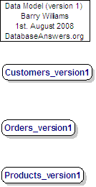

3.3 Creating Entities
This is how you create an Entity in Dezign
1. Right-click on a blank area in the diagram
2. From the drop-down list, choose Insert and Entity
3. Check the 'PK' box for the Primary Key attribute, which will usually be the first one on the Entity.
4. Click on Close to save the results.

3.4 Primary Keys
This diagram shows Entities with Primary Keys.

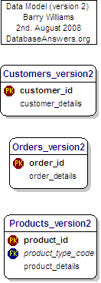

- At this Stage, we show only the Entities with no Relationships and minimum Attributes. and specify only the Primary Key and one 'details' field that will be replaced later on..
- The Primary Key field(s) should always be first.
- You will notice that the first field in the Customers_version2 Table is the Customer_id.
- It has a 'PK' symbol beside it, which indicates that it is the Primary Key for the Table.
- The Primary Key is very important and is the way that we can recognise each individual record in the Table.

Creating a Primary Key in Dezign
1. Right-click on the Entity
2. Choose Attributes
3. Check the 'PK' box for the Primary Key attribute, which will usually be the first one on the Entity.
4. Click on Close to save the results.

3.5 Foreign Keys
This diagram shows Entities with Foreign Keys.

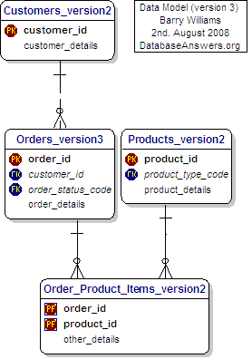

Here we have added the Relationships between the Entities.
When this Primary Key is used in another Table, it is referred to as a 'Foreign Key'.
We can see a good example in this diagram, where the customer_id appears in the Customers_Payment_Methods Table as a Foreign Key.
This is shown with an 'FK' symbol beside it

Mandatory Key Fields
A Foreign Key is usually mandatory, in other words, a value for a customer_id in the Customers_Payment_Methods Table must correspond to an actual value of the customer_id in the Customers_Version_1 Table.
This is shown in the diagram by the short straight line at the end of the dotted line close to the Customers Table.
Foreign Keys in Dezign
Foreign Keys are created automatically when you make a Relationship between two Entities.
We recommend that you move the field up in the Entity so that it takes it place alphabetically among the Key fields.
To do this, right-click on the Entity choose the Attributes option, then click on the up or down arrow on the right-hand side.

3.6 One-to-Many Relationships

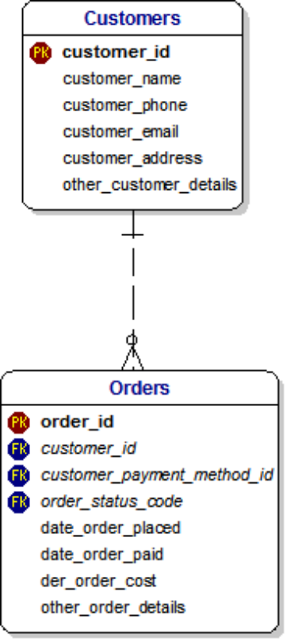

In this diagram, a Customer can place one or many Orders.
This is shown by the symbol that has three small lines at that end of the Relationship dotted line, which is referred to as Crow's Feet.

Optional Key Fields
Strictly speaking, a Customer does not have to place an Order.
He or she could change their mind and walk out without ordering anything.
In other words, we would say that the Relationship is optional at the Orders end.

This is shown by the little 'O' at that end of the Relationship dotted line.
A Customer can place many Orders.
This defines a One-to-Many Relationship.

A Data Modeller would say “For every Customer, there can be zero, one or many Orders”.

TERM | DEFINITION
Customer | Any Unit that can raise a Demand
Demand | A request for Assets to be supplied.  The format of a request can be an electronic message, a paper Form and so on.

Business Rules : A Customer can raise zero, one or many Demands.
: A Demand must be associated with a valid Customer.

3.7 Many-to-Many Relationships
This diagram shows a many-to-many relationship between Orders and Products.
An Order can include many Products and a Product can appear on many Orders.
We can also say that a Demand can request many Products.
A Data Modeller would say “A Demand can request many Products, and each Product can be in many Demands”.
This defines a Many-to-Many Relationship and is shown in a Data Model as follows :-

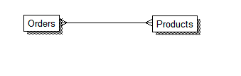
Many-to-Many Relationship cannot be implemented in Relational Databases.
Therefore we resolve this many-to-many into two one-to-many Relationships, which we show in a Data Model as follows :-

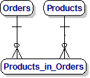

Sometimes it is good to see the Key fields to ensure that everything looks alright.

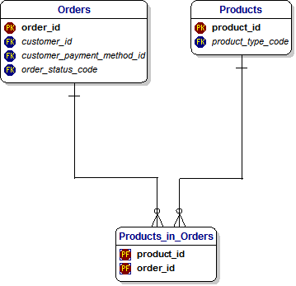

When we look closely at this Data Model, we can see that the Primary Key is composed of the Order_ID and Product_ID fields.
This reflects the underlying logic, which states that every combination of Order and Product is unique.
In the Database, this will define a new record.
When we see this situation in a Database, we can say that this reflects a many-to-many Relationship.
However, we can also show the same situation in a slightly different way, which reflects the standard design approach of using a surrogate key as the Primary Key and showing the Demand and Product IDs simply as Foreign Keys.

The benefit of this approach is that it avoids the occurrence of too many Primary Keys if more dependent Tables occur where they cascade downwards.
The benefit of the previous approach is that it avoids the possibility of ‘orphan’ records in the ‘Products in a Demand’ table.
In other words, invalid records that have invalid Demand ID and/or Product ID values.

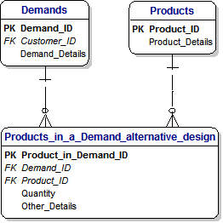

TERM | DEFINITION
Order | A request for Products to be supplied.  The format of a request can be an electronic message or a paper Form.
Product | An Item that can be supplied on request.  It can be something small, like a Muffin, or something that contains other Products, like a sandwich with multiple fillings.

Business Rules : A Order can refer to one or many Products.
: A Product can appear in zero, one or many Orders.
: In other words, there is a Many-to-Many Relationship between
Demands and Products.

3.8 Hierarchies and Rabbit’s Ears
Hierarchies are very common and we can see them all around us.
Fortunately, we can handle them every easily in Data Models.

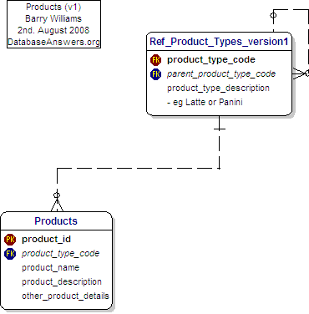

This diagram shows how the hierarchies of Products and Product Types that we have just discussed are shown in our Entity-Relationship Diagram.
You will notice that the table called 'Product_Types_v1' has a dotted line coming out on the right-hand side and going back in again on the top-right corner.
Data Analysts call this a Reflexive Relationship, or informally, simply 'Rabbits Ears'.
In plain English, we would say that the Table is joined to itself and it means that a record in this Table can be related to another record in the Table.
This approach is how we handle the situation where each Product can be in a hierarchy and related to another Product.
For example, a Product called Panini could be in a Product Sub-Category called 'Miscellaneous Sandwiches' which could be a higher Product Category called 'Cold Food', which itself could be in a higher Product Super-Category called simply 'Food'.
Next time you go into Starbucks, take a look at the board behind the counter and try to decide how you would design the Products area of the Data Model.
You should pay special attention to the little 'zeros' at each end of the dotted line.
These are how we implement the fact that the 'Parent Product Type Code' is
optional, because the highest level will not have a Parent.

This Tutorial is also available in the Database Answers Website :-
- http://www.databaseanswers.org/tutorial4_data_modelling/index.htm

A number of Data Models show examples of Inheritance, including :-
- Charities
- City Tourist Guide
- CMDB - Configuration Mgt DB
- Customers Commercial and Personal
- Event Registrations
- Games Store
- Insurance Brokers
- Libraries for Lawyers
- National Trust (UK)
- New Egg
- Photo Catalogs
- School Management Systems
- Shrek 2 Movie
- Tracking Manufactured Items
- Travel & Tourism Worldwide
- Vehicle Imports

- In the Military
We start with the definition of a Unit, which at its simplest, looks like this :-
In this case, we use a meaningless ID which is simply a unique number.

.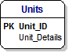

Then we think about the fact that every Unit is part of a larger organisation.
In other words, every Unit rreports to a higher level within the overall organisation.

Fortunately, we can show this in a very simple and economical fashion by creating a relationship that adds a parent ID to every Unit.
. This is accomplished by adding a relationship that joins the table to itself.

This is formally called a Reflexive relationship, and informally called ‘Rabbits Ear’s, and it looks like this :-

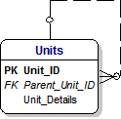

The Unit at the very top of organisation has no-one to report to, and a Unit at the lowest level does not have any other Unit reporting to it.

In other words, this relationship is Optional at the top and bottom levels.

We show this by the small letter ‘O’ at each end of the line which marks the relationship.

3.9 Inheritance
Inheritance is a very powerful technique.
It allows us to model complex situations in a manner and style that is very simple.

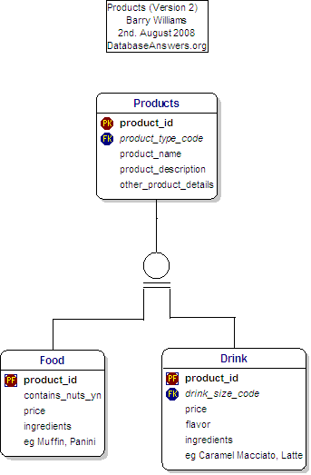
In this situation, we are thinking about Food and Drink.

Food and Drink are specific examples of the more general Thing called a Product.
They inherit common attributes from the Product, and also have some of their own.
For example, Food can contain Nuts but Drink may not contain nuts, but both have a Product Name.
The unusual symbol in the middle of the diagram, composed of a circle with two small lines underneath it is how Inheritance is shown with the Dezign Data Modelling Tool that I am using.

Inheritance is a very important topic when you are creating a Data Model.
In plain English, we would say that Inheritance occurs where a Parent-Child relationship exists between Things of Interest (or Entities).
You can ask the simple 'Is-a' question - in this case, if we ask 'Is a Book a Product' then clearly the answer is 'Yes' so we think there is an Inheritance relationship between them.

In the example of Inheritance shown in this diagram, we can see that all Products have Names and Descriptions.

Therefore, Books, Food and Drink will inherit these characteristics from the parent Product.

However, each type of Product will have specific characteristics that it does not share with other types of Products. For example, Books have ISBNs and Authors, but Food and Drink do not.

One of the important things in your Data Model is to be sure you have identified all the Inheritance relationships.
However, from many years of experience as a DBA, I should point out that relationship is often blurred in a real physical Database because it can be clumsy to implement.

Inheritance can appear in a Logical Data Model but it disappears in the Physical Database, which is what ultimately becomes the Database.
The reason is that Relational Databases do not support Inheritance.

Inheritance is a very simple and very powerful concept.
We can see examples of Inheritance in practice when we look around us every day.

For example, when we think about ‘Houses’, we implicitly include Bungalows and Ski Lodges, and maybe even Apartments, Beach Huts and House Boats.

In a similar way, when we discuss Aircraft we might be talking about Rotary Aircraft, Fixed Wing Aircraft and Unmanned Aircraft.

However, when we want to design or review a Data Model that includes Aircraft, then we need to analyse how different kinds of Aircraft are shown in the design of the Data Model.

We use the concept of ‘Inheritance’ to achieve this.
Inheritance is exactly what it sounds like.
It means that at a high level, we identify the general name of the ‘Thing of Interest’ and the characteristics that all of these Things share.
For example, an Aircraft will have a name for the type of Aircraft, such as Tornado and it will be of a certain type, such as Fixed Wing or Rotary.

At the lower level of Fixed-Wing Aircraft, an Aircraft will have a minimum length for the runway that the Aircraft needs in order to take off.

This situation is shown in the following diagram :-

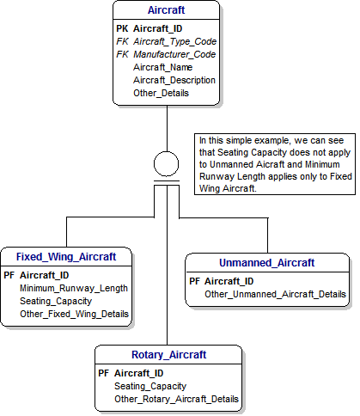

3.10 Reference Data
Reference Data is very important.
Wherever possible, it should conform to appropriate external standards, particularly national or international standards.
For example, the International Standards Organization (‘ISO’) publishes standards for Country Code, Currency Codes, Languages Codes and so on.

For Addresses, the UK Post Office Address File, ‘PAF’ File, is used to validate Addresses within the UK.

3.10.1 Aircraft example
This diagram shows two basic examples of Reference data that might apply to our simple Aircraft Data Model.

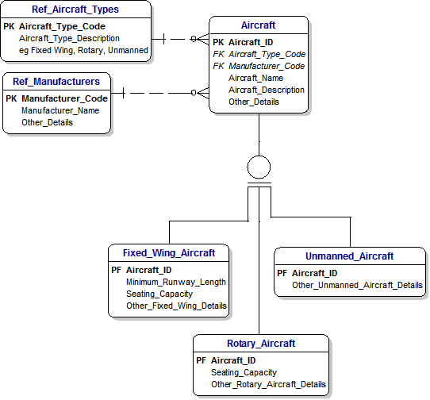

3.10.2 Address Types example
Another simple example of Reference Data is Address Types.

There are two design possibilities.
The first is good because it shows clearly the logical relationship where a Customer Address can be identified uniquely by a combination of the Customer ID, the Address ID and the Date From when the Address was valid for the Customer.

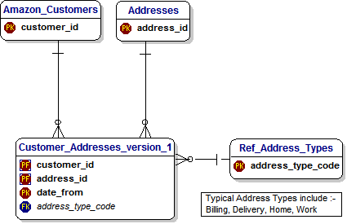

Of course, it is not always possible to determine the ‘Date From’ value, and it is not something that it is appropriate to ask the Customer.
Therefore, a better general approach is to use a Surrogate Key for a record and leave the ‘Date From’ field optional.

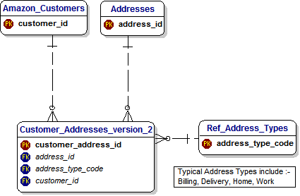
Reference Data has the following characteristics :-
- it does not change very much
- it has a relatively small number of values, usually less than a few dozen and never more than a few hundred.
- Therefore we can show it with a Code as a Primary Key.
- Data in Reference Data Tables can be used to populate drop-down lists for Users to select from.
- In this way, it is used to ensure that all new data is valid.

Standards
- In the Address Table, you will see a field called 'iso_country_codes'.
- iso stands for the 'International Standards Organisation'.
- It is always good to use national or international standards.
Customer Addresses
This is a general and flexible approach to handling Addresses in our Data Model.
We have a separate Address Table, which allows us to have more than one Address for any Customer very easily.
This design also has other benefits :-
- We can accommodate more than one person at the same Address. We need to do this because different members of a family may sign-up separately with Amazon.
- With a separate table of Addresses, we can easily use commercial software to validate our Addresses.
- To find this kind of software, simply Google for "Address Validation Software".
- I have used QAS with great success in the past.
- With this approach, we can always be sure that we have 100% good Address data in our Database.

3.11 Topics we have covered
So far we have covered the basic concepts in Data Modelling, which are :-
- Primary and Foreign Keys
- One-to-Many and Many-to-Many Relationships
- Rabbit’s Ears or Reflexive Relationships
- Inheritance

We can see examples of each of these in this Data Model :-

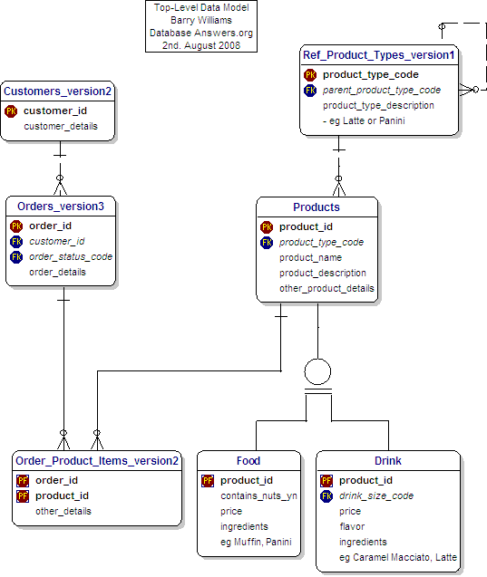

4. ‘Bang for the Buck’ Data Models
This Chapter will discuss some examples of small, economical Data Models.
These will be chosen from this page on the Website :-
'Bang for the Buck' Models
  - Catalogs of Products
  - Customers and Products
  - Customers and Services
  - Marriages (Contemporary)
  - Marriages (Traditional)
  - Partnerships and Relationships
  - Product Catalogs
  - Generic Foundation
  - Reservations

5. Design Patterns

5.1 Introduction
The purpose of this document is to help in looking at a Data Model and understanding it.
It is based on the concept of Design Patterns which are general solutions to common problems which occur on a regular basis.

This document starts with some simple Concepts and then discusses common Applications that use these Concepts.
The document applies in two situations :-
i) Data Models created by Reverse Engineering existing Databases.
ii) Other Data Models.
This document will help in the Quality Assurance (‘QA’) of these Data Models, which might be
produced internally or externally, by Partners, for activities such as Data Migration.
.
i) For the first situation, it is not appropriate to try to do a Quality Assurance of the Model.
This is primarily because Databases in operational systems have usually gone through a series of changes and usually the impact on design has not been thought through and there has not been time to redesign the Database.
The objective is primarily to understand the Database.

The many-to-many Pattern will not occur because this cannot be implemented directly in a Relational Database. This applies also to Inheritance which can only be identified by implication.

It is often useful to create a general Business Data Model that renames Tables as appropriate to replace the physical Table names with corresponding Business Terms.

For complex Databases, it is usually valuable to create a Top-Level Data Model with lower-level Subject Area Models.

It is important to try to establish a Glossary of Terms, covering descriptions of the most important Tables and Attributes and Reference Data.
Another important activity is to establish the Business Rules that define the logic underlying any Database.

Some simple examples that can be used as Templates have been shown in this document.

ii) For the second situation, it is appropriate to do a Quality Assurance of the Model
This would include a number of tasks, such as :-
- looking for examples of the Design Patterns being used where appropriate.
- review of the Reference Data

5.2 Addresses
This is taken from the Data Model shown on this page :-
- http://www.databaseanswers.org/data_models/customers_and_addresses/index.htm
Option 1 : The simplest Design
This simple basic Design stores the Address with the Customer Table :-

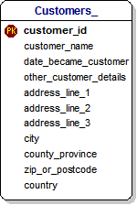

Barry start here

5.3 Master and Details
Examples include Invoices and Items or Orders and Products.
This is taken from the Data Model shown on this page on Wikipedia :-
- http://en.wikipedia.org/wiki/Master-detail

It is a classical One-to-Many Relationship.

5.5 Orders and Products
This is taken from the Data Model shown on this page :-

Option 2 : A more general Standards-based Design
This Design stores the Address in a separate Table.
This makes it possible to validate Addresses using bespoke or commercial software, such as QAS :-
The Addresses Table shown here is compatible with the two-line standard –
- http://pe.usps.com/text/pub28/PUB28C2.html
recommended by the US Postal Service
- http://pe.usps.com/
It is also compatible with the UK standard, which favours 4 lines.
You can find a discussion of the Universal Postal Union UPU S42 International Address Standard, published in 2003 by following this Link :-
- http://xml.coverpages.org/Lubenow-UPUS42.html

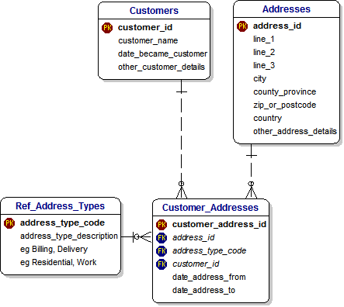

5.3 Data Warehouse

5.3.1 Design of an ERD
This Data Model is an Entity-Relationship-Diagram (‘ERD’) for Customers and Demands :-

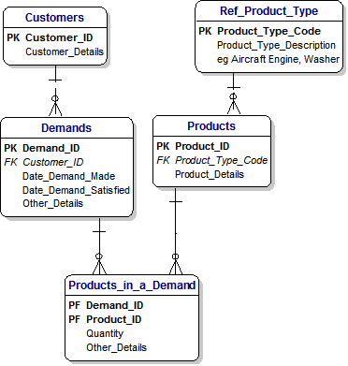

We could describe it in these terms :-
“Customers place Demands for Products of different Types.”

5.3.2 Design of a Data Warehouse
This Data Model shows the corresponding Data Warehouse for Customers and Demands :-
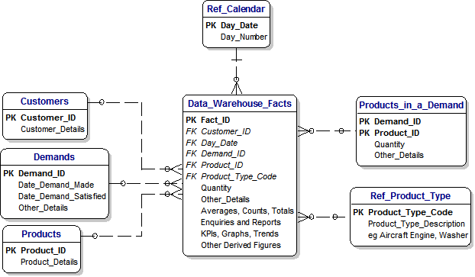

The design of this Data Warehouse simply puts all data into a ‘big basket’

5.3.3 Reviewing the Design of a Data Warehouse
The design of any Data Warehouse will conform to this patter with Dimensions and Facts.
Dimensions correspond to Primary Keys in all the associated Tables (ie the Entities in the ERD) and the Facts are the derived values that are available.

Therefore, reviewing the Design of a Data Warehouse involves looking for this Design Pattern.

With one exception, the Relationships are optional because the Enquiries need not involve any particular Dimension.
The one exception to this rule is that the Relationship to the Calendar is mandatory because an Enquiry will always include a Date.
Of course, an Enquiry might include all data since the first records, but the principle still applies.

The purpose of the Data Warehouse is to make it easy to retrieve data in any combination in order to answer questions like this :-
- Which Customers ordered the most Products ?
- Which were the most popular Products in the first week of April ?
- What was the average time it took to respond to demands for Aircraft Engines ?
- How many Demands did we receive in May ?

5.4 Applications

5.4.1 Customers and Demands
The design of the ERD in the Chapter on Data Warehouses shows a typical Customers and Orders Data Model which represent a widespread kind of application.

5.4.2 Units and Demands
Here is a slightly different Model showing Units instead of Customers and highlighting the power of Rabbits Ears.

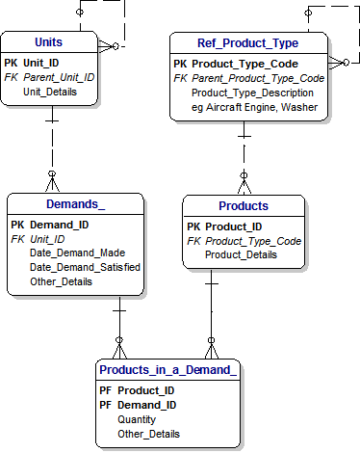

5.4.3 Deliveries
A Simple Design Pattern
This Data Model is a simple Design Pattern that covers the activities of delivering items in a Demand to a designated address.
The process of reviewing a Data Model is to ask :-
“How do I describe the Business Rules behind this Model ?”

In this case, we could say :-
“A Customer can raise a Demand for Products to be delivered to a specified Address”.

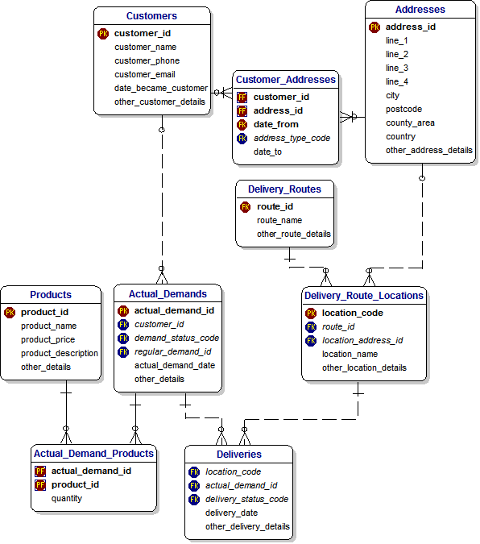

A Complex Design Pattern
This shows a complex Pattern which adds Regular Demands.

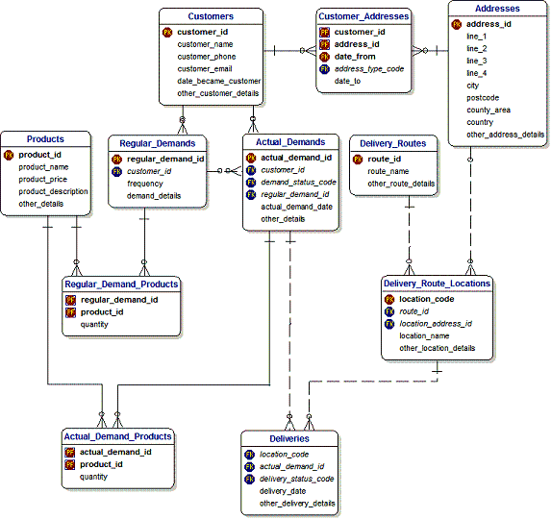

5.4.4 Maintenance of Equipment
The scope of this Data Modelis the Maintenance of Assets by Third-Party Companies.
The Business Rules state :-
* An Asset can have a Maintenance Contract.
* An Asset consists of Asset Parts
* Faults occur with these Parts from time to time.
* Third Party Companies employ Maintenance Engineers to maintain these Assets.
* Engineers pay Visits which are recorded in a Fault Log.
* They correct the Faults and this is recorded in the Fault Log.

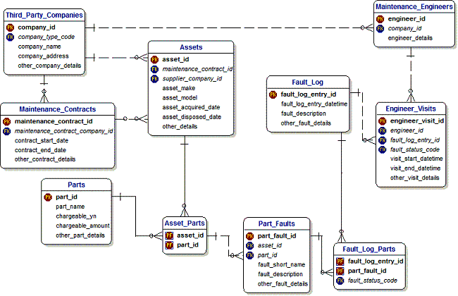

5.4.5 Subject Areas
Complex Data Models which are common in large organisations can best be understood when they are broken down into a Top-Level Model and Lower-Level Subject Areas.
Typical Subject Area Models are Deliveries and Maintenance.

These are shown in earlier Sections of thsi document.

Top-Level Model
This is a top-level Model showing the Entities that are important at the top level.
It provides a suitable form of communication with a wide range of stakeholders.

A lower-level Model has been created for each specific Subject Area.

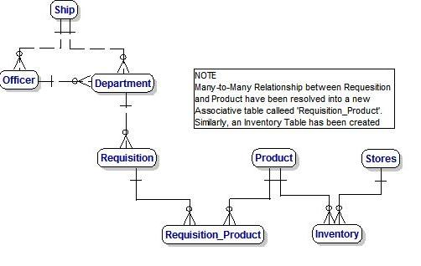

6. Master Data Management (MDM)

6.1 MDM for Customer Relationship Management (CRM)
This Chapter covers MDM for CRM.
This Tutorial presents the Steps involved as Best Practice.
Topics covered in this Tutorial include Data Sources and Targets, mapping between them, Data Quality, Data Governance and Reference Data
These are the Steps in the Tutorial :-
- Agree the Scope of the Project
- Identify the Data Sources
- Determine the Target
- Specify the Mapping between Sources and Target.
- Review Guidelines for managing Reference Data
- Address the Issue of Data Quality
- Ensure compliance with Data Governance
- Check that the MDM Data Model can provide data for Performance Reports.

6.1.1 Top-Level CRM Data Model
This is the MDM CRM Data Model which is the Target.
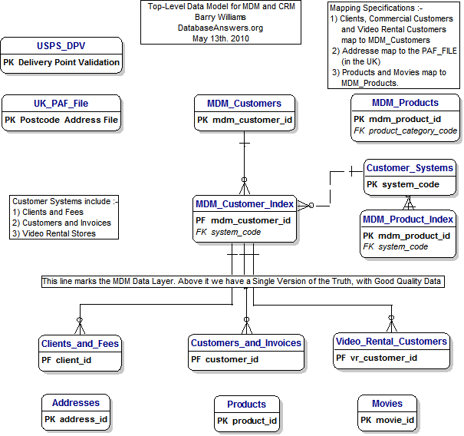

6.1.2 Reference Data Model

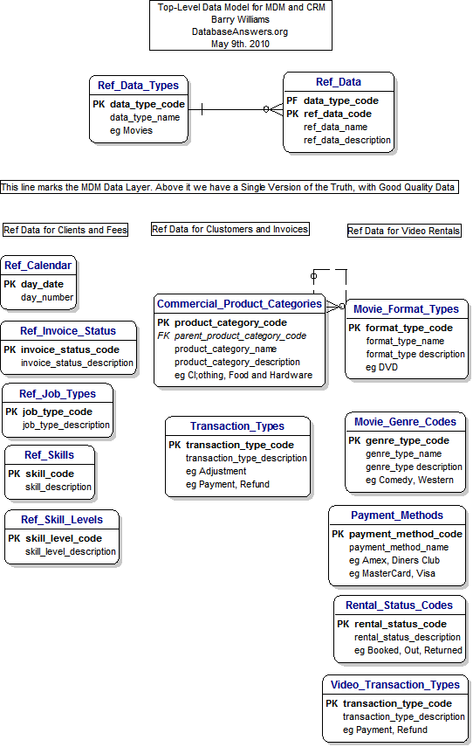

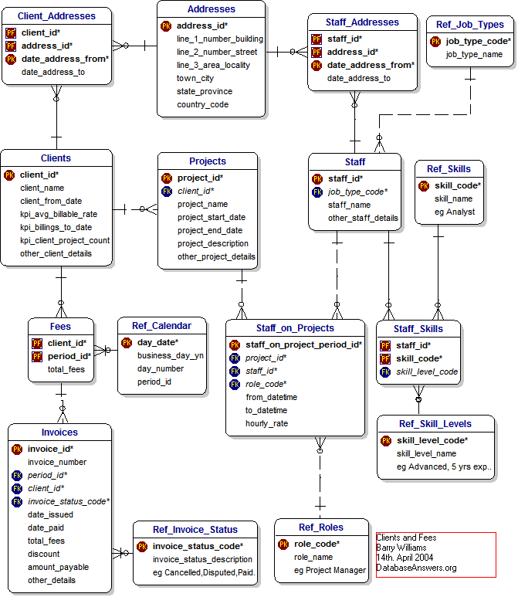
6.1.3 Clients and Fees

6.1.4 Customers and Invoices
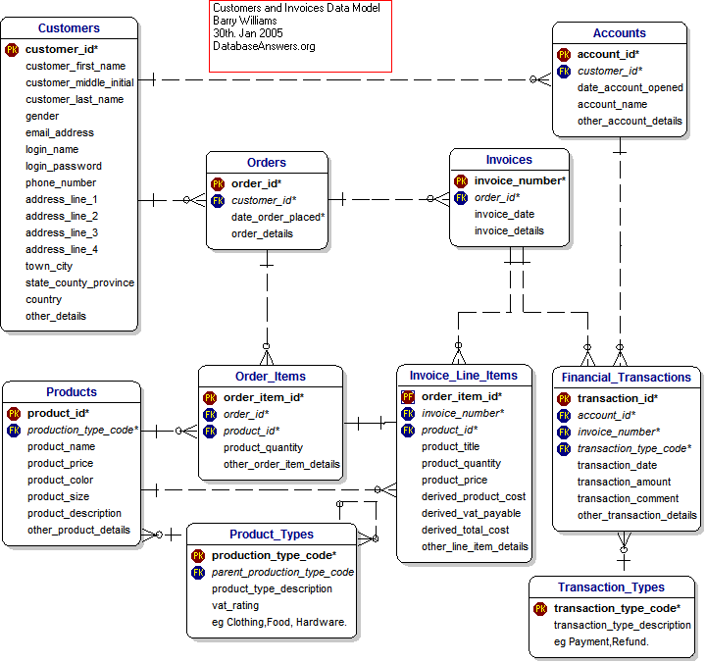
This Model shows that Customers receive Invoices for Orders that they place.

6.1.5 Video Rental Stores

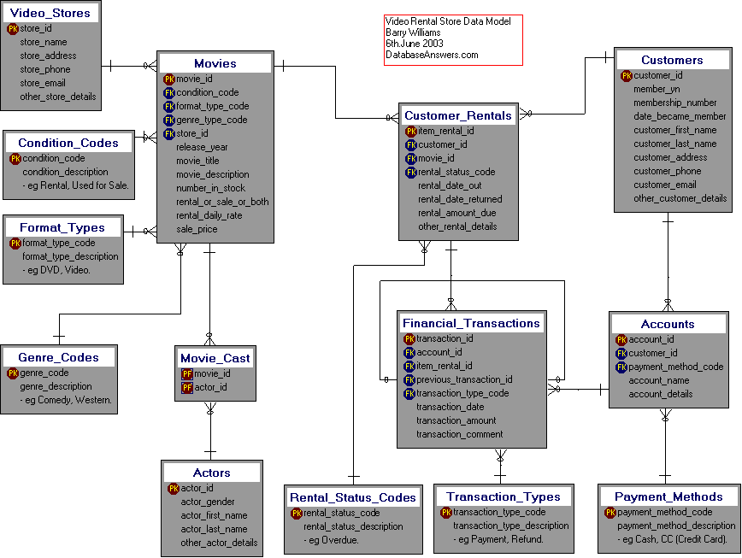

6.1.6 Summary
During this short Tutorial, we have covered the following Topics :-
  - An Approach to MDM
  - Creating a Data Dictionary
  - Mapping from Sources to the Target MDM Data Model.
  - Reference Data

6.2 MDM for Law Enforcement
This Chapter covers Master Data Management for Law Enforcement
This Tutorial is on Master Data Management for Law Enforcement.
It presents the Steps involved as Best Practice.
Topics covered in this Tutorial include Data Sources and Targets, mapping between them, Data Quality, Data Governance and Reference Data
I hope you find this Tutorial interesting and helpful.
Please email me and let me know.
These are the Steps in the Tutorial :-
- Agree the Scope of the Project
- Identify the Data Sources
- Determine the Target
- Specificy the Mapping between Sources and Target.
- Review Guidelines for managing Reference Data
- Address the Issue of Data Quality
- Ensure comliance with Data Governance
- Check that the MDM Data Model can provide data for Police Information Reports and the National Intelligence Model.

The starting-point is a list of relevant Data Models for Law Enforcement.

6.2.1 Top-Level Police Data Model
This is the MDM Police Data Model which is the Target.
It shows how data from a number of sources is integrated into one Generic Master Data Management Model

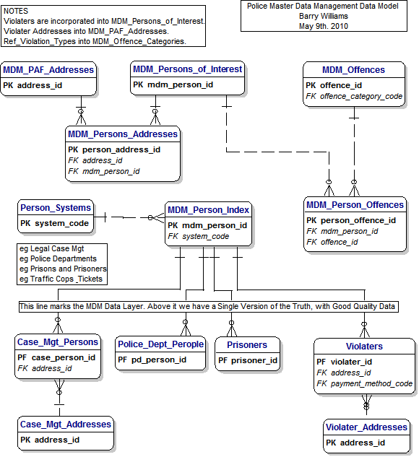

6.2.2 Reference Data
Each Data Source will have its own sets of Reference Data.
These have to be mapped to a common set of Data, which in turn is subject to corporate Data Governance.

6.2.3 Case Management
Details to be completed.
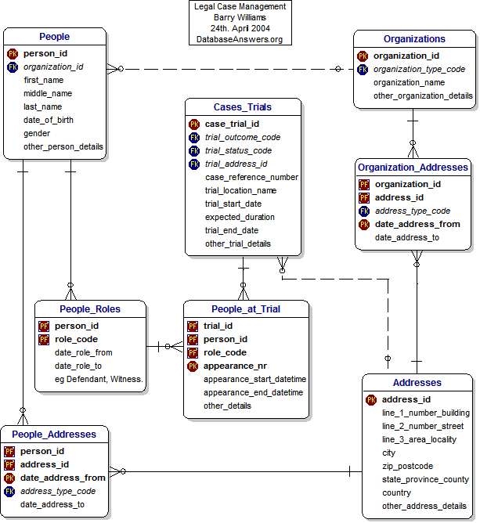

6.2.4 Police Departments
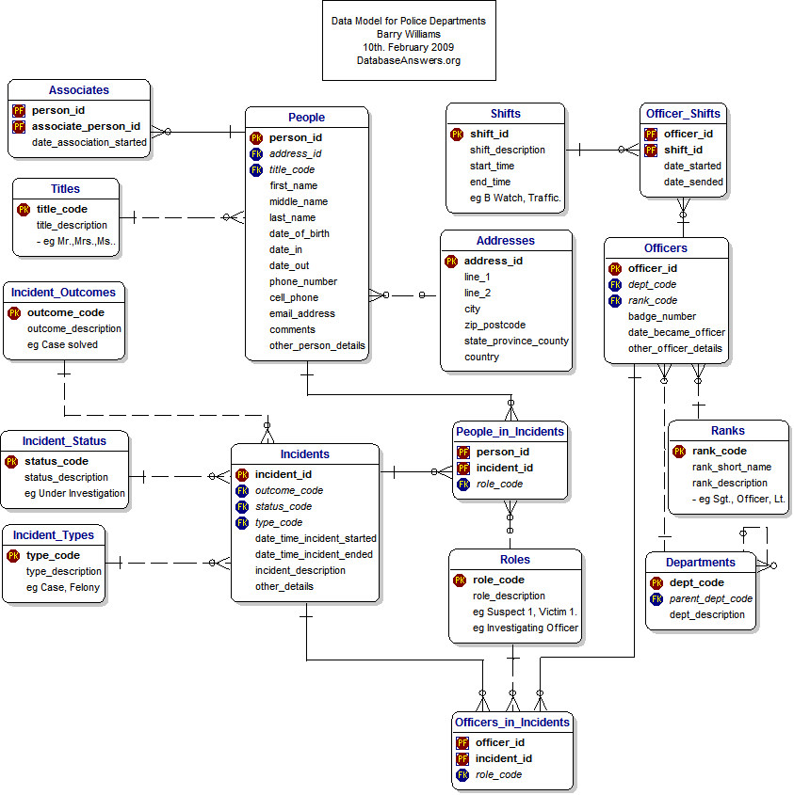
Details to be completed.

6.2.5 Prisons and Prisoners
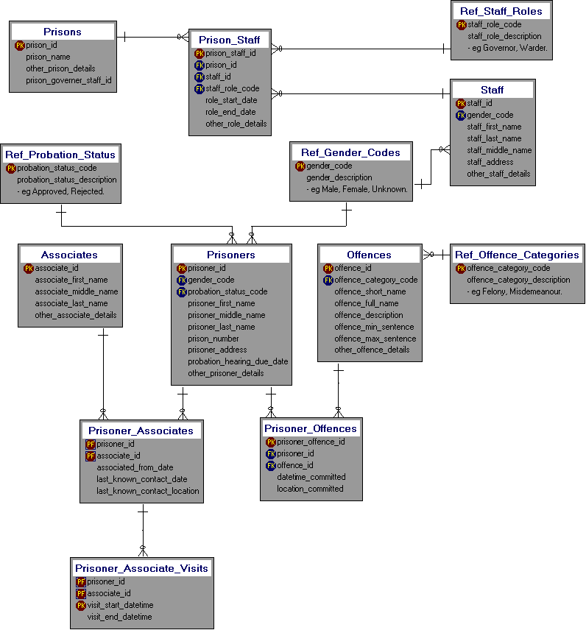
Details to be completed.

6.2.6 Tracking Evidence
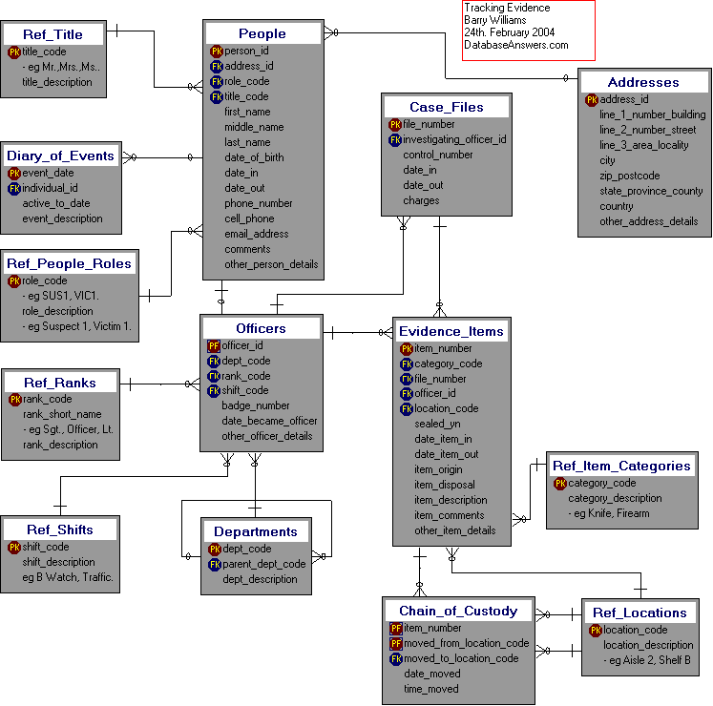
Details to be completed.

6.2.7 Traffic Cops and Tickets
Details to be determined.
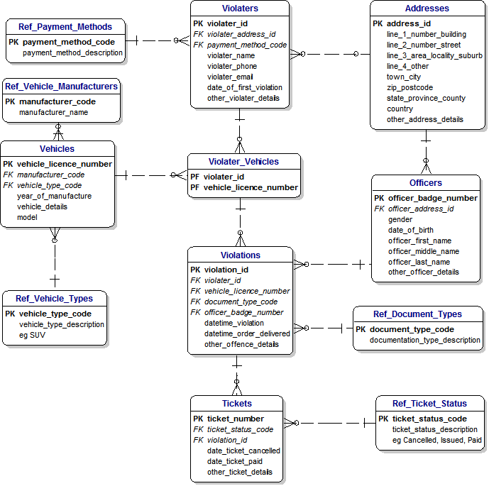

6.3 MDM for Local Government
These are the Steps in the Best Practice :-
- Agree the Scope of the Project
- Identify the Data Sources
- Determine the Target
- Review Reference Data

6.3.1 Top-Level Data Model
This is the MDM Local Government Data Model which is the Target
This shows how data from a number of sources is integrated into one Generic MDM Model.
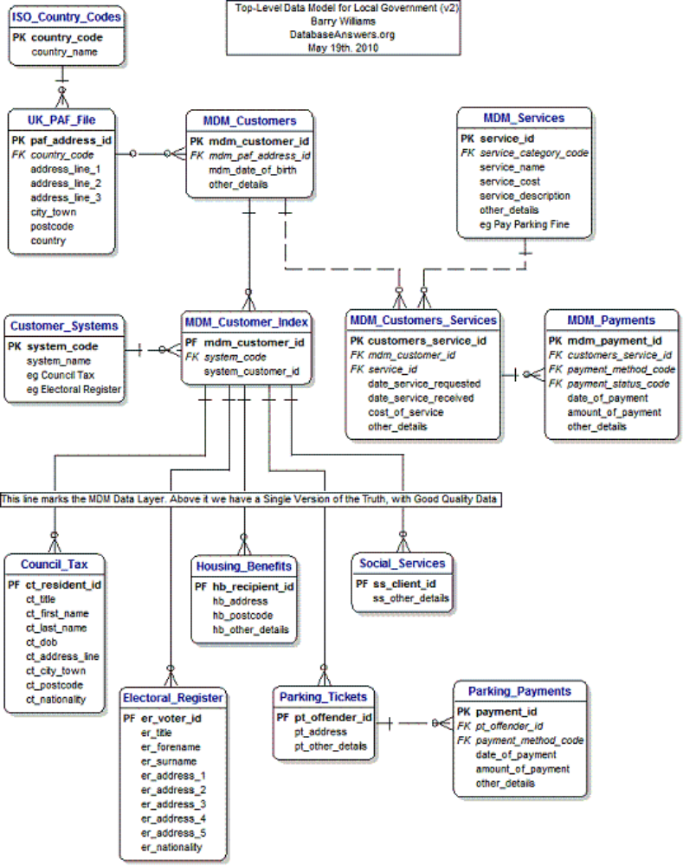

6.3.2 Reference Data
Each Data Source will have its own sets of Reference Data.
These have to be mapped to a common set of Data, which subject to corporate Data Governance.

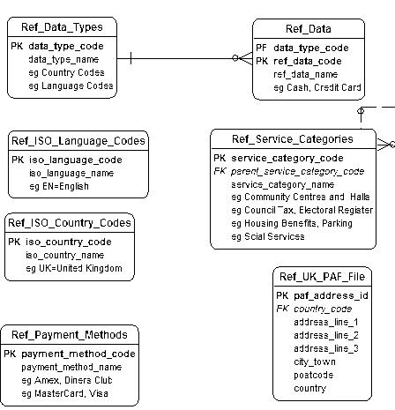

6.3.3 MDM and Customers and Services

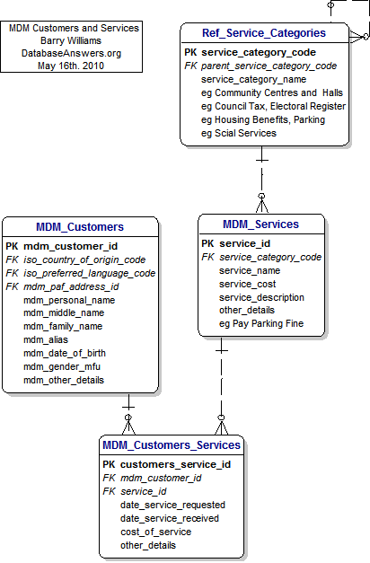

6.3.4 Council Tax
This shows the fields in the Tables that are candidates for mapping to the MDM Tables.
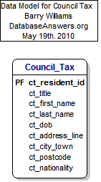

6.3.5 Housing Benefits
This shows the fields in the Tables that are candidates for mapping to the MDM Tables.
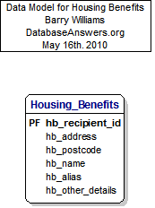

6.3.6 Parking Tickets
This shows the fields in the Tables that are candidates for mapping to the MDM Tables.
Parking Tickets are not Master Data and are not included in this mapping activity.
However, the Payment Methods are Master Data and they are included in the Reference Data category.

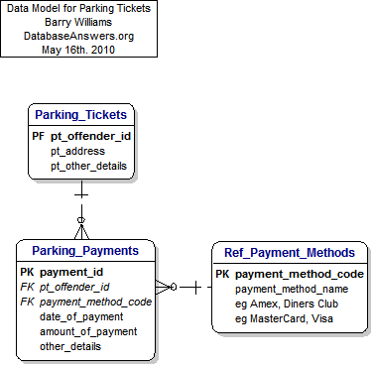

6.3.7 Social Services
This shows the fields in the Tables that are candidates for mapping to the MDM Tables.
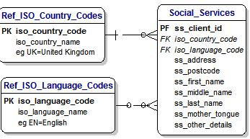

7. Build your Own

7.1 Introduction
This Chapter will discuss how to create your own Data Model.
This will focus on starting from one or more existing Data Models and extending them to meet your own specific requirements.
In this Scenario, we plan to open a Pool Hall, taking our starting-point as this Model on Pool League.

7.2 Opening a Pool Hall
Where do we start with our Data Model ?
Our starting-point is our Library of hundreds of Data Models on the Database Answers Website :-
- http://www.databaseanswers.org/data_models/index.htm
We find this Model on Pool League Statistics which might be useful :-
- http://www.databaseanswers.org/data_models/pool_league_statistics/index.htm
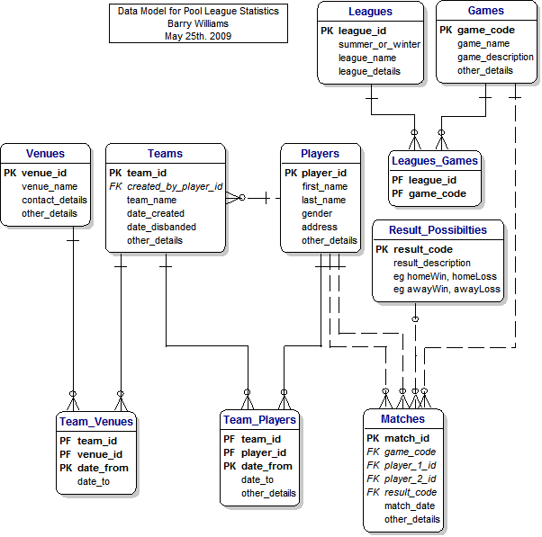
We need a Reservations facility and we have a wide choice :-
- Reservations :-
  - Apartment Rentals
  - Airline Reservations
  - Car Hire
  - Cinema Bookings
  - Coach Trips
  - Doctors Practice
  - Driving School
  - Event Reservations
  - Flights for Children's Charities
  - Hairdressers Appointments
  - Health Centers
  - Holiday Homes
  - Hotel Reservations
  - Limousine Services
  - Online Scheduling
  - Railway Reservations
  - Restaurant Bookings
  - Sports Centers
  - Ticketmaster
  - Vehicle Rental

Our situation is that we have a fixed number of facilities, ie pool tables, which are normally all available during our opening hours.
Each of our Pool Tables can accommodate up to four players at the same time.
We need to record reservations in our Database and allow for cancellations and changes.
We have quite a number of available Databases to choose from, including these :-
  - Apartment Rentals
  - Driving School
  - Hairdressers Appointments
  - Railway Reservations
  - Sports Centers

  - Apartment Rentals
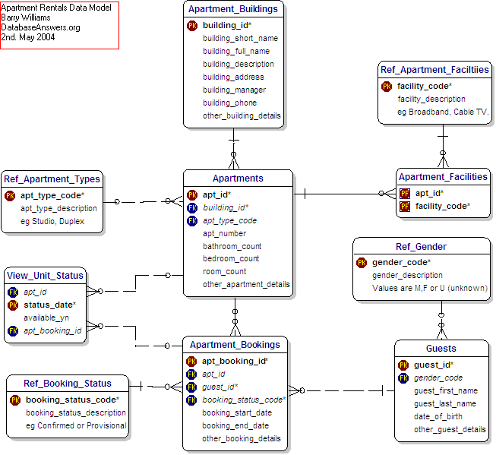

- Driving Schools
This has Lessons which look like what we need, but it also has Customer and Payment details that we don’t need.

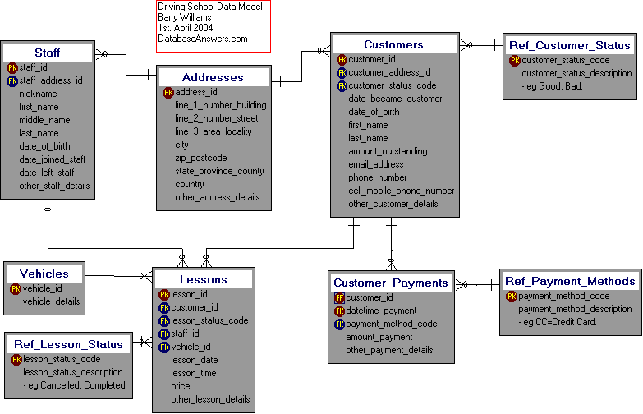

- Hairdressers Appointments
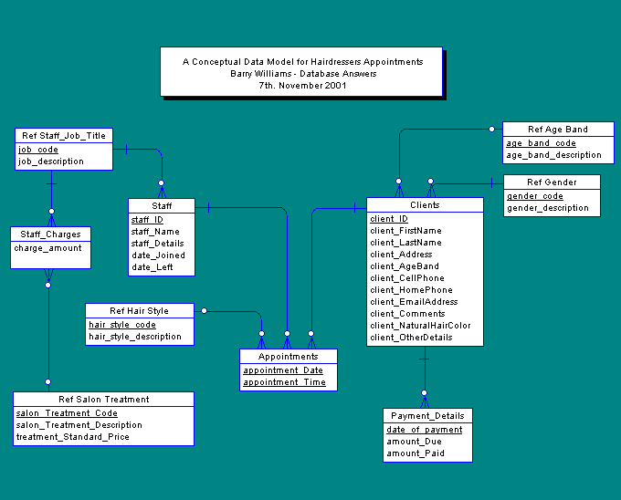

  - Railway Reservations
This looks too complicated and includes that we don’t need, such as Stations !!!
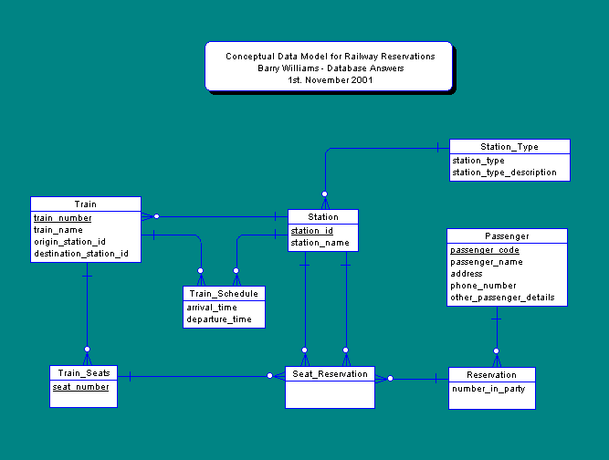

- Sports Centers
- http://www.databaseanswers.org/data_models/sports_centers/index.htm
We notice that this Model has code to check on the availability of facilities by the hour.
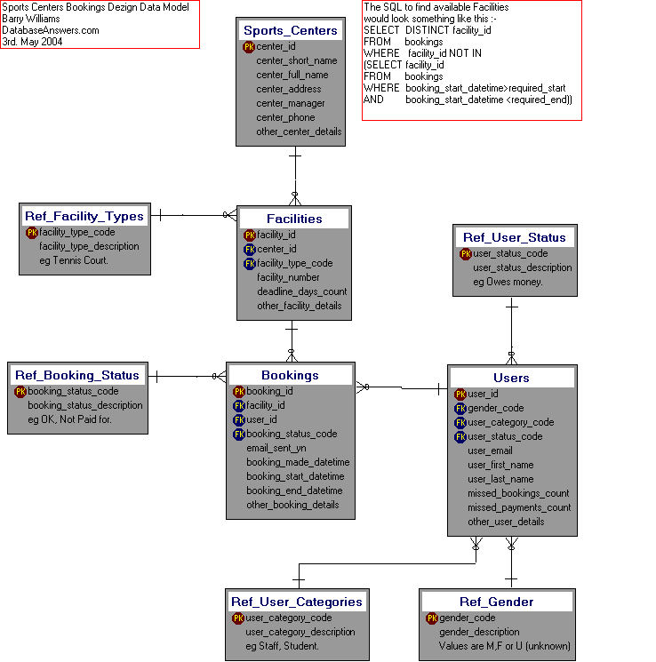

Step 1. Start with the Customer
First, we start by copying the Sports Centers Model.
We take Cardholders Entity from this Model of Customers and Credit Cards and rename it Customers. We do this simply because it contains a representative number of attributes :-
- http://www.databaseanswers.org/data_models/customers_and_credit_cards/customers_and_credit_cards_with_attributes.htm
So our Data Model consists of just this Customer Entity :-
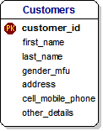

Step 2. Add Tables and Bookings
This is done in a style consistent with the Sports Centers Model.
Full payment is made in advance.
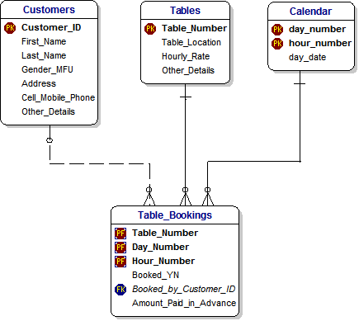

Step 3. Add Customers and Payment Methods
Then we add Payments Methods from the Customers and Payments Model :-
http://www.databaseanswers.org/data_models/customers_and_payments_e_govt/customers_and_payments_subject_area.htm

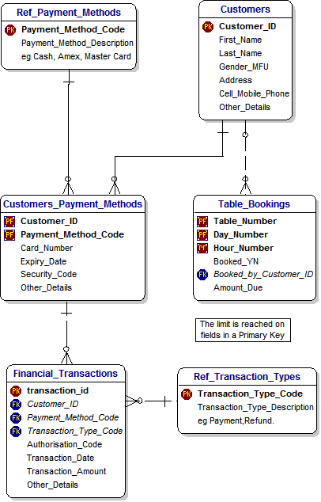

Step 4. Add Regular Bookings
This Step adds Repeat Bookings.
Booking Frequencies table is at the top because logically that is where it belongs.
However, it gives it an importance that it does not deserve.

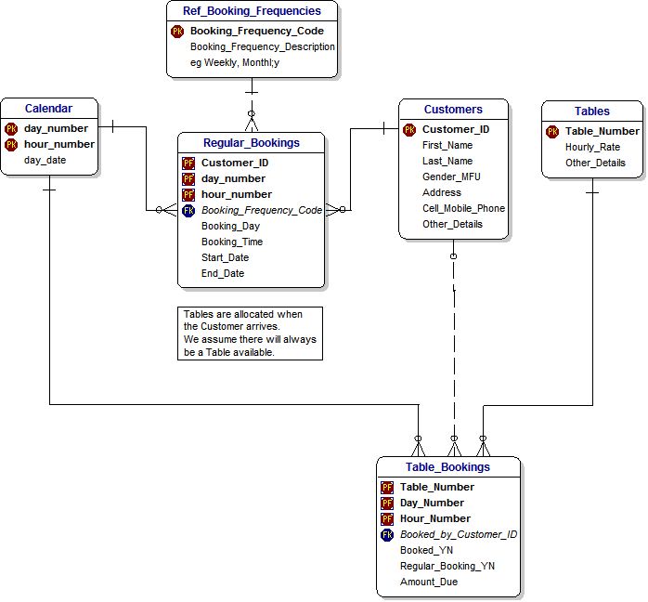

Step 5. Add Inheritance
Generic Customers contain common Attributes from Personal and Commercial Customers.

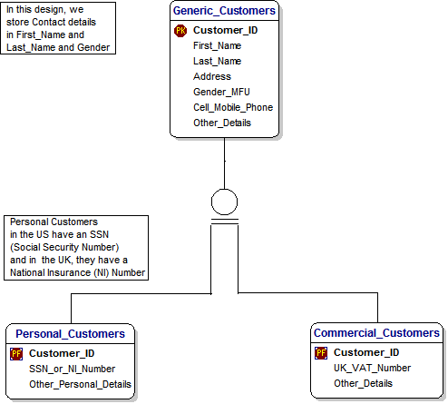

Step 6. Let’s have a Party
This Step introduces Inheritance and the concept of Parties, which are a ‘Super-Type’.
Personal and Commercial Customers are ‘Sub-Types’, along with Staff and Suppliers.

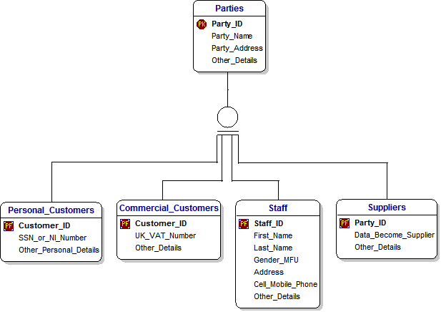

Step 7. Reference Data
This shows all of the Reference Data that we have referred to so far in our Pool Hall Management Data Model.
It is good practice to put Ref_ at the beginning of every Entity or Table.
This makes it very easy to identify the Reference Data.
Some data might be considered Reference Data under certain circumstances.
For example, a Calendar is always Reference Data because it is predictable and never changes.
Products, on the other hand, could change regularly and should not be considered Reference Data.
For example, Products in finance or banking could change on a weekly basis and are therefore not Reference Data.
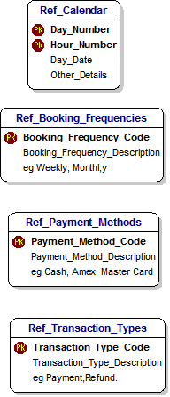

Step 8a. The Complete Model
This diagram shows all the Tables, all the Keys and Attributes, including Reference Data.
It is suitable for discussion with Developers, Data Analysts and other Data Modellers who want to see all the details of every Table.
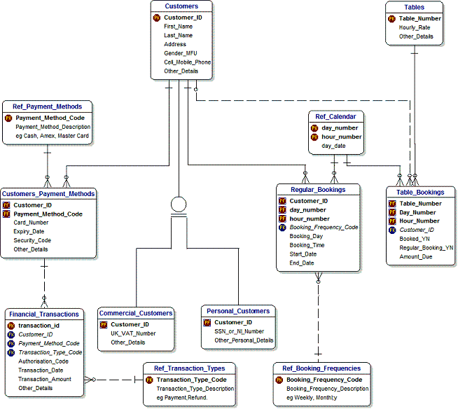

Step 8b. The Complete Model - showing Key Fields only
This shows all the Tables, with just the Keys.
This is much easier to understand at a glance.
This is suitable for discussion with developers, Data Analysts an d other Data Modellers.

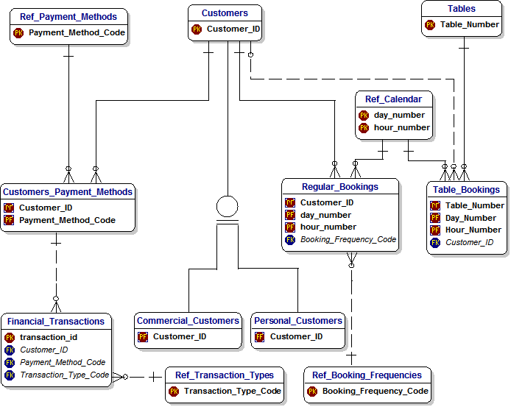

Step 8c. The Complete Model - showing Entity names only
This shows the minimum possible to explain the Data Model.
This is the easiest to understand at a glance.
This is suitable for discussion with business users, management and other stakeholders who are not interested in the details but want to understand the scope of the Model.

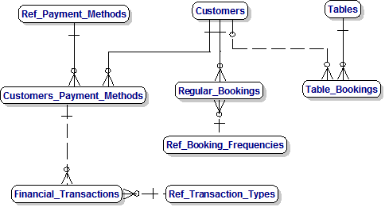
Step 8c. The Complete Model - showing Entity names only without Reference Data Tables
This is even easier and is usually acceptable to senior stakeholders.
They will understand the concept of Reference Data but do not need to see it shown explicitly.
One benefit of this approach is that it makes it easy to define the Business Rules, which Users can then understand, agree to and sign-off.
For example, Business Rules would say :-
- Customers can make Regular Bookings, but does not have to.
- Regular Booking must always be associated with a Customer.

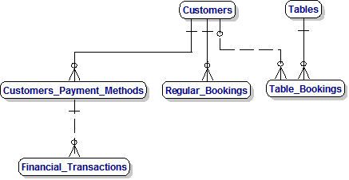

7.2.2 Top-Level Model

7.2.3 Subject Area Models

7.2.3.1 Bookings

7.2.3.2 Customers

7.2.3.3 Payments

7.2.3.4 Data Mart

7.3 Opening a Funeral Home
Here is another finished product :-
- http://www.databaseanswers.org/data_models/funeral_homes/index.htm
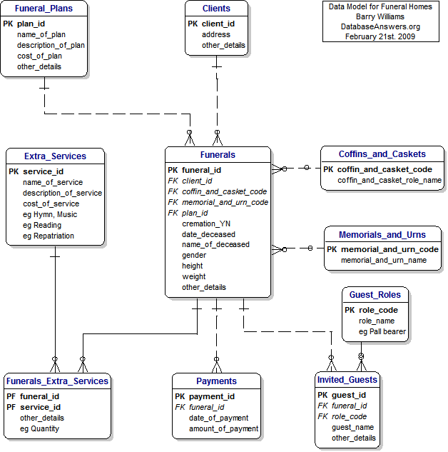

7.4 Making a Movie
For this Model, we have a simple finished Model to start with :-
- http://www.databaseanswers.org/data_models/movie_making/making_a_movie4_beginners.htm

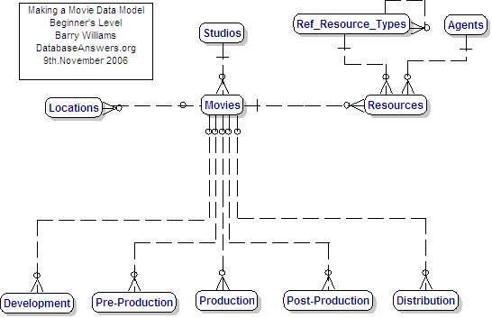

And here’s a complex version :-
- http://www.databaseanswers.org/data_models/movie_making/index.htm
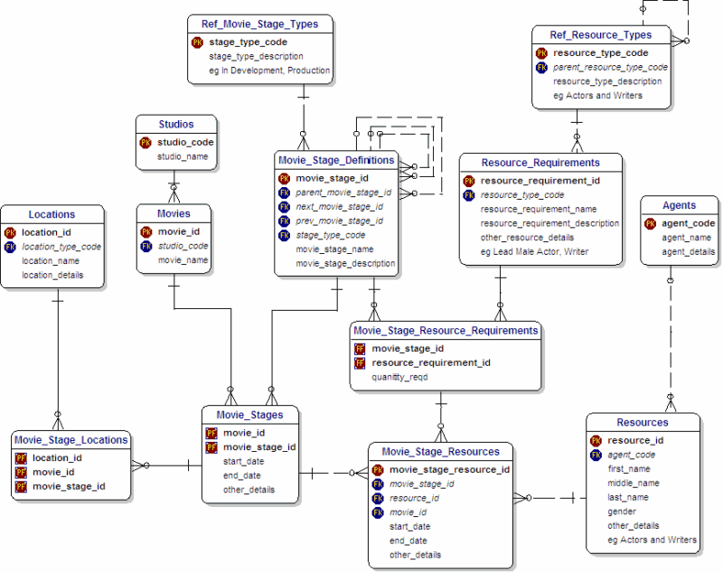

8. Generic Data Models
This Chapter will discuss some examples of powerful Data Models that cover a wide area of applications taken from these examples on the Database Answers Website.
A number of Generic Data Models have been created :-
  - Circus (Events & Players)
  - Customers and Services
  - Document Management
  - Father of All Models
  - Generic Foundation
  - Generic Me and My Life
  - Organisations and People
  - Organisations, People and Transactions
  - Organisations,Members & Meetings
  - Patient Care
  - Reservations
  - Shrek 2 Movie (Events & Places)
  - Transport
  - User-defined Hierarchies

8.1 Circus
This Model is a very interesting example of a generic Model involving Customers, Events and People, in this case, of course, Performers.
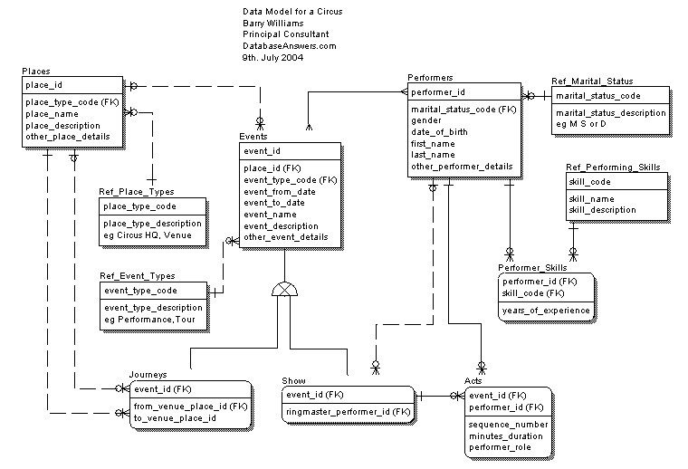

8.2 Father of all Data Models
This version of the Data Model includes a Data_Values Table showing how data could be stored in this flexible design.
This is an example of the "Entity-Attribute-Value" Approach and Wikipedia has a useful Entry - http://en.wikipedia.org/wiki/Entity-attribute-value_model
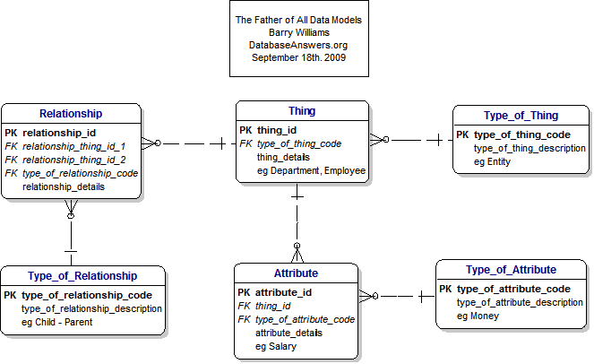

8.3 Customers
This Model can provide a very good starting-point for any Model involving Customers, People and Events.
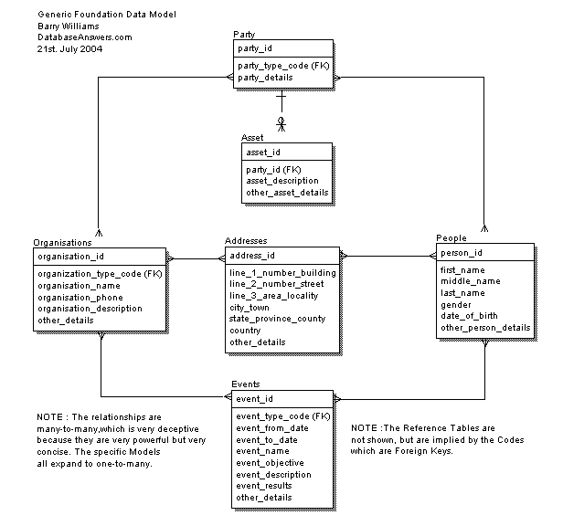

8.4 My Life
Generic and Specific Data Models are very important because they illustrate how a number of specific Data Models can be incorporated into one Generic Model.
In this case, the concept of a Life-Cycle from the Cradle to the Grave is used to generate Scenarios :-
1. Baby (Me and Mommy)
2. Teenager (Traffic Cops and Tickets
3. Student (Behaviour Monitoring)
4. Adult (Partnerships and Relationships)
5. Adult (Golf Club Tournament)
6. Senior Citizen (Health Centres)
Here is the Page :-http://www.databaseanswers.org/data_models/generic_and_specific_models/index.htm

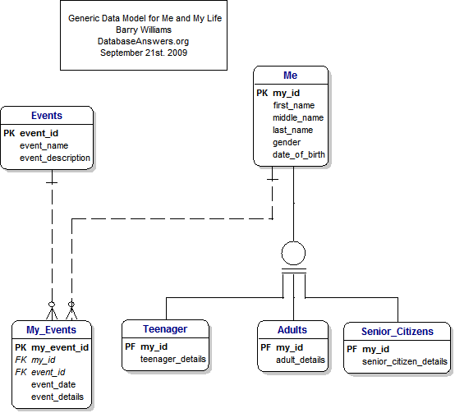

8.5 Reservations
http://www.databaseanswers.org/data_models/generic_reservations/index.htm

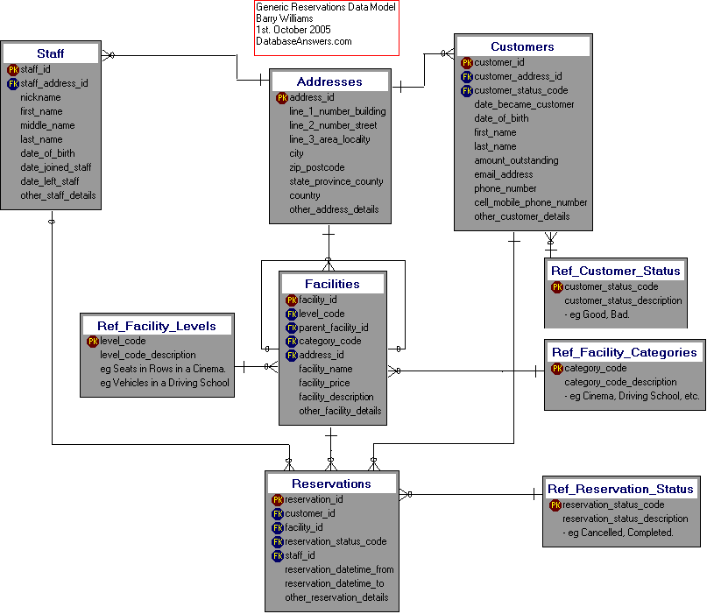

8.6 Shrek Movie
This Model turned out to be a n interesting exercise in generality.
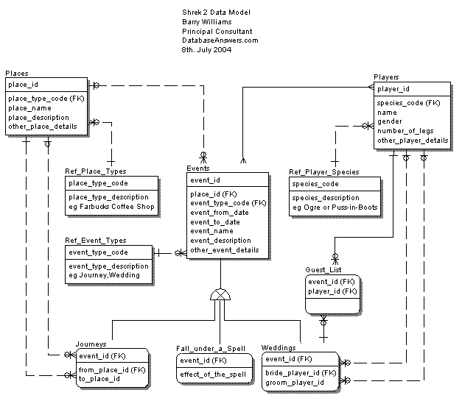

8.7 User-Defined Hierarchies
Here is the page Link :-
- http://www.databaseanswers.org/data_models/user_defined_hierarchies/index.htm

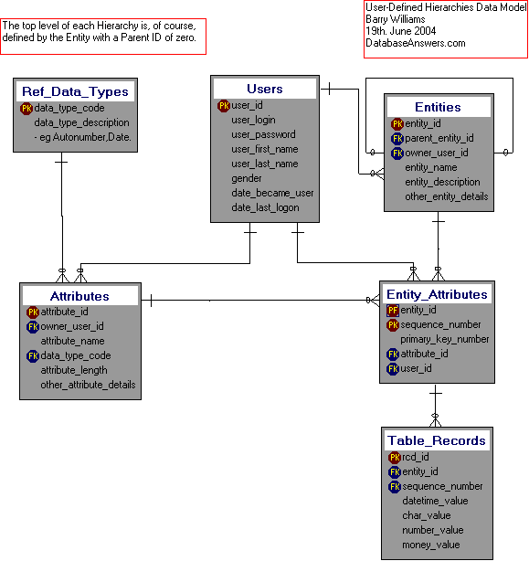

8.8 Usual Suspects
Here is the page Link :-
- http://www.databaseanswers.org/data_models/usual_suspects/index.htm
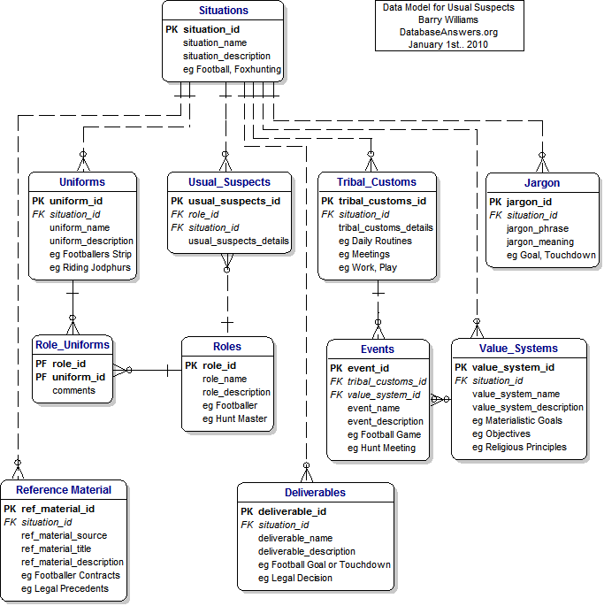

9. From the Cradle to the Grave
This Chapter discusses Data Models covering a typical life cycle.
Topics covered include :-
  - Primary Keys

10.1.1 I am a new Baby
Topics covered include :-
• Entities
• Primary Keys
The approach I have chosen for this Tutorial is to cover the Life span of a typical human being, from the cradle to the grave.
This allows me to trace the increasing complexity in life and match it to an increasing complexity in Data Models.
• The first task is to decide on the scope of our Data Model.
• My Approach has three Steps :-
- Establish the Scope of the Data Model
- Identify the 'Things of Interest' that are within the Scope, These will be called Entities.
- Determine the Relationships between them.
DECIDING THE SCOPE OF OUR DATA MODEL
• I have decided that the Scope is 'From the Cradle to the Grave'.
• This will include childhood, teenage years, becoming a student, getting a job, getting married, getting sick, and finally dying
• Therefore, anything outside this scope are not 'Things of Interest'.

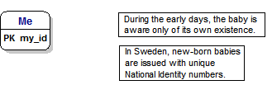

10.1.2 Me and Mommy
At this Stage, the baby becomes aware of Mommy’s existence so we add her to the Model because she is now in scope.
Topics covered include :-
  - Foreign Keys

Here we add a Relationships between the Entities.
When this Primary Key is used in another Table, it is referred to as a'Foreign Key'.
We can see a good example in this diagram, where the ‘mommys_id’ field appears in the Me Table as a Foreign Key. This is shown with an 'FK' symbol beside it
The ‘mommys_id’ field then appears as the Primary key in the Mommy Table.

Mandatory Key Fields
A Foreign Key is usually mandatory, in other words, a value for a mommys_id in the Me Table must correspond to the value of the mommys_id for a record in the Mommy Table.
In plain English, of course, the Business Rule would say ‘Each Baby must have a real Mommy’.
This is shown in the diagram by the short straight line at the end of the dotted line close to the Customers Table.

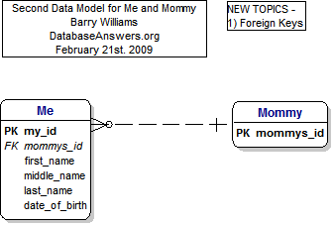

10.1.3 Me, Mommy and Meals
Now I become aware that I am eating at regular times.
Topics covered include :-
  - One-to-Many Relationships

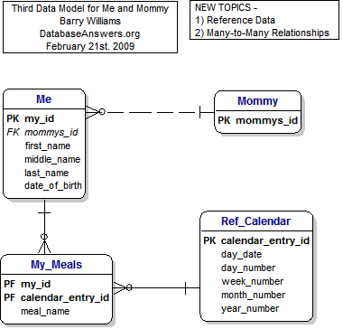

10.1.4 Children’s Playgroups
Topics covered include :-
  - Many-to-Many Relationships

• Here we have added the Relationships between the Entities.
- When this Primary Key is used in another Table, it is referred to as a'Foreign Key'.
- We can see a good example in this diagram, where the customer_id appears in the Customers_Payment_Methods Table as a Foreign Key.
- This is shown with an 'FK' symbol beside it

• Mandatory Key Fields
- A Foreign Key is usually mandatory, in other words, a value for a customer_id in the Customers_Payment_Methods Table must correspond to an actual value of the customer_id in the Customers_Version_1 Table.
- This is shown in the diagram by the short straight line at the end of the dotted line close to the Customers Table.
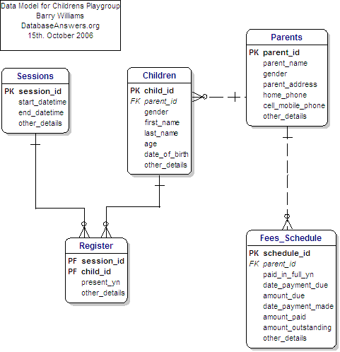

10.1.5 Church Sunday School

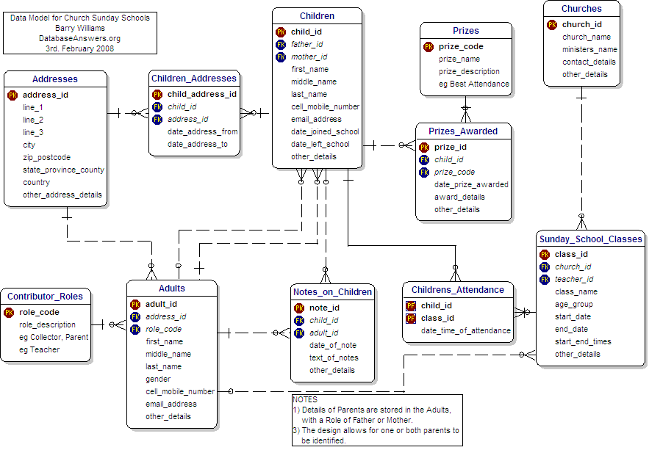

10.1.6 Student Accommodation
At this Stage, I MOVE INTO STUDENT ACCOMMODATION :
Topics covered include :-
  - Primary and Foreign Keys
  - One-to-Many and Many-to-Many Relationships
  - Reference Data

• This diagram shows how the hierarchies of Products and Product Types that we have just discussed are shown in our Entity-Relationship Diagram.
Rabbits Ears
• You will notice that the table called 'Product_Types_v1' has a dotted line coming out on the right-hand side and going back in again on the top-right corner.
• Data Analysts call this a Reflexive Relationship, or informally, simply 'Rabbits Ears'.
• In plain English, we would say that the Table is joined to itself and it means that a record in this Table can be related to another record in the Table.
• This approach is how we handle the situation where each Product can be in a hierarchy and related to another Product.
• For example, a Product called Panini could be in a Product Sub-Category called 'Miscelleneous Sandwiches' which could be a higher Product Category called 'Cold Food', which itself could be in a higher Product Super-Category called simply 'Food'.
• Next time you go into Starbucks, take a look at the borad behind the counter and try to decide how you design the Products area of the Data Model.
• You should pay special attention to the little 'zeros' at each end of the dotted line.
• These are how we implement the fact that the 'Parent Product Type Code' is optional, because the highest level will not have a Parent.
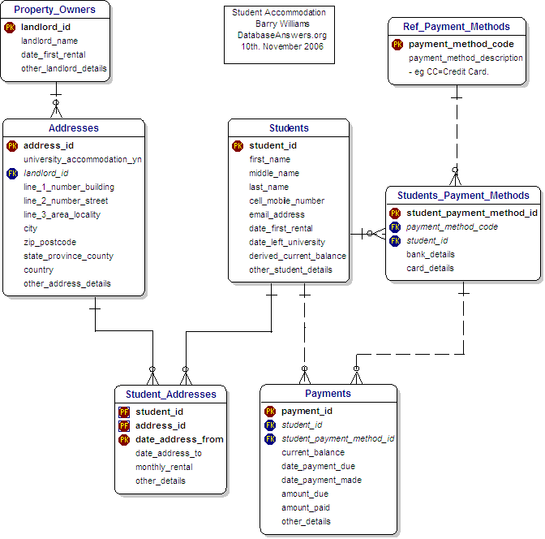

10.1.7 Student Assessments
Topics covered include :-
  - Primary and Foreign Keys
  - One-to-Many and Many-to-Many Relationships
  - Reference Data - Addresses

• Food and Drink are specific examples of the more general Thing called a Product.
• They inherit some common attributes from the Product, and also have some of their own.
• For example, Food can contain Nuts but Drink do not contain nuts, but both have a Product Name.
• The unusual symbol in the middle of the diagram, composed of a circle with two small lines underneath it is how Inheritance is shown using the particular Data Modelling Tool that I am using,which is called Dezign.
• Inheritance is a very important topic when you are creating a Data Model.
• In plain English, we would say that Inheritance occurs where a Parent-Child relationship exists between Things of Interest (or Entities).
• You can ask the simple 'Is-a' question - in this case, if we ask 'Is a Book a Product' then clearly the answer is 'Yes' so we think there is an Inheritance relationship between them.
• In the example of Inheritance shown in this diagram, we can see that all Products have Names and Descriptions. Therefore, Books, Food and Drink will inherit these characteristics from the parent Product.
• However, each type of Product will have specific characteristics that it does not share with other types of Products. For example, Books have ISBNs and Authors, but Food and Drink do not.
• One of the important things in your Data Model is to be sure you have identified all the Inheritance relationships.
• However, from many years of experince as a DBA, I should point out that relationship is often blurred in a real physical Database because it can be clumsy to implement.
• I sometimes find myself showing Inheritance in a Logical Data Model which then disappears when I design the Physical Database, which is what ultimately becomes the Database.

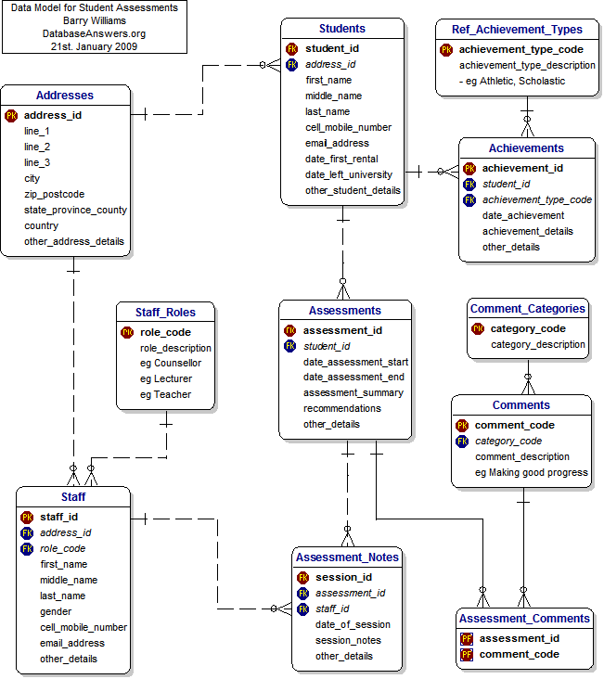

10.1.8 Joining Facebook
Topics covered include :-
  - Primary and Foreign Keys
  - One-to-Many and Many-to-Many Relationships
  - Reference Data

What about Inheritance ???

- This diagram shows Address Types, which are an example of Reference Data.
- This kind of data has the following characteristics :-
  - it doesn't change very much
  - it has a relatively small number of values, usually less than a few dozen and never more than a few hundred.
  - Therefore we can show it with a Code as a Primary Key.
  - Data in Reference Data Tables can be used to populate drop-down lists for Users to select from.
  - In this way, it is used to ensure that all new data is valid.
- Standards
  - In the Address Table, you will see a field called 'iso_country_codes'.
  - iso stands for the 'International Standards Organisation'.
  - Where possible, it's always good to use national or international standards.
Customer Addresses
  - This is a general and flexible approach to handling Addresses in our Data Model.
  - We have a separate Address Table, which allows us to have more than one Address for any Customer very easily.
  - This design also has some other benefits :-
    - We can accommodate more than one person at the same Address. We need to do this because different members of a family may sign-up separately with Amazon.
    - With a separate table of Addresses, we can easily use commercial software to validate our Addresses. To find this kind of software, simply Google for "Address Validation Software". I have used QAS with great success in the past. With this approach, we can always be sure that we have 100% good Address data in our Database.

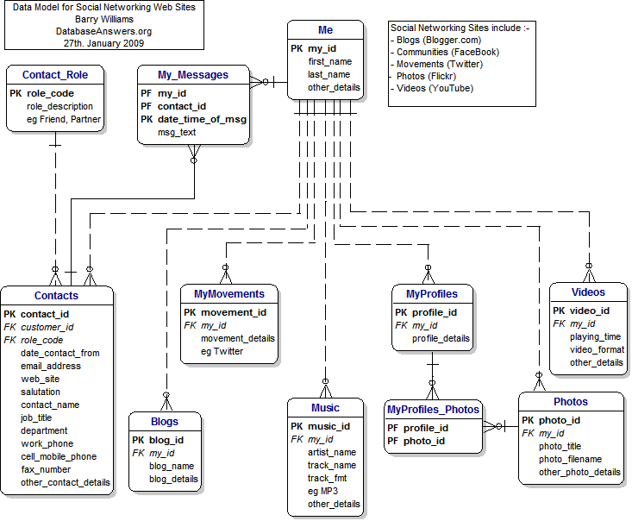

10.1.9 Joining a Swimming Club
Topics covered :-
  - Primary and Foreign Keys
  - One-to-Many and Many-to-Many Relationships
  - Reference Data (eg Address Types and Payment Methods)

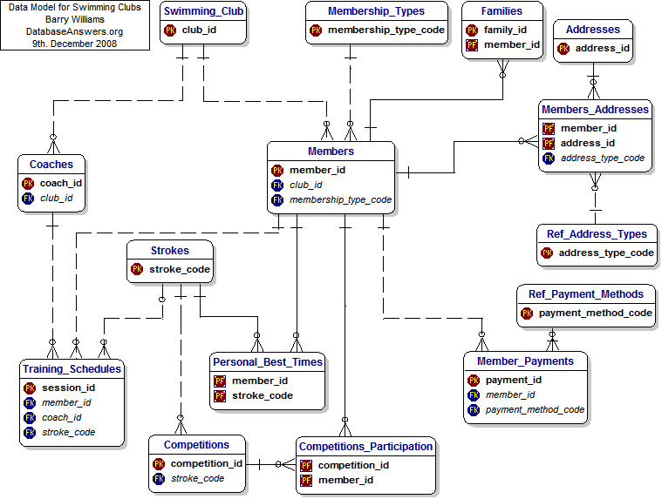

10.1.10 A Ticket from a Traffic Cop
Topics covered :-
  - Primary and Foreign Keys
  - One-to-Many and Many-to-Many Relationships
  - Reference Data

10.1.11 I Get Married
Topics covered :-
  - Primary and Foreign Keys
  - One-to-Many and Many-to-Many Relationships
  - Reference Data

This Model was created using a different Data Modelling Tool, called ERWin from Computer Associates.
It shows that if you are familiar with the underlying principles that you will be able to understand and ERD.
• [RBW] - Mention IDEFIX (Wikipedia)
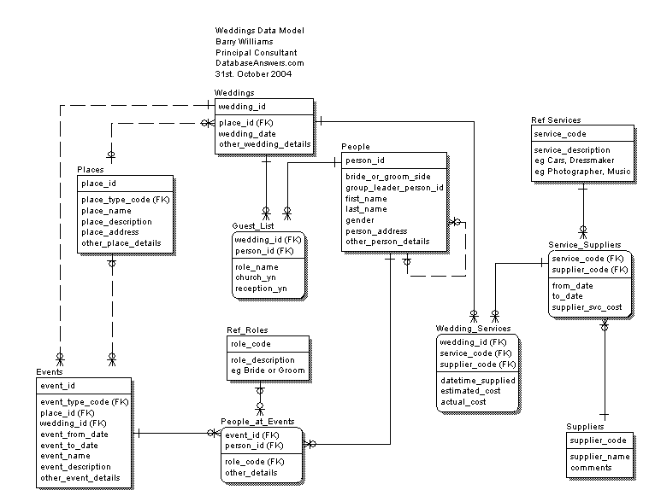

10.1.12 I Become a Baseball Umpire
Topics covered :-
  - Primary and Foreign Keys
  - One-to-Many and Many-to-Many Relationships
  - Reference Data

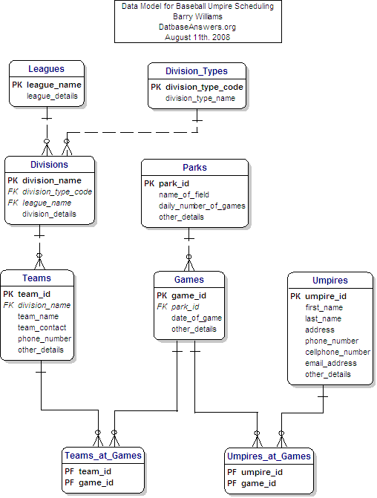

10.1.13 I Go to Hospital
Topics covered :-
  - Primary and Foreign Keys
  - One-to-Many and Many-to-Many Relationships
  - Reference Data

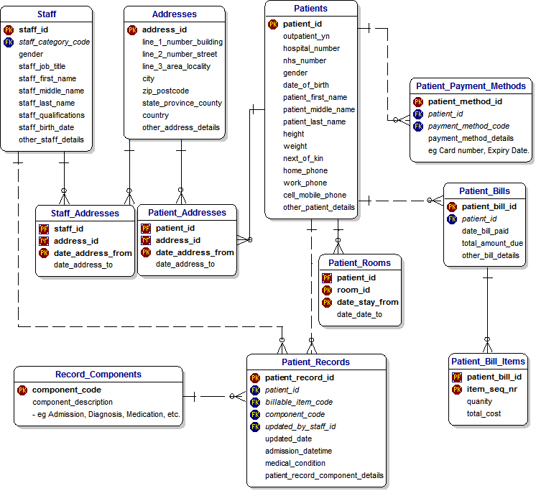

10.1.14 I Visit a Funeral Home
Topics covered :-
  - Primary and Foreign Keys
  - One-to-Many and Many-to-Many Relationships
  - Reference Data

10.1.15 Events in my Life
Topics covered :-
  - Primary Keys
  - Foreign Keys
  - One-to-Many Relationships
  - Many-to-Many Relationships
  - Reference Data

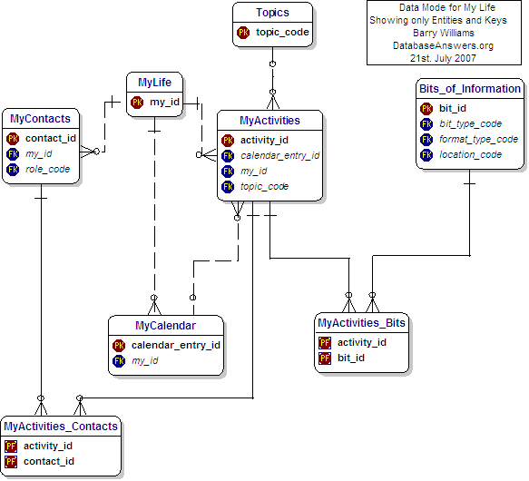

10.1.16 Events in my Work
Topics covered :-
  - Primary Keys and Foreign Keys
  - One-to-Many and Many-to-Many Relationships
  - Hierarchies (eg Organisations)
  - Inheritance (from Info Cat to Customer_Data, Invoices, Contracts & Orders.
  - Reference Data eg Status_Codes

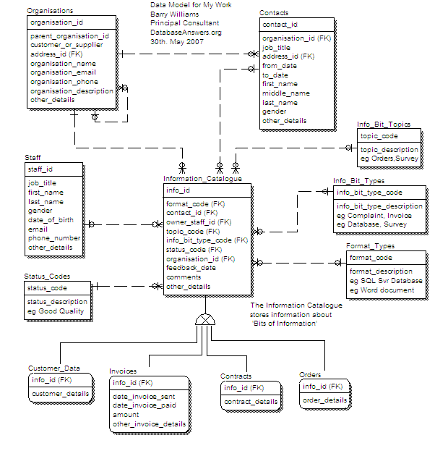

10.1.17 Summary of Topics
Topics covered :-
  - Primary Keys and Foreign Keys
  - One-to-Many and Many-to-Many Relationships
  - Hierarchies
  - Inheritance
  - Reference Data

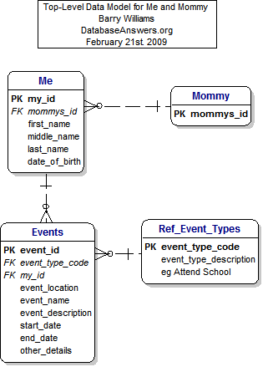

10. Commercial Web Sites
- Avon Cosmetics
- Cirque du Soleil
- Dice (Job Seekers Web Site)
- Dog Whisperer
- eBay Deals
- Just Giving (Charity)
- MyLifeBits Research
- NewEgg
- SalesForce
- Shrek 2 Movie
- Ticketmaster
- Woot

To be completed

11. Vertical Applications

11.1 Introduction
Selection from these possibilities :-
- Vertical Applications
  - CRM and Customers
  - e-Commerce
  - Education
  - Entertainment
  - Health and Fitness
  - Law Enforcement
  - Students :-
    - Behavior Monitoring
    - Church Sunday Schools
    - Class Scheduling
    - Credit Accumulation (Europe)
    - e-Learning
    - High School Football
    - School Catering Businesses
    - School Management Systems
    - Schools Sports Tournaments
    - Student Accommodation
    - Student Activities
    - Student Assessments (Simple)
    - Student Assessments (Complex)
  - Transport and Travel

11.2 Students

11.2.1 Student Registration
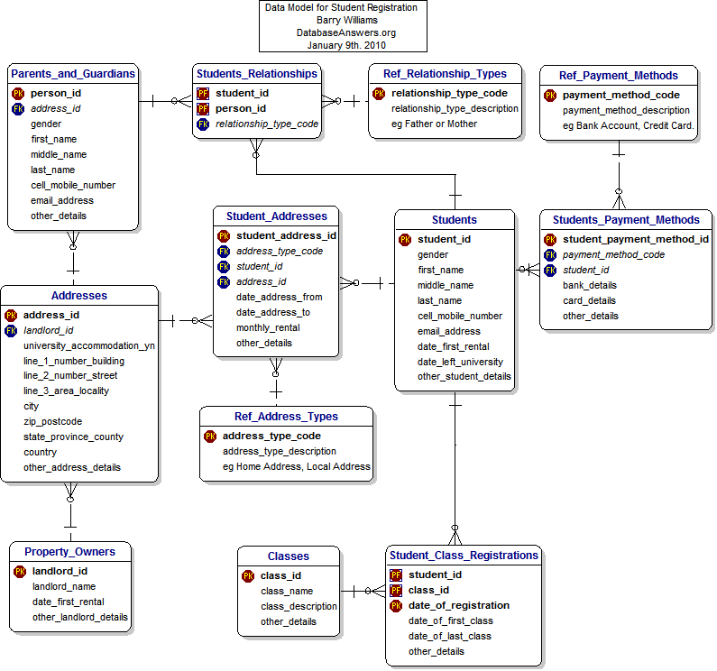

11.2.2 Students Registration Data Mart
This simplifies the tasks of producing analytical data for Enquiries and Reports
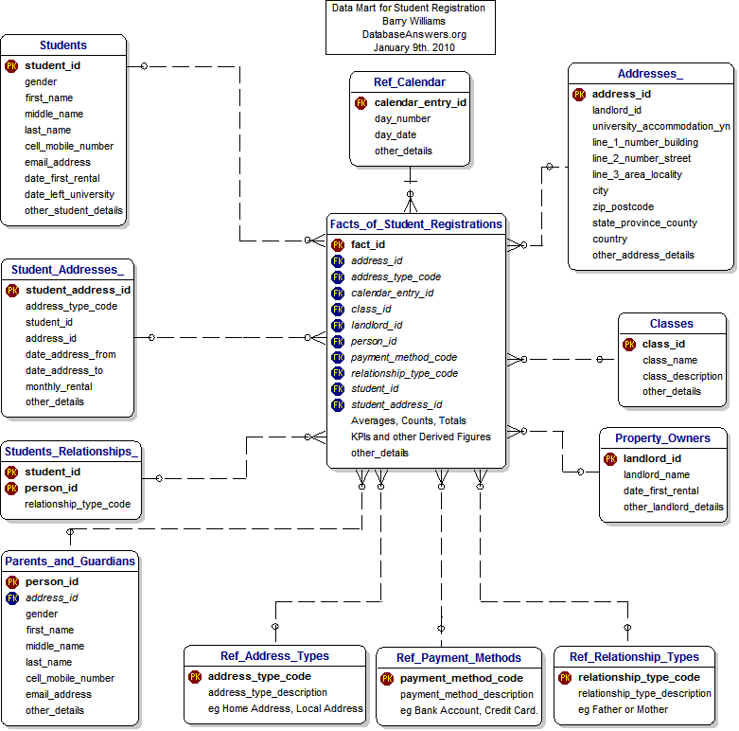

11.2.3 Students Achievements Data Mart
This simplifies the tasks of producing analytical data for Enquiries and Reports
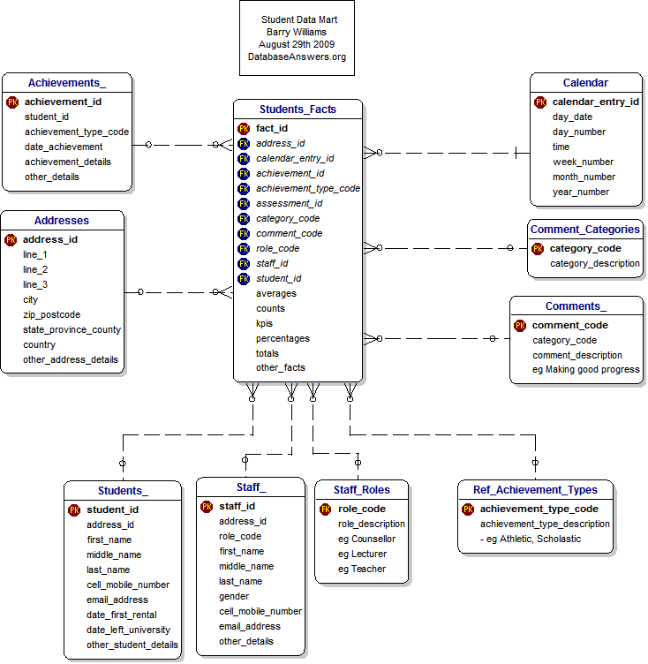

11.2.4 Student Loans

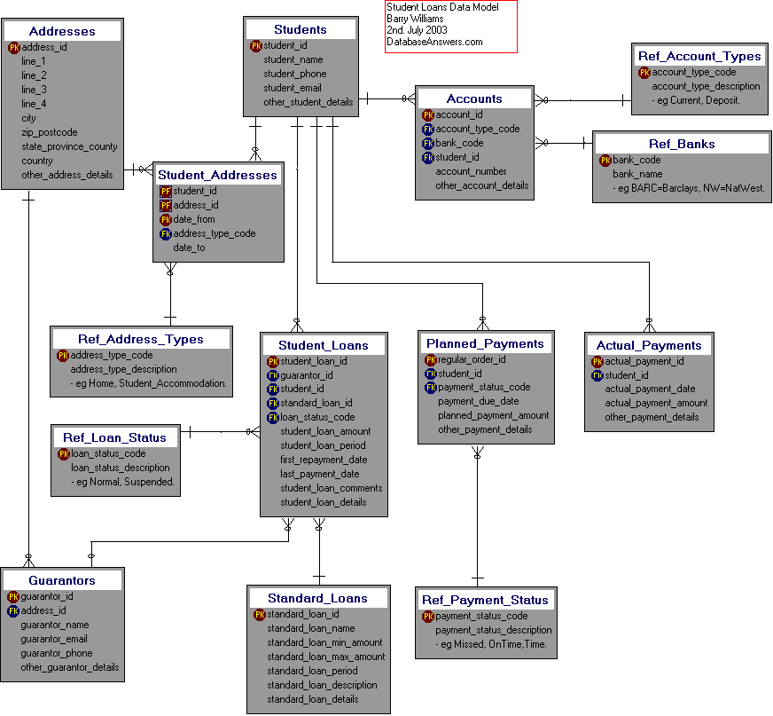

Appendix A. Business Rules
Sample can be used as a Template.
Email us for blank Templates and Templates for specific Applications.

Appendix B. Glossary of Terms

