Barry Williams barryw@databaseanswers.org

1.A Blueprint for an Architecture
This diagram shows an example of a generic Teradata Blueprint for an Architecture with a number of Rooms or which becomes Subject Areas in the context of a Data Model.
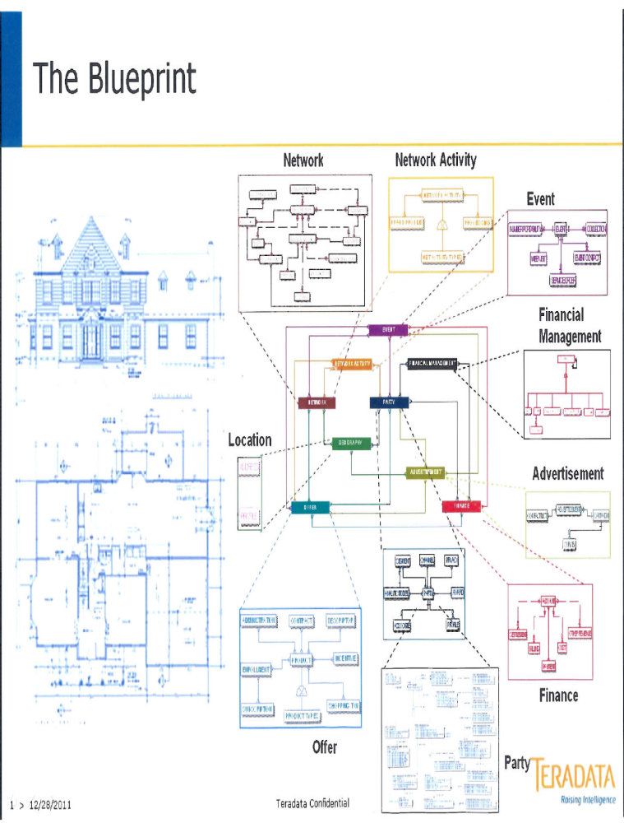

2. An Enterprise Data Model (EDM)
The yellow area in this diagram shows an EDM with separate Subject Areas :-
- Agreement, Asset, Event, Geography, Party, Service, Shipment and Transportation.
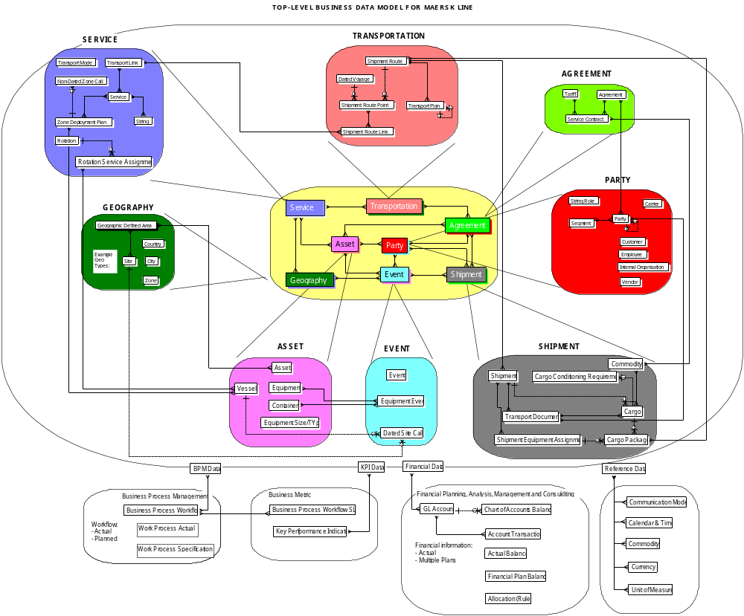

3. A BI Ready Road Map
This shows six Stages in a Road Map for Enterprise Data Management.
BI Ready provides the functionality within the dotted lines which corresponds to the Data Integration and Data Marts Stages in the Database Answers Road Map.
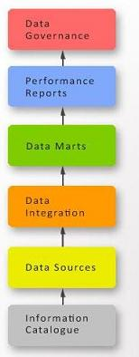

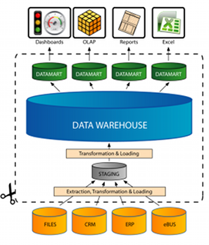

4.Three Levels of BI Ready
This shows how BI Ready facilities can be packaged in three levels for three distinct markets.
Level 3) Blue-Chip Level MDM, Single View, Migration to Teradata.

Level 2) SME Level ETL, Data Warehouse/ Mart with Oracle

Level 1) Entry Level CSV Data Entry using 3rd Party product

5. Getting Started
This shows a Common Data Model that provides an excellent Starting Point for building an Enterprise Data Warehouse.
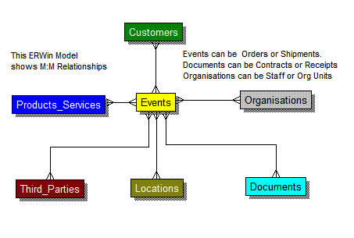

6. Generic Dimensional Model
The existence of Dimensions and Facts makes it possible to define a Generic Design for a range of Dimensional Models.
This example shows six Dimensions and six Facts.
Each of these Dimensions and Facts can be translated from the generic names to specifics, such as Customer, Store, Product and so on.

