1. Introduction
2. Common Data Model
3. Subject Area Models
3.1 Deliveries
3.2 Deliveries showing Attributes
3.3 Maintenance
3.4 Maintenance showing Attributes
3.5 Requisitions showing Attributes
3.6 Data Architecture for MDM - Entity names only
3.7 Data Architecture for MDM - showing Entities and Keys
3.8 Data Architecture for MDM - showing Entities and Attributes

1. Introduction
This document defines a Top-Level Conceptual Data Model or ‘CDM’.

The purpose is to establish a common point of reference.

Any future requests for Data Modelling will be reviewed in the context of this CDM.

If approved, they will be either modifications or extensions to the CDM.

The CDM will be aligned with the design of any new Systems, such as GOLDesp MIRO.

2. Conceptual Data Model
This is a top-level Business Data Model that shows the Entities that are important at the top level.
It provides a suitable form of communication with a wide range of stakeholders.

There are a number of lower-level Models for specific Subject Areas.

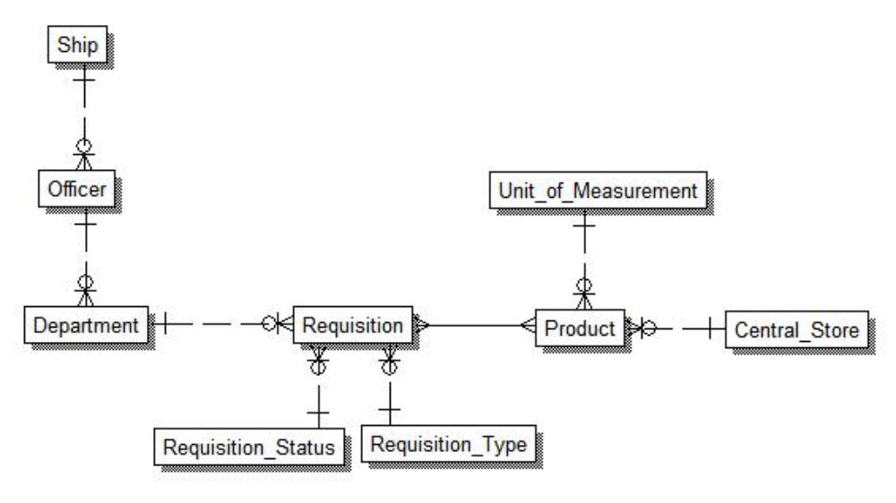

3. Subject Area Models
The Subject Areas are for specific Areas of Interest, such as Deliveries and Requisitions.

3.1 Deliveries
This diagram is simple and easy to discuss and understand.

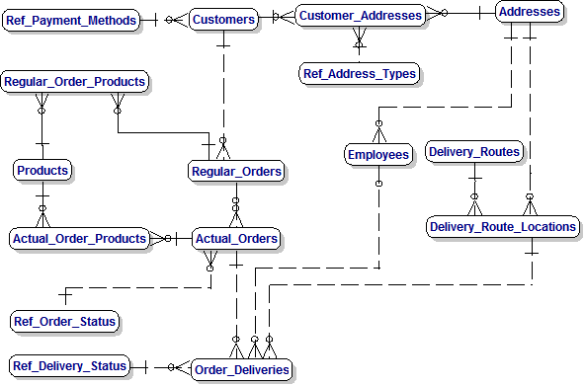

3.2 Deliveries showing Attributes
This diagram shows details of the Attributes for detailed discussion.

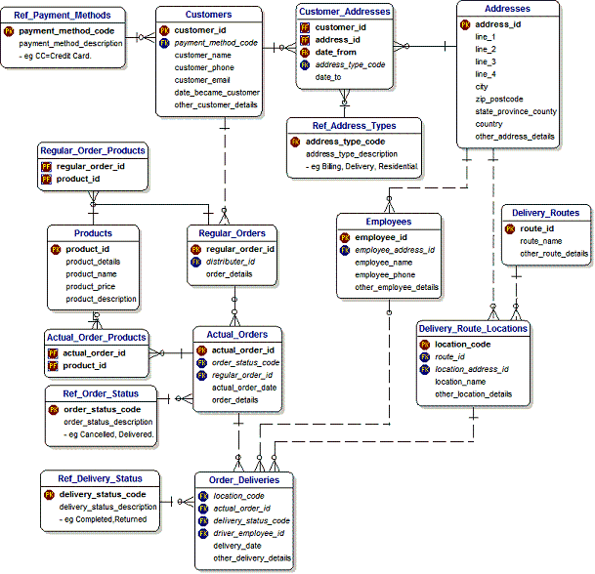

3.3 Maintenance
This diagram is simple and easy to discuss and understand.

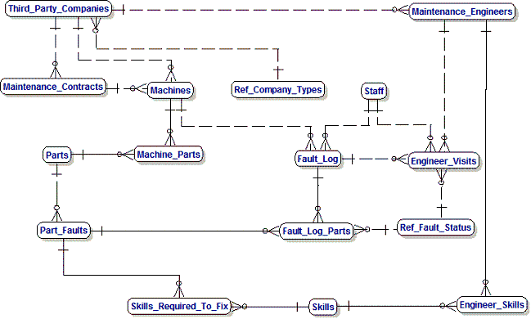

3.4 Maintenance showing Attributes
This diagram shows details of the Attributes and is suitable for resolution of detailed questions..

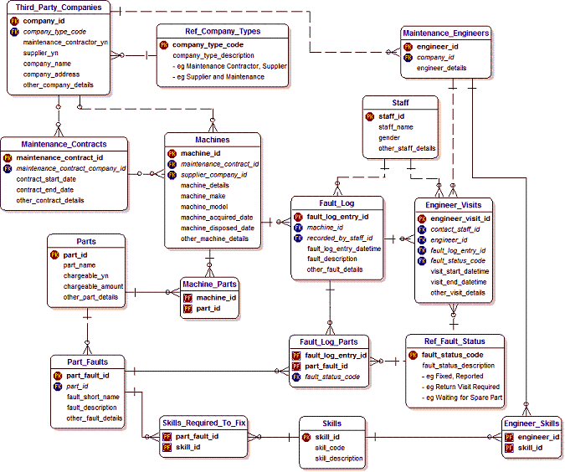

3.5 Requisitions showing Attributes
This diagram shows details of the Attributes.

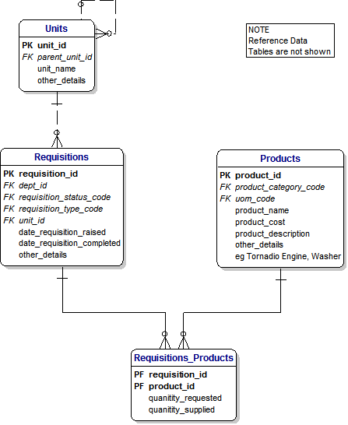

3.6 Data Architecture for MDM - Entity names only
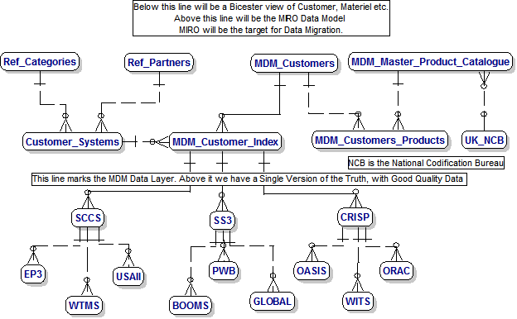

3.7 Data Architecture for MDM - showing Entities and Keys

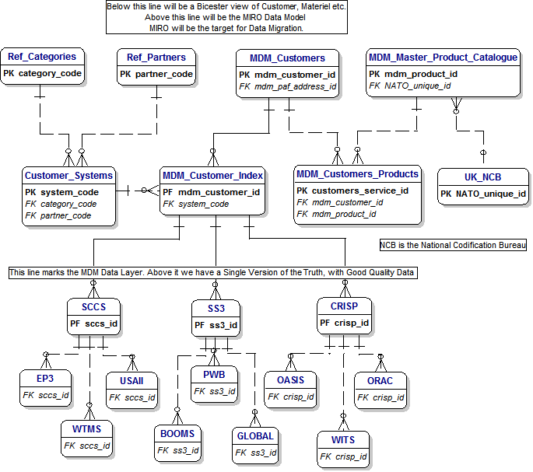

3.8 Data Architecture for MDM - showing Entities and Attributes

