



Defence Equipment & Support

Data Centre of Excellence

Template
Current State Analysis

written by: | Lawrence Grech, Dinyar Cooper | approved by:
unit: | Glue Reply, Data Management Practice | doc ID:
review: |  | issue date: |  | doc. model
Privacy notes

State of the document

Review | date | changes | (approved by)

Changes summary

Main changes list compared to the previous version:

Attachments:

Plan

Schedule

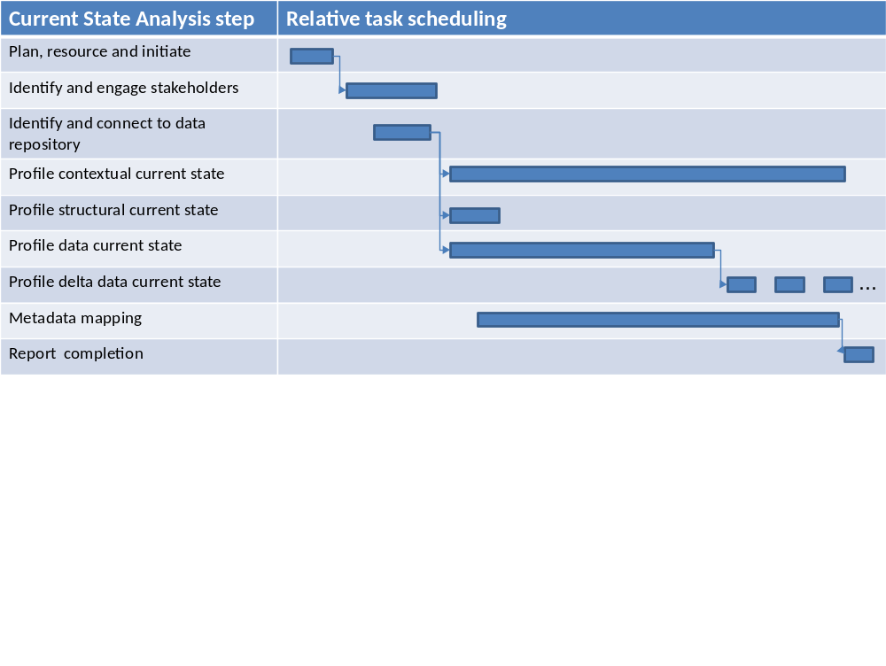

Durations
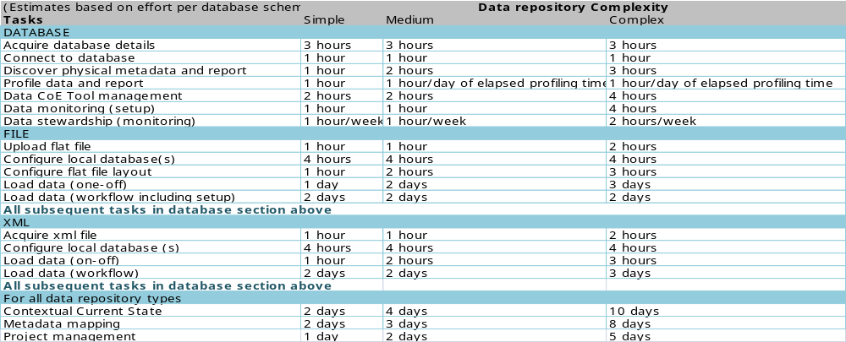

Involvement

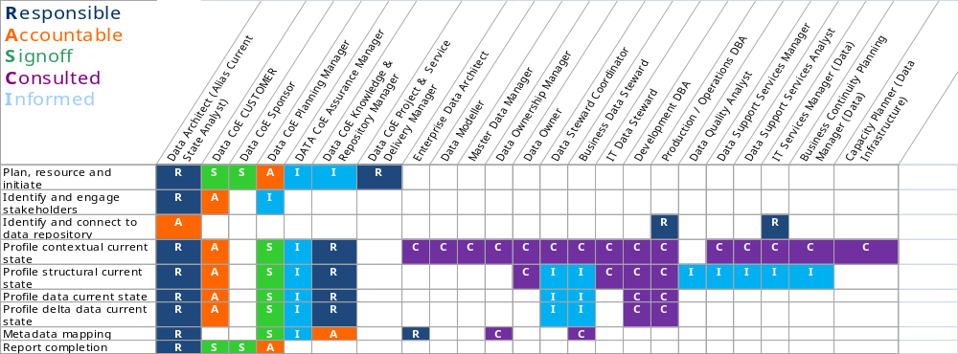

Contextual Current State Analysis

Documentation
Title | Document curator contact info | Location/reference | Date Created | Date updated | Comment

Functional purpose

Financial valuation of data repository

Organisational Context
Dept/team | Data producer/consumer | Applications/interfaces involved | Process steps involved
Data Owner
Data Steward
Data Administrators
Data Modellers
Etc.

Business Process Context

Business rules

Projects and Change Management
Date on which projects where listed (dd-mmm-yyyy):

Programme name | Project name | Programme manager | Project manager | Start date | Completion date | Known data issues | Project status (RAG) | Data contact

Applications

System name | Application name | Application purpose | Version | Application owner | Business processes fulfilled | Planned change (cross reference to Projects and Change Management

Data Imports

Source of data | Target | Data transmission technology (FTP, Informatica etc.) | Data Format (e.g. flat file, XML etc.) | Purpose | Description of import process

Data Exports

Source of data | Target | Data transmission technology (FTP, Informatica etc.) | Data Format (e.g. flat file, XML etc.) | Purpose | Description of import process

Enterprise Data Architecture Context

Standards, Methods, Tools Used
Name | Standard, Method, Tool | References to further description | Purpose

Technical Context

Do not reveal details that could constitute a security breach. If in doubt consult Security.

Describe;

- Hosting hardware with versions
- Disk space
- Capacity analysis of storage and its consumption trends by the data repository
- Operating systems with versions
- Database Management software specification
- Licensing details and restrictions
- Operating team contact
- Database Administrator team contact
- Infrastructure Access to the hosting hardware

Performance Service Levels

Operational Context

Backup and Archival Context

Special Security Considerations

Anecdotal Evidence

Data Challenges

Structural Current State

The resultant structural profiling will be held in the data profiling tool.

Existing design documents

Location | Description | Modelling tool (Erwin, Visio etc.) | Type (Architectural, Conceptual, Logical, Physical etc.) | Subject areas | Create date | Last updated | Owner/Contributors

Physical Metadata

Information produced is dependent on the tool used to profile the structure but should include;

- Database, file, directory
- Language and character set
- Database management technology
- Table, file, schema level
- Row, record, document level
- Column, field, tag level
- Data type (simple and domains)
- Connections and references between all components
- Physical storage such as disk space occupied
- Indexing and lookup characteristics
- Volumetric such as row count
- Others, depending on the profiling tool used

Data Current State

The resulting data repository profiling will be held in the data profiling tool.

Data Profiling Feasibility

Are data volumes feasible?
Total records to be profiled | No. Of minutes to profile 10,000 rows | Total Estimated time for full data profiling | All stakeholders consulted that sufficient processing windows can be found (Y/N) | Proposed Processing window schedule (dates, times, durations)

Instances of Data Repository
Instance type (Production, Backup, Read only, extract, redo logs etc.) | Size (Gb) | Availability for profiling (comment) | Number of records

Full or Partial Profiling Requirement

- List of tables/files/fields that can be excluded.
- Temporary tables/files that can be excluded
- Decision on whether to take a statistical sample or complete scan of the records/rows
- Details of any pre-processing required (e.g. XML documents to be loaded into relational tables for profiling)

Commence Profile

See templates for Request for Information and Commencement Notice

Delta Profiling

The resulting data repository profiling will be held in the data profiling tool.

Delta Profiling Plan

Processing windows available | Type of delta profiling required (Structural/Data/Both | If data which tables/files? | Will the profiling operate within the allotted processing window (Benchmark may be required) | Does the profiling terminate if it exceeds the processing window?

Commence Delta Profile

See templates for Request for Information and Commencement Notice

