**About**

A simple guide to help new developers set up an environment for developing the Access Labs applications.

Firstly, there are some links below you must refer to before this doc.

New hire enablement plan:

<https://mojo.redhat.com/docs/DOC-92816>

Access Labs guide | parent doc

<https://mojo.redhat.com/docs/DOC-932924>

There are something to be clarified in a more explicit way from the stand of a new comer.

Installing IRC client

Setting up an environment that mimics the Access Labs development space

Setting up HTTP proxy

Setting up VPN

Joining mailing lists

**Installing IRC client**

Step 1:

Install X-chat in any way you know, e.g. #sudo yum install xchat.x86_64

Step 2:

Click “Add” in “Networks” area and input your network name, e.g. “RH”

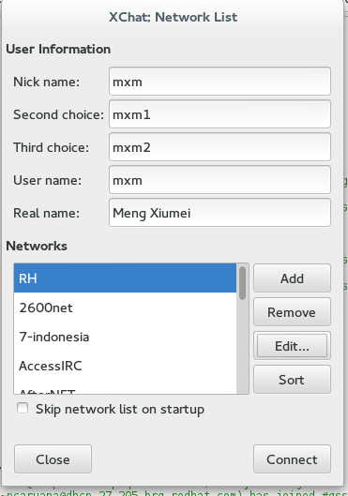

Step 3:

Chose your network and “Edit” to add server and port.

IRC servers: please refer to [https://docspace.corp.redhat.com/docs/DOC-43560](https://mojo.redhat.com/docs/DOC-75960).

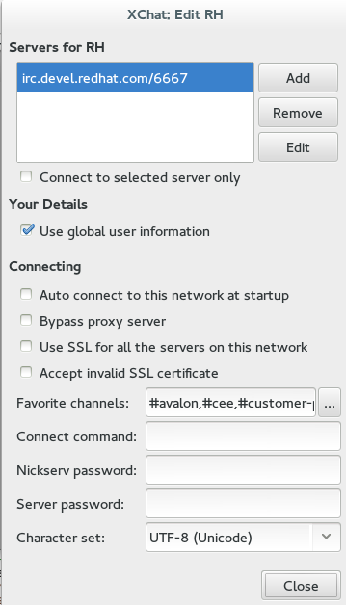

Step 4:

Edit you “Favorite channels” and our team members should add channels below:

#avalon,#cee,#customer-platform,#gss,#gss_china,#jbossas,#jbosscn



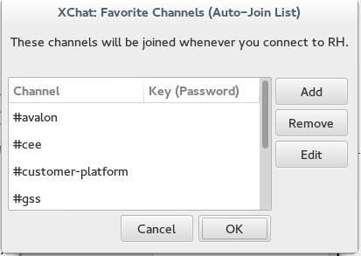

**Setting up an environment that mimics the Access Labs development space**

Step 1:

Install Apache2.

Step 2:

[Create a DDNS Entry](https://mojo.redhat.com/docs/DOC-13143) and you are going to access the app with username.domain

Step 3:

Set up a virtual host and some proxy passes so that the JS chroming services work in /etc/httpd/conf/httpd.conf.

Note: make sure ssl has been installed and modules/mod_ssl.so has been loaded.

|  |
| --- |
| <VirtualHost *:443>  SSLEngine On  SSLProxyEngine On  SSLCertificateFile /etc/httpd/ssl/httpd.pem  SSLCertificateKeyFile /etc/httpd/ssl/httpd.key  ServerName localhost.localdomain  # Example of a passthrough to a local Ruby application  #ProxyPass /labs/ http://localhost:3000/labs/    # Example of a passthrough to a local Java application  #ProxyPass /labs/ http://localhost:8080/labs/  </VirtualHost>  <IfModule mod_proxy.c>  ProxyRequests on  RewriteEngine On  SSLEngine on  SSLProxyEngine on  SSLCertificateFile /etc/httpd/ssl/httpd.pem  SSLCertificateKeyFile /etc/httpd/ssl/httpd.key  ProxyPass /webassets/ https://access.redhat.com/webassets/  ProxyPass /chrome_themes/ https://access.redhat.com/chrome_themes/  ProxyPass /services/ https://access.redhat.com/services/  ProxyPass /click/ https://access.redhat.com/click/  ProxyPass /suggest/ https://access.redhat.com/suggest/  </IfModule> |

Step 4:

Execute command “service httpd start” as root and test the proxy using the url <https://localhost/webassets/avalon/j/lib/angular/1.2.8/angular.min.js> or https://<localhost.localdomain>/webassets/avalon/j/lib/angular/1.2.8/angular.min.js.

If some contents of js are shown, the configuration works.

**Setting up HTTP proxy**

Set up HTTP proxy squid.apac.redhat.com in your browser with port 3128

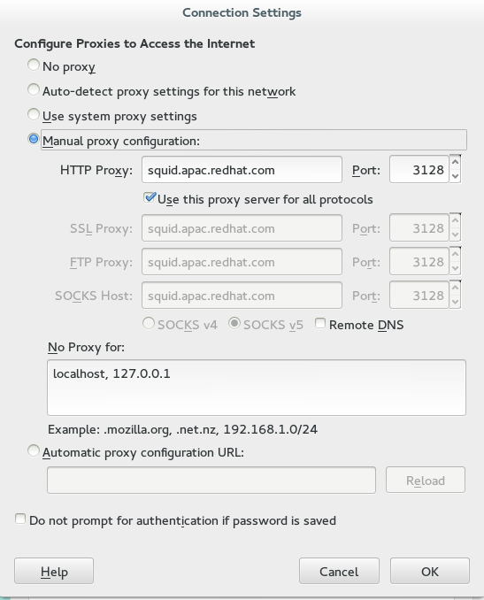

**Setting up VPN**

Step 1:

Install VPNC in any way you know, e.g. #sudo yum install vpnc.x86_64

Step 2:

Open /etc/vpnc/default.conf and add content below to the file.

|  |
| --- |
| #Phoenix  #IPSec gateway vpn-phx2.redhat.com  #Amsterdam  #IPSec gateway vpn-ams2.redhat.com  #Singapore  #IPSec gateway vpn-sin2.redhat.com  #Brisbane  #IPSec gateway vpn-bne.redhat.com  #Beijing  #IPSec gateway vpn-nay.redhat.com  #Tel Aviv  #IPSec gateway vpn-tlv.redhat.com  #Tokyo  #IPSec gateway vpn-nrt.redhat.com  #Raleigh  IPSec gateway vpn-rdu.redhat.com  IPSec ID RH-standard  IPSec secret nodnerip  Xauth username <your userName> |

Step 3:

Run vpnc with your ID and pin+token.

**Joining mailing lists**

Subscribe mailing lists from <http://post-office.corp.redhat.com/mailman/listinfo>

There are several lists that our team members should join, they are: China-list, access-lab, diagnostics-dev-list and avalon-dev-list.

There will be hundreds of mails being received if you join the mailing lists above, so you can catalog your mails by adding filters to your mail system.

Step 1:

Right click “Folders” on the left of your mail system and chose “New Folder”.

Input a name for your folder, e.g. China-list.

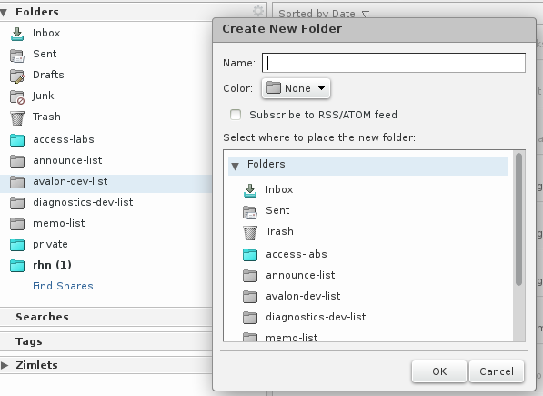

Step 2:

Switch to tab “Preferences” and click “Filters”, you'll see the “Incoming Message Filters” setting page.

Rules can be added and mails will be cataloged to the folder that you created in the previous step by clicking 'New Filter”.

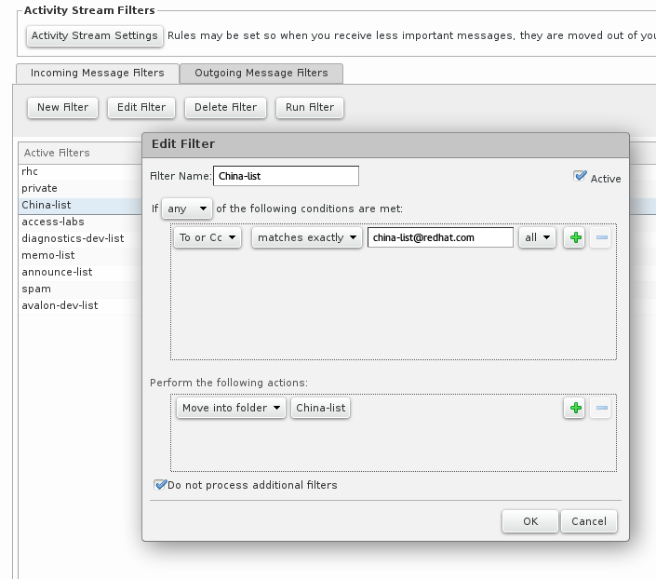Step 3:

Chose a filter in the list and run it, your mails have been received in “inbox” will be moved to specific folder according to the rules.

