**有限元大作业报告**

**班级：** 0117001

**学号：** 011710906

**姓名：** 许晓宇

**题号：** 15

**日期：**2020.07.06

**题目：**

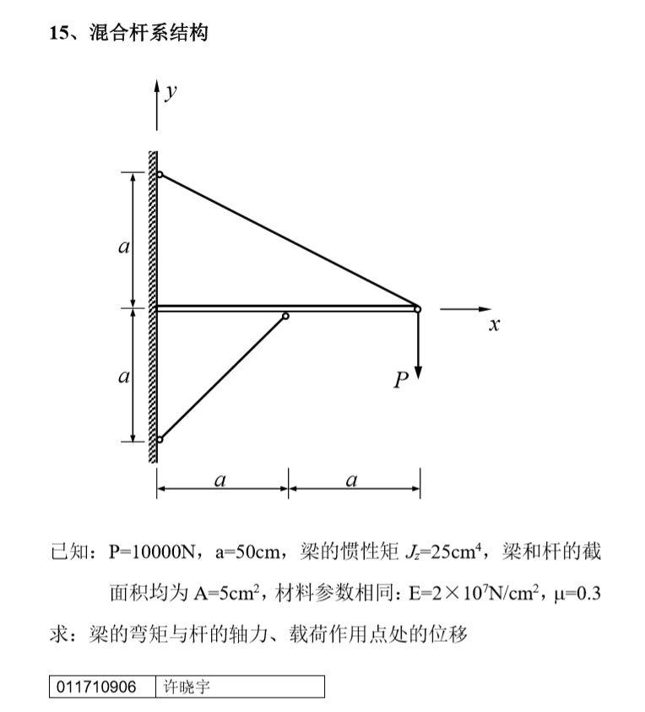

**节点编号与单元编号如图所示**：

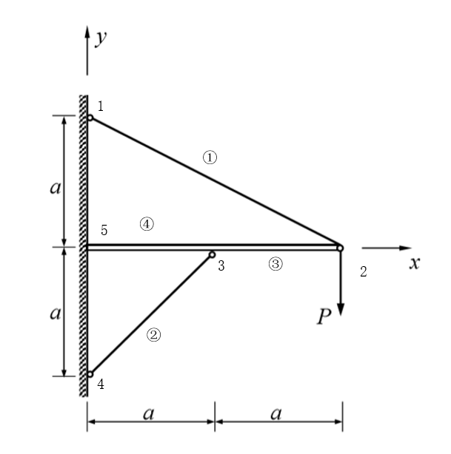

杆单元：

|  |  |  |  |  |  |  |  |  |  |  |
| --- | --- | --- | --- | --- | --- | --- | --- | --- | --- | --- |
| 单元号 | | 节点坐标 | | | | | | | 方向余弦 | |
| 编号 | i-j | xi/cm | yi/cm | xj/cm | yj/cm | l/cm | A/cm2 | E/(N/cm2) |  |  |
| 1 | 1-2 | 0 | 100 | 100 | 50 |  | 5 | 2*107 |  |  |
| 2 | 3-4 | 50 | 50 | 0 | 0 |  | 5 | 2*107 |  |  |

梁单元：

|  |  |  |  |  |  |  |  |  |  |
| --- | --- | --- | --- | --- | --- | --- | --- | --- | --- |
| 单元号 | | 节点坐标 | | | | | | | |
| 编号 | i-j | xi/cm | yi/cm | xj/cm | yj/cm | L/cm | A/cm2 | J/cm4 | E/(N/cm2) |
| 3 | 2-3 | 100 | 50 | 50 | 50 | 50 | 5 | 25 | 2*107 |
| 4 | 3-5 | 50 | 50 | 0 | 50 | 50 | 5 | 25 | 2*107 |

续：

|  |  |  |  |
| --- | --- | --- | --- |
| 方向余弦 | | | |
|  |  |  |  |
| -1 | 0 | 0 | -1 |
| -1 | 0 | 0 | -1 |

杆单元在局部坐标下的刚度矩阵： $\left[\overline{k^{e}}\right]=\frac{EA}{l}\left[\begin{matrix}1 & -1 \\ -1 & 1\end{matrix}\right]$

杆单元在总体坐标下的刚度矩阵： $\left[k^{ⅇ}\right]={\left[λ^{ⅇ}\right]}^{\overline{l}}\left[\overline{k^{e}}\right]\left[λ^{ⅇ}\right]$

梁单元在xoy平面内局部坐标下的刚度矩阵：

$$\left[\overline{k^{e}}\right]=\left[\begin{matrix}\frac{EA}{l} & & & & & \\ 0 & \frac{12EI_{z}}{l^{3}} & & & sym & \\ 0 & \frac{6EI_{z}}{l^{2}} & \frac{4EI_{z}}{l} & & & \\ -\frac{EA}{l} & 0 & 0 & \frac{EA}{l} & & \\ 0 & -\frac{12EI_{z}}{l^{3}} & -\frac{6EI_{z}}{l^{2}} & 0 & \frac{12EI_{z}}{l^{3}} & \\ 0 & \frac{6EI_{z}}{l^{2}} & \frac{2EI_{z}}{l} & 0 & -\frac{6EI_{z}}{l^{2}} & \frac{4EI_{z}}{l}\end{matrix}\right]$$

梁单元在xoy平面内总体坐标下的刚度矩阵： $\left[k^{ⅇ}\right]={\left[λ^{ⅇ}\right]}^{\overline{l}}\left[\overline{k^{e}}\right]\left[λ^{ⅇ}\right]$

按 $\left\{P\right\}$ 与 $\left\{Δ\right\}$ 的排列顺序叠加得到结构刚度矩阵[K]：

PS：采用了置大数法

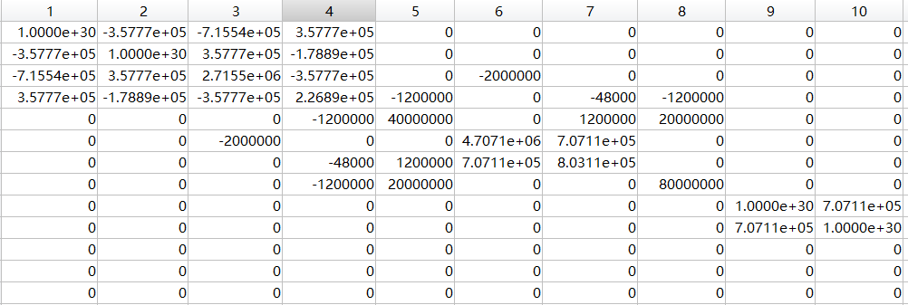

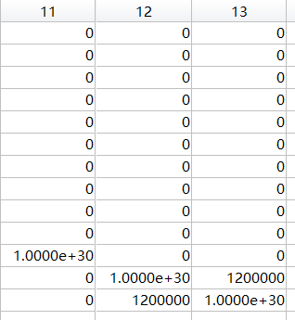

解算得到各节点位移：

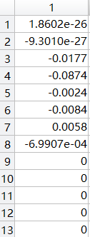

计算得到轴力与弯矩：（轴力拉为正，单位：N）

N1=2.0798e+04

N2=-2.5701e+03

N3=-1.8602e+04

Q3=-698.9927

N4=-1.8602e+04

Q4=1.1184e+03

弯矩：M3=698.9927*x （单位：N*cm）

M4=-1.1184e+03*x+3.4950e+04