**MathRacer Documentation**

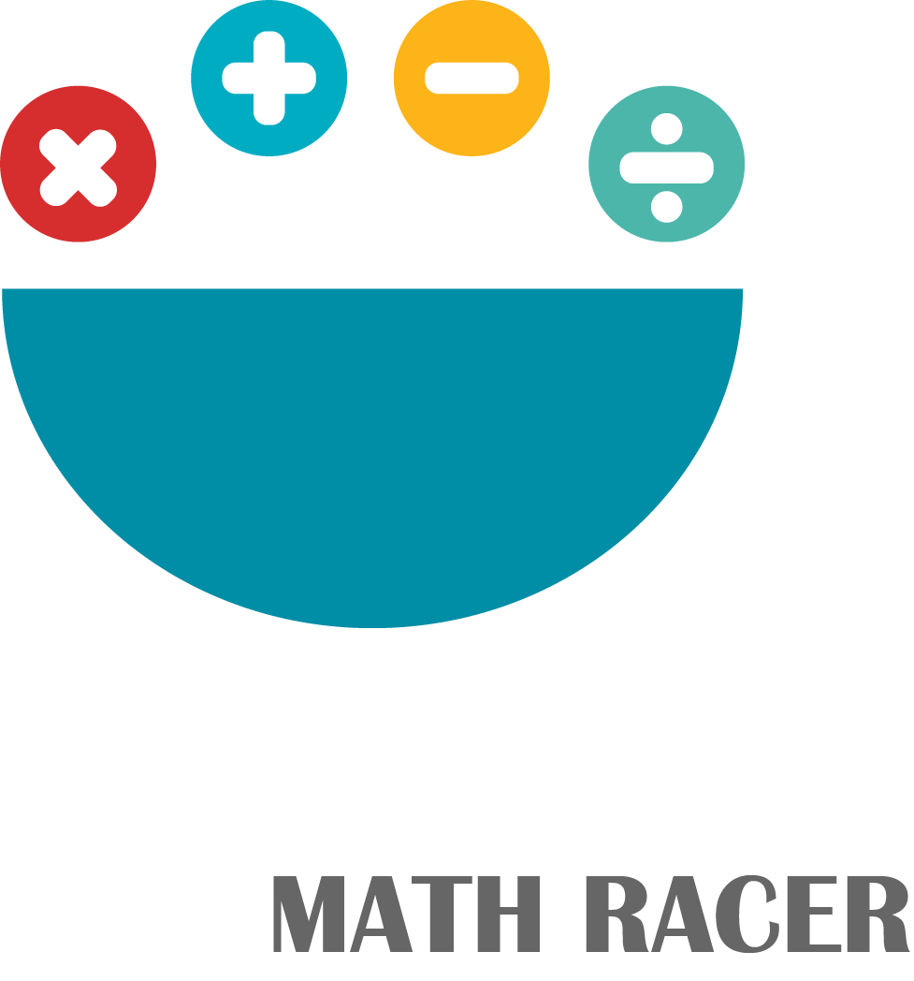

**“Math Racer” -** is the application for group of devices of "Universal Windows Platform" written in C# and using SQLitePCL Database.

The database folder resides in default directory of local computer and is created once the application is started.

The main idea for creating “MathRacer” is to improve user’s arithmetic skills. The application provides number of methods for learning new arithmetic methods and train user’s brain to consolidate received knowledge.

Application has 4 main sections:

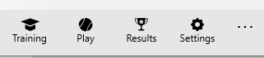

1. “Training” – section, that is where the user of application learns new arithmetic methods. Each of them is explained with the use of images to make user experience uncomplicated and more enjoyable.
2. “Play” – section, that is where the user of application solves different arithmetic tasks.
3. “Results” – section, that is where multiple users can see their detailed results such as score, time of the game and username.
4. “Settings” – section, that is where user can modify and adjust application according to their will.
5. **“Training”**

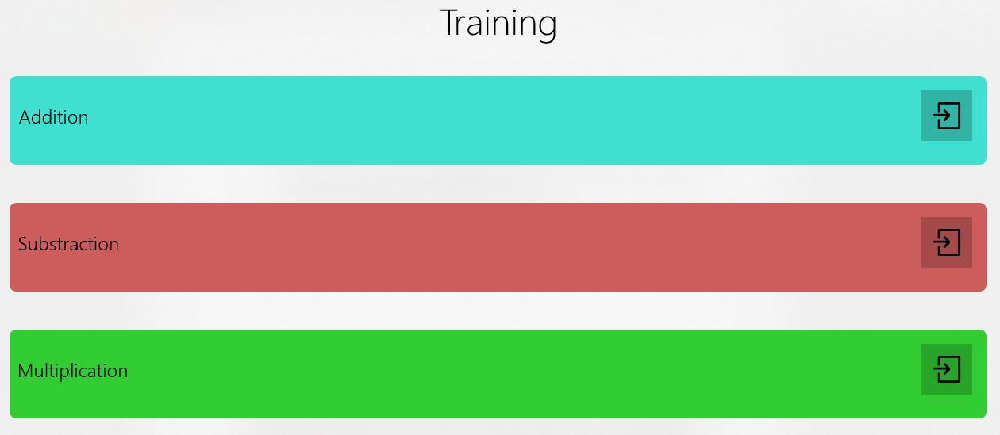

“Training” section has several subsections. Every subsection describes instruction about certain arithmetic method.

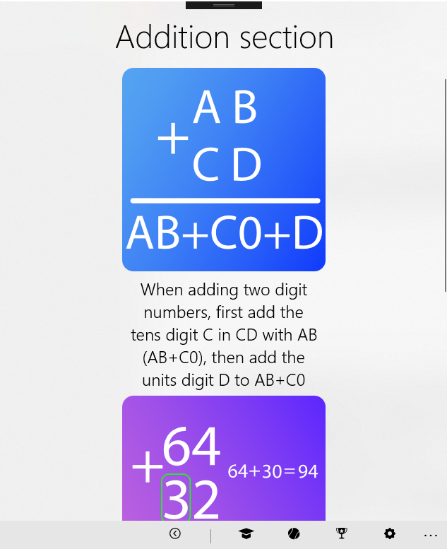

1. **“Play”**

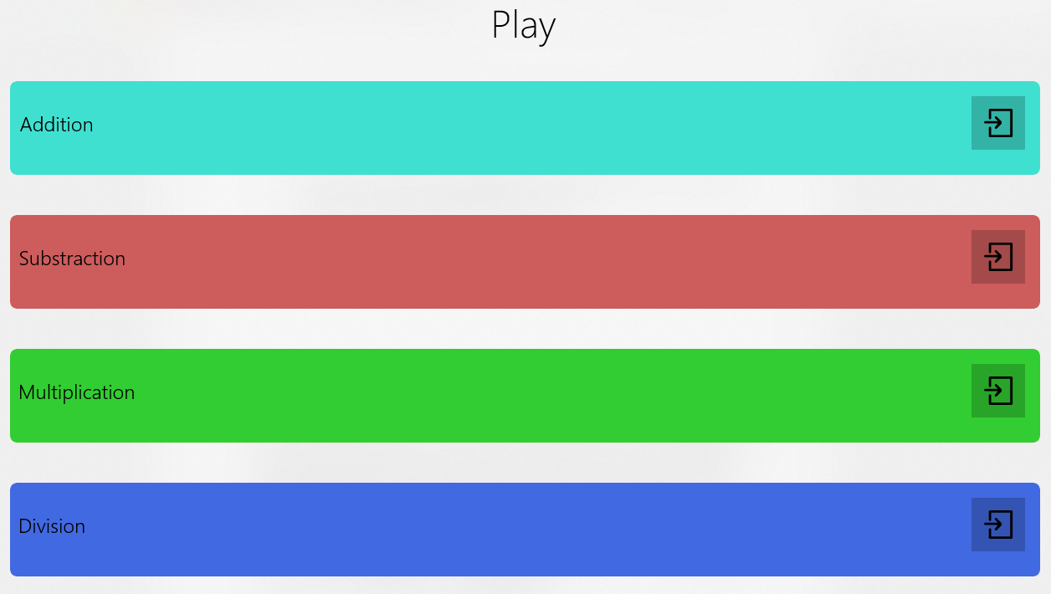

Section “Play” also has several subsections.

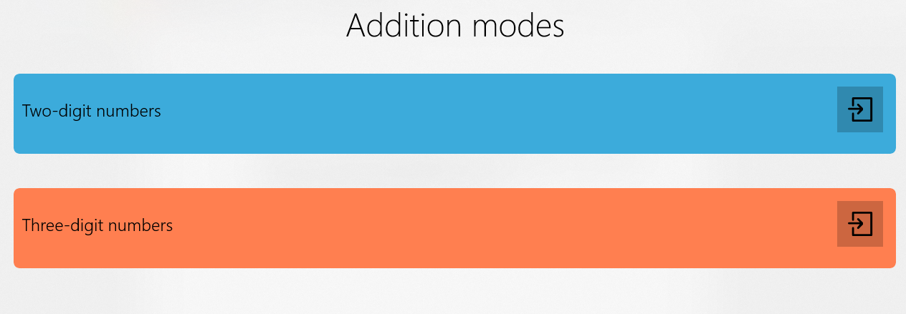

Every subsection contains 2 types of game:

1. 2-digits numbers
2. 3-digits numbers

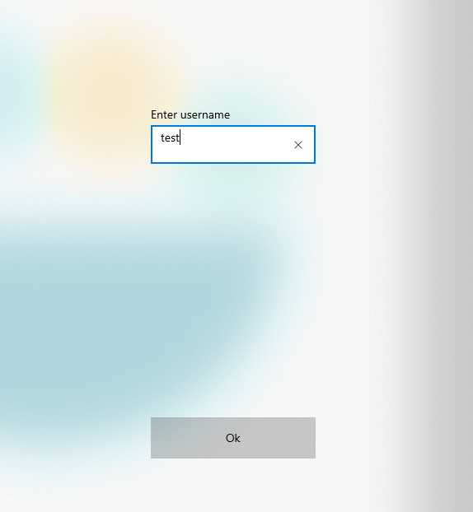

“MathRacer” is designed to support multiplayer use. Each user is promted to insert their nickname before every game.

1. **“Results”**

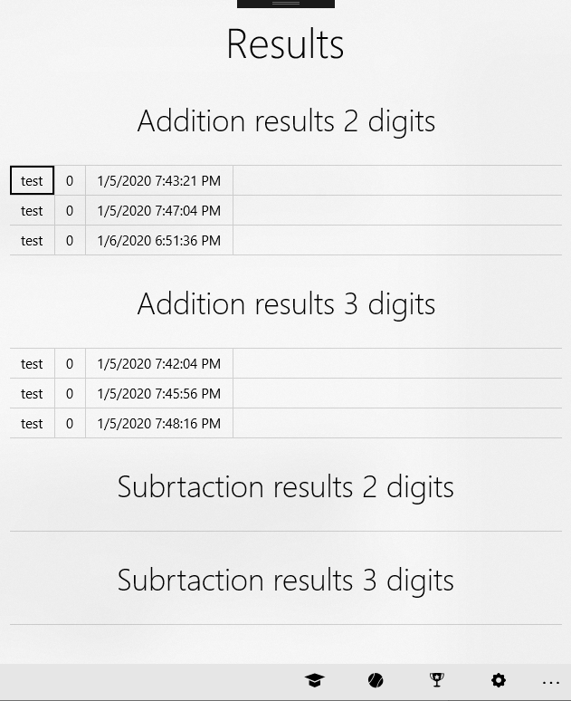

After each games user’s nickname, score and time would be written to Data Base. “Results” section has several tables with information about played games.

1. **“Settings”**

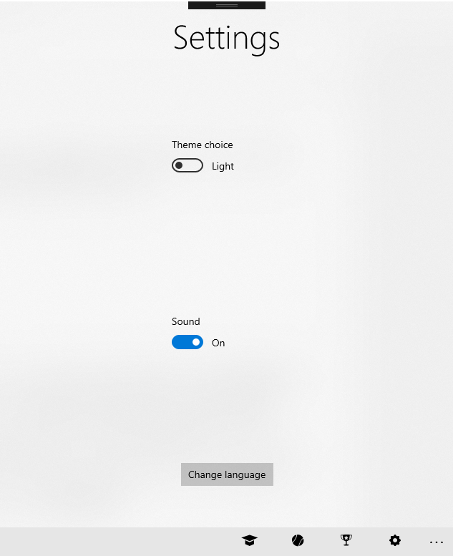In section “Settings” user has 3 functions to modify:

1. Choose dark or light theme.

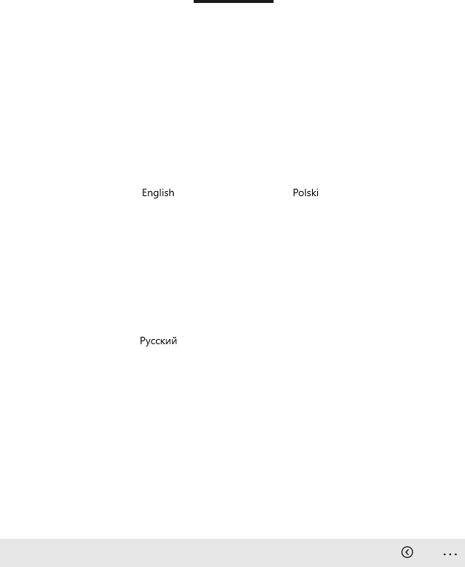

1. On/Off Sound.
2. Change language of application.

User has 3 languages to choose: English, Polish and Russian.

**5.Application’s structure**

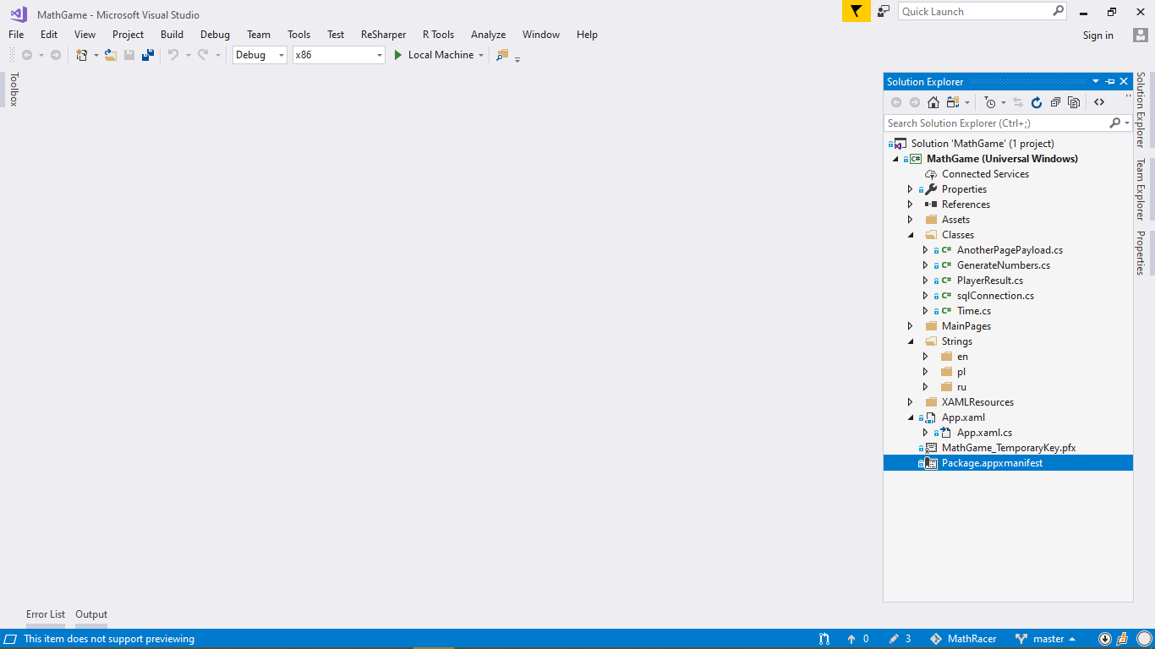

*Classes* folder contains all classes that are used across whole application:

*AnotherPagePayload -* this class is used to generate objects that contain all necessary information sent across pages during navigation.

*GenerateNumbers-* this class serves to generate random numbers used in the process of creating arithemic tasks.

*PlayerResult –* objects of this class contain information about users’ score.

*sqlConnection-* this class provides the connection and creation of database.

*Time-* objects of this class are used to adjust the time of the game.

*MainPages-* this folder contains all .xaml pages and their corresponding .cs files that provide functionality of 4 main sections mentioned in the introduction

*Strings-* this folder provides resources for translation to each language version.

*XamlResources-* the page that resides in this folder defines resources used in theme settings.

**6.Testing**

In order to assess correct functionality of the application ,it underwent series of tests. Each testing procedure is presented below:

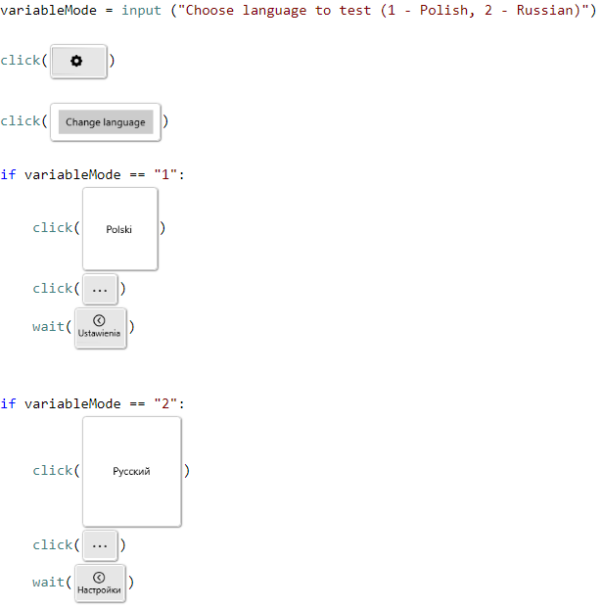

This proofing method requires user to choose the value of *variableMode* variable corresponding to given language to be tested.

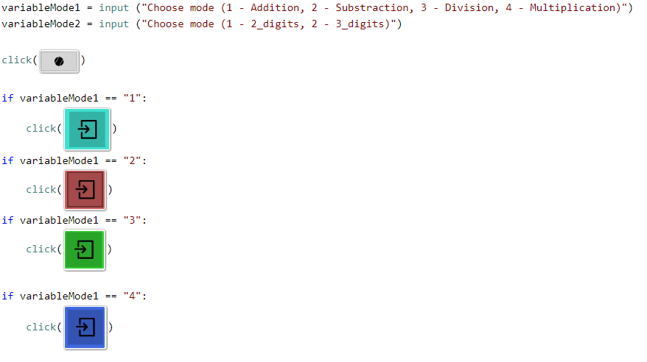

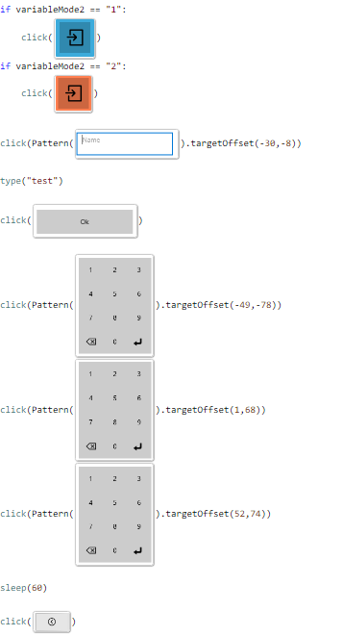

The testing procedure presented above serves to evaluate each subcategory of *“Play”* section. The process of choosing suitable subcategory is performed by setting corresponding variables to given values(as seen above).