3” flexible Fire Hose
filled with water weighs approximately 210 to 420
pounds per leg

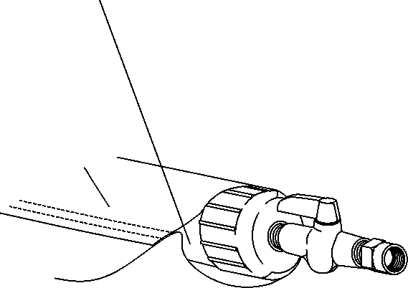

Vinyl Material

The Runway Closure-X60
is two 10’ x 60’ Pieces of Bright Yellow Vinyl.

The Taxiway Closure-X30
is two 5’ x 30’ Pieces of Bright Yellow Vinyl.

