-

Training: Java BDD
Workbook
(edition 1.0, September, 2019)

Training: Java BDD
The author: | Cătălin Tudose (ftudose@luxoft.com)
Product version: | JUnit 5, Cucumber, JBehave

Exercise 1
Making the step from TDD to BDD

Project
lab1

Duration
90 min

Objectives
Move an existing application to emulate BDD with the help of JUnit 5. Understand the business logic, introduce the needed dependencies and write the tests to verify the business logic in BDD style. Correct the possible discovered bugs. Refactor the application and check that it maintains its functionality with the help of the written tests.

Description
The input program of the exercise manages credit offers and customers. The bank maintains a policy regarding adding and removing a customer to an offer.
The offers may be of a few types - economy and business are known at the time. We may consider adding other types at a later time.
You will check the business logic and refactor the application.
You will build a hierarchy of labeled nested tests using the @Nested and @DisplayName annotations, to create tests BDD style, but without any additional framework.

Tasks
We assume that we are joining the development of a program to manage credit offers and customers.
The bank maintains a policy regarding adding and removing a customer to an offer. The offers may be of a few types - economy and business are known at the time, but we consider that we may add other types at a later time, depending on the requirements.
If the offer is an economy one, both VIP customers and usual ones may be added to it. If the offer is a business one, only VIP customers may be added to it.
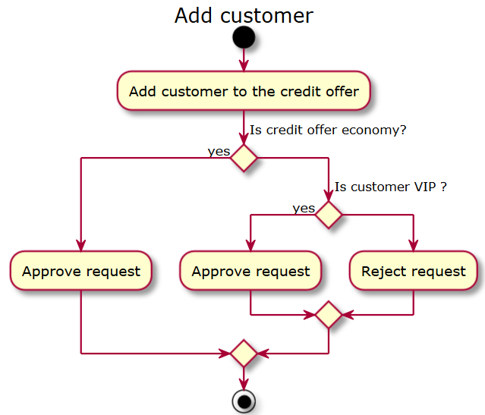

And there is also a policy for removing a customer from an offer. It also involves answering to yes/no questions.

A usual customer may be removed from an offer, a VIP customer cannot be removed. As we see from these two activity diagrams, the initial business logic focuses on decision making.

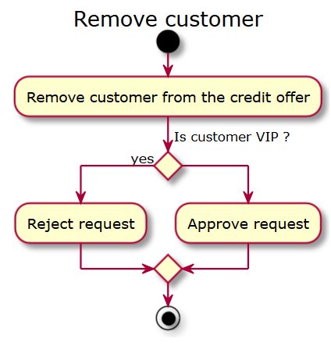

We maintain a field called creditOfferType inside the CreditOffer class. Based on its value, we have to write the behavior of the addCustomer and removeCustomer methods. The programmer will have to focus on decision making at the level of the code of these two methods.

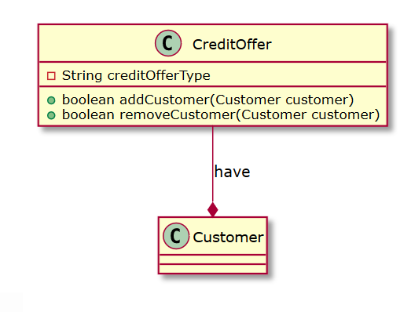

Move the application to use JUnit 5 by introducing the needed Maven dependencies.
<dependencies>
<dependency>
<groupId>org.junit.jupiter</groupId>
<artifactId>junit-jupiter-api</artifactId>
<version>5.0.1</version>
<scope>test</scope>
</dependency>
<dependency>
<groupId>org.junit.jupiter</groupId>
<artifactId>junit-jupiter-engine</artifactId>
<version>5.0.1</version>
<scope>test</scope>
</dependency>
</dependencies>
</project>

Create the tests that will check the business logic of the application and that will cover all presented scenarios.

Verify each scenario and, in case of any bugs into the initial behavior, do the corrections.

Insert the JaCoCo plugin into the pom.xml Maven configuration.

<plugin>
<artifactId>maven-surefire-plugin</artifactId>
<version>2.19.1</version>
<dependencies>
<dependency>
<groupId>org.junit.platform</groupId>
<artifactId>junit-platform-surefire-provider</artifactId>
<version>1.0.1</version>
</dependency>
</dependencies>
</plugin>
<plugin>
<groupId>org.jacoco</groupId>
<artifactId>jacoco-maven-plugin</artifactId>
<version>0.7.9</version>
<executions>
<execution>
<goals>
<goal>prepare-agent</goal>
</goals>
</execution>
<execution>
<id>report</id>
<phase>test</phase>
<goals>
<goal>report</goal>
</goals>
</execution>
<execution>
<id>jacoco-check</id>
<phase>test</phase>
<goals>
<goal>check</goal>
</goals>
<configuration>
<rules>
<rule>
<element>PACKAGE</element>
<limits>
<limit>
<counter>LINE</counter>
<value>COVEREDRATIO</value>
</limit>
</limits>
</rule>
</rules>
</configuration>
</execution>
</executions>
</plugin>

From the command line, execute mvn test.

Expand the target/site/jacoco folder and open the index.html file, study the code coverage report.
- Refactor the application according to the diagram below.
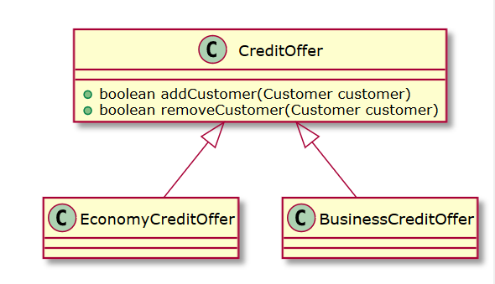

- Re-run the tests in order to make sure that the functionality has been kept.
- Run mvn test and inspect the new code coverage.
Redesign the existing tests to use a hierarchy of annotated classes and tests.
The top-level test class should be named BankTest.
The BankTest class must contain two nested test classes, EconomyCreditOfferTest and BusinessCreditOfferTest.
Each of these two ones should contain two nested classes, called UsualCustomer and VipCustomer. Each test nested class should be annotated with @Nested and @DisplayName.
Each of these most inner four ones should have one single test. These ones must be annotated using @DisplayName.
You must use, instead of a series of assertEquals verifications, an assertAll to check all conditions.
Make sure that the tests are still successfully running and measure the code coverage.
The hierarchy of test classes and their annotations should generate the following execution:

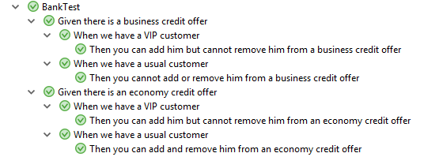
Exercise 2
Move the existing JUnit 5 application to Cucumber

Project
lab2

Duration
60 min

Objectives
Move the testing process of the Bank Application to Cucumber, using features and scenarios.

Tasks
Transform the existing hierarchical JUnit 5 nested tests into Cucumber scenarios. Generate the feature file containing the scenarios. Generate the Cucumber tests from the scenarios. Write the corresponding code for the tests. Run them and check their correctness.
Exercise 3
Use Cucumber to introduce a new credit type offer

Project
lab3

Duration
45 min

Objectives
Add new functionality to the application, defining first the business logic, writing the corresponding scenarios with the help of Cucumber and its features, then fix the tests by writing the expected behavior.

Description
Introduce a new credit offer type, Premium, and a policy concerning this credit offer type. Extend the existing scenarios using Cucumber and its features. Fix the tests by implementing the functionality.

Tasks
Introduce a new class, PremiumCreditOffer. The hierarchy will look this way:

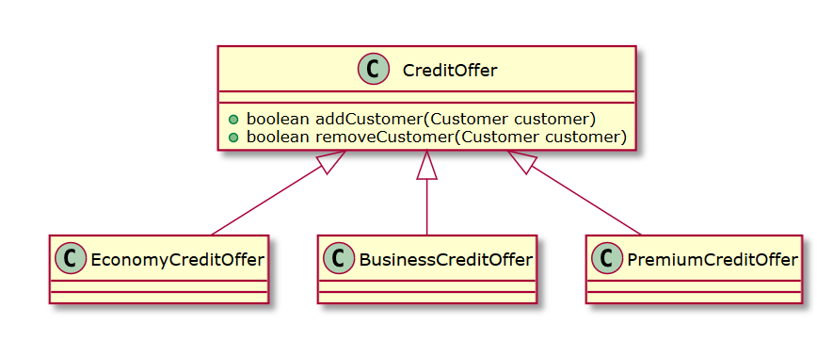
The functionality of the PremiumCreditOffer is described into the following activity diagrams:

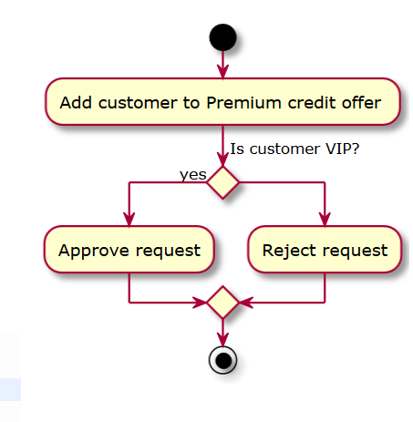

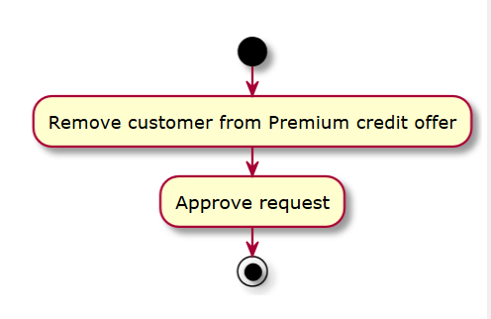

Extend the existing Cucumber scenarios to cover the expected behavior of a Premium credit offer for both a usual customer and a VIP customer, according to the activity diagrams above.
Generate the tests corresponding to the scenarios. Implement the new required functionality so that the tests will pass. Measure the code coverage.
Exercise 4
Implement the unicity of customers added to a credit offer

Project
lab4

Duration
45 min

Objectives
Add new functionality to the application: a customer cannot be assigned to a credit offer more than once. Define the business logic, write the corresponding scenarios with the help of Cucumber, then fix the tests by writing the expected behavior.

Description
Introduce a new policy concerning the unicity of customers added to a credit offer type. Extend the existing tests using Cucumber. Fix the scenarios by implementing the new functionality.

Tasks
The new functionality can be described this way:
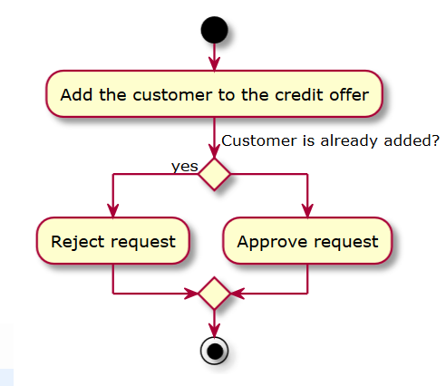

Write the scenarios that will check that a customer cannot be added to a credit offer more than once.
Implement the new required functionality so that the scenarios will pass. One suggested solution is to keep the customers as a set and not as a list – this will ensure the unicity. Measure the code coverage.
Exercise 5
Implement the bonus points policy with the help of Cucumber

Project
lab5

Duration
120 min

Objectives
Add new functionality to the application: a customer may receive bonus points depending on the amount of credit offer that he has applied for. Define the business logic, write the corresponding tests with the help of Cucumber, then fix the tests by writing the expected behavior.

Description
Introduce a new policy concerning the bonus points provided for customers that applied for credit offers. Extend the existing tests using Cucumber, scenario outlines and examples.

Tasks
The new functionality can be described this way:
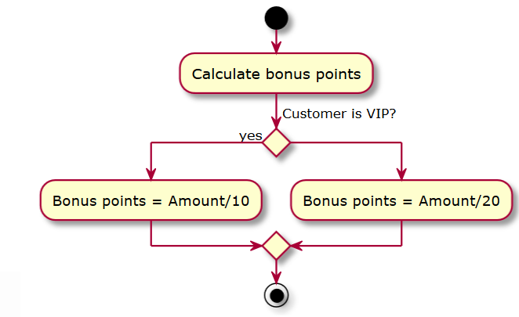
Exercise 6
Move the existing JUnit 5 application to JBehave

Project
lab6

Duration
45 min

Objectives
Move the testing process of the Bank Application from lab 1 to JBehave, using stories, narratives and scenarios.

Tasks
Transform the existing hierarchical JUnit 5 nested tests into JBehave scenarios. Generate the story file containing the scenarios. Generate the JBehave tests from the scenarios. Write the corresponding code for the tests. Run them and check their correctness.
Exercise 7
Use JBehave to introduce a new credit type offer

Project
lab7

Duration
30 min

Objectives
Add new functionality to the application, defining first the business logic, writing the corresponding scenarios with the help of JBehave, then fix the tests by writing the expected behavior.

Description
Introduce a new credit offer type, Premium, and a policy concerning this credit offer type. Extend the existing scenarios using JBehave. Fix the tests by implementing the functionality.

Tasks
Introduce a new class, PremiumCreditOffer. The hierarchy will look this way:

The functionality of the PremiumCreditOffer is described into the following activity diagrams:

Extend the existing JBehave scenarios to cover the expected behavior of a Premium credit offer for both a usual customer and a VIP customer, according to the activity diagrams above.
Generate the tests corresponding to the scenarios. Implement the new required functionality so that the tests will pass. Measure the code coverage.
Exercise 8
Implement the unicity of customers added to a credit offer

Project
lab8

Duration
30 min

Objectives
Add new functionality to the application: a customer cannot be assigned to a credit offer more than once. Define the business logic, write the corresponding scenarios with the help of JBehave, then fix the tests by writing the expected behavior.

Description
Introduce a new policy concerning the unicity of customers added to a credit offer type. Extend the existing tests using JBehave. Fix the scenarios by implementing the new functionality.

Tasks
The new functionality can be described this way:

Write the scenarios that will check that a customer cannot be added to a credit offer more than once.
Implement the new required functionality so that the scenarios will pass. One suggested solution is to keep the customers as a set and not as a list – this will ensure the unicity. Measure the code coverage.
Exercise 9
Implement the bonus points policy with the help of JBehave

Project
lab9

Duration
75 min

Objectives
Add new functionality to the application: a customer may receive bonus points depending on the amount of credit offer that he has applied for. Define the business logic, write the corresponding tests with the help of JBehave, then fix the tests by writing the expected behavior.

Description
Introduce a new policy concerning the bonus points provided for customers that applied for credit offers. Extend the existing tests using JBehave, scenario outlines and examples.

Tasks
The new functionality can be described this way:

