The idea is to use the grid to depict lefts & rights away from the course axis
- The semi-graphical nature of that shows patterns quickly, without relying on memory to decide them
- The page is divided into two columns, use them one after the other
- Header fields: Date, boat, recorder, and page number.
Write the course axis bearing into the center cell of the first column, under Wind Direction. This is the reference you will use to show left and right changes in direction.
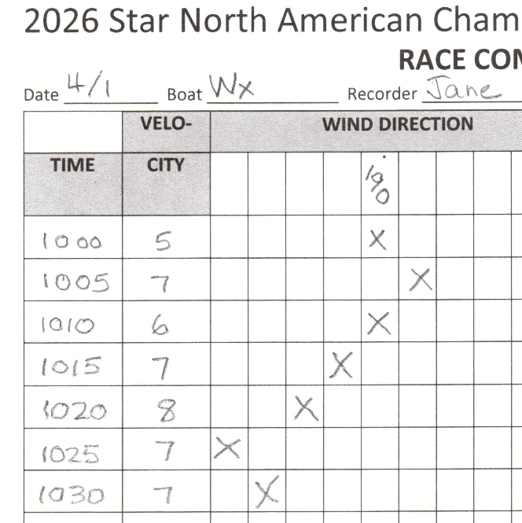
- Each column left and right will be 5 degrees - (to the left) or + (to the right).
- Round all compass readings or bearings to the nearest 5 degrees.
- EVERY 5 MINUTES, Fill the time hhmm, the wind speed, and make a mark "X" in the cell that matches the direction seen
- Use the cells at the end of the line to write in overflow bearings
- TELL THE PRO what you see: steady, tending, or TRENDING.
When the change clocks or veers enough that you run off the end twice, the PRO will likely be seriously getting ready (or wanting to) deploy a change mark at the weather end.
- Weather mark boat - get moving!
- Leeward mark boat - get your change signaling gear ready
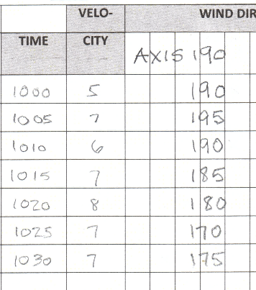
Write a new reference when the course has moved.
IF ALL THAT’S TOO MUCH, JUST LOG THE DATA
Persistent left shift.

RESOURCES



